Al Balqa App[lied University
College of Medicine

Lecture 9
Schistosoma

Dr. Hala Al Daghistani

The Organisms
- More than 200 million people are infectedworldwide with Schistosomaspecies.
- The adult worms arelong and slender (males are 6–12 mm in length; females are7–17 mm in length) and can live in copula for 10–20 yearswithin the venous system
- S.mansoni: inferiormesenteric veins of large intestine
- S.japonicum: inferiorand superior mesenteric veins of small intestine
- S.haematobium:veins of urinary bladder.

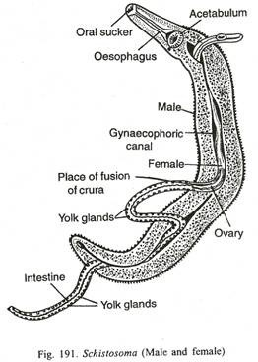

- Humans acquire the infection when they contact waterinfested with the Infectiouscercariae. Cercariae are attractedto the warmth of a body and skin lipids and begin to burrowinto exposed skin. Within 30 minutes, the cercariae have penetratedthe epidermis and transformed into Schistosomules,which enter the peripheral circulation, where they eventuallybecome adults in the hepatoportal system or venous plexussurrounding the bladder.
- The female schistosomesbeginreleasing eggs approximately 5–8 weeks after infection.

Pathology and Pathogenesis

- The most significant pathology is associated with the schistosomeeggs, not the adult worms.
- Female schistosomescan lay hundreds or thousands of eggs per day within thevenous system. When eggs are released, many are sweptback into the circulation and lodge in the liver (S mansoniand S japonicum) or urinary bladder (S haematobium)
- In chronic cases, blood flow to the liver isimpeded, which leads to portal hypertension, accumulationof ascites in the abdominal cavity, hepatosplenomegaly, andesophageal varices.

- In travelers to endemic countries, clinical findings ofacute schistosomiasis include an itchy rash (swimmer’s itch)that occurs within an hour after cercariae penetrate the skin,followed by headache, chills, fever, diarrhea, and eosinophilia

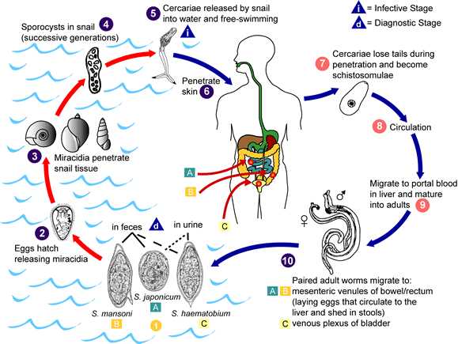
Diagnosis is by O&P:
- S.mansoni(lateral spine) egg in stool
- S.japonicum(nubby spine) eggs in stool
- S.haematobium(terminal spine) eggs in urine

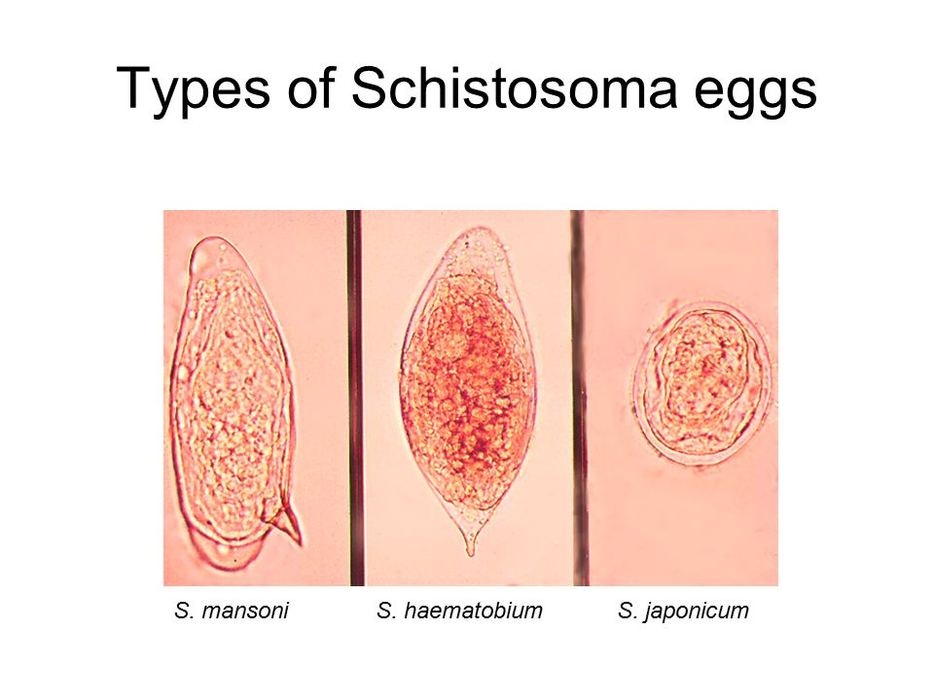

Echinococcus granulosus (hydatid cyst)
- Echinococcusgranulosusis a small, three-segmented tapewormfound in the intestine of dogs and others.

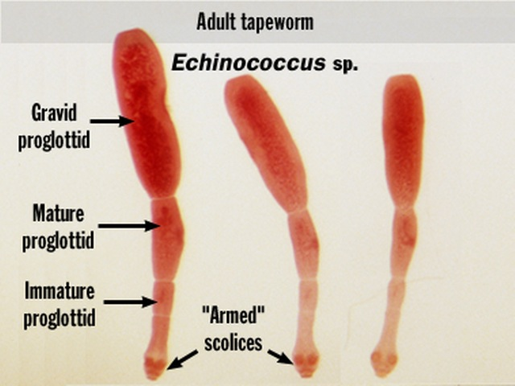

- The eggs leave these hosts and infect grazing animals.The larva hatches fromthe egg, penetrates the gut, and migrates tovarious tissues,especially liver, spleen, muscle, and brain.
- The larva of Echinococcus develops into a fluid-filled cyst called a hydatid cyst. The cyst contains germinal epithelium in which thousands of future larvae(called protoscolices) develop
- Inside the hydatid cyst, the protoscolices are contained within brood capsules. If the hydatid cyst ruptures, the brood capsules can spill out of the cyst, metastasize to other sites, and develop into a hydatid cyst. Thus, ingestion of a single egg can give rise to several hydatid cysts, each containing several brood capsules.
- Humans are infected only by ingesting Echinococcus eggs from food contaminated with dog feces. The dog, in turn, can acquire the infection only from an infected herbivore (cyst).
- Humans are only the intermediate and never the final host of this tapeworm.

Pathology and Pathogenesis
- Hydatid cysts can grow about 1–7 cm per year, and the symptoms depend on the location of the cysts in the body. The liver is the most common site, where compression, atrophy, portal hypertension from mechanical obstruction, and cirrhosis can occur.
- Extreme care must be taken when removing the cyst. If the cyst ruptures, the highly immunogenic hydatid fluid can lead to anaphylactic shock and brood capsules can metastasize to form additional hydatid cysts.
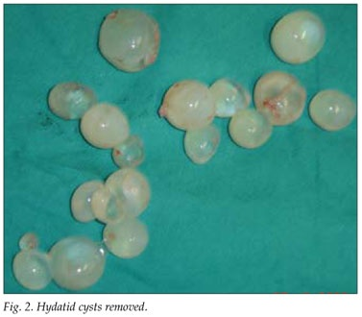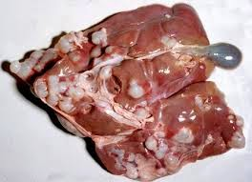

In conclusion:
- The lifecycle of E. granulosus involves dogs and wild carnivores as a definitive host for the adult tapeworm. Definitive hosts are where parasites reach maturity and reproduce. Wild or domesticated animals, such as sheep, and human serve as an intermediate host.
- The larval stage results in the formation of echinococcal cysts in intermediate hosts (human). Echinococcal cysts are slow growing, but can cause clinical symptoms in humans and be life-threatening. Cysts may not initially cause symptoms, in some cases for many years. Symptoms developed depend on location of the cyst, but most occur in the liver, lungs, or both

