

**Al- Balqa Applied University**

**Faculty of Medicine Dr. Hala Al Daghistani**

**Lecture six, and seven**

**Blood Flagellates**

**Trypanosoma , Leishmania, and Filariasis**

**Two distinct types of human Trypanosomes are present:**

1. African**, which causes Sleeping sickness, and is transmitted by tsetse flies. The disease caused by two species:**

* ***Trypanosoma brucei rhodesiense***
* ***Trypanosoma brucei gambiense***

1. **American, which causes Chagas disease, is transmitted by kissing bugs, and caused by**

* ***Trypanosoma cruzi.***

**African Trypanosoma: The genus Trypanosoma appears in the blood as:**

1. **Trypomastigotes with elongated bodies supporting an undulating membrane and a flagellum emerges at the anterior end as a whiplike extension. The kinetoplast (circular DNA inside the single mitochondrion) is a darkly staining body lying immediately adjacent to the basal body from which the flagellum arises.**

[](http://keywordsuggest.org/gallery/668625.html)

* **it is a non-dividing form that is infectious spread to lymph nodes, Bloodstream, and, in terminal stages, to the CNS where they produce:**
* **Typical sleeping sickness syndrome.**
* **Inability to eat**
* **Unconsciousness, and death.**
* **CNS involvement is most characteristic of African Trypanosomiasis.  
  - The Trypanosomes are transmissible through the placenta, and congenital infections occur in hyperendemic areas.**

**B- Amastigote is the intracellular dividing form in the cytoplasm of vertebrate cells.**

**C- Epimastigote is found in the intestinal tract of the insect vector.**

[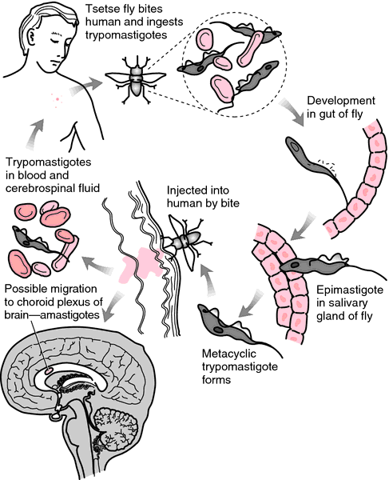](http://medical-dictionary.thefreedictionary.com/Trypanosoma)

**Pathology and pathogenesis:**

**Infective Trypanosomes of *T. bruci gambiense* and *T bruci rhodesiense a*re introduced through the bite of the tsetse fly and multiply at the site of inoculation to cause swelling (the primary lesion), which may progress to form a trypanosomal chancre.**

* **The African trypanosomes of the *T brucei* complex are remarkable in that they undergo antigenic variation through a series of genetically controlled surface glycoproteins that coat the surface of the organism (variant surface glycoproteins, or VSGs).**
* **By producing VSGs, the parasite is able to evade the host’s antibody response.**
* **Each trypanosome is thought to possess about 1000 VSG genes, an example of mosaic gene formations**

**American trypanosoma:   
Trypanosoma cruzi has three developmental stages:   
1. Epimastigotes in the vector.**

**2. Trypomastigotes (in the bloodstream): The blood forms of *T cruzi* are present during the early acute stage and at intervals thereafter in smaller numbers. They contain a large, rounded terminal kinetoplast, but they are difficult to morphologically distinguish from African trypanosomes.**

**3. Amastigote (rounded intracellular stage). The tissue forms, which are most common in heart muscle, liver, and brain.**

[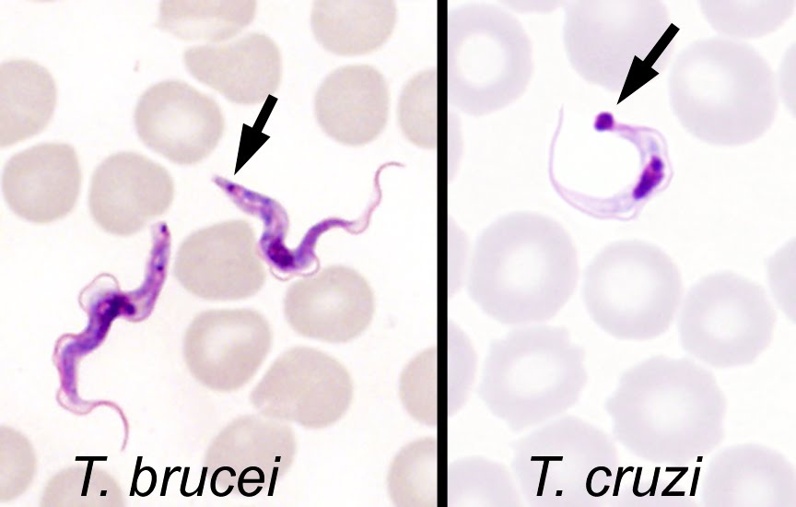](http://parasitewonders.blogspot.com/2011/01/answer-to-case-147.html)

**Pathology and pathogenesis**

* **Infective forms of *T. cruzi* are introduced when infected bug feces are rubbed into the conjunctiva, the bite site, or a break in the skin.**
* **At the site of *T. cruzi* entry, there may be a subcutaneous inflammatory nodule or Chagoma. Swelling of the eyelids, especially in children.**
* **The primary lesion is accompanied by**
* **Fever**
* **acute regional lymphadenitis**
* **dissemination to blood and tissues.**
* **Interstitial myocarditis is the most common serious condition in chagas disease**
* **other organs affected are the liver, spleen, and bone marrow**

**The genus Leishmania**

**- Divided into a number of species infecting humans, causes**

**1. Cutaneous lishmaniasis** (Oriental sore, Baghdad boil, wet cutaneous sore, dry cutaneous sore, Delhi boil, and other names). ***Leishmania tropica, L major, L mexicana, L braziliensis,*** and other ***cutaneous forms*** induce a dermal lesion at the site of inoculation by the **Sandfly.**

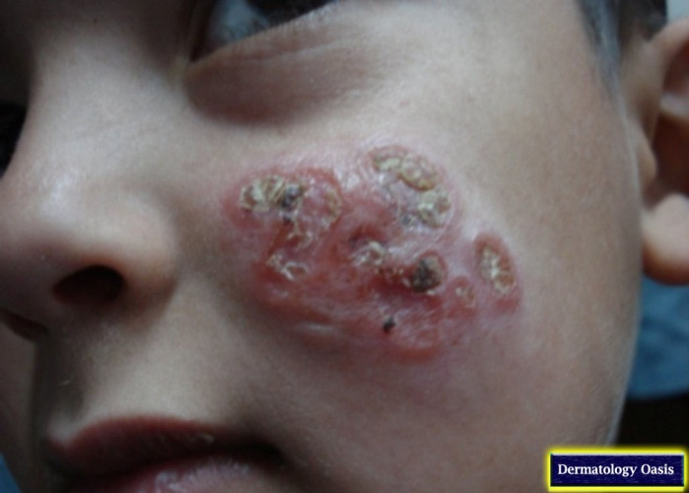 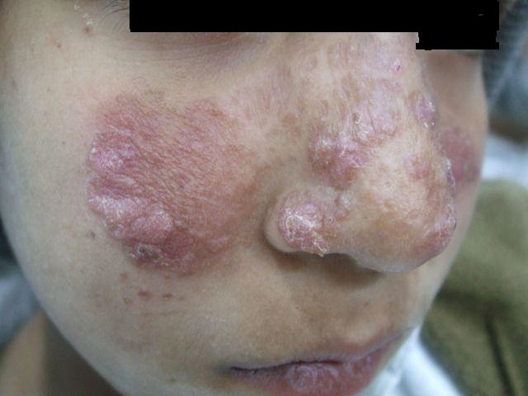

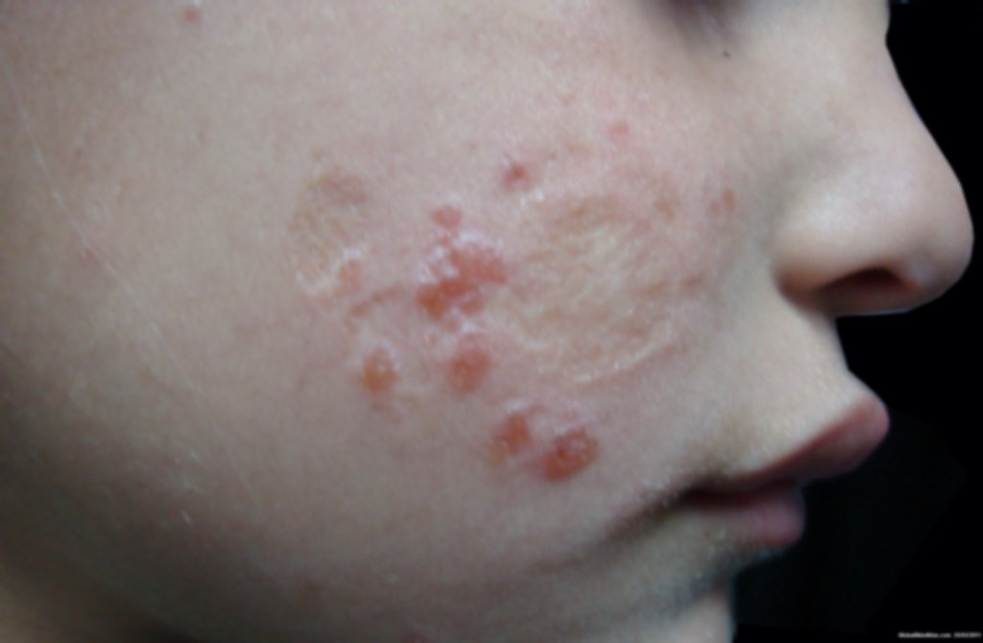 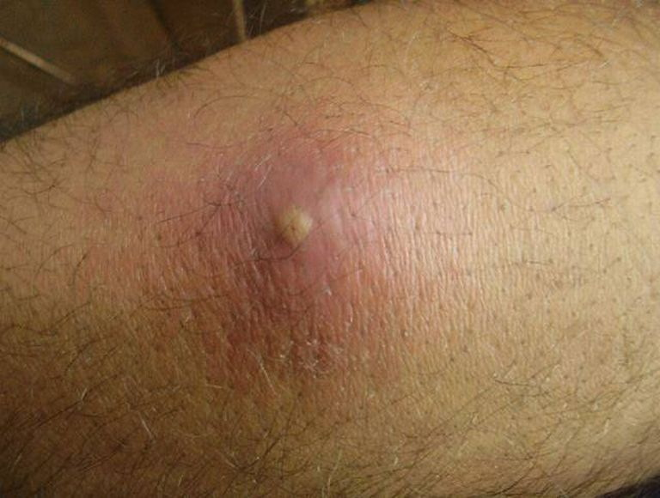

**2. Mucocutaneous leshmaniasis (*Leishmania braziliensis*** causes ***mucocutaneous or nasopharyngeal leishmaniasis*** in South America. The lesions are slow growing but extensive.

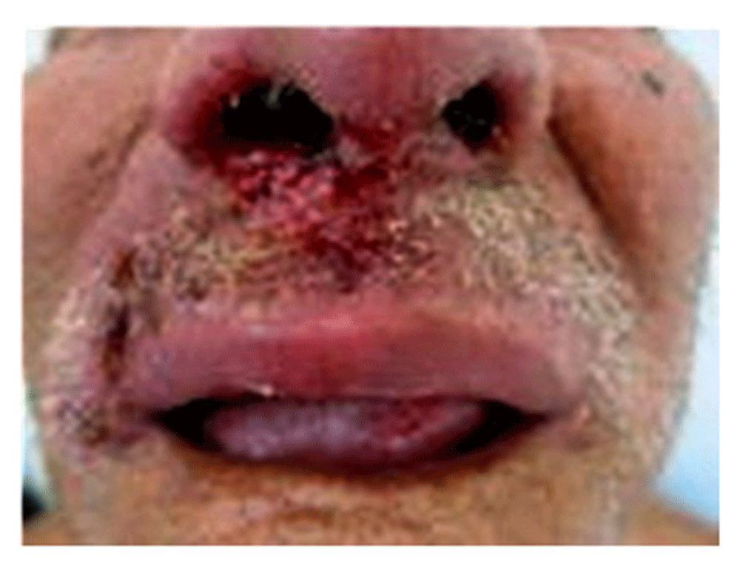 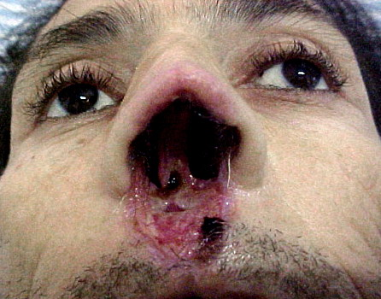

**3. Visceral (kala-azar) leishmaniasis. *Leishmania donovani,*** which causes **visceral leishmaniasis** , spreads from the site of inoculation to multiply in reticuloendothelial cells, especially macrophages in spleen, liver, lymph nodes, and bone marrow.  **All of these infections are transmitted by sand flies**

**Morphology & Identification**

* **The sand fly transmits the infective Promastigotes by bite. The promastigotes rapidly change to Amastigotes after phagocytosis by macrophages, and then multiply, filling the cytoplasm of the macrophages. The infected cells burst, the released parasites are again phagocytosed, and the process is repeated, producing a cutaneous lesion or visceral infection depending upon the species of parasite and the host response.**

**The Amastigotes are oval, 2–6 × 1–3 μm, with a laterally placed oval vesicular nucleus and a dark staining, rod-like kinetoplast.**

[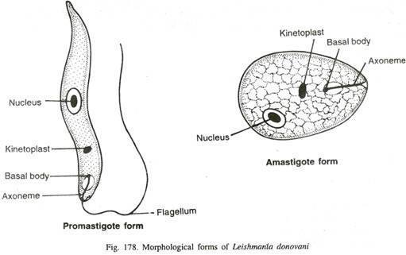](https://microbeonline.com/laboratory-diagnosis-of-leishmaniasis-visceral-leishmaniasis-kala-azar-part-one/)

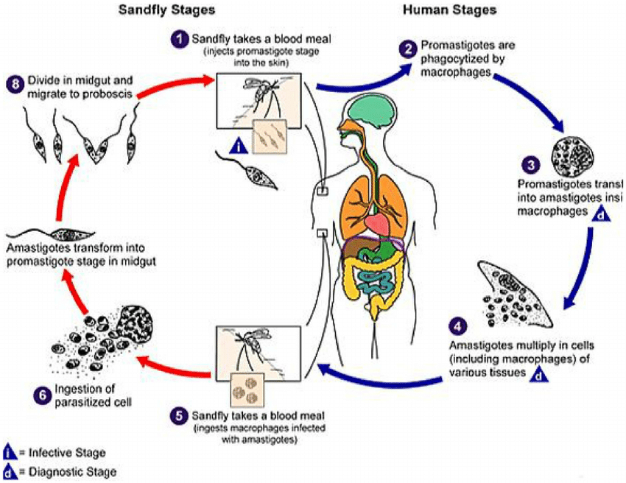

* **Only the intracellular Amastigote occurs in mammals**

[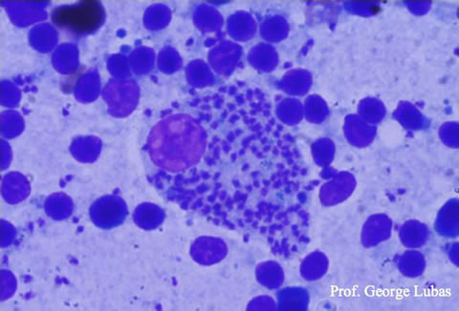](http://www.gruppoleishmania.org/it/macrofago-gigante-ingolfato-di-leishmania-i-striscio-da-agoinfissione-da-linfonodo)

**Pathogenesis, Pathology, & Clinical Findings**

***L donovani,* which causes kala-azar, spreads from the site of inoculation to multiply in reticuloendothelial cells, especially macrophages in spleen, liver, lymph nodes, and bone marrow. This is accompanied by**

* **hyperplasia of the spleen.**
* **weakness.**
* **Irregular fever**
* **Untreated cases with symptoms of kala-azar usually are fatal.**

**Diagnostic Laboratory Tests**

**A. SPECIMENS**

* **Lymph node aspirates, blood, and spleen, liver, or bone marrow puncture are important in kala-azar.**
* **An (ELISA) technique using a 70-kDa antigen has been studied as a rapid and accurate field-applied tool to detect visceral leishmaniasis (detection of antibody)**

**B. MICROSCOPIC EXAMINATION**

**Giemsa-stained smears and sections may show Amastigotes, especially in material from kala-azar**

**CULTURE AND GROWTH CHARACTERISTICS**

**NNN (Nicolle-NovyMacneal) medium is the medium most generally used. A diphasic rabbit blood agar culture, Tobie’s medium, at about 26–28 °C, is especially suitable.**

***L donovani* usually grows slowly.**

* **Lymph node aspirates are suitable**
* **tissue aspirates,**
* **biopsy material**
* **scrapings**

**Only Promastigotes can be cultivated in the absence of living cells.**

**D. SEROLOGY**

* **IHA (indirect hemagglutination antibody)**
* **IFA (indirect fluorescent antibody) test may be useful, but they lack sufficient sensitivity*.* ELISA test**
* **polymerase chain reaction (PCR)**

**A skin test (Montenegro test) is epidemiologically important in indicating past exposure to any of the leishmania. It is a delayed hypersensitivity test. 0.2 ml of leishmania antigens (dead promastigotes) is injected intradermaly and the results read after 48-72h. Positive results is indicative by an indurations of 5mm or more.**

**‬‏** 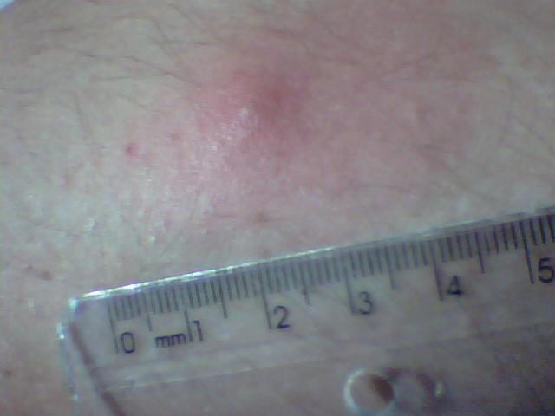

**Epidemiology, Prevention, & Control**

* **Kala-azar, caused by *L donovani,* is found in most tropical and subtropical countries. Its local distribution is related to the prevalence of specific sandfly vectors. In the Mediterranean and in middle Asia and South America, domestic and wild canis are reservoirs, and in the Sudan, various wild carnivores and rodents are reservoirs of endemic kala-azar.**
* **Control is aimed at destroying breeding places and dogs, where appropriate, and also protecting people from sandfly bites.**

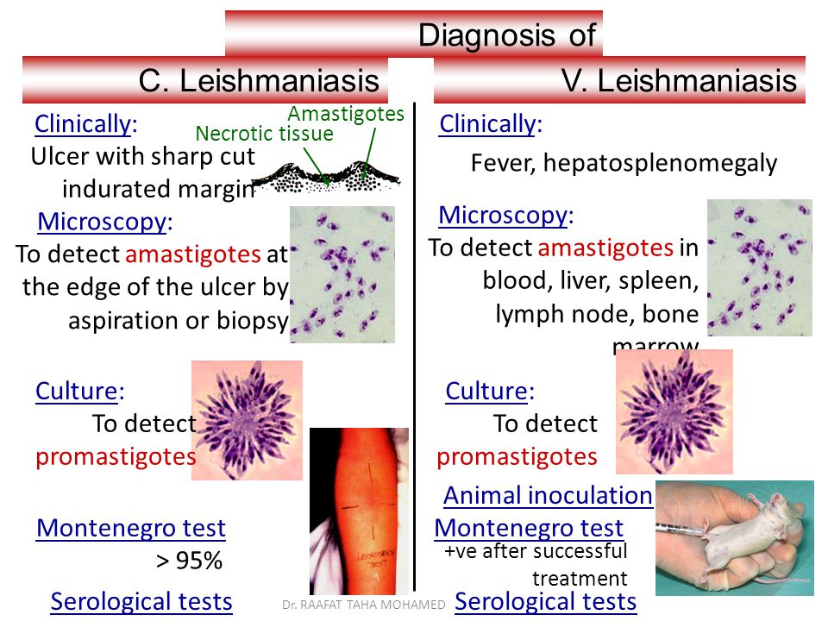

**Filariasis**

**Is a**[**parasitic disease**](https://en.wikipedia.org/wiki/Parasitic_disease)**caused by an infection with**[**roundworms**](https://en.wikipedia.org/wiki/Roundworms)**. These are spread by blood-feeding**[**black flies**](https://en.wikipedia.org/wiki/Black_fly)**and**[**mosquitoes**](https://en.wikipedia.org/wiki/Mosquito)**. This disease belongs to the group of diseases called [helminthiases](https://en.wikipedia.org/wiki/Helminthiases" \o "Helminthiases).**

[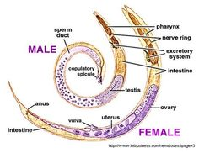](https://www.pinterest.com/pin/435019645237232041/)

**Eight known filarial nematodes use humans as their definitive hosts. These are divided into three groups according to the niche they occupy in the body:**

[**Lymphatic filariasis**](https://en.wikipedia.org/wiki/Lymphatic_filariasis)**is caused by the worms *[Wuchereria bancrofti](https://en.wikipedia.org/wiki/Wuchereria_bancrofti" \o "Wuchereria bancrofti)*, *[Brugia malayi](https://en.wikipedia.org/wiki/Brugia_malayi" \o "Brugia malayi)*, and *[Brugia timori](https://en.wikipedia.org/wiki/Brugia_timori" \o "Brugia timori)*. These worms occupy the**[**lymphatic system**](https://en.wikipedia.org/wiki/Lymphatic_system)**, including the lymph nodes; in chronic cases, these worms lead to the syndrome of *elephantiasis*.**

**Subcutaneous filariasis is caused by**[***Loa loa***](https://en.wikipedia.org/wiki/Loa_loa)**(the eye worm), *[Mansonella streptocerca](https://en.wikipedia.org/wiki/Mansonella_streptocerca" \o "Mansonella streptocerca)*, and *[Onchocerca volvulus](https://en.wikipedia.org/wiki/Onchocerca_volvulus" \o "Onchocerca volvulus)*. These worms occupy the**[**subcutaneous**](https://en.wikipedia.org/wiki/Subcutaneous_tissue)**layer of the skin, in the fat layer. *Loa loa* causes**[***Loa loa* filariasis**](https://en.wikipedia.org/wiki/Loa_loa_filariasis)**, while *O. volvulus* causes** [**river blindness**](https://en.wikipedia.org/wiki/Onchocerciasis)**.**

**Serous cavity filariasis is caused by the worms *[Mansonella perstans](https://en.wikipedia.org/wiki/Mansonella_perstans" \o "Mansonella perstans)* and *[Mansonella ozzardi](https://en.wikipedia.org/wiki/Mansonella_ozzardi" \o "Mansonella ozzardi)*, which occupy the**[**serous cavity**](https://en.wikipedia.org/wiki/Serous_membrane)**of the**[**abdomen**](https://en.wikipedia.org/wiki/Abdomen)**.**

**Life cycle**

* **life cycle consists of five stages. After the male and female worms mate, the female gives birth to live Microfilariae. The Microfilariae are taken up by the**[**vector**](https://en.wikipedia.org/wiki/Vector_(epidemiology))**insect (intermediate host) during a blood meal. In the intermediate host, the microfilariae molt and develop into third-stage (infective) larvae. Upon taking another blood meal, the vector insect injects the infectious larvae into the dermis layer of the skin. After about one year, the larvae molt through two more stages, maturing into the adult worms.**
* **Individuals infected by filarial worms may be described as either "microfilaraemic" or "amicrofilaraemic", depending on whether microfilariae can be found in their peripheral blood.**
* **Filariasis is diagnosed in microfilaraemic cases primarily through direct observation of microfilariae in the peripheral blood. Occult filariasis is diagnosed in amicrofilaraemic cases based on clinical observations and, in some cases, by finding a circulating antigen in the blood.**

**[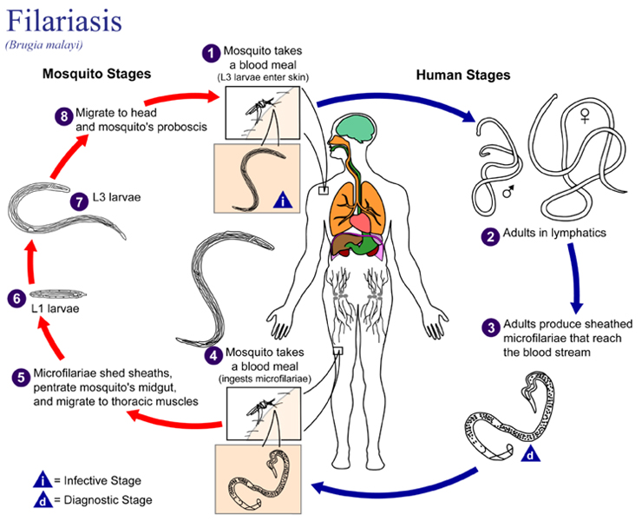](http://www2.warwick.ac.uk/fac/cross_fac/zeeman_institute/zeeman_research/epidemiology/humans/ntds/lymphaticfilariasis/)**

**Signs and symptoms**

* **The most important symptom of lymphatic Filariasis is elephantiasis—edema with thickening of the skin and underlying tissues**
* **Elephantiasis results when the parasites lodge in the**[**lymphatic system**](https://en.wikipedia.org/wiki/Lymphatic_system)**.**
* **Elephantiasis affects mainly the lower extremities.**
* **However, different species of filarial worms tend to affect different parts of the body**

1. [***Wuchereria bancrofti***](https://en.wikipedia.org/wiki/Wuchereria_bancrofti)**can affect the legs, arms,**[**vulva**](https://en.wikipedia.org/wiki/Vulva)**, breasts, and**[**scrotum**](https://en.wikipedia.org/wiki/Scrotum)**(causing [hydrocele](https://en.wikipedia.org/wiki/Hydrocele" \o "Hydrocele) formation),**
2. [***Brugia timori***](https://en.wikipedia.org/wiki/Brugia_timori)**rarely affects the genitals.**
3. **Those who develop the chronic stages of elephantiasis are usually free from microfilariae (Amicrofilaraemic)**
4. **The subcutaneous worms present with: rashes, urticarial**[**papules**](https://en.wikipedia.org/wiki/Papule)**, and**[**arthritis**](https://en.wikipedia.org/wiki/Arthritis)**, as well as hyper- and hypopigmentation [macules](https://en.wikipedia.org/wiki/Macule" \o "Macule).**

**Lymphatic filariasis**

**PATHOLOGY AND PATHOGENESIS**

* Pathologic changes, which are confined primarily to the lymphatic system, can be **divided into acute and chronic lesions**.
* In **acute disease**, the presence of molting adolescent worms and dead or dying adults stimulates dilatation of the lymphatics, hyperplastic changes in the vessel endothelium, infiltration by lymphocytes, plasma cells, and eosinophils, and thrombus formation (ie, acute lymphangitis).
* These developments are followed by granuloma formation, fibrosis, and permanent lymphatic obstruction.
* Repeated infections eventually result in massive lymphatic blockade. The skin and subcutaneous tissues become edematous, thickened, and fibrotic. Dilated vessels may rupture, spilling lymph into the tissues or body cavities. Bacterial and fungal superinfections of the skin contribute to tissue damage.

**DIAGNOSIS**

* Eosinophilia is usually present during the acute inflammatory episodes
* The presence of microfilaria in the blood or lymphatic, ascitic, or pleural fluid sought in Giemsa- or Wright-stained thick and thin smears is evidence.
* Because the appearance of the microfilariae is usually periodic, specimen collection must be properly timed.
* Circulating filarial antigens can be found in most microfilaremic patients.

