

**Al- Balqa Applied University**

**Faculty of Medicine Dr. Hala Al Daghistani**

**Lecture Two**

**Yersinia pestis**

[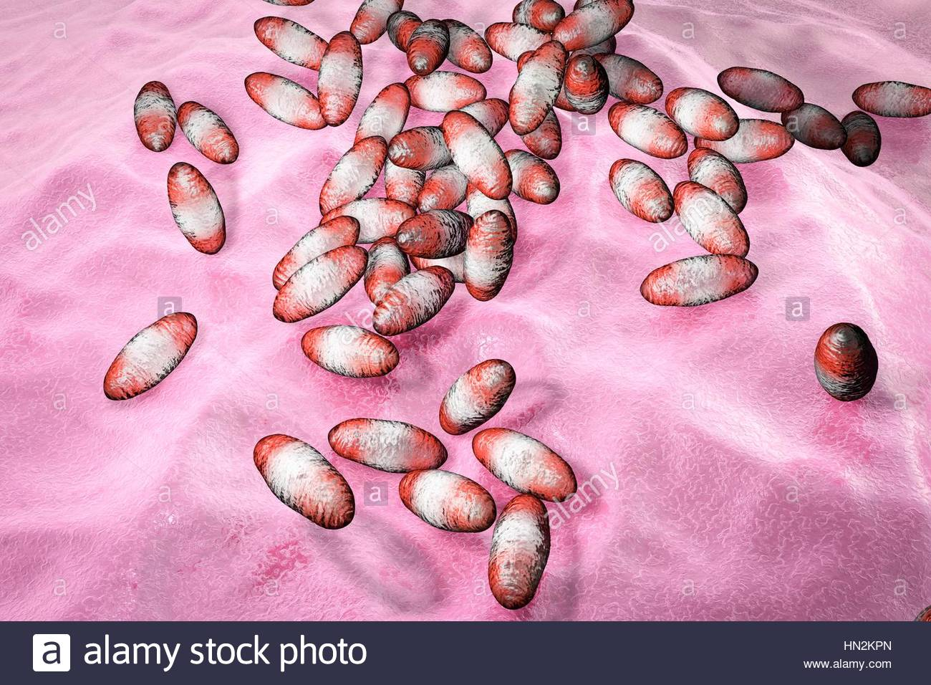](http://www.alamy.com/stock-photo-plague-bacteria-yersinia-pestiscomputer-illustrationypestis-are-gram-133439789.html)

**Yersinia species**

* **Short, pleomorphic gram-negative rods that can exhibit bipolar staining.**
* **Catalase positive, and microaerophilic or facultatively anaerobic.**
* **Animals are their natural hosts.**
* ***Yersinia pseudotuberculosis* and *Yersinia enterocolitica,* important causes of human diarrheal diseases**
* ***Y. pestis* exhibits bipolar staining (safety pin shape)**
* **It is nonmotile.**
* **Growth is more rapid in media containing blood or tissue fluids at 30°C.**

**Yersinia and plague**

**Plague is an infection of wild rodents transmitted from one rodent to another and occasionally from rodents to humans by the bites of fleas. Serious infection often results, which in previous centuries produced pandemics of “black death” with millions of fatalities.**

***Y. pesti*s causes the disease** [**plague**](https://en.wikipedia.org/wiki/Plague_(disease))**, which takes three main forms:** [**Pneumonic**](https://en.wikipedia.org/wiki/Pneumonic_plague)**,** [**Septicemic**](https://en.wikipedia.org/wiki/Septicemic_plague)**, and** [**Bubonic plagues**](https://en.wikipedia.org/wiki/Bubonic_plague)**. The ability of this organism to be transmitted by aerosol and the severity and high mortality associated with pneumonic plague make *Y. pestis* a potential biological weapon.**

**Antigenic Structure**

* **LPS (endotoxin)**
* **The virulent Yersinia produce V and W antigens (antiphagocytic). They yield the requirement for calcium for growth at 37°C.**
* **Compared with the other pathogenic Yersinia, *Y. pestis* has plasminogen-activating protease that has temperature dependent coagulase activity (20°–28°C, the temperature of the flea) and fibrinolytic activity (35°–37°C, the temperature of the host).**
* **Capsular protein that confers antiphagocytic properties.**
* **Phospholipase D, which is required for organism survival in the flea midgut.**
* **Siderophore, Yersiniabactin (Fe3+ binding agents)**
* **Several exotoxins produced**

**Pathogenesis and Pathology**

* **When a flea feeds on a rodent infected with *Y. pestis* , the ingested organisms multiply in the gut of the flea and, helped by the coagulase, block its proventriculus so that no food can pass through.**
* **Subsequently, the “blocked” and hungry flea bites, and the aspirated blood, contaminated with *Y pestis* from the flea, is regurgitated into the bite wound.**
* **The inoculated organisms may be phagocytosed by PMN and macrophages.**
* **The bacteria multiply in the macrophages, produce capsule and resist phagocytosis.**
* **The pathogens reach the lymphatics, and an intense hemorrhagic inflammation develops in the enlarged lymph nodes, which may undergo necrosis (neck, groin, or axillae). This is the bubonic Plaque.**
* ***Y. pestis* organisms often reach the bloodstream and become widely disseminated.**
* **Hemorrhagic and necrotic lesions may develop in all organs; meningitis, pneumonia, and serosanguineous pleuropericarditis are prominent features.**
* **Pneumonic plague results from inhalation of infective droplets and it is characterized by hemorrhagic consolidation, sepsis, and death.**

[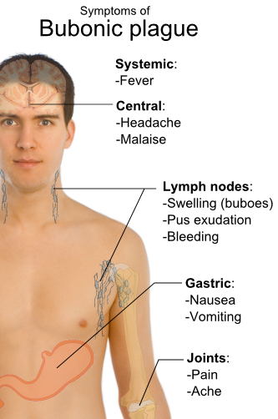](http://www.dovemed.com/diseases-conditions/bubonic-plague/)[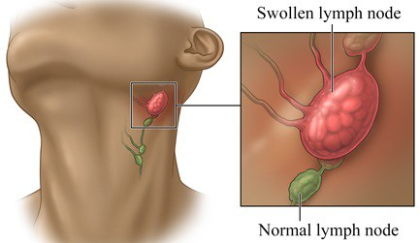](http://drfelipeades.com/2017/11/13/quando-suspeitar-do-aumento-dos-linfonodos-ganglios-de-defesa/)

* ***Y. pestis* can be transmitted to humans through the handling of fluids or tissue from infected animals. Once *Y. pestis* has entered the human host, the bacterium spreads throughout the lymphatic system and enters the bloodstream within 2-6 days.**
* **The spread of *Y. pestis* throughout the lymphatic system triggers a large-scale immune response with the appearance of buboes. Contact with contaminated fluid or tissue typically results in bubonic plague or Septicemic plague**
* **In humans, the infectious dose of *Y. pestis* has been estimated to range from 100 organisms to 20,000 organisms. The incubation period of the bubonic, septicemic, and pneumonic plague types ranges from 2-6 days.**
* ***Y. pestis* colonizes macrophages, reaches lymph nodes, escapes the macrophages, and proliferates extracellularly.**

**Clinical Findings**

* **The clinical manifestations of plague depend on the route of exposure.**
* **high fever and painful lymphadenopathy, commonly with greatly enlarged, tender nodes**
* **Disseminated intravascular coagulation leads to hypotension, altered mental status, and renal and cardiac failure.**
* **Patients often have chest pain, cough, hemoptysis, and severe respiratory distress.**

**Diagnostic Laboratory Tests**

**Plague should be suspected in febrile patients who have been exposed to rodents in known endemic areas.**

**A. Specimens**

* Blood is taken for culture and aspirates of enlarged lymph nodes for smear and culture.
* Acute and convalescent sera may be examined for antibody levels.
* In pneumonia, sputum is cultured; in possible meningitis, cerebrospinal fluid is taken for smear and culture.

**Bubonic, Septicemic, and Pneumonic Plague**

[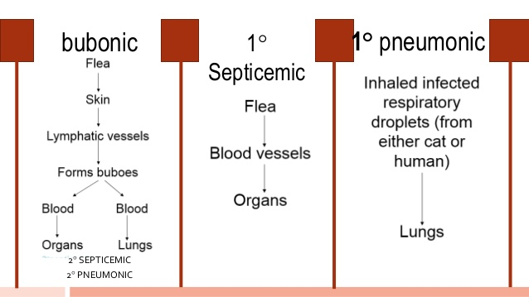](https://www.slideshare.net/kitheridgette/diseases-of-the-circulatory-system-40801800)

**B. Smears**

* *Y. pestis* are small gram-negative bacilli that appear as single cells or as pairs or short chains in clinical material.
* Wright, Giemsa stains may be more useful when staining material from a suspected buboe or a positive blood culture result because of the striking bipolar appearance
* More specific direct staining methods (possibly available through reference laboratories) include the use of fluorescent antibody stains targeting the capsular F1 antigen.

[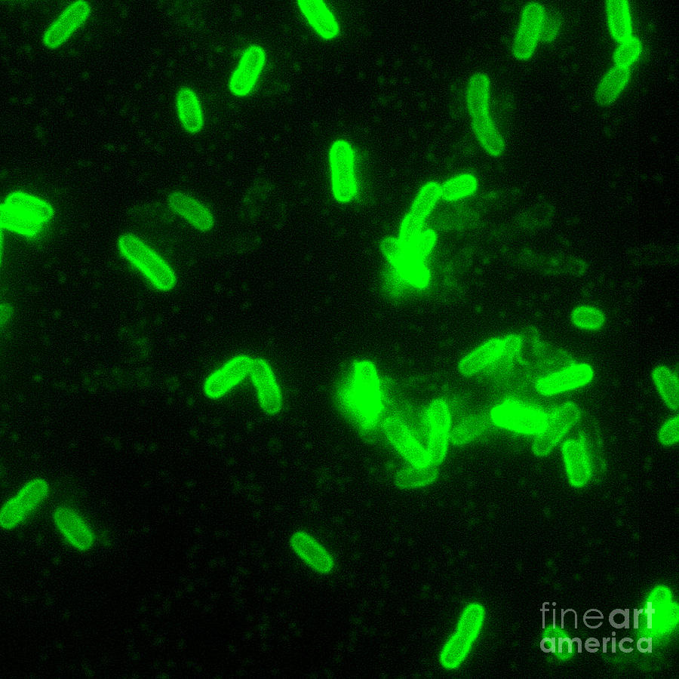](https://www.pinterest.com/pin/560979697305234502/)

**C. Culture**

* All materials are cultured on **blood agar**, **chocolate**, and **MacConkey agar** plates and in **brain–heart infusion broth (24-48h).**
* Cultures can be tentatively identified by biochemical reactions.

[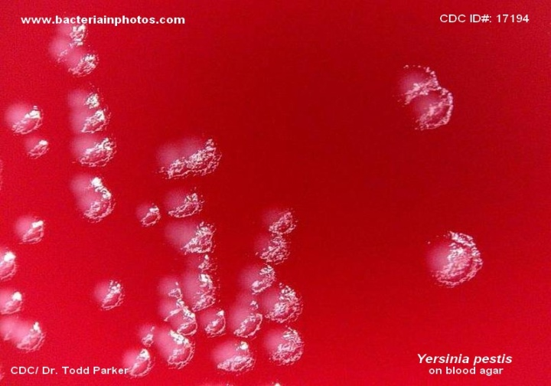](http://www.bacteriainphotos.com/yersinia_pestis_colonies.html)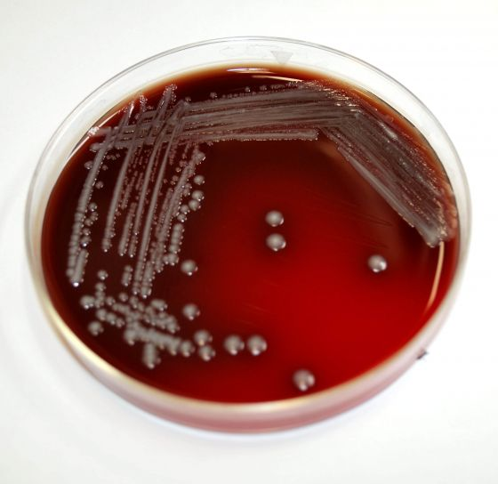

[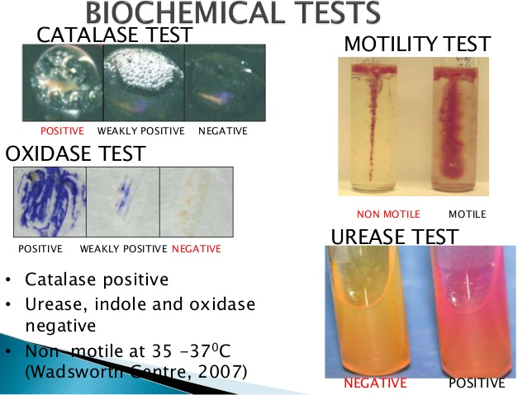](https://www.google.jo/url?sa=i&rct=j&q=&esrc=s&source=images&cd=&ved=2ahUKEwj69Lj85fDZAhUIaFAKHbWWAL0QjRx6BAgAEAU&url=https://www.slideshare.net/Adeloyeaderinsola/yersinia-pestis-48925077&psig=AOvVaw2VDsYLnz-G3ujjLxte-y68&ust=1521288080392564)

**Treatment and Control**

**Unless promptly treated, plague may have a mortality rate of nearly 50%; pneumonic plague, nearly 100%.**

* The control of plague requires **surveys of infected animals**, **vectors,** and human contacts
* In the United States, this is done by county and state agencies with support from the Plague Branch of the CDC and by destruction of plague infected animals.
* All patients with suspected plague should be isolated
* Killed whole-cell vaccines are no longer available.