Control of cardiovascular system:
LOCAL CONTROL OF BLOOD FLOW IN RESPONSE TO TISSUE NEEDS
Variations in Blood Flow in Different Tissues and Organs.
Example:
Total blood flow of 1350 ml/min in the liver, which is 95 ml/min/100 g of liver tissue.
The extremely large blood flow through the kidneys (1100 ml/min (360 ml/min/100 g), Brain (50 ml/min/100 g)
Convrsely, most surprising is the low blood flow to all the inactive muscles of the body (only a total of 750 ml/min) even though the muscles constitute between 30 and 40 percent of the total body mass.
In the resting state, the metabolic activity of the muscles is very low, as is the blood flow (only 3 to 4 ml/min/100 g). Yet, during heavy exercise, muscle metabolic activity can increase more than 60-fold and the blood flow as much as 20-fold, increasing to as high as 16,000 ml/min in the body’s total muscle vascular bed (or 80 ml/min/100 g of muscle).
The blood flow to each tissue usually regulated at the minimal level that will supply the tissue’s requirements no more, no less.
Local blood flow control divided into two phases:
(1) Acute control:
Acute control achieved by rapid changes in local vasodilation or vasoconstriction of the arterioles, met-arterioles, and pre-capillary sphincters that occur within seconds to minutes to provide very rapid maintenance of appropriate local tissue blood flow.
Factors related to acute control of local blood flow:
A. Increases in tissue metabolism increase tissue blood flow
An increase in metabolism up to eight times normal increases the blood flow acutely about fourfold.
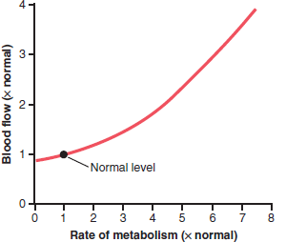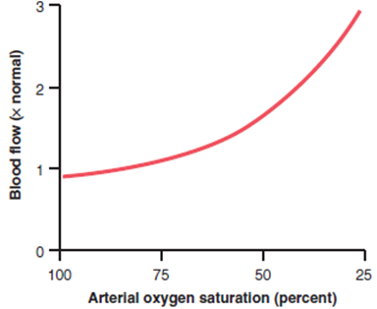
B. Reduced Oxygen Availability Increases Tissue Blood Flow.
One of the most necessary of the metabolic nutrients is oxygen.
Some cause for decrease in tissue oxygen:
(1) at a high altitude at the top of a high mountain,
(2) in pneumonia,
(3) in carbon monoxide poisoning (which poisons the ability of hemoglobin to transport oxygen), or (4) in cyanide poisoning (which poisons the ability of the tissues to use oxygen),
Whenever the availability of oxygen to the tissues decreases, the blood flow through the tissues increases markedly.
Auto-regulation:
- The capacity of tissues to regulate their own blood flow referred to as (auto-regulation).
Most vascular beds have an intrinsic capacity to compensate for moderate changes in perfusion pressure by changes in vascular resistance, so that blood remains relatively constant. This capacity well developed in the kidney, but it observed in the mesentery, skeletal muscle, brain, liver, and myocardium.
The mechanisms by which tissue blood flow not fully understood, but two main theories proposed:
I. Metabolic theory of auto-regulation:
1. Vasodilator Theory for Acute Local Blood Flow Regulation (Possible Special Role of Adenosine):
According to the vasodilator theory, the greater the rate of metabolism or the less the availability of oxygen or some other nutrients to a tissue, the greater the rate of formation of vasodilator substances in the tissue cells. The vasodilator substances then believed to diffuse through the tissues to the pre-capillary sphincters, met-arterioles, and arterioles to cause dilation. Some of the different vasodilator substances that suggested are adenosine, carbon dioxide, adenosine phosphate compounds, histamine, potassium ions, and hydrogen ions. Each has its own vasodilator skin and brain: increase in CO₂Skeletal muscle: K and lactateheart: adenosineinjured tissue: histamine
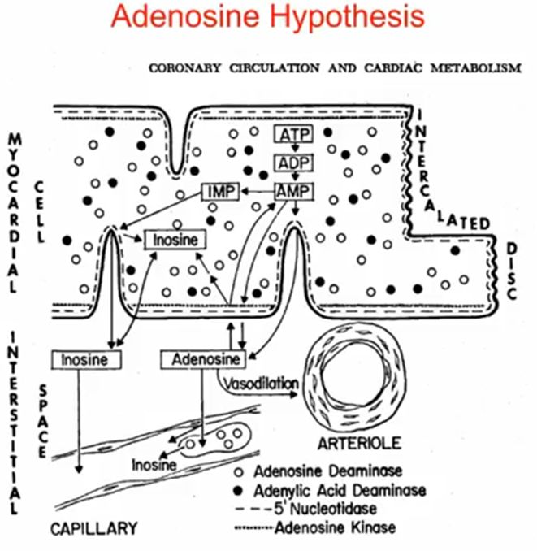
Vasodilator substances released from the tissue in response to oxygen deficiency
Many physiologists believe that adenosine is an important local vasodilator for controlling local blood flow. For example, minute quantities of adenosine released from heart muscle cells when coronary blood flow becomes too little, and this release of adenosine causes enough local vasodilation in the heart to return coronary blood flow to normal.
Whenever the heart becomes more active than normal and the heart’s metabolism increases an extra amount, this, too, causes increased utilization of oxygen, followed by
(1) decreased oxygen concentration in the heart muscle cells with
(2) consequent degradation of adenosine triphosphate (ATP), which
(3) increases the release of adenosine.
It is believed that much of this adenosine leaks out of the heart muscle cells to cause coronary vasodilation, providing increased coronary blood flow to supply the increased nutrient demands of the active heart.
2. Oxygen Demand Theory (or the nutrient demand theory) for Local Blood Flow Control.
The explanation of this theory:
a. Oxygen is one of the metabolic nutrients required to cause vascular muscle contraction (with other nutrients required as well). Therefore, in the absence of adequate oxygen, it is reasonable to believe that the blood vessels would relax and therefore dilate.
b. increased utilization of oxygen in the tissues as a result of increased metabolism theoretically could decrease the availability of oxygen to the smooth muscle fibers in the local blood vessels, and this decreased availability, too, would cause local vasodilation.
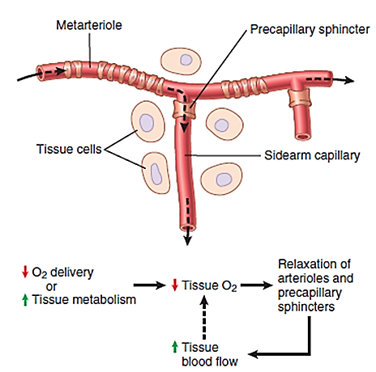
Possible Role of Other Nutrients besides Oxygen in Control of Local Blood Flow.
Under special conditions, it shown that lack of other substances can cause local tissue vasodilation:
glucose
amino acids or fatty acids,
vitamin deficiency disease beriberi, in which the patient has deficiencies of the vitamin B substances thiamine, niacin, and riboflavin.
Special Examples of Acute “Metabolic” Control of Local Blood Flow
1. “Reactive Hyperemia”
Occurs after the Tissue Blood Supply Is Blocked for a Short Time
When the blood supply to a tissue blocked for a few seconds to as long as an hour or more. Then is unblocked, blood flow through the tissue usually increases immediately to four to seven times normal; this increased flow will continue for a few seconds if the block has lasted only a few seconds but sometimes continues for as long as many hours if the blood flow has been stopped for an hour or more. The extra blood flow during the reactive hyperemia phase lasts long enough to repay almost exactly the tissue oxygen deficit that has accrued during the period of occlusion.
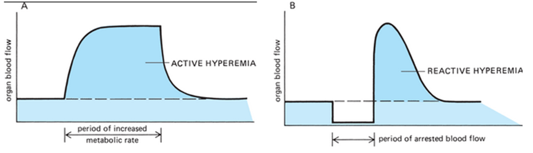
2. “Active Hyperemia”
Occurs When Tissue Metabolic Rate Increases
When any tissue becomes highly active, such as an exercising muscle, a gastrointestinal gland during a hyper-secretory period, or even the brain during increased mental activity, the rate of blood flow through the tissue increases.
The increase in local metabolism causes the cells to devour tissue fluid nutrients rapidly and also to release large quantities of vasodilator substances. The result is dilation of local blood vessels and increased local blood flow. In this way, the active tissue receives the additional nutrients required to sustain its new level of function. As pointed out earlier, active hyperemia in skeletal muscle can increase local muscle blood flow as much as 20-fold during intense exercise
II. Auto-regulation of Blood Flow during Changes in Arterial Pressure (“Metabolic” and “Myogenic” Mechanisms)
In any tissue of the body, a rapid increase in arterial pressure causes an immediate rise in blood flow. However, within less than a minute, the blood flow in most tissues returns almost to the normal level, even though the arterial pressure is kept elevated. This return of flow toward normal is called “autoregulation”. After autoregulation has occurred, the local blood flow in most body tissues will be related to arterial pressure
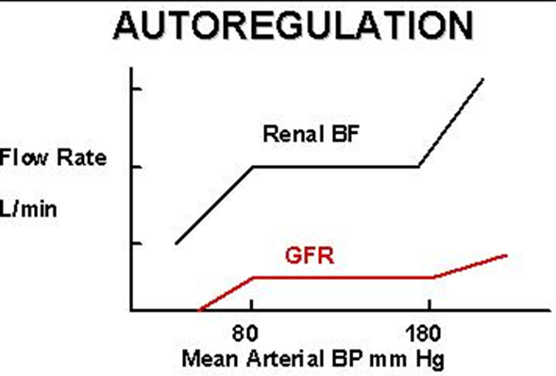
Note that between arterial pressures of about 70 mm Hg and 175 mm Hg the blood flow increases only 20 to 30 percent even though the arterial pressure increases 150 percent. In some tissues, such as the brain and the heart, this auto-regulation is even more precise.
For almost a century, two views proposed to explain this acute autoregulation mechanism:
(1) The metabolic theory
The metabolic theory can understood easily by applying the basic principles of local blood flow regulation discussed in previous sections. Thus, when the arterial pressure becomes too great, the excess flow provides tissues and “washes out” the vasodilators released by the tissues. These nutrients (especially oxygen) and decreased tissue levels of vasodilators then cause the blood vessels to constrict and return flow to nearly normal despite the increased pressure.
(2) The myogenic theory
The myogenic theory, however, suggests that still another mechanism not related to tissue metabolism explains the phenomenon of autoregulation. This theory based on the observation that sudden stretch of small blood vessels causes the smooth muscle of the vessel wall to contract. Therefore, it proposed that when high arterial pressure stretches the vessel, this in turn causes reactive vascular constriction that reduces blood flow nearly back to normal. Conversely, at low pressures, the degree of stretch of the vessel is less, so that the smooth muscle relaxes, reducing vascular resistance and helping to return flow toward normal.

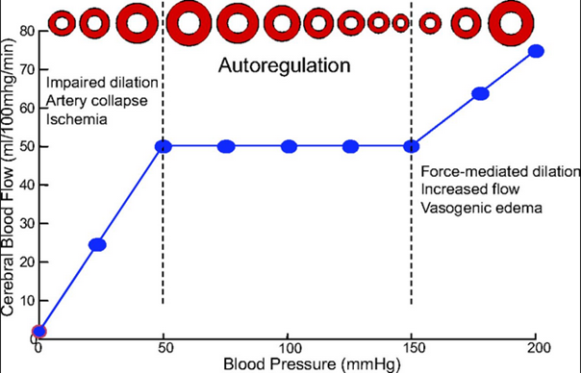
The myogenic mechanism is inherent to vascular smooth muscle and can occur in the absence of neural or hormonal influences.
The myogenic mechanism most pronounced in arterioles but can observed in arteries, venules, veins, and even lymphatic vessels.
The myogenic mechanism appears to be important in preventing excessive stretching of blood vessels when blood pressure is increased
Myogenic contraction initiated by
a. stretch-induced vascular depolarization, which then rapidly increases calcium ion entry from the extracellular fluid into the cells, causing them to contract.
b. Changes in vascular pressure may also open or close other ion channels that influence vascular contraction.
Muscle during exercise
If flow were measured in the outflow vein, the venous outflow would increase during contraction and decrease during relaxation - the opposite of what occurs on the arterial side of the circulation.
After just a couple of seconds, mean and peak flows, begin to increase (active hyperemia). After 15-20 seconds, the increased flow will reach a steady state that is determined by the force and frequency of contraction, and the metabolic demands of the tissue. When contractions cease, blood flow may transiently increase because of the loss of compressive forces, and then over the next minute or so the flow will return to control.
At the end of the contractions, the blood flow remains very high for a few seconds but then returns toward normal during the next few minutes.
Increased blood flow in muscle capillaries & Vasodilation during exercise
Vasodilation of the arterial tree results in increased blood flow, which carries more oxygen to the tissues per unit time.
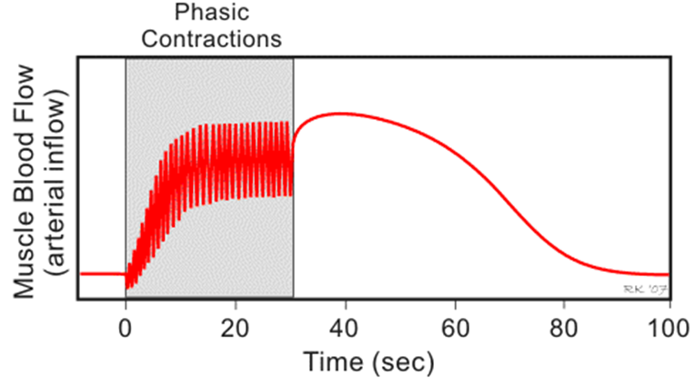
In addition, the enhanced blood flow increases micro-vessel hematocrit, which also supports increased oxygen delivery to the active muscles.
Vasodilation of small arterioles also enhances functional capillary density (increased number of perfused capillaries) which shortens the diffusion distance for oxygen and other substrates.
Perfused capillary density is proportional to oxygen consumption in red muscles, but correlates with lactate production in white muscle.
In addition, small arteries also vasodilation in an axially coordinated fashion with the change in caliber in arterioles, the net effect of which is to produce a 2- to 5-fold larger increment in blood flow, and thus oxygen delivery to the active muscles.
During rest, some muscle capillaries have little or no flowing blood, but during strenuous exercise, all the capillaries open. This opening of dormant capillaries
diminishes the distance that oxygen and other nutrients must diffuse from the capillaries to the contracting muscle fibers and
sometimes contributes a twofold to threefold increased capillary surface area through which oxygen and nutrients can diffuse from the blood to the tissues.
Under resting conditions, oxygen extraction ranges between 20% and 40%. During heavy exercise, approximately 70–80% of the oxygen delivered to the active muscles extracted.
Control of blood flow in skeletal muscle
I. Humeral Control of Muscle Blood Flow
The tremendous increase in muscle blood flow that occurs during skeletal muscle activity caused mainly by chemicals acting directly on the muscle arterioles to cause dilation.
Reduction of oxygen in the muscle tissues
When muscles are active, they use oxygen rapidly, thereby decreasing the oxygen concentration in the tissue fluids. This in turn causes local arteriolar vasodilation
because the arteriolar walls cannot maintain contraction in the absence of oxygen and
because oxygen deficiency causes release of vasodilator substances.
Vasodilator substances
1. Adenosine may be an important vasodilator substance, but experiments have shown that even large amounts of adenosine infused directly into a muscle artery cannot increase blood flow to the same extent as during intense exercise and cannot sustain vasodilation in skeletal muscle for more than about 2 hours.
2. Fortunately, even after the muscle blood vessels have become insensitive to the vasodilator effects of adenosine, other vasodilator factors continue to maintain increased capillary blood flow as long as the exercise continues.
These factors include
(1) potassium ions
(2) adenosine triphosphate (ATP),
(3) lactic acid
(4) carbon dioxide.
II. Nervous Control of Muscle Blood Flow
Sympathetic Vasoconstrictor Nerves
The sympathetic vasoconstrictor nerve fibers secrete norepinephrine at their nerve endings.
When maximally activated; this mechanism can decrease blood flow through resting muscles to as little as one-half to one-third normal. This vasoconstriction is of physiologic importance in attenuating decreases of arterial pressure in circulatory shock and during other periods of stress when it may even be necessary to increase blood pressure.
In addition to the norepinephrine secreted at the sympathetic vasoconstrictor nerve endings, the medullae of the two adrenal glands also secrete large amounts of norepinephrine plus even more epinephrine into the circulating blood during strenuous exercise.
The circulating norepinephrine acts on the muscle vessels to cause a vasoconstrictor effect similar to that caused by direct sympathetic nerve stimulation. The epinephrine, however, often has a slight vasodilator effect because epinephrine excites more of the beta-adrenergic receptors of the vessels, which are vasodilator receptors, in contrast to the alpha vasoconstrictor receptors excited especially by norepinephrine.
Norepinephrine acting on alpha receptors causes vasoconstriction. This effect in strong in the skin, digestive tract and kidneys. In these organs, normal blood flow greatly surpasses that required to keep the tissues alive. Instead, most of the blood flow serves specific physiological functions in the organs. By contrast, such vasoconstriction does not occur in the brain or heart, where blood flow serves to keep the cells in these vital organs alive and healthy.
Not:
1. The effect of local (or humeral) and neural control are not equal at different tissues some the neural control is dominant (as skin) and other the local control is dominant (like heart and brain)
2. Skeletal muscle and skin do not receive parasympathetic nerve
3. Sympathetic stimulation which work through nor-epinephrine cause’s vasoconstriction to skeletal blood vessels but also to other vessels this will help to shift blood from organ does not need blood to organs needs it
4. Sympathetic stimulation also causes vein constriction (but with less extent than arteries because it possess less smooth muscle). Vein constriction help to return blood to arterial tree.
5. During rest: the neural effect is more prominent than local effect on skeletal muscle blood vessels. During exercise: both local effect (due to accumulation of metabolites) causing vasodilation and neural causing vasoconstriction affect the muscle blood vessel.
The local effect is more prominent than neural effect on skeletal muscle blood vessels and end result is vasodilation
6. Sympathetic stimulation also stimulate adrenal medulla to secret epinephrin and nor-epinphrin. Nor-epinphriin causes vasoconstriction and epinephrin causes vasodilation
(2) Long-term control
Long-term control means slow, controlled changes in flow over a period of days, weeks, or even months.
Long-term control changes provide even better control of the flow in proportion to the needs of the tissues.
Long-term control changes come about as a result of an increase or decrease in the physical sizes and numbers of blood vessels supplying the tissues.
Thus far, most of the mechanisms for local blood flow regulation that we have discussed act within a few seconds to a few minutes after the local tissue conditions have changed. Yet, even after full activation of these acute mechanisms, the blood flow usually adjusted only about three quarters of the way to the exact additional requirements of the tissues. For instance, when the arterial pressure suddenly increases from 100 to 150 mm Hg, the blood flow increases almost instantaneously about 100 percent. Then, within 30 seconds to 2 minutes, the flow decreases back to about 10 to 15 percent above the original control value. This example illustrates the rapidity of the acute mechanisms for local blood flow regulation, but at the same time, it demonstrates that the regulation is still incomplete because there remains a 10 to 15 percent excess blood flow in some tissues.
However, over a period of hours, days, and weeks, a long-term type of local blood flow regulation develops in addition to the acute control. This long-term regulation gives far more complete control of blood flow. For instance, in the aforementioned example, if the arterial pressure remains at 150 mm Hg indefinitely, within a few weeks the blood flow through the tissues gradually approaches almost exactly the normal flow level.
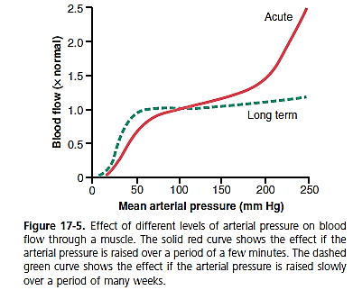
Figure 17-5 shows by the dashed green curve the extreme effectiveness of this long-term local blood flow regulation. Note that once the long-term regulation has had time to occur, long-term changes in arterial pressure between 50 and 250 mm Hg have little effect on the rate of local blood flow.
Long-term regulation of blood flow is especially important when the metabolic demands of a tissue change. Thus, if a tissue becomes chronically overactive and therefore requires increased quantities of oxygen and other nutrients, the arterioles and capillary vessels usually increase both in number and size within a few weeks to match the needs of the tissue, unless the circulatory system has become pathological or too old to respond.
I. Blood Flow Regulation by Changes in Tissue Vascularity
A key mechanism for long-term local blood flow regulation is to change the amount of vascularity of the tissues. For instance, if the metabolism in a tissue is increased for a prolonged period, vascularity increases, a process generally called angiogenesis; if the metabolism is decreased, vascularity decreases.
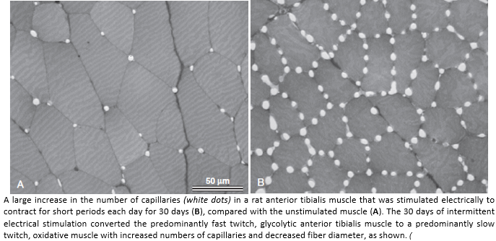
Thus, actual physical reconstruction of the tissue vasculature occurs to meet the needs of the tissues.
This reconstruction occurs rapidly (within days) in young animals.
This reconstruction also occurs rapidly in new growth tissue, such as in scar tissue and cancerous tissue, but it occurs much more slowly in old, well-established tissues. Therefore, the time required for long-term regulation to take place may be only a few days in the neonate or as long as months in the elderly person. Furthermore, the final degree of response is much better in younger than in older tissues; thus, in the neonate, the vascularity will adjust to match almost exactly the needs of the tissue for blood flow, whereas in older tissues, vascularity frequently lags far behind the needs of the tissues.
Importance of Vascular Growth Factors in Formation of New Blood Vessels “angiogenic factors”
A dozen or more factors that increase growth of new blood vessels have been found, almost all of which are small peptides.
The four factors that have been best characterized are
fibroblast growth factor,
platelet-derived growth factor (PDGF)
angiogenin,
vascular endothelial growth factor (VEGF)
Each of these has been isolated from tissues that have inadequate blood supply. Presumably, it is deficiency of tissue oxygen or other nutrients, or both, that leads to formation of the vascular growth factors (also called “angiogenic factors”).
Angiogenesis begins with new vessels sprouting from other small vessels.
First step is dissolution of the basement membrane of the endothelial cells at the point of sprouting.
Second step is followed by rapid reproduction of new endothelial cells that stream outward through the vessel wall in extended cords directed toward the source of the angiogenic factor.
Third step is the cells in each cord continue to divide and rapidly fold over into a tube.
Fourth step is the tube connects with another tube budding from another donor vessel (another arteriole or venule) and forms a capillary loop through which blood begins to flow.
If the flow is great enough, smooth muscle cells eventually invade the wall, so some of the new vessels eventually grow to be new arterioles or venules or perhaps even larger vessels.
Thus, angiogenesis explains the manner in which metabolic factors in local tissues can cause growth of new vessels.
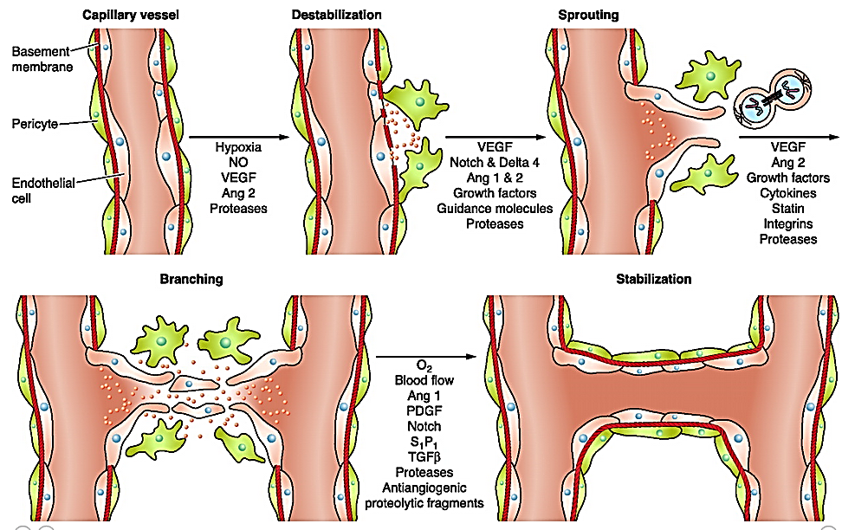
The cellular steps involved in angiogenesis. Hypoxia induces the production of nitric oxide (NO) and the expression of vascular endothelial growth factor (VEGF) and angiopoietin-1 and -2 (Ang 1 and Ang 2), which interact with extracellular matrix (ECM) proteases to increase permeability of the capillary vessel wall. Destabilization then allows endothelial cells to migrate and proliferate to form tubules, aided by VEGF, angiopoietins, guidance molecules, growth factors, cytokines, and degradation of the ECM. Maturation of the newly formed vessel is accompanied by increased expression of antiangiogenic factors, many released as a result of proteolysis. PDGF, platelet-derived growth factor; S1P1, sphingosine-1-phosphate-1; TGFβ, transforming growth factor-β
Factors inhibit angiogenesis:
steroid hormones, have exactly the opposite effect on small blood vessels, occasionally even causing dissolution of vascular cells and disappearance of vessels.
Peptides produced in the tissues can also block the growth of the protein plasminogen, is a naturally occurring inhibitor of angiogenesis.
Endostatin is another antiangiogenic peptide that is derived from the breakdown of collagen type XVII.
Although the precise physiological functions of these antiangiogenic substances are still unknown, there is great interest in their potential use in arresting blood vessel growth in cancerous tumors and therefore preventing the large increases in blood flow needed to sustain the nutrient supply of rapidly growing tumors.
Role of Oxygen in Long-Term Regulation
Oxygen is important not only for acute control of local blood flow but also for long-term control. One example of this is increased vascularity in tissues of animals that live at high altitudes, where the atmospheric oxygen is low. In premature human babies who are put into oxygen tents for therapeutic purposes, the excess oxygen causes almost immediate cessation of new vascular growth in the retina of the premature baby’s eyes and even causes degeneration of some of the small vessels that already have formed. When the infant is taken out of the oxygen tent, explosive overgrowth of new vessels then occurs to make up for the sudden decrease in available oxygen. Indeed, often so much overgrowth occurs that the retinal vessels grow out from the retina into the eye’s vitreous humor, eventually causing blindness, a condition called retrolental fibroplasia.
Factors control long term blood flow:
I. Vascularity
An especially valuable characteristic of long-term vascular control is that vascularity is determined mainly by the maximum level of blood flow need rather than by average need. For instance, during heavy exercise the need for whole body blood flow often increases to six to eight times the resting blood flow. This great excess of flow may not be required for more than a few minutes each day. Nevertheless, even this short need can cause enough angiogenic factors to be formed by the muscles to increase their vascularity as required. Were it not for this capability, every time a person attempted heavy exercise, the muscles would fail to receive the required nutrients, especially the required oxygen, and thus the muscles simply would fail to contract.
However, after extra vascularity does develop, the extra blood vessels normally remain mainly vasoconstricted, opening to allow extra flow only when appropriate local stimuli such as a lack of oxygen, nerve vasodilatory stimuli, or other stimuli call forth the required extra flow.
II. Collateral Circulation
In most tissues of the body, when an artery or a vein is blocked, a new vascular channel usually develops around the blockage and allows at least partial resupply of blood to the affected tissue. The first stage in this process is dilation of small vascular loops that already connect the vessel above the blockage to the vessel below. This dilation occurs within the first minute or two, indicating that the dilation is likely mediated by metabolic factors. After this initial opening of collateral vessels, the blood flow often is still less than one quarter of that required to supply all the tissue needs. However, further opening occurs within the ensuing hours, so that within 1 day as much as half the tissue needs may be met, and within a few days the blood flow is usually sufficient to meet the tissue needs.
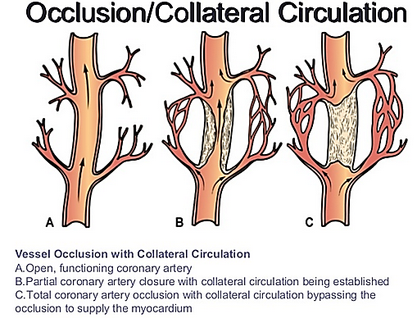
The collateral vessels continue to grow for many months thereafter, usually forming multiple small collateral channels rather than one single large vessel. Under resting conditions, the blood flow may return to nearly normal, but the new channels seldom become large enough to supply the blood flow needed during strenuous tissue activity. Thus, development of collateral vessels follows the usual principles of both acute and long-term local blood flow control, the acute control being rapid metabolic dilation, followed chronically by growth and enlargement of new vessels over a period of weeks and months.
An important example of the development of collateral blood vessels occurs after thrombosis of one of the coronary arteries. By the age of 60 years most people have experienced closure or at least partial occlusion of at least one of the smaller branch coronary vessels, but they are not aware of it because collateral blood vessels have developed rapidly enough to prevent myocardial damage. When collateral blood vessels are unable to develop quickly enough to maintain blood flow because of the rapidity or severity of the coronary insufficiency, serious heart attacks occur.
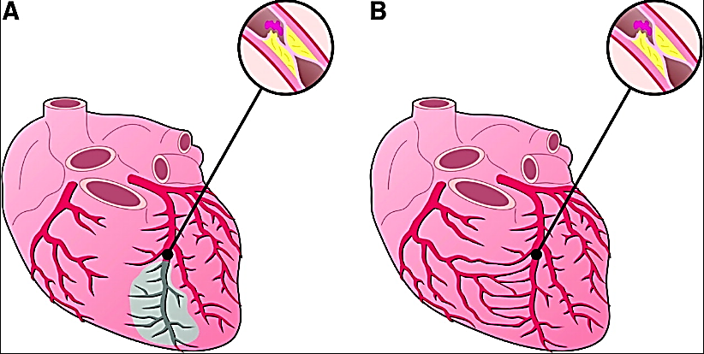
II Vascular Remodeling in Response to Chronic Changes in Blood Flow or Blood Pressure
Vascular growth and remodeling are
After several months of chronic exercise training critical components of tissue development and growth Vascularity of the trained muscles increases to accommodate their higher blood flow requirements.
Adaptive response to long-term changes in blood pressure or blood flow there may be changes in the structure of large blood vessels in response to long-term changes in blood pressure and blood flow.
Large and small arteries and arterioles
The large and small arteries and arterioles remodel to accommodate the increased mechanical wall stress of the higher blood pressure.
A. Short term response
In most tissues the small arteries and arterioles rapidly (within seconds) respond to increased arterial pressure with vasoconstriction, which helps auto-regulate tissue blood flow, as discussed previously. The vasoconstriction decreases lumen diameter, which in turn tends to normalize the vascular wall tension (T), which, according to Laplace’s equation, is the product of the radius (r) of the blood vessel and its pressure (P): T = r × P.
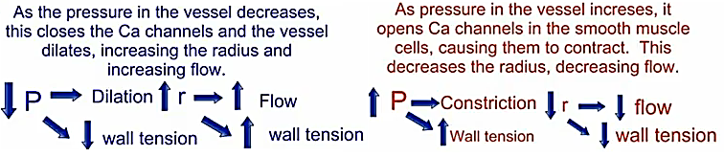
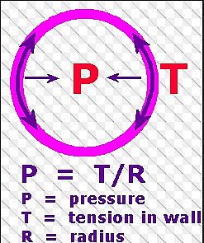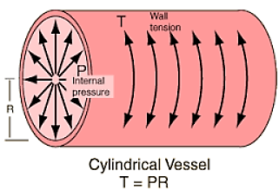
B. Long term response
i. In small blood vessels that constrict in response to increased blood pressure, the vascular smooth muscle cells and endothelial cells gradually (over a period of several days or weeks)rearrange themselves around the smaller lumen diameter, a process called inward eutrophic remodeling, with no change in the total cross-sectional area of the vascular wall.
ii. In larger arteries that do not constrict in response to the increased pressure, the vessel wall is exposed to increased wall tension that stimulates a hypertrophic remodeling response and an increase in the cross-sectional area of the vascular wall.
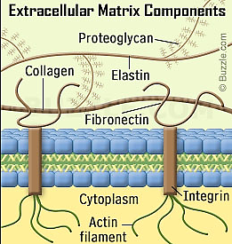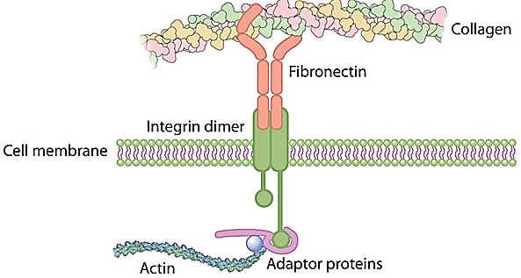
The hypertrophic response increases the size of vascular smooth muscle cells and stimulates formation of additional extracellular matrix proteins, such as collagen and fibronectin (Fibronectin is a high-molecular weight (~440kDa) glycoprotein of the extracellular matrix (area between cells) that binds to membrane-spanning receptor proteins called integrins. Similar to integrins, fibronectin binds extracellular matrix components such as collagen, fibrin, and heparan sulfate proteoglycans (e.g. syndecans)); that reinforce the strength of the vascular wall to withstand the higher blood pressures.
However, this hypertrophic response also makes the large blood vessels stiffer, which is a hallmark of chronic hypertension.
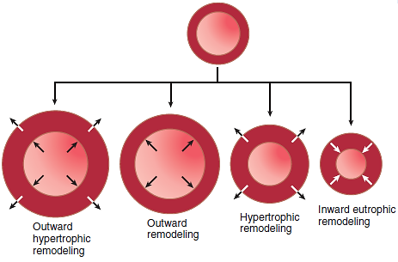
Vascular remodeling in response to a chronic increase in blood pressure or blood flow. In small arteries and arterioles that constrict in response to increased blood pressure, inward eutrophic remodeling typically occurs because the lumen diameter is smaller and the vascular wall is thicker, but the total cross-sectional area of the vessel wall is hardly changed. In large blood vessels that do not constrict in response to increased blood pressure, there may be hypertrophic remodeling with increases in thickness and total cross-sectional area of the vascular wall. If blood vessels are exposed to chronic increases in blood flow, there is typically outward remodeling with increases in lumen diameter, little change in wall thickness, and increased total cross-sectional area of the vascular wall. If the blood vessel is exposed to long-term increases in blood pressure and blood flow, there is usually outward hypertrophic remodeling with increases in lumen diameter, wall thickness, and total cross-sectional area of the vascular wall. Chronic reductions in blood pressure and blood flow have the opposite effects, as previously described
Large vein
Large vein (often the saphenous vein) is implanted in a patient for a coronary artery bypass graft procedure. Veins are normally exposed too much lower pressures than arteries and have much thinner walls, but when a vein is sewn onto the aorta and connected to a coronary artery, it is exposed to increases in intraluminal pressure and wall tension.
The increased wall tension initiates hypertrophy of vascular smooth muscle cells and increased extracellular matrix formation that thicken and strengthen the wall of the vein; as a result, several months after implantation into the arterial system, the vein will typically have a wall thickness similar to that of an artery

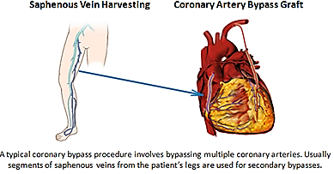
Arterio-venous (A-V) fistula
Vascular remodeling also occurs when a blood vessel is exposed chronically to increased or decreased blood flow. The creation of a fistula connecting a large artery and a large vein, thereby completely bypassing small resistance vessels and capillaries, provides an especially interesting example of remodeling in the affected artery and vein. In patients with renal failure who undergo dialysis, an arteriovenous (A-V) fistula directly from the radial artery to the antecubital vein of the forearm is created to permit vascular access for dialysis.
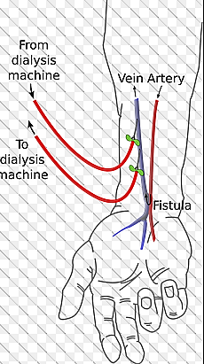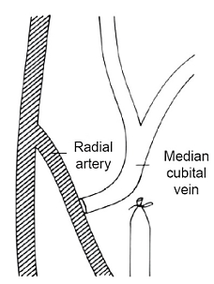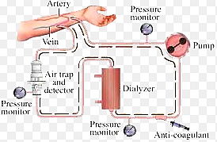
Blood flow rate in the radial artery may increase as much as 10 to 50 times the normal flow rate depending on the patency of the fistula.
Radial artery
As a result of the high flow rate and high shear stress on the vessel wall:
The luminal diameter of the radial artery increases progressively (outward remodeling) while the thickness of the vessel wall may remain unchanged, resulting in an increase in cross-sectional area of the vascular wall.
Vein
As a result of increases in vascular wall tension:
In contrast, wall thickness, lumen diameter, and the cross-sectional area of the vascular wall on the venous side of the fistula increase in response to increases in pressure and blood flow (outward hypertrophic remodeling). This pattern of remodeling is consistent with the idea that long-term increases in vascular wall tension cause hypertrophy and increased wall thickness in large blood vessels while increased blood flow rate and shear stress causes outward remodeling and increased luminal diameter to accommodate the increased blood flow.
Chronic reductions in blood pressure and blood flow have effects that are opposite to those previously described. When blood flow is greatly reduced, the diameter of the vascular lumen is also reduced, and when blood pressure is reduced, the thickness of the vascular wall is usually decreased. Thus, vascular remodeling is an important adaptive response of the blood vessels to tissue growth and development, as well as to physiological and pathological changes in blood pressure and blood flow to the tissues.

