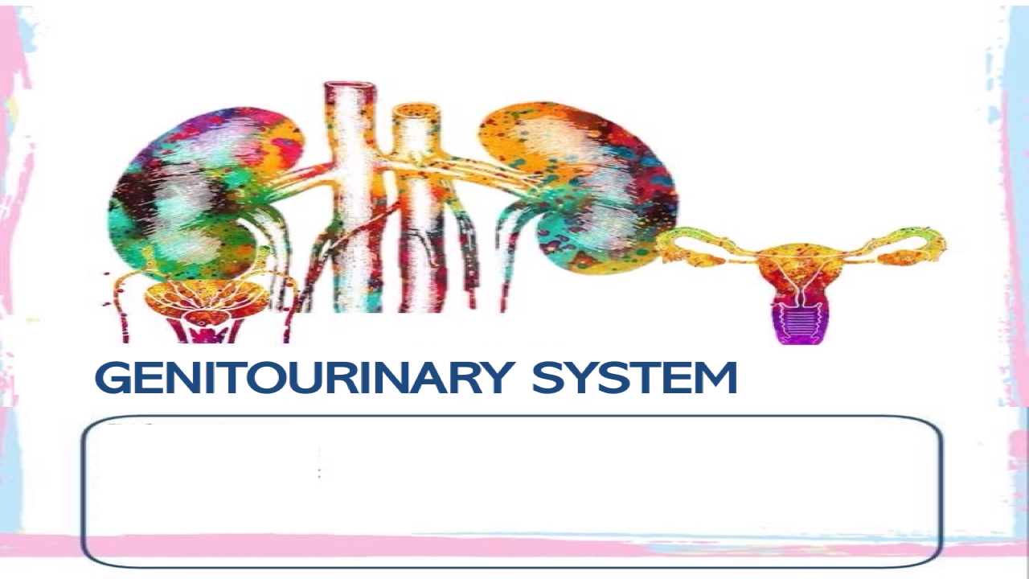
Subsystem: Physiology
Lecture title: Regulation of absorption
Lecture date: 14/4/2020
Writer: Ahmad Abueishih
Editor: Marah Alajou

*NOTE: This sheet includes everything written in the slides.
*NOTE: I’ve added some information from Guyton to make it easier for you.

Remember: absorption can happen in the PCT, loop of Henle, DCT, and the collecting duct.
There are multiple factors that regulate tubular reabsorption:
1-Nervous factors.
2-Hormonal factors.
3-Local control (renal autoregulation).
Glomerulotubular balance: One of the most basic mechanisms for controlling tubular reabsorption is the intrinsic ability of the tubules to increase their reabsorption rate in response to increased tubular load (increased tubular inflow). This act together with autoregulation to prevent large change in fluid flow in the distal tubule(by macula densa) . For example, if GFR is increased from 125 ml/min to 150 ml/min, the absolute rate of proximal tubular reabsorption also increases from about 81 ml/min (65 percent of GFR) to about 97.5 ml/min (65 percent of GFR). Thus, glomerulotubular balance refers to the fact that the total rate of reabsorption increases as the filtered load increases.
Peritubular capillary and renal interstitial fluid physical forces: there are 4 forces that regulate the reabsorption:
1-Hydrostatic pressure inside the peritubular capillaries (Pc), which opposes reabsorption and equals -13 mmHg (the minus means opposing).
2-Hydrostatic pressure in the renal interstitium (Pif), which favors reabsorption and equals 6 mmHg.
3-Colloid osmotic pressure in the peritubular capillaries (πc), which favors reabsorption and equals 32 mmHg.
4-Colloid osmotic pressure in the renal interstitium (πif), which opposes reabsorption and equals -15 mmHg.
-SO, the net reabsorption pressure= forces that favor reabsorption – forces that oppose reabsorption = (32+6) – (13+15) =10 mmHg.
-IMPORTANT: there is another factor (in addition to net reabsorption pressure) that must be included to calculate the reabsorption which is the filtration coefficient (Kf) and is equal to 12.4 (it is explained in the next page).
-Now, we can calculate the normal rate of peritubular capillary reabsorption:
Reabsorption= filtration coefficient (Kf) * net reabsorption pressure= 12.4*10= 124 ml/min.
-Remember that GFR is 125 ml/min, while peritubular capillary reabsorption is 124 ml/min, so only 1 ml is excreted as urine each minute.
More absorption from the interstitium to the peritubular capillaries means that there is more absorption from tubular cells toward the interstitium and more absorption from tubular lumen toward tubular cells.
Filtration coefficient (Kf): a measure of a membrane's permeability to water; specifically, the volume of fluid filtered in a unit time through a unit area of membrane per unit pressure difference, and it defined as the glomerular filtration rate (GFR) for both kidneys per millimeter of mercury (mmHg) of filtration. The normal filtration coefficient for a healthy adult human is 12.5 ml per minute per mmHg of filtration pressure. A high value of Kf indicates a highly water permeable capillary. The glomerular filtration coefficient depends on the surface area of the filtering membrane which is greatly reduced in case of a disease (DM and Hypertension).
The two determinants of peritubular capillary reabsorption that are directly influenced by renal hemodynamic changes are the hydrostatic and colloid osmotic pressures of the peritubular capillaries:
1-The peritubular capillary hydrostatic pressure is influenced by:
a-Increasing arterial pressure: tends to raise peritubular capillary hydrostatic pressure and decreases reabsorption rate.
b-Increasing the resistance of either the afferent or the efferent arterioles: reduces peritubular capillary hydrostatic pressure and tends to increase reabsorption rate.
2-The peritubular capillary colloid osmotic pressure: raising the colloid osmotic pressure increases peritubular capillary reabsorption. The colloid osmotic pressure of peritubular capillaries is determined by:
a-The systemic plasma colloid osmotic pressure: increasing the plasma protein concentration of systemic blood tends to raise peritubular capillary colloid osmotic pressure, thereby increasing reabsorption.
b-The filtration fraction; the higher the filtration fraction, the greater the fraction of plasma filtered through the glomerulus and, consequently, the more concentrated the protein becomes in the plasma that remains behind. Thus, increasing the filtration fraction also tends to increase the peritubular capillary reabsorption rate.
Ultimately, changes in peritubular capillary physical forces (the 2 in the previous page) influence tubular reabsorption by changing the physical forces in the renal interstitium surrounding the tubules. For example, a decrease in the reabsorptive force across the peritubular capillary membranes, reduces the uptake of fluid and solutes from the interstitium into the peritubular capillaries. This in turn raises renal interstitial fluid hydrostatic pressure and decreases interstitial fluid colloid osmotic pressure because of dilution of the proteins in the renal interstitium. These changes then decrease the net reabsorption of fluid from the renal tubules into the interstitium (same to what is written in the box in the previous page).
-Again, the same thing. So, when the net reabsorption rate is decreased?
Answer: when the capillary hydrostatic pressure is increased or when the capillary colloid osmotic pressure is decreased.
-again and again, forces that increase peritubular capillaries reabsorption also increase reabsorption from renal tubules and vice versa.
A summary for the previous page

Pressure natiuresis and pressure diuresis:
-Because of the autoregulatory mechanisms, increasing the arterial pressure between the limits of 75 and 160 mm Hg usually has only a small effect on renal blood flow and GFR. When GFR autoregulation is impaired, as often occurs in kidney disease, increases in arterial pressure cause much larger increases in GFR
-Increased renal arterial pressure will:
1-raise urine output.
2-decrease the percentage of the filtered load of sodium and water that is reabsorbed by the tubules. The mechanisms responsible for this effect include a slight increase in peritubular capillary hydrostatic pressure, and a subsequent increase in the renal interstitial fluid hydrostatic pressure (an increase in the renal interstitial fluid hydrostatic pressure enhances backleak of sodium into the tubular lumen, thereby reducing the net reabsorption of sodium and water and further increasing the rate of urine output when renal arterial pressure rises).
-Another factor that contributes to the pressure natriuresis and pressure diuresis mechanisms is reduced angiotensin II formation. Angiotensin II itself increases sodium reabsorption by the tubules, it also stimulates aldosterone secretion, which further increases sodium reabsorption. Therefore, decreased angiotensin II formation >> decrease aldosterone and both decrease tubular sodium reabsorption & increase urine output that occur when arterial pressure is increased.
Hormonal control:
1-Aldosterone:
-Site of action: distal tubule and the collecting duct.
-Functions:
1-Increases the reabsorption of NaCl and H2O.
2-Stimulates potassium secretion.
3-Increases sodium permeability on the luminal side.
-related diseases:
1-Addison’s disease: simply NO aldosterone, as occurs with adrenal destruction or malfunction, there is marked loss of sodium from the body and accumulation of potassium.
2-Conn’s syndrome" Primary Aldosteronism '' (adrenal tumor): excess aldosterone secretion is associated with sodium retention and decreased plasma potassium concentration due to excessive potassium secretion by the kidneys.

2-Angiotensin II:
-Site of actions: on proximal tubule and thick segment of loop of henle and distal tubule and collecting duct .
-Functions:
1-Increases the reabsorption of NaCl and H2O.
2-Stimulates H+ secretion.
3-Stimulates aldosterone secretion.
4-Constricts the efferent arteriole.
5-Stimulates sodium reabsorption by:
a-Stimulating the Na-K pump.
b-Stimulating the Na-H+ exchanger.
c-Stimulating the Na-bicarbonate co-transporter (remember co-transport means 2 substances move in the same direction, while counter-transport means 2 substances move in opposite direction. For example, one substance is absorbed and the other is excreted).

Atrial natriuretic peptide is secreted when there is excess fluid in the body(volume overload ) so the body doesn't need more fluid so it will decrease reabsorption .

3-ADH (arginine vasopressin):
-Site of action: distal, collecting tubule and the collecting duct epithelium.
-Function: increases reabsorption of H2O.
-ADH binds to specific V2 receptors increasing the formation of cyclic AMP and activating protein kinases. This stimulates the movement of an intracellular protein, called aquaporin­2 (AQP­2), to the luminal side of the cell membranes. The molecules of AQP-2 cluster together and fuse with the cell membrane by exocytosis to form water channels that permit rapid diffusion of water through the cells.

4-Atrial natriuretic peptide: secreted by specific cells of the cardiac atria, when distended because of plasma volume expansion.
-Site of action: Distal tubule and collecting duct.
-Functions:
1-Decreases Na+ and H2O reabsorption and increases urinary excretion, which helps to return blood volume back toward normal.
2-Inhibits renin secretion and therefore angiotensin II formation.
-its elevated in the case of heart failure (low cardiac output and fluid accumulate in the atria) when the cardiac atria are stretched because of impaired pumping of the ventricles.
5-Parathyriod hormone:
-Site of action: proximal tubule, thick ascending loop of Henle, and the distal tubule.
-Functions:
1-Decreases PO4- reabsorption.
2-Increases Ca+2 reabsorption.
Nervous control (sympathetic nervous system): it increases sodium and water reabsorption by:
1-constricting afferent and efferent arterioles by activation alpha adrenergic receptors on the renal tubular epithelial cells.
2-Increasing renin and angiotensin II formation (which stimulates aldosterone secretion and both increase sodium reabsorption).
Quantifying kidney function:
1-Use of clearance methods to quantify kidney function: The rates at which different substances are “cleared” from the plasma provide a useful way of quantitating the effectiveness with which the kidneys excrete various substances. The renal clearance of a substance is the volume of plasma that is completely cleared of the substance by the kidneys per unit time.
-Clearance rate of plasma (Cs)= urine concentra. of a substance (Us) * urine volume rate (v)
Plasma concentration of a substance (Ps)
A-Inulin clearance can be used to estimate GFR: Inulin is a substance that isn’t produced by the body (given IV), can be used to estimate GFR because it is freely filtrated, not absorbed and not secreted so the rate at which it is excreted in the urine is (Us X V) which is equal to its filtration by kidneys (GFR X Ps) …. LOOK at the next figure for better understanding.
>> GFR x Ps=Us x V
so... GFR= Us x V Then Cs=GRF (this is true in case of inulin only, because the clearance rate of other substances is lower than GFR).
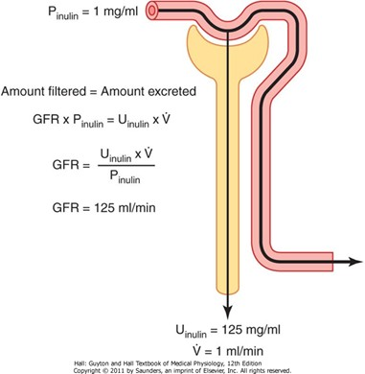
Ps
-Figure 27-19 shows the renal handling of inulin. In this example, the plasma concentration is 1 mg/ml, urine concentration is 125 mg/ml, and urine flow rate is 1 ml/min. Therefore, 125 mg/min of inulin passes into the urine. Then, inulin clearance is calculated as the urine excretion rate of inulin divided by the plasma concentration, which yields a value of 125 ml/min. Thus, 125 milliliters of plasma flowing through the kidneys must be filtered to deliver the inulin that appears in the urine.
-So, in case of inulin, the GFR is equal to CInulin). Thus,
GFR= U(inulin)*V/P(inulin)

B-Creatinine clearance: creatinine clearance & plasma creatinine concentration can be also used to estimate GFR:
-Creatinine is product of muscle metabolism.
-GFR x P(creatinine)=U(creatinine) x V
If GFR decreases the creatinine filtration & excretion decrease & plasma concentration increases. For example, If GFR suddenly decreases by 50%, the kidneys will transiently filter and excrete only half as much creatinine, causing accumulation of creatinine in the body fluids and raising plasma concentration.

Inulin > Iv
*to avoid injection > we use Creatinine (present in our body)
MORE GFR >>MORE excretion >> LESS plasma Creatinine conc.
A very good indicator for kidney disease is the creatinine clearance.
2-Renal plasma flow: PAH (para-aminohippuric acid) clearance can be used to estimate renal plasma flow:
*There is no known substance that is completely cleared by the kidneys. One substance, however, PAH, is about 90 percent cleared from the plasma. Therefore, the clearance of PAH can be used as an approximation of renal plasma flow. The percentage of PAH removed from the blood known as the extraction ratio of PAH and averages about 90 percent in normal kidneys. The extraction ratio can be calculated as:
Extraction ratio= (renal arterial PAH – renal venous PAH) / renal arterial PAH
-The calculation of RPF can be demonstrated by the following example: Assume that the plasma concentration of PAH is 0.01 mg/ml, urine concentration is 5.85 mg/ml, and urine flow rate is 1 ml/min. PAH clearance can be calculated from the rate of urinary PAH excretion (5.85 mg/ml × 1 ml/ min) divided by the plasma PAH concentration (0.01 mg/ ml). Thus, clearance of PAH calculates to be 585 ml/min. If the extraction ratio for PAH is 90 percent, the actual renal plasma flow can be calculated by dividing 585 ml/ min by 0.9, yielding a value of 650 ml/min. Thus, total renal plasma flow can be calculated as
- Total renal plasma flow= PAH clearance / PAH extraction ratio
** Renal plasma flow is 55% of renal blood flow as blood hematocrit is 45%, so renal blood flow can be calculated accordingly.

LOOK at the figure in the next page...
3-Filtration fraction: which is the fraction of plasma that is filtered through glomerular membrane and = GFR/RPF (remember not all of the plasma is filtered, only 20% is filtered in the glomerulus).
4-Reabsorption =Kf x Net reabsorption force (again, Kf: Filtration coefficient: Measure of permeability and surface area of the capillaries normal=12.4 ml/min/mm Hg).
-So, to summarize:
-Inulin clearance = GFR (that means amount filtered = amount excreted).
-PAH clearance / 0.9 = Renal plasma flow.
-If the substance is completely cleared from the plasma (by filtration & secretion) , the clearance of substance = to the total renal plasma flow (amount delivered to kidneys in blood= amount excreted in urine).
-PAH removed from the plasma by filtration & secretion (90%) called extraction ratio.
-If GFR x Ps > Us x V there is reabsorption.
-If GFR x Ps < Us x V there is secretion.
-Again, to assess kidney function, you need:
1-Plasma concentration of the substance.
2-Urine concentration of the substance.
3-Volume of the urine.
4-GFR.

-some notes about the figure on the left:
Part (A): no reabsorption or secretion.
Part (B): some of the filtered substances is reabsorbed. So, the concentration in the plasma is more than that in urine.
Part (C): all of the filtered substances are reabsorbed (ex: glucose and amino acids).
Part (D): the concentration in the plasma is less than that in urine.
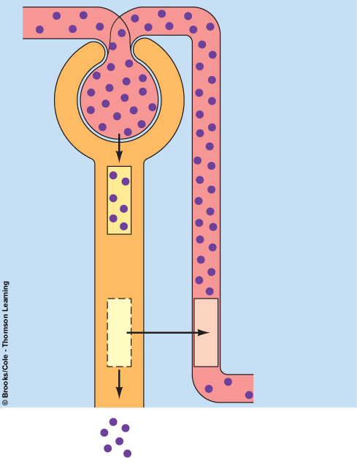
Complete reabsorption of the substance.
-‖the substance in the plasma doesn’t appear in urine‖
Here, if 6 molecules are filtrated without reabsorption or secretion, all of them will be excreted in urine.
-‖what’s filtrated is secreted‖
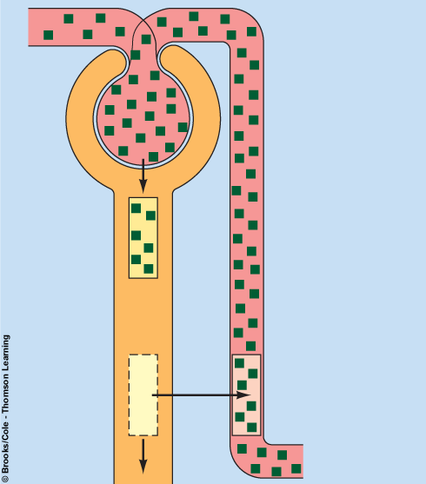

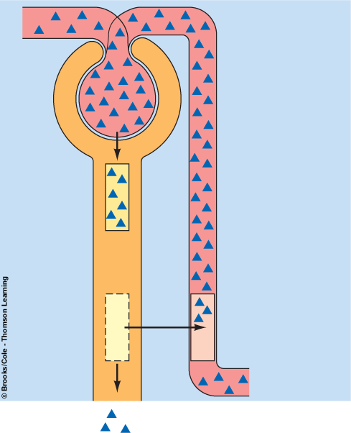
Partially reabsorption of the substance.
-‖concentration of these sub. in urine is less than plasma‖
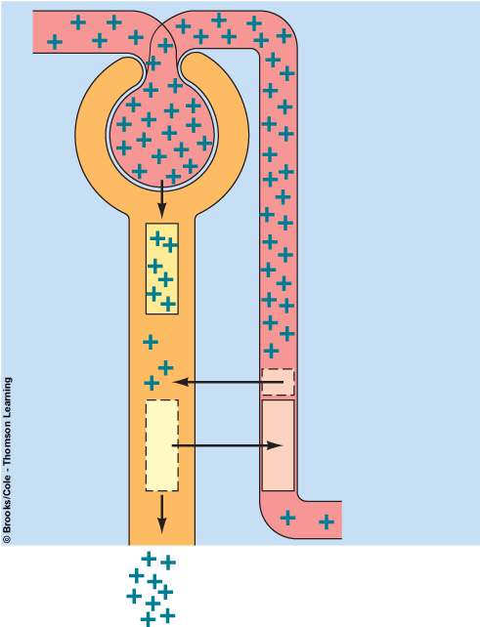
No reabsorption, but there is secretion.
-‖concentration of the sub. In the urine is more than the plasma‖
-DON’T forget:
*Inulin clearance rate is equal to GFR.
*Creatinine clearance rate is higher than inulin because in addition to the filtered part, there is a part that is secreted.

