#Physiology Lecture 3
Sunday 4th of February

- Plasma osmolality measures the body's electrolyte-water balance
- In water -> osmolality = osmolarity
★ هناك أكثر من طريقة للحصول عليها Measured Osmolality 1(
باستخدام جهاز تحليلي) Osmometer( , القراءة التي نحصل عليها تكون بال osmolality أي أن وحدتها
)mOsm/kg h2o(
2) Calculated Osmolarity
ولها قانونان لحسابها
a) Calculated Osmolarity = 2[NA] + [Glucose] + [Urea] (all measured in mmol/L) Or
= 2[Na] + 2[K] + [Glucose] + [Urea] (all measured in mmol/L)

الطريقة المستخدمة في الولايات الامريكية b)
Calculated Osmolarity = 2[NA] + [Glucose]/18 + [BUN]/2.8 (all measured in mg/dl) كالتالي mOsm/L يتم تحويله ل mg/dl المعطى بوحدة ال Glucose مثلا في تركيز ال
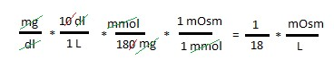

❑ لهذا قمنا بالقسمة على الثوابت السابقة) 18 , 2.8(

♦ اذا كان المريض قد شرب الكحول نقوم باضافة تركيز الكحول في حساباتنا فتصبح المعادلة
Calculated Osmolarity = 2[NA] + [Glucose]/18 + [BUN]/2.8 + [Ethanol]/3.7 (all in mg/dl)
* BUN stands for blood urea nitrogen. Urea nitrogen is what forms when protein breaks down (digestion of the protein )

mOsm/L ملاحظة: في الحسابات يجب التحويل لوحدة ♦ [Example] Given the concentrations below, calculate the osmolarity of blood.
[Na] = 0.140 mol/L | [Glucose] = 150mg/100ml | [BUN] = 20 mg/100ml
mOsm/L نحول الى )1 [Na] in mOsm/L = 0.140(mol/l) * (1000mmol/mol) * (2 mOsm/mmol) = 280 mOsm/L
ملاحظة : التحويل من mmol او mol الى mOsm او Osm يتم من خلال الضرب بعدد الجزيئات عند التفكك
)معامل فان هوف( فهنا الصوديوم يكون على شكل مركب NaX فعند تفككه يعطي Na+ و X- اي جزيئين
[Glucose] = 150(mg/100ml) * (1000ml/L) * (mmol/180.2mg) * ( 1 mOsm/mmol) =
8.32 mOsm/L
[BUN] = 20mg/100ml * (1000ml/L) * (mmol/28.01) * (1 mOsm/mmol) = 7.1 mOsm/L
Calculated Osmolarity of blood = 280 +8.32 + 7.1 =~ 295

    - الOsmolality الطبيعية في بلازما الانسان تتراوح بين 285-295 mOsm/kg h2o
    - ال Osmolality تزداد عند الجفاف و تقل عند الشرب الزائد للماء

▪ OsmolarGap
هو الفرق الرقمي بين الطريقة المقاسة و الطريقة الحسابية, طبيعيا يجب ان يكون اقل من 10mOsm/Kg
ويتم استخدام هذا الفرق للكشف عن وجود مواد تأثر على الاسموزية غير متوقع وجودها طبيعيا و معظمها
سام مثل الكحول بأنواعه

A) Osmotic Pressure: is the minimum amount of pressure applied on the solution to prevent the inward flow of water across a semipermeable membrane

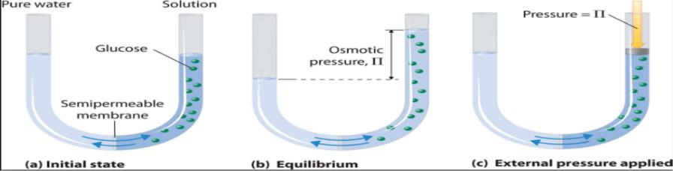

• الفرق في الضغط الاسموزي هو ما يسبب حركة الماء من الوسط الاقل ضغط الى الوسط الأعلى ضغط من خلال الغشاء شبه النافذ

→ Calculating osmotic pressure
(A)
Π = g * c * RT C = concentration or molarity (mol/L) C= عدد المولات\الحجم
عدد المولات = الكتلة\الكتلة المولية
g = عدد الجزيئات التي يتفكك اليها المركب R = 0.821 ثابت الغازات L.atm/mol.K T = - الحرارة بالكلفن Converting from Celsius to kelvin by using K = C°+ 273.15

(B)

♦ العوامل التي يعتمد عليها ) Π (
1( G )عدد الجزيئات(
فمثلا محلول من 1 M CaCl2 له ضغط اسموزي أعلى من محلول من 1 M KCl لان عدد الجزيئات الناتجة من تفكك مول من ال CaCl2 أعلى من عدد الجزيئات الناتجة من تفكك مول من ال KCL

Of solute .conc )التركيز( C )2
A solution of 3M CaCl2 has a higher osmotic pressure than a solution of 1M CaCl2
)C(
♦ كلما كان الضغط الاسموزي اعلى كانت حجم الماء الذي يدخل الوسط أكثر
)D(
♦ الضغط الاسموزي للعوالق هو الضغط الاسموزي الناتج عن البروتينات )مثال : بروتينات البلازما(

3) Reflection coefficient (σ)

هو رقم بين 1 و صفر يصف مقدار السهولة التي ينفذ بهاالمذاب من خلال الغشاء
1( اذا كان 1 اذا المذاب غير نافذ اذن يظل في الوعاء و يقوم بتسبيب ضغط اسموزي و يسبب تدفق الماء example serum albumin has a reflection coefficient of nearly one example urea has a اذا كان صفر اذا هونافذ ولن يقوم بعمل ضغط اسموزي و لن يسبب تدفق الماء 2( reflection coefficient of nearly zero

→ Calculating Effective Osmotic Pressure Effective Osmotic Pressure = σ * Π
= σ * g * c * RT
*If the reflection coefficient is one, the solute will exert maximal effective osmotic pressure.
*If the reflection coefficient is zero, the solute will exert no osmotic pressure.
*Two solutions having the same effective osmotic pressure are isotonic because no water flows across a semi-permeable membrane separating them.
*If two solutions separated by a semi-permeable membrane have different effective osmotic pressures,
- The solution with the higher effective osmotic pressure is hypertonic
- The solution with the lower effective osmotic pressure is hypotonic.
Water flows from the hypotonic to the hypertonic solution.
→ Tonicity:
(1) Tonicity means effective osmolality.
Effective osmolality: osmotic force that is mediating the shift of water between ECF and ICF
Effective osmolality = 2 x Na (mmol/L) + Glucose (mmol/L) (Note: nearly the same as osomlarity) o Tonicity is equal to the sum of the concentrations of the solutes which have the capacity to exert an osmotic force across the membrane into and out of the cell example Na, glucose o Tonicity is the measure of the osmotic pressure gradient between two solutions

(2)Tonicity as a term is used to describe the osmolality of a solution relative to plasma
- Isotonicty: same osmolarity (iso-osmolarity or iso-osmolar) as plasma so it will not affect the cells of the blood
- Hypertonicty: greater osmolarlity (hyper-osmolarity or hyperosmolar) than plasma
- Hypotonicty: lesser osmolarity (hypo-osmolarity or hypo-osmolar) than plasma

(3)Tonicity is a physiological term describing how a cell’s volume changes if the cell is placed in a solution
- Isotonic solution: will not affect the cells of the blood
- Hypertonic solution: causes cells to shrink (water moves out of the cell) • Hypotonic solution: causes cells to swell (water moves into of the cell).

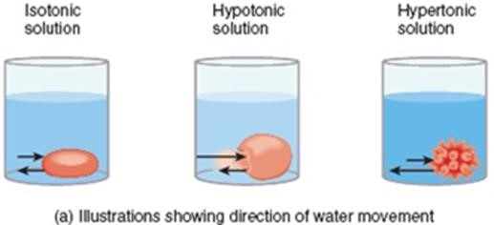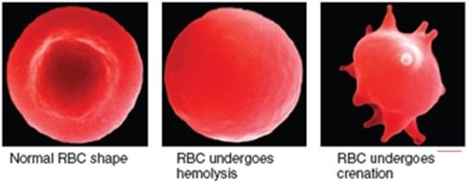

★ مثال : عند مرضى السكري -< يكون انتاج الانسولين اللازم لدخول الغلوكوز الى الخلايا قليل او غير فعال لذلك يتراكم الغلوكوز في البلازما و فتصبح Hypertonic بالنسبة للخلايا فتتدفق المياه من الخلايا الى البلازما لتعادل فرق الضغط الاسموزي الفعال
→ Tonicity depends on
- osmolarity
- Nature of solutes (osmotically active) and
- Permeability of membrane

★ ملاحظة: الفرق بين ال tonicity و ال osmolarity هو انه في ال tonicity يتم حساب تراكيز المواد غير العابرة فقط اما في ال osmolarity يتم حساب تراكيز جميع المواد بغض النظر عن نفاذيتها
In addition, tonicity always is in reference of the extracellular non-penetrating solute concentration relative to the cell's non-penetrating solutes مثال توضيحي ❖
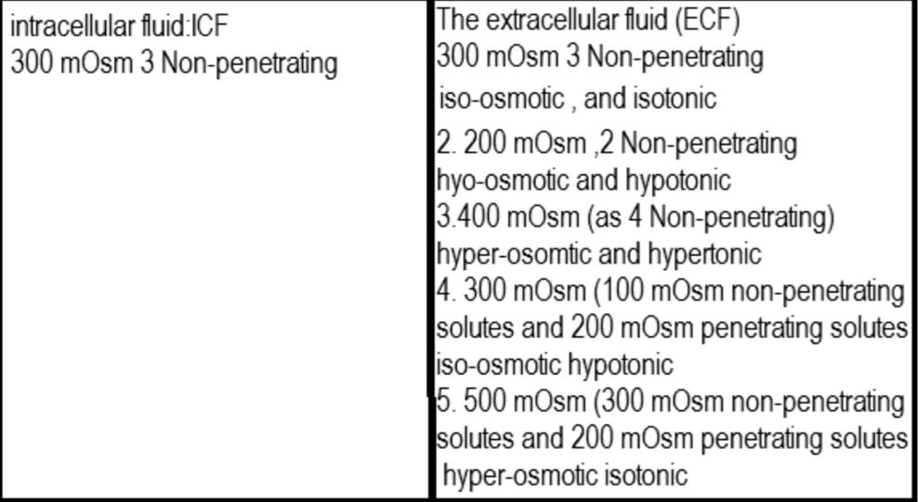

(

(a
%5 غلوكوز محلول Iso-osmolar لكن hypotonic لماذا؟ Iso-osmolar لان ال osmolarity الخاصة به هي 227 mOsm/L فهي قريبة لل Osmolarity الخاصة بالبلازما
لكنه hypotonic لانه في الانسان الطبيعي يقوم الانسولين بتمرير الغلوكوز الى داخل الخلايا
اما في مريض السكري فخلل عمل ال انسولين يؤدي الى عدم نفاذية الغلوكوز فيصبح hypertonic
Note: 5% glucose water is the same as 5% dextrose because dextrose is glucose produced from corn; biochemically glucose and dextrose are identical b) 0.9% normal saline is iso-osmolar but isotonic why?
Because the osmolarity of 0.9% normal saline = 306 milliosmole/L which is near the osmolarity of plasma
And because Na and Cl do not enter the cell and are in the same concentration as that of the cells it is isotonic

C) Facilitated diffusion
a. Characteristics
- Occurs down a concentration gradient (downhill)
- Is passive (does not require metabolic energy)
- Is more rapid than simple diffusion 4) Is carrier mediated

→ Because it is carrier mediated it inherits some features

1) Stereo-specificity

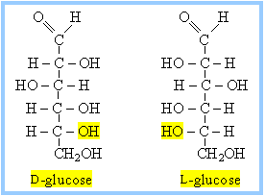

★ أي ان دخول الجزء يعتمد على دورانه )اتجاهه( ثلاثي الابعاد بالاضافة الى شكله فمثلا جزيء ال glucose المتجه بالاتجاه D-glucose يمر من الcarrier لكن جزيء الglucose ذو الاتجاه L-glucose لا يمر

2) Saturation
★ أي الاشباع , حيث أن عدد النواقل محدود فبالتالي تزداد سرعة الانتشار بزيادة الجزيئات الى أن تصبح جميع النواقل مشبعة )هذا الامر مشابه للأنزيمات في عملها(

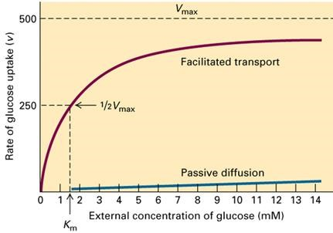

▪ عند وصول السرعة ل2/1 Vmax يقل التسارع بسبب محدودية النواقل

3) Competition
★ الجزيئات المشابهة في التركيب تنافس الجزيء الاساسي فجزيئات ال Galactose تنافس جزيئات ال
Glucose )هذه الخاصية أيضا مشابهة للنزيمات(

4) Types of proteins involved in facilitated diffusion

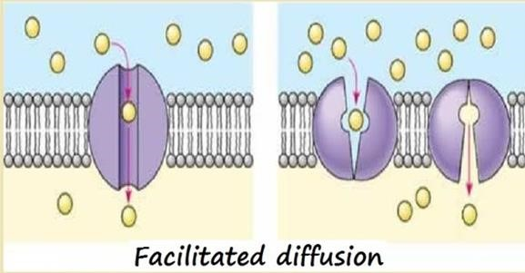

a) Carrier proteins (such as the glucose transporter GLUT1) b) Channels (which facilitate the diffusion of ions down a concentration gradient)
❖ A carrier transports only one or a few solute molecules per conformational cycle, whereas a single channel opening event may allow flux of many thousands of ions.

- Example of facilitated diffusion
• Glucose transport in muscle and adipose cells is "downhill," is carrier-mediated, and is inhibited by sugars such as galactose; therefore, it is categorized as facilitated diffusion. In diabetes mellitus, glucose uptake by muscle and adipose cells is impaired because the carriers for facilitated diffusion of glucose require insulin.

- Facilitated vs Simple Diffusion

- Facilitated diffusion needs carriers while simple diffusion not
- The carrier protein undergoes repetitive conformational changes during which the binding site for the substance is alternatively exposed to the intra and extra-cellular fluid (permeases).
- The substance is more likely to bind to the carrier where it is more highly concentrated and dissociate from the carrier where it is less highly concentrated (therefore, it flow down its concentration gradient).
- Unlike simple diffusion, the rate of facilitated diffusion rises as the concentration gradient increase until all of the binding sites are filled. At this point, the rate of diffusion can no longer rise with increasing particle concentration. This is called saturation; unlike free diffusion which is linear in the concentration difference.
- the temperature dependence of facilitated transport is substantially different due to the presence of an activated binding event, as compared to free diffusion where the dependence on temperature is mild

2) Active transport

a) Primary active transport

1) Occurs against the concentration gradient
- Requires metabolic energy in the form of ATP
- It is carrier mediated so it also inherits it’s features that were discussed above in this sheet.

→ The most common type of active transporters is the Sodium-Potassium ATPase (or pump)
It maintains high [K] and low [Na] inside the intracellular fluid by transporting three Na ions out of the ICF while bringing in 2 K ions into the ICF in each phosphorylation cycle
It is an electro-genic pump (it generates voltage difference in the membrane) because it pumps three positive ions out while pumping in 2 positive ions so the intracellular part of the membrane becomes negative relatively to the extracellular part

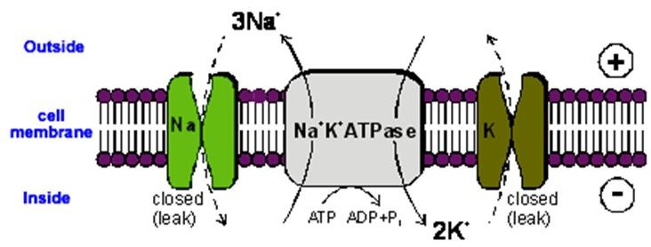
- The pump is made out of an alpha sub-unit which weighs 100,000 daltons, (this subunit is where the intracellular binding site of Na and ATP is located and the extracellular binding site for K is located)
- It also has a beta sub-unit that weighs 55,000 Dalton and is a glycoprotein

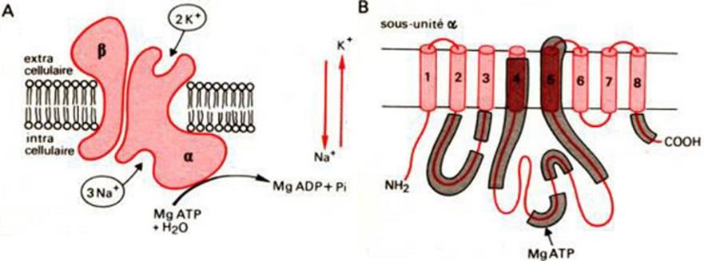

When Na binds to ά sub-unit,
▼
ATP also binds and is converted to ADP,
▼
with a phosphate binding transferred to Asp 376, the phosphorylation site.
▼
This causes a change in the configuration of the protein,
▼
extruding Na into the extra-cellular fluid.
▼
K then binds extra-cellularly,
▼
de-phosphorylation of the ά sub-units which
▼
returns to its previous conformation,
▼
releasing K into the cytoplasm

→ This process (The active transport of Na and K) is one of the major energy-using processes in the body.
On the average, it accounts for about 24% of the energy utilized by cells, and in neurons it account for 70%. Thus, it accounts for a large part of the basal metabolism.

Academic team - OVERDOSE
Written by : Saeed Karajah
Edited by : Dana Abu Hanak
Best of Luck ...

