Physiology of Smooth Muscle
A. Structure of Smooth Muscle
1. The cytoplasm of a smooth muscle cell is homogeneous (with no visible striations) when viewed by light microscopy.
2. Specialized contacts between individual smooth muscle cells have two functions in communication and as mechanical linkages.
a. Gap junctions (nexus)
Gap junctions are areas of close opposition (~2 nm) between plasma membranes of separate cells. Gap junctions serve as a low-resistance electrical coupling structure.
b. Attachment plaques (mechanical coupling)
Attachment plaques are characterized by a 10- to 30-nm gap between plasma membranes of adjacent cells.
Attachment plaques structures may serve as anchor points for thin filaments.
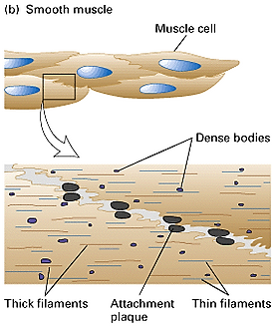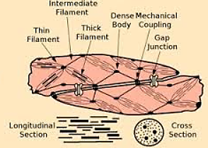
3. Smooth muscle cells contain sarco-plasmic reticulum but in less abundant quantities compared to skeletal muscle. Like skeletal muscle sarco-plasmic reticulum, the smooth muscle sarco-plasmic reticulum accumulates and releases Ca2+.
4. Smooth muscle does not have a T-tubule system. However, surface vesicles called caveolae (meaning little cave) in individual cells are thought to have an analogous role in transmission of action potentials.
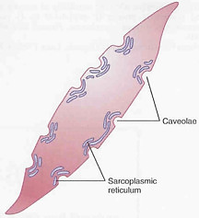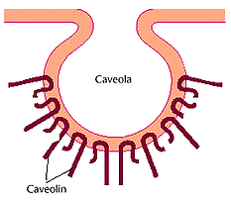
5. Dense bodies.
Some of these dense bodies are dispersed inside the cell; others are attached to cell membrane. Dense bodies apparently serve the same function as Z disks in skeletal muscle.
The other end of the thin filaments in many smooth muscle cells is connected to attachment plaques, which are similar to dense bodies but are located at the plasma membrane of a muscle cell. Like a Z disk, an attachment plaque is rich in the actin-binding protein alpha-actinin; it also contains a second protein, vinculin, which binds to an integral membrane protein in the plaque and to alpha-actinin, thereby attaching actin filaments to membrane adhesion sites.
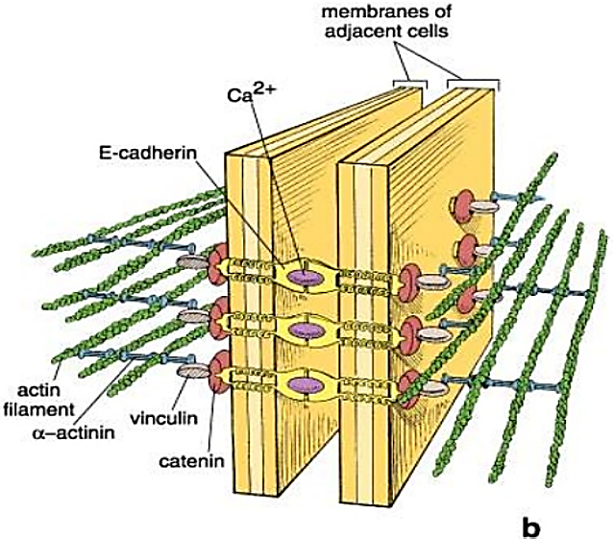
6. Intermediate filaments: non-contractile filaments that anchor to dense bodies which are attached to adjacent sarcolemma
7. Smooth muscle does not have troponin
B. Physiology of Smooth Muscle
1. Smooth muscle is typically subdivided into two classes: unitary or visceral smooth muscle; multiunit smooth muscle.
2. Both classes of smooth muscle share the following characteristics:
a. Smooth muscle is capable of contractions that are slow in onset but are sustained for long periods of time with relatively little energy input required (the rate of ATP use is 1/10 to 1/300 that of skeletal muscle).
b. Physiologic anatomy of smooth muscle neuromuscular junctions.
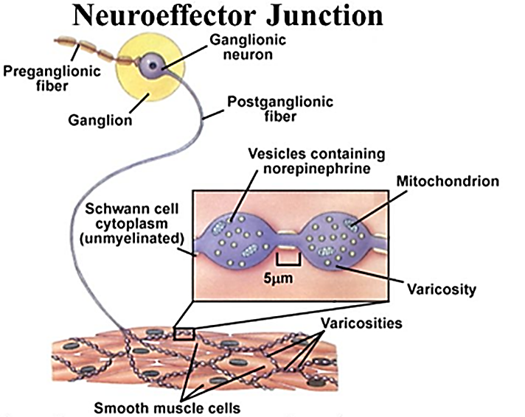
Neuromuscular junctions of the highly structured type found on skeletal muscle fibers do not occur in smooth muscle.
Instead, the autonomic nerve fibers that innervate smooth muscle generally branch diffusely on top of a sheet of muscle fibers.
In most instances, these fibers do not make direct contact with the smooth muscle fiber cell membranes but instead form diffuse junctions that secrete their transmitter substance into the matrix coating of the smooth muscle often a few nanometers to a few micrometers away from the muscle cells; the transmitter substance then diffuses to the cells. Furthermore, where there are many layers of muscle cells, the nerve fibers often innervate only the outer layer. Muscle excitation travels from this outer layer to the inner layers by action potential conduction in the muscle mass or by additional diffusion of the transmitter substance.
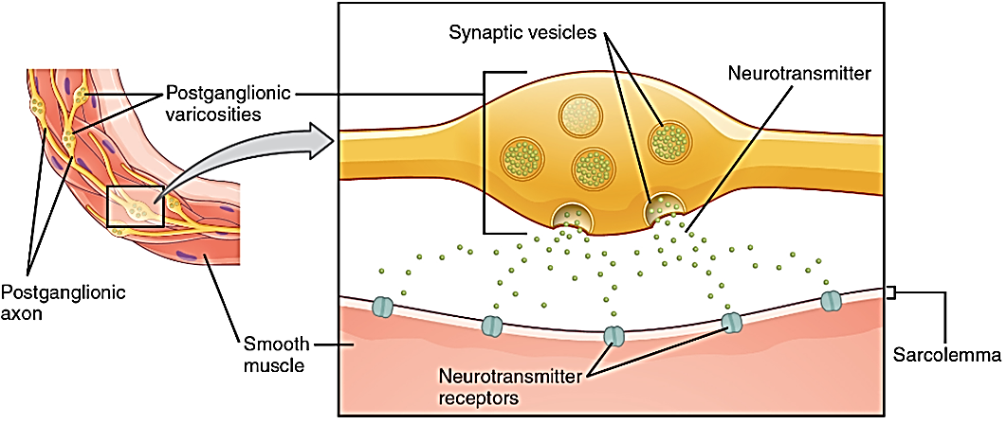
Unitary smooth muscle mass c. All smooth muscle exhibits a certain degree of intrinsic tone, or basal resting tension; contractions are superimposed on this tone.
Excitatory and inhibitory transmitter substances secreted at the smooth muscle neuromuscular junction.
The most important transmitter substances secreted by the autonomic nerves innervating smooth muscle are acetylcholine and norepinephrine, but they are never secreted by the same nerve fibers. Acetylcholine is an excitatory transmitter substance for smooth muscle fibers in some organs but an inhibitory transmitter for smooth muscle in other organs. When acetylcholine excites a muscle fiber, norepinephrine ordinarily inhibits it. Conversely, when acetylcholine inhibits a fiber, norepinephrine usually excites it.
Much smooth muscle contraction is initiated by stimulatory factors acting directly on the contractile machinery, without action potentials. Such local chemical factors include hypoxia: low blood oxygen (relaxation), hypercapnia: increase CO2 in blood (relaxation), proton: increase hydrogen ions concentration (relaxation), temperature (relaxation), lactic acid (relaxation), hyperkalemia: blood increased K+, hypocalcaemia: blood low Calcium (relaxation)
Types of smooth muscles:
A. Unitary (single-unit) smooth muscle
The term “unitary” is confusing because it does not mean single muscle fibers.
Unitary smooth muscle mass of hundreds to thousands of smooth muscle fibers that contract together as a single unit.
Unitary smooth muscle fibers usually are arranged in sheets or bundles
Unitary smooth muscle cell membranes are adherent to one another at multiple points so that force generated in one muscle fiber can be transmitted to the next.
Unitary smooth muscle cell membranes are joined by many gap junctions through which ions can flow freely from one muscle cell to the next so that action potentials, or simple ion flow without action potentials, can travel from one fiber to the next and cause the muscle fibers to contract together.
Unitary smooth muscle is also called
a. Syncytial smooth muscle because of its syncytial interconnections among fibers; syncytial (a multinucleate mass of cytoplasm that is not separated into cells)
b. Visceral smooth muscle because it is found in the walls of most viscera of the body, including the gastrointestinal tract, bile ducts, arterioles, and the genitourinary tract (uterus, ureter, and bladder).
i. In single-unit organization the smooth muscle there are fewer neurons
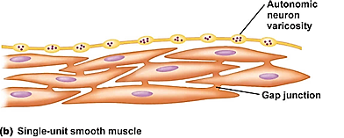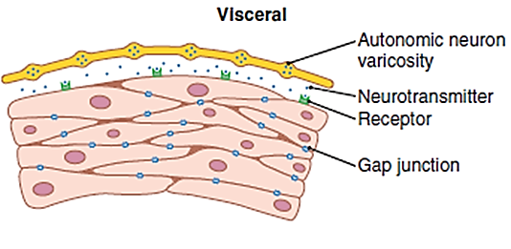
ii. Spontaneous activity is initiated in pacemaker areas and spreads throughout the entire muscle.
Unlike pacemakers in cardiac muscle, smooth muscle pacemakers move around.
iii. It has a high degree of electrical coupling (intimate cytoplasmic contact) between cells and, therefore, permits coordinated contraction of the organ
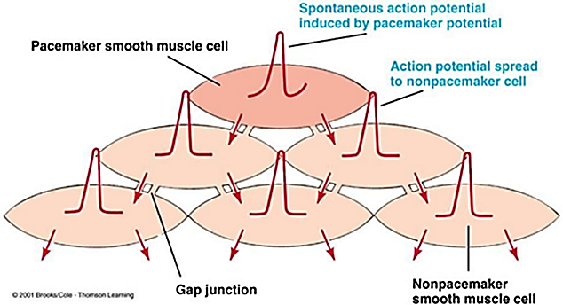
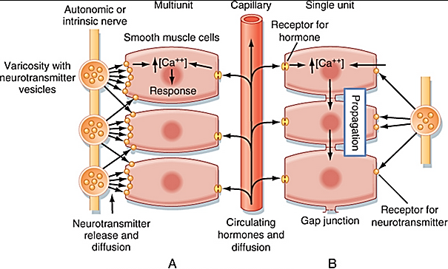
iv. Tension develops in response to stretch.
When visceral (unitary) smooth muscle is stretched sufficiently, spontaneous action potentials are usually generated. They result from a combination of
(1) the normal slow wave potentials and
(2) a decrease in overall negativity of the membrane potential caused by the stretch.
This response to stretch allows the gut wall, when excessively stretched, to contract automatically and rhythmically. For instance, when the gut is overfilled by intestinal contents, local automatic contractions often set up peristaltic waves that move the contents away from the overfilled intestine, usually in the direction of the anus.
v. Effect of Local Tissue Factors and Hormones to Cause Smooth Muscle Contraction without Action Potentials
Approximately half of all smooth muscle contraction is likely
a. non-nervous: initiated by stimulatory factors acting directly on the smooth muscle contractile machinery and
b. non-action potential: without action potentials.
Two types of non-nervous and non-action potential stimulating factors often involved are
(1) local tissue chemical factors: many local factors may affect smooth muscle wall of arterioles which will be discussed later
(2) various hormones.
Many circulating hormones in the blood affect smooth muscle contraction to some degree, and some have profound effects. Among the more important of these hormones are norepinephrine, epinephrine, angiotensin II, endothelin, vasopressin, oxytocin, serotonin, and histamine.
A hormone causes contraction of a smooth muscle when the muscle cell membrane contains hormone-gated excitatory receptors for the respective hormone.
Conversely, the hormone causes inhibition if the membrane contains hormone-gated inhibitory receptors for the hormone rather than excitatory receptors.
Generally, contractions are initiated by circulating hormones and are not typically initiated by motor nerve impulses. However, contractile activity may be modified and regulated by motor nerve input.
B. Multiunit smooth muscle:
i. Multiunit smooth muscle behaves as separate motor units
ii. Multi-unit smooth muscle is composed of discreteمميز, separate smooth muscle fibers.
iii. Each Multi-unit smooth muscle fiber operates independently of the others
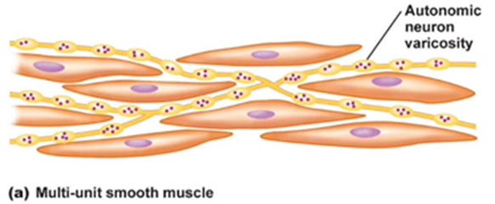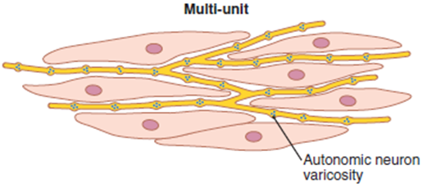
iv. Multi-unit smooth muscle often is innervated by a single nerve ending, as occurs for skeletal muscle fibers. Multiunit smooth muscle is more similar to skeletal muscle than it is to visceral smooth muscle
v. Multiunit smooth muscle is densely innervated; contraction is controlled and activated by neural innervations (e.g., autonomic nervous system).
vi. Multiunit smooth muscle have little or no electrical coupling between cells
vii. The outer surfaces of these fibers, like those of skeletal muscle fibers, are covered by a thin layer of basement membrane–like substance (a mixture of fine collagen and glycoprotein that helps insulate the separate fibers from one another).
viii. Multiunit smooth muscle does not contract spontaneously
ix. Multiunit smooth muscle only minimally responsive to circulating hormones,
x. Multiunit smooth muscle does not respond to stretch by developing tension
xi. Multiunit smooth are found in places where fine control of contraction is needed such as respiratory airways and large arteries. Some examples of multi-unit smooth muscle are the ciliary muscle (the muscle that focuses the eye), the iris muscle of the eye, and the piloerector muscles that cause erection of the hairs when stimulated by the sympathetic nervous system.
Smooth muscle action potential:
Electrical activity of unitary (single-unit) or visceral smooth muscle:
Resting membrane potential:
In visceral smooth muscle is unstable (i.e. there is no true resting membrane potential), ranging from -55 to -35 mV.
Action potential:
When depolarization reaches threshold potential, an action potential is generated and will be transmitted to the adjacent muscle through the gap junction.
The types of action potential are:
A. Slow wave potentials in unitary smooth muscle can lead to spontaneous generation of action potentials.
Some smooth muscle is self-excitatory—that is, action potentials arise within the smooth muscle cells without an extrinsic stimulus. This activity is often associated with a basic slow wave rhythm of the membrane potential.
Slow wave in seen a visceral smooth muscle of the gut.
Slow wave itself is not the action potential. That is, it is not a self-regenerative process that spreads progressively over the membranes of the muscle fibers.
Slow wave is a local property of the smooth muscle fibers that make up the muscle mass.
Slow wave rhythm cause is unknown.
One suggestion is that the slow waves are caused by waxing and waning of the pumping of positive ions (presumably sodium ions) outward through the muscle fiber membrane; that is, the membrane potential becomes more negative when sodium is pumped rapidly and less negative when the sodium pump becomes less active.
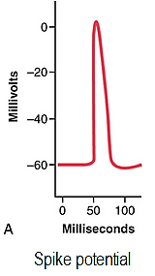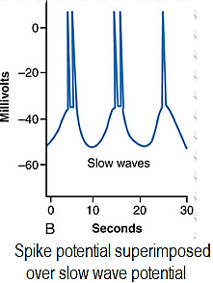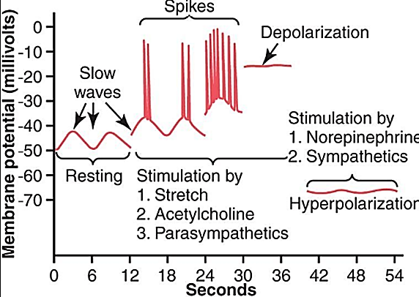
Another suggestion is that the conductance of the ion channels increase and decrease rhythmically.
Slow wave importance is that, when they are strong enough, they can initiate action potentials.
Slow wave themselves cannot cause muscle contraction. However, when the peak of the negative slow wave potential inside the cell membrane rises in the positive direction from −60 to about −35 millivolts (the approximate threshold for eliciting action potentials in most visceral smooth muscle), an action potential develops and spreads over the muscle mass and contraction occurs.
Slow wave each peak, one or more action potentials occur. These repetitive sequences of action potentials elicit rhythmical contraction of the smooth muscle mass. Therefore, the slow waves are called pacemaker waves.
For a muscle to contract spontaneously and rhythmically, there must be an intrinsic rhythmical “pacemaker.” Intestinal smooth muscle, for example, exhibits a rhythmical slow-wave potential that transiently depolarizes and repolarizes the muscle membrane. This slow wave does not stimulate contraction itself, but if the amplitude is sufficient, it can trigger one or more action potentials that result in Calcium influx and contraction. Although they are typical of smooth muscle, neither “slow” voltage sensitive Calcium channels nor action potentials with “plateaus” play a necessary role in rhythmical contraction. A high resting cytosolic Calcium concentration would support a sustained contraction, and hyperpolarization would favor relaxation.
b. Spike potential:
It is similar to that seen in skeletal muscle
It is observed in most, if not all, single unite smooth muscle
It is average duration (10 to 50 msec), with very low amplitude.
It is stimulated by electrical, hormonal, neurotransmitters, and stretch
C. Action potential with plateau:
It is seen in ureter and some vascular smooth muscle.
It started as rapid depolarization and delayed re-polarization (100 to 1000 msec)
The importance of the plateau is that it can account for the prolonged contraction that occurs in some types of smooth muscle, such as the ureter (the uterus under some conditions) and certain types of vascular smooth muscle
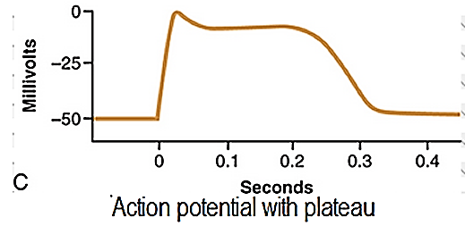
Ionic basis of action potential:
In smooth muscle the depolarization is due to entry of Calcium and not sodium because sodium channel are small in number
Open of Calcium channel will help to entry of Calcium which is relate to contraction and will explain why action potential is prolonged.

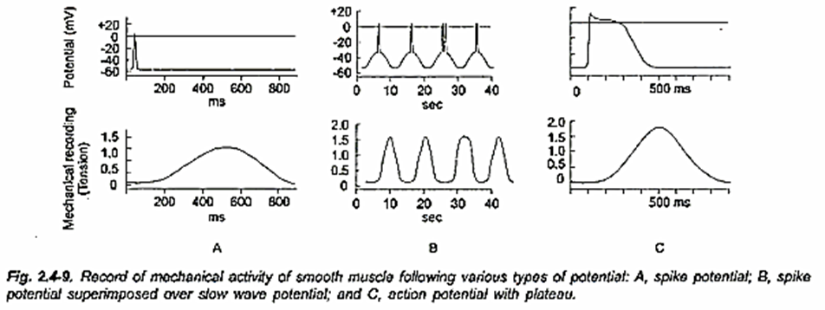
Depolarization of multi-unit smooth muscle without action potentials:
The smooth muscle fibers of multi-unit smooth muscle normally contract mainly in response to nerve stimuli. The nerve endings secrete acetylcholine in the case of some multi-unit smooth muscles and norepinephrine in the case of others.
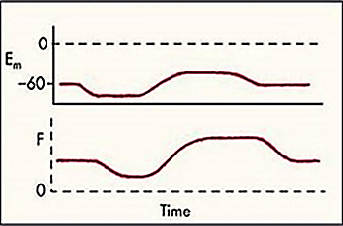
In both instances, the transmitter substances cause depolarization of the smooth muscle membrane, and this depolarization in turn elicits contraction. Action potentials usually do not develop because the fibers are too small to generate an action potential. (When action potentials are elicited in visceral unitary smooth muscle, 30 to 40 smooth muscle fibers must depolarize simultaneously before a self-propagating action potential ensues.) Yet in small smooth muscle cells, even without an action potential, the local depolarization (called the junctional potential) caused by the nerve transmitter substance itself spreads “electrotonically” over the entire fiber and is all that is necessary to cause muscle contraction.
Electrotonically: the spread of electrical activity through cells in the absence of repeated action potentials
Mechanical contraction of smooth muscle:
Smooth muscle tissue has no myofibrils or sarcomeres. As a result, this tissue also has no striations and is called non-striated muscle.
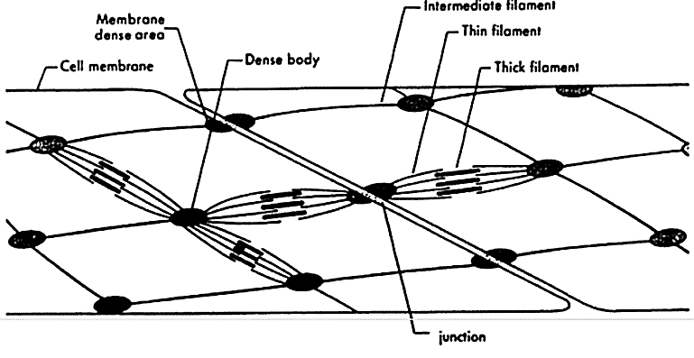
The thin filaments in a smooth muscle cell are attached to dense bodies (Instead of Z line), structures distributed throughout the sarcoplasm in a network of intermediate filaments composed of the protein desmin. Some of the dense bodies are firmly attached to the sarcolemma.
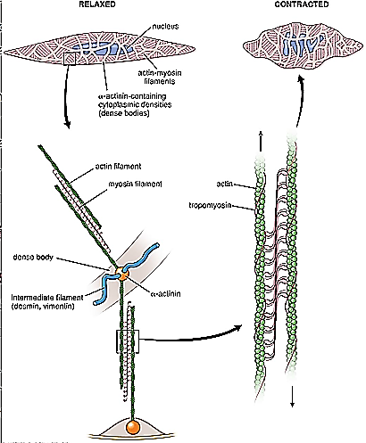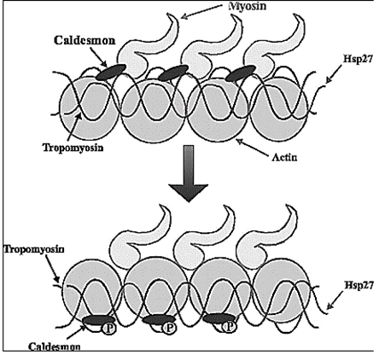
The dense bodies and intermediate filaments anchor the thin filaments such that, when sliding occurs between thin and thick filaments, contraction pull the dense bodies’ together ►the cell shortens.
The actin filaments of smooth muscle and skeletal muscle have similar structures, except that the calcium regulator protein troponin is not present in smooth muscle.
Caldesmon and calponin block the binding site
The cellular content of actin and tropomyosin is greater in smooth muscle than in striated muscle
Smooth muscle has less myosin; myosin: actin (1:12) while in striated muscle myosin: actin (1:6)
Although smooth muscle cells are surrounded by connective tissue, the collagen fibers never unite to form tendons or aponeuroses as they do in skeletal muscles. Sheets of smooth muscle cells work together because they are interconnected by gap junctions and connective tissue.
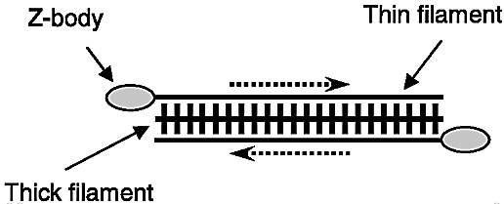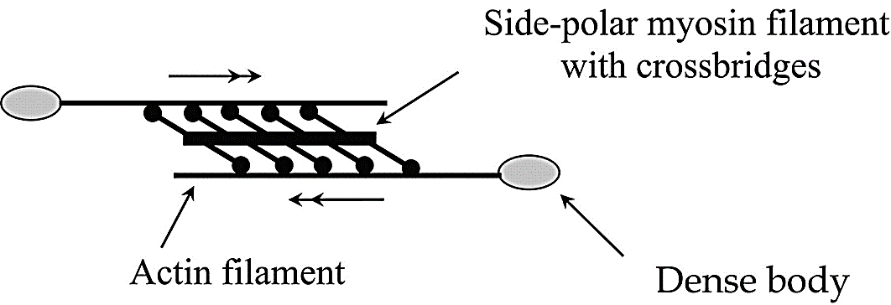
Most of the myosin filaments have “side-polar” or “face polar” (اي وجه او قطب واحد وليس اثنان) cross-bridges arranged so that the bridges on one side hinge in one direction and those on the other side hinge in the opposite direction. This configuration allows the myosin to pull an actin filament in one direction on one side while simultaneously pulling another actin filament in the opposite direction on the other side. The value of this organization is that it allows smooth muscle cells to contract as much as 80 percent of their length instead of being limited to less than 30 percent, as occurs in skeletal muscle.
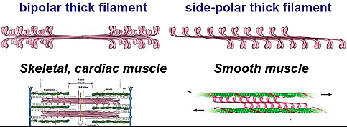
Thick filaments are scattered throughout the sarcoplasm of a smooth muscle cell and smooth muscle cells have more cross-bridges per thick filament.
Dense bodies are not arranged in straight lines, so when a contraction occurs, the muscle cell twists like a corkscrew (the cell to a more rounded appearance).
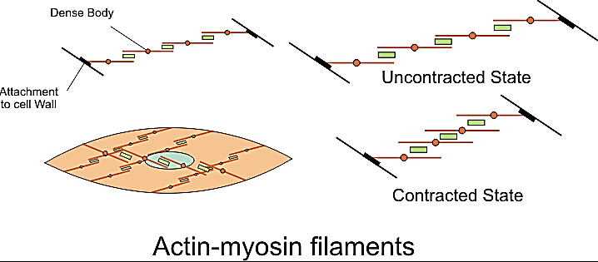
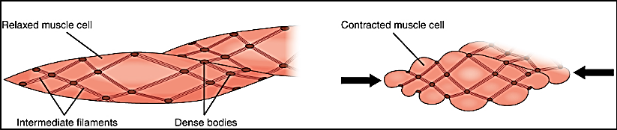
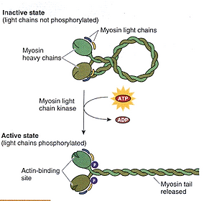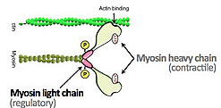
What do smooth muscle cells do besides contraction?
They secrete connective tissue matrix.
Synthesize type IV and type III collagen, elastin
Contraction of smooth muscle:
Molecular basis of contraction:
1. Calcium concentration in the cytosolic fluid of the smooth muscle increases as a result of
A. the influx of calcium from the extracellular fluid through calcium channels
The concentration of calcium ions in the extracellular fluid is greater than 10⁻³ molar, in comparison with less than 10⁻⁷ molar inside the smooth muscle cell; this situation causes rapid diffusion of the calcium ions into the cell from the extracellular fluid when the calcium channels open. The time required for this diffusion to occur averages 200 to 300 milliseconds and is called the latent period before contraction begins. This latent period is about 50 times as great for smooth muscle as for skeletal muscle contraction.
B. and/or release of calcium from the sarcoplasmic reticulum.
Small invaginations of the cell membrane, called caveolae, about the surfaces of these tubules.
The caveolae suggest a rudimentary analog of the transverse tubule system of skeletal muscle. When an action potential is transmitted into the caveolae, this is believed to excite calcium ion release from the abutting ملاصقsarcoplasmic tubules (sarcoplasmic tubules that lie near the cell membrane in some larger smooth muscle cells) in the same way that action potentials in skeletal muscle transverse tubules cause release of calcium ions from the skeletal muscle longitudinal sarcoplasmic tubules. In general, the more extensive the sarcoplasmic reticulum in the smooth muscle fiber, the more rapidly it contracts.
Although changing the extracellular fluid calcium ion concentration from normal has little effect on the force of contraction of skeletal muscle, this is not true for most smooth muscle. When the extracellular fluid calcium ion concentration decreases to about 1/3 to 1/10 normal, smooth muscle contraction usually ceases. Therefore, the force of contraction of smooth muscle is usually highly dependent on the extracellular fluid calcium ion concentration.
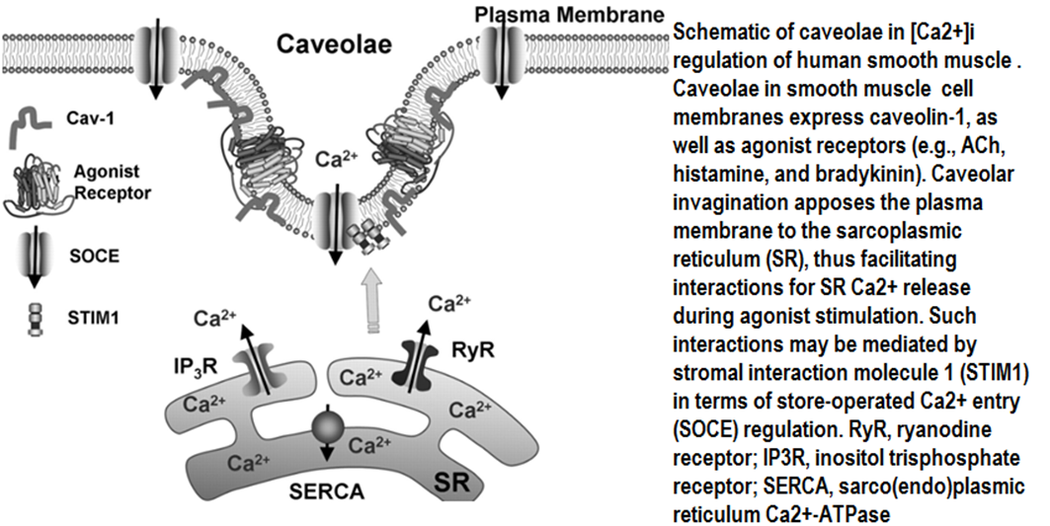
2. The calcium ions bind reversibly with calmodulin.
In place of troponin, smooth muscle cells contain a large amount of another regulatory protein called calmodulin. Although this protein is similar to troponin, it is different in the manner in which it initiates contraction. Calmodulin initiates contraction by activating the myosin cross-bridges.
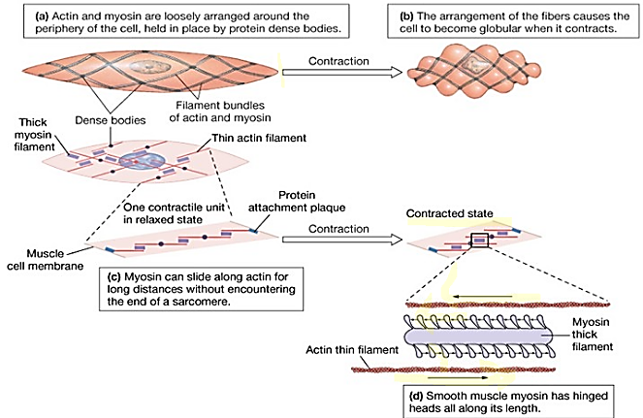
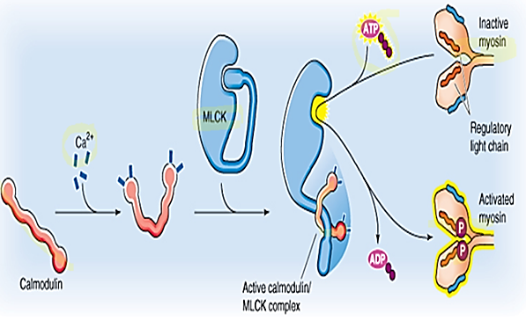
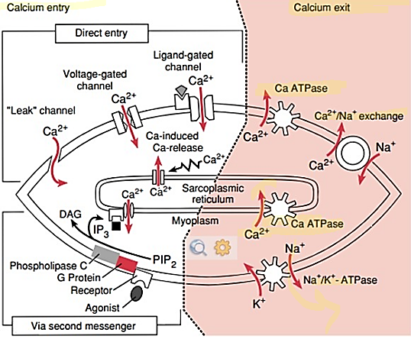
3. The calmodulin-calcium complex then joins with and activates myosin light chain kinase (it is a phosphorylating enzyme).
4. One of the light chains of each myosin head, called the regulatory chain, becomes phosphorylated by myosin light chain kinase on serine at position 19.
ال( MLCK ) يأخذ ذرة فوسفور من ( ATP وتتحول الى ADP) ويوعطيها الى ال((myosin تصبح مزودة بالطاقة للتقلص
When the regulatory chain is phosphorylated, the head has the capability of binding repetitively with the actin filament and proceeding through the entire cycling process of intermittent “pulls,” the same as occurs for skeletal muscle, thus causing muscle contraction.
However, when this chain is not phosphorylated, the attachment-detachment cycling of the myosin head with the actin filament does not occur.
ملاحضة:ان عدم وجون ( Troponin C and I ) في ( skeletal muscle) فان بداله في ( smooth muscle) هي
1. بديل (Troponin C) هو( calmodulin) 2. بديل (Troponin I ) هو( not phosphorylate myosin light chain)
After that contraction of smooth muscle occurs with same steps discussed for skeletal muscle contraction (cross bridge cycle)
Relaxation of smooth muscle:
Intracellular calcium concentrations are very important in regulating smooth muscle contraction. The concentration of intracellular calcium depends upon the balance between the calcium enters the cells, and the calcium that is released by intracellular storage sites (e.g., sarcoplasmic reticulum), and removal of calcium either back into storage sites or out of the cell. Calcium is re-sequestered by the sarcoplasmic reticulum by a ATP-dependent calcium pump. Calcium is removed from the cell to the external environment by either ATP-dependent calcium pump or by the sodium-calcium exchanger.
Sequence of events in relaxation of visceral smooth muscle:
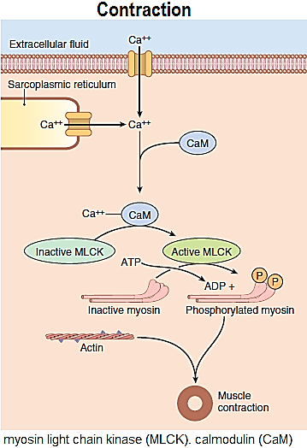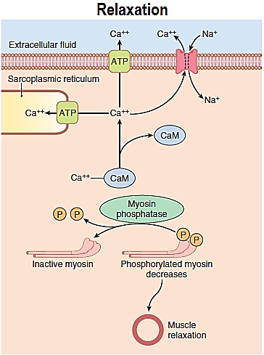
- Dephosphorlation of myosin by myosin light chain phosphatase: myosin is de-phosphor-ylated by myosin light chain phosphatase in the cell, which will cause relaxation.
- De-phosphorlation of myosin light chain kinase does not necessarily lead to relaxation of the smooth muscle. Various mechanisms are involved. One appears to be a (latch bridge) mechanism by which myosin cross- bridges remain attached to actin for some time after the cytoplasmic Calcium concentration falls. This produces sustained contraction with little expenditure of energy, which is especially important in vascular smooth muscle relaxation. Relaxation of the muscle presumably occurs when there is final dissociation of the Ca-calmodulin complex or when some other mechanism comes into play.
Smooth muscle contraction is regulated by both Ca++ and myosin light chain phosphorylation.
When the cytosolic Calcium concentration decreases following the initiation of contraction, myosin kinase becomes inactivated. However, cross-bridge formation continues, even in the absence of Calcium, until the myosin light chains are dephosphorylated through the action of myosin light chain phosphatase.
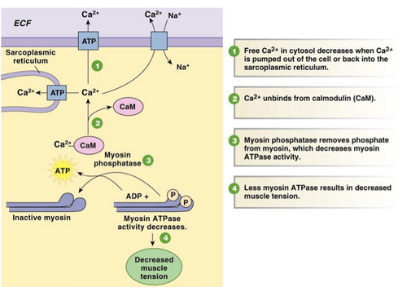
Comparison of Smooth Muscle Contraction and Skeletal Muscle Contraction
(1) Slow Cycling of the Myosin Cross-Bridges.
The rapidity of cycling of the myosin cross-bridges in smooth muscle—that is, their attachment to actin, then release from the actin, and reattachment for the next cycle—is much slower than in skeletal muscle; in fact, the frequency is as little as 1/10 to 1/300 that in skeletal muscle. Yet, the fraction of time that the cross-bridges remain attached to the actin filaments, which is a major factor that determines the force of contraction, is believed to be greatly increased in smooth muscle. A possible reason for the slow cycling is that the cross-bridge heads have far less ATPase activity than in skeletal muscle, and thus degradation of the ATP that energizes the movements of the cross-bridge heads is greatly reduced, with corresponding slowing of the rate of cycling.
(2) Low Energy Requirement to Sustain Smooth Muscle Contraction.
Only 1/10 to 1/300 as much energy is required to sustain the same tension of contraction in smooth muscle as in skeletal muscle. This, too, is believed to result from the slow attachment and detachment cycling of the cross-bridges and because only one molecule of ATP is required for each cycle, regardless of its duration.
This low energy utilization by smooth muscle is important to the overall energy economy of the body because organs such as the intestines, urinary bladder, gallbladder, and other viscera often maintain tonic muscle contraction almost indefinitely.
Tonic muscles as continuously active muscles within the body that are usually filled with fluid.
Phasic muscles are active for short periods but spend most of the time in a relaxed state
(3) Slowness of Onset of Contraction and Relaxation of the Total Smooth Muscle Tissue.
Most skeletal muscles contract and relax rapidly, most smooth muscle contraction is prolonged tonic contraction, sometimes lasting hours or even days.
A typical smooth muscle tissue begins to contract (latent period) 50 to 100 milliseconds after it is excited, reaches full contraction (contraction period) about 0.5 second later, and then declines in contractile force (relaxation period ) in another 1 to 2 seconds, giving a total contraction time of 1 to 3 seconds. This is about 30 times as long as a single contraction of an average skeletal muscle fiber. However, because there are so many types of smooth muscle, contraction of some types can be as short as 0.2 second or as long as 30 seconds.
The slow onset of contraction of smooth muscle, as well as its prolonged contraction, is caused by the slowness of attachment and detachment of the cross-bridges with the actin filaments. In addition, the initiation of contraction in response to calcium ions is much slower than in skeletal muscle.
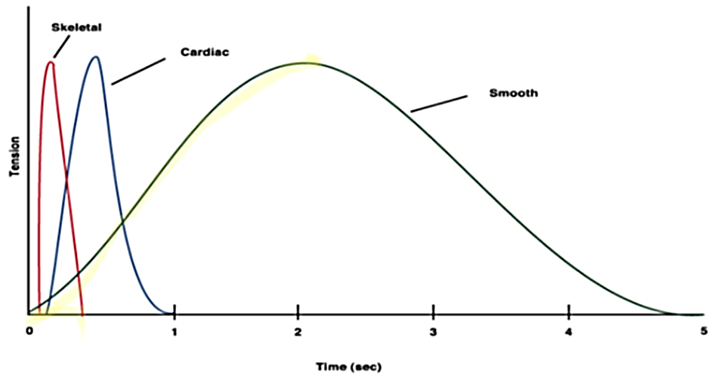
(4) The Maximum Force of Contraction Is Often Greater in Smooth Muscle Than in Skeletal Muscle.
Despite the relatively few myosin filaments in smooth muscle, and despite the slow cycling time of the cross-bridges, the maximum force of contraction of smooth muscle is often greater than that of skeletal muscle—as great as 4 to 6 kg/ cm2 cross-sectional area for smooth muscle, in comparison with 3 to 4 kg/ cm2 cross-sectional area for skeletal muscle. This great force of smooth muscle contraction results from the prolonged period of attachment of the myosin cross-bridges to the actin filaments.
(5) The “Latch” Mechanism Facilitates Prolonged Holding of Contractions of Smooth Muscle.
Latch: قفل او ترباس او اقفل او تربس
Once smooth muscle has developed full contraction, the amount of continuing excitation can usually be reduced to far less than the initial level even though the muscle maintains its full force of contraction. Further, the energy consumed to maintain contraction is often minuscule, sometimes as little as 1/300 the energy required for comparable sustained skeletal muscle contraction. This mechanism is called the “latch” mechanism.
The importance of the latch mechanism is that it can maintain prolonged tonic contraction in smooth muscle for hours with little use of energy. Little continued excitatory signal is required from nerve fibers or hormonal sources.
Among the many mechanisms that have been postulated, one of the simplest is the following:
When the myosin kinase and myosin phosphatase enzymes are both strongly activated, the cycling frequency of the myosin heads and the velocity of contraction are great. Then, as the activation of the enzymes decreases, the cycling frequency decreases, but at the same time, the deactivation of these enzymes allows the myosin heads to remain attached to the actin filament for a longer and longer proportion of the cycling period. Therefore, the number of heads attached to the actin filament at any given time remains large. Because the number of heads attached to the actin determines the static force of contraction, tension is maintained, or “latched,” yet little energy is used by the muscle because ATP is not degraded to ADP except on the rare occasion when a head detaches.
(6) "Stress-relaxation" of smooth muscle
"Stress-relaxation" or "delayed compliance" of visceral smooth muscle
Another important characteristic of smooth muscle, especially the visceral unitary type of smooth muscle of many hollow organs, is its ability to return to nearly its original force of contraction seconds or minutes after it has been elongated or shortened.
For example, a sudden increase in fluid volume in the urinary bladder, thus stretching the smooth muscle in the bladder wall, causes an immediate large increase in pressure in the bladder. However, during the next 15 seconds to a minute or so, despite continued stretch of the bladder wall, the pressure returns almost exactly back to the original level. Then, when the volume is increased by another step, the same effect occurs again.
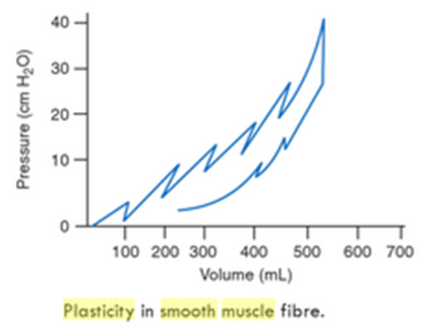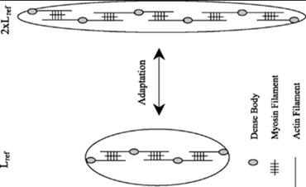
Conversely, when the volume is suddenly decreased, the pressure falls drastically at first but then rises in another few seconds or minutes to or near to the original level. These phenomena are called stress-relaxation and reverse stress-relaxation. Their importance is that, except for short periods, they allow a hollow organ to maintain about the same amount of pressure inside its lumen despite sustained, large changes in volume.
It is this property that is referred to as the (plasticity) of smooth muscles. The best example for this property is the gall bladder
Smooth muscle is unique in its ability to generate various degrees of tension at a constant concentration of intracellular calcium. This change in calcium sensitivity of smooth muscle can be attributed to differences in the activity of MLCP. Smooth muscle contracts when the myosin light chain is phosphorylated by the actions of myosin light chain kinase (MLCK). MLCP is a phosphatase that can dephosphorylate the myosin light chain, rendering it inactive and therefore attenuating the muscle contraction.

