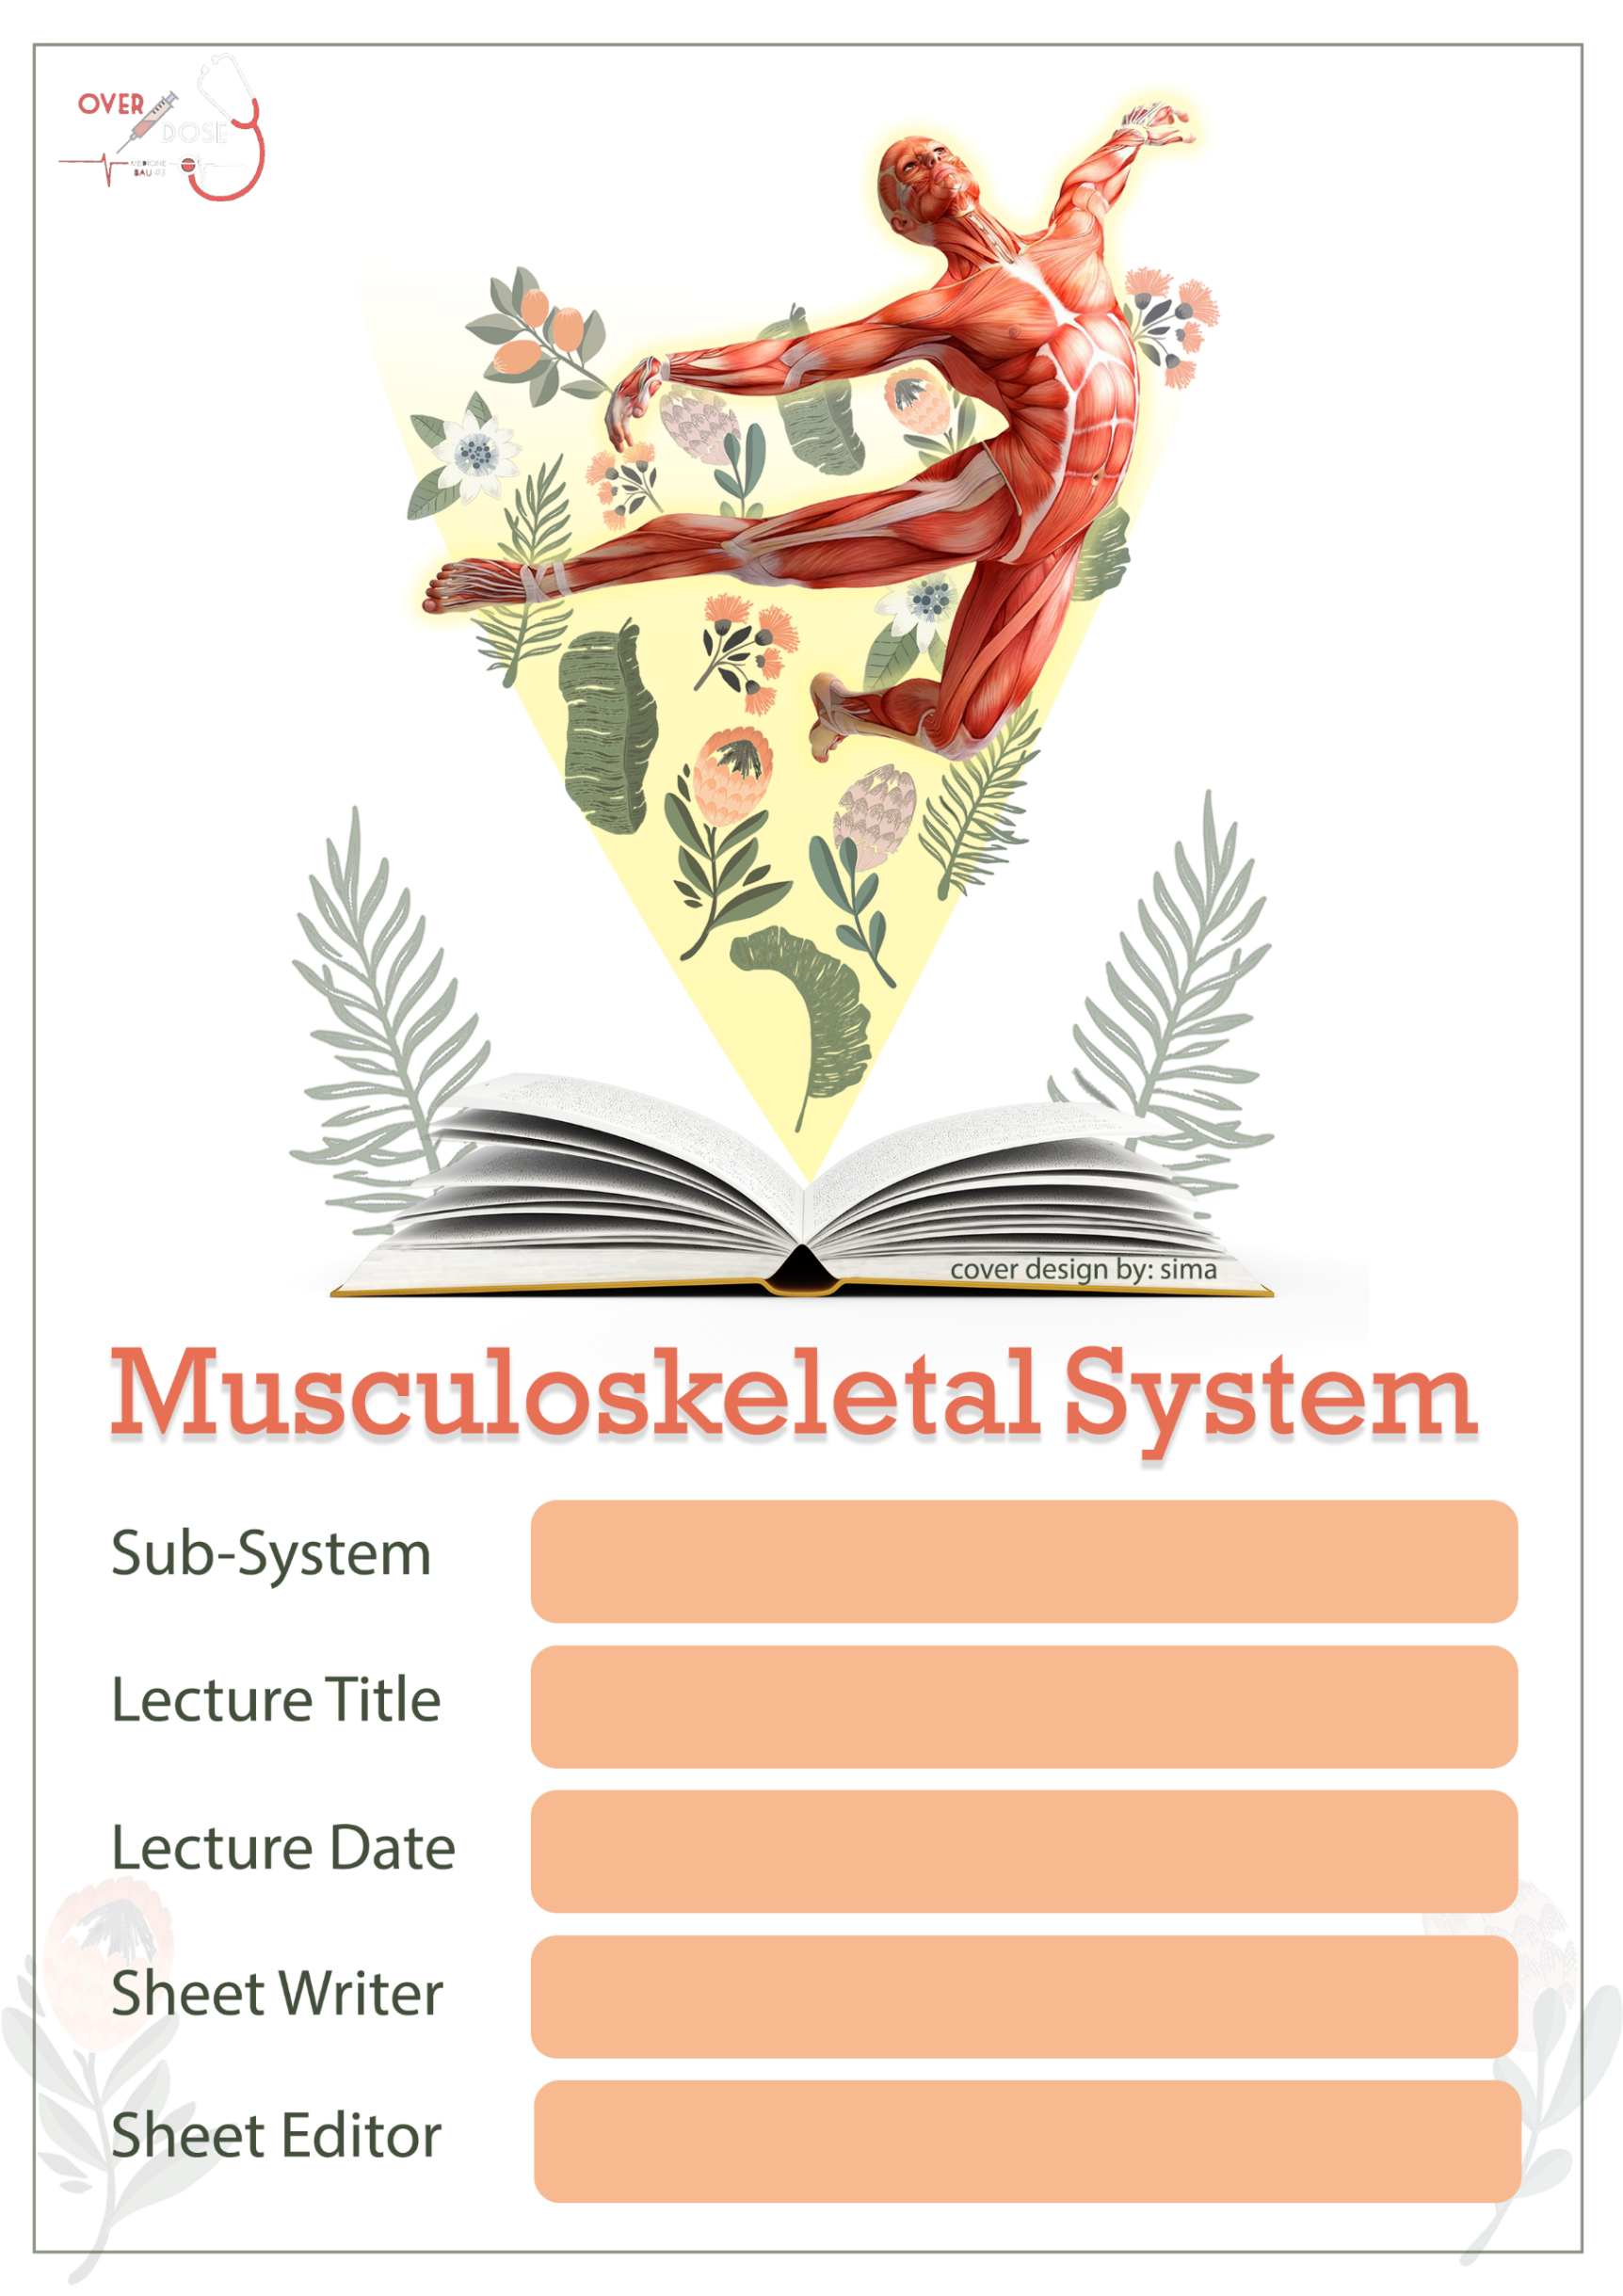

Anatomy – Lecture 21
Lower Limb – Part 4
9/10/2019
Ahmad Dabbour
Antoun Khabbaz

Sheet Correction Link: bit.ly/mssanatomy

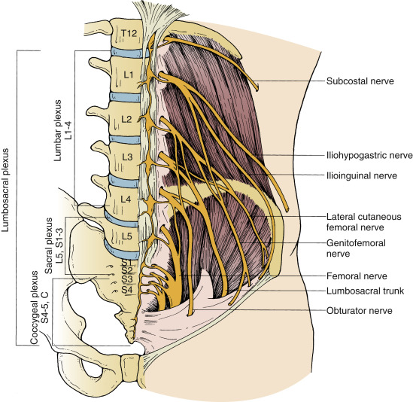
Nerves of the Anterior Compartment of the thigh:
# Lumbar Plexus:
-From ventral rami of L1,2,3 and part of the upper part of L4.
-Lies within the substance of psoas muscle.
-Gives branches that innervate:
*The lower limb.
*Muscles of the anterior abdominal wall.
*Skin of the external genitalia.
..............................
The branches of the lumbar plexus form the following nerves:
(1) Ilio-inguinal nerve (From L1).
(2) Ilio-hypogastric nerve (From L1) .
(3) Lateral cutaneous nerve of thigh (From L2, L3):
It passes over the iliacus muscle then medial to ASIS & below the inguinal ligament then passes to the lateral skin of the thigh.
# Clinical Notes:
(1) Heavy abdomen in the pregnant women and obese people may press the lateral cut. nerve of thigh leading to numbness on the area which innervated by this nerve.
(2) Appendix lies over the iliacus muscle on the right side of the body, and when it is inflamed (appendicitis), the fascia of the iliacus muscle will be affected. The patient will come to the clinic with flexion position on the hip joint (when he extends the joint, the iliacus muscle will be stretched leading to increase the pain by the lateral cut. nerve of the thigh.)

(4) Femoral nerve:
- Arises from lumber plexus (posterior divisions of L2,3,4 spinal nerves within psoas major).
- The main nerve supply for the anterior compartment.
- Passes along lateral border of psoas muscle (between iliopsoas muscles) deep to the inguinal ligament to enter the femoral triangle lateral to femoral artery and outside the femoral sheath.
- In the femoral triangle, it divides into:
- Anterior division:
Gives:
- Two muscular branches to sartorius and pectineus muscles (SP).
- Two cutaneous branches: medial and intermediate cutaneous nerves of the thigh.

- Posterior Division:
Gives:
- Muscular branches to quadriceps muscles.
- One cutaneous nerve: the saphenous nerve.
- Articular branches to hip and knee joints.

Femoral nerve

(3) Articular branches to:
- Knee and hip joints.
(2) Cutaneous branches to:
- anterior and medial side of the thigh by medial and intermediate branches, respectively.
(1) Muscular branches to:
- anterior compartment of the thigh (Quadriceps femoris).
- iliacus.
- Pectineus muscle (mainly) <sometimes it’s supplied by obturator nerve>.

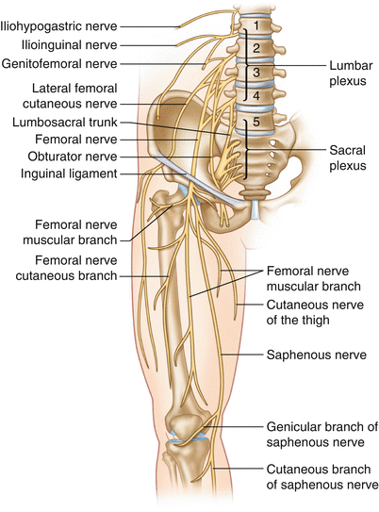
(5) Genito-femoral nerve (From L1, L2):
- It will give two branches:
- Femoral branch laterally to innervate the skin on the thigh.
- Genital branch medially to innervate the skin on the male and female genitalia (scrotum in men, mons pubis in women).

(6) Obturator nerve:
- Originates from anterior division of L2,3,4 to innervate the adductors passes medial to psoas muscle crosses the pelvis to pass through the obturator foramen (obturator canal) divides into anterior and posterior divisions as it reaches obturator externus muscle.

Obturator nerve
(3) Articular branches to:
- Knee and hip joints.
(2) Cutaneous branches to:
- innervate the skin over the upper medial aspect of thigh (which has its own reflex (obturator nerve reflex or maternal reflex).
(1) Muscular branches to:
- all adductor muscles except part of the adductor magnus muscle. (hamstring part).

# Remember that the lumbar plexus is formed by (L1,2,3 and upper part of L4) because the lower part of L4 will unite with L5 to form the (LumboSacral Trunk ) which is related to sacral plexus ,,, this trunk will pass above the ala of the sacrum.

Overview of the muscles of medial Compartment of the thigh :
- All originated from the pubic bone except 2 from ischium (in general ischio-pubic ramus, the doctor means inferior pubic ramus and ischial ramus).
- All inserted into linea aspera except for Gracilis muscle.
- All adduct the thigh at the hip joint.
- All supplied by profunda femoris and obturator arteries.
- All innervated by obturator nerve except the hamstring part of the adductor magnus by sciatic nerve.

- Muscles:
(1) adductor Longus :
- originated from inf. Pubic ramus.
- inserted into linea aspera.
- nerve supply by obturator nerve.
- action: adduction at the hip joint.
(2) adductor brevis :
- originated from Pubic-ischial ramus.
- inserted into linea aspera.
- nerve supply by obturator nerve.
- action: adduction at the hip joint.
(2) Hamstring part:
- originated from ischial tuberosity (all hamstring muscles originated from it).
- inserted into adductor tubercle.
# the space between the two insertions will form the adductor hiatus (which transfers the femoral vessels).
- nerve supply by sciatic nerve
- action: extension at the hip joint.

(3) adductor magnus : two parts :
(1) adductor part:
- originated from ischio-pubic ramus.
- inserted into lower 2\3 of linea aspera.
- nerve supply by obturator nerve
- action: adduction at the hip joint.

(4) Gracilis : (medial one )
- originated from body of pubic bone and inf. pubic ramus.
- inserted into SGS area on tibia (important).
- nerve supply by obturator nerve.
- action: adduction at the hip joint, flexion at the knee joint (because it crosses two joints it works on both of them.)
(5) Pectineus.
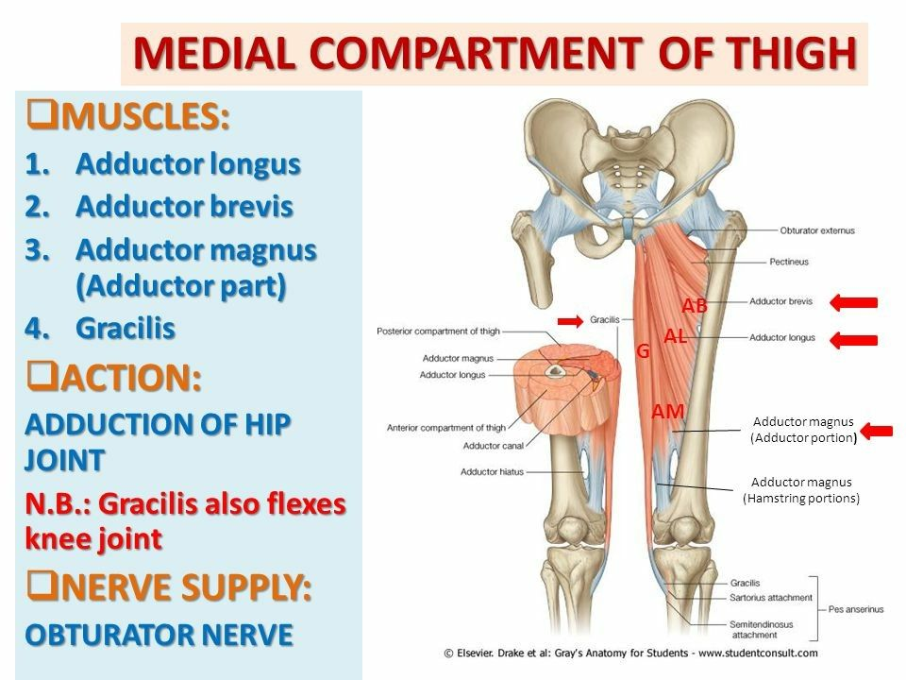

Gluteal Region:
- outer surface of the ilium is convex in shape and has 3 Gluteal lines (anterior, posterior and middle).

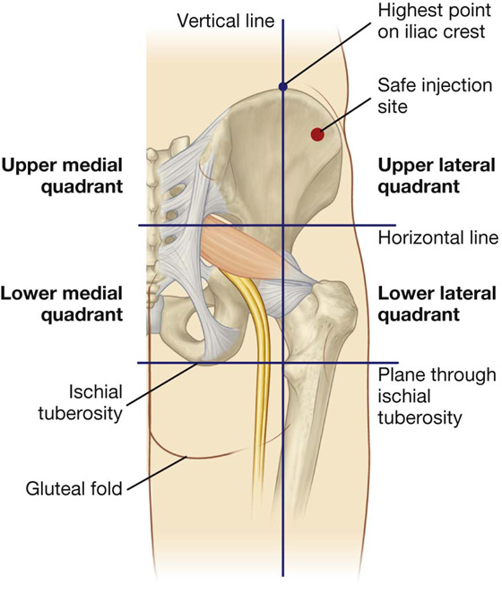
# Clinical Notes:
- the gluteal region can be divided into quadrants (upper lateral, upper medial, lower lateral, lower medial) by 2 imaginary lines positioned by palpable bony landmarks.
- Gluteal region is a typical site for an IM injection and this procedure must be carried out without injuring neurovascular structures (mainly sciatic nerve which passes through the Lower medial quadrant).
- The best place (safest) for this injection is the upper lateral quadrant (anterior corner): this region can be reached by putting your thumb at ASIS and the tip of the index postero-laterally where the gluteus medius muscle is found.
- In some obese women that have a large fatty gluteal region, you need to move posteriorly more than normal people for more safe injection.

The bulk of the gluteal region is formed by the largest muscle of the body: the gluteus maximus
- Origin: ilium, sacrum, coccyx.
- Insertion: upper 2\3 iliotibial tract.
Lower 1\3 gluteal tuberosity of proximal femur.
- nerve supply: inferior gluteal nerve (sacral plexus).
- action: extension & lateral rotation of the hip.
-Full extension (complete lock) of the knee with tensor fascia lata muscle (because both of them inserted into iliotibial tract).
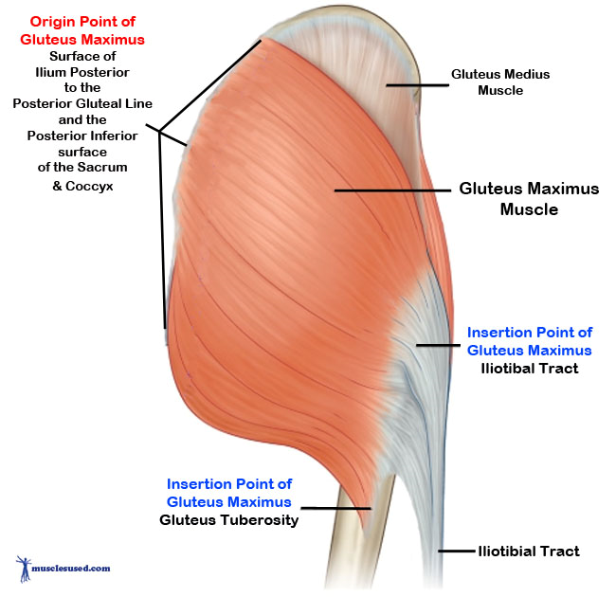

# Clinical Note:
- If the inf. gluteal nerve is cut, the patient will come to your clinic with medial rotation at the hip joint and a smaller gluteal maximus muscle (muscle atrophy).

THE END

