Lecutre two
THE BORDETELLAE

Dr. Hala Al- Daghistani

- Bordetella pertussis, a highly communicable and important pathogen of human, causes Whooping Cough (pertussis).
- Bordetella parapertussis can cause a similar disease.
- Bordetella bronchiseptica (Bordetella bronchicanis) causes diseases in animals, such as kennel cough in dogs and snuffles in rabbits, and only occasionally causes respiratory disease and bacteremia in human.

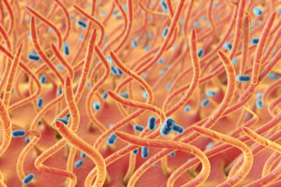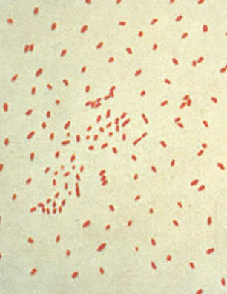

Bordetella pertussis
Morphology and Identification
A. Typical Organisms
- Gram-negative coccobacilli, bipolar metachromatic granules can be demonstrated.
- A capsule is present.

B. Culture
- Bordet-Gengou medium (potato-blood-glycerol agar)

C. Growth Characteristics
- Oxidase and catalase positive, hemolysis is associated with virulent B pertussis.

Antigenic Structure, Pathogenesis, and Pathology
- Pertactin (PRN) is a highly immunogenic virulence factor. It is an outer membrane protein that promotes adhesion to tracheal epithelial cells.
- Filamentous hemagglutinin and fimbriae mediate adhesion to ciliated epithelial cells and are essential for tracheal colonization.
- Pertussis toxin promotes lymphocytosis, sensitization to histamine, and enhanced insulin secretion and has adenosine diphosphate– ribosylating activity (activation of adenylate cyclase) . It is a Hexamer protein that consists of 6 subunits with 1A-5B structure. Toxin converted to toxoid.
- Dermonecrotic toxin
- Hemolysin
- Tracheal cytotoxin, inhibits DNA synthesis in ciliated cells
- Lipopolysaccharide in the cell wall may also be important in causing damage to the epithelial cells of the upper respiratory tract.
- The organism adheres to and multiplies rapidly on the epithelial surface of the trachea and bronchi and interferes with ciliary action.

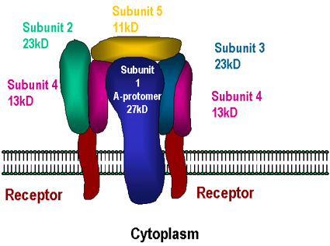

- The bacteria liberate the toxins and substances that irritate surface cells, causing coughing.
- Later, there may be necrosis of parts of the epithelium and polymorphonuclear infiltration, with peribronchial inflammation and interstitial pneumonia.
- Obstruction of the smaller bronchioles by mucous plugs results in atelectasis (reduce lung volume with inadequate O₂), and diminished oxygenation of the blood. This probably contributes to the frequency of convulsions in infants with whooping cough. The blood is not invaded by the bacteria.

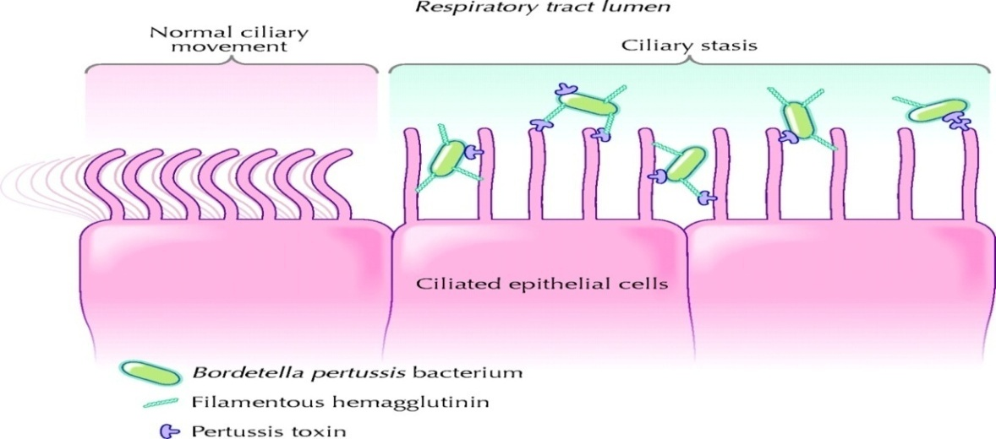
Clinical Findings
- Catarrhal stage develops, with mild coughing and sneezing. During this stage, large numbers of organisms are sprayed in droplets, and the patient is highly infectious but not very ill. In the catarrhal stage, the primary feature is a profuse and mucoid rhinorrhea that persists for 1 to 2 weeks. Nonspecific findings such as malaise, fever, sneezing, and anorexia may also be present.

- During the Paroxysmal stage, the cough develops its explosive character and the characteristic “whoop” upon inhalation. This leads to rapid exhaustion, vomiting, and cyanosis, and convulsions, lymphocytosis. The combination of mucoid secretions, whooping cough, and vomiting produces a miserable, exhausted child, not able to breath.

- During the 3- to 4-week Convalescent stage, the frequency and severity of paroxysmal coughing and other features of the disease gradually fade. Partially immune persons and infants under 6 months of age may not show all the typical features of pertussis.

The most common complication of pertussis is pneumonia caused by a superinfecting organism such as S. pneumoniae. other complications include, atelectasis, convulsions and subconjunctival or cerebral bleeding, are related to the venous pressure effects of the paroxysmal coughing and the anoxia produced by inadequate ventilation.

Diagnostic Laboratory Tests
A. Specimens
- A saline nasal wash is the preferred specimen. Nasopharyngeal swabs, or cough droplets expelled onto a “cough plate” .
- Polymerase chain reaction (PCR) is the most sensitive method to diagnosis pertussis.

Prevention
Multiple acellular pertussis vaccines are licensed .The vaccines have at least two of the following antigens: inactivated pertussis toxin, filamentous hemagglutinin, fimbrial proteins, and pertactin. Pertussis vaccine is usually administered in combination with toxoids of diphtheria and tetanus (DTaP).

Epidemiology and Control
- The source of infection is usually a patient in the early catarrhal stage of the disease. Communicability is high, ranging from 30–90%.

Bordetella parapertussis
This organism may produce a disease similar to whooping cough, but it is generally less severe. The infection is often subclinical.
B. parapertussis has a silent copy of the pertussis toxin gene.

Corynebacterium
- Corynebacterium species are members of the normal flora of skin and mucous membranes of humans
- Corynebacterium diphtheriae, an organism that produces a powerful exotoxin that causes diphtheria in humans
- Corynebacterium species and related bacteria tend to be clubbed or irregularly shaped

Corynebacterium diphtheria
Morphology & Identification
- Corynebacteria possess irregular swellings at one end that give them the "club-shaped" appearance
- Irregularly distributed within the rod (often near the poles) are granules staining deeply with aniline dyes (metachromatic granules) that give the rod a beaded appearance
- Individual corynebacteria in stained smears tend to lie parallel or at acute angles to one another .
- Four biotypes of C diphtheriae have been widely recognized:
- C. diphtheriae gravis
- C. diphtheriae mitis
- C. diphtheriae intermedius
- C. diphtheriae belfanti.
C. diphtheriae and other corynebacteria grow on Loeffler serum medium.
When some nontoxigenic diphtheria organisms are infected with bacteriophage, the offspring of the exposed bacteria are lysogenic and toxigenic, and this trait is subsequently hereditary.
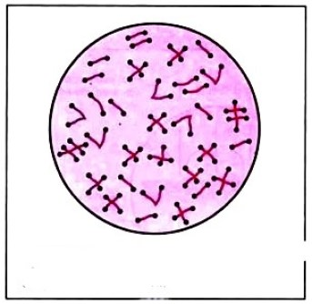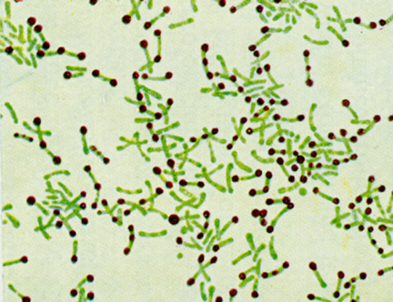
Pathogenesis
In nature, C. diphtheriae occurs in the respiratory tract (nose), in wounds, or on the skin of infected persons or as a normal flora. Corynebacterium diphtheriae was considered a member of the normal flora before the widespread use of the diphtheria toxoid, which is used to immunize against the disease.
- It is spread by droplets or by contact to susceptible individuals ; the bacilli then grow on mucous membranes or in skin abrasions, and those that are toxigenic start producing toxin. Diphtheria toxin is a heat-labile that can be lethal in a dose of 0.1 µg/kg. it consist of A, B fragment.
- Fragment A inhibits polypeptide chain elongation—by inactivating the elongation factor EF-2(similar to pseudomonas toxin).
- It arrest the protein synthesis and responsible for the necrotizing and neurotoxic effects of diphtheria toxin.
Pathology
- Bacteria multiply and necrotic epithelium becomes embedded in exuding fibrin and red and white cells, so that a grayish "pseudomembrane" is formed-commonly over the tonsils, pharynx, or larynx.
- The regional lymph nodes in the neck enlarge, and there may be marked edema of the entire neck.
- The diphtheria bacilli within the membrane continue to produce toxin actively. This is absorbed into the mucous membranes and causes destruction of epithelium and a superficial inflammatory response. Distant toxic damage includes, necrosis in heart muscle, liver, kidneys, and adrenals, sometimes accompanied by gross hemorrhage. The toxin also produces nerve damage, resulting often in paralysis of the eye muscles, or extremities.
In wound or skin diphtheria a membrane may form on an infected wound that fails to heal. However, absorption of toxin is usually slight and no systemic effects. C.diphtheriae does not need to be toxigenic to establish localized infection in the nasopharynx or skin

.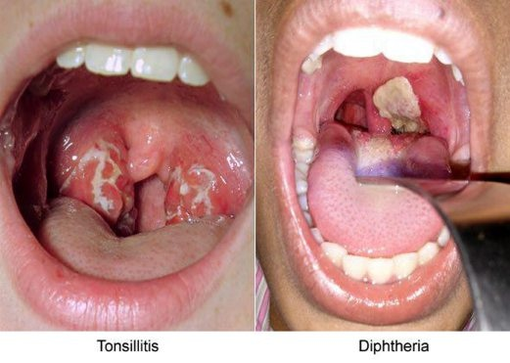
Clinical Findings
- Sore throat, fever, dyspnea follow because of the obstruction caused by the membrane.
- Irregularities of cardiac rhythm indicate damage to the heart.
- Difficulties with vision, speech, swallowing, or movement of the arms or legs.
A presumptive C diphtheriae isolate should be subjected to testing for toxigenicity. One of the method used for toxicity is Elek test
A filter paper disk containing antitoxin is placed on an agar plate. The cultures to be tested for toxigenicity are inoculated. After 48 hours of incubation, the antitoxin diffusing from the paper disk has precipitated the toxin diffusing from toxigenic cultures and has resulted in precipitin bands between the disk and the bacterial growth. This is the modified Elek method
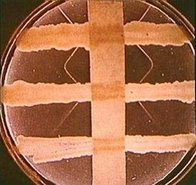

Epidemiology, Prevention, & Control
- Before artificial immunization, diphtheria was mainly a disease of small children.
- By age 6–8 years, approximately 75% of children in developing countries where skin infections with C. diphtheriae are common have protective serum antitoxin levels. Absorption of small amounts of diphtheria toxin from the skin infection presumably provides the antigenic stimulus for the immune response
- Active immunization in childhood with diphtheria toxoid (DTaP) yields antitoxin levels that are generally adequate until adulthood

