Endocrinal Physiology
Pituitary gland (hypophysis)
Pituitary gland is connected to the hypothalamus by the pituitary (or hypophysial) stalk.
Physiologically, the pituitary gland is divisible into two distinct portions:
The anterior pituitary, also known as the adenohypophysis,
The posterior pituitary, also known as the neurohypophysis.
Between these is a small, relatively avascular zone called the pars intermedia, which is much less developed in the human being but is larger and much more functional in some lower animals.
Hypothalamus Controls Pituitary Secretion
Almost all secretion by the pituitary is controlled by either hormonal or nervous signals from the hypothalamus. Indeed, when the pituitary gland is removed (Hypophysectomy) from its normal position beneath the hypothalamus and transplanted to some other part of the body, its rates of secretion of the different hormones (except for prolactin) fall to very low levels.
Secretion from the posterior pituitary is controlled by nerve signals that originate in the hypothalamus and terminate in the posterior pituitary. The bodies of the cells that secrete the posterior pituitary hormones are not located in the pituitary gland itself but are large neurons, called magnocellular neurons, located in the supraoptic and paraventricular nuclei of the hypothalamus. The hormones are then transported in the axoplasm of the neurons’ nerve fibers passing from the hypothalamus to the posterior pituitary gland.
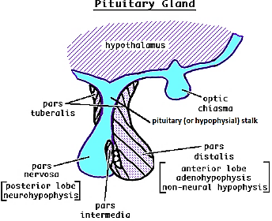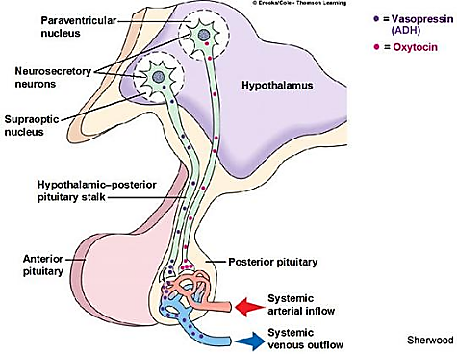
In contrast, secretion by the anterior pituitary is controlled by hormones called hypothalamic releasing and hypothalamic inhibitory hormones (or factors) secreted within the hypothalamus and then conducted, to the anterior pituitary through minute blood vessels called Hypothalamic-hypophysial portal vessels. In the anterior pituitary, these releasing and inhibitory hormones act on the glandular cells to control their secretion.
About 30 to 40 percent of the anterior pituitary cells are somatotropes that secrete growth hormone, and about 20 percent are corticotropes that secrete ACTH.
Each of the other cell types accounts for only 3 to 5 percent of the total; Somatotropes stain strongly with acid dyes and are therefore called acidophils

Hypothalamic hormone | Pituitary cell | Pituitary hormone | Organ
Growth hormone–releasing hormone (GHRH), which causes release of growth hormone, and growth hormone inhibitory hormone (GHIH), also called somatostatin, which inhibits release of growth hormone | Somatotrope | human growth hormone (hGH) | Total body
Corticotropin releasing hormone (CRH) | Corticotropes | Adreno-cortico-tropin hormone (ACTH) | Adrenal cortex
Thyrotropin-releasing hormone (TRH) | Thyrotropes | thyroid-stimulating hormone (TSH) | Thyroid gland
Gonadotropin-releasing hormone (GnRH) | Gonadotrope | luteinizing hormone (LH) and  follicle-stimulating hormone (FSH) | gonads
Prolactin inhibitory hormone (PIH) found to be dopamine inhibit prolactin production  thyrotropin-releasing hormone (TRH) that stimulate prolactin production | Lactotropes | prolactin (PRL) | Brest
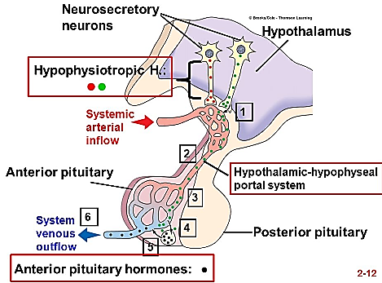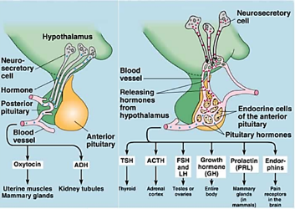
Growth hormone
Growth hormone, also called somatotropic hormone or somatotropin, is a small protein molecule that contains 191 amino acids in a single chain and has a molecular weight of 22,005.
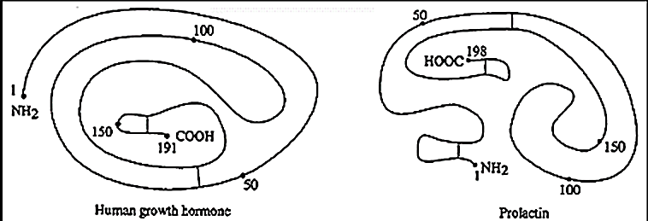
Growth hormone and prolactin show about 25% sequences identity
Growth Hormone Effects:
Growth Hormone metabolic effects
Aside from its general effect in causing growth, growth hormone has multiple specific metabolic effects, including
(1) Growth hormone increase rate of protein synthesis in most cells of the body
(2) Growth hormone enhances fat utilization for energy
Excessive Growth Hormone causes excessive mobilization of fat from the adipose tissue which has causes “Ketogenic” Effect this lead to:
Large quantities of aceto-acetic acid are formed by the liver and released into the body fluids, thus causing ketosis
Frequently causes a fatty liver.
Therefore,
Under the influence of growth hormone, fat is used for energy in preference to the use of carbohydrates and proteins.
Growth hormone’s ability to promote fat utilization, together with its protein anabolic effect, causes an increase in lean body mass (mean free fat body mass).
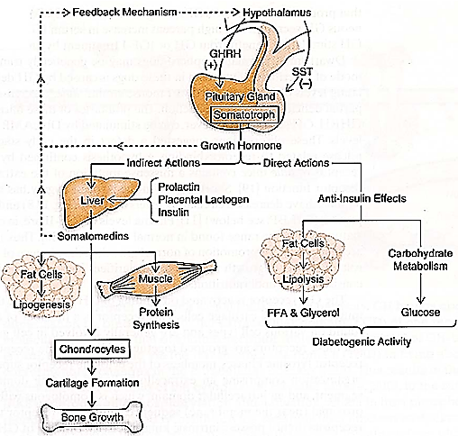
(3) Growth hormone decreased rate of glucose utilization throughout the body.
Growth hormone causes multiple effects that influence carbohydrate metabolism, including
(1) decreased glucose uptake in tissues such as skeletal muscle and fat,
(2) Increased glucose production by the liver
(3) Increased insulin secretion.
For these reasons,
Growth hormone’s effects are called diabetogenic, and excess secretion of growth hormone can produce metabolic disturbances similar to those found in patients with type II (non-insulin-dependent) diabetes, who are also resistant to the metabolic effects of insulin.
Growth hormone fails to cause growth in animals that lack a pancreas; it also fails to cause growth if carbohydrates are excluded from the diet. This shows that adequate insulin activity and adequate availability of carbohydrates are necessary for growth hormone to be effective.
Growth Hormone effect on Cartilage and Bone Growth
Growth Hormone causes growth of almost all tissues of the body that are capable of growing.
Growth Hormone most obvious effect is to increase growth of the skeletal frame.
This results from multiple effects of growth hormone on bone, including
(1) Increase deposition of protein by the chondrocytic and osteogenic cells that cause bone growth,
(2) Increase rate of reproduction of chondrocytic and osteogenic cells
(3) A specific effect of converting chondrocytes into osteogenic cells, thus causing deposition of new bone.
There are two principal mechanisms of bone growth.
First, Lengthening of Long Bones: in response to growth hormone stimulation, the long bones grow in length at the epiphyseal cartilages, where the epiphyses at the ends of the bone are separated from the shaft by epiphyseal plate.
This growth first cause’s deposition of new cartilage, followed by its conversion into new bone, thus 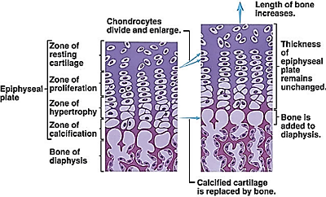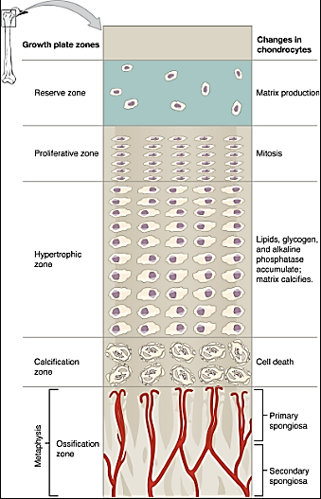
The epiphyseal plate is divided into five zones that, while distinct, all merge together. The zones are:
1. Zone of resting cartilage (or Zone of reserve cartilage)
It consists of
chondroblasts and chondrocytes that are at rest (they’re not undergoing mitosis or secreting matrix
a network of capillaries that supply oxygen and nutrients to the chondrocytes of the epiphyseal plate
2. Zone of proliferating cartilage (or Zone of proliferation)
It consists of chondrocytes that are undergoing mitosis so zone allows for the constant production of chondrocytes to replace those that are dying and being replaced by bone in the diaphyseal zones
The chondrocytes
Line up in columns
Proliferate
Produce cartilage matrix
Chondrocyte increase in number + Production of cartilage matrix increase in thickness
3. Zone of maturing cartilage (or Zone of maturation and hypertrophy)
The chondrocytes gradually increase in size
The chondrocytes (proliferation + hypertrophy) and Production of cartilage matrix

The chondrocytes pushed towards the diaphysis
4. Zone of calcification
The cartilage matrix becomes calcified inhibiting the diffusion of nutrients the dying chondrocytes removed the dying chondrocytes and calcified cartilage matrix by osteoclast leaving longitudinal empty lacunae (cavity) of calcified cartilage
5. Zone of ossification
Osteoblasts cells migrate into the cavities with the new blood vessels. New bone forms on the scaffold of calcified cartilage
Remember that this happens at both ends of the diaphysis, so, in effect, the epiphyseal plates are being pushed away from each other by a bony diaphysis that is increasing in length as a result of the replacement of cartilage.
Epiphyseal plate is found in children and adolescents; in adults, who have stopped growing. Epiphyseal plate is replaced by an epiphyseal line. This replacement is known as epiphyseal closure.
As soon as bony fusion occurs between the shaft and the epiphysis at each end, so no further lengthening of the long bone can occur.
Flat bone for instance, the jaw bones can be stimulated to grow even after adolescence, causing forward protrusion of the chin and lower teeth. Likewise, the bones of the skull can grow in thickness and give rise to bony protrusions over the eyes.
لايمكن زيادة الطول بعد الوصول للطول النهائي في عمر البلوغ بسبب ان نهايات العظم تقفل epiphyseal plate closer
يستثنى من ذلك العظام المسطحة لان ليس لديها epiphyseal plate
Epiphyseal plate sometime called growth plate or epiphyseal growth plate
Second, Thickening of Long Bones; the increase in diameter is called appositional growth:
Osteoblasts in the periosteum (covers the outside of bones) form compact bone around the external bone surface. At the same time, osteoclasts in the endosteum (lines the inner surface of the medullary cavity) break down bone on the internal bone surface, around the medullary cavity. These two processes together increase the diameter of the bone and, at the same time, keep the bone from becoming excessively heavy and bulky.
Growth hormone strongly stimulates osteoblasts. Therefore, the bones can continue to become thicker throughout life under the influence of growth hormone; this is especially true for the membranous bones.
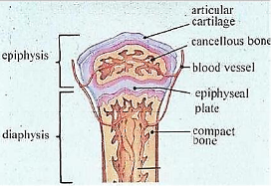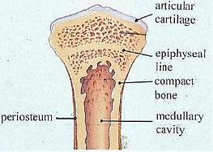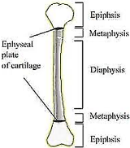
Growth Hormone exerts much of its effect through intermediate substances called “Somatomedins” (Also Called “Insulin-Like Growth Factors”)
Growth hormone causes the liver (and, to a much less extent, other tissues) to form several small proteins called somatomedins that have the potent effect of increasing all aspects of bone growth.
Many of the somatomedin effects on growth are similar to the effects of insulin on growth. Therefore, the somatomedins are also called insulin-like growth factors (IGFs: somatomedin A, which is another name for insulin-like growth factor 2 (IGF-2)
Somatomedin C another name is insulin-like growth factor 1(IGF-1)
Somatomedin C (IGF-1) molecular weight is about 7500
Somatomedin C (IGF-1) concentration in the plasma closely follows the rate of growth hormone secretion.
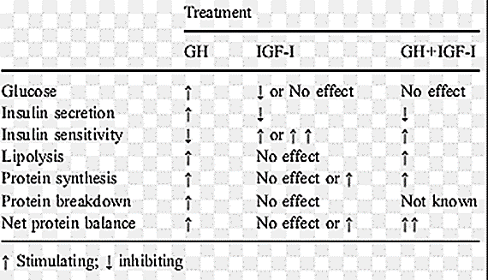
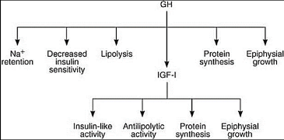
Growth hormone attaches only weakly to the plasma proteins in the blood. Therefore, it is released from the blood into the tissues rapidly, having a half-time in the blood of less than 20 minutes. By contrast, somatomedin C (IGF-1) attaches strongly to a carrier protein in the blood that, like somatomedin C (IGF-1), is produced in response to growth hormone. As a result, somatomedin C (IGF-1) is released only slowly from the blood to the tissues, with a half-time of about 20 hours. This greatly prolongs the growth-promoting effects of the bursts of growth hormone secretion. It has been postulate that most, if not nearly all of the growth effect of GH results from somatomedin C (IGF-1) and other somatomedins, rather than from direct effects of growth hormone on the bone and other tissues.
Somatomedin C (IGF-1) has insulin like effect
Growth hormone release is episodic and pulsatile (regular release)
Plasma Growth hormone levels may change as much as 10fold within minutes.
Diurnal variations in growth hormone secretion superimposed on these developmental stages.
Growth hormone is found at relatively low levels during the day, unless specific triggers for its release are present.
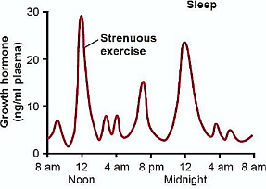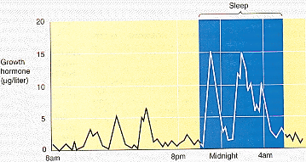

During sleep, on the other hand, large pulsatile bursts of growth hormone secretion occur. One of the largest increases occur shortly after the onset of sleep.
The stimulator of Growth hormone secretion is Growth Hormone Releasing Hormone (GHRH)
Growth Hormone Releasing Hormone (GHRH) increases slow wave sleep and feeding behavior.
Role of the Hypothalamus, Growth Hormone–Releasing Hormone, and Somatostatin in Controlling Growth Hormone Secretion
It is known that growth hormone secretion is controlled by two factors secreted in the hypothalamus and then transported to the anterior pituitary gland through the hypothalamic-hypophysial portal vessels. They are growth hormone–releasing hormone (GHRH) and growth hormone inhibitory hormone (also called somatostatin). Both of these are polypeptides; GHRH is composed of 44 amino acids, and somatostatin is composed of 14 amino acids.
Regulation of growth hormone secretion
(1) Hypothalamic control:
• Growth Hormone Releasing Hormone (GHRH) stimulates the synthesis and secretion of growth hormone.
• Ghrelin.
The main site of ghrelin synthesis and secretion is the stomach, but it is also produced in the hypothalamus and has marked growth hormone-stimulating activity.
Ghrelin appears to be involved in the regulation of food intake.
• Somatostatin inhibits secretion of growth hormone by blocking the response of the anterior pituitary to GHRH.
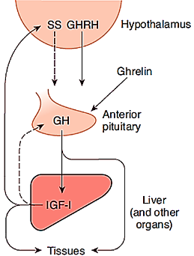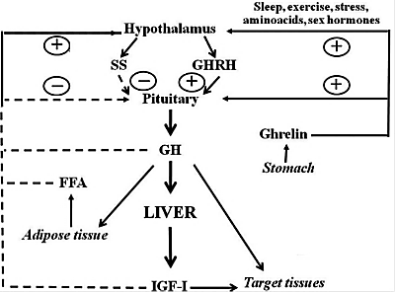
(2) Negative feedback control by somatomedin C (or Insulin like growth Factor-I: IGF-I)
• Somatomedins inhibit the secretion of growth hormone
By acting directly on the anterior pituitary
By stimulating the secretion of somatostatin from the hypothalamus.
(3) Negative feedback control by GHRH and growth hormone
• GHRH inhibits its own secretion from the hypothalamus.
• Growth hormone also inhibits its own secretion by stimulating the secretion of somatostatin from the hypothalamus.
Several factors related to a person’s state of nutrition or stress is known to stimulate secretion
Stimulate Growth Hormone Secretion | Inhibit Growth Hormone Secretion
1. Decreased blood glucose | 1. Increased blood glucose
2. Decreased blood free fatty acids | 2. Increased blood free fatty acids
3.Increased blood amino acids (arginine) | 3. Growth hormone (exogenous)
4. Growth hormone–releasing hormone | 4. Aging
5.Starvation or fasting, protein deficiency | 5. Obesity
6.Ghrelin | 6.Growth hormone inhibitory hormone (somatostatin)
7.Trauma, stress, excitement | 7.Somatomedins (insulin-like growth factors)
8.Exercise
9.Testosterone, estrogen
10.Deep sleep (stages II and IV)
Abnormalities of Growth Hormone Secretion
Pan-hypo-pituitarism.
This term means decreased secretion of all the anterior pituitary hormones.
Dwarfism.
Most instances of dwarfism result from generalized deficiency of anterior pituitary secretion (panhypopituitarism) during childhood. In general, all the physical parts of the body develop in appropriate proportion to one another, but the rate of development is greatly decreased.
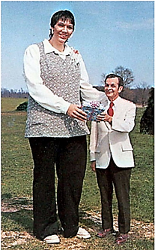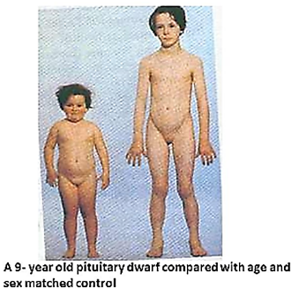
Gigantism.
Occasionally, the acidophilic, become excessively active. As a result, large quantities of growth hormone are produced.
All body tissues grow rapidly, including the bones.
The giant ordinarily has hyperglycemia
Acromegaly.
If an acidophilic tumor occurs after adolescence the person cannot grow taller, but the bones can become thicker and the soft tissues can continue to grow. This condition is known as acromegaly.
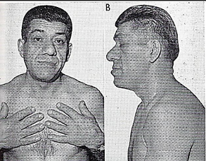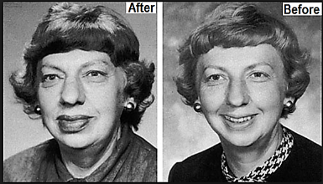
Enlargement is especially marked in the Bones of the Hands (spade-like hand) Feet
Thicken and increase size in the membranous bones, including the cranium, nose bosses on the forehead, supraorbital ridges lower jawbone
Changes in many soft tissue organs, such as the tongue, heart, liver, and especially the kidneys, become greatly enlarged.
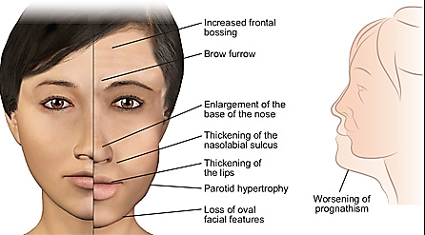
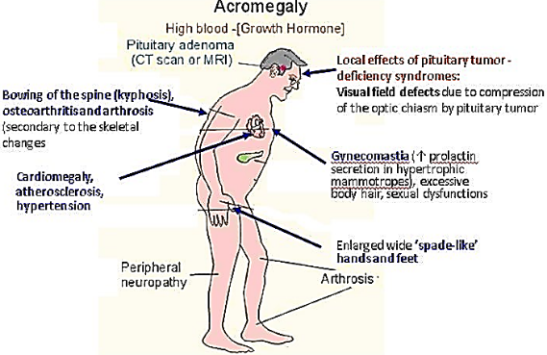
Physiology of growth
Growth period:
In human, there are two periods of rapid growth:
The first in infancy: is partly a continuation of the fetal growth period.
The second in late puberty just before growth stops: is due to hormonal cause and the subsequent cessation is due in part to closer of the epiphyses by (estrogen, testosterone).
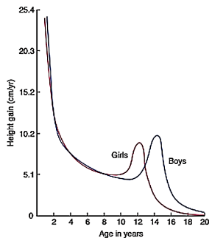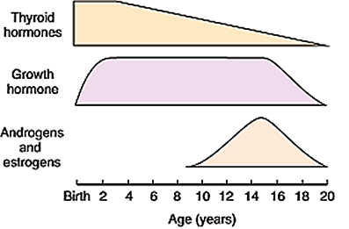
Since girls mature earlier than boys, this growth spurt appears earlier in girls. Of course, in both sexes the rate of growth of individual tissue varies.
The factors affecting growth including:
1. Genetic effects:
2. Nutrition effects: The food supply is the most important extrinsic factor affecting growth.
3. Hormonal effects:
The hormones affecting growth are:
Growth hormone:
Sex hormones:
Although androgen and estrogen initially stimulate growth, estrogen ultimately terminate growth by causing the epiphyses to fuse to the long bones (epiphysial colures).
Thyroid hormone:
Thyroid hormone effect is permissive to that of growth hormone
Insulin: affect growth through the effects of insulin on protein metabolism.
Adreno- cortical hormones:
Prolactin Hormone
Although estrogen and progesterone are essential for the physical development of the breasts during pregnancy, a specific effect of both these hormones is to inhibit the actual secretion of milk.
Conversely, the hormone prolactin has exactly the opposite effect on milk secretion—promoting it.
This hormone is secreted by the mother’s anterior pituitary gland, and its concentration in her blood rises steadily from the fifth week of pregnancy until birth of the baby, at which time it has risen to 10 to 20 times the normal non-pregnant level.
After birth of the baby, the basal level of prolactin secretion returns to the non-pregnant level over the next few weeks. However, each time the mother nurses her baby, nervous signals from the nipples to the hypothalamus (during child milk suckling) causes a 10- to 20-fold surge in prolactin secretion that lasts for about 1 hour. This prolactin acts on the mother’s breasts to keep the mammary glands secreting milk into the alveoli for the subsequent nursing periods. If this prolactin surge تدفق is absent or blocked as a result of hypothalamic or pituitary damage or if nursing does not continue, the breasts lose their ability to produce milk within 1 week or so. However, milk production can continue for several years if the child continues to suckle, although the rate of milk formation normally decreases considerably after 7 to 9 months
a. Regulation of prolactin secretion
(1) Hypothalamic control by dopamine and thyrotropin-releasing hormone (TRH)
• Prolactin secretion is tonically inhibited by dopamine [previously called prolactin inhibiting factor (PIF)] secreted by the hypothalamus. Thus, interruption of the hypothalamic-pituitary tract causes increased secretion of prolactin and sustained lactation. TRH increases prolactin secretion.
(2) Negative feedback control
• Prolactin inhibits its own secretion by stimulating the hypothalamic release of dopamine.
b. Actions of prolactin
(1) Stimulates milk production in the breast.
(2) Stimulates breast development (in a supportive role with estrogen)
(3) Inhibits ovulation by decreasing synthesis and release of gonadotropin releasing hormone (GnRH)
(4) Inhibits spermatogenesis (by decreasing GnRH)
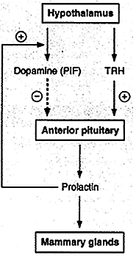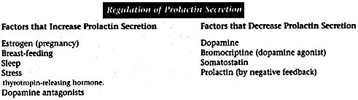
c. Patho-physiology of prolactin
(1) Prolactin deficiency (destruction of the anterior pituitary)
• Results in the failure to lactate.
(2) Prolactin excess
• Results from hypothalamic destruction (due to loss of the tonic "inhibitory" control by dopamine), or from prolactin-secreting tumors (prolactinomas).
• causes galactorrhea (Galactorrhea is the spontaneous flow of milk from the breast, unassociated with childbirth or nursing) and decreased libido.
• causes failure to ovulate and amenorrhea because it inhibits GnRH secretion
• can be treated with bromocriptine, which reduces prolactin secretion by acting as a dopamine agonist
Pituitary Intermediate-lobe
Intermediate-lobe cells and corticotropes of the anterior lobe both synthesize a large precursor protein that is cleaved to form a family of hormones. After removal of the signal peptide, this prohormone is known as pro-opio-melano-cortin (POMC). This molecule is also synthesized in the hypothalamus, the lungs, the gastrointestinal tract, and the placenta.
In corticotropes, it is hydrolyzed to ACTH and a polypeptide of unknown function called β -lipotropin (LPH), plus a small amount of β-endorphin, and these substances are secreted. In the intermediate lobe cells, POMC is hydrolyzed to corticotropin-like intermediate-lobe peptide (CLIP), γ- LPH, and appreciable quantities of β-endorphin. ACTH will hydrolyzes to CLIP and α-MSH indicated similarity in structure between ACTH and α-MSH
The functions, if any, of CLIP and γ-LPH are unknown, whereas β-endorphin is an opioid that has the five amino acid residues of met-enkephalin at its amino terminal end. The melanotropins α- and β-MSH are also formed. However, the intermediate lobe in humans is rudimentary, and it appears that neither α -MSH nor β-MSH is secreted in adults.
In some animals, an intermediate “lobe” of the pituitary gland, called the pars intermedia, is highly developed, lying between the anterior and posterior pituitary lobes. This lobe secretes an especially large amount of MSH. Furthermore, this secretion is independently controlled by the hypothalamus in response to the amount of light to which the animal is exposed or in response to other environmental factors. For instance, some arctic القطب الشماليanimals develop darkened fur in the summer and yet have entirely white fur in the winter.
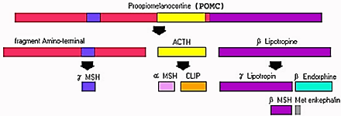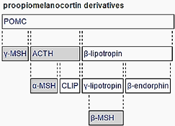
Posterior pituitary gland and its relation to the hypothalamus
If the pituitary stalk is cut above the pituitary gland but the entire hypothalamus is left intact, the posterior pituitary hormones continue to be secreted normally, after a transient decrease for a few days; they are then secreted by the cut ends of the fibers within the hypothalamus and not by the nerve endings in the posterior pituitary. The reason for this is that the hormones are initially synthesized in the cell bodies of the supraoptic and paraventricular nuclei and are then transported in combination with “carrier” proteins called neurophysins down to the neurohypophysis through the pituitary stalk (hypophysial stalk). The nerve endings are bulbous knobs that contain many secretory granules.
When nerve impulses are transmitted downward along the fibers from the supraoptic or paraventricular nuclei, the hormone is immediately released from the secretory granules in the nerve endings by the usual secretory mechanism of exocytosis and is absorbed into adjacent capillaries. Both the neurophysin and the hormone are secreted together, but because they are only loosely bound to each other, the hormone separates almost immediately. The neurophysin has no known function after leaving the nerve terminals.
The endings lie on the surfaces of capillaries, where they secrete two posterior pituitary hormones:
ADH is formed primarily in the supraoptic nuclei
Oxytocin is formed primarily in the paraventricular nuclei.
Each of these nuclei can synthesize about one sixth as much of the second hormone as of its primary hormone.
Both ADH and oxytocin are considered as a type of neuroendocrine hormones
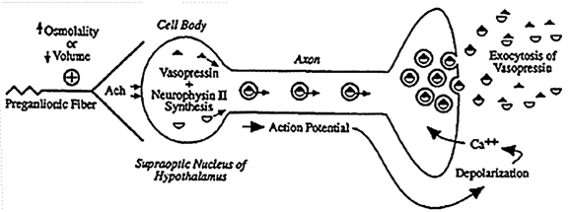
Chemical Structures of Antidiuretic Hormone and Oxytocin
Both oxytocin and ADH (vasopressin) are polypeptides and may acts as neurotransmitters, each containing nine amino acids.
Note that these two hormones are almost identical except that in vasopressin, phenylalanine (3) and arginine (8) replace isoleucine and leucine of the oxytocin molecule.
The similarity of the molecules explains their partial functional similarities.
Their amino acid sequences are the following:
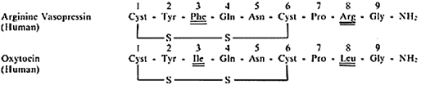
Physiological Functions of Antidiuretic Hormone
The injection of extremely minute quantities of ADH (as small as 2 nano-grams) can cause decreased excretion of water by the kidneys (anti-diuresis: decrease urine volume, or reducing urination).
Factors stimulate the release of vasopressin are:
Angiotensin II,
Sympathetic stimulation,
Hyper-osmolarity (through osmo-receptors in the hypothalamus)
An increase in plasma osmolality is the principal physiological stimulus for vasopressin secretion.
Hypovolemia, Hypotension
Severe hypovolemia/hypotension also is a powerful stimulus for vasopressin release.
In addition, Hypoglycemia, pain, nausea, Nicotine, opiates, antineoplastic drugs and hypoxia can stimulate vasopressin secretion
Factors inhibits the release of vasopressin are:
Decrease serum osmolarity
Ethanol
Alpha-agonists
Atrial natriuretic peptide
Atrial receptors respond to a decrease in blood volume or blood pressure and osmo-receptors in hypothalamus respond to a decrease in blood osmolarity both cause the release of vasopressin from the posterior pituitary.
Increased extracellular fluid osmolarity stimulates antidiuretic hormone secretion.
Significant changes in secretion occur when osmolality is changed as little as 1 % from normal
When a concentrated electrolyte solution is injected into the artery that supplies the hypothalamus, or
When the extracellular fluid becomes too concentrated
▼
Fluid is pulled by osmosis out of the osmo-receptor cell
▼
Increasing the ADH secretionوالعكس ايضا صحيح))

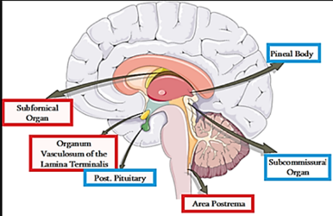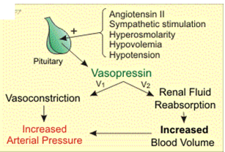
Although some researchers place these osmo-receptors in the hypothalamus itself (possibly even in the supra-optic nuclei), others believe that they are located in the organum vasculosum a highly vascular structure in the antero-ventral wall of the third ventricle and lacks a blood brain barrier.
Low blood volume and low blood pressure stimulate ADH secretion (vasoconstrictor Effects of ADH):
Decreased blood volume 15 to 25 percent or more
▼
Atria have stretch receptors will be unexcited
(Note: the atria have stretch receptors are excited by overfilling)
▼
Signals to the brain to stimulate ADH secretion
والعكس ايضا صحيح))

Minute concentrations of ADH Higher concentrations of ADH
▼ ▼
↑ Water conservation by the kidneys have a potent effect of constricting the arterioles
▼ ▼
↑ Systolic pressure ↑diastolic pressure
For this reason, ADH has another name, vasopressin (vaso: vasoconstriction: pressin: pressure)
Changes in plasma osmolarity is more potent than changes in blood volume to affect ADH secretion
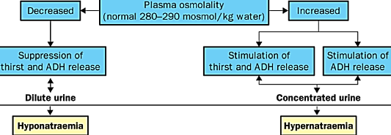
Oxytocin Hormone
Regulation of oxytocin secretion:
1) Suckling
• is the major stimulus for oxytocin secretion.
• Afferent fibers carry impulses from the nipple to the spinal cord. Relays in the hypothalamus trigger the release of oxytocin
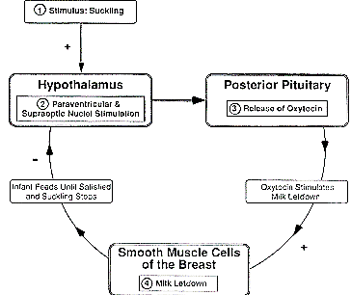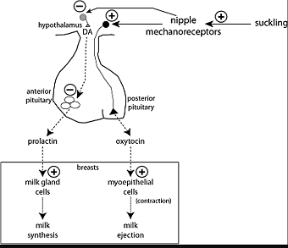
2) Dilation of the cervix and orgasm
• increase the secretion of oxytocin.
Effects of oxytocin
Oxytocin is now believed to be involved in a wide variety of physiological and pathological functions such as sexual activity, penile erection, ejaculation, pregnancy, uterine contraction, milk ejection, maternal behavior, social bonding, stress and probably many more, this why sometimes is call “Love hormone” or "cuddle عناقhormone"
The hormone oxytocin, in accordance with its name, powerfully stimulates contraction of the pregnant uterus, especially toward the end of gestation. Therefore, many obstetricians believe that this hormone is at least partially responsible for causing birth of the baby.
The sensitivity of the uterine musculature to oxytocin is enhanced by estrogen and inhibited by progesterone.
In late pregnancy, the uterus becomes very sensitive to oxytocin coincident with a marked increase in the number of oxytocin receptors
Oxytocin secretion is increased during labor.
After dilation of the cervix, descent of the fetus down the birth canal initiates impulses in the afferent nerves that are relayed to the supraoptic and paraventricular nuclei, causing secretion of sufficient oxytocin to enhance labor
Oxytocin may also act on the non-pregnant uterus to facilitate sperm transport.
Circulating oxytocin increases at the time of ejaculation in males, and it is possible that this increase causes increased contraction of the smooth muscle of the vas deferens, propelling sperm toward the urethra.
Oxytocin Aids in Milk Ejection by the Breasts.
In lactation, oxytocin causes milk to be expressed from the alveoli into the ducts of the breast so that the baby can obtain it by suckling. This mechanism works as follows: The suckling stimulus on the nipple of the breast causes signals to be transmitted through sensory nerves to the oxytocin neurons in the paraventricular and supraoptic nuclei in the hypothalamus, which causes release of oxytocin by the posterior pituitary gland. The oxytocin is then carried by the blood to the breasts, where it causes contraction of myoepithelial cells that lie outside of and form a latticework surrounding the alveoli of the mammary glands. In less than a minute after the beginning of suckling, milk begins to flow.
• Oxytocin can be used to
Induce labor and
Reduce postpartum bleeding.

Thyroid Hormones
Thyroid Hormones have slow onset and long duration of action.
 | latent period | Maximum activity | half-life
triiodothyronine | 6 to 12 hour | 2 to 3 days | 1 day
thyroxine | 2 to 3 days | 10 to 12 days | 5 to 7 days
The actions of triiodothyronine occur about four times as rapidly as those of thyroxine
Some of the thyroxine activity persists for as long as 6 weeks to 2 months.
Most of the latency and the prolonged period of action of these hormones are probably caused by their binding with proteins both in the plasma and in the tissue cells, followed by their slow release.
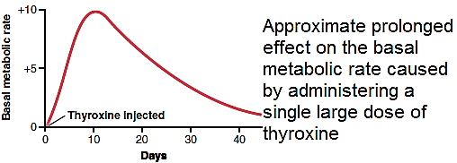
Thyroid Hormones Activate Nuclear Receptors
1) T3 and T4 are lipid soluble proteins and can cross the cell membrane of the target cells easily
2) Before acting on the genes to increase genetic transcription, one iodide is removed from almost all the thyroxine, thus forming triiodothyronine by (D2 deiodinase).
3) Intracellular thyroid hormone receptors have tenfold affinity for T3 than they have to T4, for that T3 is much more potent than T4.
Consequently, more than 90 percent of the thyroid hormone molecules that bind with the receptors is triiodothyronine.
3) Thyroid hormones have intra-cellular effects
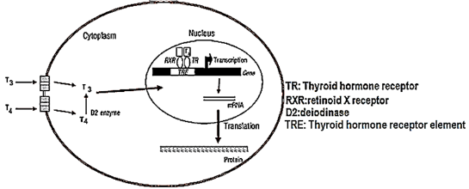
A. genomic cellular effects (Slow effect: hours to days)
The thyroid hormone receptor (TR) usually forms a heterodimer with retinoid X receptor (RXR) at specific thyroid hormone response elements (TRE) on the DNA.
Retinoid X receptor become activated and initiate the transcription process.
Large numbers of different types of messenger RNA are then formed, followed within another few minutes or hours by RNA translation on the cytoplasmic ribosomes to form hundreds of new intracellular proteins.
B. Non-genomic cellular effects (Fast effect: minutes)
Non-genomic thyroid hormone action have been described in several tissues, including the heart and pituitary, as well as adipose tissue.
Non-genomic thyroid hormone action appears to be the plasma membrane, cytoplasm, and perhaps some cell organelles such as mitochondria.
Non-genomic thyroid hormone action include the regulation of ion channels and oxidative phosphorylation and appear to involve the activation of intracellular secondary messengers such as cyclic adenosine monophosphate (cAMP) or protein kinase signaling cascades.
Effects of thyroid hormones:
A. Increase Basal metabolic effects:
Basal metabolic rate (BMR): is the minimum amount of energy required by body to maintain life at complete physical and mental rest in post absorptive rest.
Maintain life (like work of heart, renal tubule, GI motility, ion transport across membrane etc.)
Basal metabolic rate (BMR) by the following steps:
a. is the amount of O2 (in milliliters) consumed per unit of time
b. corrected to standard temperature and pressure
c. converted to energy production by multiplying by 4.82 kcal/L of O2 consumed
d. corrected to surface area with factor time
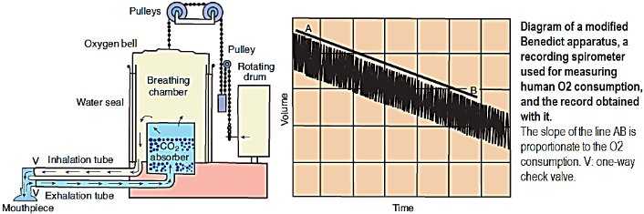
Normal BMR
a. Adult male 35-38 cal/ sq.m/hr; b. adult women: 32-35 cal/ sq.m/hr
BMR value between -15% and +20% is considered normal
Factors affecting BMR:
1. Surface area: directly proportional to surface area
2. Sex: men have marginally higher BMR (5%) than female
3. Age: on infant and growing children is higher. In adult BMR decreases at rate of 2% per decade
4. Hormones: thyroid hormones, (mainly) and epinephrine, sex hormones, cortisol, growth hormones all increase BMR
5. Physical activity: BMR increase with exercise
6. Environment: BMR is higher in cold climates, compared to warm climates
7. Starvation: during starvation a decrease in BMR up to 50% has been reported
8. Fever: BMR increase by 10% for every 1ºC rise in body temperature
9. Diseases: BMR is elevated in infection, leukemia, cardiac failure, hypertension etc.
Because thyroid hormone increases metabolism in almost all cells of the body, excessive quantities of the hormone can occasionally increase the basal metabolic rate 60 to 100 percent above normal.
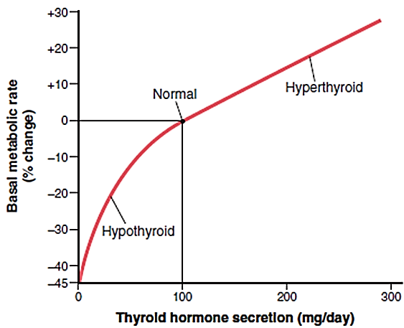
Secondary effects of increase basal metabolic effects of thyroid hormone:
1) Calorigenic action
Calorigenic action means increase body temperature
Some of the calorigenic effect of thyroid hormone is due to:
A. Thyroid hormones
▼
Increase the number and activity of mitochondria
▼
Increases the rate of formation of ATP to energize cellular function
▼
↑ BMR
▼
↑ Body temperature
B. Thyroid hormones
▼
Increase the activity of the membrane-bound Na-K ATPase
▼
Increases the rate of transport of both sodium and potassium ions through the cell membranes
▼
Increases the amount of heat produced in the body,
C. Thyroid hormones
▼
Cell membrane of most cells to become leaky to Na ions
▼
Increase the activity of the membrane-bound Na-K ATPase
▼
Increases the rate of transport of both sodium and potassium ions through the cell membranes
▼
Increases the amount of heat produced in the body
2) Stimulation of oxygen consumption.
T₃ and T₄ increase the oxygen consumption of almost all metabolically active tissue.
The exceptions are the adult brain, testes, uterus, lymph nodes, spleen, and anterior pituitary.
T₄ actually depresses the oxygen consumption of the anterior pituitary, presumably because it inhibits TSH secretion.
3) Decreased Body Weight.
A greatly increased amount of thyroid hormone almost always decreases body weight and a greatly decreased amount of thyroid hormone almost always increases body weight; however, these effects do not always occur because thyroid hormone also increases the appetite, which may counterbalance the change in the metabolic rate.
Effects secondary to calorigenesis:
1. Effects on protein metabolism:
- When the BMR is increased by thyroid hormones in adult's nitrogen urine excretion is increased; if food intake is not increased, endogenous protein and fat stores are catabolized and weight is lost. In hypothyroid children, small dose of thyroid hormones causes a positive nitrogen balance because they stimulate growth, but large dose cause protein catabolism similar to that produced in the adult. The K liberated during protein catabolism appears in the urine, and there is an increase in urinary hexosamine (Hexosamines are amino sugars created by adding an amine group to a hexose. Examples include: Fructosamine (based upon fructose) Galactosamine & Glucosamine) and uric acid excretion.
2. Effects on carbohydrate metabolism:
Thyroid hormone stimulates almost all aspects of carbohydrate metabolism including:
- Rapid uptake of glucose by the cells.
- Enhance gluconeogenesis and glycolysis
- Increase rate of glucose absorption from GIT.
- Increase insulin secretion.
- Accelerate the degradation of insulin.
All these actions have a hyperglycemic effect and, if the pancreatic reserve is low, may lead to B cell exhaustion.
3. Effects on fat metabolism:
All aspects of fat metabolism are enhanced, in particular:
- Lipid is mobilized rapidly from the fat tissue, which decrease the fat stores of the body to a greater extent than almost any other tissue element.
- Increase the free fatty acid concentration in the plasma.
- Greatly accelerates the oxidation of free fatty acids by the cells.
Increase thyroid hormones decrease the concentration of cholesterol, phospholipids, and triglycerides in the plasma, even though it increases the free fatty acids.
The possible mechanisms by which the thyroid hormone lowers the cholesterol level are:
One of the mechanisms by which thyroid hormone decreases plasma cholesterol concentration is to increase significantly cholesterol secretion in the bile and consequent loss in the feces. A possible mechanism for the increased cholesterol secretion is that thyroid hormone induces increased numbers of low-density lipoprotein receptors on the liver cells, leading to rapid removal of low-density lipoproteins from the plasma by the liver and subsequent secretion of cholesterol in these lipoproteins by the liver cells
4. Increased requirement for vitamins:
Because thyroid hormones increase the quantity of many bodily enzymes and because vitamins are essential parts of some of the enzymes or co-enzymes, thyroid hormones causes increase need for vitamins. Therefore, a relative vitamin deficiency can occur when excess thyroid hormone is secreted. Thyroid hormones are necessary for hepatic concentration of carotene to vitamin A, and the accumulation of carotene in the blood stream (carotenemia) in hypothyroidism is responsible for the yellowish tint of the skin. Carotenemia can be distinguished from jaundice because in the former condition the sclera is not yellow.
B. Effects of thyroid hormones on cardiovascular system:
1. Increase blood flow and cardiac output:
Thyroid hormones
▼
More rapid utilization of oxygen than normal
▼
Increase metabolism in the tissue
▼
Release of greater than normal quantities of metabolic end products from the tissues.
▼
Vasodilatation in most body tissue
▼
Increasing tissue blood flow
▼
Increase cardiac output
Sometimes rising to 60 % more above normal when excessive thyroid hormone is present and falling to only 50 % of normal in very sever hypothyroidism
NOTE: The rates of blood flow in the skin especially increase because of the increased need for heat elimination from the body.
2. Increase heart rate:
The rate increases considerably more under the influence of thyroid hormone than would be expected from the increase in cardiac output. Therefore, thyroid hormone seems to have a direct effect on the excitability of the heart as T3 may influence the sensitivity of the sympathetic system, which in turn increases the heart rate. This effect is of particular physical signs that the clinical use in determining whether a patient has excessive or diminished thyroid hormone production.
3. Increased heart strength:
a. Mild increase thyroid hormone
The increased enzymatic activity caused by increased thyroid hormone production apparently increases the strength of the heart. This is analogous to the increase in heart strength that occurs in mild fevers and during exercise.
b. Marked increase of thyroid hormone. The heart muscle strength becomes depressed because of long-term excessive protein catabolism. Indeed, some severely thyrotoxic patients die of cardiac de-compensation secondary to myocardial failure and to increased cardiac load imposed by the increase in cardiac output (high cardiac Failure).
4. Normal arterial pressure:
The mean arterial pressure usually remains about normal after administration of thyroid hormone. However, because of increased blood flow through the tissues between heartbeats, the pulse pressure is often increased, with the systolic pressure elevated in hyperthyroidism 10 to 15 mmHg (due to increase strength of the heart) and the diastolic pressure reduced a corresponding amount (due to vasodilation caused by Calorigenic effect).
T₃ is not formed from T₄ in myocytes and vascular smooth muscles to any degree (due to absence of D2 de-iodonase), but circulatory T₃ enters the myocytes, combines with its receptors, and enters the nucleus, where it promotes the expression of some genes and inhibits the expression of others.
Those that are enhanced include the genes for
α-myosin heavy chain,
Sarcoplasmic reticulum Ca-ATP_{ase},
β-adrenergic receptors,
G proteins,
Na-K ATP _{ase} , and
Certain K channels.
Those that are inhibited include the genes for
β- myosin heavy chain,
phospholamban,
Two types of adenylyl cyclase,
T₃ nuclear receptors, and
The Na-Ca exchanger.
The net result is increased heart rate and force of contraction.
The heart contains two types of myosin heavy chain (MHC) isoforms, α-MHC and β-MHC
Increase α-MHC level by treatment with thyroid hormone, will increases the speed of cardiac contraction
 | α-MHC | β-MHC
Location | atria | ventricle
ATP_{ase} | more | less
hyperthyroidism | increase | Not affected
Gene expression in hypothyroidism | depress | enhanced
C. Effects of thyroid hormones on the nervous system:
- Thyroid hormones enter the brain in adult
- Thyroid hormones are found in gray matter in numerous different locations.
- In addition, astrocytes in the brain convert T₄ to T₃ and there is a sharp increase in brain D₂ (de-iodinase) activity after thyroidectomy that is reversed within 4 hours by a single intravenous does of T₃.
- Some of the effects of thyroid hormones on the brain are probably secondary to increased responsiveness to catecholamine, with consequent increased activation of the reticular activation system.
- Thyroid hormones have marked effects on brain development. The parts of the CNS most affected are the cerebral cortex and the basal ganglia. In addition, the cochlea is also affected.
- Consequently, thyroid hormone deficiency during development causes retardation, motor rigidity.
During hyperthyroidism clinically the following could be seen:
- Reaction time of stretch reflex is shortened.
- Increased cerebration.
- Extreme nervousness and many psychoneurotic tendencies.
Such as anxiety complexes, extreme worry, and paranoia.
- Feeling of constant tiredness, because of
a. the excitable effects of thyroid hormone on the synapses,
b. it is difficult to sleep.
- Fine muscle tremor. This tremor is believed to be caused by reactivity of the neuronal synapses in the areas of the spinal cord that control muscle tone.
D. Effects of thyroid hormones on skeletal muscle:
  - Muscle weakness occurs in most patients with hyperthyroidism (thyro-toxic myopathy), and when the hyperthyroidism is sever and prolonged, the myopathy may be sever. The muscle weakness may be due in part to increased protein catabolism.
  - Thyroid hormones affect the expression of the MHC (myosin heavy chain) genes in skeletal as well as cardiac muscle. However, the effects produced are complex and their relation to the myopathy is not established.
  - Hypothyroidism is also associated with muscle weakness, cramps, and stiffness.
E. Effects of thyroid hormone on growth:
- Thyroid hormones are essential for normal growth and skeletal maturation.
A. In children with hypothyroidism,
a. the rate of growth is greatly retarded.
b. growth hormones secretion is also depressed as thyroid hormones potentate the effect of growth hormone on the tissue.
c. bone age is less than chronologie age (the actual measure of time elapsed since a person's birth). Hypothyroid dwarfs (also known as cretinism)
B. In children with hyperthyroidism, excessive skeletal growth often occurs, causing the child to become considerably taller at an earlier age. However, the bones also mature more rapidly and the epiphyses close at an early age, so the duration of growth and the eventual height of the adult actually may be shortened.
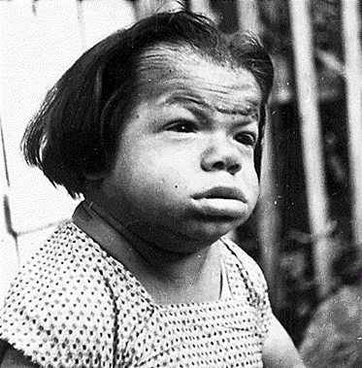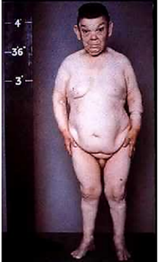
F. Effects of thyroid hormone on sexual function:
In male:
  - Hypothyroidism: loss of libido.
  - Hyperthyroidism: impotence.
In female:
- Hypothyroidism: menorrhagia, polymenorrhea.
- Hyperthyroidism: amenorrhea, oligomenorrhea.
G. Effects of thyroid hormone on gastrointestinal tract:
Hyperthyroidism associated with
a. Increase appetite and food intake.
b. Increase both the rate of secretion of digestive juices and the motility of GIT.
c. Diarrhea often results in hyperthyroidism.
Lack of thyroid hormone can cause constipation.
H. Effects of thyroid hormone on respiration:
The increased rate of metabolism increases the utilization of oxygen and formation of carbon dioxide; these effects activate all the mechanisms that increase the rate and depth of respiration.
I. Other effects of thyroid hormone:
Skin: the normally contains a verity of proteins combined with polysaccharides, hyaluronic acid, and chondroitin sulfuric acid. In hypothyroidism, these complexes accumulate, promoting water retention and the characteristic puffiness of the skin (myxedema). When thyroid hormones are administered, the proteins are metabolized, and diuresis continues until the myxedema is cleared.
Milk secretion: milk secretion is decreased in hypothyroidism and stimulated by thyroid hormones.
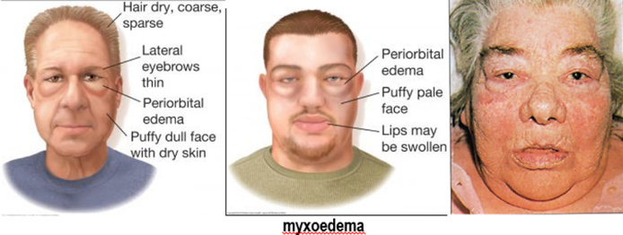
J. Effect on Other Endocrine Glands.
Increased thyroid hormone increases the rates of secretion of several other endocrine glands, but it also increases the need of the tissues for the hormones.
For instance, increased thyroxine secretion
A. Increase insulin secretion:
Increases the rate of glucose metabolism almost everywhere in the body and therefore causes a corresponding need for increased insulin secretion by the pancreas.
B. increase parathyroid hormone:
Increase thyroid hormone increases many metabolic activities related to bone formation and, as a consequence, increases the need for parathyroid hormone.
C. increase in adrenocorticotropic hormone
Thyroid hormone increases the rate at which adrenal glucocorticoids are inactivated by the liver. This increased rate of inactivation leads to feedback increase in adrenocorticotropic hormone production by the anterior pituitary and, therefore, an increased rate of glucocorticoid secretion by the adrenal glands.
The factors affecting TSH and TRH (thyroid releasing hormone) are:
1. Exposure to cold stimulate the release of TSH and TRH in experimental animals and human infants, the rise produced by cold in adult human is negligible. Consequently , in adult , increased heat production due to increased thyroid hormone secretion ( thyroid hormone thermo-genesis ) play little if any role in the response to cold.
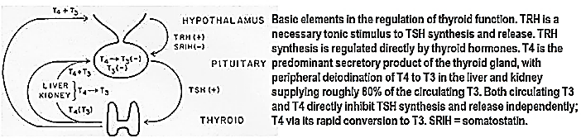
2. Excitement and anxiety (condition that greatly stimulate the sympathetic nervous system) cause an acute decrease in secretion TSH and TRH.
3. Somatostatin and dopamine inhibits TRH-stimulation of TSH
Feedback control of thyroid secretion:
The negative feedback effect of thyroid hormones on TSH secretion is excreted in part at the hypothalamic level , but it is also due in large part to an action on the pituitary , science T4 and T3 block the increase in TSH secretion by TRH .
Hypothyroidism:
The syndrome of adult hypothyroidism is generally called (Myxedema) .Hypothyroidism may be the end result of number of diseases of the thyroid gland, or it may be secondary to pituitary failure (pituitary hypothyroidism) or hypothalamic failure (hypothalamic hypothyroidism).
Hyperthyroidism:
The most common cause of hyperthyroidism is Graves' disease, which account for 60 to 80 % of the cases. The condition (which for unknown reasons is much common in women) is an auto-immune disease
Thyroid stimulating hormone receptor antibodies (TSHR-Ab):
TSHR-SAbs is elevated in at least 80% of patients with Graves' disease.
These antibodies have TSH agonist activity, thereby stimulating hormone synthesis and release.
This produces marked T4 and T3 secretion and enlargement of the thyroid gland (Goiter).
However, due to the feedback effects of T4 and T3. Plasma TSH is low, not high.
TSHR-SAbs includes two types of autoantibodies that attach to proteins in the thyroid to which TSH normally binds (TSH receptors):
a. Thyroid stimulating immunoglobulin (TSI) binds to receptors and promotes the production of thyroid hormones that has a similar effect to TSH but much longer time leading to hyperthyroidism.
b. Thyroid binding inhibitory immunoglobulin (TBII) blocks TSH from binding to receptors, blocking production of thyroid hormones and resulting in hypothyroidism.
TBII is not routinely tested, but TSI is often used to help diagnose Graves’ disease.
Thyroid stimulating Hormone
Thyroid stimulating Hormone (TSH) is made up of two subunits, designated α and β.
Thyroid stimulating Hormone-α is identical to the α subunit of LH, FSH, and hCG-α
Thyroid stimulating Hormone (TSH) action on thyroid gland
Thyroid stimulating Hormone (TSH), also known as thyrotropin,
Thyroid stimulating Hormone (TSH) is an anterior pituitary hormone;
Thyroid stimulating Hormone (TSH) is a glycoprotein with a molecular weight of about 28,000.
Thyroid stimulating Hormone (TSH) increases secretion of thyroxine and triiodothyronine by the thyroid gland.
Thyroid stimulating Hormone (TSH) has the following specific effects on the thyroid gland:
1. Increased proteolysis of the thyroglobulin that has already been stored in the follicles, releasing the thyroid hormones into the circulating blood and diminishing the follicular substance
2. Increased activity of the iodide pump, which increases the rate of “iodide trapping” in the glandular cells, sometimes increasing the ratio of intracellular to extracellular iodide concentration in the glandular substance to as much as eight times normal
3. Increased iodination of tyrosine to form the thyroid hormones
4. Increased size and increased secretory activity of the thyroid cells
5. Increased number of thyroid cells plus a change from cuboidal to columnar cells and much in folding of the thyroid epithelium into the follicles
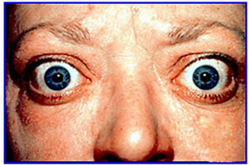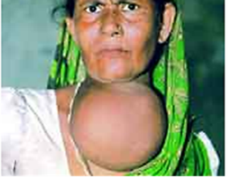
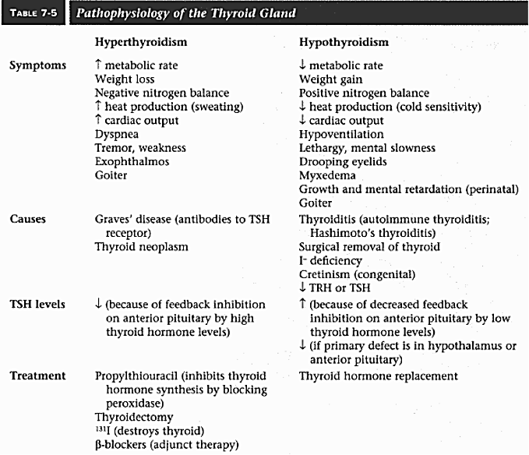

Physiology of calcium and phosphate:
The plasma and interstitial fluids have a normal ionic calcium ion concentration of about 1.16 mmol/L (or 2.4 mEq/L, because it is a divalent ion), a level only one-half the total plasma calcium concentration. This ionic calcium is the form that is important for most functions of calcium in the body, including the effect of calcium on the heart, the nervous system, and bone formation.
Increases in calcium ion concentration above normal (hypercalcemia) cause
Progressive depression of the nervous system (depressive effects begin to appear when the blood level of calcium rises above about 12 mg/dl)
Reflex activities of the central nervous system are sluggish;
Decreases the QT interval of the heart
Lack of appetite
Constipation;
Conversely, decreases in calcium concentration (hypocalcemia) cause the nervous system to become more excited about 6 mg/dl. The result is hypocalcemic tetany, which is characterized by extensive spasms of skeletal muscle (carpopedal spasm), involving especially the muscles of the extremities. Laryngospasm can become so severe that the airway is obstructed and fatal asphyxia is produced. It is usually lethal at about 4 mg/dl.
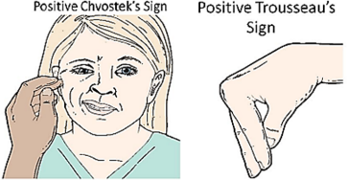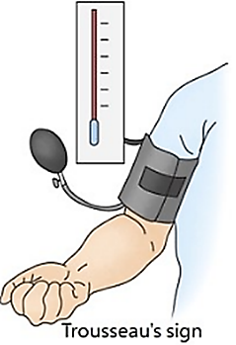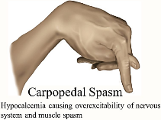
The possible mechanism behind hypocalcemic tetany (pathophysiology):
Hypocalcemia
▼
No complete closure of Na channels at rest
▼
Na leak into the cell from ECF
▼
Intracellular become less negative and approaching more to threshold (more excitable)
So less amount of dis required to initiate depolarization
▼
Slight stimuli cause action potential
The extent of Ca ²⁺ binding by plasma proteins (i.e the free Ca2+ level) is proportional to
the plasma protein level (example pregnancy)
Other electrolytes
pH.
Thus, for example, symptoms of tetany appear if the patient have higher plasma protein or hyperventilates,
Hyperventilates
▼
More wash of blood CO2
▼
Alkalosis (respiratory alkalosis)
▼
Plasma protein are more ionized when pH is high
▼
Increase Ca binding to plasma protein
▼
Hypocalcemia even though normal level of plasma protein
Calcium exchange between bone and extra-cellular fluid:
The calcium in bone is of two types:
A readily exchangeable reservoir
A much larger pool of stable calcium that is only slowly exchangeable.
These are two independent but interacting homeostatic systems affect the calcium in bone.
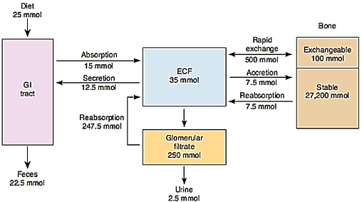
Exchangeable reservoir is the system that regulates plasma Ca2+ , providing for the movement of about 500 mmol of Ca2+ per day into and out of the readily exchangeable pool in the bone.
Most of the exchangeable calcium is in the bone.
Exchangeable reservoir normally amounts to about 0.4 to 1 percent of the total bone calcium. This calcium is deposited in the bones in a form of readily mobilizable salt such as CaHPO4 and other amorphous calcium salts.
The importance of exchangeable calcium is that it provides a rapid buffering mechanism to keep calcium ion concentration in the extracellular fluids from rising to excessive levels or falling to low levels under transient conditions of excess or decreased availability of calcium.
A small portion of this exchangeable calcium is also the calcium found in all tissue cells, especially in highly permeable types of cells such as those of the liver and the gastrointestinal tract.
Physiology of phosphate:
Total body phosphorus is 500 to 800 g (16.1–25.8 mol) distributed as:
Approximately 85–90% of the body’s phosphate is stored in bones,
14 to 15 percent is in the cells, and
Less than 1 percent is in the extracellular fluid.
Total plasma phosphorus is about 12 mg/dL (because it is difficult to calculate inorganic phosphate),
two-thirds of this total in organic compounds
Phosphate is found in ATP, cyclic adenosine monophosphate (cAMP), 2,3-diphosphoglycerate, many proteins, and other vital compounds in the body.
the remaining inorganic phosphorus (Pi) mostly in PO₄^{3–}, HPO₄^{2–}, and H₂PO₄–.
The amount of phosphorus normally entering bone is about 3 mg (97 μmol)/kg/d, with an equal amount leaving via reabsorption
Phosphorylation and dephosphorylation of proteins are involved in the regulation of cell function. Therefore, it is not surprising that, like calcium, phosphate metabolism is closely regulated.
When the pH of the extracellular fluid becomes more acidic, there is a relative increase in H₂PO₄– and a decrease in HPO₄^{2–}, whereas the opposite occurs when the extracellular fluid becomes alkaline.
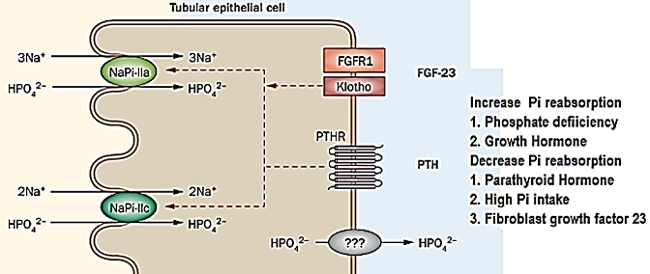
Inorganic phosphorus (Pi) in the plasma is filtered in the glomeruli, and 85–90% of the filtered Pi is reabsorbed.
Inorganic phosphorus Active transport in the proximal tubule of the kidney:
Inorganic phosphorus Active transport in the proximal tubule accounts for most of the reabsorption and involves two cotransporters, NaPi-IIa (Na:Pi, 3:1) and NaPi-IIc (Na:Pi, 2:1).
NaPi-IIa is powerfully inhibited by parathyroid hormone, which causes its internalization and degradation of NaPi-IIa and NaPi-IIc, thus a reduction in renal Pi reabsorption.
Inorganic phosphorus Active transport in the duodenum and small intestine
Phosphate absorption occurs primarily in the small intestine and its relative efficiency is greater in the duodenum, followed by the jejunum, and then the ileum. The majority of phosphate is absorbed in the jejunum due to its greater length. Uptake occurs by a transporter related to those in the kidney, NaPi-IIb (2:1); that takes advantage of the low intracellular sodium concentration established by the Na, K ATPase on the basolateral membrane of intestinal epithelial cells to load Inorganic phosphorus (Pi) against its concentration gradient. However, the pathway by which Inorganic phosphorus (Pi) exits into the bloodstream is not known. Many stimuli that increase Ca2+ absorption, including 1,25-dihydroxycholecalciferol, also increase Pi absorption via increased NaPi-IIb expression
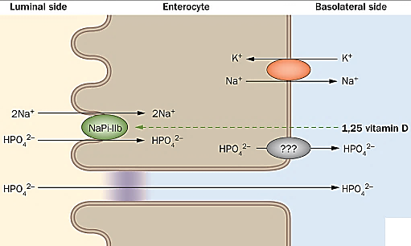
Vitamin D
The term vitamin D is generally used in this report to refer to both the D₂ and D₃ forms as well as their metabolites. Vitamin D (or calciferol), Vitamin D₂ (or ergocalciferol), Vitamin D₃ (or cholecalciferol),
25-hydroxycholecalciferol, or 25-hydroxyvitamin D (or calcidiol or calcifediol)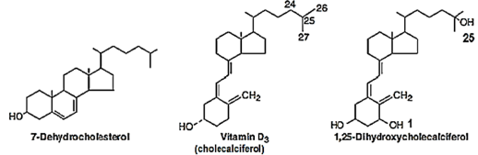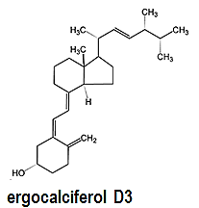
The active transport of Ca²⁺and PO4^{3–}from the intestine is increased by a metabolite of vitamin D. The term “vitamin D” is used to refer to a group of closely related sterols produced by the action of ultraviolet light on certain pro-vitamins.
Vitamin D₃, which is also called cholecalciferol, is produced in the skin of mammals from 7-dehydrocholesterol by the action of sunlight. The reaction involves the rapid formation of pre-vitamin D₃, which is then converted more slowly to vitamin D₃.
Vitamin D₃ and its hydroxylated derivatives are transported in the plasma bound to a globulin vitamin D binding protein (DBP).
Vitamin D₃ is also ingested in the animal diet source or ingested from plant diet source and converted to (D2 or ergo-calciferol).
In the liver, vitamin D₃ is converted to 25-hydroxy-cholecalciferol (calcidiol, 25-OHD₃). The process is limited because the 25-hydroxycholecalciferol has a feedback inhibitory effect on the conversion reactions. This feedback effect is extremely important for two reasons
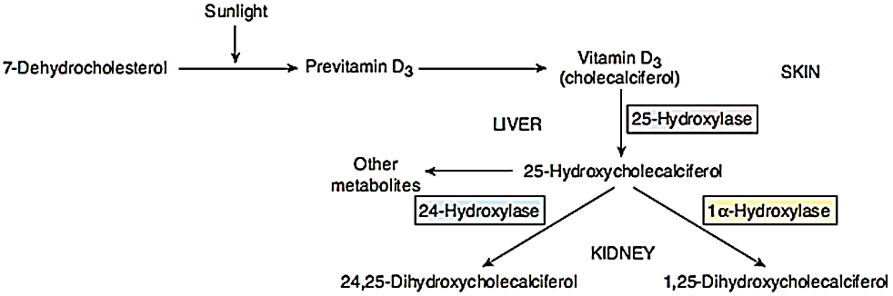
First, the feedback mechanism precisely regulates the concentration of 25-hydroxycholecalciferol in the plasma, the intake of vitamin D₃ can increase many times and yet the concentration of 25-hydroxycholecalciferol remains nearly normal.
This high degree of feedback control prevents excessive action of vitamin D when intake of vitamin D3 is altered over a wide range.
Second, this controlled conversion of vitamin D₃ to 25-hydroxycholecalciferol conserves the vitamin D stored in the liver for future use. Once vitamin D₃ is converted, the 25-hydroxycholecalciferol persists in the body for only a few weeks, whereas in the vitamin D3 form can be stored in the liver for many months.
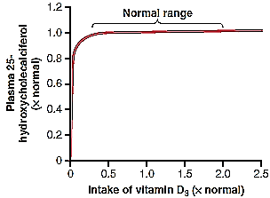
The 25-hydroxy-cholecalciferol is converted in the cells of the proximal tubules of the kidneys to the more active metabolite 1,25-dihydroxycholecalciferol, which is also called calcitriol or 1,25-(OH)₂D₃ (is by far the most active form of vitamin D) effect by the presence of 1α-hydroxylase. Therefore, in the absence of the kidneys, vitamin D loses almost all its effectiveness. 1,25-Di-hydroxy-cholecalciferol is also made in the placenta, in keratinocytes in the skin, and in macrophages.
Vitamin D₃ is also ingested in the animal diet source or ingested from plant diet source and converted to (D2 or ergocalciferol). In the liver by the aid of 25-hydroxylase will be converted to 25-hydroxy- ergocalciferol. 25-hydroxy- ergocalciferol will be converted to 1, 25, di-hydroxyby-cholecalciferol the aid of 1 alpha-hydroxylase.

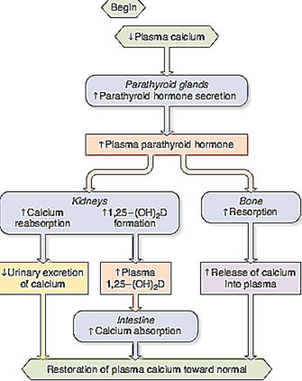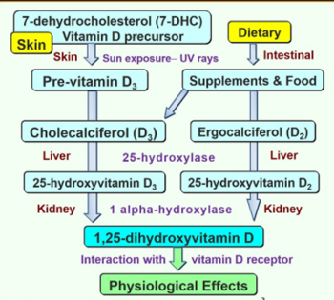
Regulation of synthesis of1,25-dihydroxycholecalciferol (calcitriol):
Primary regulator:
1. Parathyroid hormone (PTH)
The conversion of 25-hydroxycholecalciferol to 1, 25-dihydroxycholecalciferol requires PTH.
In the absence of PTH, almost none of the 1, 25-dihydroxycholecalciferol is formed. Therefore, PTH exerts a potent influence in determining the functional effects of vitamin D in the body.
2. Calcium level:
Hypercalcemia ►↓ parathyroid hormone production ►
a. ↓1 α -hydroxylase ►decrease conversion 25-hydroxy-cholecalciferol to1, 25 dihydroxy-cholecalciferol
b. ↑ 24-hydroxylase ► increase conversion 25-hydroxy-cholecalciferol to 24, 25 dihydroxy-cholecalciferol
3. Phosphate level:
High phosphate level has a direct on inhibit 1α-hydroxylase (so decrease production of 1,25-hydroxy-cholecalciferol). The reverse is also true.
4. 1,25-di-hydroxy-cholecalciferol
↑ 1,25-di-hydroxy-cholecalciferol ►↓1α-hydroxylase ►decrease conversion 25-hydroxy-cholecalciferol to1, 25 dihydroxy-cholecalciferol (direct negative feedback effect). The reverse is also true
Secondary regulator: Prolactin, estrogen, androgen, progesterone, insulin, growth hormone, human chorionic somatomammotropin (HCS), thyroid hormone, and calcitonin all increase 1, 25-hydroxy-cholecalciferol, while hyperthyroidism is associated with a decrease in 1,25-hydroxy-cholecalciferol.
Intestinal Epithelia can absorb Ca⁺² by para-cellular and trans-cellular transport.
Passive and paracellular Ca2 transport takes place across the tight junctions and is driven by the electrochemical gradient for Ca2.
The active form of vitamin D (1,25-(OH)2D3) stimulates the individual steps of trans-cellular Ca2 transport by increasing the expression levels of the luminal Ca2 channels, calbindins D9k, and the extrusion systems.
Active and transcellular Ca2 transport is carried out as a three-step process.
After entry of Ca2 through the (hetero) tetrameric epithelial Ca2 channels, TRPV5 (transient receptor potential vanilloid type 5) and TRPV6 (transient receptor potential vanilloid type 6)
Ca2 bound to calbindin diffuses to the basolateral membrane.
At the basolateral membrane, Ca2 is extruded via an
a. ATP-dependent Ca2-ATPase (PMCA1b: The plasma membrane calcium pump type 1b)
b. Na/Ca2 exchanger (NCX1).
In this way, there is net Ca2 absorption from the luminal space to the extracellular compartment.
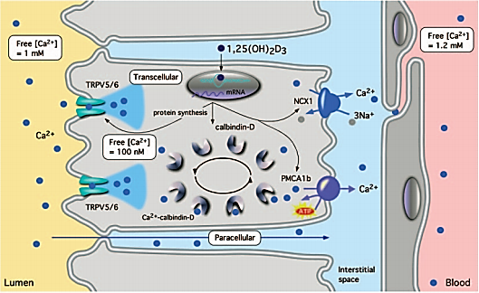
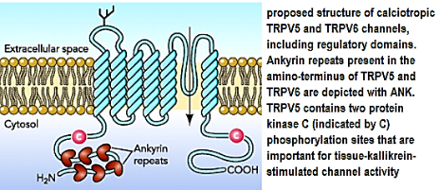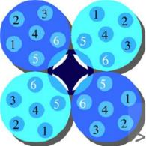
Since the discovery of α-Klotho, it was found to play a role in Bone metabolism, aging processes,
Nephrology, Immunology, etc. α-Klotho is found in two forms
A. α Klotho transmembrane protein
The Klotho family consists of three single-pass transmembrane proteins—αKlotho, βKlotho and γKlotho.
Each of them combines with fibroblast growth factor (FGF) receptors (FGFRs) to form receptor complexes for various FGF’s. α-Klotho is a co-receptor for physiological FGF23 signaling. FGF23 thereby
Kidney:
a. Inhibits 1α-hydroxylase, ►reducing levels of 1,25-dihydroxycholecalciferol (Calcitriol synthesis)
b. decreases renal Na-dependent phosphate cotransporters (NaPi-IIa and NaPi-IIc) expression

Increase phosphate excretion (Negative phosphate balance)
Parathyroid gland
Inhibit parathyroid hormone ►reducing levels of 1,25-dihydroxycholecalciferol (Calcitriol synthesis)
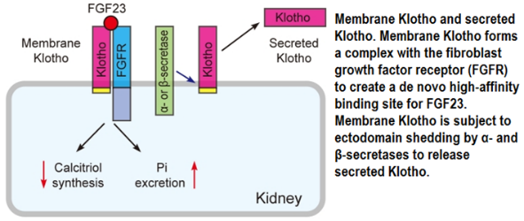
b. α-Klotho protein
α-Klotho protein also plays a FGF23-independent role in phosphate homeostasis.
Animal experimental studies and clinical observations have demonstrated that
αKlotho deficiency leads to severe hyperphosphatemia, accelerated aging, decreased bone mineral density, calcifications, and hypercalcemia;
moderate elevation of α-Klotho reduces serum phosphate
extremely high αKlotho induces hypophosphatemia and high-FGF23.
α-Klotho maintains circulating phosphate in a narrow range by
modulating intestinal phosphate absorption,
urinary phosphate excretion by the kidney,
phosphate distribution into bone rather than soft tissue in concerted interaction with other calico-phosphotropic hormones such as PTH, FGF23, calcitriol
The role of αKlotho in maintenance of phosphate homeostasis is mediated by
direct suppression of Na-dependent phosphate cotransporters (NaPi-II) in target organs.
α-Klotho plays an important role in stabilizing the membrane localization of proteins important in calcium and phosphate (re)absorption, such as TRPV5 and Na-K ATPase
It is already known that α-Klotho levels in blood decrease with age.
Low α-klotho levels are often associated with age-related diseases.
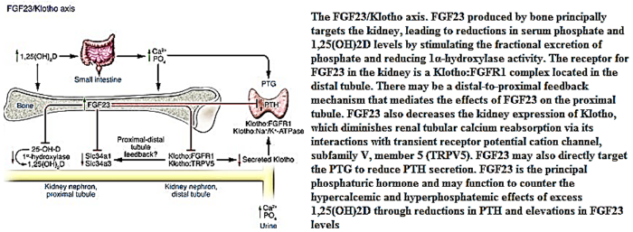
The functions of 1,25-dihydroxycholecalciferol
• are coordinated to increase both [Ca2+] and [phosphate] in ECF to mineralize new bone.
a. Increases intestinal Ca2+ absorption (directly or indirectly through increase PTH)
b. Increases intestinal phosphate absorption.
c. Increases renal re-absorption ofCa2+ and phosphate, analogous to its actions on the intestine.
The actions of vitamin D on bone will be:
a. Small quantity of 1,25-hydroxy-cholecalciferol promote bone calcification by maintaining normal quantity of calcium and phosphate.
b. Extreme quantity of 1,25-hydroxy-cholecalciferol causes absorption of bone.
c. In the absence of 1,25-hydroxy-cholecalciferol, the effect of parathyroid hormone in causing bone absorption is greatly reduced.
d. increasing osteoclast activity
When dietary calcium–and, therefore, intestinal calcium absorption–is low, 1,25(OH)2D binds to osteoblasts, thereby increasing osteoclast activity and causing the release of skeletal calcium.
Other effects of Vitamin D
Vitamin D exhibits local (paracrine) effects on cell proliferation and differentiation and immune function.
Research has shown that vitamin D might play an important role in regulating mood and warding off depression.
Most cells in the body express vitamin D receptor (VDR) and 1α-hydroxylase, thereby permitting local production of 1,25(OH)2D, which has therapeutic implications. For example,
Topical 1,25 (OH)2D is used to treat psoriasis.
Ongoing studies are aiming to clarify the role of 1,25 (OH)2D in the treatment of cancer and immune disorders, including rheumatoid arthritis (RA).
Failure of skin synthesis of vitamin D can be caused by:
1. Aging (synthesis is reduced by 75% at age 70)
2. Skin pigmentation (melanin absorb UV photon and prolong exposure time require for synthesis
3. Body fat (excess body fat takes up and store newly synthesized Vitamin D
4. Regular sunscreen, clothing, atmospheric pollution, sun avoidance all decrease amount of exposure to sun
Parathyroid hormone (PTH)
Parathyroid hormone has a molecular weight of about 9500.
Smaller compounds with as few as 34 amino acids adjacent to the N terminus of the molecule have also been isolated from the parathyroid glands that exhibit full PTH activity. In fact, because the kidneys rapidly remove the whole 84–amino acid hormone within minutes but fail to remove many of the fragments for hours, a large share of the hormonal activity is caused by the fragments.
The half-life of PTH is approximately 10 min.
Parathyroid hormone (PTH) effects:
PTH acts directly on bone to increase bone resorption and mobilize Ca2+ and phosphate.
PTH has two effects to mobilize calcium and phosphate from bone.
One is a rapid phase that begins in minutes and increases progressively for several hours. This phase results from activation of the already existing bone cells (mainly the osteocytes) to promote calcium and phosphate release.
The second phase is a much slower one, requiring several days or even weeks to become fully developed
On a longer time scale, PTH stimulates both osteoblasts and osteoclasts.
PTH results from proliferation of the osteoclasts, followed by greatly increased osteoclastic resorption of the bone itself, not merely release of the calcium and phosphate salts from the bone.
PTH increases phosphate excretion in the urine and thereby depresses plasma phosphate levels. This phosphaturic action is due to a decrease in reabsorption of phosphate via effects on NaPi-IIa in the proximal tubules, as discussed previously. The decline in phosphate concentration is caused by a strong effect of PTH to increase renal phosphate excretion, an effect that is usually great enough to override increased phosphate absorption from the bone.
PTH also increases renal tubular reabsorption of calcium at the same time that it diminishes phosphate reabsorption.
a. renal tubular reabsorption of calcium
Plasma Ca2+ is filtered in the kidneys, but 98–99% of the filtered Ca2+is reabsorbed.
About 60% of the reabsorption occur in the proximal tubules and the remainder in the ascending limb of the loop of Henle and the distal tubule.
The effect of PTH to increase calcium reabsorption occurs mainly in the late distal tubules, the early collecting ducts, and possibly the ascending loop of Henle to a lesser extent.
Although Ca2+ excretion in the urine is often increased in hyperparathyroidism because the increase in the load of filtered calcium overwhelms the effect on reabsorption
b. phosphate reabsorption.
Model of calcium reabsorption in the distal convoluted tubule (DCT).
Apical calcium transport is mediated by TRPV5 channels, which can be activated by the β-glucuronidase Klotho (Reduced production of this protein has been observed in patients with chronic renal failure (CRF), and this may be one of the factors underlying the degenerative processes (e.g., arteriosclerosis, osteoporosis, and skin atrophy). Cytosolic calcium is immediately bound by calbindin-D28K, which shuttles calcium to the basolateral aspect of the distal tubules cell, where it can be transported out by the type 1 sodium calcium exchanger (NCX1) or calcium ATPases. These processes are tightly regulated by hormones, such as parathyroid hormone and vitamin D
PTH also increases the formation of 1,25-dihydroxycholecalciferol, and this increases both calcium and phosphate absorption from the intestine.
PTH increases reabsorption of magnesium ions and hydrogen ions while it decreases reabsorption of sodium ions, potassium ions, and amino acid in much the same way that it affects phosphate.
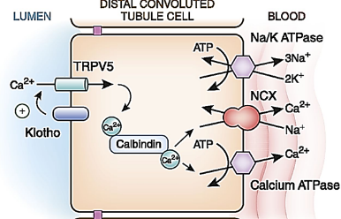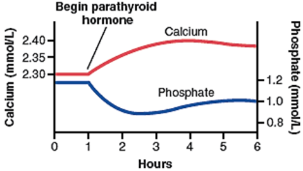
Control of parathyroid secretion by calcium ion concentration
Even the slightest decrease in calcium ion concentration in the extracellular fluid causes the parathyroid glands to increase their rate of secretion within minutes; if the decreased calcium concentration persists, the glands will hypertrophy, sometimes fivefold or more.
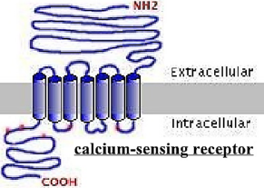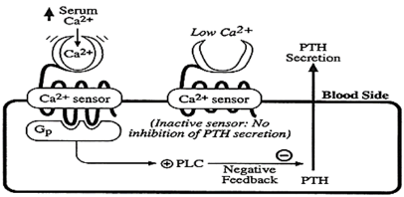
The parathyroid glands become greatly enlarged in persons with
rickets,
pregnancy,
lactation
The parathyroid glands become greatly depressed in persons with
excess quantities of calcium in the diet,
increased vitamin D in the diet
bone resorption caused by factors other than PTH (e.g., disuse of the bones)
Changes in extracellular fluid calcium ion concentration are detected by a calcium-sensing receptor in parathyroid cell membranes.
Mild decreases in serum [Mg2+] stimulate PTH secretion.
Severe decreases in serum [Mg2+] inhibit PTH secretion and produce symptoms of hypo-parathyroidism (e.g., hypocalcemia).
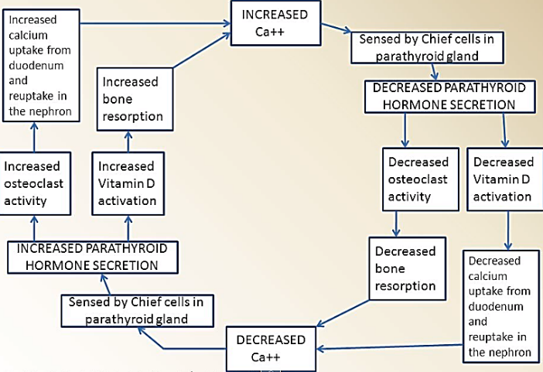
Parathyroid hormone-related protein (PTHrP),
Parathyroid hormone related protein (PTHrP), is produced by many different tissues in the body.
Parathyroid hormone related protein has 140 amino acid residues
Parathyroid hormone related protein bind the same receptor of PTH this why it has same activates of PTH
Parathyroid hormone related protein actions
Parathyroid hormone related protein has a marked effect on the growth and development of cartilage in utero
a. stimulated cartilage cells proliferate b. their terminal differentiation is inhibited.
Parathyroid hormone related protein expressed in the brain, where evidence indicates that it inhibits excite-toxic damage to developing neurons.
Parathyroid hormone related protein is involved in Ca2+ transport in the placenta.
Parathyroid hormone related protein is also found in keratinocytes in the skin, in smooth muscle, and in the teeth, where it is present in the enamel epithelium that caps each tooth.
In the absence of Parathyroid hormone related protein teeth cannot erupt تسنين.
Parathyroid hormone related protein play a role of hypercalcemia in malignancy such as lung cancer

Calcitonin:
In mammals, calcitonin is produced by the para-follicular cells of the thyroid gland, which are also known as the clear or C cells.
Human calcitonin has a molecular weight of 3500 and contains 32 amino acid residues.
Calcitonin gene-related peptide (CGRP: is a polypeptide that exists in two forms in humans: CGRPα and
CGRPβ) and the calcium-lowering hormone calcitonin are both products of the calcitonin gene.
In the thyroid gland, splicing produces the mRNA that codes for calcitonin, whereas in the brain, alternative splicing produces the mRNA that codes for CGRPα where it act as neurotransmitter
CGRP has little effect on Ca2+ metabolism, and calcitonin is only a weak vasodilator
Secretion of calcitonin is increased when the thyroid gland is exposed to plasma calcium level of approximately 9.5 mg/dL.
Above this level, plasma calcitonin is directly proportionate to plasma calcium.
β-adrenergic agonists, dopamine, and estrogens also stimulate calcitonin secretion.
Gastrin, cholecystokinin (CCK), glucagon, and secretin have all been reported to stimulate calcitonin secretion, with gastrin being the most potent stimulus. Thus, the plasma calcitonin level is elevated in Zollinger–Ellison syndrome and in pernicious anemia. However, the dose of gastrin needed to stimulate calcitonin secretion is supra-physiological and not seen after eating in normal individuals, so dietary calcium in the intestine probably does not induce secretion of a calcium lowering hormone prior to the calcium being absorbed. In any event, the actions of calcitonin are short-lived because it has a half-life of less than 10 min in humans
Calcitonin actions:
Calcitonin exact physiologic role is uncertain.
Calcitonin receptors are found in bones and the kidneys.
Calcitonin lowers circulating calcium levels.
Calcitonin exerts its calcium-lowering effect by
a. inhibiting bone resorption. This action is direct, and calcitonin inhibits the activity of osteoclasts in vitro.
b. increases Ca2+ excretion in the urine.
Calcitonin content of the human thyroid is low.
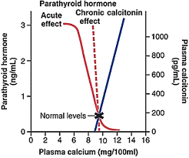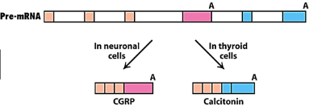
After thyroidectomy, bone density and plasma Ca2+ level are normal as long as the parathyroid glands are intact. In addition, there are only transient abnormalities of Ca2+ metabolism when a Ca2+ load is injected after thyroidectomy. This may be explained in part by secretion of calcitonin from tissues other than the thyroid. However, there is general agreement that the hormone has little long term effect on the plasma Ca2+ level in adult animals and humans.
Further, unlike PTH and 1, 25-dihydroxycholecalciferol, calcitonin does not appear to be involved in phosphate homeostasis. Moreover, patients with medullary carcinoma of the thyroid have a very high circulating calcitonin level but no symptoms directly attributable to the hormone, and their bones are essentially normal.
No syndrome due to calcitonin deficiency has been described.
More Calcitonin is secreted in young individuals, and Calcitonin may play a role in skeletal development.
Calcitonin may protect the bones of the mother from excess calcium loss during pregnancy.
Bone formation in the infant and lactation are major drains on Ca2+ stores, and plasma concentrations of 1, 25-dihydroxycholecalciferol are elevated in pregnancy. They would cause bone loss in the mother if bone resorption were not simultaneously inhibited by an increase in the plasma calcitonin level.
SUMMARY
PTH increases plasma Ca2+ by mobilizing this ion from bone.
PTH increases Ca2+ reabsorption in the kidney, but this may be offset by the increase in filtered Ca2+.
PTH also increases the formation of 1,25-dihydroxycholecalciferol.
1,25-Dihydroxycholecalciferol increases Ca2+ absorption from the intestine
1,25-Dihydroxycholecalciferol increases Ca2+ reabsorption in the kidneys.
Calcitonin inhibits bone resorption and
Calcitonin increases the amount of Ca2+ in the urine.
Effects of other hormones and humoral agents on calcium metabolisms
Growth hormone
Increases calcium excretion in the urine
Increases intestinal absorption of Ca2+, and this effect may be greater than the effect on excretion, with a resultant positive calcium balance.
Insulin-like growth factor I (IGF-I) generated by the action of growth hormone stimulates protein synthesis in bone.
Thyroid hormones may cause hypercalcemia, hypercalciuria, and, in some instances, osteoporosis.
Estrogens prevent osteoporosis by inhibiting the stimulatory effects of certain cytokines on osteoclasts.
Insulin increases bone formation, and there is significant bone loss in untreated diabetes.
Glucocorticoids
Lower plasma Ca2+ levels by inhibiting osteoclast formation and activity, over long periods they cause osteoporosis by decreasing bone formation and increasing bone resorption. They decrease bone formation by inhibiting protein synthesis in osteoblasts. They also decrease the absorption of Ca²⁺ and PO4^{3–} from the intestine and increase the renal excretion of these ions. The decrease in plasma Ca²⁺ concentration also increases the secretion of PTH, and bone resorption is facilitated.

Chronic renal failure
• Decreased glomerular filtration rate (GFR) leads to decreased filtration of phosphate, phosphate retention, and increased serum [phosphate].
• Increased serum phosphate complexes Ca2+ and leads to decrease ionized [Ca2+].
• Decreased production of 1,25-dihydroxycholecalciferol by the diseased renal tissue also contributes to the decreased ionized [Ca2+] .
• Decreased [Ca2+] causes secondary hyperparathyroidism.
• The combination of increased PTH levels and decreased l,25-dihydroxycholecalciferol produces renal osteodystrophy, in which there is increased bone resorption and osteomalacia.
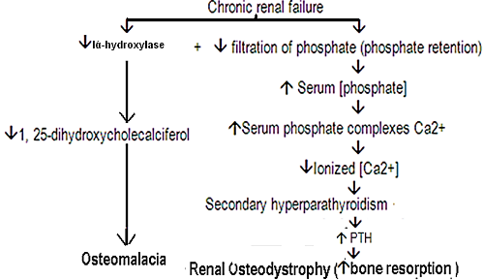
Physiology of the teeth:
Function of different parts of the teeth:
The tooth can be divided into crown (which is the portion that protrudes out from the gum into the mouth), and the root (which is the portion within the bony socket of the jaw).The collar between the crown and the root where the tooth is surrounded by the gum is called the neck. The inside parts of the tooth are:
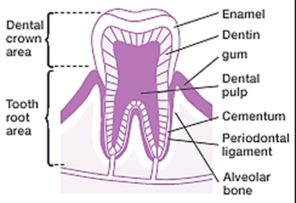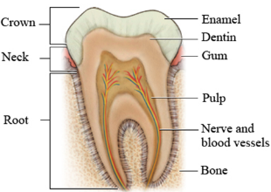
Enamel:
- It forms the outer surface of the tooth
- It is formed by special epithelial cells called ameloblast.
- It is formed before tooth eruption, once the tooth is erupted, no more enamel is formed.
It is composed of very large and very dense crystals of hydroxyapatite with adsorbed carbonate, magnesium, sodium, potassium, and other ions imbedded in the fine meshwork of strong and almost insoluble protein fibers that are similar in physical characteristics (but not chemically identical ) to the keratin of hair.
- Fluorapatite (Ca10(PO4 )6 F2) is fluoride modification of hydroxyapatite, which is often used therapeutically in order to prevent caries
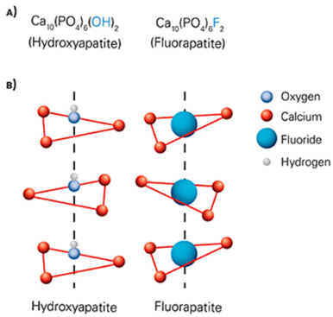
- Crystalline structure of salts makes the enamel extremely heard.
- The special protein fiber meshwork , although constituting only about 1% of the enamel mass, makes enamel resistant to acids , enzymes, and other corrosive agent because this protein is one most insoluble and resistant protein known.
Dentin:
  - It is made up principally of hydroxyapatite crystals similar to those in the bone but much denser. These crystal are imbedded in strong mesh work of collagen fibers (i.e. the principle constituent of dentin is much the same those of bone).
  - Dentin does not contain any osteoblast, osteocytes, osteoclasts, or spaces for blood vessels or nerve.
  - Dentin nourishment is by a layer of cells called odontoblast, which line is inner surface along the wall of the pulp cavity.
  - The calcium salts in dentin makes it extremely resistant to compression force and the collagen fibers makes it tough and resistant to tensional force.
Cementum:
- It is bony substance secreted by cells of the periodontal membrane, which lines the tooth socket.
- Many collagen fiber pass directly from the bone of the jaw, through the periodontal membrane, and then into the cementum (periodontal ligament). These collagen fibers and the cementum hold the tooth in place.
- The cementum becomes thicker and stronger with age and with exposure to excessive strain causing the teeth to become more firmly seated in the jaws.
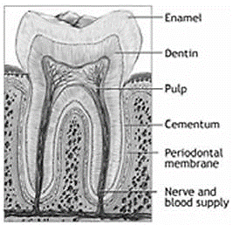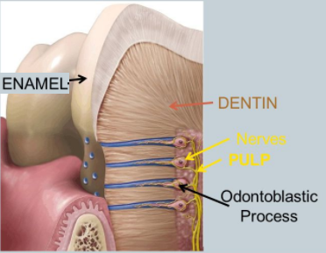
Pulp (or endodontium):
- It is the tooth cavity which is composed of connective tissue with abundant supply of nerve fibers, blood vessels and lymphatic.
- The cell lining the surface of the pulp cavity are the odontoblast, which , during the formative years of the tooth, lay down the dentin but at the same time encroach تتجاوزmore and more on the pulp cavity, make it smaller. In later life, the dentin stops growing and the pulp cavity remains essentially constant in size.
- The odontoblast send projections into small dentinal tubules that penetrate all the way through the dentin: they are important for exchange of calcium, phosphate with the dentin.
Dentition:
Human develop two sets of teeth during a lifetime. The first teeth are called the (deciduous teeth, or milk teeth), and they number 20 in human. They erupt between the 7th month and the 2nd year of life, and they last until the 6th to the 13th year. After each deciduous tooth is lost, a permanent tooth replaces it and additional 8 to 12 molars appear posteriorly in the jaws, making the total number of permanent teeth 28 to 32, depending on whether the four wisdom teeth finally appear.
Mineral exchange in teeth:
- The salts of teeth, like those of bone, are composed of hydroxyapatite with adsorbed carbonates and various cations bound together bound together in a heard crystalline substance. New salt are constantly being deposited while old salts are being reabsorbed from the teeth, as occurs in bone.
- Deposition and reabsorption occur mainly in the dentin and cementum and to a very limited extent in the enamel. In the enamel, these processes occur mostly by diffusion exchange of mineral with saliva instead of with the fluid of the pulp cavity.
- The rate of absorption and deposition of minerals in the cementum is about equal to that in the surrounding bone of the jaw, whereas the rate of deposition and absorption of minerals in dentin is only 1/3 that of bone.
- The cementum has characteristics almost identical to those of usual bone, including the presence of osteoblast and osteoclast, whereas dentin does not have these characteristics.

Pancreas
The pancreas is composed of two major types of tissues:
(1) The acini, which secrete digestive juices into the duodenum, and
(2) The islets of Langerhans, which secrete insulin and glucagon directly into the blood.
The islets of Langerhans number in human pancreas is 1 to 2 million.
The islets of Langerhans is only about 0.3 millimeter in diameter
The islets of Langerhans is organized around small capillaries, into which its cells secrete their hormones.
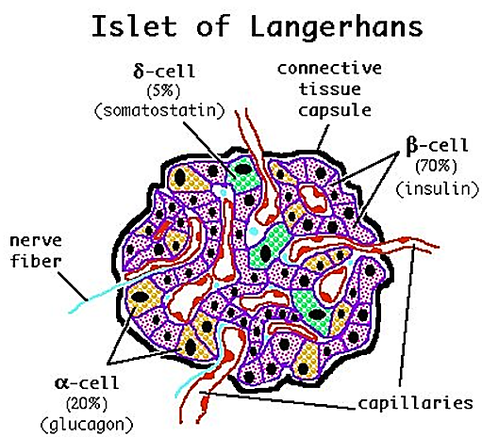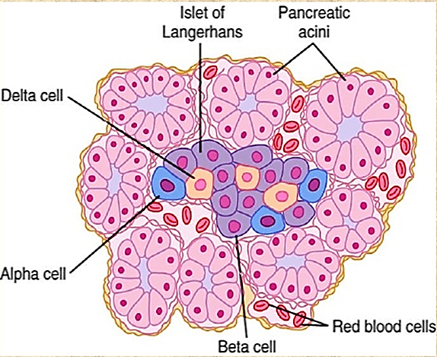
The islets of Langerhans contain three major types of cells
The islets of Langerhans beta cells, constituting about 60 percent of all the cells of the islets, lie mainly in the middle of each islet and secrete insulin and amylin, a hormone that is often secreted in parallel with insulin, although its function is not well understood.
The islets of Langerhans alpha cells, about 25 percent of the total, secrete glucagon
The islets of Langerhans delta cells, about 10 percent of the total, secrete somatostatin.
In addition the PP cell, is present in small numbers in the islets and secretes a hormone of uncertain function called pancreatic polypeptide.
A and D cells and pancreatic polypeptide-secreting cells are generally located around the periphery of the islets, with the B cells in the center.
There are clearly two types of islets, glucagon-rich islets and pancreatic polypeptide-rich islets, but the functional significance of this separation is not known.
The islet cell hormones released into the ECF probably diffuse to other islet cells and influence their function
Insulin
Insulin chemistry and synthesis:
Insulin is a small protein (molecular weight of 5808). 51 amino acids
Insulin is composed of two amino acid chains that are connected to each other by disulfide linkages. When the two amino acid chains are split apart, the functional activity of the insulin molecule is lost.
The gene for insulin is located on the short arm of chromosome 11 in human .Pre-pro-insulin has a 23-amino-acid signal peptide (leader sequence) removed as it enters the endoplasmic reticulum. The remainder of the molecule is then folded, and the disulfide bonds are formed to make Pro-insulin.
The pro-insulin is composed of the A and B chains connected by disulfide linkages, and the C chain peptide, called connecting peptide (C peptide).
C peptide is removed at Golgi apparatus
C peptide and insulin are packaged in the secretory granules and secreted in equi-molar amounts.
C peptide and separated disulfide insulin, pro-insulin have virtually no insulin activity.
C peptide levels can be measured in insulin-treated diabetic patients to determine endogenous (how much of their own natural) insulin they are still producing.
The insulin circulates almost entirely in an unbound form.
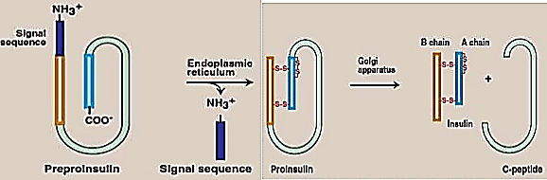
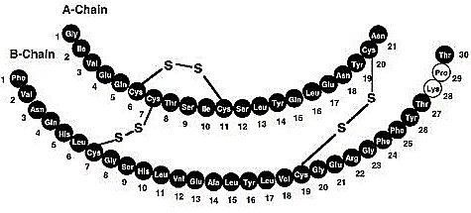
The insulin has a plasma half-life that averages only about 6 minutes, it is mainly cleared from the circulation within 10 to 15 minutes.
The insulin is degraded by the enzyme insulinase mainly in the liver, to a lesser extent in the kidneys and muscles, and slightly in most other tissues.
Plasma contains a number of substances with insulin-like activity in addition to insulin (insulin-like growth factors IGF). There are two types of insulin-like growth factors (IGF-I and IGF-II). The insulin-like activities of IGF-I and IGF-II are weak compared to that of insulin (only 10% of insulin activity).
Insulin receptor
Insulin receptor molecular weight of about 300,000
The insulin receptor is a combination of four subunits held together by disulfide linkages:
two alpha subunits that lie entirely outside the cell membrane
two beta subunits that penetrate through the membrane, protruding into the cell cytoplasm and has tyrosine kinase activity. Thus, the insulin receptor is an example of an enzyme-linked receptor
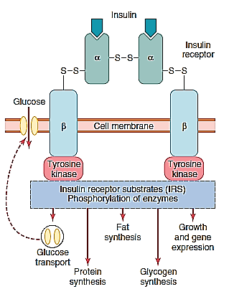
The insulin binds with the alpha subunits on the outside of the cell
▼
The beta subunits protruding into the cell will become auto-phosphorylated
▼
Auto-phosphorylation activates a local tyrosine kinase,
▼
Local tyrosine kinase phosphorylat of multiple other intracellular enzymes, including a group called insulin-receptor substrates (IRS). Different types of IRS (e.g., IRS-1, IRS-2, and IRS-3) are expressed in different tissues
▼
Begin of physiological action of insulin
When insulin binds to its receptors, the insulin-receptors aggregate in patches and are taken into the cell by receptor-mediated endocytosis. Eventually, the insulin-receptor complexes enter lysosomes, where the receptors are presumably broken down or recycled. The half-life of the insulin receptor is about 7 hours. The number or the affinity, or both, of insulin receptors is affected by insulin and other hormones, exercise, food, and other factors.
The number of receptors per cell is decreases concentration (down regulation) in
Exposure to increased amount of insulin, obesity acromegaly, diabetes type two
The number of receptors per cell is increased concentration (up regulation) in
Exposure to decreased insulin levels starvation exercise
The affinity of the receptors is increases by adrenal insufficiency and decreased insulin levels
The affinity of the receptors is decreased by excess glucocorticoid increase insulin levels
Insulin in turn causes rapid uptake, storage, and use of glucose by almost all tissues of the body especially (i.e. insulin activity) by the muscle, adipose tissue and liver. Insulin has NO effect on brain, RBC, kidney, intestine, β cell of island of Langerhans
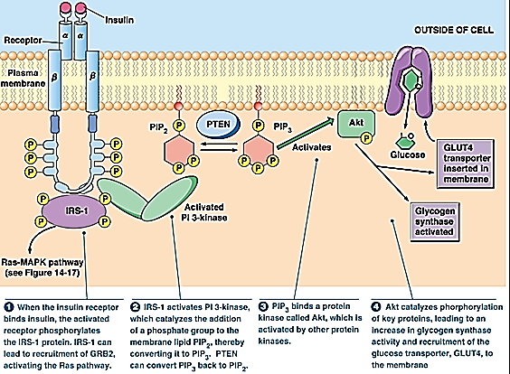
Principal actions of insulin.
The only mechanism by which cells can take up glucose is by facilitated diffusion through a family of hexose transporters, hexose transporters is of two types
a. Transport hexoses down a concentration gradient by GLUT: GLUcose Transporter.
The glucose transporters that are responsible for facilitated diffusion of glucose across cell membrane. The glucose transporters are a family of closely related proteins that cross the cell membrane 12 times. The glucose transporters have their amino and carboxyl terminal inside the cell.
Five of the 12 putative trans-membrane helical segments (segments 3, 5, 7, 8, and 11) are capable of forming the walls of a water-filled pathway through which glucose traverses the lipid bilayer through conformation changes where the glucose is released inside the cell.
Twelve different glucose transporters called in order of discovery GLUT 1 through GLUT 12
The glucose transporters contain 492 to 524 amino acid residue and their affinity for glucose varies.
Each transporter, appear to have evolved for special task
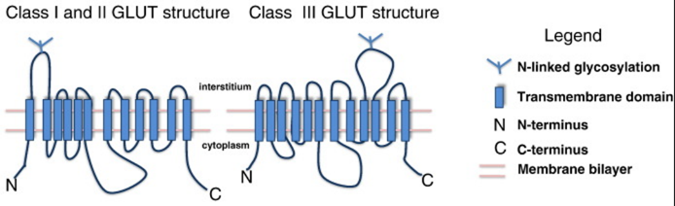
b. Transport hexoses against a concentration gradient using energy provided by an electrochemical gradient of sodium, which is co-transported with the hexose (SGLUT1, SGLUT2); SGLUT: Sodium GLUcose Transporter
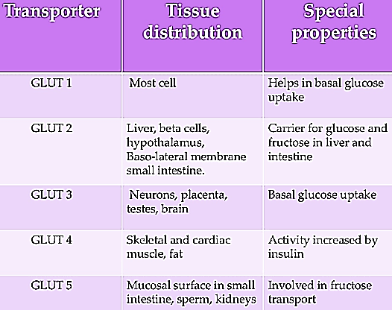
Metabolic effect of insulin on glucose level:
The most important effect of insulin is to decrease blood glucose level by:
First Short term: facilitate entry of glucose from blood to tissues
Second intermediate term: the excess amount of glucose with be transfer to glycogen by then liver and muscle to less extent
Third long term: if there will be still more glucose; it will be converted to fat by the liver and to less extent by adipose tissue
Immediately after a high-carbohydrate meal is consumed, glucose that is absorbed into the blood causes rapid secretion of insulin. The insulin in turn causes rapid uptake, storage, and use of glucose by almost all tissues of the body (about 80 percent of the body’s cells)
Insulin promotes muscle glucose uptake and metabolism
GLUT 4 is the transporter in muscle and adipose tissue that is stimulated by insulin. A pool of GLUT 4 molecules is maintained in vesicles in the cytoplasm of insulin-sensitive cells. When the insulin receptors of these cells are activated, the vesicles move rapidly to the cell membrane and fuse with it, inserting the receptors into the cell membrane. Activation of the insulin receptor brings, about the movement of the vesicles to the cell membrane by activating phosphoinositide Kinase, but how this activation triggers vesicle movement is still unsettled.
When insulin action ceases, the transporter-containing patches of membrane are endocytosed, and the vesicles are ready for the next exposure to insulin.
When insulin is no longer available, these vesicles separate from the cell membrane within about 3 to 5 minutes and move back to the cell interior to be used again and again as needed
Most of the other GLUT transporters that are not insulin-sensitive appear to stay in the cell membrane.
In the tissue in which insulin increase the number of glucose transporters in the cell membrane , the rats of phosphorylation of the glucose , once it has entered the cells , regulated by other hormones .
Growth hormone and cortisol both inhibit phosphorylation in certain tissues. However, the process is normally so rapid that it is a rat-limiting step in glucose metabolism only when the rat of glucose entry is high.
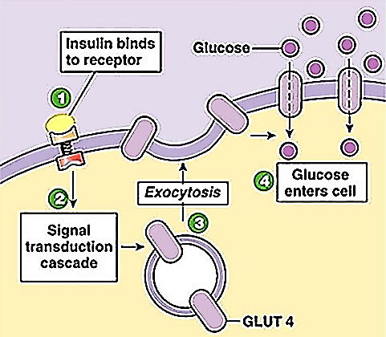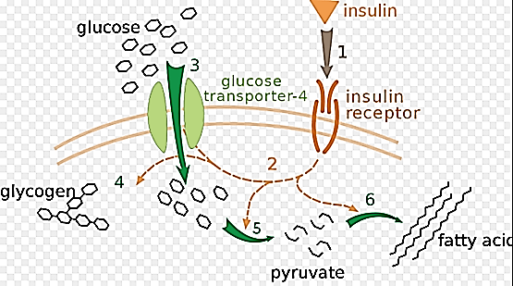
During much of the day, resting muscle tissue depends not on glucose but on fatty acids for its energy.
Most of the day (between meal + sleeping) ►Low glucose ►low insulin ►Low glucose entry
Most of the day (between meal + sleeping) ►Fat enter to muscle with no help of insulin
Under two conditions the muscles do use large amounts of glucose.
One is during moderate or heavy exercise.
The entry of glucose into skeletal muscle is increased during exercise in the absence of insulin (i.e. decrease use of insulin) by causing an insulin-independent increase in the number of GLUT 4 transporters in muscle cell membranes. This increase in glucose entry persists for several hours after exercise, and regular exercise training can also produce prolonged increases in insulin sensitivity.
Second during the few hours after a meal.
After meal ►increase glucose ►increase insulin ►increase enter of glucose
It is clear that insulin can increase the rate of transport of glucose into the resting muscle cell by at least 15-fold.
B. Under the influence of insulin cell membrane becomes more permeable to many of the amino acids, potassium ions, and phosphate ions, causing increased transport of these substances into the cell.
Insulin Promotes Protein Synthesis and Storage
Proteins, carbohydrates, and fats are stored in the tissues during the few hours after a meal when excess quantities of nutrients are available in the circulating blood; insulin is required for this storage to occur. The manner in which insulin causes protein storage is not as well understood as the mechanisms for both glucose and fat storage. Here are some of the facts:
Insulin stimulates transport of many of amino acids into the cells.
Insulin increases the translation of messenger RNA.
Insulin increases the rate of transcription of selected DNA genetic sequence.
Insulin inhibits the catabolism of protein.
Insulin depresses the rate of gluco-neo-genesis in the liver
In summary, insulin promotes formation of protein and prevents degradation of proteins
Insulin Promotes K entry to cells
Insulin causes K to enter cells, with a resultant lowering of extra-cellular K concentration. Influence of insulin and glucose significantly lower the plasma K level in normal individuals and are very effective for temporary relief of hyperkalemia in patients with renal failure. Insulin increases the activity of Na-K ATP_{ase} in cell membrane, so that more K is pumped into cells.
Regulation of insulin secretion:
1. Plasma Glucose level
a. Effects of the plasma glucose level on insulin plasma level:
As the blood glucose concentration rises above 100 mg/100 ml of blood, secretion of insulin rises rapidly, reaching a peak some 10 to 25 times the basal level at blood glucose concentrations between 400 and 600 mg/100 ml
The action of glucose on insulin secretion is biphasic (i.e. insulin secretion increases markedly in two stages)
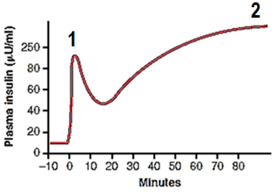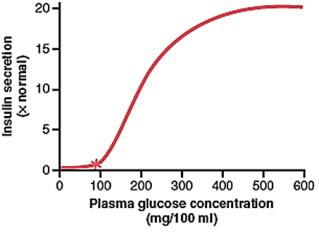
A. The concentration of insulin in plasma increases almost 10-fold within 3 to 5 minutes after acute elevation of the blood glucose. This increase results from immediate dumping اغراقof preformed insulin from the beta cells of the islets of Langerhans. However, the initial high rate of secretion is not maintained; instead, the insulin concentration decreases about halfway back toward normal in another 5 to 10 minutes. The initial response is due to release of performed insulin by increased cytoplasmic Calcium.
B. Beginning at about 15 minutes, insulin secretion rises a second time and reaches a new plateau in 2 to 3 hours, this time usually at a rate of secretion even greater than that in the initial phase. This secretion results both from the additional release of preformed insulin and from activation of the enzyme system that synthesizes and releases new insulin from the cells.
The feedback control of plasma glucose on insulin secretion normally operates with great precision احكام, so that plasma glucose and insulin level parallel each other with remarkable consistency.
b. Mechanism of release of insulin from B cell
The major control of insulin secretion is exerted by a feedback effect of plasma glucose directly on the B cells of the pancreas.
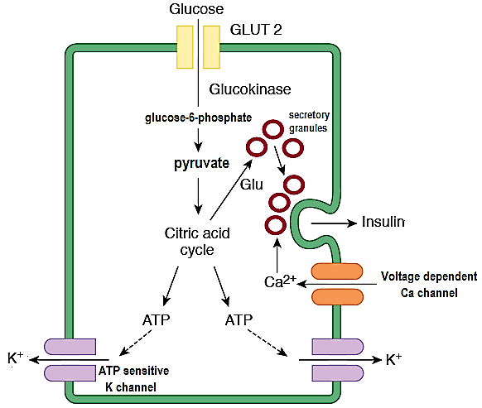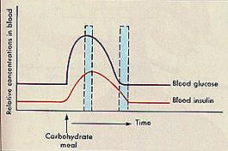
Glucose enters B cells via the GLUT 2 transporter, (which is present in large amounts and does not depend on insulin for activation)

Once inside the cells glucose is phosphorylated to glucose-6-phosphate by glucokinase
This phosphorylation appears to be the rate-limiting step for glucose metabolism in the beta cell and is considered the major mechanism for glucose sensing and adjustment of the amount of secreted insulin to the blood glucose levels.

Glucose-6-phosphate then metabolized to pyruvate in the cytoplasm.

The pyruvate enters the mitochondria and is metabolized to CO2 and H2O via the citric acid cycle with the formation of ATP by oxidation phosphorylation.

The ATP enters the cytoplasm, where it inhibits ATP-sensitive K channels. The resultant decrease in K efflux depolarizes the cell membrane.

This opens voltage-sensitive Ca channels and Ca enters the cells. The increase in intra-cellular Ca triggers release of insulin by exocytosis.
Sulfonylurea drugs (e.g., tolbutamide, glyburide) stimulate insulin secretion by closing these K+ channels.
Metabolism of pyruvate via the citric acid cycle also causes an increase in intra-cellular glutamate. The glutamate appears to act on second pool of secretary granules, committing them to the reliable form. The action of glutamate may be to decrease the pH in the secretary granules, a necessary step in maturation. The release of these granules then produces the prolonged second phase of the insulin response to glucose. Thus, glutamate appears to act as an intracellular second messenger that primes يعبي ينضجsecretary granules for secretion.
Mannose also stimulates insulin secretion, so dose fructose which is converted to glucose intra-cellularly.
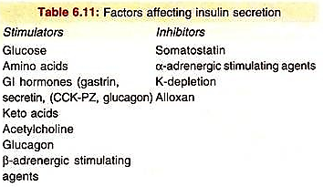
2. Protein and fat derivatives:
The most potent of these amino acids are arginine and lysine.
Amino acids administered in the absence of a rise in blood glucose cause only a small increase in insulin secretion. Thus, amino acids strongly potentiate the glucose stimulus for insulin secretion.
The stimulation of insulin secretion by amino acids is important because the insulin in turn promotes transport of amino acids into the tissue cells, as well as the intracellular formation of protein
3. Autonomic nerve:
The pancreas islets are richly innervated with sympathetic and parasympathetic nerves.
Stimulation of the parasympathetic nerves to the pancreas can increase insulin secretion during hyperglycemic conditions, whereas sympathetic nerve stimulation may increase glucagon secretion and decrease insulin secretion during hypoglycemia.
Alpha 2 adrenergic receptors inhibit insulin release
Beta 2 adrenergic receptors stimulate insulin release
The effects of glucose do not require intact innervations, since they occur in the transplanted pancreas, but there is some evidence that the nerve fibers maintain normal islet sensitivity to glucose
Glucose concentrations are believed to be detected by specialized neurons of the hypothalamus and brain stem, as well as by glucose-sensing cells in peripheral locations such as the liver.
4. Effects of K depletion:
K depletion decrease insulin secretion.
5. Gastrointestinal Hormones
A. Incretin
It was observed that insulin response to oral glucose exceeded that of intravenous glucose administration. This is why it was concluded that factors in gut, or incretins, affected the release of insulin after a meal is consumed. When nutrients enter the stomach and intestines, incretin hormones are released which stimulates insulin secretion.
Incretin effect:
i. Insulin synthesis and release:
Incretins are a group of GI hormones that cause an increase in the amount of insulin release from the beta cell of the islets of Langerhans after eating, even before blood glucose levels become elevated.
ii. Suppression of glucagons,
iii. Slowing gastric emptying, bowel motility and acid secretion,
iv Increasing satiety شبع and decrease food intake
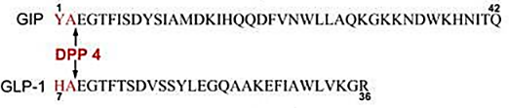
The two main candidate molecules that fulfill criteria for an incretin are:
Glucagon like peptide-1 (GLP-1):
GLP-1 is a product of the glucagons gene.
GLP-1 secretion is caused by endocrine and neural signal started when nutrients enter the GIT. Within minutes of food ingestion, GLP-1 level rise rapidly.
Gastric inhibitory peptide (also known as: glucose-dependent insulin-tropic polypeptide or GIP).
Both GLP-1 and GIP are rapidly inactivated by the enzyme di-peptidyl peptidase-4 (DPP-4).
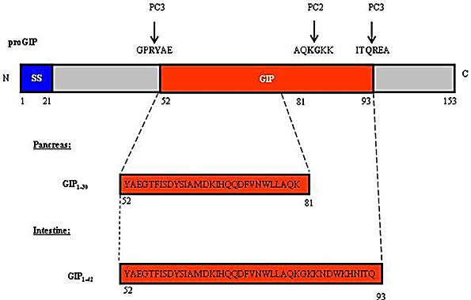
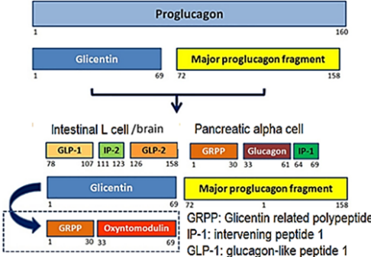
Over lapping and contrasting actions of GLP-1 and GIP
GLP-1 | GIP
1. Is 30 amino acid peptide | 1. Is 42 amino acid peptide
2.Released from L-cell in ileum and colon | 2. Released from K-cell in duodenum and proximal jejunum
3. Stimulate insulin release from beta cell in glucose dependent manner | 3. Stimulate insulin release from beta cell in glucose dependent manner
4. Inhibit gastric emptying | 4. minimal effect on gastric emptying
5. Reduce food intake and body weight | 5. insignificant effect on satiety or food intake
6. Inhibits glucagon secretion from alpha cell | 6. no effect on glucagon secretion from alpha cell
7. Significantو كبير واضحeffect on beta cell growth and survival | 7. Potential محتملeffect on beta cell growth and survival
8. preserved يحافضInsulino-tropic action in type-2 diabetes (stimulating or affecting the production and activity of insulin) | 8. Defective ناقص او قليلInsulino-tropic action preserved in type-2 diabetes
B. Other GIT hormones: secretin, cholecystokinin (CCK), gastrin
Serum secretin levels rose rapidly after the oral ingestion of glucose or protein and preceded the elevation of serum insulin. An intravenous infusion of highly purified secretin caused a release of insulin when the serum secretin levels were within the physiological range
C. Other hormones that either directly increase insulin secretion or potentiate the glucose stimulus for insulin secretion include glucagon, growth hormone, cortisol, and, to a lesser extent, progesterone and estrogen.
Amylin
Amylin is a naturally occurring hormone that is co-secreted from β-cells with insulin.
People with diabetes have either a relative or complete lack of amylin.
Amylin has three major mechanisms of action:
Suppression of post-meal glucagon secretion,
Regulation of the rate of gastric emptying from the stomach to the small intestine
The suppression of appetite
Insulin Deficiency (Diabetes Mellitus):
Long-term changes in B cell responses:
Although the B cells respond to stimulation with hypertrophy like other endocrine cells, they become exhausted and stop secretion (B cell exhaustion) when the stimulation is marked or prolonged. Exhaustion of the remaining B cell can produce by procedure that chronically raises the plasma glucose level. This is the cause of diabetes produced in animals with limited pancreatic reserves by anterior pituitary extracts , growth hormones , or the prolonged continuous infusion of glucose alone .The diabetes precipitated by hormones in animals is at first reversible , but with prolonged treatment it become permanent .
Pathophysiology of Diabetes Mellitus
1. Type 1 Diabetes Mellitus:
Type 1 DM, previously referred to as insulin-dependent or juvenile-onset DM constitutes 5% to 10% of all diagnosed cases of DM.
Type 1 DM usually is diagnosed in children and adults younger than 30 years of age, although the disease can present at any age.
Type 1 DM is an autoimmune disease in which insulin production β-cell in the pancreas destroyed, leaving the individual insulin-deficiency.
Pathogenesis:
1. Genetic factor:
Numerous susceptibility loci (genes that predispose to type I DM) have been found. Several of these loci are located in major histo-compatibility complex (MHC) region on the short arm of chromosome 6 which contains genes that regulate the immune response. The incidence is greatly increased in individuals with a specific point mutation in HLA-DQ and DR gene. Over 95% of people with Type 1 DM have HLA-DR3 and HLA-DR4 mutation present.
2. Viral infection:
Epidemics of viral infections in the winter months are associated with increase in the incidence of DM. Several viruses (e.g. coxsakie B, entro-viruses, rubella, mump, and cyto-megalo-virus) have been implicated in the etiology of type I DM.
3. Environmental factors:
a. Nutritional:
Brest feeding seems to provide protection against the risk of developing type I DM. Many new patients with type I DM have IgG antibodies to bovine serum albumin (protein in cow milk) with similarities to islet cell antigen.
b. Stress:
The cause of this is unclear but may relate to stress-induced impairment of resistance to infection in genetically susceptible individuals.
Antibody development:
In addition, these individuals often develop auto-antibodies
Anti-beta islet cell antibodies,
Insulin auto-antibodies, or
Glutamic acid decarboxylase autoantibodies
Insulinoma-associated-2 autoantibodies
More than 90% of persons with Type 1 DM have at least one diabetes-related antibodies present.
As more β-cells are destroyed, glucose metabolism becomes compromised due to reduced insulin release following a glucose load. At time of diagnosis, most patients have a 90% loss of β-cell function. The remaining 10% of β-cell function at diagnosis creates "honeymoon period" during which blood glucose levels are easier to control and smaller amount of insulin are required. Once this remaining β-cell function is lost, patient become completely insulin-deficient and require more exogenous insulin.
Diagnosis of Type 1 DM occurs before the age of 30 in approximately 70% of patents.
Approximately one in 400 people under the age of 20 are diagnosed with Type 1 DM.
2. Type 2 Diabetes Mellitus,
Type 2 DM previously referred to as adult-onset or non-insulin- dependent DM, is the most prevalent form of the disease and accounts for approximately 90% to 95% of all diagnosed cases.
How to differential between type 1DM & type 2 DM:
Measurement of C-peptide levels, insulin levels, and auto-antibodies can be used to distinguish between Type 1 DM and Type 2 DM. It has been suggested that the easiest way to differentiate between type 1 and type 2 DM is by measuring C-peptide levels. People with Type 1 diabetics have C-peptide levels below 1 ng/mL, whereas those with type 2 disease will have values greater than 1 ng/mL.
Risk factors for type 2 diabetes include:
• Pre-diabetes (i.e., previously identified with impaired glucose tolerance or impaired fasting glucose)
Type 2 DM is usually slow and progressive in its development and often is preceded by pre-diabetes.
The development of pre-diabetes places the individual at high risk of eventually developing diabetes.
It is currently estimated that 41 million persons in the United States have pre-diabetes.
Type 2 diabetes is usually slow and progressive in it is development and is often preceded by pre-diabetes.
• First-degree family history of DM (i.e., parents or siblings)
The genetic component in type 2 diabetes is actually stronger than the genetic component in type 1 diabetes. In some patients, type 2 diabetes is due to defects in identified genes. Over 60 of these defects have been described. They include defects in glucokinase (about 1% of the cases), the insulin molecule itself (about 0.5% of the cases), the insulin receptor (about 1% of the cases), GLUT 4 (about 1% of the cases), or IRS-1 (about 15% of the cases).
• Overweight or obese
• Habitual physical inactivity
• Race or ethnicity (Native American, Latino/Hispanic-American, Asian-American, African-American)
• Hypertension (Greater than or equal to 140/90 mm Hg)
• High-density lipoprotein (HDL) less than 35 mg/dL (0.91mmol/L) and/or a triglyceride level greater than 250 mg/dL (2.83 mmol/L)
• History of
a. gestational diabetes or delivery of a baby weighing greater than 9 pounds (4.09 Kg)
b. vascular disease
c. polycystic ovary disease
d. Other conditions associated with insulin resistance (e.g., acanthosis nigricans)
Insulin Resistance
Insulin resistance (IR) is a physiological condition where the natural hormone insulin becomes less effective at lowering blood sugars.
Insulin resistance is impaired biological responses to insulin
Insulin resistance is the primary factor that differentiates type 2 DM from other forms of diabetes.
Insulin resistance may be present up to 10 years prior to the diagnosis of DM and can continue to progress throughout the course of the disease.
Insulin resistance occurs most significantly in skeletal muscle and the liver.
Insulin resistance in the liver poses a double threat because the liver becomes non-responsive to insulin for glucose uptake, and hepatic production of glucose after meal does not cease, which leads to elevated fasting and post-meal blood glucose levels
Metabolic syndrome is a constellation مجموعة متآلفة of cardiovascular risk factors related to: hypertension, abdominal obesity, dyslipidemia, and insulin resistance.
The risk of developing IHD and related complications is two-fold higher in patients with metabolic syndrome. Therefore, detection and appropriate management of these patients is important. While there are several criteria used to diagnose metabolic syndrome, those endorsed by the National Cholesterol Education Program are probably the most widely accepted. To diagnose metabolic syndrome, patients must meet at least three of the following criteria:
• Increased waist circumference (greater than 40 inches or 102 cm in males and greater than 35 inches or 89 cm in females).
• Triglycerides of 150 mg/dL (1.70 mmol/L) or greater or active treatment to lower triglycerides.
• Low high-density lipoprotein (HDL) cholesterol (less than 40 mg/dL or 1.04 mmol/L in males and less than 50 mg/dL or 1.3 mmol/L in females) or active treatment to raise HDL cholesterol.
• Blood pressure of 130/85 mm Hg or greater or active treatment with antihypertensive therapy.
• Fasting blood glucose of 100 mg/dL (5.55 mmol/L) or greater or active treatment for diabetes.
Other hormonal irregularities, primarily glucagon, are key problem with type 2 DM.
Various disease states make body tissues more resistant to the actions of insulin include:
1. Insulin resistance is often found in people with:
Hypertension,
Hyperglycemia
Dyslipidemia
Overweight
A. Obesity
The majority of people the type 2 DM are overweight an increasing number of cases in children have been observed.
Greater weight means a higher risk of insulin resistance, because fat interferes with the body's ability to use insulin.
The adverse effect of obesity on glucose metabolism is evident early in childhood.
Furthermore, the inverse relationship between insulin and abdominal fat is strong for visceral than for subcutaneous fat.
It is interesting to note that adipose tissue expanding in obese state synthesize and secret metabolites and signaling proteins such as adiponectin, tumor necrotic factor-alpha, leptin and resistin. These factors are known to alter insulin secretion and sensitivity and even cause insulin resistance.
B. visceral adiposity
Visceral adiposity (i.e., a high degree of fatty tissue within the abdomen – as distinct from subcutaneous adiposity or fat between the skin and the muscle wall, especially elsewhere on the body, such as hips or thighs),
With respect to visceral adiposity, a great deal of evidence suggests two strong links with insulin resistance.
First, unlike subcutaneous adipose tissue, visceral adipose cells produce significant amounts of pro-inflammatory cytokines such as tumor necrosis factor-alpha (TNF-α), Interleukins -1,6 and 18 transforming growth factor-β, monocyte chemotactic protein-1 RBP4, retinol binding protein 4; serum amyloid A
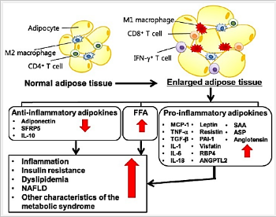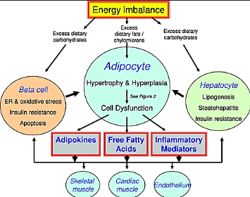
Visceral adipose cells→ pro-inflammatory cytokines → disrupt normal insulin action→ insulin resistance
Second, visceral adiposity is related to an accumulation of fat in the liver, a condition known as nonalcoholic fatty liver disease (NAFLD). The result of NAFLD is an excessive release of free fatty acids into the bloodstream (due to increased lipolysis), and an increase in hepatic glucose production, both of which have the effect of exacerbating peripheral insulin resistance and increasing the likelihood of Type 2 diabetes mellitus.
Visceral adipose cells→ nonalcoholic fatty liver disease →free fatty acids into the bloods + ↑ hepatic glucose production→ insulin resistance
2. Infection (mediated by the cytokine TNF-α) and acidosis.
3. Certain drugs may be associated with insulin resistance (e.g., glucocorticoids).
4. Insulin resistance is often associated with a hyper-coagulable state (impaired fibrinolysis) and increased inflammatory cytokine levels.
5. Insulin resistance is occasionally found in patients who use insulin.
In this case, the production of antibodies against insulin leads to lower-than-expected glucose level reductions (glycemia) after a specific dose of insulin.
With the development of human insulin and analogues in the 1980s and the decline in the use of animal insulin (e.g., pork, beef), this type of insulin resistance has become less common. This form of insulin resistance is not what is being referred to in the metabolic syndrome.
6. Magnesium (Mg) is present in living cells and its plasma concentration is remarkably constant in healthy subjects.
Plasma and intracellular Mg concentrations are tightly regulated.
With normal insulin-insulin receptor function, a signal is sent to the Na2+/Mg2+ pump and this is thought to be the mechanism for magnesium transport into cells.
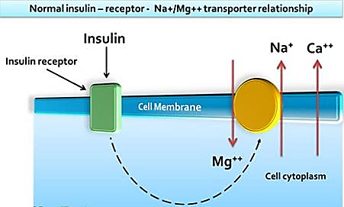
Magnesium may act as Calcium blocker
Sub-optimally low extracellular levels of magnesium (as with low magnesium intake or insulin resistance or both) will allow the calcium channels to stay open allowing an influx of calcium into cells. Having an optimal level of magnesium, allows this mineral to act as a calcium channel blocker. This could have the
Offset calcium-related excitation-contraction coupling,
Decrease smooth cell responsiveness to depolarizing stimuli.
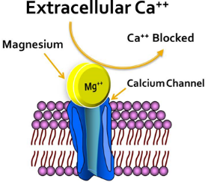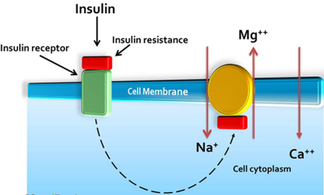
Insulin has a significant effect on intracellular magnesium stores
Insulin may modulate the shift of Mg from extracellular to intracellular space
Magnesium depletion is common in both insulin resistance and type-1 diabetes mellitus
Poor intracellular Mg concentrations, as found in Type 2 diabetes mellitus and in hypertensive patients, may result in a defective tyrosine-kinase activity at the insulin receptor level (means no phosphorylation of insulin receptors i.e. it will be NOT active) and exaggerated intracellular calcium concentration. Both events are responsible for impairment in insulin action, and a worsening of insulin resistance in noninsulin-dependent diabetic and hypertensive patients.
Type 2 diabetes mellitus → Poor intracellular Mg→ defective tyrosine-kinase activity +↑ intra-cellular calcium concentration→ impairment insulin action→ insulin resistance
Intracellular Mg concentration has been shown to be effective in modulating insulin action (mainly oxidative glucose metabolism),
By contrast, in Type 2 diabetes mellitus patients daily Mg administration, restoring a more appropriate intracellular Mg concentration, contributes to improve insulin-mediated glucose uptake.
The benefits deriving (from daily Mg supplementation in type 2 diabetes mellitus patients are further supported by epidemiological studies showing that high daily Mg intake are predictive of a lower incidence of type 2 diabetes mellitus
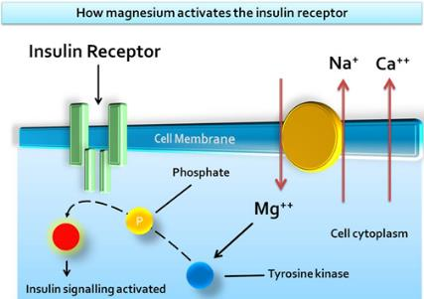
Glucagon
Glucagon, a hormone secreted when the blood glucose concentration falls
Glucagon most important of these functions is to increase the blood glucose concentration, an effect that is opposite to that of insulin.
When the blood glucose concentration falls, 1μg/kg of glucagon can elevate the blood glucose concentration about 20 mg/100ml of blood (a 25 % increase). For this reason, glucagon is also called the hyperglycemic hormone
Glucagon molecular weight of 3485 and is composed of a chain of 29 amino acids.
Glucagon has a half-life in the circulation of 5 to 10 minutes.
A. Effects of glucagon on glucose metabolism
The major effects of glucagon on glucose metabolism are
First: Breakdown of liver glycogen (glycogenolysis)
Infusion of glucagon for about 4 hours can cause such intensive liver glycogenolysis that all the liver stores of glycogen become depleted.
Second: Increased gluconeogenesis in the liver
Glucagon increase the rate of amino acid uptake by the liver cells and then the conversion of many of the amino acids to glucose by gluconeogenesis.
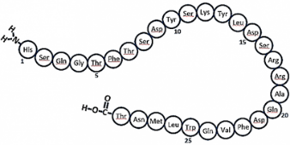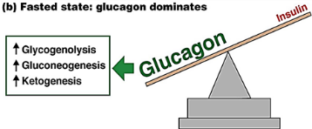
B. Other Effects of Glucagon
Most other effects of glucagon occur only when its concentration rises well above the maximum normally found in the blood.
i. Effect of glucagon on fat metabolism
a. Glucagon activates adipose cell lipase, making increased quantities of fatty acids available to the energy systems of the body. Perhaps this is the most important effect
b. Glucagon inhibits the storage of triglycerides in the liver, which prevents the liver from removing fatty acids from the blood; this also helps make additional amounts of fatty acids available for the other tissues of the body.
ii. Glucagon has positively inotropic effects on the heart without producing increased myocardial excitability
iii. Glucagon increases blood flow in some tissues, especially the kidneys;
iv. Glucagon enhances bile secretion
v. Glucagon inhibits gastric acid secretion.
vi. Glucagon has calorigenic effect
These effects of glucagon are probably of much less importance in the normal function of the body compared with its effects on glucose.
Regulation of glucagon secretion:
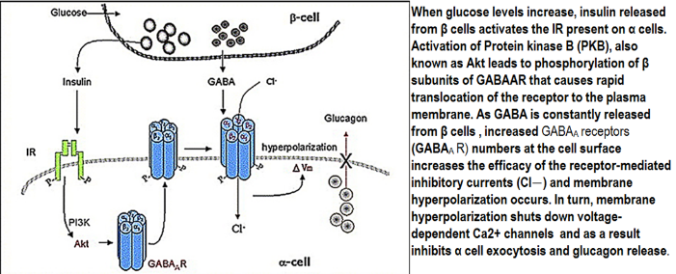
1 .Blood glucose level:
Secretion of glucagon is increased by hypoglycemia and decreased by a rise in plasma glucose.
Pancreatic B cells contain GABA, and evidence suggests that coincident صدفةwith the increased insulin secretion produced by hyperglycemia, GABA is released and acts on the A cells to inhibit glucagon secretion by activating GABA_{A} receptors. The GABA_{A} receptors are Cl– channels, and the resulting Cl– influx hyperpolarizes the A cells.
2. Protein level:
A protein meal and infusion amino acids especially the amino acids (alanine and arginine) increase glucagon.
Glucagon secretion increases during starvation. It reaches a peak on the third day of a starvation.
The glucagon response to oral administration of amino acids is greater than the response to intra-venous infusion of amino acids, suggesting that a glucagon-stimulating factor is secreted from the GIT mucosa. CCK and gastrin increase glucagon secretion, whereas secretin inhibits it.
3. Fat level:
Glucagon secretion is inhibited by FFA and Ketones.
4. Exercise:
During exercise, there is an increase in glucose utilization that is balanced by an increase in glucose production caused by an increase in circulation glucagon levels.
The stimulatory effects of various stresses and possibly of exercise and infection are mediated at least in part via the sympathetic nervous system
5. Autonomic control:
Secretion is also increased by stimulation of the sympathetic stimulation; and this sympathetic effect is mediated via β-adrenergic receptors and cAMP.
The effect of β-receptors predominates in the glucagon-secreting cells than insulin-secretion cell
Parasympathetic stimulation stimulate secretion of glucagon
Somatostatin
Somatostatin 14 (SS 14) and its amino terminal-extended form somatostatin 28 (SS 28) are found in the D cells of pancreatic islets, SS 28 is more active than SS 14 in inhibiting insulin secretion
Somatostatin has an extremely short half-life of only 3 minutes in the circulating blood.
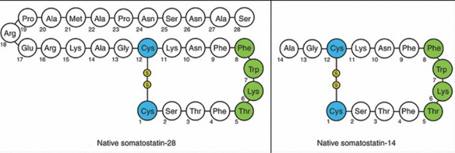
Somatostatin is secreted by almost all factors related to the ingestion of food stimulate:
(1) Increased blood glucose,
(2) Increased blood amino acids,
(3) Increased blood fatty acids, and
(4) Increased concentrations of several of the gastrointestinal hormones released from the upper gastrointestinal tract in response to food intake.
Somatostatin has multiple inhibitory effects, as follows:
1. Somatostatin acts locally within the islets of Langerhans themselves to depress secretion of both insulin and glucagon.
2. Somatostatin decreases motility of the stomach, duodenum, and gallbladder.
3. Somatostatin decreases both secretion and absorption in the gastrointestinal tract.
In putting all this information together, it has been suggested that the principal role of somatostatin is to extend the period over which the food nutrients are assimilated into the blood. At the same time, the effect of somatostatin in depressing insulin and glucagon secretion decreases utilization of the absorbed nutrients by the tissues, thus preventing rapid exhaustion of the food and therefore making it available over a longer period.
Somatostatin is released from:
the pancreas and
the gastrointestinal tract into the peripheral blood
the hypothalamus as growth hormone inhibitory hormone
Human pancreatic polypeptide
Human pancreatic polypeptide is a linear polypeptide that contains 36 amino acid residues and is produced by F cells in the islets.
Human pancreatic polypeptide is closely related to two other 36-amino acid polypeptides, polypeptide YY, a gastrointestinal peptide, and neuropeptide Y, which is found in the brain and the autonomic nervous system. All end in tyrosine and are amidated at their carboxyl terminal.
Human pancreatic polypeptide secretion is under cholinergic control; plasma levels fall after administration of atropine.
Human pancreatic polypeptide secretion is increased by
meal containing protein (Infusions of leucine, arginine, and alanine do not affect it, so the stimulatory effect of a protein meal may be mediated indirectly )
fasting,
exercise, and
acute hypoglycemia.
Secretion is decreased by
somatostatin and
intravenous glucose.
Pancreatic polypeptide slows the absorption of food in humans, and it may smooth out the peaks and valleys of absorption and is known to stimulate the gastric secretion of HCl and pepsin However, its exact physiologic function is still uncertain.
Organization of the pancreatic islets:
The presence in the pancreatic islets of hormones that affect the secretion of other islet hormones suggests that the islets function as secretory units in the regulation of nutrient homeostasis.
Somatostatin inhibits the secretion of insulin, glucagon, and pancreatic polypeptide;
Insulin inhibits the secretion of glucagon;
Glucagon stimulates the secretion of insulin and somatostatin.
Amylin inhibits insulin secretion
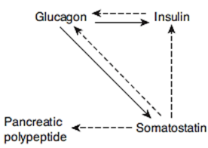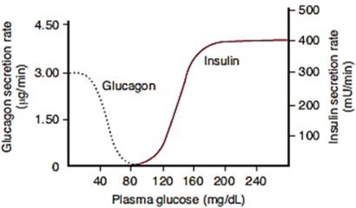
It has been demonstrated that gap junctions are present between A, B, and D cells and that these permit the passage of ions and other small molecules from one cell to another, which could coordinate their secretory functions.
The close interrelations among these cell types in the islets of Langerhans allow cell-to-cell communication and direct control of secretion of some of the hormones by the other hormones.
Insulin excess:
All the known consequences of insulin excess are manifestations, directly or indirectly, of the effects of hypoglycemia on the nervous system. Except in individuals who have been fasting for some time, glucose is the only fuel used in appreciable quantities by the brain. The carbohydrate reserves in neural tissue are very limited, and normal function depends upon a continuous glucose supply. As the plasma glucose level falls, the first symptoms are palpitation, sweating, and nervousness due to autonomic discharge. At lower plasma glucose level, so-called neuro-glycopenic symptoms begin to appear. These include hunger as well as confusion.
Compensatory mechanisms:
One important compensation for hypoglycemia is cessation of the secretion of endogenous insulin.
Inhibition of insulin secretion is complete at a plasma glucose level of about 80 mg/dL.
In addition, hypoglycemia triggers increased secretion of at least four counter-regulatory hormones: glucagon, epinephrine, growth hormone, and cortisol.
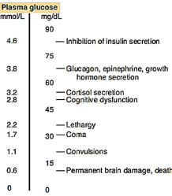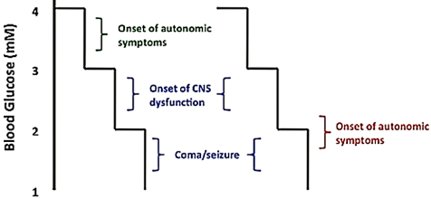
The epinephrine response is reduced during sleep.
Glucagon and epinephrine increase the hepatic output of glucose by increasing glycogenolysis.
Growth hormone decreases the utilization of glucose in various peripheral tissues, and
Cortisol decreases the utilization of glucose in various peripheral tissues
The keys to counter-regulation appear to be epinephrine and glucagon: if the plasma concentration of either increases, the decline in the plasma glucose level is reversed; but if both fail to increase, there is little if any compensatory rise in the plasma glucose level.
The actions of the other hormones are supplementary.
Note that the autonomic discharge and release of counter regulatory hormones normally occurs at a higher plasma glucose level than the cognitive deficits and other more serious CNS changes
Insulin Deficiency (Diabetes Mellitus):
The key features of insulin deficiency
First: effect of insulin deficiency on carbohydrate metabolism
Decreased entry of glucose entry of glucose into many tissues► decreased peripheral glucose utilization.
Increased net release of glucose from the liver (increased production), due in part to glucagon excess. The resultant hyperglycemia
a. blood hyper-osmolarity
b. there is glycosuria because the renal capacity for glucose reabsorption is exceeded► Excretion of the osmotically active glucose molecules entails the loss of large amounts of water (osmotic diuresis & polyuria ►dehydrating ► polydipsia (increase water intake).
In the face of intra-cellular glucose deficiency
appetite is stimulated
Deficient glucose utilization and deficient hormone sensing (insulin, leptin, CCK) in the cells of the hypothalamus that regulate satiety are the probable causes of hyperphagia in diabetes. The feeding area of the hypothalamus is not inhibited and thus satiety is not sensed so food intake is increased.
Glucose is formed from protein (gluconeogenesis)
Energy supplies are maintained by metabolism of proteins and fats.
All will causes Weight loss, debilitating protein deficiency, and inanition جوع
Second: Effect of insulin deficiency on protein metabolism
The increased gluconeogenesis in diabetes is due to, lack of insulin, increase Glucagon and Adrenal glucocorticoids
↑ Protein catabolism
▼
↑ Amino acid in blood
▼
↑ Gluconeogenesis + ↑ use of amino acid for energy
▼
Enhanced urea excretion in the urine
Both growth hormone and insulin function synergistically to promote growth, with each performing a specific function separate from that of the other.
So, both growth hormone and insulin should be present to have natural growth
Third: effect of insulin deficiency on fat metabolism
Increased Fat catabolism, and the system is flooded with triglycerides and free fat acid (FFA).
Decreased Fat synthesis
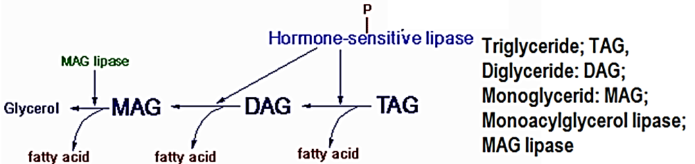
Adipose tissue
Lack of insulin
▼
The enzyme hormone-sensitive lipase in the fat cells becomes strongly activated
▼
This activation causes hydrolysis of the stored triglycerides,
▼
Releasing large quantities of fatty acids and glycerol into the circulating blood
▼
The plasma concentration of free fatty acids begins to rise within minutes. These free fatty acids then become the main energy substrate used by essentially all tissues of the body except the brain.
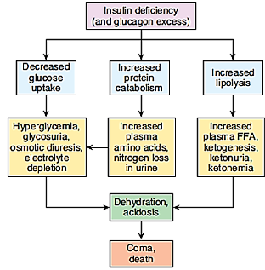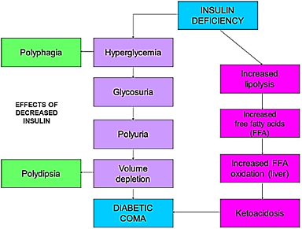
The fat of fatty acid formed from adipose tissue will depend on the degree of insulin deficiency:
A. Less Sever insulin deficiency:
Liver promotes conversion of the fatty acids into phospholipids and cholesterol.
+
Excess triglycerides formed at the same time in the liver, are then discharged into the blood
▼
Increase blood lipoprotein.
In diabetes, the plasma cholesterol level is usually elevated and this plays a role in the accelerated development of the atherosclerotic vascular disease that is a major long-term complication of diabetes in humans. The rise in plasma cholesterol level is due to an increase in the plasma concentration of very low density lipoprotein (VLDL) and low-density lipoprotein (LDL). These in turn may be due to increased hepatic production of VLDL or decreased removal of VLDL and LDL from the circulation.
A. Sever insulin deficiency:
Large amount of fatty acid formed from adipose tissue and will be transferred to the liver
▼
In the liver, fatty acid will be converter to acetyl Co-A which by itself converted to acetoacetic acid.
▼
Some of the acetoacetic acid is also converted into β-hydroxybutyric acid and acetone. These two substances, along with the acetoacetic acid, are called ketone bodies, and their presence in large quantities in the body fluids is called ketosis.
▼
Most of this acetoacetic acid passes to the peripheral cells, where it is again converted into acetyl-CoA and used for energy in the usual manner. Thus,
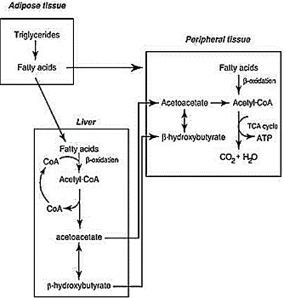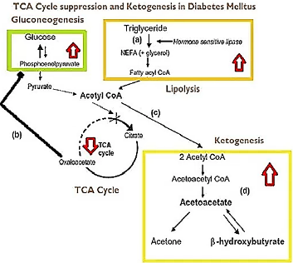
So much acetoacetic acid is released from the liver that it cannot all be metabolized by the tissues.
At the same time, the absence of insulin also depresses utilization of acetoacetic acid in peripheral tissues.
The ketones are for the most part organic acids, which accumulate in the circulation (ketosis)
▼
In severe diabetes, the acetoacetic acid and the β-hydroxybutyric acid can cause severe metabolic acidosis develops as the ketones accumulate and coma, which may lead to death.
The resulting acidosis stimulates respiration, producing the rapid, deep respiration described by Kussmaul as “air hunger” and named Kussmaul breathing. The urine becomes acidic. However, when the ability of the kidneys to replace the plasma cations accompanying the organic anions with H⁺ and NH4+ is exceeded, Na+ and K+ are lost in the urine. The electrolyte and water losses lead to dehydration, hypovolemia, and hypotension. Finally, the acidosis and dehydration depress consciousness to the point of coma. The hyperosmolarity of the plasma can also causes unconsciousness (hyperosmolar coma).
Long-standing Diabetes mellitus complications
A. The microvascular abnormalities are
diabetic retinopathy: proliferative scarring of the retina leading to blindness
diabetic nephropathy leading to renal failure.
B. The macrovascular abnormalities are due to accelerated atherosclerosis, which increased incidence of stroke and myocardial infarction.
C. diabetic neuropathy: involve the autonomic nervous system and peripheral nerves (motor and sensory)
The neuropathy plus the atherosclerotic circulatory in sufficiency in the extremities and reduced resistance to infection can lead to chronic ulceration and gangrene, particularly in the feet.
Many metabolic pathways have been suggested to be involved in the pathogenesis of these vascular complications.
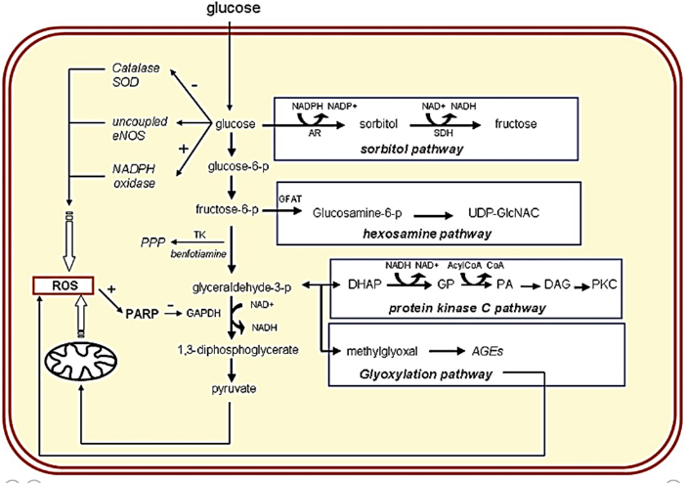
Some of the important pathways are,
I. Aldose reductase or Polyol pathway
II. Advanced glycation end product (AGE) pathway
III. Protein Kinase C (PKC) activation pathway
IV. Hexosamine pathway
V. Oxidative stress pathway
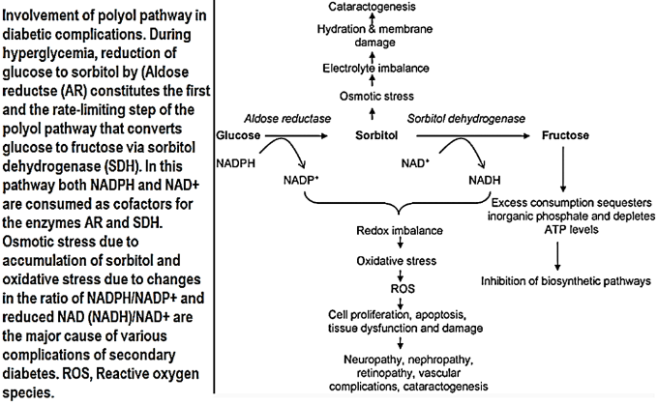
Potential mechanisms by which hyperglycemia and its immediate biochemical sequelae induce hyperglycemic damage:
Various mechanisms have been proposed to explain how hyperglycemia causes diabetic vascular dysfunction. Under normal conditions, glucose is metabolized through the glycolytic pathway. An increase in intracellular glucose will lead to an increase in four pathways: the flux of glucose to sorbitol via the sorbitol pathway, an increase in fructosamine 6-phosphate via the hexosamine pathway, the activation of PKC via de novo synthesis of DAG, and the formation of AGEs. In several cell types, excess glucose can be metabolized in the sorbitol pathway to sorbitol and fructose by aldose reductase (AR) and sorbitol dehydrogenase (SDH). In the hexosamine pathway, fructose 6-phosphate is converted into fructosamine 6-phosphate by the enzyme glutamine: fructose-6-phosphate amidotransferase (GFAT) and, subsequently, into GlcNAc. The mechanism responsible for the activation of PKC by hyperglycemia is related to de novo synthesis of the PKC activator DAG from a stepwise acylation of glycerol 3-phosphate (GP) and phosphatidic acid (PA). Recent evidence indicates that these four biochemical and metabolic mechanisms are the consequence of a hyperglycemia-induced overproduction of oxidative stress in the mitochondria. Three of the major biochemical pathways implicated in the pathogenesis of hyperglycemia-induced vascular damage (the hexosamine pathway, the DAG/PKC pathway and the formation of AGEs) can be inhibited by the lipid-soluble thiamine derivative benfotiamine by activating the pentose phosphate pathway (PPP) enzyme transketolase (TK)]. In addition to this pathway, hyperglycemia may lead to increased ROS by activation of NAPDH oxidase, inactivation and reduced expression of the antioxidant enzymes catalase and superoxide dismutase (SOD), or uncoupling of eNOS.
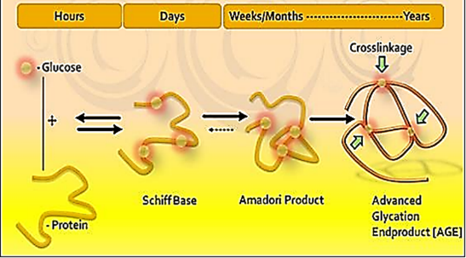
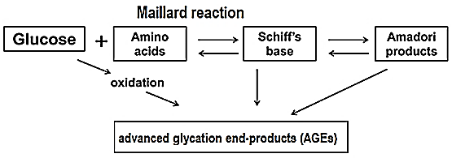
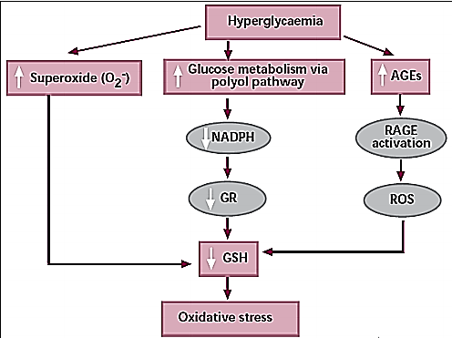
Adrenal Gland
Adrenal medulla:
Adrenal medulla structure and function of medullary hormones:
1. Catecholamines:
Norepinephrine, epinephrine, and dopamine are secreted by the adrenal medulla.
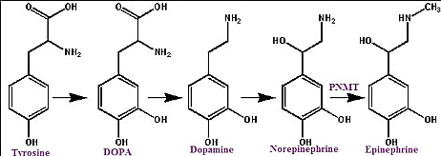
Most of the catecholamine output in the adrenal vein is epinephrine.
Norepinephrine enters the circulation from noradrenergic nerve endings
Sulfate conjugates are inactive and their function is unsettled.
In recumbent مستلقي نائمhumans, the normal plasma level of free norepinephrine is less than standing. On standing, the level increases 50– 100%.
The plasma norepinephrine level is generally unchanged after adrenalectomy, but the free epinephrine level, falls to essentially zero.
The epinephrine found in tissues other than the adrenal medulla and the brain is for the most part absorbed from the bloodstream rather than synthesized in situ.
Interestingly, low levels of epinephrine reappear in the blood sometime after bilateral adrenalectomy, and these levels are regulated like those secreted by the adrenal medulla. They may come from cells such as the intrinsic cardiac adrenergic (ICA) cells. (Intrinsic cardiac adrenergic (ICA) cells are present in mammalian hearts (atria more than ventricle) and contain catecholamine-synthesizing enzymes sufficient to produce biologically active norepinephrine levels), but their exact source is unknown.
Half the plasma dopamine comes from the adrenal medulla, whereas the remaining half presumably comes from the sympathetic ganglia or other components of the autonomic nervous system.
The catecholamines have a half-life of about 2 min in the circulation.
For the most part, they are methoxylated and then oxidized to 3-methoxy-4-hydroxymandelic acid (vanillylmandelic acid [VMA].
2. Chromogranin A:
Chromogranin A is major soluble protein of chromaffin granules.
In the medulla, norepinephrine and epinephrine are synthesized by adrenal medulla secretory cell (chromaffin cell or post-ganglionic cell) and stored in chromaffin granules along with ATP, chromogranin A
Chromogranin A released from the adrenal medulla together with catecholamines (80% epinephrine and 20% norepinephrine) upon stimulation of the splanchnic nerve, and also present in various neuro-endocrinal tissues.
Chromogranin A widely used tumor marker (Pheochromocytoma and neuro-endocrinal such as carcinoid tumor and neuroblastoma).
3. Adrenomedullin
Adrenomedullin was initially isolated from a pheochromocytoma, a tumor of the adrenal medulla
Adrenomedullin is a 52 amino acid peptide
Adrenomedullin present in adrenal medulla and in other tissues, heart, kidney, and intestine.
Adrenomedullin is structurally similar to CGRP (calcitonin-gene related peptide) 27% homologue.
Adrenomedullin was
has vasodilator and natriuretic effects.
up-regulating angiogenesis
increasing the tolerance of cells to oxidative stress and hypoxic injury
Effects of epinephrine and nor-epinephrine:
Catecholamines (norepinephrine and epinephrine) mimicking يشابه the effects of noradrenergic nervous discharge.
Catecholamines potentiate and sustain the effects of sympathetic stimulation
Catecholamines (norepinephrine and epinephrine) exert metabolic effects that include
a. mobilization of free fatty acids (FFA) from adipose tissue
b. increased plasma lactate,
c. stimulation of the metabolic rate.
Catecholamines (norepinephrine and epinephrine) effects on CVS system
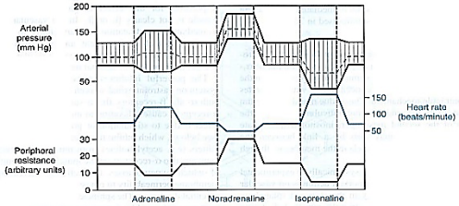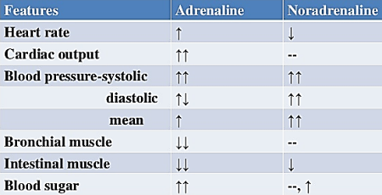
a. norepinephrine and epinephrine increase the force and rate of contraction of the isolated heart.
These responses are mediated by β 1 receptors.
b. norepinephrine and epinephrine increase myocardial excitability, causing extra-systoles and, occasionally, more serious cardiac arrhythmias.
c. Norepinephrine produces vasoconstriction in most if not all organs via α1 receptors, but epinephrine dilates the blood vessels in skeletal muscle and the liver via β2 receptors. This usually overbalances the vasoconstriction produced by epinephrine elsewhere, and the total peripheral resistance drops.
d. When norepinephrine is infused slowly in normal animals or humans, the systolic and diastolic blood pressures rise.
The hypertension stimulates the carotid and aortic baroreceptors, producing reflex bradycardia that overrides the direct cardio-acceleratory effect of norepinephrine. Consequently, cardiac output per minute falls.
e. Epinephrine causes a widening of the pulse pressure, but because baroreceptor stimulation is insufficient to obscure the direct effect of the hormone on the heart, cardiac rate and output increase.
Most adrenal medullary tumors (pheochromocytomas) secrete norepinephrine, or epinephrine, or both, and produce sustained hypertension. However, 15% of epinephrine-secreting tumors secrete this catecholamine episodically, producing intermittent bouts of palpitations, headache, glycosuria, and extreme systolic hypertension. These same symptoms are produced by intravenous injection of a large dose of epinephrine
Catecholamines increase alertness.
Epinephrine and norepinephrine are equally potent in increase alertness
Epinephrine usually evokes more anxiety and fear.
The catecholamines have several different actions that affect blood glucose.
a. Epinephrine and norepinephrine both cause glycogenolysis.
Epinephrine and norepinephrine produce this effect via β -adrenergic receptors that increase cyclic adenosine monophosphate (cAMP), with activation of phosphorylase, and via α -adrenergic receptors that increase intracellular Ca 2+
b. Epinephrine and norepinephrine increase the secretion of insulin and glucagon via β -adrenergic mechanisms and inhibit the secretion of these hormones via α -adrenergic mechanisms.
c. Epinephrine and norepinephrine produce a prompt rise in the metabolic rate that is independent of the liver and a smaller, delayed rise that is abolished by hepatectomy and coincides بنفس الانwith the rise in blood lactate concentration.
The initial rise in metabolic rate may be due to cutaneous vasoconstriction, which decreases heat loss and leads to a rise in body temperature, or to increased muscular activity, or both.
The second rise is probably due to oxidation of lactate in the liver.
When injected, epinephrine and norepinephrine cause an initial rise in plasma K ⁺ because of release of K + from the liver and then a prolonged fall in plasma K ⁺ because of an increased entry of K + into skeletal muscle that is mediated by β2 -adrenergic receptors. Some evidence suggests that activation of α receptors opposes this effect.
Effects of dopamine:
The physiologic function of the dopamine in the circulation is unknown.
Injected dopamine produces
a. renal and mesentery artery vasodilation and vasoconstriction in other arteries, probably by releasing norepinephrine
b. positively inotropic effect on the heart by an action on β1 -adrenergic receptors.
c. The net effect of moderate doses of dopamine is
an increase in systolic pressure
no change in diastolic pressure.
Because of these actions, dopamine is useful in the treatment of traumatic and cardiogenic shock. d. Dopamine is made in the renal cortex; so Dopamine causes natriuresis and may exert this effect by inhibiting renal Na⁺– K⁺ ATPase
Adrenal Cortex
The adrenal cortex three distinct layers secretions:
1. The zona glomerulosa, secreting significant amounts of aldosterone
2. The zona fasciculata secretes the glucocorticoids (cortisol and corticosterone) as well as small amounts of adrenal androgens and estrogens.
3. The zona reticularis secretes the adrenal androgens, small amounts of estrogens and some glucocorticoids.
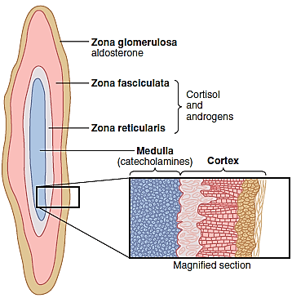
Factors such as angiotensin II that specifically increase the output of aldosterone and cause hypertrophy of the zona glomerulosa have no effect on the other two zones. Similarly, factors such as ACTH that increase secretion of cortisol and adrenal androgens and cause hypertrophy of the zona fasciculata and zona reticularis have little effect on the zona glomerulosa.
All human steroid hormones, including those produced by the adrenal cortex, are synthesized from cholesterol provided by low-density lipoprotein (LDL) in the circulating plasma.
Adrenocortical hormones are bound to plasma proteins.
Approximately 90 to 95 percent of the cortisol in the plasma binds to plasma proteins, especially a globulin called cortisol-binding globulin or transcortin and, to a lesser extent, to albumin. This high degree of binding to plasma proteins slows the elimination of cortisol from the plasma; therefore, cortisol has a relatively long half-life of 60 to 90 minutes. Only about 60 percent of circulating aldosterone combines with the plasma proteins, so about 40 percent is in the free form; as a result, aldosterone has a relatively short half-life of about 20 minutes.
Mineralocoticoid:
In humans, aldosterone exerts nearly 90 percent of the mineralocorticoid activity of the adrenocortical secretions, but cortisol, the major glucocorticoid secreted by the adrenal cortex, also provides a significant amount of mineralocorticoid activity.
The mineralocorticoid activity of aldosterone is about 3000 times greater than that of cortisol
The intense glucocorticoid activity of the synthetic hormone dexamethasone, which has almost zero mineralocorticoid activity, makes it an especially important drug for stimulating specific glucocorticoid activity.
Functions of aldosterone:
1. Aldosterone reabsorb Na+ and H₂O and secrete K⁺ especially in the principal cells of the collecting tubules and, to a lesser extent, in the distal tubules and collecting ducts.
Aldosterone binds the mineralocorticoid receptor (MR) inside the cell.
mineralocorticoid receptor (MR) are found in high concentration in
A. Epithelial sites: renal collecting duct (Principle cell) colon ducts of sweat and salivary glands
B. Non-epithelial sites: heart brain vascular smooth muscle liverperipheral blood leukocytes.
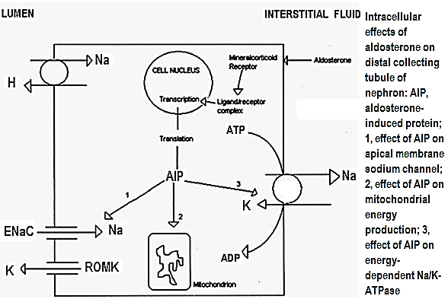
Aldosterone (A) binds the mineralocorticoid receptor (MR) or aldosterone receptor or nuclear receptor subfamily 3 inside the cell forming MR-A complex

MR-A Complex join DNA forming aldosterone-induced protein (AIP)

AIP will have the following effects:
A. Affects mitochondria to increase energy production
B. Open epithelium Na channels (ENaC) increase Na inside the cellNa pushed out by Na-K ATPase
The efflux of sodium from the epithelial cells is an energy-dependent process that is mediated by sodium-potassium ATPase (Na, K-ATPase) in the basolateral membrane
C. Na-K ATPase (the energy supply (ATP) will be form mitochondria) will increase K concentrationK will be secretion to urine by opening K antagonist channels-ROMK. The Renal Outer Medullary potassium channel (ROMK) is an ATP-dependent potassium channel that transports potassium out of cells.
Epithelium Na channels (ENaC) or amiloride-sensitive epithelial sodium channel (ENaC) is the major determinant of renal sodium re-absorption. About 45 minutes is required before the rate of sodium transport begins to increase; the effect reaches maximum only after several hours.
Epithelium Na channels availability in open conformation at the apical membrane of the cell is increased by: aldosterone vasopressin, glucocorticoids, and insulin.
Down-regulate by elevated intracellular levels of: calcium and sodium
About 2% of overall Na⁺ re-absorption are affected by aldosterone
When sodium is reabsorbed by the tubules, simultaneous osmotic absorption of almost equivalent amounts of water occurs.
2. Excess aldosterone increases tubular hydrogen ion secretion and causes alkalosis.
Aldosterone causes secretion of hydrogen ions in exchange for potassium in the intercalated cells of the cortical collecting tubules. This decreases the hydrogen ion concentration in the extracellular fluid, causing metabolic alkalosis.
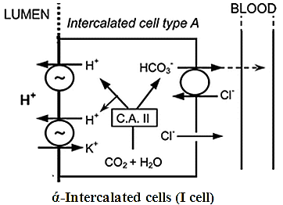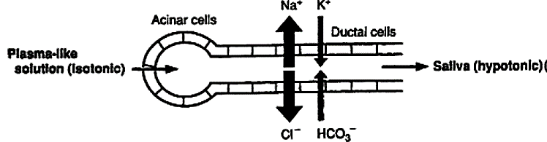
3. Effect of aldosterone on sweat and salivary glands and intestinal epithelial cells:
A. Sweat and salivary glands:
The sweat and salivary gland secretions which contains same quantity of Na and Cl as plasma passes the duct. In the duct Na and Cl will be absorb and K and HCO3 will be secreted. This processes will be enhanced by aldosterone. Causing a decrease of Na and Cl secretion by these glands.
B. Colon epithelium:
Aldosterone stimulate Na reabsorption which means enhance water reabsorption (osmotic gradient), and Cl reabsorption (electrical gradient).
Regulation of aldosterone secretion:
Regulation of aldosterone secretion by the zona glomerulosa cells is almost entirely independent of regulation of cortisol and androgens by the zona fasciculata and zona reticularis.
The following four factors are known to play essential roles in regulation of aldosterone:
1. Increased potassium ion concentration in the extracellular fluid greatly increases aldosterone secretion.
2. Increased angiotensin II concentration in the extracellular fluid greatly increases aldosterone secretion.
The factors affecting the secretion of aldosterone through angiotensin:
i) A drop in ECF volume or intra-arterial volume:
They lead to a reflex increase in renal nerve discharge and decrease renal arterial pressure. Both changes increase renin secretion, and the angiotensin II formed by the action of renin increase the rate of secretion of aldosterone. The aldosterone causes Na and, secondarily, water retention, expanding ECF volume and shutting off the stimulus that initiated increase renin secretion.
ii) Hemorrhage:
Hemorrhage stimulates ACTH and renin secretion.
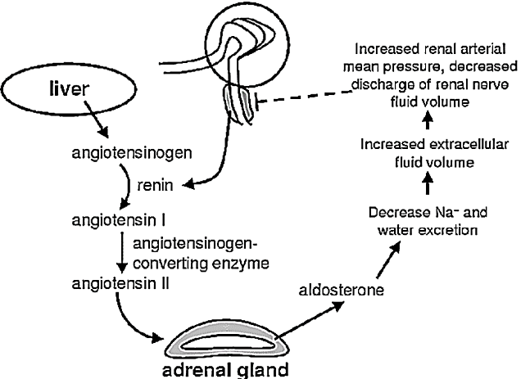
iii) Standing and constriction of the thoracic inferior vena cava:
Those two conditions associate with a decrease in intra-arterial volume.
iv) Dietary sodium restriction:
Dietary sodium restriction causes:
First: reflex increases in the activity of the renal nerves.
Second: up-regulation of the angiotensin II receptors in the adrenal cortex and hence increase the response to angiotensin II, whereas it down-regulates the angiotensin receptors in the blood vessels.
3. Increased sodium ion concentration in the extracellular fluid very slightly decreases aldosterone secretion. An acute decline in plasma in plasma Na about 20 meq/L stimulates aldosterone secretion but changes of this magnitude are rare.
4. ACTH from the anterior pituitary gland is necessary for aldosterone secretion but has little effect in controlling the rate of secretion in most physiological conditions.
ACTH appears to play a “permissive” role in regulation of aldosterone
Of these factors, potassium ion concentration and the renin-angiotensin system are by far the most potent in regulating aldosterone secretion.
5. Effect of other factors:
◊Aldosterone secretion increase in the individuals carrying on activities in the upright position due to a decrease in the rate of the removal of aldosterone from the circulation by the liver.
◊ Atrial natriuretic peptide (ANP) inhibits renin secretion and decrease the responsiveness of the zona glomerulosa to angiotensin II.
◊Individuals who are confined to bed show a circadian rhythm of Aldosterone and Renin secretion, with the highest values in the early morning before awakening.
The factors control the Na levels are:
Aldosterone, ANP, Osmotic diuresis.
Changes in tubular re-absorption of Na independent of Aldosterone.
Renin-angiotensin-aldosterone system (RAAS)
• is a slow, hormonal mechanism.
• is used in long-term blood pressure regulation by adjustment of blood volume.
• RAAS is a circulatory hormone system (circulating RAAS), all of its components also exist locally in tissues, e.g. in the kidney, blood vessel wall, heart, brain and adrenal cortex (Tissue RAAS). Therefore, RAAS seems to be a regional regulator as well; although the exact function of Tissue RAAS is unsettled.
Renin
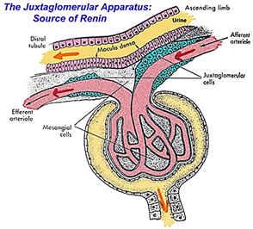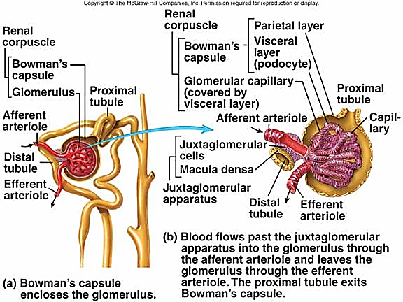
• Renin is an enzyme; which is secreted from juxtaglomerular cells of the kidney.
Juxtaglomerular apparatus (JGA): (juxta- means near).
A specialized collection of two cell types
A. Macula densa cells:
Specialized chemoreceptor cells in the wall of the distal convoluted tubule which responds to changes in:
Solute concentration (especially sodium levels) in the urine in the distal convoluted tubule
Oxygen levels in the blood passing to the glomerulus;
This sensory information is conveyed to the juxta-glomerular cells which will adjust their output of renin accordingly.
B. Juxta-glomerular cells: Specialized smooth muscle cells which act as mechanoreceptors (Intra-renal baro-receptors) which stretch in response to increases in the blood pressure of the afferent arteriole; they also synthesize and secrete the enzyme renin
• Renin only known function is to convert angiotensinogen which is derived from the liver to inactive deca-peptide angiotensin I.
• The main stimulators of renin release are:
Decreased sodium and chloride concentration in the distal tubule across macula densa
Decreased in afferent arteriolar blood pressure
Increase sympathetic activity via renal nerves,
Increase circulating catecholamines through adrenergic  ₁ -receptor stimulation,
• The main inhibitors of renin release are:
Angiotensin II,
Plasma Cl⁻, K, Na concentration
Antidiuretic hormone
Atrial natriuretic peptide
Increase sodium and chloride concentration across the distal tubule across macula densa
Increase afferent arteriolar pressure
Angiotensin I is inactive.
Angiotensin II is physiologically active.
There are different enzymatic routes of angiotensin II formation from angiotensin I.
1. ACE pathway: Angiotensin I is activated by angiotensin converting enzyme (ACE), which is mainly located on the surface of the vascular endothelium and the lung epithelium.
2. Non-ACE pathway: Other enzymes, including chymase, cathepsin G, Chymostatin-sensitive ANG II generating enzyme (CAGE), can also convert angiotensin I to angiotensin II. In humans, the non-ACE pathways are reported to represent at least 40% of total angiotensin II formation. Some evidence exists that ACE-independent pathways become quantitatively more important under pathological conditions such as diabetes.
Angiotesin II can be formed directly from angiotensinogen directly without converting to angiotensin I by tissue-type plasminogen activator (t-PA), kallikrein, chymotrypsin and trypsin
Angiotensin III,
Angiotensin III is one of the peptide fragments of angiotensin II. Angiotensin III has 40% of the presser activity of Angiotensin II, but 100% of the aldosterone-producing activity.
Physiological effects of angiotesin II:
At least two types of angiotensin receptors are present on the surface of the target cells:
1. Angiotensin II type 1 (AT₁)
AT₁ receptors are serpantin receptor couple by G protein (G_{q})
AT₁ receptors can be further subdivided into subtype A (AT_{1A}) and subtype B (AT_{1B}) receptors
First: AT_{1A} subtype is found in blood vessel walls, the brain, it mediates most of the known effects of angiotensin II.
Second: AT_{1B} subtype found in the anterior pituitary and adrenal cortex.
An excess of angiotensin II down regulates the vascular receptors (AT_{1A}), but it up regulates the adreno-cortical receptors (AT_{1B)}, making the gland more sensitive to the aldosterone-stimulating effect of the peptide.
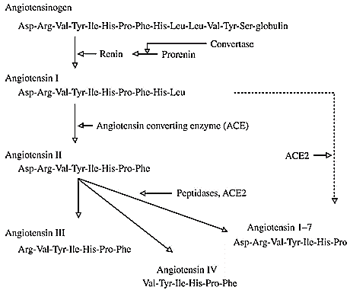
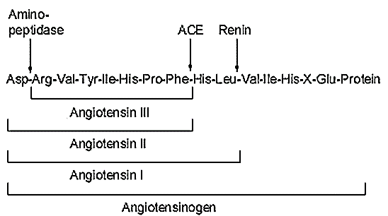
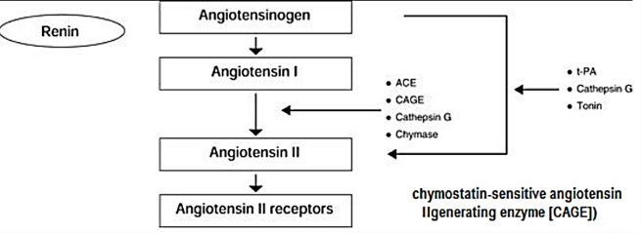
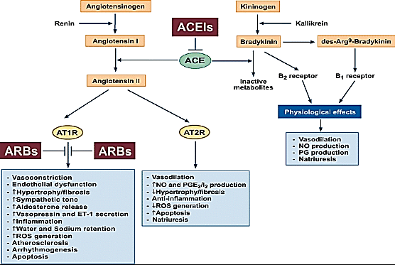
Physiological actions of Angiotensin II type 1A (AT_{1A})
AT_{1A} receptor is the major subtype mediating cardiovascular and renal effects of angiotensin II; these include:
Contraction of vascular smooth muscle, by Enhancement of calcium sensitivity of the contractile apparatus of the smooth muscle,
Increased endothelin production,
Facilitation of noradrenalin biosynthesis and Release and inhibition of its reuptake in sympathetic nerve terminals,
Stimulation of catecholamine release from the adrenal medulla,
Positive inotropic and chronotropic action on the heart
Facilitation of aldosterone biosynthesis and secretion in the adrenal cortex
AT₁ receptor stimulation augments
Tubular sodium re-absorption in the kidney,
Inhibition of renin release,
Releases vasopressin from the pituitary gland
Induces polydipsia (thirst)
Angiotensin II leads to contraction alkalosis (Contraction alkalosis refers to the increase in blood pH that occurs as a result of fluid losses (volume contraction). The change in pH is especially pronounced with acidic fluid losses caused by problems like vomiting
Stimulate cell growth
2. Angiotensin II type 2 (AT₂) receptors:
AT₂ receptors it is more plentiful in fetal and neonatal life, but they persist in the brain and other organs in adult.
The stimulation of AT₂ receptors is proposed to antagonize the AT₁ -mediated blood pressure increase,
Physiological actions of Angiotensin II type 2 (AT₂)
Vasodilatation
Inhibition of angiogenesis and cell growth
Increase endothelial nitric oxide (NO) production
Apoptosis of cells
Factors inhibits release of angiotensin II
Increase renal artery mean pressure
Decrease discharge of renal nerve
Increase fluid volume
Response of the renin-angiotensin-aldosterone system to acute blood loss
Angiotensin II elevate both systolic and diastolic pressure
This pressure effect is decrease in sodium-depleted individuals.
Acute hemorrhage

Arterial pressure

Renal perfusion pressure

Renin

Angiotensinogen ────────────angiotensin I

Angiotensin II
The possible mechanisms that cause this pressure effect are:
Angiotensin II is one of the most potent vasoconstrictors known, being 4 to 8 times as active as nor-epinephrine on weight basis in normal individuals.
Angiotensin II vasoconstriction ( TPR) BP
Angiotensin II acts directly on adrenal cortex to increase aldosterone.
Angiotensin II aldosteroneNa and water retentionvenous volume Preload
SV COBP
Angiotensin II facilitates the release of nor-epinephrine by a direct action on post-ganglionic sympathetic neurons.
Angiotensin II norepinephrine vasoconstriction ( TPR) BP
Angiotensin II acts on the brain to:
a. decrease the sensitivity of baro-reflex.
Angiotensin II decrease the sensitivity of baro-reflex pressure effect of Angiotensin II
b. increase water intake (dipsogenic effect).
Angiotensin II water intake venous volumePreloadSVCOBP
c. increase the secretion of vasopressin
Angiotensin II vasopressin water retention+ vasoconstrictionSV+CO+TPR BP
5. Angiotensin II acts on the kidney to cause:
A. contraction of mesangial cells glomerular filtration rate venous volume PreloadSV + CO BP
B. Direct effect on the renal tubules to increase Na re-absorption venous volume PreloadSV + CO BP
Relation of mineralo-corticoid to gluco-corticoid:
The plasma concentration of cortisol is nearly 2000 times that of aldosterone.
The receptor is activated by mineralocorticoids such as aldosterone and its precursor deoxycorticosterone as well as glucocorticoids, like cortisol. In intact animals, the mineralocorticoid receptor is "protected" from glucocorticoids by co-localization of an enzyme, Corticosteroid 11-β-dehydrogenase isozyme 2 also known as 11-β-hydroxysteroid dehydrogenase 2(11β-HSD2), that converts cortisol to inactive cortisone (do not bind to the receptor) thus allowing aldosterone to bind to its receptor
Excess Mineralocorticoid
Hyperaldosteronism associated with Hypokalemia, hypertension, hypernatremia, metabolic alkalosis
A. Hypokalemia ► severe muscle weakness often develops. This muscle weakness is caused by alteration of the electrical excitability of the nerve and muscle fiber membranes, which prevents transmission of normal action potentials.
B. Severe renal sodium chloride and water retention ►hypertension
Aldosterone escape
Aldosterone escape means the escape of the kidney from salt and water retention effect of Hyperaldosteronism. Hyperaldosteronism effects (Hypokalemia, Na and water retention and hypertension) will continue only for few days and after that these effects will stop and water and Na levels return to normal.
Aldosterone escape is a protective mechanism during abnormal elevation of aldosterone or Na retention
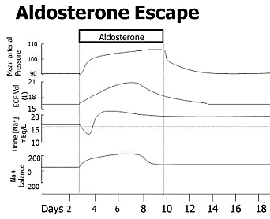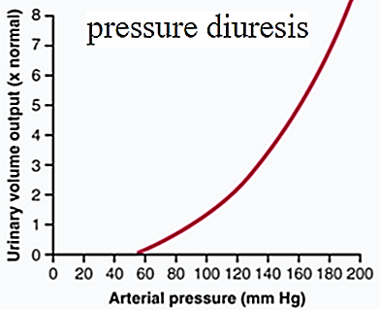
(1) Primary hyperaldosteronism or Conn's syndrome
Possible Aldosterone escape explanation caused by Primary hyperaldosteronism
Hyperaldosteronism ► Na and water retention ►increase blood pressure ►
a. Pressure natriuresis (increase Na secretion)
b. Pressure diuresis (increase water secretion secretion)
NO edema is found
In Conn’s syndrome, large amounts of aldosterone are secreted. Because aldosterone causes sodium retention, hypertension is a common finding in patients with this condition. However, the degree of sodium retention is modest, as is the resultant increase in extracellular fluid volume. This occurs because the rise in arterial pressure offsets the sodium-retaining effects of aldosterone, limiting sodium retention and permitting daily sodium balance to be achieved.
(2) Secondary (or Refractory) hyperaldosteronism
The inability of angiotensin-converting enzyme (ACE) inhibitor therapy to reliably suppress aldosterone release (i.e. temporary increase of aldosterone)
The possible explanation Secondary (or Refractory) hyperaldosteronism
a. Aldosterone is produced by tissues other than adrenal cortex (as heart and blood vessels)
b. Aldosterone is produced by a system other than Renin-Angiotensin-aldosterone system
c. ACE inhibitor ►suppress aldosterone secretion ►hyperkalemia ►stimulate aldosterone secretion
Possible Aldosterone escape explanation caused by Secondary hyperaldosteronism
Secondary hyper-aldosteronism ► Na and water retention ►ANP release ► natriuresis + diuresis
Secondary hyper-aldosteronism ► Na retention ►increase plasma osmolarity
i. Increase thirst ►water intake ►decrease plasma osmolarity
ii. Increase vasopressin ►water retention ►decrease plasma osmolarity
This why it is preferred to use aldosterone antagonist to avoid aldosterone elevation during heart failure treatment
Mineralocorticoid deficiency causes
Hypoaldosteronism associated with Hyperkalemia, hypotension, hyponatremia, metabolic acidosis
A. Hyperkalemia ► serious cardiac toxicity, including weakness of heart contraction and development of arrhythmia, becomes evident, and progressively higher concentrations of potassium lead inevitably to heart failure.
B. Severe renal sodium chloride and water exertion ► the total extracellular fluid volume and blood volume become greatly reduced ► circulatory shock
Total loss of adrenocortical secretion may cause death within 3 days to 2 weeks unless the person receives extensive salt therapy or injection of mineralocorticoids.
Glucocorticoid
At least 95 percent of the glucocorticoid activity of the adrenocortical secretions results from the secretion of cortisol, known also as hydrocortisone. In addition, a small but significant amount of glucocorticoid activity is provided by corticosterone
Effects of cortisol in physiological level
1. Effect of cortisol on carbohydrate metabolism
A. Stimulation of Gluconeogenesis.
Glucocorticoid stimulates gluconeogenesis (i.e., the formation of carbohydrate from proteins and some other substances) by the liver, often increasing the rate of gluconeogenesis as much as 6- to 10-fold.
i. Cortisol increases the enzymes required to convert amino acids into glucose in liver cells.
ii. Cortisol causes mobilization of amino acids from the extra-hepatic tissues, mainly from muscle.
iii. Cortisol antagonizes insulin’s effects to inhibit gluconeogenesis in the liver
The net effect of cortisol is to increase glucose production by the liver.
B. Cortisol causes a moderate decrease in glucose utilization by most cells in the body
Although the precise cause of this decrease is unclear,
i. Glucocorticoids decrease translocation of the glucose transporters GLUT 4 to the cell membrane, especially in skeletal muscle cells, leading to insulin resistance.
ii. Glucocorticoids may also depress the expression and phosphorylation of other signaling cascades that influence glucose utilization directly or indirectly by affecting protein and lipid metabolism.
Secondary diabetes make up 5% of the total cases of diabetes caused by: chronic pancreatitis, total pancreatectomy, Cushing syndrome (adrenal diabetes: due to high glucose level & insulin resistance, and acromegaly (pituitary diabetes).
2. Effect of cortisol on protein metabolism:
A. Effect of glucocorticoids on extra hepatic tissues:
Increase protein catabolism + decrease amino acid transport to extra-hepatic cell + Increase amino acid transport from cell to plasma ►increase plasma amino acid concentration
B. A. Effect of glucocorticoids on hepatic tissues:
Cortisol mobilizes amino acids from the non-hepatic tissues and in doing so diminishes the tissue stores of protein.
The increased plasma concentration of amino acids and enhanced transport of amino acids into the hepatic cells by cortisol could also account for enhanced utilization of amino acids by the liver to cause such effects as
i. increased rate of deamination of amino acids by the liver,
ii. increased protein synthesis in the liver,
iii. increased formation of plasma proteins by the liver
iv. increased gluconeogenesis.
3. Effect of cortisol on fat metabolism:
A. Cortisol promotes mobilization of fatty acids from adipose tissue.
The mechanism by which cortisol promotes fatty acid mobilization:
Transport of glucose into the fat cells
▼
α-glycero-phosphate (before formation of glycerol), which is derived from glucose, is required for both deposition and maintenance of triglycerides in these cells.
▼
This ↑ the concentration of free fatty acids in the plasma.
▼
Cortisol has a direct effects to enhance the oxidation of fatty acids in the cells
▼
↑ fat utilization for energy.
All will shift the metabolic systems of the cells from utilization of glucose for energy to utilization of fatty acids in times of starvation or other stresses.
B. The cortisol mechanism, requires several hours to become fully developed (not nearly so rapid or so powerful an effect as a similar shift elicited by a decrease in insulin).
C. The cortisol mechanism that increases use of fatty acids for metabolic energy is an important factor for long-term conservation of body glucose and glycogen.
In pathological and pharmacological quantities glucocorticoids have other effects including:
1. Anti-inflammatory effects of high levels of cortisol
Five main stages of inflammation occur:
(i) Release from the damaged tissue cells of chemicals such as histamine, bradykinin, proteolytic enzymes, prostaglandins, and leukotrienes that activate the inflammation process;
(ii) An increase in blood flow in the inflamed area caused by some of the released products from the tissues, an effect called erythema;
(iii) leakage of large quantities of almost pure plasma out of the capillaries into the damaged areas because of increased capillary permeability, followed by clotting of the tissue fluid, thus causing a non-pitting type of edema;
(iv) Infiltration of the area by leukocytes; and
(v) After days or weeks, ingrowth of fibrous tissue that often helps in the healing process.
When large amounts of cortisol are secreted or injected into a person, the glucocorticoid has two basic anti-inflammatory effects:
(1) It can block the early stages of the inflammation process before noticeable inflammation even begins
Cortisol has the following effects in preventing inflammation:
(i) Cortisol stabilizes lysosomal membranes
(ii) Cortisol decreases permeability of the capillaries, probably as a secondary effect of the reduced release of proteolytic enzymes. This decrease in permeability prevents loss of plasma into the tissues.
(iii) Cortisol decreases both migration of white blood cells into the inflamed area and phagocytosis of the damaged cells.
(iv) Cortisol suppresses the immune system, causing lymphocyte reproduction to decrease markedly.
(v) Cortisol attenuates fever mainly because it reduces release of interleukin-1 from white blood cells,
(2) if inflammation has already begun, it causes rapid resolution of the inflammation and increased rapidity of healing. These effects are explained further in the following sections.
Perhaps this results from
(i) The mobilization of amino acids and use of these acids to repair the damaged tissues;
(ii) The increased glucogenogesis that makes extra glucose available in critical metabolic systems;
(iii) Increased amounts of fatty acids available for cellular energy; or
(iv) Some effect of cortisol for inactivating or removing inflammatory products.
Administration of large amounts of cortisol can usually block inflammation or even reverse many of its effects once it has begun this is why it is beneficial in some conditions such as rheumatoid arthritis, rheumatic fever, and acute glomerulonephritis. All these diseases are characterized by severe local inflammation, and the harmful effects on the body are caused mainly by the inflammation and not by other aspects of the disease.
When cortisol or other glucocorticoids are administered to patients with these diseases, almost invariably the inflammation begins to subside within 24 hours. Even though the cortisol does not correct the basic disease condition, preventing the damaging effects of the inflammatory response can often be a lifesaving measure.
2. Effect on blood cells and on immunity in infectious diseases.
(i) Decreased the number of circulating eosinophils by increasing their sequestration in the spleen and lungs.
(ii) Lower the number of basophile in circulation and increase the number of neutrophils, platelets, and RBC.
(iii) Decreased the circulating lymphocytes count and the size of the lymph node and thymus by inhibiting lymphocytes mitotic activity. The reduce secretion of the cytokine IL-2 leads to reduced proliferation of lymphocytes, and these cells undergo apoptosis.
Cortisol blocks the inflammatory response to allergic reactions.
The basic allergic reaction between antigen and anti-body is not affected by cortisol, and even some of the secondary effects of the allergic reaction still occur. Glucocorticoids are anti-allergic because they protect against the release of secretion products of granulocytes, mast cells, and macrophages, which have vesicles containing serotonin, histamine, and hydrolases that contribute to the inflammatory response. Glucocorticoids inhibit cellular de-granulation, inhibit histamine synthesis, and stabilize the lysosomal membranes.
3. Permissive action:
Small amount of cortisol must be present for a number of metabolic reactions to occur, although the cortisol does not produce the reaction by themselves. This effect is called their (permissive action).
Permissive effects means requirement for cortisol to:
For glucagon and catecholamine to exert their calorigenic effects,
For catecholamine to exert their lipolytic effects
For catecholamine to produce presser response and broncho-dilation.
4. Delayed wound healing.
Effects of cortisol insufficiency:
- The vascular smooth muscle becomes unresponsive to nor-epinephrine and epinephrine so the capillary dilated.
- EEG waves slower than normal
- Personality abnormality (irritability, apprehension, and inability to concentrate).
- an inability to excrete a water load, causing the possibility of water intoxication
- Glucose infusion may cause high fever (glucose fever).
The cortisol control system:
The key to this control is the excitation of the hypothalamus by different types of stress. Stress stimuli activate the entire system to cause rapid release of cortisol, through release of CRF (Corticotropin releasing factor) which by itself stimulate anterior hypothalamus to release ACTH (adreno-corticotrophin hormone). The ACTH will cause the release of cortisol from adrenal gland.
Cortisol has direct negative feedback effects on:
- The hypothalamus to decrease the formation of CRF.
- The anterior pituitary gland to decrease the formation of ACTH.
The factors affects the release of cortisol includes:
Stress: any change in the environment that changes or threatens to change an existing optimal steady state.
Almost any type of stress, whether physical or neurogenic, causes an immediate and marked increase in ACTH and cortisol.
The different types of stress that increase cortisol release:
Trauma, Infection, Intense heat or cold, Injection of norepinephrine and other sympathomimetic drugs, Surgery, Injection of necrotizing substances beneath the skin, Restraining an animal so it cannot move, Debilitating diseases, prolonged heavy exercise, decreased oxygen supply, sleep deprivation, pain, fright, and other emotional stresses.
The reason an elevated circulating ACTH, and hence glucocorticoid level, is essential for resisting stress remains for the most part unknown.
Most of the stressful stimulate:
The possible benefit of increase steroid in stress is
1. Glucocorticoids cause rapid mobilization of amino acids and fats from their cellular stores, making them immediately available both for energy and for synthesis of other compounds, including glucose, needed by the different tissues of the body.
2. Part of the function of circulating glucocorticoids may be maintenance of vascular reactivity to catecholamines.
3. Glucocorticoids are also necessary for the catecholamines to exert their full FFA-mobilizing action, and the FFAs are an important emergency energy supply
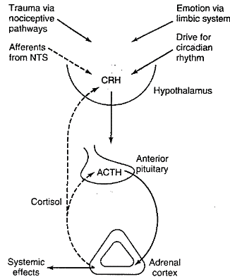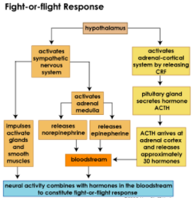
A. Emotion and Mental stress:
This is believed to result from increased activity in the limbic system, especially in the region of the amygdala and hippocampus.
B. Circadian (diurnal) rhythm:
CRF, ACTH is secreted in irregular throughout the day and plasma cortisol rends to rise and fall in response to these bursts.
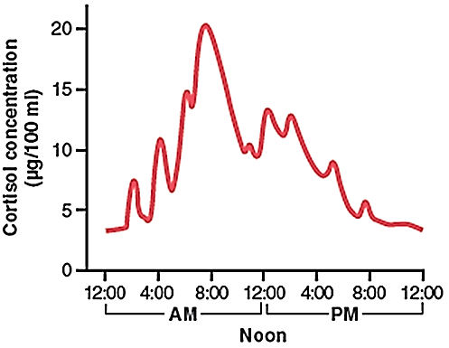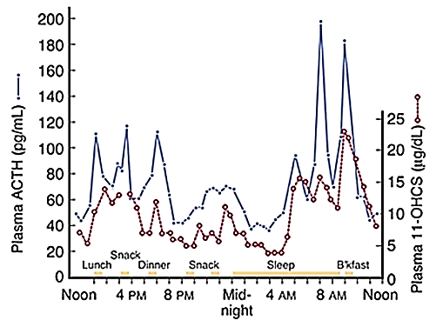
In, human the burst are most frequent in the early morning, and about 75% of the daily production of cortisol occurs between 4 AM and 10 AM. The burst are least frequent in the evening. If the day is lengthened experimentally to more than 24 hours (i.e. if the individual is isolated and day’s activities are spread over more than 24 hours) the adrenal cycle also lengthened, but the increase in ACTH secretion still occurs during the period of sleep. The biological clock responsible for the diurnal ACTH rhythm is located in the suprachiasmatic nuclei of the hypothalamus.
C. Impulses ascending to the hypothalamus via the nociceptive pathways and the reticular formation trigger increased ACTH secretion in response to injury.
D. The baroreceptors exert an inhibitory input via the nucleus tractus solitarius (NTS)
Adrenal androgens:
Several moderately active male sex hormones called adrenal androgen are continually secreted by the adrenal cortex especially during fetal life.
Secretion of the adrenal androgens is controlled acutely by ACTH and not by gonadotropins
In Male:
Androgens are the hormones that exert
a. masculinizing effects
b. promote protein anabolism and growth.
c. It is possible that part of the early development of the male sex organs results from childhood secretion of adrenal androgens
Some of the adrenal androgens are converted to testosterone, the major male sex hormone, in the extra-adrenal tissue, which probably accounts for much of their androgenic activity.
The secretion of adrenal androgens is nearly as great in castrated males and females as it is in normal males, so it is clear that these hormones exert very little masculinizing effect when secreted in normal amounts.
Testosterone from the testes is the most active androgen and the adrenal androgens have less than 20% of its activity.
However, they can produce appreciable masculinization when secreted in excessive amounts.
In adult males, excess adrenal androgens merely accentuate existing characteristics, but in Pre-pubertal boys they can cause precocious development of the secondary sex characteristics without testicular growth (precociousمبكر pseudopuberty ).
In Female
Adrenal androgens exert mild effects in the female, not before puberty but also throughout life.
Much of the growth of the pubic and axillary’s hair in the female results from the action of these hormones.
Excess adrenal androgens in females cause female the Congenital adrenal hyperplasia also known as adrenogenital syndrome, is a common cause of female pseudo-hermaphroditism Female pseudo-hermaphroditism refers to an individual with ovaries but with secondary sexual characteristics or external genitalia resembling those of a male
Estrogen
Also, progesterone and estrogen, which are female sex hormones, are secreted from adrenal cortex in minute quantities.
The adrenal androgen androstenedione is converted to testosterone and to estrogens (aromatized) in fat and other peripheral tissues. This is an important source of estrogens in men and postmenopausal women
Pathophysiology of the adrenal cortex
a. Adreno-cortical insufficiency:
Primary adreno-cortical insufficiency (Addison's disease):
It is the most commonly caused by autoimmune destruction of adrenal cortex and causes acute adrenal crisis.
• is characterized by the following:
(a) ↓adrenal glucocorticoid, androgen, and mineralocorticoid
(b) ↑ ACTH (Low cortisol levels stimulate ACTH secretion by negative feedback.)
(c) Hypoglycemia (caused by cortisol deficiency)
(d) Weight loss, weakness, nausea, and vomiting
(e) Hyperpigmentation (Low cortisol levels stimulate ACTH secretion; ACTH contains the MSH fragment.)
(f)↓pubic and axillary hair in women (caused by the deficiency of adrenal androgens)
(g) ECF volume contraction, hypotension, hyperkalemia, and metabolic acidosis (caused by aldosterone deficiency)
b. Adrenocortical excess
Cushing's disease only when it is caused by overproduction of ACTH from pituitary gland
Cushing's syndrome all other causes other than overproduction of ACTH from pituitary gland most commonly caused by the administration of pharmacologic doses of glucocorticoids or ACTH, but may also cause by primary hyperplasia of the adrenal glands or any other causes
Cushing's disease and Cushing's syndrome is characterized by the following:
(1) ↓ACTH Cushing's syndrome; ↑ACTH Cushing's disease
(2) ↑ cortisol and androgen levels
(3) Hyperglycemia (caused by elevated cortisol levels)
(4) ↑ protein catabolism and muscle wasting
(5) Central obesity :Excess cortisol secretion, causes excess deposition of fat in the chest “a buffalo-like torso” and head “moon face” this obesity results from excess stimulation of food intake, fat being generated in some tissues of the body more rapidly than it is mobilized and oxidized
(6) Poor wound healing
(7) Virilization of women (caused by elevated levels of adrenal androgens)
(8) Hypertension (caused by elevated levels of cortisol and aldosterone)
(9) Osteoporosis (elevated cortisol levels causes increased bone resorption)
(10) Striae.
• Ketoconazole, an inhibitor of steroid hormone synthesis, can be used to treat Cushing's disease.
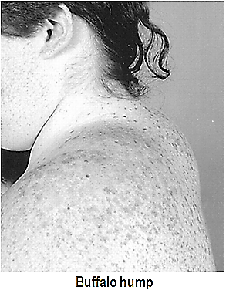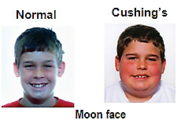
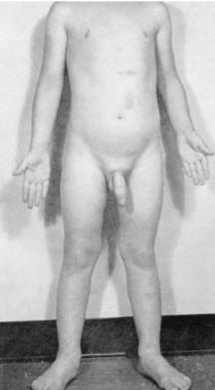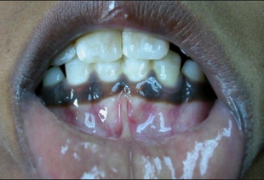

Natriuretic hormones
The muscle cells in the atria and, to a much lesser extent in the ventricles, contains secretory granules.
The granules increase in number when NaCl intake is increased and ECF expanded, and extracts of atrial tissue cause natriuresis.
The types of natriuretic peptide are:
 | amino acids | half-life
Atrial natriuretic peptide (ANP) | 28 | 2 min
Brain natriuretic peptide (BNP) | 32 | 22 minute
C- type natriuretic peptide (CNP) | 53 and 22 | 2.6 min
Dendroaspis natriuretic peptide (DNP) | 38
1. Atrial natriuretic peptide (ANP):
Atrial natriuretic peptide is synthesized and secreted by the cardiac atria and much lower in ventricles
2. Brain natriuretic peptide (BNP):
Brain natriuretic peptide isolated from porcine brain
Brain natriuretic peptide is also present in the brain in humans, but more is present in the human heart, including the ventricles.
3. C- type natriuretic peptide (CNP):
C-type natriuretic peptide is present in the brain, the pituitary, the kidneys, and vascular endothelial cells. However, very little is present in the heart and the circulation, and it appears to be primarily a paracrine mediator.
4. Dendroaspis natriuretic peptide (DNP):
Dendroaspis natriuretic peptide is derived from the venom of the Green Mamba snake
Dendroaspis natriuretic peptide is found in human plasma and atrial myocardium
Dendroaspis natriuretic peptide has 38 amino acids
The existence of various natriuretic hormones has characteristic 17-amino-acid ring formed by a disulfide bond between two cysteines.
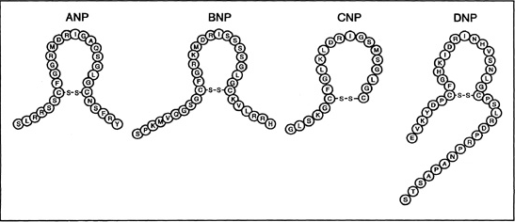
Natriuretic peptide receptors:
Three different natriuretic peptide receptors have been isolated and characterized.
type A natriuretic peptide receptor (NPRA)
type B natriuretic peptide receptor (NPRB).
type C natriuretic peptide receptor (NPRC)
The natriuretic peptides can stimulate the production of cGMP through the activation of specific receptors: type A natriuretic peptide receptor (NPRA); type B natriuretic peptide receptor (NPRB).
The NPRA receptor selectively responds to ANP and, to a lesser extent, to BNP.
The NPRB receptor is selectively activated by CNP and, in a lesser degree, by ANP and BNP.
The NPRC receptor is composed of two identical subunits held together by disulfide bonds
The NPRC receptor is known to have its major role in the clearance of natriuretic peptides from blood circulation.
The NPRC receptor has no intrinsic ability to generate cGMP although it mediates changes in cAMP and phosphoinositides.
The NPRC receptor binds the three natriuretic peptides with approximately equal affinity, as well as ring-deleted and truncated linear peptides
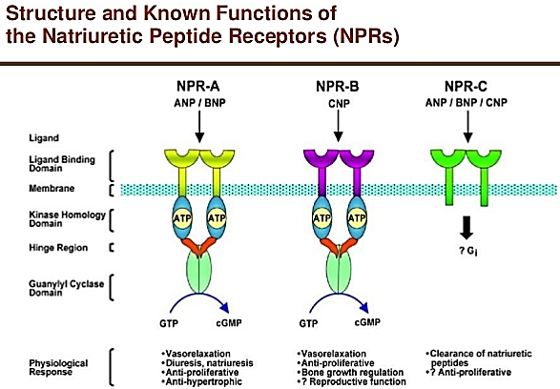
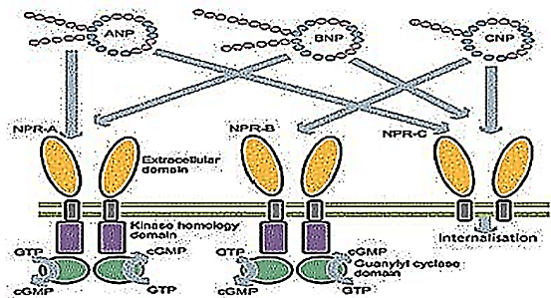
Secretion and metabolism
Atrial natriuretic peptide (ANP) is released in response to
a. the atrial stretch: any condition that causes atrial distension. Therefore, elevated levels of ANP are found during hypervolemic states (elevated blood volume), such as occurs in, the ECF volume is increased by infusion of isotonic saline or heart failure or immersion in water up to the neck (a procedure that counteracts the effect of gravity on the circulation and increases central venous and consequently atrial pressure)
(Note: immersion causes decrease in renin and aldosterone and increase ANP)
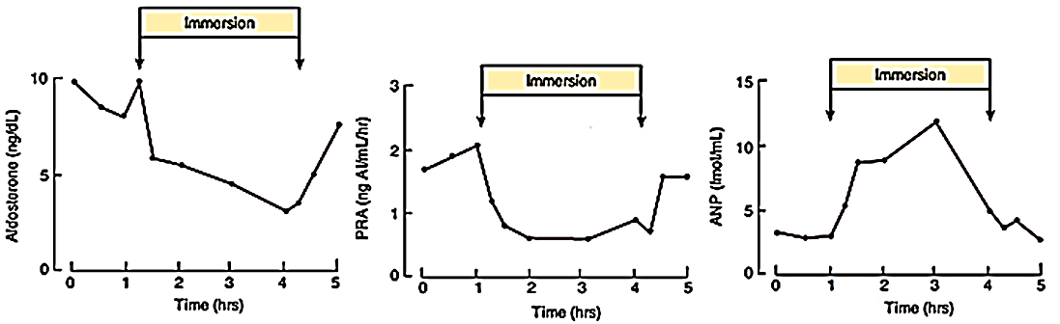
The reverse is also true such as dehydration. A small but measurable decrease in plasma ANP occurs in association with a decrease in central venous pressure on rising from the supine to the standing position.
b. Blood pressure
c. High NaCl intake
d. Humoral effect:
i. Rennin-angiotensin-aldosterone system
ii. endothelin
e. Sympathetic stimulation (beta-adrenoreceptors mediated)
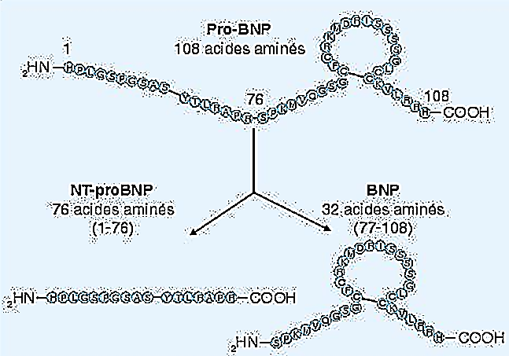
BNP secretion is increased when the ventricles are stretched.
Similarly, BNP secretion is proportional to the degree to which the ventricles are stretched.
BNP expression is increased in heart failure, hypertension and renal failure.
Proteolysis of pro-BNP (108 amino acids) results in BNP (32 amino acids) and the N-terminal piece of pro-BNP (NT-pro-BNP; 76 amino acids). Both BNP and NT-pro-BNP are sensitive, diagnostic markers for heart failure patients.
Neutral endopeptidase (NEP; also called neprilysin) is a circulating enzyme that degrades natriuretic peptides.
Physiological effects:
A. Renal:
1. Increase of glomerular filtration and aqueous (water) diuresis
Dilating afferent arterioles ► Increases Renal Blood Flow► increases glomerular filtration► Increases Urine Volume
2. Enhanced urinary excretion of sodium (= natriuresis) and of other electrolytes, phosphate, magnesium, calcium, potassium
a. act on the renal tubules to inhibit Na reabsorption► Increases Sodium Excretion
b. decreases blood flow through the vasa recta, which will wash the solutes (NaCl and urea) out of the medullary interstitium ►This will lower osmolarity of the medullary interstitium leads to less reabsorption of tubular fluid and increased excretion.
B. Cardiovascular:
1. Vasodilation (relax vascular smooth muscle in arterioles and venules)
2. CNP has a greater dilator effect on veins than ANP and BNP.
3. Decrease of vascular reactivity to vasoconstrictive agents (pressor effects of catecholamine’s and angiotensin II).
4. In the brain, ANP is present in neurons, and an ANP-containing neural pathway projects from the anteromedial part of the hypothalamus to the areas in the lower brain stem that are concerned with neural regulation of the cardiovascular system.
In general, the effects of ANP in the brain are opposite to those of angiotensin II, and ANP-containing neural circuits appear to be involved in lowering blood pressure and promoting natriuresis
5. ANP reduces sympathetic tone by dampening of baroreceptors, suppressing the release of catecholamine’s from autonomic nerve endings and suppressing sympathetic outflow from the CNS.
6. An increase in capillary permeability, leading to extravasation of fluid
The over all of these effects is decline in blood pressure
C. Cellular effects:
1. anti-mitogenic effects
D. Hormonal:
1. Inhibition of aldosterone and renin secretion and perhaps of ACTH and arginine vasopressin secretion
2. Overall opposite effects to angiotensin II.
3. Decrease the feeling of thirst and appetite for salt.
E. Stimulation of lipolysis.
Natriuretic peptides (NPs) are involved in the long-term regulation of sodium and water balance, blood volume and arterial pressure. There are two major pathways of natriuretic peptide actions:
1) Vasodilator effects
2) Renal effects that leads to natriuresis and diuresis.

Pineal Gland:
The pineal gland is a coned-shaped, pea-sized gland located just beneath the center of brain; behind the hypothalamus
After the age 7 pineal gland undergo involution (shrinkage), down 75% by end of puberty and to tiny mass of shrunk tissue in adult. Involution is accompanied by the appearance of granules of calcium phosphate and calcium carbonate called pineal sand
The pineal gland is innervated by sympathetic neurons.
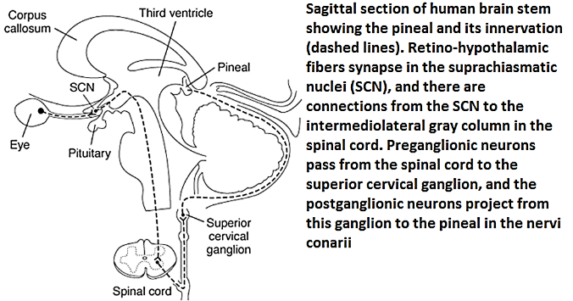
The pineal gland synthesizes (melatonin ◄ serotonin ◄ tryptophan)
The pineal has a close association with the cerebrospinal fluid of the third ventricle. Evidence suggests that the gland's chief secretory product, melatonin, is released in part directly into the third ventricle
Melatonin
Melatonin plays an important role in the followings:
Regulate the circadian rhythms (daily body cycles)
Melatonin is a hormone produced by the pineal gland of our body at night in response to darkness.
The brain may secrete up to 20 times more melatonin at night than in the day time, hence melatonin is nicknamed "the hormone of darkness"
There is a high concentration of melatonin receptors in the SCN because this is where melatonin mediates the majority of its effects on circadian rhythm
Human infants' melatonin levels become regular in about the third month after birth, with the highest levels measured between midnight and 8:00 am. Human melatonin production decreases as a person ages. Also, as children become teenagers, the nightly schedule of melatonin release is delayed, leading to later sleeping and waking times.
For people who sleep "normal hours", natural melatonin production rises sharply in the evening, and peaks between 1 am and 3 am. The peaks become smaller with advancing age after early childhood.
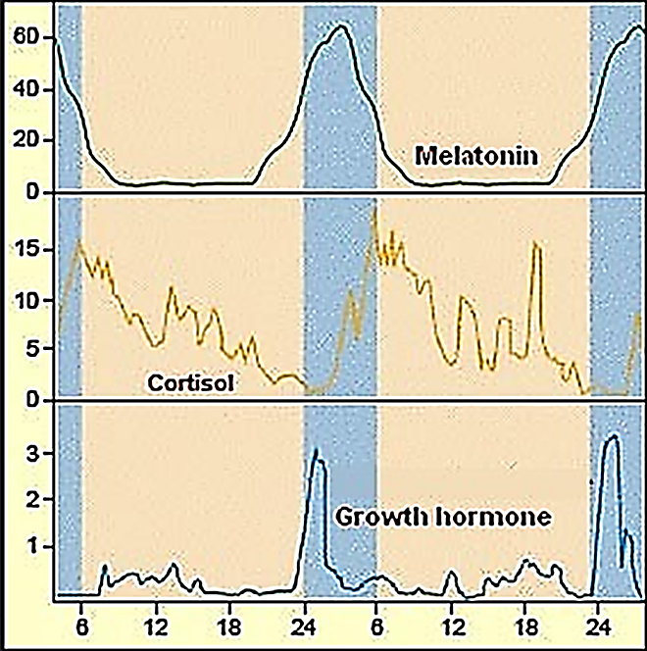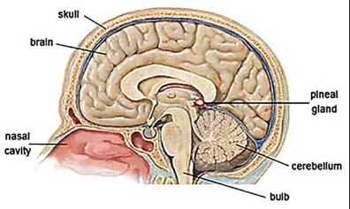
Regulate the sleep patterns. This includes the speed of falling asleep, duration and the quality of sleep
Influence hormones in the body that regulate reproduction, the timing of ovulation, melatonin has the ability to suppress ovulation in humans
Anti-aging: melatonin is a powerful free-radical scavenger and wide-spectrum antioxidant, a compound that blocks the action of free radicals (activated oxygen molecules) that can damage cells. Therefore some scientists suggest that it has anti-aging functions
Anti-cancer and anti-inflammatory: Some studies showed that melatonin may suppress the growth of certain types of cancer cells, and may stimulate the natural killer cells (a type of white blood cells) to attack tumors. Melatonin may be useful fighting infectious diseases
Melatonin is also called "seat of the soul" because of the influence of melatonin on emotions
Adipose tissue as endocrinal gland:
The classic function of the adipocyte is to store and release lipid fuel
Most recent data emphasize the role of adipose tissue as a hormonally active system, influencing inflammation, metabolism, and body weight, and lipid and glucose metabolism
These secreted proteins, which include tumor necrosis factor (TNF)-alpha, resistin, IL-6, Acylation Stimulating Protein, angiotensinogen, plasminogen activator inhibitor-1 (PAI-1) ("bad" adipokines) and leptin, adiponectin ("good" adipokines) seem to play important regulatory roles in a variety of complex processes, including fat metabolism, feeding behavior, hemostasis, vascular tone, energy balance, and insulin sensitivity, but none is without controversy regarding its respective mechanism and scope of action.
Endocrine function of the adipocyte can be divided into proteins and enzymes involved in steroid metabolism
A. adipocytokines (or adipokines or Protein):
Leptin
Leptin is secreted not only from white adipocytes, but also from placenta and stomach
Leptin is found more in subcutaneous than visceral fat.
Leptin identification in 1994
Leptin endocrine effects include regulation of immune function, hematopoiesis, angiogenesis, and bone development.
Leptin has been known for its role in controlling body weight, food intake through hypothalamic pathways, glucose homeostasis
Leptin primary function is to increase satiety and energy expenditure through action on the hypothalamus.
Leptin action in the muscle, increases glucose uptake and glucose metabolism.
Leptin action in the liver increases glucose production
Leptin action in the pancreases, increases insulin
Leptin activates the hypothalamic-pituitary-adrenal axis
Leptin suppresses the hypothalamic-pituitary - thyroid axis and the hypothalamic -pituitary-gonadal axis
Leptin is involved in the regulation of reproductive development and function by indirectly influencing GnRH neuron activity.
Adiponectin:
Adiponectin is exclusively secreted by adipocytes
Adiponectin with higher serum concentration in females
Adiponectin is found more in the subcutaneous adipose deposits than in the visceral deposits.
Adiponectin In the liver decreases glucose production and free fatty acid synthesis.
Adiponectin In the muscle increases free fatty acid oxidation and decreases triglyceride production
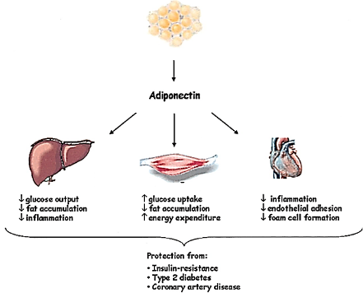
Adiponectin has anti-atherogenic activity because it acts through:
A. the insulin receptor of the vascular endothelium to increase nitric oxide (NO)
B. positive correlation to high-density lipoprotein cholesterol and inverse correlations to low-density lipoprotein cholesterol, triglycerides, insulin resistance, and diastolic blood pressure
A strong and consistent inverse association between adiponectin and both insulin resistance and an inflammatory state has been established:
A. Adiponectin activity increases during insulin sensitivity and decreases insulin resistance
B. Adiponectin seems to have anti-inflammatory
Taken together, these studies suggest that adiponectin is a unique adipocyte-derived hormone with anti-diabetic, anti -inflammatory and anti-atherogenic effects.
Adipsin & Acylation Stimulating Protein
Adipsin is found more in the subcutaneous adipose deposits than in the visceral deposits.
Adipsin is the enzyme required for the production of Acylation Stimulating Protein (ASP).
Both adipsin and Acylation Stimulating Protein positively correlate with adiposity, insulin resistance, dyslipidemia, and cardiovascular disease
Acylation Stimulating Protein increases insulin secretion.
Acylation Stimulating Protein in the adipose tissue:
A. increases glucose transport and Triglycerides synthesis by increasing the activity of diacylglycerol acyltransferase, and decreases lipolysis and release of Non-esterified ("free" or unsaturated) fatty acid from adipocytes
B. decreases lipolysis and free fatty acid release
Resistin
Resistin is 15 times greater in the visceral adipose deposits than in the subcutaneous deposits.
Resistin increase in insulin resistance and type 2 diabetes mellitus
Resistin potentially linking obesity with insulin resistance
Tumor necrosis factor-alpha (TNP-ά)
Tumor necrosis factor-alpha is secreted more from the subcutaneous adipose deposits than from the visceral deposits and may be dependent on regional fat mass.
The primary action of Tumor necrosis factor-alpha is to increase insulin resistance in liver, muscle and adipose tissue.
Additional action on the liver include increased free fatty acid (FFA) production and cholesterol synthesis and decreased glucose uptake and free fatty acid storage
Protein from the renin angiotensin system
Renin angiotensin system proteins are found more in visceral adipose deposits than subcutaneous deposits. RAS proteins include: rennin, angiotensinogen, angiotensin I, angiotensin II, angiotensin converting enzyme
Similar to the renin-angiotensin system in the kidney, these proteins affect the same target organs.
In the adrenal gland, aldosterone is increased, increasing the reabsorption of sodium and water in the kidneys.
In the vasculature, vasoconstriction is primary activity from adipocyte renin angiotensin system.
In the liver, renin angiotensin system results in decreased lipolysis with increased lipogenesis, gluconeogenesis, glycogenolysis, and insulin resistance
Interleukin-6
Interleukin-6 is found more in visceral adipose deposits than in subcutaneous deposits.
Approximately 1/3rd of the circulating Interleukin-6 originates from the adipose tissue.
Interleukin-6 primary function is to increase insulin resistance at the insulin receptor or insulin signaling pathway in hepatic, muscle and adipose tissue.
Interleukin-6 increases hepatic hyperlipidemia and glucose production.
In the central nervous system, Interleukin-6 deficiency decreases energy expenditure
Plasminogen activator inhibitor-1
Plasminogen activator inhibitor-1 is found more in visceral adipose deposits than in subcutaneous deposits.
Fibrinolysis the breaking down of blood clots. Plasminogen activator inhibitor-1inhibits tissue plasminogen activator which initiates the fibrinolysis cascade: thus, Plasminogen activator inhibitor-1 inhibits fibrinolysis.
Tumor necrosis factor-alpha increases Plasminogen activator inhibitor-1 in adipose tissue
B. Steroidgenic enzymes:
Several enzymes from the adipose tissue are involved in steroid metabolism; activation, inter-conversion and inactivation.
The steroid activity can be divided into sex steroids and glucocorticoid activity
For the most part, the enzymes involved in sex steroids convert androgens to estrogens.
More specifically, they also convert specific sex steroids to their more active form; that is, androstenedione to testosterone and estrone to estrodiol.
In glucocorticoid activity, steroidgenic enzymes increase insulin sensitivity and control visceral adipose tissue deposition
Hunger & satiety:
There are several levels of energy balance in metabolism.
The obvious balance is that of food intake and energy expenditure. In the balance of caloric intake and energy expenditure, the factors affecting caloric intake include:
Hunger is a physiological urge to consume food.
Satiety is the signal for cessation of food intake.
Appetite is a physiological preference for specific foods.
The feelings of hunger and satiety are stimulated by the “gut-brain axis”, where a crucial role is played by gastrointestinal hormones: glucagon-like peptide 1, glucose-dependent insulinotropic polypeptide, pancreatic polypeptide, peptide YY, oxyntomodulin, cholecystokinin and ghrelin. These hormones affect not only the functioning of the digestive tract, but also might have effects on insulin secretion and are mediators which affect brain areas involved in the regulation of food intake.
How much of these factors can be modified by psychological factors in the control of food intake for humans?
Ghrelin
Ghrelin is an endogenous peptide with 28 amino acid peptide
Ghrelin is the substance found to be associated with meal initiation in humans.
Ghrelin is secreted by the stomach and intestine.
Ghrelin has been found to increase before meals; it is believed that glucose concentrations and energy balance have a role in ghrelin production and release.
Ghrelin fall to its lowest point within one hour following the meal;
Functions of Ghrelin
Ghrelin increases growth hormone.
Ghrelin acts as an antagonist of somatostatin that inhibits the secretion but not the synthesis of GH. Together with GHRH, ghrelin acts synergistically to stimulate the release of GH from the somatotrophic cells of the hypophysis.
As ghrelin is both orexigenic (appetite-stimulating) and adipogenic,
Ghrelin actions of feeding are independent from the growth hormone actions.
Ghrelin participates in the regulation of energy homeostasis, increases food intake, and decreases energy expenditure by lowering the catabolism of fat.
Ghrelin increases food intake and weight gain in experimental animals and induces hunger in humans. Ghrelin is part of a complex neuroendocrine network involved in the regulation of appetite and energy homeostasis. Peripheral ghrelin may exert its effects on the CNS by crossing the blood brain barrier (BBB) although the rate at which it passes the BBB is very low. Several studies suggested that the orexigenic signal of ghrelin secreted from the stomach is transmitted to the brain via the vagal afferent nerve
Areas in the brain that are implicated in the regulation of feeding behavior express receptors for ghrelin
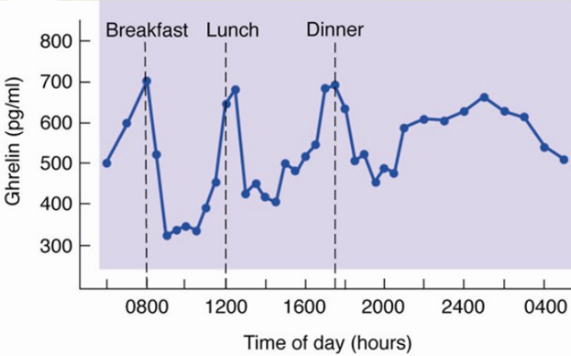
Obestatin
Obestatin is 23 amino acid peptide
Obestatin was initially considered to oppose the orexigenic effects of ghrelin. Later studies, however, cast doubt on the initial findings as subsequent studies failed to confirm the anorexigenic effects (appetite suppressant) of obestatin.
Obestatin has been reported to have additional roles such as
The inhibition of thirst
The regulation of memory, anxiety, and sleep
Stimulate the proliferation of human retinal cells
Promote the survival of pancreatic β-cells and human islets
The regulation of adipocyte metabolism and adipogenesis.
Leptin,
Leptin a satiety hormone produced by white adipose tissue, and represents another appetite regulator. Leptin and ghrelin are supposed to share hypothalamic pathways regulating food intake and energy homeostasis.

