**Al Balqa App[lied University**



**College of Medicine**

Lecture 1

Helicobacter and gastritis

**Dr. Hala Al Daghistani**

**Helicobacter pyloriis a spiral-shaped gram-negative rod. *H. pylori* is associated with antral gastritis, duodenal (peptic) ulcer disease, gastric ulcers, gastric adenocarcinoma and gastric mucosa-associated lymphoid tissue (MALT) lymphomas. Other *Helicobacter* species that infect the gastric mucosa exist, but are rare.**

**[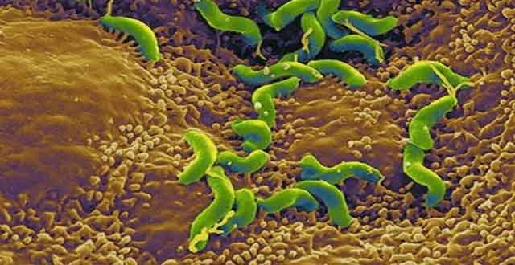](http://www.kostleige.com/2013/09/09/una-bacteria-podria-ser-responsable-del-cancer-de-estomago/)**

**Morphology and Identification**

**A. Typical Organisms**

Spiral with multiple flagella at one pole and is actively motile.

**B. Culture**

The media for primary isolation include Skirrow’s medium with antibiotics, chocolate medium, and other selective media with antibiotics

**C. Biochemical Characteristics**

*H. pylori* is oxidase positive and catalase positive, and is a strong producer of urease.

[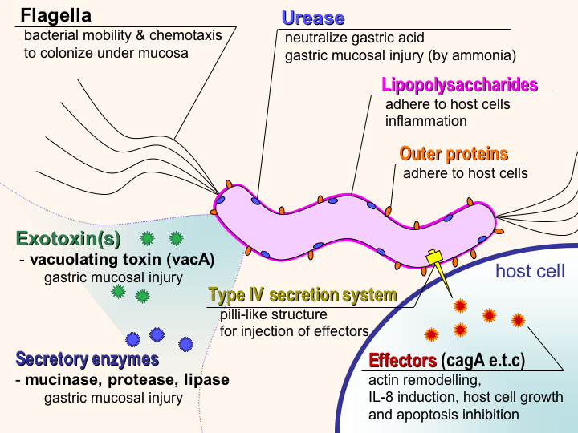](https://commons.wikimedia.org/wiki/File:H_pylori_virulence_factors_en.png)

**Pathogenesis and Pathology**

* *H. pylori* grows optimally at a pH of 6.0–7.0 and would be killed or not grow at the pH within the gastric lumen.
* Gastric mucus is relatively impermeable to acid and has a strong buffering capacity.
* On the lumen side of the mucus, the pH is low (1.0–2.0); on the epithelial side, the pH is about 6.8- 7.4. *H. pylori* is found deep in the mucous layer near the epithelial surface where physiologic pH is present.

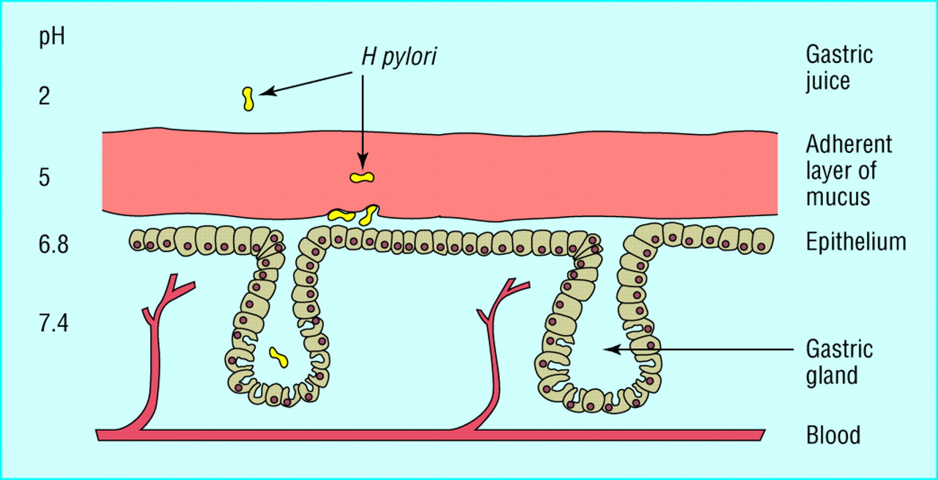

* *H. pylori* also produces a **protease** that modifies the gastric mucus. Also have potent **urease** activity, which yields ammonia and further buffering of acid.
* The mechanisms by which *H. pylori* causes mucosal inflammation and damage are not well defined but probably involve both bacterial and host factors.
* The bacteria invade the epithelial cell surface to a limited degree. **Vacuolating toxins** and **lipopolysaccharide** may damage the mucosal cells, and the **ammonia** produced by the urease activity may also directly damage the cells.
* Histologically, gastritis is characterized by acute and chronic inflammation.
* PMN and mononuclear cell infiltrates are seen within the epithelium and lamina propria.
* Ingestion of *H. Pylori* resulted in the development of gastritis and hypochlorhydria.
* There is a strong association between the presence of *H. pylori* infection and duodenal ulceration.
* **The bacteria invade the epithelial cell surface. Toxins and LPS may damage the mucosal cells, and the ammonia produced by the urease activity may also directly damage the cells.**

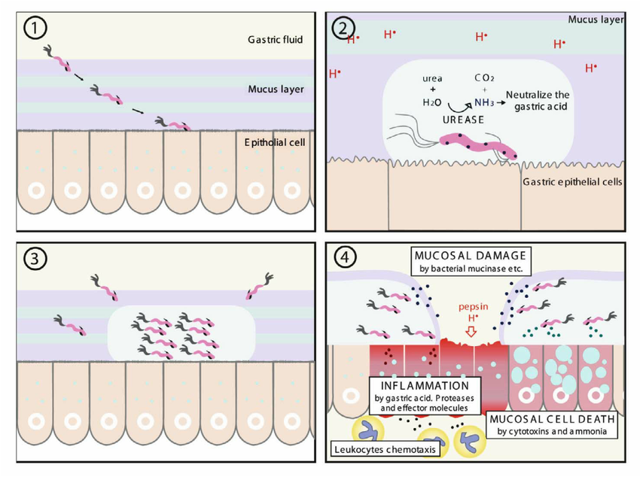

* Some *H. pylori* bacteria use a needle-like appendage to inject a toxin produced by a gene called [**cytotoxin**](https://www.cancer.gov/Common/PopUps/popDefinition.aspx?id=CDR0000691480&version=Patient&language=English)**-associated gene A (*cagA*)** into the junctions where cells of the stomach lining meet. This toxin (known as CagA) alters the structure of stomach cells and allows the bacteria to attach to them more easily. Long-term exposure to the toxin causes chronic inflammation. However, not all strains of *H. pylori* carry the *cagA* gene; those that do are classified as *cagA*-positive.
* Vacuoles within cells are often pronounced. Destruction of the epithelium is common, and glandular atrophy may occur. *H. pylori* thus is a major risk factor for gastric cancer. (ITP, Idiopathic Thrombocytopenia)

[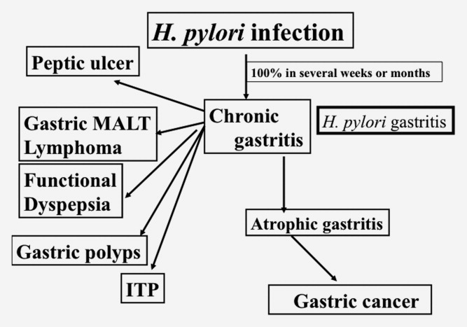](https://www.researchgate.net/figure/Progress-of-H-pylori-infection-H-pylori-related-chronic-gastritis-is-leading-to-peptic_fig1_233770599)

**Clinical Findings**

* Acute infection can yield an upper gastrointestinal illness with nausea and pain; heart burn, dyspepsis, bleching, poor appetite, bloody stool, vomiting and fever may also be present.
* The acute symptoms may last for less than 1 week or as long as 2 weeks.
* After colonization, the *H. pylori* infection persists for years and perhaps decades or even a lifetime.
* About 90% of patients with duodenal ulcers and 50–80% of those with gastric ulcers have *H. pylori* infection.

**Diagnostic Laboratory Tests**

**A. Specimens**

- Gastric biopsy specimens can be used for histologic examination

- Blood is collected for determination of serum antibodies.

- Stool samples may be collected for *H pylori* antigen detection.

**B. Smears & Culture**

Curved or spiral-shaped organisms. Culture is performed when patients are not responding to treatment.

**C. Special Tests**

**Helicobacter pylori infection can be diagnosed with:**

1. **Invasive techniques** requiring endoscopy and biopsy (e.g. histological examination, culture and rapid urease test).

**Rapid urease test:** Gastric biopsy material can be placed onto a urea-containing medium with a color indicator. If *H. pylori* is present, the urease rapidly splits the urea (1–2 hours), and the resulting shift in pH yields a color change in the medium.

1. **Non-invasive techniques**, such as serology, the urea breath test, or detection of H. pylori antigen in stool specimen.

**In vivo tests for** **urease activity** can be done also. In urea breath tests, 13C- or 14C-labeled urea is ingested by the patient. If *H pylori* is present, the urease activity generates labeled CO2 that can be detected in the patient’s exhaled breath.

Detection of ***H. pylori* antigen** in stool specimens is appropriate as a test of cure for patients with known *H. pylori* infection who have been treated.

**Epidemiology**

* *H. pylori* is present on the gastric mucosa of fewer than 20% of persons younger than years 30 but increases in prevalence to 40–60% of persons age 60 years, including persons who are asymptomatic.
* In developing countries, the prevalence of infection may be 80% or higher in adults.