Lecture: Components of the innate immune system

Date :24/9/2019

Done and edited by: Zain Alsharrab & Reem Alsarhan

Sheet correction link: bit.ly/odimmuno

Last slide from the first lecture :

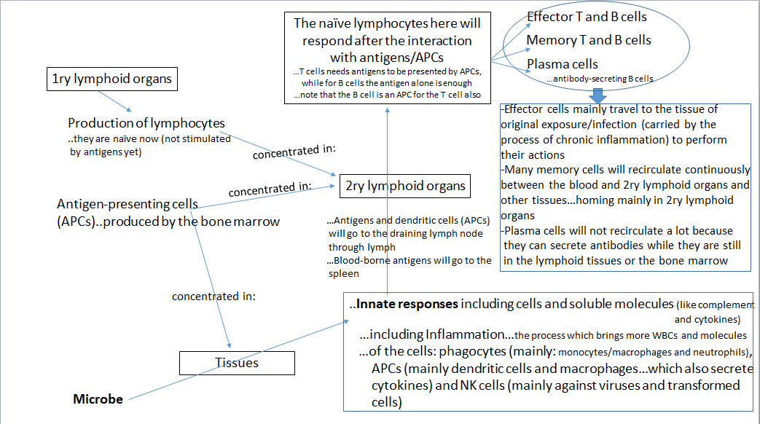

About lymphocyte:
# in 1ry lymphoid organ produced mature lymphocytes but still naïve (not stimulated by Antigen)
# concentrated mainly in: 2ry lymphoid organs // lymph nodes, spleen, mucosa associated lymphoid tissue (MALT), cutaneous associated lymphoid tissue // and here lymphocytes will be activated (stimulated by antigen)

About APCs (antigen presenting cells):
# in bone marrow production of APCs (dendritic cells, macrophages also B cells work as APCs for T cells) note: dendritic cells are also phagocytic cells
# concentrated in: 2ry lymphoid organs & Tissues

Summary: (Note: this diagram shows us the connections between both innate & adaptive immune systems)
- a microbe Attacked tissues and penetrates the mechanical barriers.

- now the innate responses which include cells & biochemical molecules start ( note : molecules could be secreted by cells or could be a cell attached molecules in both systems ; innate and adaptive ) inflammation happened as a part of the innate response ( note : inflammation takes a place in both systems // in the adaptive system : chronic inflammation ) which includes the dilation of blood vessels & Leukocyte Recruitment & the main cells are :

- phagocytic cells : mainly macrophages and neutrophils ( work on extracellular microbes )
- APCs : dendritic cells and macrophages
- natural killer cells ( work on viruses and intracellular bacteria ) note : this cells are non-phagocytic cells

- after the innate responses : Antigens and dendritic cells (APCs) will go to the draining lymph node through lymph & Blood-borne antigens will go to the spleen
- In the 2ry lymphoid organs ; lymphocytes will become activated after the interaction with Ag or APCs , NOTE :

- T cells : cannot interact with the free Ag , it can be activated only by APCs
- B cells : can interact with the free Ag

- Now the adaptive responses start , lymphocytes are activated and give us

- Effector T and B cells
- Memory T and B cells
- Plasma cells ( note : there are 2 types of plasma cells : effector and memory cells)
- Effector cells mainly travel to the tissue of original exposure/ infection (carried by the process of chronic inflammation) to perform their actions

- Many memory cells will recirculate continuously between the blood and 2ry lymphoid organs and other tissues…homing mainly in 2ry lymphoid organs

- Plasma cells will not recirculate a lot because they can secrete antibodies while they are still in the lymphoid tissues or the bone marrow

2nd lecture : Components of the innate immune system
Note : sheet notes are shown after \\ and inside boxes
Components of the innate immune system(خط الدفاع الأول) are:
- Physical barriers
- Biochemical “weapons”
- Biological barriers \\ sheet note: like normal flora
- Cells \\ sheet note : mainly WBCs

1st : physical barriers
- Skin
- Mucous membranes
- Skin (epidermis)
- The outermost layer of epidermis is Cornified layer (stratum corneum); it composed of dead keratinized cells that are tightly linked, keratin is a water proofing protein which means 2 things:
- prevent water to cross the skin DRY environment which is not suitable for microbe growth
- Prevent dehydration no tissue injury
(X dehydration: X tissue injury: X infection)
- Continuous proliferation and sheddingremoving microbes

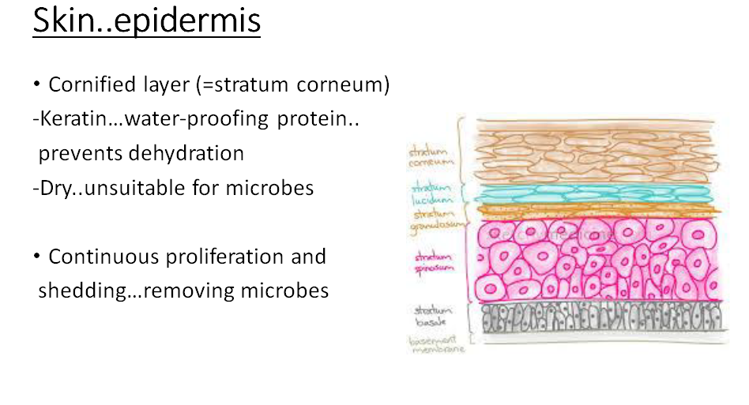 Mucous membranes
- Lining of body cavities
- In GI and respiratory tract: goblet cells…excessive amount of mucus daily
- In respiratory tract: mucus traps bacteria, fungi and particles \\ with the help of cilia movement mucus get out taking bacteria and trapped particles.
- In GI: *mucus -protects from HCL and digestive enzymes
-movement of ingested materials \\ sheet note: prevent stagnation
(يمنع ركود المواد وما تحتويه من ميكروبات)
-environment for molecular exchange
-isolation of microbes
*sloughing and renewal \\ sheet note: the renewable here is faster than skin renewable

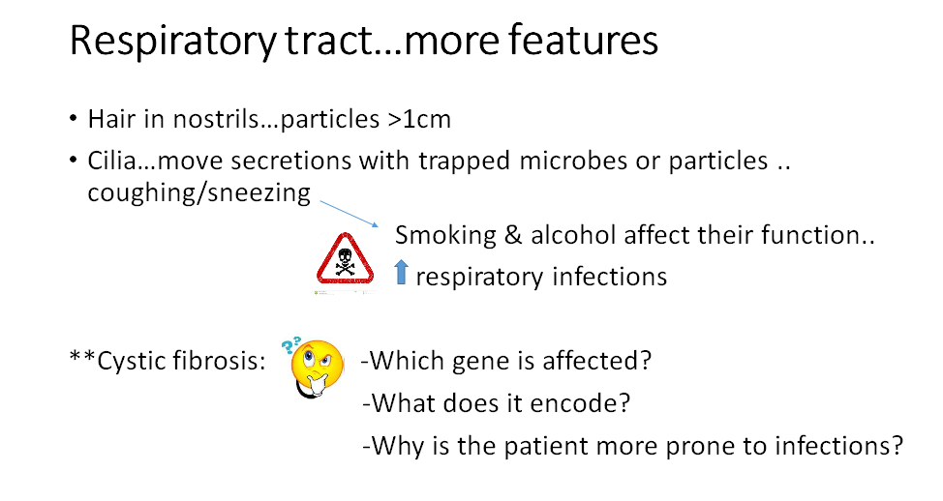
chloride channel
CFTR on Ch 7
destroy cilia
\\ Sheet notes :
The CFTR gene encodes a protein called the cystic fibrosis transmembrane conductance regulator. This protein functions as a channel across the membrane of cells that transports chloride ions into and out of cells:
Cl⁻ movement | Normal | Cystic fibrosis
Sweat ducts | From lumen toward cells | Toward the lumen
GI & Respiratory tract | Toward the lumen | Toward cells

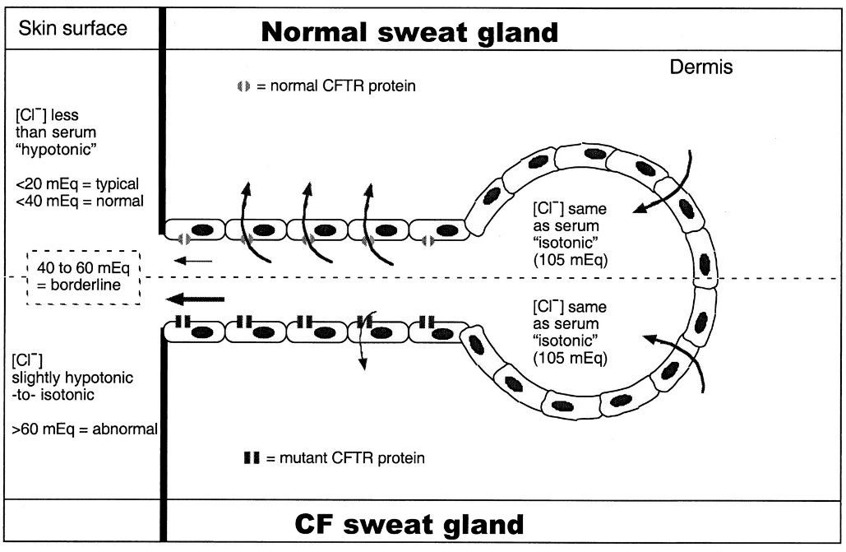
Extra figure

Sodium ions normally move toward the cells through Na+ channels BUT CFTR protein is responsible for the regulation of the function of these channels so :

Na⁺ movement | Normal Na+ channels | CFTR regulation | Cystic fibrosis
Sweat duct | From the lumen toward cells  دائماً يدخل الصوديوم للخلية | محفز لدخول الصوديوم للخلية | مانع لدخول الصوديوم الى الخلية , بقي في ال lumen
GI & respiratory tract |  | مانع لدخول الصوديوم للخلية , تبقى في ال lumen | حفز دخول الصوديوم للخلايا , الماء تبع حركة الصوديوم : اصبح الmucous في الlumen لزج و كثيف بشكل كبير

The result is:
- Sweat gland ++ sodium and chloride ions in the sweat + + salty sweat
- GI & respiratory tract - - sodium and chloride ions in the mucus - - water mucus become more viscous and dehydrated stagnation
(ركود المواد و ما فيها من ميكروبات ) infections (like pseudomonas aeruginosa and pneumonia )
- Patients don’t live long time (not normal life expectancy)

Urinary tract…special features
\\ mucosa in Urinary tract act as mechanical barrier
Urination externally directed fluid pressure \\ (discharge the microbes out of the body)
…disrupted by urinary catheter
\\ لانه ال catheter بعاكس ال externally directed fluid pressure
\\ it can cause descending UTI & ascending UTI that can be developed to urethritis and nephritis
…nosocomial UTI \\skin could be a source for s.aureus infection in Urinary tract
UTI could be caused also by E.coli

Vagina…special features
\\ Mucosa in vagina act also as mechanical barrier
-Acidic secretions…biochemical \\ lactobacillus (gram +) is responsible for this acidic environment
-Microbicidal molecules…biochemical

2nd: Biochemical “weapons”
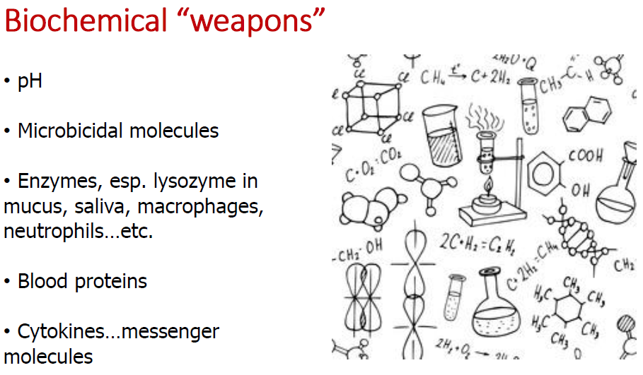
- Microbiocidal molecules :
proteins: Defensins + cathelicidins
non-protein: ROS (reactive oxygen species)
- Lysozyme lyses the cell wall of bacteria, so it works on peptidoglycans
- Two sources for enzymes and microbiocidal molecules:
1- tissues and secretion of tissues like mucous membrane and saliva
2- WBCs like macrophages and neutrophils
- Blood proteins or circulating proteins has long term of action; eg: complement system, lectin & CRP
- Cytokines is secreted from macrophage and stimulate adaptive system
- It is secreted from adaptive system and stimulate cells from innate system
Like stomach

- PH:
-Skin: 5.5…sebum, sweat and the fatty acids secreted by normal flora
\\ the acidity comes from sebum for containing: free fatty acids & lactic acid
-Stomach: 1-3…very few bacteria can live there
-Vagina: 4.4-4.6…Lactobacilli

- Microbicidal molecules:
Defensins…alpha or beta
Cathelicidins…special action against lipopolysaccharides in Gram (-) bacteria
**Defensins + cathelicidins = antimicrobial peptides
…also activate leukocytes \\ chemotaxix of leukocytes
(عملها يشبه ال antibiotic بحيث انها تحلل جدار الخلية للبكتيريا) \\
Reactive oxygen species by activated neutrophils and macrophages
\\ lysozyme is also a microbiocidal but as an enzyme

Microbicidal molecules & enzymes in specific tissues
- Skin
-Alpha-defensins
-Beta-defensins
-Cathelicidin
…Other molecules from the skin
- Fatty acids from commensal microbe
- Enzymes…
-lysozyme in sweat…breaks down peptidoglycan
-RNases and DNases
\\ RNases and DNases are very active and effective (workers in molecular biology – works in DNA & RNA – should wear gloves; so their own DNases & RNases can’t react with their work & destroy it)
- Salts in sweat

Respiratory tract
- Beta defensins
- Cathelicidin
Function: …Microbicidal and activation of leukocytes
GI
- Alpha defensins…the main producer: Paneth cells, these are called: crypticidins
\\ crypticidins: Alpha defensins produced by Paneth cells
- Digestive enzymes, esp. lysozyme in saliva
- Cathelicidin

Eye
Lacrimal secretions…lysozyme

Circulating (Blood) proteins
- Complement system…will be discussed later
- Mannose-binding lectin… = collectin(اسم العائلة)
Functions:
-Opsonization
-Activation of complement \\ (lectin pathway)
- C-reactive protein… of pentraxin family of proteins
Functions:
-Opsonization
-Activation of complement\\ (classical pathway)

Biological barriers
= Commensal microbes = normal flora
**What do you know about?
-Vaginal candidiasis
\\ If we use broad spectrum antibiotic it will kill normal flora that supposed to protect vagina and cause candidiasis
-Pseudomembranous colitis
\\ caused by clostridium difficle (gram +) growth in bowel and cause -Pseudomembranous colitis

