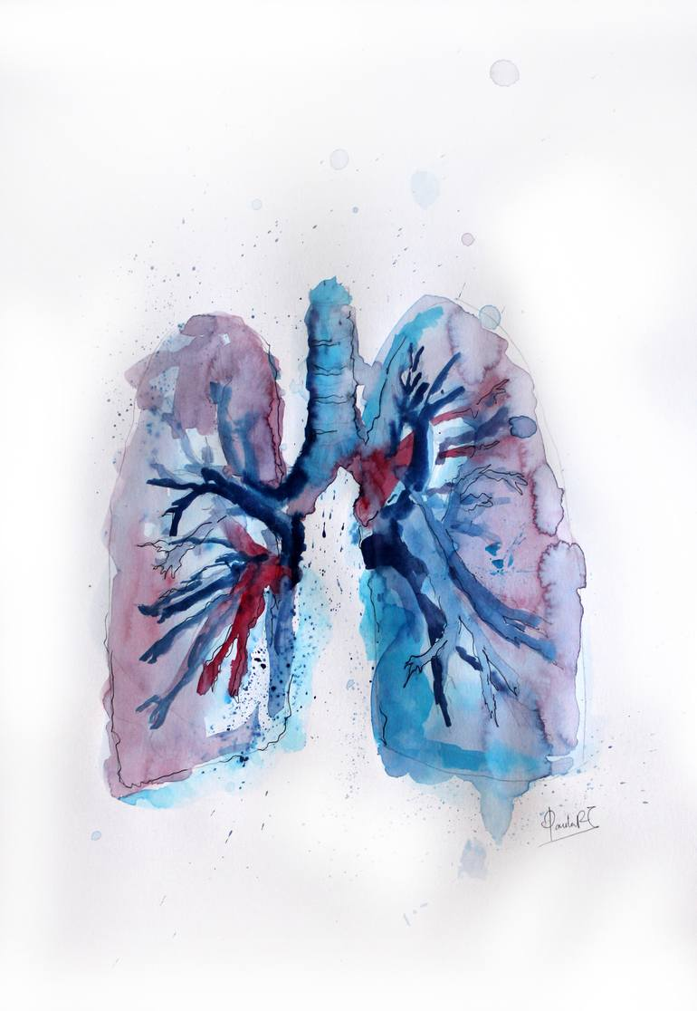
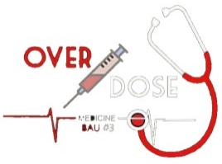

Cont. Lecture 1: Obstructive lung diseases.
THE RESPIRATORY SYSTEM
Sub-system: Pathology
Lecture Title: cont. Lec 1 + Lecture 2
Lecture Date: 12/11
Sheet Writer: Mohammad Ghanayem
Sheet Editor: Rashed Al-Arabiyat

Asthma:
Asthma characterized by triad of events:
A- Chronic bronchial inflammation rich with eosinophils.
B- Bronchial smooth muscle cell hypertrophy and hyperreactivity. Hyper responsive bronchi which mean easy bronchospasm due to minimal stimulus that due to the abundant amount of smooth muscle inside it.
C- Increased mucus secretion.
Note: the main characteristic of asthma is reversible attacks.

Which means an episodic attack of increased mucous secretion and hyper-responsive bronchi that appear in the spirometer as pulmonary function obstruction followed by a spontaneous return to normal functions or by using bronchodilators as salbutamol(that’s why the asthma is reversible).
Collectively this appears as:
Intermittent, reversible airway obstruction appear clinically as:
Episodic expiratory* wheezing, breathlessness, chest tightness, and cough, particularly at night and/or early in the morning.
*in severe cases it will be inspiratory and expiratory wheezing.
BUT even with this episodic attacks there are a group of permanent and progressive changes on bronchial wall start from the beginning and developed gradually that will not appear clinically called airway remodeling (These changes are not revisable once it occurs there is no return.).
But the manifestations of the disease, attacks and spirometry changes are reversible.

Characterized by: (look at the right pic below)
1- Increased goblet cells.
2-increased mucous glands.
3-increase in the mucous as well as the basal line.
4-hypertrophy and hyperplastic smooth muscle.
5- Chronic inflammatory cells mainly: mast cells, lymphocyte, and rich eosinophil.
6-increased vascularity in the mucosa.

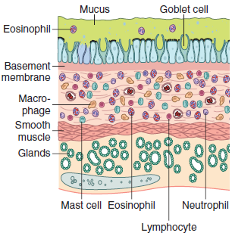
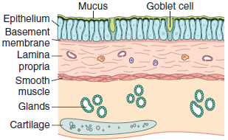

Chronically: When these changes become too much the permanent obstruction occurs which appears clinically and one spirometer.
Notice that these changes are permanent and developed gradually from the beginning. At first, it occurs as long as the attacks but chronically it will cause permanent obstruction( mechanical obstruction).
Asthma increased in the western world.
F
That explained by the hygiene hypothesis which people in the last decades are less exposure to microbes, so mainly T-cells will be less tolerant which affected to become hypersensitive to the minimal stimuli.
Multifactorial = environmental.
Atopic asthma | Non-Atopic asthma
Familial predisposition | Non Familial predisposition
Childhood-onset | Old age onset
Known allergen* | Not -Known allergen
Association with allergic rhinitis, allergic conjunctivitis, urticaria, or atopic eczema | Not associated with other allergic conditions
type-1 (immediate-type) hypersensitivity reaction.(atopy) | Immune system is not involved.
In both types are triggered by different exposures such as: exercise, stress, cold, air bone irritant and URTI (most common one).

*the known allergen that’s doesn’t mean that the attacks just related to it. Instead, there are a lot of triggers for attacks mentioned above.

Mechanism of immediate-type (type-1) hypersensitivity:
Headlines:
Characterized by excessive TH2 cell activation which will:
Imp Note: genetic factors: the gene for IL-4 receptor

1-secrete cytokines (IL-4 and IL-13 stimulate IgE production)
2-IL-5 activates eosinophils
3- IL-13 also stimulates mucus production
Detailed mechanism:
Naïve=mature but not stimulated
FIRST exposure:
Allergen presented by dendritic cells to naïve CD4 cells which converted to TH2 cell as excessive amounts. As well as the allergen will connect to the BCR of B-cell . activated TH2 will stimulate class switching in B cells into IgE .
After that the IgE connect with the FceR1 receptor on mast cells. In this matter a lot of IgE set on the mast cell before the affects appear (responsive exposure).

Repeat exposure:
Allergen found the IgE on the mast cells and make cross-linking with more than one IgE, stimulating the granulation of the mast cells.

There is two types of mediators (released by mast cells):
A-immediate type mediator:
Act within minutes after of the repeated exposure, mainly:
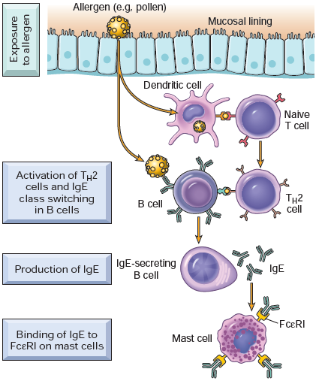
Vasoactive amines (histamine) and lipid mediators (LTC4,D4,E4 and PGD2); collectively will cause:
1-bronchoconstriction (along with neural reflex)
2-increased mucus production
3-vasodilation.

B-late phase mediators= cytokines
Act after 2-24 hours of allergen exposure, mainly:
Eotaxin a potent chemoattractant and activator for eosinophil.

Note: this mechanism for atopic asthma but the results that finally reached are the cause of atopic and non-atopic asthma.(?)

Other types of asthma:
aspirin is the most important
A-Drug-induced asthma
associated with recurrent rhinitis, nasal polyps, urticaria, and bronchospasm
mechanism: may be related to cyclooxygenase inhibition and abnormal prostaglandin metabolism

Fumes, organic and chemical dusts (wood, cotton, etc.), gases, and other
chemicals
B-Occupational asthma
Mechanism: Asthma attacks usually develop after repeated exposure to the inciting
antigen(s)

Asthma, clinical features: (most of them mentioned previously )
1-Attack of severe dyspnea, expiratory wheezing, and cough.
the episodes are due to bronchoconstriction and mucus plugging
2-Progressive hyperinflation due to air trapping in distal airspaces (mechanical expiratory dysfunction)
3-Usually, attacks last from 1 to several hours and subside either spontaneously or with therapy
4-Intervals between attacks: no symptoms and only subtle changes are still present on spirometry
5 status asthmaticus : Occasionally a severe paroxysm(attack) occurs that does not respond to therapy and persists for days and even weeks; (keep in mind that is a prolonged sudden attack not a chronic one and it’s a clincal presenation).

Bronchiectasis
Permanent dilation of bronchi and bronchioles caused by destruction of smooth muscle and the supporting elastic tissue.

It always occurs secondary to persistent infection or obstruction overlaped by over mucus production.
Either A- sever infection casuses increase mucus overproduction which casue obstruction.
B- obstruction due various conditions casue increased mucus production and strangulation so which increase risk for infection.
Infection
Excessive mucus
Obstruction
Characterized by: Cough and expectoration of copious amounts of purulent sputum.
So it needs physiotherapy as bent the back of the patient anteriorly and hit it as wll as with decongesting therapy.
For diagnosis: -good history taking + bronchial dilation on radiology.
-Failure to thrive(appear as School-age but actually he/she in adult age .

Predisposing condition for Bronchiectasis:
1-localized Obstruction due to a tumor or foreign body.
2- Obstruction due to mucus plugging in asthma or COPD.
3-difuse Cystic fibrosis: too much viscid mucus.
4- Immunodeficiency: increased risk for infection.
5- Primary ciliary dyskinesia (previously: Immotile cilia syndrome)
Usually accompained with Situs inversus is a congenital condition in which the major visceral organs are reversed or mirrored from their normal positions.to diagnoise it we cant hear the apex heart beat in the left side because actually its on the right side due to the inversion.
Kartagener syndrome is a type of primary ciliary dyskinesia that is also characterized by situs inversus totalis.
6- Necrotizing or suppurative pneumonia mainly by: S.aures,klebislla and TB(imp one)

Bronchiectasis, clinical course:
1-Severe, persistent cough associated with expectoration of mucopurulent sputum
2-Dyspnea
3-Rhinosinusitis
4-Hemoptysis
5-The symptoms often are episodic and are precipitated or increased by upper respiratory tract infections.
6-in severe and widespread disease: ventilatory defects, with hypoxemia, hypercapnia, pulmonary hypertension, and cor pulmonale(right sided heart faliure).
*Complications (rare nowadays):
-Brain abscess
-Amyloidosis
-Cor pulmonale
END of the 1st lecture.

Lecture 2: Atelectasis, acute respiratory distress syndrome & pulmonary edema.

Atlelectasis(lung collapse)
Inability of lung to expand and subsequently: No lung volume.
It will cause hypoxia (there is no ventelation) and may be complicated by infection of the collapsed lung tissue (pnemonia).

3 main types of atelectasis:
reversible
1-Resorption atelectasis obstruction
Obstruction will block the ventilation, so there is no new air to enter the lung, and the previous air in the lung gradually resorped.
-reversible by removal of the element of obstruction.
Obstruction by:
a- Bronchial tumor
b-Foreign body
c-Asthma
d-Chronic bronchitis by removing or treatment of exceesive mucous expectoration
e-Bronchiectasis

f- Postoperative: some patients have a little dyspnea after an operative so after x-ray examination the doctor notice opacities on the bronchi and this due to anesthetics that cause a little obstruction which causes a little stagnation which causes a little obstruction and dyspnea

2-compression atelectasis: anything found in the pleural cavity that compresses the lung.
a-Pneumothorax (air in the pleura)
reversible
b-Hydrothorax / pleural effusion
c-Hemothorax (blood in the pluera)
d-Chylothorax
e-Mesothelioma: The most common type of primary malignant tumor from the pluera.
f-Metastates to pleura: pleura are favored for tumor metastis.
g-Basal atelectasis: in the bedridden and in ascites.

3-contraction atelectasis: Fibrosis of the lung or the pleura
irreversible

Adult respiratory syndrome
Acute respiratory distress syndrome (ARDS)
Previously was the severe end of acute lung injury. But no there is no more use for ALI and replaced by ARDS and it graded by based on the severity of the changes in arterial blood oxygenation.
Def: *respiratory failure occurring within 1 week of a known clinical insult with bilateral opacities on chest imaging, not fully explained by effusions, atelectasis, cardiac failure, or fluid overload.
*Respiratory failure: Respiratory failure is a condition in which your blood doesn't have enough oxygen or has too much carbon dioxide.
Batwings infiltrate

Mechanism: It is an extensive bilateral alveolar damage with resultant bilateral *non-cardiogenic edema (fibrin rich edema) due to the material spilled from the blood to the alveolar spaces(bcz of destruction of alveolar blood barrier).
How to diagnose that it’s non-cardiogenic? Heart x-ray manifestation (narmal size of heart).

Rapid onset of life-threatening respiratory insufficiency, cyanosis, and
Severe arterial hypoxemia that is refractory to oxygen therapy.

Histological manifestation:
1-Diffuse alveolar damage (DAD) main character
2-hylaine membrane: pink eosinophilic lining the alveolar spaces from the inside.
**Hyaline membrane disease of the newborn (respiratory distress syndrome) is different from ARDS caused by surfactant deficiency.

Causes of ARDS:
A=Pneumonia
b- Sepsis
c- Aspiration (chemicals)
d- Trauma (including brain injury, abdominal surgery, and multiple fractures) from the salty, fluid substances and may be platelets that gave to those patient which trigger an immune response that strike and make in injury to the alveoli.mm
e- Pancreatitis: by secreting phospholipase A2 which causes damage of phospholipids( surfactant).
f- Transfusion reactions (that will cause TRALY: transfusion related acute lung injury)

Pathogenesis of ARDS:
Alveolar-capillary membrane damage due to endothelial and epithelial injury with loss of surfactant
Mainly by an inflammatory reaction due to pro-inflammatory mediators
Neutrophil recruitment BY (IL-8, IL-1 & TNF)

Clinical features OF ARDS:
In 85% of cases, it develops within 72 hours of the initial insult
The overall hospital mortality rate is 38.5%...high mortality
Most patients who survive the acute insult recover normal respiratory function within 6 to 12 months, the rest develop diffuse interstitial fibrosis leading to chronic respiratory insufficiency.

Congestion=passive
Hyperemia=active
Pulmonary edema
Left-sided heart failurevenous congestion (a passive process) in lung veinsIncreased hydrostatic pressure pulmonary edema
Morphology:
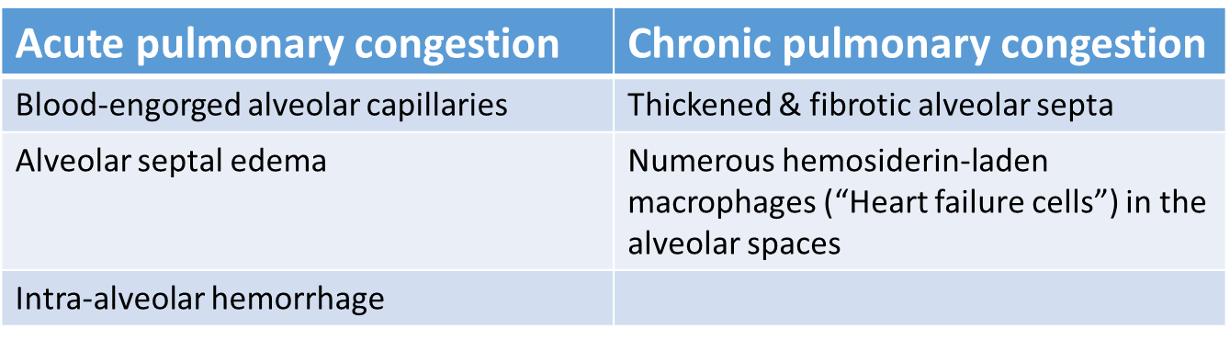

THANK YOU

