Lecture four
Mycoplasmas

Dr. Hala Al Daghistani

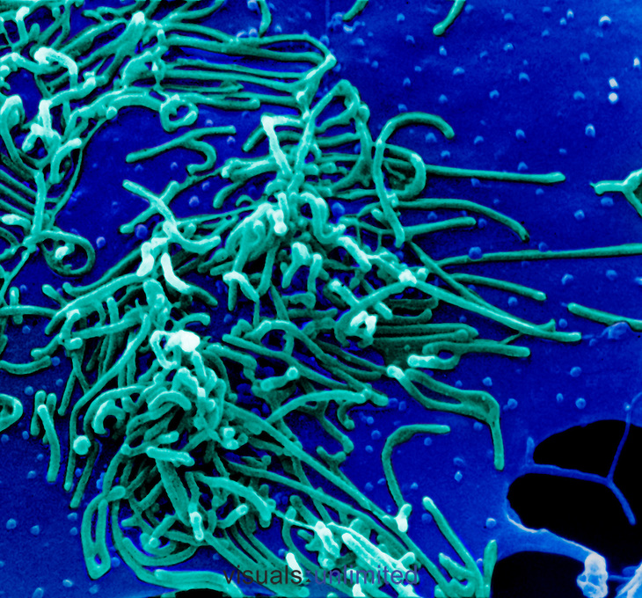

- Mycoplasmas are the smallest organisms that can be free living in nature.
They have the following characteristics:
- The smallest mycoplasmas are 125–250 nm in size
- they are highly pleomorphic because they lack a rigid cell wall and instead are bounded by a triple-layered “unit membrane” that contains a sterol
- They are completely resistant to penicillin
- Mycoplasmas can reproduce in cell-free media. The center of the whole colony is characteristically embedded beneath the surface
- Mycoplasmas have an affinity for mammalian cell membranes.

At least 16 of Mycoplasma species are thought to be of human origin; others have been isolated from animals and plants. In humans, species that are of primary importance:

- Mycoplasma pneumoniae causes pneumonia and has been associated with joint and other infections.

- Ureaplasma urealyticum is associated with lung disease in premature infants of low birth weight.

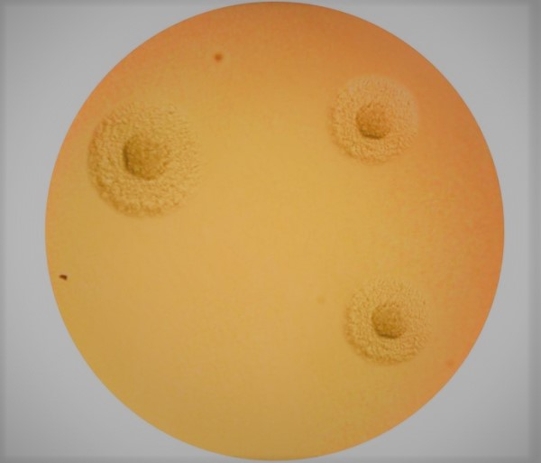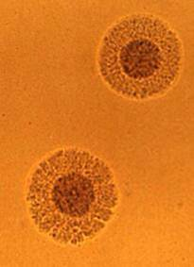

Morphology and Identification
Culture of mycoplasmas that cause disease in humans requires media with serum, a metabolic substrate such as glucose or urea, and growth factors such as yeast extract.
- The colonies are round, with a granular surface and a dark center typically buried in the agar.
- The center of the M. pneumoniae colony grows into the agar and appears denser, giving the appearance of an inverted “fried egg.”
- Growth in culture is inhibited by specific antisera directed at the particular species.
- Mycoplasmas pass through filters with 450 nm pore size and thus are comparable to chlamydiae or large viruses.
- Many Mycoplasmas use glucose as a source of energy; Ureaplasmas require urea.
- Some human Mycoplasmas produce Peroxides and hemolyzed red blood cells.
Antigenic Structure
- In humans, the species that can be identified include; M. hominis, M. salivarium, M. orale, M. fermentans, M. pneumoniae, M. genitalium, U urealyticum, and others.

Pathogenesis
- Many pathogenic mycoplasmas have filamentous shapes with specialized polar tip structures that mediate adherence to host cells (These structures are a complex group of proteins, adhesins, and adherence-accessory proteins).
- Colonies of M. pneumoniae bind red blood cells (RBCs) (hemadsorption). This is due to binding by the mycoplasma to sialic acid – containing oligosaccharides present on the RBC surface.
- Subsequent events in infection may include several factors as follows: direct cytotoxicity through generation of hydrogen peroxide and superoxide radicals
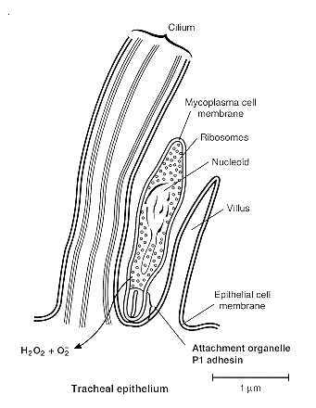

Mycoplasma pneumoniae
- M. pneumoniae produces a common form of pneumonia, which tends to occur in any season and has a predilection for younger individuals.
- The illness is characterized by a nonproductive cough, fever, and headache, with mild pneumonia.
- The course is almost always benign, but improvement is accelerated by treatment with antibiotics

Epidemiology
- M. pneumoniae accounts for approximately 10% of all cases of pneumonia.
- Infection is acquired by droplet spread. Experimental challenges indicate that the human infectious dose is very low, possibly less than 100 colony-forming units.
- Epidemics have been noted in both civilian and military populations.
- The most common age for symptomatic M. pneumoniae infection is between 5 and 15 years.
Pathogenesis
- M. pneumoniae infection involves the trachea, bronchi, bronchioles, and peribronchial tissues, and may extend to the alveoli and alveolar walls.
- Initially, the organism attaches to the cilia and microvilli of the cells lining the bronchial epithelium. This attachment is mediated by a surface mycoplasmal cytadhesin (P1) protein that binds to complex oligosaccharides found in the apical regions of bronchial epithelial cells.
- The organisms interfere with ciliary action and initiate a process that leads to inflammatory reaction and exudate. The inflammatory response is composed of lymphocytes, plasma cells, and macrophages, which may thicken the walls of the bronchioles and alveoli.

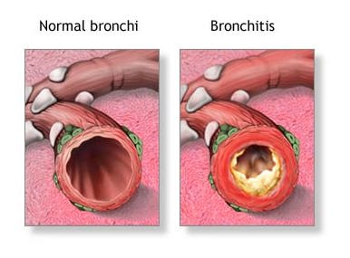

- The pneumonia is less severe than other bacterial pneumonias. It has been described as “walking” pneumonia (atypical pneumonia), because most cases do not require hospitalization.
- The disease is of insidious onset, with fever, headache, and malaise for 2 to 4 days before the onset of respiratory symptoms.
- Complications are uncommon, but hemolytic anemia may occur. The most common pathologic findings are interstitial and peribronchial pneumonitis and necrotizing bronchiolitis.

Immunity
- Both local and systemic specific immune responses occur. Local IgA antibody is produced and Complement-fixing serum antibody titers reach a peak 2 to 4 weeks after infection.
- Nonspecific immune responses to the glycolipids of the outer membrane of the organism often develop, which can be detrimental to the host. For example, Cold hemagglutinins are IgM antibodies that cross-react with the I antigen of human RBCs and are seen in about two thirds of symptomatic patients infected with M. pneumoniae.
- Cold hemagglutinins for group O human erythrocytes appear in about 50% of untreated patients, in rising titer, with the maximum reached in the third or fourth week after onset.
Diagnostic Laboratory Tests
Specimens
Specimens consist of throat swabs, sputum, inflammatory exudates, and respiratory secretions.
Microscopic Examination
Direct examination of a specimen for mycoplasmas is useless.

Serology
Antibodies develop in humans infected with mycoplasmas and can be demonstrated by CF, HI, Indirect immunofluorescence. The test that measures growth inhibition by antibody is quite specific.

Legionella pneumophila

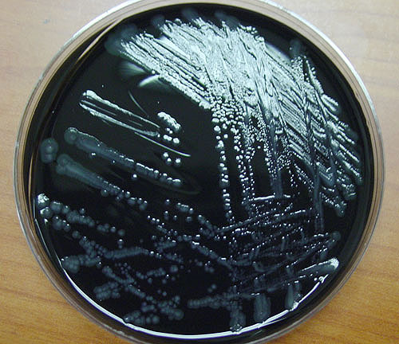

L. pneumophila is the major cause of disease in humans(legionnaires disease)
L. micdadei and a few other species sometimes cause pneumonia.

Morphology and Identification
- is a thin, pleomorphic, Gram-negative rod that may show elongated, filamentous forms.
- Polar, subpolar, and lateral flagella may be present.
- The toxicity of L. pneumophila lipopolysaccharide (LPS) is significantly less than that of other Gram-negative bacteria. This has been attributed to chemical makeup of the LPS.

Culture
- Legionellae can be grown on complex media such as buffered charcoal yeast extract agar with ἀ-ketoglutarate and iron (BCYE) and 90% humidity. Legionellae grow slowly; visible colonies are usually present after 3 days of incubation.

Growth Characteristics
- The legionellae are catalase positive, oxidase positive; the other legionellae are variable in oxidase activity.
- L. pneumophila hydrolyzes hippurate; the other legionellae do not

Antigens & Cell Products
- There are at least 16 serogroups of L. pneumophila
- Serogroup 1 was the cause of the outbreak of Legionnaires' disease
- legionellae make proteases, phosphatase, lipase, DNase, RNase, and has hemolytic and cytotoxic activity.
Epidimiology
- In nature, Legionella species are ubiquitous in fresh water particularly in warm weather. In these sites they are also found as parasites of protozoa including numerous species of amoebae which appear to be the environmental reservoir.
- Transmission to humans is possible when the water supply becomes colonized. Most outbreaks have occurred in or around large buildings such as hotels, factories, and hospitals involving cooling towers or some other part of the air-conditioning system.
- Legionella can persist in a water supply despite an adequate levels of chlorine .
- Person-to-person transmission has not been documented, and the organisms have not been isolated from healthy individuals.

Pathogenesis
- L. pneumophila attack the lung, producing a necrotizing multifocal pneumonia. Microscopically, the process involves the alveoli and terminal bronchioles, and bronchi .
- The inflammatory exudate contains fibrin, polymorphonuclear neutrophils (PMNs), macrophages, and erythrocytes. An important feature is the presence of bacteria within phagocytes and the lytic destruction of inflammatory cells.
- L. pneumophila is a facultative intracellular pathogen. Its pathogenicity depends on its ability to survive and multiply within cells of the monocyte–macrophage series.
- Inhaled Legionella bacteria reach the alveoli, where they enter alveolar macrophages utilizing mechanisms involving multiple molecules. This include:
- Outer Membrane Protein (OMP)
- binds C3
- facilitating phagocyte recognition
- induces pores in the membrane of the macrophage.

- Macrophage Invasion Potentiator (Mip) determines cell entry.
- Inside the vacuole the bacteria continue to replicate by preventing phagosomelysosome fusion

Other elements of the organism’s intracellular success include
- its ability to extract iron from intracellular transferrin
- an exotoxin that inhibits activation of the oxidative killing mechanisms of PMNs. Thus, instead of being killed by the bactericidal mechanisms of phagocytes, L. pneumophila multiplies freely.
- Death of cells is also related to induction of programmed cell death and formation of a pore-forming toxin.

Immunity
Just as intracellular multiplication is the key to L. pneumophila virulence, its inhibition by cell-mediated mechanisms appears to be the most important aspect of immunity. The role of humoral immunity appears to be less important.

Legionellosis: Clinical aspects
- Legionnaires’ disease is a severe pneumonia that begins with myalgia and headache, followed by a rapidly rising fever.
- A dry cough may develop and later become productive, but sputum production is not a prominent feature.
- Chills, pleuritic chest pain, vomiting, diarrhea, confusion, and delirium may all be seen.
- Radiologically, interstitial infiltrates with a tendency to progress toward nodular consolidation are present unilaterally or bilaterally.
- Liver function tests often indicate some hepatic dysfunction.
- Almost all with Legionnaires' experience fever, while approximately half have cough with sputum, and one third cough up blood or bloody sputum.
- The overall mortality is about 15%, but has been higher than 50% in some hospital outbreaks.
- The L.pneumophila and other species can also cause a less severe, flu-like condition known as Pontiac fever (named for a 1968 Michigan outbreak), is a nonpneumonic illness with fever, myalgia, dry cough and a short incubation period (6 to 48 hours).
- Pontiac fever is a self-limiting illness and may represent a reaction to endotoxin or hypersensitivity to components of the Legionella species or their protozoan hosts.
Diagnostic Laboratory Tests
Specimens:
- bronchial washings
- pleural fluid
- lung biopsy specimens
- blood.
Smears: Direct fluorescent antibody tests of specimens can be diagnostic. Silver stains are sometimes used on tissue specimens.
- L pneumophila are intracellular parasites of macrophages.
- Cooling towers and evaporative condensers can be heavily contaminated with L pneumophila.
- Hyperchlorination and superheating of water can help control the multiplication of legionellae in water and in air-conditioning systems.
