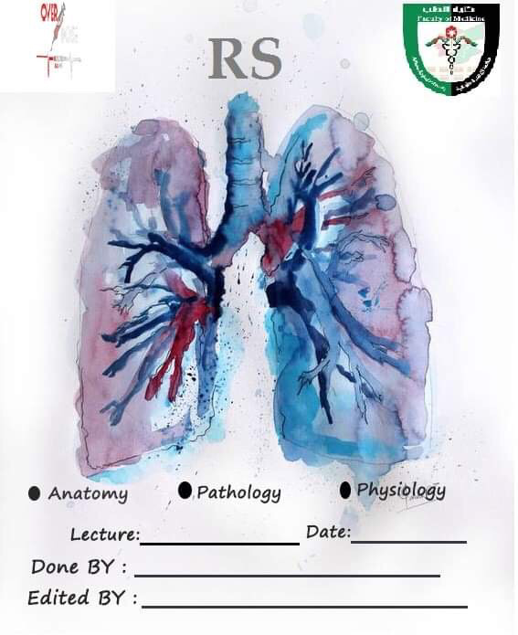

Lecture 5 31-10-2019
Saeed Karajah
Ahmad Abueisheh

Sheet Correction link -> https://www.bit.ly/rsanatomy
Pleura: Innervation (Continued from last lecture)

Most of the visceral part of the pulmonary system in the thorax is innervated by the pulmonary plexus (autonomic) which is made up of:
- Pre-ganglionic parasympathetic fibers : from the Vagus nerve (CN10)
- Post-ganglionic sympathetic fibers : T1 -> T5
These are visceral afferent fibers which means they are sensory, one of their features is that if there is a problem in the lungs the actual pain sensation will be vague or diffuse, however when they enter their spinal roots (T1 -> T4) they stimulate the somatic fibers from T1 -> T4 supplying the medial part of the upper arm (because T1 is part of the brachial plexus) and the upper 4 intercostal spaces (via the intercostal nerves), so the referred pain will be in these areas.
Note : we use referred pain to diagnose the actual internal visceral problem so it’s very useful clinically
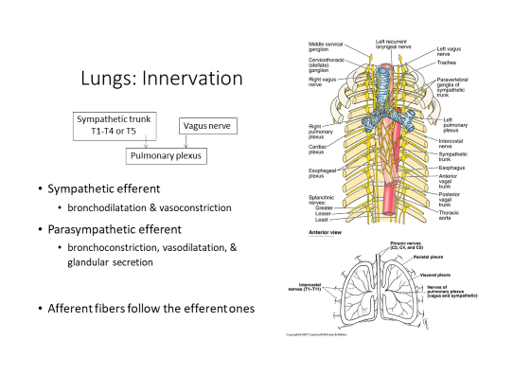
The Mediastinum
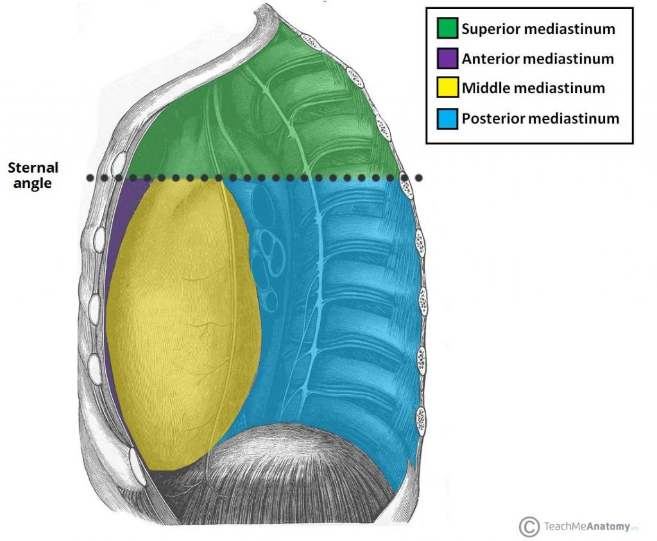
It’s an internal cavity bordered by:
- Laterally: Lt & Rt Pleural Cavities
- Anteriorly: The Sternum
- Posteriorly: The thoracic vertebrae
- Inferiorly: The diaphragm
- Superiorly: Superior thoracic aperture
The superior border of the heart separates the mediastinum into superior and inferior compartments, and the heart itself is located in the inferior mediastinum and separates it into anterior, middle and posterior compartments
Note: the middle mediastinum only contains the heart
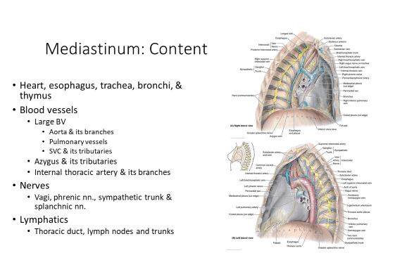
Contents of the Superior Mediastinum

Notes:
-Phrenic nerve (C3 – C5 from cervical plexus): although it arises from the cervical plexus, the areas it innervates are in the mediastinum & the diaphragm so the referred pain from these areas could reach the cervical region.
-The thymus is located in the superior & anterior mediastinum.
- Middle mediastinum -> Heart
- Anterior mediastinum -> Thymus + Phrenic Nerves
- Posterior mediastinum -> Descending Aorta, Esophagus, Sympathetic plexus, Azygus & Hemizygous veins, Splanchnic nerves, Pulmonary veins, Thoracic duct, Vagus nerves.

Internal thoracic artery
- From 1st part of subclavian
- Course : Lateral wall of the sternum , at the end of the sternum it bifurcates into the Superior epigastric (continues directly towards the abdominal wall) , Musclophrenic a. (costal margin & gives the rest of the intercostal arteries)
- Branches
  - Anterior intercostal aa. (1‐6th intercostal spaces)
  - End branches
    - Superior epigastric a.
    - Musculophrenic a.
      - Anterior intercostal aa. (7th‐9th intercostal spaces)

Ascending aorta
Relations:
- The ascending aorta emerges posterior to the pulmonary trunk and then it crosses anterior and to the right and turns into the arch of the aorta (so the end of the ascending aorta is anterior and to the right of the pulmonary trunk)
- It’s anterior the superior vena cava
The general rule in the mediastinum is that the veins are anterior to the major arteries except the ascending aorta and the superior vena cava

Relations of and some notes on the large vessels in the mediastinum
Brachiocephalic artery
Relations: Posterior to the superior vena cava
Arch of Aorta
Orientation from the proximal to distal part: It goes posterior and to the left, so its branches are posterior the ascending aorta & Lt. brachiocephalic vein

Brachiocephalic Veins
Bifurcate behind the sternoclavicular joints
The trachea is posterior and to the left of the brachiocephalic veins
Lt Common carotid and subclavian a.
The left brachiocephalic vein is anterior to both of them, and they are to the left of the trachea
Descending aorta
Relations:
- Posterior to the left primary bronchus
- To the left and then posterior to the esophagus
- Left and anterior to the hemizygous
- The azygous is right and posterior to the descending aorta
- The thoracic duct is right and posterior to the descending aorta

Pulmonary trunk
Bifurcates posterior and to the right of the arch of aorta

Pulmonary Arteries
Right:
Posterior to the ascending aorta
Anterior and inferior to the Rt. Primary bronchus
Left:
Anterior to the descending aorta
Anterior and inferior to the Lt. Primary bronchus

Superior Vena Cava
The Lt. & Rt. Brachiocephalic veins unite behind the right sternoclavicular joint to form it.
Course: posterior to the right side of the sternum
Relations:
- Anterior to the brachiocephalic artery
- Anterior and to the right of the trachea
- Posterior to the internal thoracic artery
Azygous Vein
Relations:
- Right and posterior to the descending aorta
- Right to the thoracic duct
- Anterior and to the left of the sympathetic trunk
- The Arch of the azygous is superior to the hilum of the lung

Vagus nerve: posterior to the hilum (part of the posterior mediastinum)
Phrenic nerve: anterior to the hilum (part of the anterior mediastinum)
Inferior vena cava: is anterior and superior to the esophagus at the level of the diaphragm (which is a dome)
Note from the prof. : the lung segments are important (although he said that they aren’t last lecture) so go back and learn their relations to each other because he saw a question about them in the USMLE
Note: this lecture was an interactive lecture so the doctor didn’t cover all the slides and I couldn’t cover every piece of information he said but hopefully the important facts are included. Please focus on the relations of the different structures to each other.

Slides 33 -> 48 are not included in this sheet, it’s better to study them side by side with this sheet because the pictures will be too small to see if I add them here. (The pictures are very important to visualize the relations between the structures)

