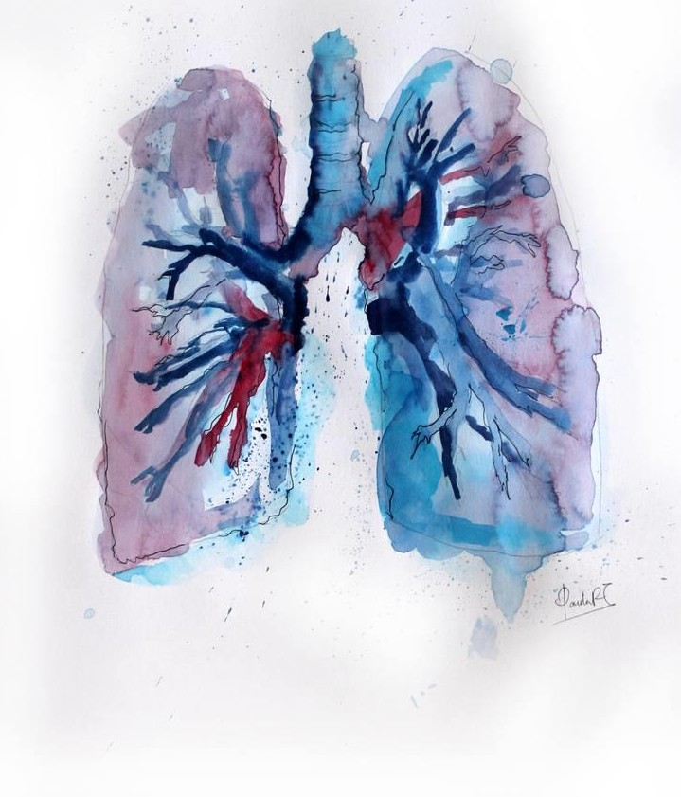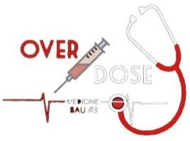

**Subject: physiology sheet 6**

**Lecture title: (Transport of O2 and CO2 in blood and tissues fluid)**

**Lecture Date: 6/11/2019**

**Done by: Duha hyasat**

**Edited by: Ban Aladamat.**

**Sheet correction link: bit.ly/rsphysio**

**Diffusion of Oxygen from the Alveoli to the Pulmonary Capillary Blood:** 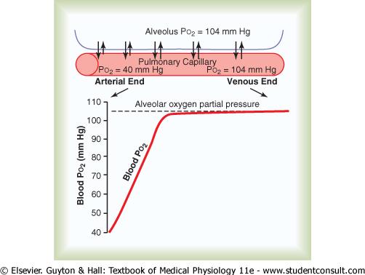

The curve shows rapid rise in blood po2 as the blood passes through the capillaries, the po2 in the alveolus averages 104 mm Hg whereas the po2 at the arterial end averages only 40 mm Hg.

**Physics of Gas Diffusion and Gas Partial Pressure**

1. Uptake of oxygen during exercise may increase as much as 20x
2. During non-exercising conditions, the blood almost becomes saturated with oxygen (po2=104 mm Hg) by the time it passes through 1/3 of pulmonary capillary, which is 0.8 sec.

**Transport of Oxygen in the arterial blood**

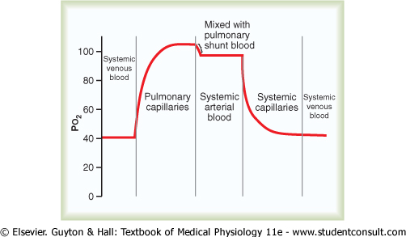The curve shows the changes in blood po2 in pulmonary capillary blood, systemic arterial blood, systemic capillary blood (the po2 decrease due to the diffusion of o2 into the tissues) and demonstrates the effect of shunted blood on the po2.

PO2 of systemic venous blood that enters the alveoli is 40 mm Hg, after oxygenation it increases up to 100-104 mm Hg. Then it falls to about 95 mm Hg when the blood of pulmonary capillaries mixes with bronchial circulation (pulmonary shunt blood i.e. the blood that supplies deep tissues of lungs that isn’t exposed to air). And finally after supplying tissues it goes back to 40 mm Hg.

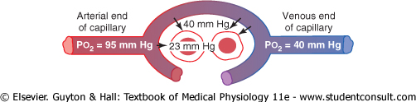

This figure shows the diffusion of o2 from peripheral tissue capillary to the cell. PO2 in interstitial fluid =40 mm Hg and in tissue cells = 23 mm Hg.

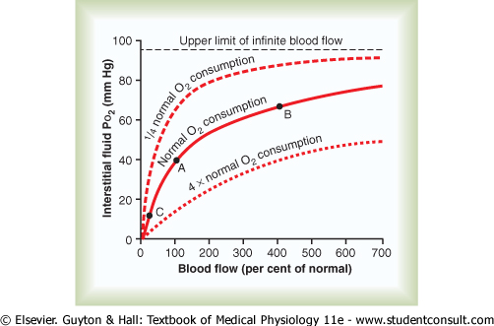This figure shows 2 things:

**1) The effect of rate of blood flow on interstitial fluid** **PO2**: if the blood flow through a particular tissue is increased, greater quantities of o2 are transported into the tissue and the tissues’ PO2 increases. Conversely, if blood flow through the tissue deceases PO2 of that tissue also decreases.

**2) The effect of rate of tissue metabolism on interstitial fluid PO2**: If o2 consumption increases than normal (4x normal o2 consumption) interstitial fluid PO2 decreases significantly, but when the cellular o2 consumption decreases (1/4 of normal o2 consumption) the po2 is significantly increased.

Note that an increase in flow to 400 percent of normal INCREASES the po2 from **40 mm Hg at point A** to **66 mmHg at point B**. هاد الشرح مقتبس من الكتاب الارقام بهاد السطر مو حفظ فقط لغايات الفهم

**Diffusion of Carbon Dioxide from the Peripheral Tissue Cells into the Capillaries And from the Pulmonary Capillaries into the Alveoli**

1. When oxygen is used by the cells, virtually all of it becomes carbon dioxide, and thus increases the intracellular PCO2
2. Carbon Dioxide diffuses about 20x as rapidly as oxygen (the pressure difference required for CO2 to diffuse is less than that of O2)
3. Carbon dioxide pressures are approximately:
4. Intracellular PCO2, 46 mm Hg; interstitial PCO2, 45 mm Hg (this difference of 1 mm Hg is sufficient for CO2 to diffuse rapidly)
5. PCO2 of the arterial blood entering the tissues, 40 mm Hg; PCO2 of the venous blood leaving the tissues, 45 mm Hg (the difference of PCO2 between arterial and venous blood isn’t as high as that of oxygen, that’s why the diffusion is very high)
6. PCO2 of blood entering the pulmonary capillaries at the arterial end, 45 mm Hg; PCO2 of the alveolar air, 40 mm Hg

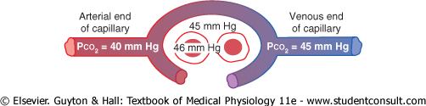

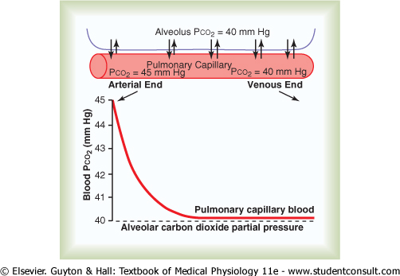

**Diffusion of carbon dioxide from the pulmonary blood into the alveolus**

* The blood Pco2 at the arterial end of pulmonary artery = 45 mm Hg.
* Remember, the arterial end of the systemic artery is oxygenated but the arterial end of the pulmonary artery is deoxygenated.

**Effect of MR and Tissue Blood Flow on Interstitial Pco2**

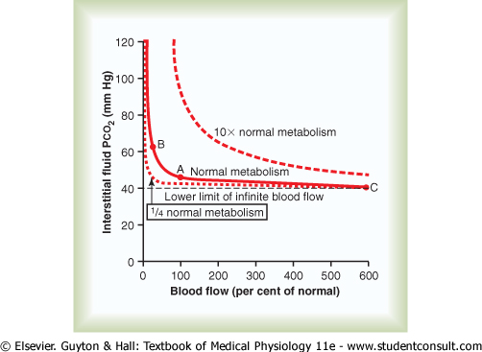

* Note: tissue capillary blood flow and tissue metabolism affect the Pco2 in ways exactly OPPOSITE to their effect on tissue PO2.
* Increase the blood flow from point A to point C, decreases the interstitial fluid PCO2. While a significant decrease of blood flow from point A to B increases the interstitial PCO2
* Note also that a 10-fold increase in tissue metabolic rate elevates the interstitial fluid PCO2 at all rates of blood flow, but decrease metabolism to ¼ of normal decreases the PCO2.
* Normally 97% of the oxygen transported from the lungs is bound to hemoglobin. 4 oxygen molecules bind to 1 molecule of Hb.
* Reversible Combination of Oxygen with Hb depends on concentration differences
* O2 present in the blood in 2 forms: dissolved (physical) form represents 3% of blood oxygen (responsible of partial pressure) and oxyhemoglobin form 97% of blood oxygen (doesn’t contribute in partial pressure).
* When interstitial PO2 decreases due to oxygen consumption, Hb dissociates oxygen to dissolve in plasma and increase interstitial po2 (brings it back to normal)

الدكتور حكى متل البنك والمصاري الي بجيبتك … البنك هو ال oxyhemoglobin

المصاري الي بجيبتك هي ال dissolved form of o2

لما تخلص المصاري الي بجيبتك بتروح عالبنك

Any change in atmospheric oxygen concentration (high altitude/pure oxygen) affects oxygen partial pressure and Hb saturation. For example when a higher percent of O2 is inspired the alveolar PO2 increases which therefore increases the Hb saturation level of oxygen, which is normally 97%, maximally to 100%, but not more than that because it has a limit. After the full saturation of Hb, the dissolved oxygen in blood increases (partial pressure) more than the normal levels (arterial and venous).

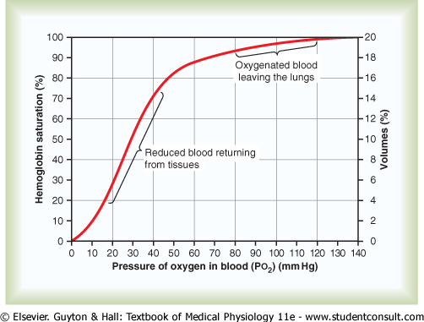  
 **Oxygen-hemoglobin dissociation curve**

This figure shows oxygen-Hb dissociation curve which demonstrates a progressive increase in the Hb saturation as blood Po2 increases.

* The usual o2 saturation of systemic arterial blood averages 97%
* The saturation of HG in venous blood returning from peripheral tissues averages 75%
* Amount of Oxygen Released from Hb When Arterial Blood Flows Through Tissues- reduced from 19.4 ml (97%) to 14.4 ml
* The yellow part of the slope represents the dissociation at rest:

1. As PO2 decreases to 40 mm Hg, the saturation decreases to 75%
2. Significant change in partial pressure (104 to 40 mm Hg) with small change in saturation (97% to 75%)

* The Green part of the slope represents the dissociation during exercise (high metabolism):

1. As PO2 decreases less than 40 mm Hg, the saturation level decreases significantly (to maintain the interstitial PO2 in the normal range)
2. Significant reduction of saturation with small change of PO2
3. This is called the steep slope.

# QUESTION in the exam: during the exercise extra o2 needed can be delivered to the tissues by? Steep slope of Hb-O dissociation curve.

**Maximum Amount of Oxygen than can combine with the hemoglobin of the blood**

* 15 grams of Hb in each 100 ml blood
* Each gram Hb  1.34 ml of O2

15 x 1.34 = 20.1 ml of O2 ( if Hb 100% saturated)

* usually expressed as “ 20 volumes %”

**Effect of blood PO2 on the quantity of oxygen bound with hemoglobin in each 100ml of blood**



**The total quantity of o2 bound** **with HG in normal arterial blood =19.4 ml per 100 ml of blood ,this quantity decreases to 14.4 because the blood passing through tissue capillaries and during strenuous exercise only 4.4 ml of o2 remain bound with HG in each 100 ml .**

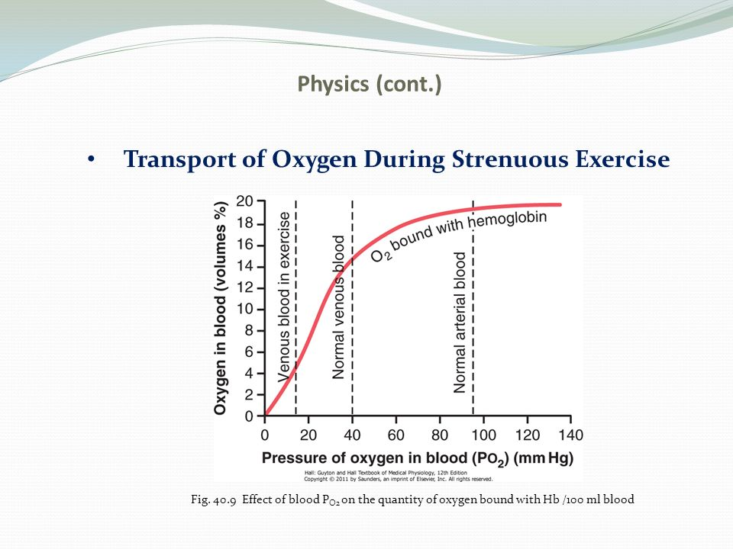

**Utilization Coefficient:**

The percentage of blood that gives up oxygen as it passes through the tissue capillaries.

1. Normal value is about 25% (at rest)
2. During strenuous exercise it may increase to 75-85%

**Effect of Hb to “Buffer ” the tissue PO2; the role of Hb in Maintaining Constant PO2 to the Tissues**

1. Under basal conditions, the tissue requires 5 ml oxygen/100 ml of blood; PO2 must be <40 mmHg
2. Cannot rise above 40 mm pressure, the oxygen needed would not be released by the Hb
3. During exercise, the extra oxygen needed can be delivered by (1) steep slope of dissociation curve, and (2) increased blood flow
4. Also remains constant when atmospheric oxygen content changes (pure oxygen/high altitude)

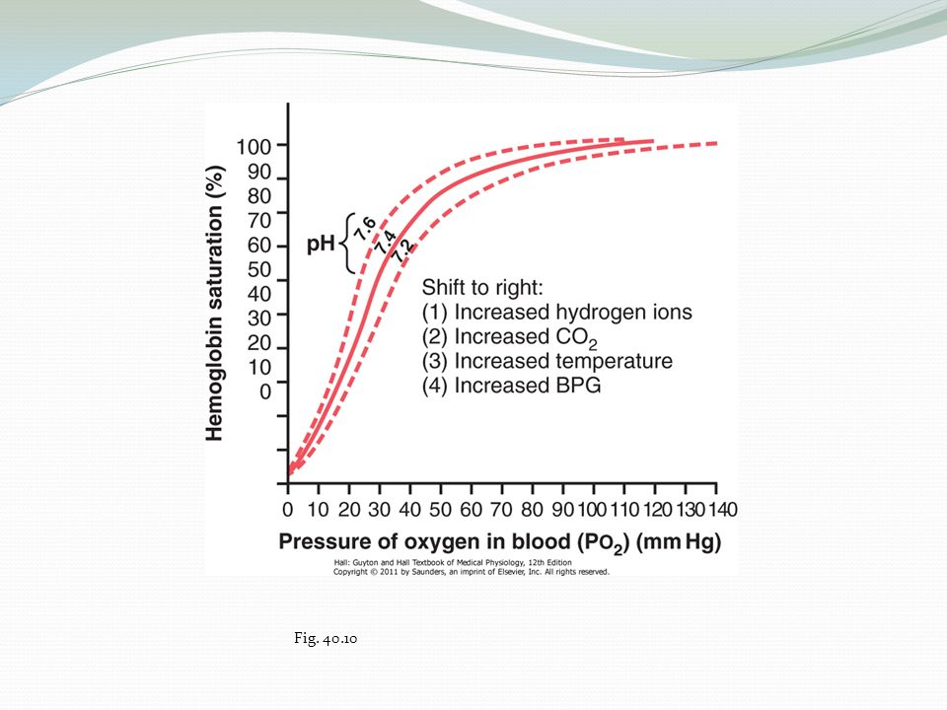**Factors that shift the oxygen-Hb dissociation curve**

1. pH; acidic it shifts to the right and if basic, it shifts to the left
2. Increased carbon dioxide concentration
3. Increased blood temperature
4. Increased BPG (2,3 bisphosphoglycerate), metabolic compound found in the blood

* The shift of the dissociation curve to the right means increase the release of o2 from Hb / o2 is required.
* Anything that needs more o2 that shifts the dissociation curve to the right like : increased the co2 means more metabolism so the tissue need more o2 and increase blood temperature also mean increase in metabolism .
* The shift of the curve to the left: increase alkalinity /low co2 less need of o2.

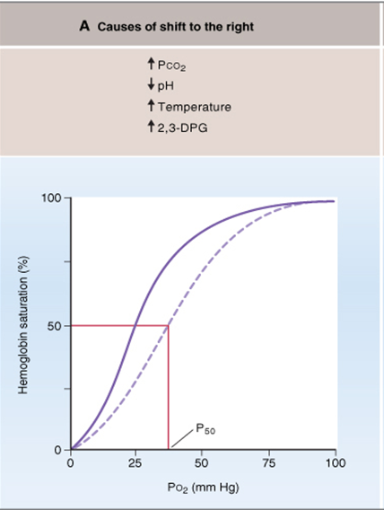

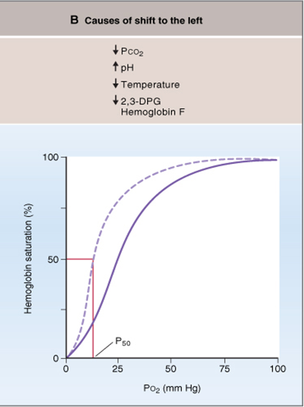

**Bohr Effect**

* A shift of the dissociation curve to the right due to increased CO2 and H ions enhances the release of oxygen from the blood into the tissues and enhances the oxygenation of the blood in the lungs.
* As blood passes through the tissues, carbon dioxide diffuses from the tissue cells into the blood. This increases PCO2 which in turn raises the blood H2CO3 (carbonic acid) and the hydrogen ion concentration. This forces oxygen away from Hb and delivers increased amounts to the tissues.
* Co2 increases the release of o2 from the blood to tissues and the binding (saturation) in alveoli (Exactly the opposite happens in the lungs)
* Metabolic use of oxygen by the cells:

1. Effect of intracellular PO2 on the rate of oxygen usage
2. Effect of diffusion distance from the capillary to the cell on oxygen usage
3. Effect of blood flow on the metabolic use of oxygen

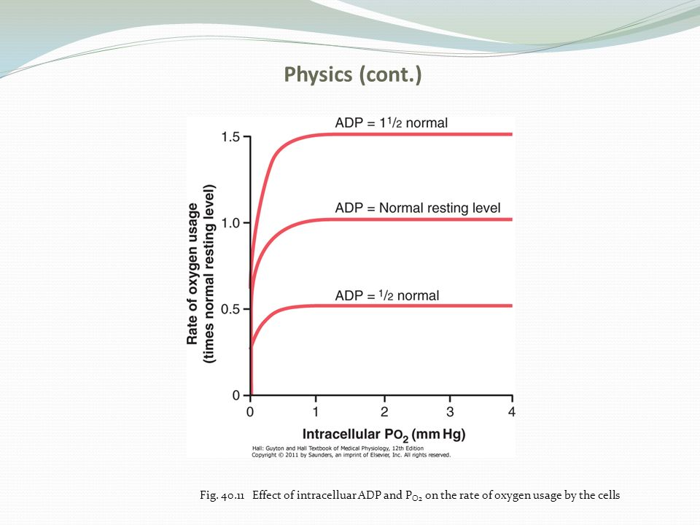

The figure shows the relation b/w intracellular po2 and the rate of o2 usage at different concentration of ADP in the cell.

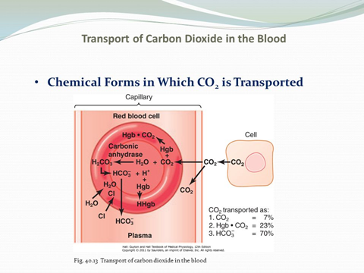**Chemical Forms in Which CO2 is Transported**

1. Transport of carbon dioxide in the dissolved state-normally about 7% of the total
2. Transport in the from of bicarbonate ion (70%)

1. Reaction of carbon dioxide with water in the RBCs- effect of carbonic anhydrase

2. Dissociation of carbonic acid into bicarbonate and hydrogen ions; also involves the “chloride shift”

1. 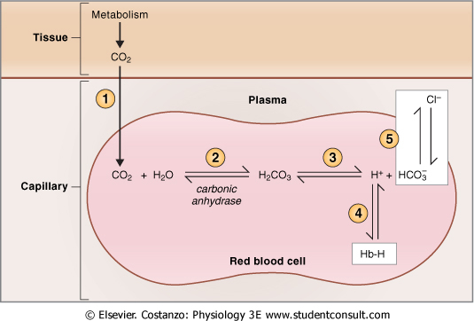Transport in combination with hb and plasma proteins-carbaminohemoglobin (25%-23%)

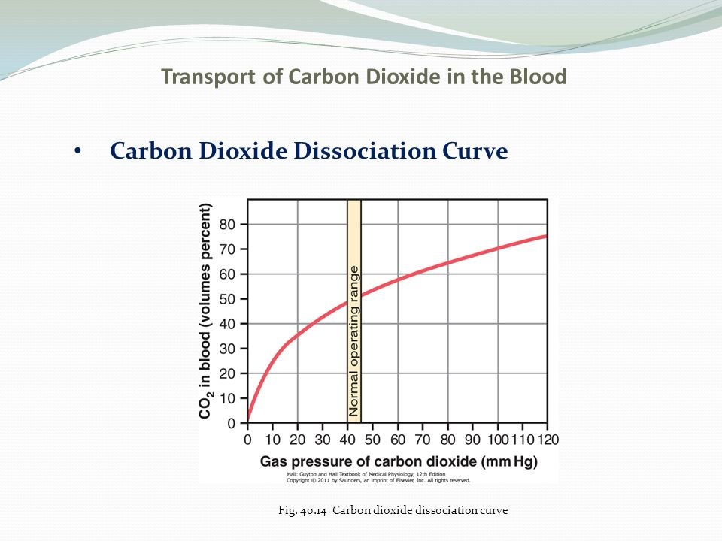**Carbon Dioxide Dissociation Curve**

Note that the normal blood pco2 ranges b/w the limits of 40 mmHg in arterial blood and 45 mmHg in venous blood, which is a very narrow range.

The saturation of Hb in venous blood is 52% and the arterial blood is 48%, the difference b/w venous and arterial Hb saturation is only 4%.

* **When Oxygen Binds with Hb, Carbon Dioxide is Released to Increase Co2 (Haldane Effect):**

1. Binding of oxygen with Hb tends to displace carbon dioxide from the blood (more important than Bohr Effect)
2. Oxygen plus Hb in the lungs causes Hb to become a stronger acid

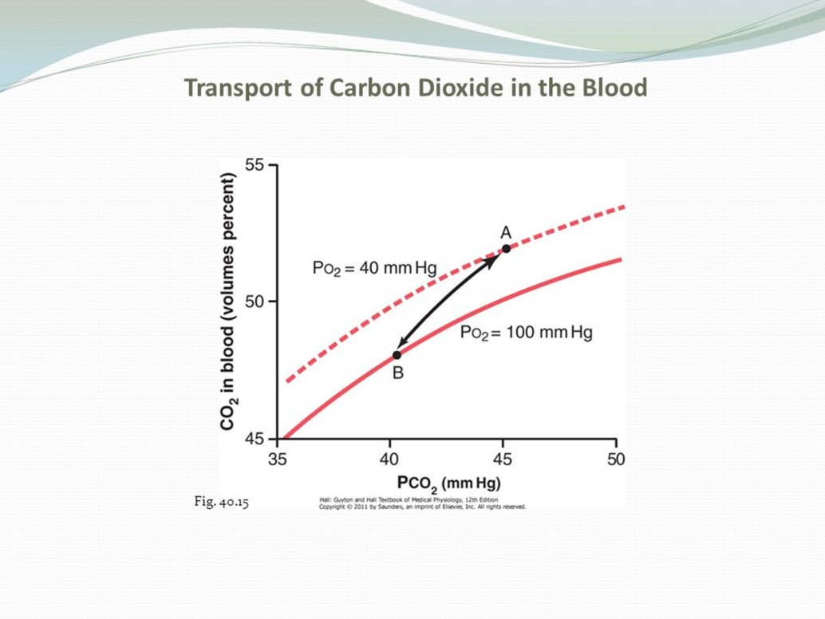The figure shows small portions of two co2 dissociation curves: (1) when the po2 is 100mmHg in capillaries of lungs (2) when the po2 is 40 mmHg (in tissues capillaries).

Point A shows that the normal pco2 in tissues of 45-46mmHg (52% saturation) with PO2 of 40 mm Hg. when entering the lungs the pco2 falls to 40 mm Hg (48% saturation) and po2 raises to 100 mmHg.

The increase in po2 in the lungs lowers the co2 dissociation curve from the top curve to the lower curve of the figure , co2 content falls from 52% (point A ) to 48% (point B).

**Respiratory Exchange Ratio**

* 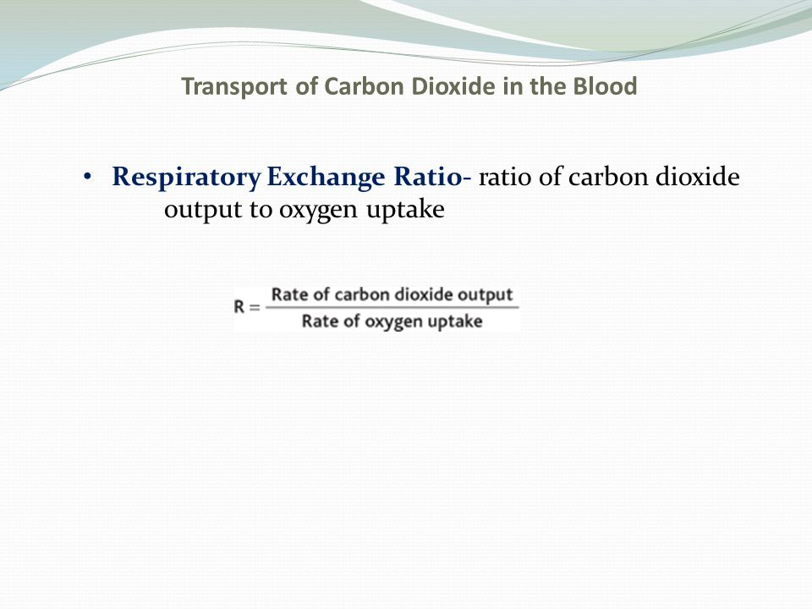Ratio of carbon dioxide output to oxygen uptake
* It explains the relation b/w how much co2 will be released and how much of o2 will be taken per minute.
* Normally it is about 0.8.
* Change of atmospheric O2 concentration markedly, the buffer effect of HB still maintain almost constant tissue PO2.
* Alveolar PO2 between 60 – 500 mmHg still tissue PO2 does not vary more than few mmHg from the normal(40mmHg)
* O2 is less in high attitude areas and this stimulate the increase of RBCs to increase Hb.

**Notes:**

* Intracellular PO2 5-40mmHg average 23mmHg
* Normal blood contain 15gm of Hb and each gm combine with 1.34 ml of O2 : 15X1.34=20.1 100% saturation.

97% =19.4 ml O2 in 100ml of blood.

* Venous blood= 14.4 ml of O2 (75% sat) PO2 40mmHg.

19.4-14.4=5 ml of O2 transport from lungs to the tissue by each 100ml of blood.

* O2 transport to the tissues in dissolved form Is 3% and this can decrease to 1.5% during heavy exercise.
* Diffusion distance is 50micometers and increase in pathological condition
* Effect of blood flow on metabolic rate use of O2



In Hb there are different sites for combination with o2 and co2 (not same site), but the site that combines with o2 is the same one that combines with CO and as the ability of CO to combine with Hb is about 250 times than of o2 so a very minimal amount of CO can kill the person. متل الناس الي بستعملوا صوبات في فصل الشتاء

Thank You