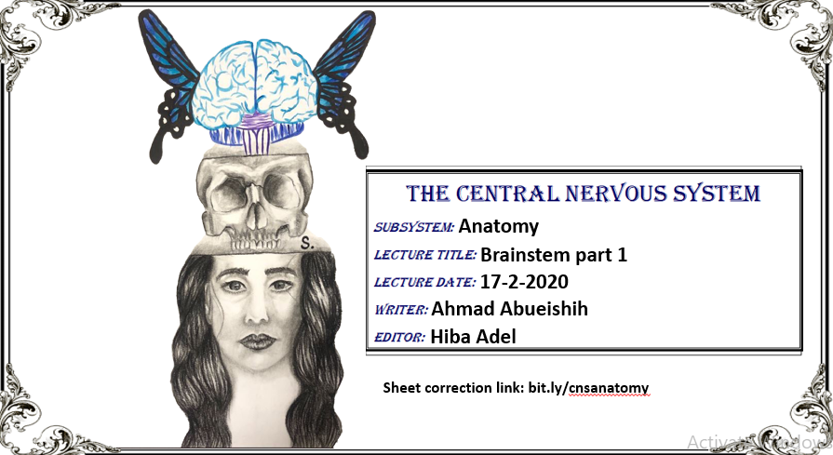
**Note 1: this sheet includes everything written in the slides but in a more organized way, so you don’t have to check the slides.
**Note 2: there will be some concepts that the doctor didn’t explain it in details because we will take them in the next few lectures, so I’ve put a star * to let you know about that (المهم في هذه المحاضرة المصطلحات وفي قادم المحاضرات سنهتم بالتفاصيل).
Recall: Principle parts of the brain:
1-Cerebrum.
2-Diencephalon: consists of: a-Thalamus.
b-Hypothalamus. c-Epithalamus.
3-Cerebellum.
4-Brainstem: consists of: a-Medulla oblongata. b-Pons. c-Midbrain.
Brainstem function:
1-Ascending and descending tracts that connect between brain and spinal cord will pass through brainstem.
2-Reflex centers: such as:
a- Cardiovascular and respiratory centers.
b-Coughing, sneezing, swallowing.
3- Nuclei of the cranial nerves: for motor and sensory nerves (except the first 2, there nuclei won’t reach the brainstem (mainly found in the cerebrum and diencephalon)).
a-The nuclei of the 3rd and 4th cranial nerves are found in midbrain.
b-The nuclei of the 5th, 6th, 7th, and half of the 8th are found in pons.
c-The remaining are found in medulla oblongata.
- All ascending and descending tracts that connect brain to spinal cord are passed through brain stem
RECALL: cell bodies of the motor fibers are found within the CNS (in brainstem). But sensory are found in the PNS
4- Consciousness and arousal(اليقظة).
External anatomy of brainstem (ventrally or anteriorly):

First: Midbrain:
Superiorly: boarded by optic tracts
Anteriorly: there is 2 bulgy structures called crus cerebri (aka cerebral peduncles or basis peduncularis). The corticospinal tracts pass through them.
Between the peduncles you will find the interpeduncular fossa, which is space-like structure (also there is interpeduncular cistern in the same area).
Some structures of the hypothalamus bulge towards the interpeduncular fossa, such as: mammillary bodies, infundibulum, and the tuber cinereum.

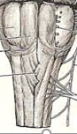
Second: Pons:
Anterior part of pons is bulging (basilar pons or Pontine base)
In the middle of the basilar part there is a sulcus (basilar sulcus) where the basilar artery passes in it.
Bulbopontine sulcus: located between pons and medulla oblongata.
Third: medulla oblongata:
Medially: we have the ventral median fissure, laterally to it there are 4 columns (see the 4 arrows on the right picture). The 2 medial columns (red arrows) are called pyramids where the corticospinal tracts collect together here and the 2 laterals (blue arrows) are called olives.
Decussation of pyramids: the right fibers of the corticospinal tracts will cross to the left side and the left fibers will cross to the right side (because the right side of the brain controls the left side and vice versa), this happens in the lower parts of the pyramids. If an injury happened above this area, the affected area of the brain will be the contralateral area, and if it happened below it, the affected area will be the ipsilateral one.
Olives: located laterally to the pyramids (internally we have a nucleus called inferior olivary nucleus, that’s why olives are bulging outside.)
Pre-olivary sulcus: located between olives and the pyramids.
Post-olivary sulcus: located between olives and the inferior cerebellar peduncles.
NOTE: the cerebellum communicates with the brainstem through cerebellar peduncles (superior, middle, and inferior peduncles).
External anatomy of brainstem (dorsally or posteriorly):

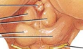
Corpora quadrigemini (aka known as superior and inferior colliculi): Quadra= 4, bulging outside (see the picture on the right), together they form the tectum which is the posterior part of the midbrain.
NOTE: Part of the pons and medulla oblongata (upper part or called the opened part) makes the floor (lateral walls) of the 4th ventricle
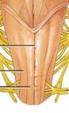
There are 4 columns in closed part of the medulla oblongata that are located inferiorly to the 4th ventricle (see the picture on the right), the 2 medial ones (red arrows) are called Gracile tubercles and the laterals (blue arrows) are called cuneate tubercles.
Rhomboid fossa:structure:
1-has 2 parts:
a-Pontine part: the upper part. b-Medullary part: the lower one.
2-Posterior median sulcus: located medially in the fossa.
3-Medial eminence: located laterally to the posterior median sulcus.
4-Facial colliculus*: located at the caudal part of the medial eminence (bulging structure).
5-Sulcus limitans*: located laterally to the facial colliculus (has an embryogenic origin).
6-Striae medullares: small fibers, make the border between pons and medulla oblongate.
7-Trigons*: located in the medullay part just lateral to the midline, bulging structure that reflects internally:
a-Vagal trigon: located laterally inferiorly.
b-Hypoglossal trigon: located medially superiorly.
8-Vestibular areas*: located laterally in the fossa, related to vetibular and cochlear nuclei.
9-Isthmus: superior constriction between 4th ventricle and the cerebral aqueduct.
10-Obex: inferior narrowing between 4th ventricle and the central canal.

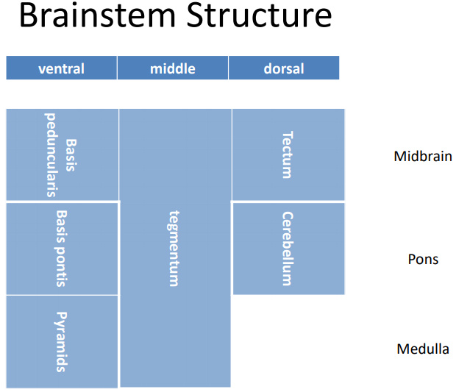

NOTES on the last table from the doctor:
1-The corticospinal tract fibers are found within the ventral part. *
2- tegmentum: most of nuclei are located here (cranial nuclei). *
Functional distribution of brainstem nuclei *:

NOTE: the nuclei in the spinal cord are fixed in their position, in contrast to the nuclei of the brainstem which may migrate and change their position. *
We’ll talk about the nuclei in the brainstem, the doctor sorted them from the medial side to the lateral one (1 is the most medial nucleus):
1-GSE: sends motor fibers to the skeletal muscles (nuclei of III, IV, VI, XII nerves).(most medially)
2-SVE: sends motor fibers specifically to the pharyngeal arches. (nuclei of V, VII, IX, X, XI nerves)more lateral .
*All motor nuclei are more medially located compared to sensory nuclei
3-GVE: nuclei of III, VII, IX, X nerves. Parasypathatic motor fiber …more lateral than somatic
4-here we have the sulcus limitans separating the afferent and the efferent fibers.
5-GVA: nucleus of tractussolitarius.
6-SVA: nucleus of tractussolitarius.
7-GSA: Trigeminal (V) sensory nuclei.
Somatic afferent come from trigeminal
8-SSA: vestibular and cochlear nuclei.

Internal structures of medulla:
NOTE: the doctor divided the medulla into several functionally related parts starting inferiorly and ascending after that:
1-Level of pyramidal decussation (closed part): you can see some structures in this area (you must differentiate between different parts of the medulla, pons, and midbrain, and this will be achieved by knowing each structures of each part.
a-Cranial nerve nuclei of the trigeminal nerve and spinal tract.
b-Motor pathways (fibers): that project from the pyramids anteriorly and decussate to go posteriorly.
c-Somatosensory pathways: gracilis and cuneatus nuclei + gracilis and cuneatus fasciculus.

Question: why the picture on the right is in white and black?
Answer: this is because of staining towards the myelin sheath. The black areas mean there are a lot of axons, while the white areas means that there are more gray matter.

2-Level of internal arcuate fibers (closed part): you can see the following structures:
a-Cranial nerve nuclei of the trigeminal nerve and spinal tract.
b-Motor pathways that project from the pyramids (same as the first part).
c-Somatosensory pathways*: gracilis and cuneatus nuclei + gracilis and cuneatus fasciculus. Also the internal arcuate fibers will decussate and form the medial lemniscus.
So, how can you differentiate between first and second parts??
Look at the nucleus gracilis (white areas) of each part, as we ascend the white areas increase, in contrast the black ones (fasciulus) decrease.

3-Level of olivary nucleus (open part): you can see the following structures:
a-Cranial nerve nuclei of:
1-Hypoglossal nerve.
NOTE: 1-3 nuclei are arranged from medial aspect to lateral aspect (so 1 is the most medial one)
2-Dorsal vagal nucleus.
3-Nucleus of tractussolitaris.
deeper
4-Vestibular nuclei.
5-Spinal tract and nucleus of trigeminal nerve.
b-Motor pathways: you can see:
1-The pyramid. 2-Olivary nucleus. 3-Inferior cerebellar peduncle.
c-Somatosensory pathways: you can see the medial lemniscus.

So… what’s the special thing about this part?
Look at the inferior olivary nucleus, it’s somehow zigzagging.

Internal structures of pons:

NOTE: the doctor divided pons into 2 parts:
1-Caudal part: you can see the following structures:
a-Cranial nerve nuclei of:
1-abducent nerve (at the level of the facial colliculus).
2-facial nerve (located posterolateral to the abducent nucleus).
NOTE: the facial colliculus has this name because the fibers of the facial nerve project from the facial nucleus and rotate around the abducent nucleus and then exit as facial nerve.
b-Motor pathways: also the corticospinal tract is seen here.
c-Somatosensory pathways: also the medial lemniscus is seen here.

2-Cranial part: you can see the following structures:
a-Cranial nerve nuclei of:
1-Trigeminal nerve. 2-Main sensory nucleus of trigeminal nerve.
b-Motor pathways: you will find:
1-Middle and superior cerebellar peduncles.
2-Pontine nuclei: surrounding the corticospinal fibers.
3-Corticospinal fibers.
c-Somatosensory pathways: also the medial lemniscus is seen here.

Internal structures of midbrain:

NOTE: the doctor divided midbrain into 2 levels:
1-Level of inferior colliculi: you can see the following structures:
a-Cranial nerve nuclei of:
1-Trochlear nerve.
2-Mesencephalic nucleus of trigeminal nerve.
b-Motor pathways: (from anteriorly to posteriorly):
1-Crus cerebri.
2-Substantia nigra.(we will talk about it later)
3-Decussation of superior cerebellar peduncles.
4-Inferior colliculi.
c-Somatosensory pathways: also the medial lemniscus is seen here (as we ascend the medial lemniscus goes more laterally).
2-Level of the superior colliculi: you can see the following structures:
a-Cranial nerve nucleus of the oculomotor nerve.
b-Motor pathways (from anteriorly to posteriorly):
1-Crus cerebri.
2-Substantia nigra.
3-Red nucleus: important for motor coordination (of axial muscles that are responsible of posture).it is the easiest way to differentiate b/w the upper part of the brain and the inf. part
4-Superior colliculi.
c-Somatosensory pathways: also the medial lemniscus is seen here (its target is the thalamus).

