Sheet # 1
Immunology
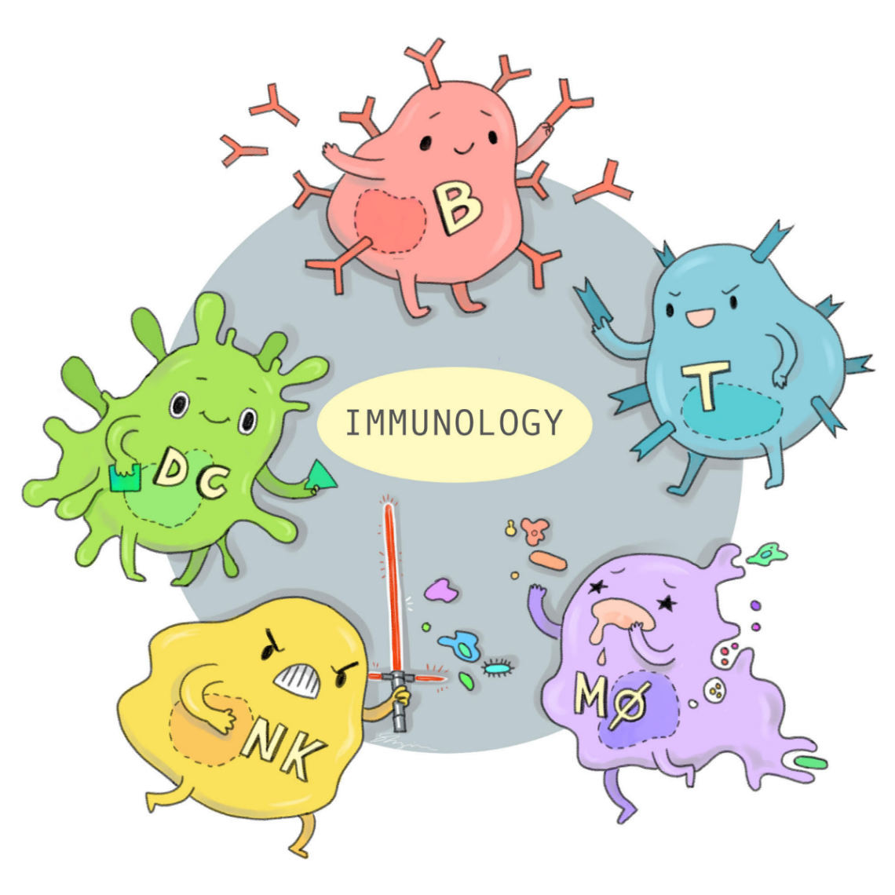

By : Tasnim Badwan & Raghad Dweedar
Slides are included .
If you come by any mistake (whether it be spelling, grammatical or scientific) while browsing this sheet, kindly report it to the academic team 2023od@gmail.com

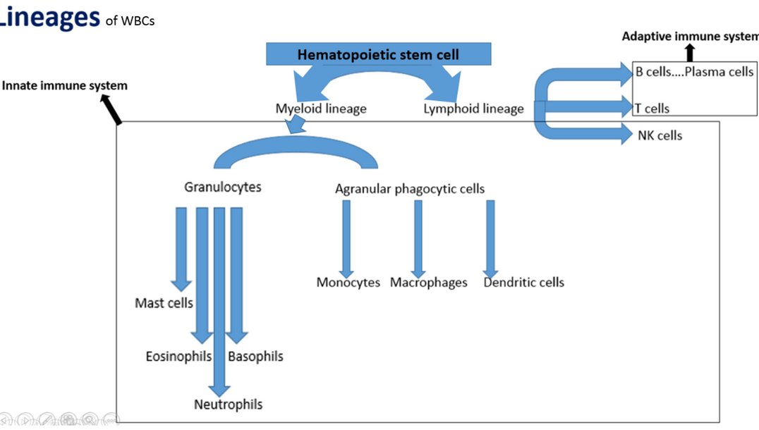
The immune system is composed of two main component :
- Innate immune system maily composed of
- All myeloid cells
- Natural killer cells

- Adaptive immune system
- T cells
- B cells

Notes:
- you have to remember three important words related to the adaptive immune system (mainly acting in it)
- Lymphocyte
- Plasma cells
- Antibodies (Ig)
2-The major two phagocytic cells are related to the innate immune system.
3- There is an overlab between the adaptive and the innate immune system and depend on each other .
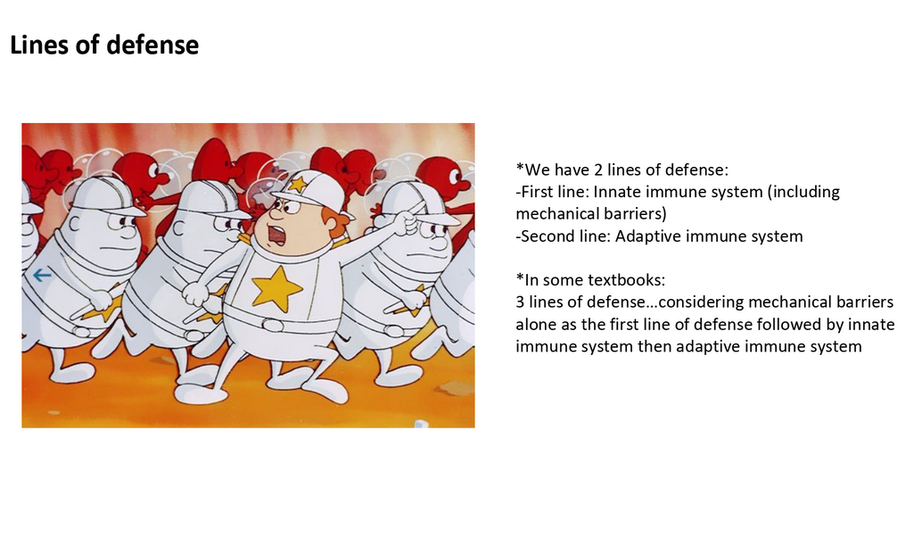

Multipotential hematopoietic stem cells : all cells derived from
those are hematopoietic
In adult there is specialized stem cells in the bone morrow which give rise to all blood cells generally divided into 2 categories :
- Lymphoid lineage gives : WBCs
- Myeloid lineage : give RBCs , platelet(from megakaryocytes) , WBCs
So WBCs are derived from lymphoid which give T, B lymphocyte , natural killer cells and myeloid which give all other types of WBCs .
All WBCs derived from myloid are able to do phagocytosis(even mast cells).
- Mast cells تقابل basophils
- The most important phagocytic cells are neutrophils & macrophages .
Plasma cell is the B lymphocyte when it secrets the antibody .
Antibody=IG = B cell receptor ; when the B cell is made it has receptor called B cell receptor (BCR) , then when it mature thus called plasma cell BCR are released from its surface and called Ig
Plasma cells = antibody secreting B lymphocytes.
The innate immune system :
- Innate immune system = “natural” = “native.
- is the first line defense and its cells are already exist in the body before microbes enter the body and fights mainly against microbial products or died cells in destroyed tissue .
- Mechanism: ready to fight infection before its occurrence
- Do not distinguishes fine differences between microbes .(not specific to every change)
- e.g: neutrophils has limited numbers of types of receptor and each type has the ability to recognize a group of pathogens wich has some differences from each other so in the innate immune

- system has lesser diversity since all the neutrophils in one body have the same genetic code and lesser specificity
- same response with repetition
The mechanical barrier ( skin , mucosa )is part of The innate immune sys.
Innate immune system = “natural” = “native”
-Mainly against microbes and microbial products…and dead cells
-The mechanisms are ready to react to infections even before they occur, reacts earlier than adaptive..
-Identify groups of related microbes…not distinguishing fine differences,
which means:
…limited diversity and less specificity (each type of innate white blood cells (for example, a neutrophil) has limited types of receptors each of which identifies agroup of related microbes

Note :Lippincott book classify the mecganical barrier as a separate third division of immune sys .
-Germline: the white blood cells of the innate system do not undergo genetic rearrangements
during their life span
…e.g., Every neutrophil when produced in a human body will have the same genetic material and
accordingly equipped with the same set of receptor types of all other neutrophils in the body

What we mean by germline?

The neutrophils during their life spans (from the day they were made in the bone marrow and went to the blood until they’re dead ) they have the same genetic material.
So producing of receptors by neutrophils depends on the genetic material ,the types of receptors on their surfaces are the same in all neutrophils and there are no others .
- All of the neutrophils which exist in the body are the same in one human .
- neutrophils during their life span will NOT differ from other neutrophils in genetic material and it will make the same receptors that have the same properties .
- The genetic material of all neutrophils are preserve and don’t change .
Germline immune system>>>>innate system
Adaptive immune system = “acquired” = “specific”
Microbial and non-microbial substances
The mechanisms act later after exposure…follow and activated by early innate responses
It adapts: performance with repetitive exposure…the ability to remember (memory)
High specificity… distinguishing fine differences…specific receptor for every specific target
molecule
…the specific target molecules = antigens
Large diversity… by somatic recombination of gene segments>>>>> ..will be explained later
Immunoglobulins…the antigen receptors on B lymphocytes
…if secreted, they are called antibodies (or again: immunoglobulins)
…plasma cell is the B lymphocyte that secretes immunoglobulin.

The adaptive immune system is NOT Germline .

1ry VS 2ry lymphoid organs
1ry (= generative/primary/central) lymphoid organs:
…they are the organs or tissue in which lymphocytes are produced
…they are:
-Bone marrow (postnatally) & yolk sac/fetal liver/fetal spleen (in embryo)
…where both B & T lymphocytes are produced
-Thymus…where T lymphocytes development is completed
2ry (= peripheral) lymphoid organs:
…they are the organs or tissues where:
…they are: lymph nodes, spleen, and mucosal & cutaneous lymphoid tissues
Lymphocytes come into contact with foreign antigen, are
clonally expanded & mature into effector cells
…mucosal lymphoid tissue is called: MALT (mucosa-associated lymphoid tissue)

For example :
Hematopoietic stem cell produce lymphocytes (in the beginning ,it was immature lymphocyte, then it will be mature )
the genetic material of immature lymphocytes will change by somatic recombination (genetic rearrangement)
The DNA of immature lymphocytes is cut in some regions and joined to the other parts of it .
Suppose that hematopoietic stem cell produced 5 immature lymphocytes (in the beginning ,the genetic material are same in all of them ,then each one of them randomly has somatic recombination (remove parts of DNA then join the others) after that ,they will be mature and each one of them gives clones )
Each one of these cells will specialize to have specialized receptor (BCR;B cell receptor ) and special antibody (when it will become plasma cell)
Either lymphocytes were B or T lymphocyte ,they will undergo to this process.
In lymphocyte we care about only one receptor to one specific antigen , unlike the neutrophil that has a lot of receptors for a lot of antigen .
According to this process(genetic recombination ),the diversity will happen significantly .
the immune competent person has a sufficient diversity in lymphocytic receptors that if any antigen enters to his/her body ,he/she has the receptor that fits this antigen .
بسبب التنوع الهائل في هذا النظام فإن اي مولد ضد يدخل على الجسم لابد له ان يجد جسم مضاد مناسب له ومتخصص كفاية له وحده فقطط.
- Adaptive system has high specificity and diversity
- This diversity occurs before microbial entery
The genetic recombination will repeat for each hematopoiesis not on time in the life .
the producing of T lymphocyte will stop in a certain stage of life but producing of B lymphocyte won’t stop .
if the antigen differs slightly from the antibody ,the antibody will not join with antigen (high specificity )
adaptive immune system:
- :مع تكرار stimulous ال performance بسير افضل (Faster & stronger and memory )
specific molecule that will be attacked by specific receptor in adaptive immune system.
- Acquired immune system is NOT Germline because the changes(genetic recombination) occur after the creation of lymphocytes .
- Antigen is related to the adaptive system.
Lymphoid organs:
There are factories in the body that produce the lymphocyte(primary and secondary lymphoid organs).
Primary lymphoid organs are also called generative lymphoid organs: the production of lymphocytes occur in them(bone marrow:produces all types of blood cells and thymous)
T lymphocytes are produced in bone marrow and complete in the thymus gland .
B lymphocytes are produced in bone marrow .

Primary lymphoid organs
Befor birth | After birth
Yolk sac ,fetus spleen and fetus liver | Bone marrow and thymus

Secondary lymphoid organs :are organs or tissues where the reaction between lymphocytes and antigen occurs(lymph nodes ,spleen ,mucosal associated lymphoid tissue (MALT),cutaneous lymphoid tissue ).
The lymphocytes produced in bone marrow and concentrated in the Secondary lymphoid organs mainly(because the lymphocytes circulate with the blood).

