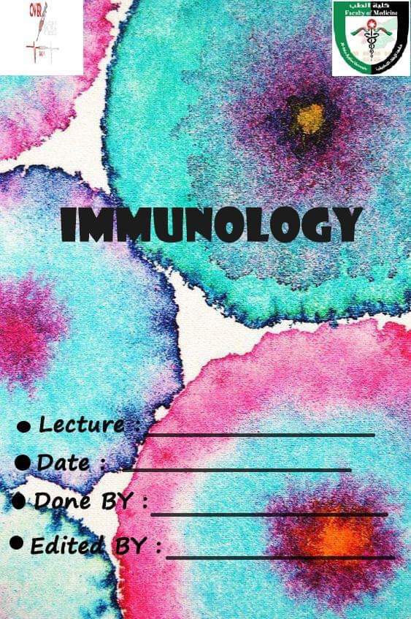

Development of T-cells and T cell-mediated immunity
4\11\2019.

Ayya Al-warawreh.

Amal Haj Ahmad.

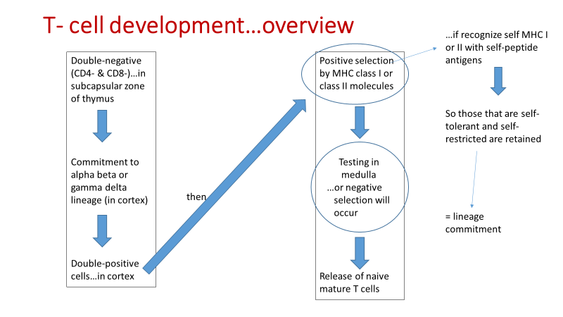
→T cells is developed in bone marrow, but the important stages of maturation occur in the thymus.
→The lymphocytes in thymus which will become T cells known as Thymocytes.
→Most stages occur in cortex.
The first stage of maturation is double-negative stage:
→So called because the thymocytes do not have CD4 or CD8 and TCR also is not expressed yet.
→Found in subcapsular zone and outer cortex and migrate during maturation to ward the medulla and finally to the blood.
→We will produce the commitment of TCR which will be one of two types (alpha-beta or gamma-delta, and the most abundant one is alpha-beta -more than 95% -) which means recombination
→Then it will become double positive (have CD4 and CD8) in cortex.
The second stage is double positive stage:
→In this stage positive selection happened which means that some cells will be CD4 T-cells and other will be CD8 T-cells by choosing one of the receptors (CD4 and CD8) to be expressed.
→The positive selection controlled by MHC1 and MHC2. (extra note: these MHC are found on thymic epithelial cells).
→If it recognizes MHC1 peptide self-antigen, it will become CD8
& if it recognizes MHC2 peptide self-antigen, it will become CD4.
→And now they are known as self-restricted T-cells (produce CD4 or CD8).
(keep in mind that some of self-restricted cells bind to the peptides of MHC(self antigen) in high affinity so they called ‘’ non self-tolerant ‘’)
→The positive selection process also known as lineage commitment.
→In the medulla there is a test to recognize which is self-tolerant and which is non self-tolerant restricted cells >>cells pass will be expressed in the blood as a naïve and mature T cells and the other(which recognize self)will go in negative selection pathway (it was mentioned in the previous lecture).
Note : all the above is a general view and many details below . so let’s start

- Congenital absence of thymus will cause immunodeficiency such as DiGeorge syndrome.
- Thymus involutes with age…but memory T cells have long life span.
- Precursors from fetal liver and adult bone marrow will seed the thymus.
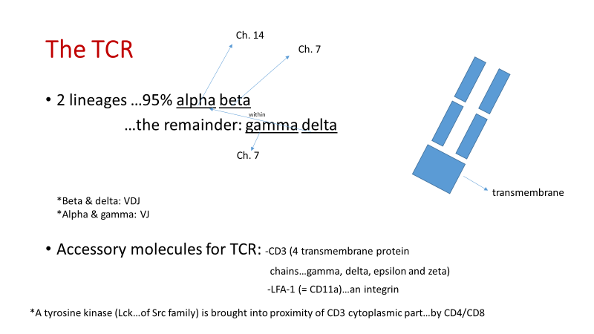

→Gamma-delta TCR has functions like innate immune system (as B1 cells).
→TCRs shape is similar to FABs.
→TCRs consist of alpha and beta or gamma and delta chains (alpha and gamma are like the light chain of immunoglobulin & beta and delta are like the heavy chain).
→note: the genetic code of delta is located within alpha genetic code.
** ارقام الكروموسومات ليست للحفظ **
→CD4 and CD8 receptors are co-receptors which bring the CD3 cytoplasmic part near to the tyrosine kinase(Lck) after binding to peptide antigens to start a signal transduction>>so TCR is turned on .
-co-receptors mean that when CD4 bind MHC II or CD8 bind MHC I ,at the same time TCR bind to peptide antigen.

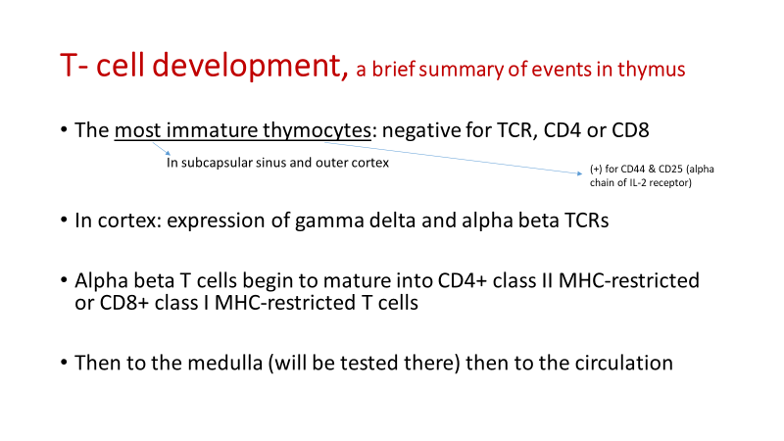

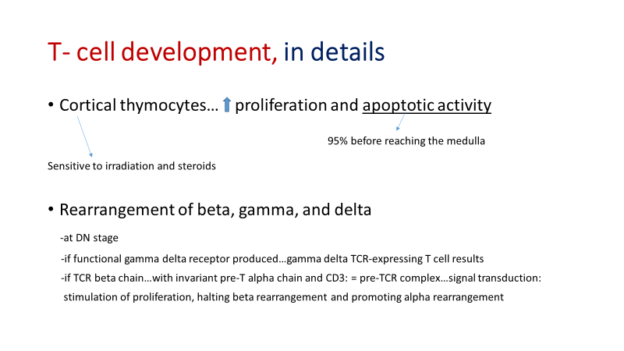

DN: double negative
→if TCR beta chain…with invariant pre-T alpha chain and CD3: = pre-TCR complex…signal transduction:
→stimulation of proliferation, halting beta rearrangement and promoting alpha rearrangement and Allelic exclusion occur know they are double positive (DP).

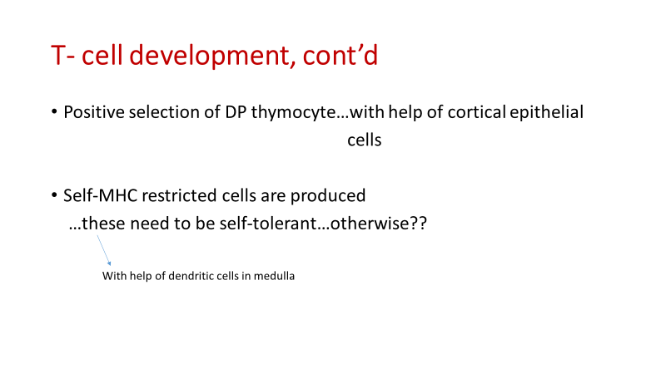
→There are thymic epithelial cells have MHC1 with peptide self-antigen and other thymic epithelial cells have MHC2 with peptide self-antigen:
if Double positive cells recognize MHC1 it will become CD8 T-cells and if double positive cells recognize MHC2 it will become CD4 T-cells.(these cells either self-tolerant or non self-tolerant)
**remember that some of these cells have high affinity for self- antigen.>> so we need to test them in the medulla to know these cells and get rid of them .
→In medulla another test by dendritic cells to recognize self-tolerant of self-restricted cells to be expressed in the blood by using MHC I with peptide self antigen for CD8 cells and MHC II with peptide self antigen for CD4 cells and if they have high affinity>>(fail)>> they will go in negative selection pathway.

Autoimmune regulator gene (AIRE)
- Regulate expression of antigens of endocrine cells in thymic epithelial and non-epithelial cells
- Mutation…autosomal recessive disease autoimmune polyendocrine syndrome I (APS-I)

Note: this gene regulates the expression of the self antigen on endocrine cells .

**end of Development of B and T lymphocytes lecture.

Note : The doctor re-explained the following part in the lecture 11 and you can just read it from here.
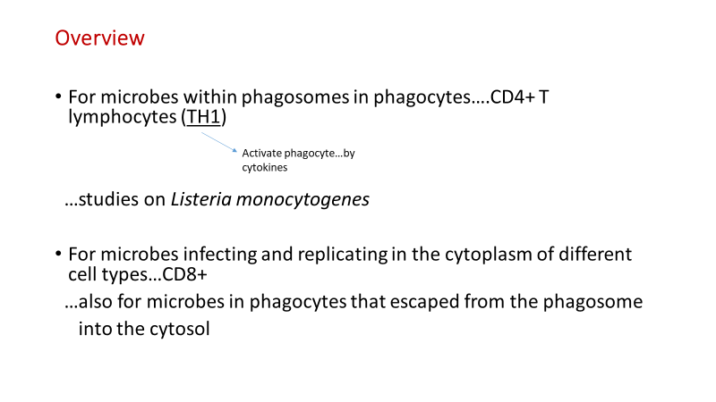
T cell-mediated immunity.

→Adaptive immunity two types:
- cellular immunity by T-cells and
- humoral immunity by soluble molecules (antibodies).
→NOTE: CD8 is responsible for attacking : microbes in cytosol of host cell and for microbes escape from the phagosome.
→Remember:
→There are another T-helper cell types, but these what we will study about.
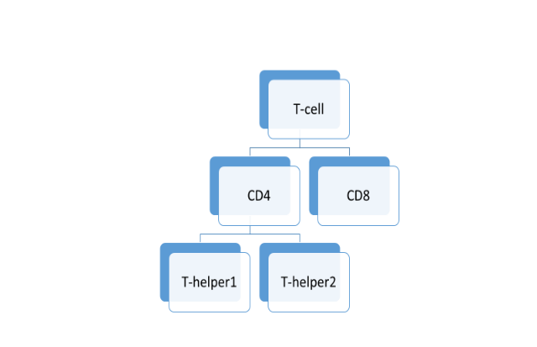
→CD8 cells are cytotoxic T-lymphocytes.

→TH1 cells help the phagocytes to destroy the phagocytosed microbes inside the lysosome, this role of TH1 is prominent in the action against listeria monocytogenes because it is resistant to the enzymes in phagocytes.

→CD8+ are defines against microbes in cytoplasm (virus, malignant cell and microbes that migrate from the phagolysosome to the cytoplasm).

→Remember that cellular immunity may harms our bodies by two pathways:
- Defect in development lead to formation of cells that attach our bodies antigens (autoimmune disease).
- Sever response against foreign microbes leads to collateral damage (such as TB).

→These two pathways are delayed hypersensitivity reaction (type 4)(the process is caused by TH1).
**remember that other cells can also cause delayed hypersensitivity reaction such as CD8.
FROM SLIDE
Delayed hypersensitivity reaction : consist of T cell-dependent macrophage activation and inflammation may damage tissues.
→TH2 functions :
- Stimulate secretion of IgE.
- Stimulate eosinophils and mast cells.
- Defense against Helminths.

CD4+
TH2
IFN-gamma & IL-12

Transcription factors that work here are: STAT1, T-bet, & STAT4

Naïve CD4+

IL-4

TH1 | TH2
IFN-gamma | IL-4, IL-5, IL-13, IL-10
CXCR3, CCR5 | CCR4, CCR8, CXCR4
Ligands for E- & P-selectin
Classically activate macrophages | Alternatively activate macrophages

##one of its functions: inhibition of TH1 development
TH1
##One of its functions: promotion of TH2 differentiation

Of its functions: further differentiation of TH1 and inhibition of TH2 proliferation

Note: INF gamma and IL-12 will stimulate CD4 to be TH1 (IL-12 is Produced by macrophage that phagocytosed microbe)
Note: IL-4 stimulate CD4 to become TH2.(IL-4 may be produced by eosinophils and mast cells).
Note: INF gamma may be produced by TH1 to stimulate further CD4 to become TH1.

