

**GIT MICROBIOLOGY**

SHEET #10

LECTURE 8: HEPATITIS

DONE BY: Reem Ijayan, Aseel Salameh and Batool Qutami

Hepatitis

* Inflammation of the liver
* May result from drug or chemical toxicity, EB virus, CMV, or the Hepatitis viruses
* Symptoms- abdominal pain or distention, fatigue, jaundice, loss of appetite, low-grade fever, nausea , vomiting, and weight loss

**Epidemiological and clinical features of hepatitis viruses**

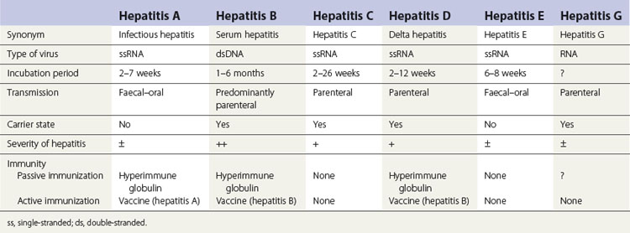

## #All of them are ssRNA except Hepatitis B which is dsDNA .

## #Longest incubation period is for Hepatitis B (1-6 months ).

## #shortest incubation period is for Hepatitis A (2-7 weeks ).

## #Hepatitis A & Hepatitis E are fecal oral transmission , the rest are parental .

## #Most severe one is Hepatitis B then Hepatitis C .

## Immunity: * Active immunity (الجسم يكون رد فعل مناعي ضد العامل الممرض) from vaccination or infection.

## #we use vaccine (Hepatitis B ) for Hepatitis D !! because these types happened in a co-infection pattern at the same time or patient get pre infection with Hepatitis B then Hepatitis D .

## *Passive immunity : immunity that an infant acquires from its mother OR by giving the patient Immunoglobulin (mostly the one who takes Immunoglobulin against Hepatitis is immunocompromised ).

## #What is the problem of using Immunoglobulin , for example against Hepatitis A ? we have to know that humans can't take Immunoglobulin more than one time because of hypersensitivity reaction . (we prepare Immunoglobulin from horses , we give fecal oral viruses to horse so he will form antibodies against them . when we take the serum from the horse it will also contain proteins from the horse besides the Ab that he forms . patient body will form Ab against these proteins and if he takes Immunoglobulin one more time the Ab will attack and cause problem .

Hepatitis Virus

* Viral hepatitis is a systemic disease primarily involving the liver.
* Most cases of acute viral hepatitis in children and adults are caused by one of the following six agents:
* **Hepatitis A virus(HAV),** the etiologic agent of viral hepatitis type A (infectious hepatitis معدي). HAV is a distinct member of the picornavirus,cubic, ssRNA. Only one serotype is known

**(اذا اصيب الشخص يصبح لديه مناعة ولا يصاب مرة اخرى)**

**Hepatitis B virus (HBV)**, which is associated with viral hepatitis B (serum hepatitis ينتقل عن طريق الدم )

* **Hepatitis C virus (HCV)**, the agent of hepatitis C (posttransfusion hepatitis)
* **Hepatitis D (HDV),** a defective virus dependent on coinfection or preinfectionwith HBV.
* **Hepatitis E virus (HEV),** the agent of enterically transmitted hepatitis. HEV is transmitted enterically and occurs in epidemic form in developing countries, where water or food supplies are sometimes fecally contaminated. Pregnant women may have a high (20%) mortality rate if fulminant (severe and sudden in ons hepatitis develops.
* **HepatitisGvirus(HGV)**,a distant relative of HCV.Often patients with hepatitis G are infected at the same time by [hepatitis](http://medical-dictionary.thefreedictionary.com/hepatitis+B)B or C virus, or both.

**HBV HCV**

* **Virus Classification DNA RNA**
* **Family Hepadnavirus Flavivirus**
* **Clinical illness (jaundice) 30%–50% 20%**
* **Chronic infection 90% (infants) ~70%**

**5–10% (adults)**

* **Mortality from CLD, cirrhosis25% 1-5%**

**Hepatitis Type B**

**Structure and Composition of HBV**

The virus particle consists of an outer [lipid](https://en.wikipedia.org/wiki/Lipid) envelope and an [icosahedral](https://en.wikipedia.org/wiki/Icosahedron) [nucleocapsid](https://en.wikipedia.org/wiki/Nucleocapsid" \o "Nucleocapsid) core composed of [protein](https://en.wikipedia.org/wiki/Protein). Electron microscopy reveals **three morphologic forms.** The most numerous are spherical particles(or surface) made up exclusively of **HBsAg** that are surrounds a inner nucleocapsid core (**HBcAg**)

* Infectious virion attaches to cells and becomes uncoated. In the nucleus, the viral genomeis converted to covalently closed circular dsDNA which serves as templatefor all viral transcripts.

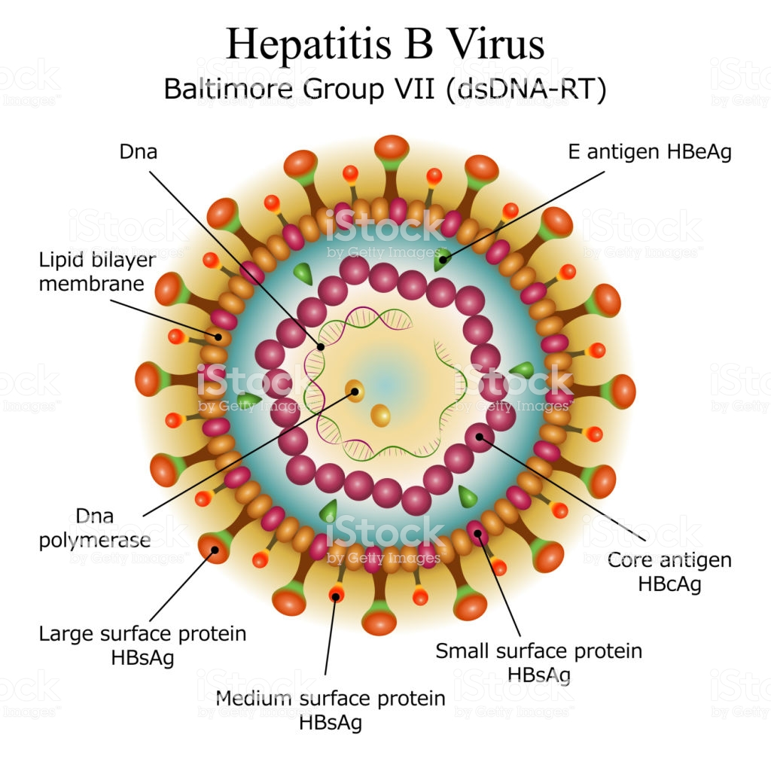

Abs that formed against surface antigens are important for detection of acute and chronic infections

Doctor mentioned them all

Histopathology of HBV infection

* Parenchymal cell degeneration, with necrosis of hepatocytes
* Adiffuse lobular inflammatory reaction and disruption of liver cell cords.
* These parenchymal changes are accompanied by reticuloendothelial (Kupffer) cell hyperplasia,periportal infiltration by mononuclear cells, and cell degeneration.
* Later in the course of the disease, there is an accumulation of macrophages near degenerating hepatocytes.
* The damaged hepatic tissue is usually restored in 8–12 weeks.
* Chronic carriers of HBsAg may or may not have demonstrable evidence of liver disease. Persistent (unresolved) viral hepatitis, a mild benign disease is characterized by sporadically abnormal aminotransferase values and hepatomegaly with slight to absent fibrosis.
* None of the hepatitis viruses are typically cytopathogenic, and it is believed that the cellular damage seen in hepatitis is immune-mediated.
* Both HBV and HCV have significant roles in the development of hepatocellular carcinoma that may appear many (15–60) years after establishment of chronic infection.

Caused by : infection or vaccines

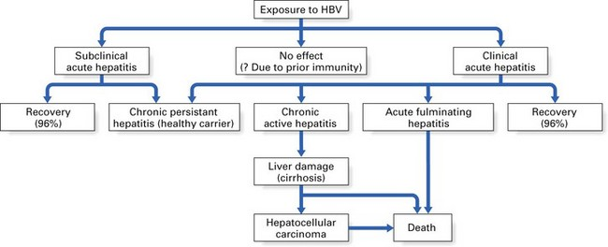

Surface antigen is exist

Completely cure (rare)🡺 mean that surface antigen is not exist in serum but Abs are exist

**Hepatitis Type C**

* Several non-A, non-B (NANB) hepatitis agents that, based on serologic tests, were not related to HAV orHBV. The major agent was identified as HCV.
* Most cases of post-transfusion NANB hepatitis were caused by HCV.Most new infections with HCV are subclinical.
* In some countries, as in Japan, HCV infection often leads to hepatocellular carcinoma.
* The virus undergoes sequence variation during chronic infections. This complex viral population in a host is referred to as “quasi-species.” This genetic diversity is not correlated with differences in clinical disease, although differences do exist in response to antiviral therapy according to viral genotype.

#sheet :1-"quasi-species" this happens not only in hepatitis C but in any other type of viruses .

2-In one single day , trillion copies of the virus may be produced, and these trillion copies may involve mutations( as if they resemble a new strain) , which are clinically the same as the original virus but genetically differ. They are called :"quasi-species".

3- The immune system may fail to overcome them . And they need another treatment other than the original hepatitis C virus.

* **Chronic infection with the hepatitis C virus (HCV) is a major risk factor for the development of hepatocellular carcinoma (HCC) worldwide. The pathogenesis of HCC in HCV infection has extensively been analysed. Hepatitis C virus-induced chronic inflammation and the effects of cytokines in the development of fibrosis and liver cell proliferation are considered as one of the major pathogenic mechanisms.**

**Hepatitis viruses produce acute inflammation of the liver, resulting in a clinical illness characterized by :**Fever, Nausea, Vomiting, jaundice.

* In viral hepatitis, onset of jaundice is often preceded by gastrointestinal symptoms such as nausea, vomiting, anorexia, and mild fever.
* Jaundice may appear within a few days of the prodromal period, but anicteric hepatitis is more common (A mild form of hepatitis in which there is no jaundice).
* Extrahepatic manifestations of viral hepatitis (primarily type B) include a transient serum sickness-like prodrome consisting of fever, skin rash, and polyarthritis; necrotizing vasculitis (polyarteritisnodosa); and glomerulonephritis.
* 80–95% of infants and young children infected with HBV become chronic carriers, and their serum remains positive for HBsAg. Chronic carriers are at high risk of developing hepatocellular carcinoma. The vast majority of individuals with chronic HBV remain asymptomatic for many years; there may or may not be biochemical and histological evidence of liver disease.
* Hepatitis C is usually clinically mild, with only minimal to moderate elevation of liver enzymes. 70–90% of cases progress to chronic liver disease. Most patients are asymptomatic, but histologic evaluation often reveals evidence of chronic active hepatitis,especially in those whose disease is acquired after transfusion.

Cirrhosis is a disease in which liver cells become damaged and are replaced by scar tissue. People with cirrhosis have an increased risk of liver cancer. There are several possible causes of cirrhosis. Most cases occur in people who abuse alcohol or have chronic HBV or HCV infections.

**Serological diagnosis**

* **HBsAg is a general and first marker for infection.**
* **HBsAg persists for more than 6 months** (chronic infection)
* **HBsAg indicates that the person is a carrier and potentially infective**.
* HBeAg indicate active replication of the virus
* This state can persist for months until recovery, or for years in chronic carrier states.
* Antibody to hepatitis B surface antigen (anti-HBs) appears in serum during the recovery phase and is long-lived; its presence indicates recovery and immunity to further HBV infection; also seen in high titer after successful vaccination for HBV, as the active ingredient of the hepatis

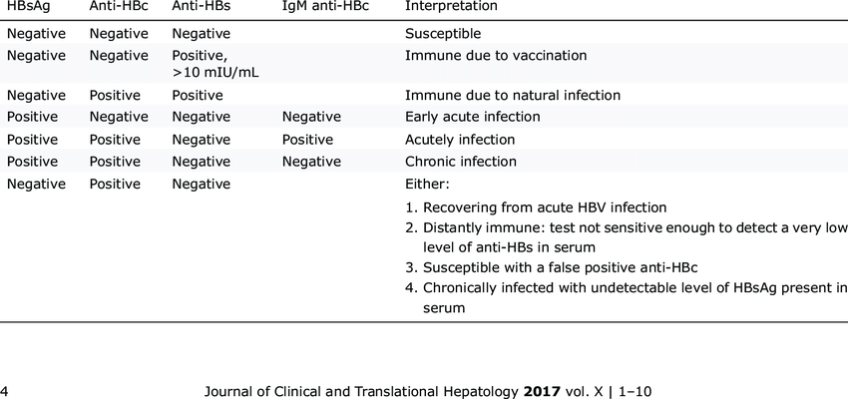

SHEET NOTES:

In the case of immunity due to natural infection, it would be more logical if the HBsAg was positive.

In the case of early acute infection, the levels of antibodies are still not detectable.

If there was positive HBsAg and positive Anti-HBs---chronic infection

If there was negative HBsAg and positive Anti-HBs---completely cured case which is very rare/vaccination.

Only HBsAg is positive--- active acute infection.

If there was HBe antigen---active replication of the virus اصابة حديثة جدا

How do we distinguish between acute and chronic infection?!

IgM antibodies--- acute infection

IgG antibodies---chronic infection

IgM antibodies are the first ones to form.(not sure)