Al Balqa Applied University
College of Sciences
Dr. Hala Al Daghistani

Anaerobic infection
- Anaerobes and aerobic bacteria often join to form synergistic infections (gangrene, necrotizing fasciitis, and cellulitis).
- It is usually difficult to pinpoint one specific organism as being responsible for the progressive lesion, since mixtures of organisms are usually involved.

Anaerobic Infections
- A large majority of the bacteria that make up the normal human microbiota are anaerobes.
Certain characteristics are suggestive of anaerobic infections:
(1) They are often contiguous with a mucosal surface.
(2) They tend to involve mixtures of organisms.
(3) They tend to form closed-space infections, either as discrete abscesses (lung, brain, pleura, peritoneum, and pelvis) or by burrowing through tissue layers.
(4) Pus from anaerobic infections often has a foul odor.
(5) Most of the pathogenically important anaerobes except Bacteroides and some Prevotella species are highly susceptible to penicillin G.
(6) Anaerobic infections are favored by reduced blood supply, necrotic tissue, and a low oxidation-reduction potential. Therefore, trauma, foreign bodies, malignancy, surgery, edema, shock, colitis, and vascular disease may serve as predisposing factors
Clostridia
- The clostridia are large, spore-forming, Gram-positive bacilli.
- They are able to survive for years in the environment and return to the vegetative form when placed in a favorable conditions
- The shape of the cell and location of the spore varies with the species, but the spores themselves are rarely seen in clinical specimens.
- The medically important clostridia are potent producers of one or more protein exotoxins.

Other groups of anaerobic bacteria
- Peptostreptococcus: Positive cocci, NF. in Mouth and intestine, cause Oropharyngeal infections, brain abscess
- Propionibacterium: gram Positive rods, small pleomorphic bacilli, are among the most common bacteria in the normal flora of the skin.
- Bacteroides: B. fragilis group, gram negative rods (coccobacillary), mostly isolated from anaerobic infection, The lipopolysaccharide (LPS) in its outer membrane have a much lower lipid content and thus lower toxic activity than that of most other Gram-negative bacteria. Virtually all B. fragilis strains have a polysaccharide capsule. Fusobacterium: Elongated gram Negative rods. Cause several human diseases, including periodontal diseases, and topical skin ulcers.
- Prevotella: Negative rods, are members of the oral, vaginal, and gut microbiota and are often recovered from anaerobic infections of the RT. They have been isolated from abscesses and burns in the vicinity of the mouth, bites, paronychia
(Infection of the skin around the nail), and periodontal abscesses.
- Porphyromonas: Negative rods, associated with periodontal disease, as well as in the upper GI, RT infections.
Except for infections with some environmental Clostridia, anaerobic infections are almost always endogenous with the infective agent(s) derived from the patient’s normal flora.
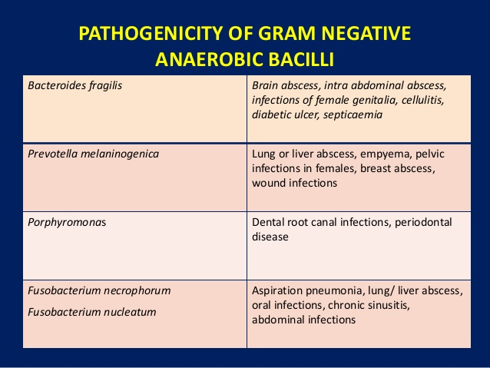
PATHOGENESIS
- The anaerobic flora normally lives in a commensally relationship with the host. However, when displaced from their niche on the mucosal surface into normally sterile tissues these organisms may cause life-threatening infections. This can occur as the result of
- Trauma (eg, gunshot, surgery)
- Disease
- Isolated events (eg, aspiration).
- Host factors such as malignancy
- Impaired blood supply

- All increase the probability that the dislodged flora eventually produce an infection. The organisms involved are anaerobes normally found at the mucosal site adjacent to the infection.
- The relationship between normal flora and site of infection may be indirect. For example, aspiration pneumonia, lung abscess, and empyema typically involve anaerobes found in the oropharyngeal flora.
- In contaminated open wounds, Clostridia can come from the intestinal flora or from spores surviving in the environment.
Additional virulence factors are needed for anaerobes to produce infection. Classical virulence factors such as toxins and capsules are known only for the toxigenic Clostridia and B. fragilis, but a feature such as the ability to survive brief exposures to oxygenated environments can also be viewed as a virulence factor.

The great majority of anaerobic infections are mixed; that is, two or more anaerobes are present, often in combination with facultative bacteria such as Escherichia coli. In some cases the components of these mixtures are believed to synergize each other’s growth either by
- providing growth factors
- Lowering the oxidation-reduction potential.
- Bacteroides, Fusobacterium, and Peptostreptococci, alone or together with other facultative or obligate anaerobes, are responsible for the majority of localized abscesses within the cranium, thorax, peritoneum, liver, and female genital tract.
- Foul-smelling pus and crepitation (gas in tissues) are signs associated with anaerobic infections.
Clostridium perfringens
- C. perfringens is a large, Gram-positive, non-motile rod with square ends.
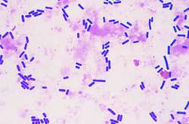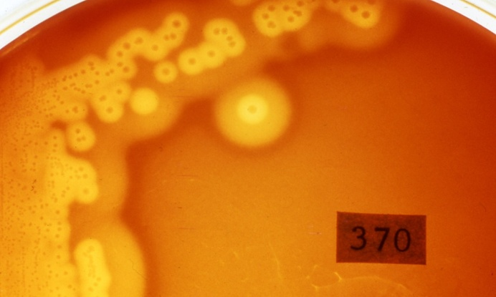
- It grows overnight on blood agar medium under anaerobic conditions, producing colonies surrounded by a double zone of hemolysis
- In broth containing fermentable carbohydrate, produce large amounts of hydrogen and carbon dioxide gas, which can also be produced in necrotic tissues; hence the term gas gangrene.
- C. perfringens produces multiple exotoxins that serve as the basis for classification with. The bacterium produces at least 11 exotoxins that have hemolytic or other cytotoxic and necrotic effects.
- The most important exotoxin is the ἀ-toxin, a phospholipase that hydrolyzes lecithin and sphingomyelin, thus disrupting the cell membranes of various host cells, including erythrocytes, leukocytes, and muscle cells. The ἀ -toxin alters capillary permeability and is toxic to heart muscle.
- C. perfringens produces a wide range of wound and soft tissue infections. The most important is “Gas Gangrene” begins as a wound infection but progresses to shock and death in a matter of hours.
- Gas gangrene develops in traumatic wounds with muscle damage when they are contaminated with foreign material containing C. perfringens. The clostridia can come from the patient’s own intestinal flora or spores in the environment.
- Compound fractures, bullet wounds, or the kind of trauma seen in wartime are prototypes for this infection.

Pathogenesis of Gas Gangrene (Myonecrosis)
- If the oxidation–reduction potential in a wound is sufficiently low, C. perfringens spores can germinate and can multiply, elaborating toxins.
- Fermentation of organic compounds in host tissues causes formation of gas bubbles.
- The process passes along the muscle bundles, producing rapidly spreading edema and necrosis as well as conditions that are more favorable for growth of the bacteria.
- Very few leukocytes are present in the myonecrotic tissue. This suggests that the host response to Clostridium perfringens type A infection is defective.

Clinical aspects of Gas Gangrene
- Clostridial myonecrosis is characterized by rapidly spreading edema and necrosis associated with bacterial proliferation and exotoxin production (usually begins 1 to 4 days after the injury but may start within 10 hours.
- The earliest reported finding is severe pain at the site of the wound associated with a sense of heaviness or pressure. The disease then progresses rapidly with edema, tenderness, discoloration and hemorrhagic bullae.
- The gas is apparent as crepitance in the tissue, but this is a late sign.
- Systemic findings are those of shock with intravascular hemolysis, hypotension, and renal failure leading to coma and death.
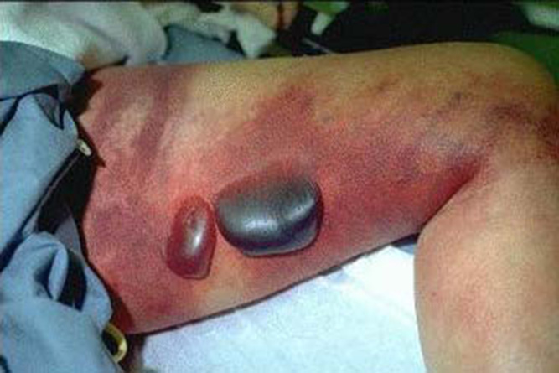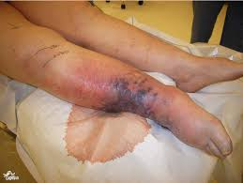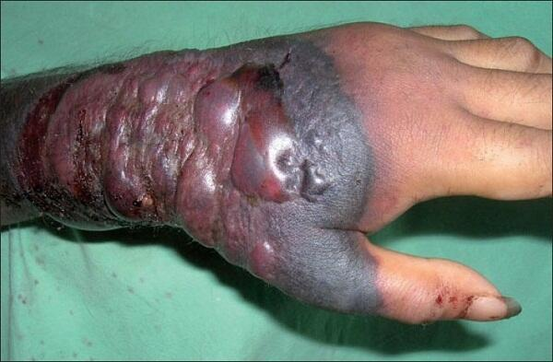

Anaerobic Cellulitis is a Clostridial infection of wounds and surrounding subcutaneous tissue in which there is marked gas formation (more than in gas gangrene) but in which the pain, swelling, and toxicity of gas gangrene are absent. This condition is much less serious than gas gangrene

Endometritis: If C. perfringens gains access to the uterus, it may multiply and infect the endometrium. Necrosis of uterine tissue and septicemia with massive intravascular hemolysis due to toxins that may then follow.

DIAGNOSIS
Specimen, preferably pus or fluid aspirated directly from the infected site. Swabs are not used since cotton fibers are detrimental. Tissue samples should be digested and put in degasses sealed container.
- The specimen needs to be taken quickly to the microbiology laboratory and protected from oxygen exposure while on the way.
- A direct Gram-stained smear of clinical material demonstrating Gram-negative and/or Gram-positive bacteria of various morphologies is highly suggestive, often even diagnostic of anaerobic infection.
- Because of the typically slow and complicated nature of anaerobic culture, the Gram stain often provides the most useful information’s for clinical decision-making.
- The simple anaerobic jar is sufficient for isolation of the clinically significant anaerobes.
- The use of media that contain reducing agents (cysteine, thioglycollate) and growth factors needed by some species further facilitates isolation of anaerobes.
- The polymicrobial nature of most anaerobic infections requires the use of selective media to protect the slow growing anaerobes
- Once the bacteria are isolated, identification procedures including morphology, biochemical characterization, Nagler reaction, and metabolic end-product detection by gas chromatography may begin.
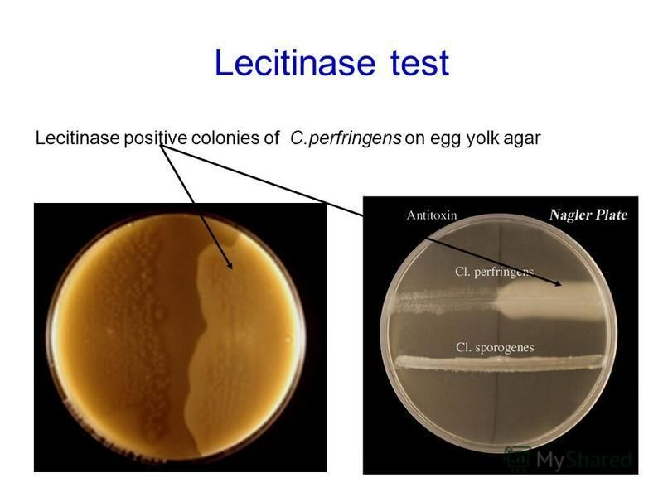

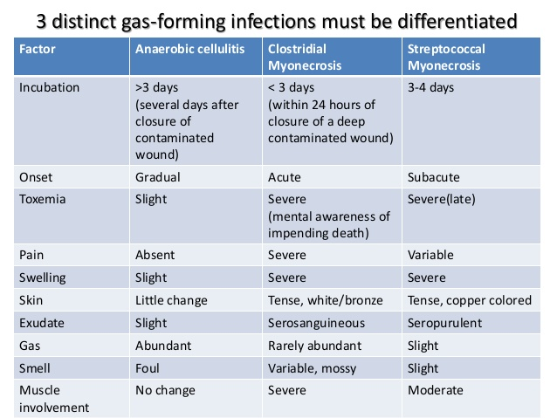
Bacteroides fragilis
- The B. fragilis group constitutes the most common opportunistic pathogens of the genus Bacteroides. These are
- Pale-staining
- Capsulated
- Gram-negative rods
- Form colonies overnight on blood agar medium.
- Have surface pili

EPIDEMIOLOGY Like the other Gram-negative anaerobes, B. fragilis infections is endogenous, originating in the patient’s own intestinal flora. It is typically mixed with other anaerobes and facultative bacteria. It is can cause infection if displaced into the bloodstream or surrounding tissue following surgery, disease, or trauma such as animal/human bites, burns, cuts, or penetration of foreign objects, including those involved in surgery.

PATHOGENESIS
- Its pili have adhesive properties, and the polysaccharide capsule confers resistance to phagocytosis and inhibits macrophage migration.
- The most distinguishing pathogenic feature of the organism is its ability to cause abscess formation. The capsule stimulates abscess formation. Other virulence factor include, LPS, agglutinin, beta-lactamases, O2 tolerance.
- B. fragilis and other Bacteroides species produce a number of extracellular enzymes (collagenase, fibrinolysin, and hyaluronidase) that may also contribute to the formation of the abscess.

IMMUNITY
Although it has been demonstrated that antibody to capsular polysaccharide facilitates classical complement pathway killing, there is no evidence that this confers immunity to reinfection (no role of humoral immunity). In contrast, there is some evidence that cell-mediated immunity may be protective.
Clinical aspects manifestations
- There is no evidence the organism is invasive on its own.
- The local effects of the developing abscess include abdominal pain and tenderness, often with a low-grade fever.
- The subsequent course depends on whether the abscess remains localized or ruptures through to other sites such as the peritoneal cavity. This may cause several other abscesses or peritonitis.
- Spread to the bloodstream is more common with B. fragilis than any other anaerobe.

TREATMENT:
Drainage of abscesses and debridement (the removal of unhealthy tissue from a wound to promote healing can be done by surgical, chemical, mechanical, or autolytic removal of the necrotic tissue

