Anatomy – lecture 24
Lower limb – part 7
10/10/2019
Sawsan Bawadi

Sheet correction link: bit.ly/mssanatomy
Reminder:
- Limbs rotated in utero around their long axis but in opposite directions.
- The lower limbs rotate in utero 90-degree medially. While upper limbs rotate 90-degree laterally.
- Thus the limbs are 180 degrees out of phase with one another (Knee anterior and big toe medial versus Elbow posterior and thumb lateral).

Bones of the lower limb (leg):
- Tibia is the only weight-bearing bone of the leg.
- Most muscles originate from tibia is called tibialis.
- Tibia is triangular in cross-section, so it has 3 borders and 3 surfaces.
- Most of the tibia on medial surface and anterior border is subcutaneous , that’s why any injury or fracture on it is highly complicated because of the poor blood supply .
- The fracture of the tibia is called shin fracture.
- Fibula is only for muscle attachments (non-weight bearing bone).
- Sometimes fibula is used to bone transplant, especially if someone has an accident and injured his mandible, the replacement of the mandible done by the fibula.
- On the posterior surface of the tibia, there is an oblique line called soleal line (for a muscle called soleus muscle), that’s why in physiology the venous return in the lower limb against gravity is done via soleal bump.
- Above the soleal line is the origin of popletius muscle, below it is the origin of soleus muscle .
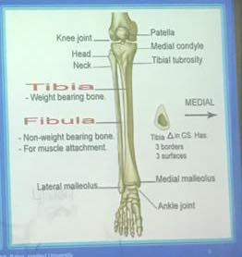
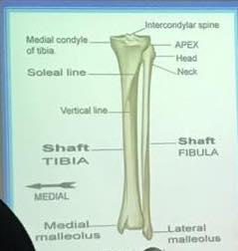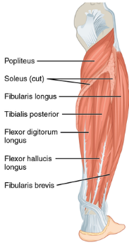

- The keystone of the foot > talus, so if it is broken this lead to flat foot because of the weight is go vertical on it .

Deep fascia of the leg :

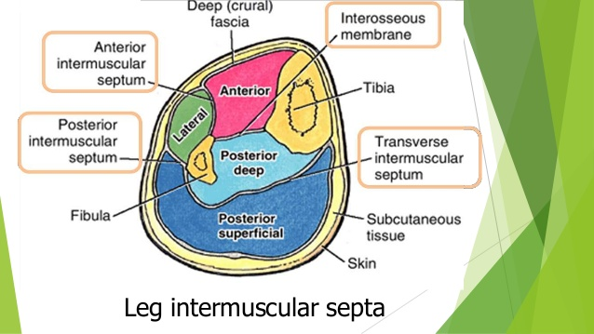

- The deep fascia of the leg sends 2 intermuscular septa to the fibula (anterior and posterior intermuscular septa) that divide the leg into 3 compartments with the interosseous membrane (anterior, lateral and posterior compartments).
- Extra note: there is another septum posteriorly from fibula to tibia called transverse intermuscular septum that divides the posterior compartment into superficial and deep layers.
- Anterior compartment (extensor compartment) lies between the tibia and ant. Intermuscular septum. Lateral compartment (fibular/peroneal/eversion compartment) lies between ant. and pos. intermuscular septa . Posterior compartment (flexor compartment) lies between tibia and pos. intermuscular septum.

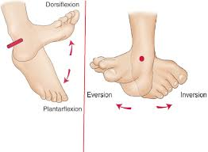
- The deep fascia extends down to the malleoli and ankle. At the ankle joint it is form 2 thickening bands of the fascia (superior and inferior extensor retinaculum) > the tendons of extensor muscles passing below them.
- Inferior extensor retinaculum is Y-shaped.
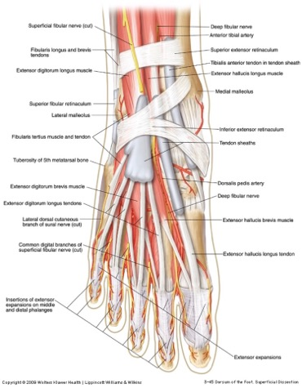

Anterior compartment of the leg :
- It is composed of 4 muscles :
- Tibialis anterior.
O > origin
I > insersion
F > function
O : tibia (lateral condyle)
I : base of first metatarsal
F : dorsiflexion + inversion
- Extensor hallucis longus.
O : fibula
I : distal phalanx of first digit
F : dorsiflexion + extension of first digit
- Extensor digitorium longus.
O : tibia + fibula
I : distal phalanges of lateral four digits.
F : dorsiflexion + extends the four lateral digits
- Fibularis tertius or peroneus tertius
O : fibula
I : base of fifth metatarsal
F : inversion (eversion المفروض )

- All innervated by deep fibular (peroneal) nerve
(The common peroneal nerve which is a lateral branch of sciatic nerve , divides into 2 branches (deep and superficial branches) , the deep branch is the one that innervates the anterior compartment of the leg, but the superficial branch innervates lateral compartment .
- All supplied by anterior tibial artery > branch from popliteal artery .
- All extend foot at the ankle (Dorsiflex the foot)
# cut or injury in deep peroneal nerve , the patient cannot dorsiflex the foot (cannot elevate the foot).

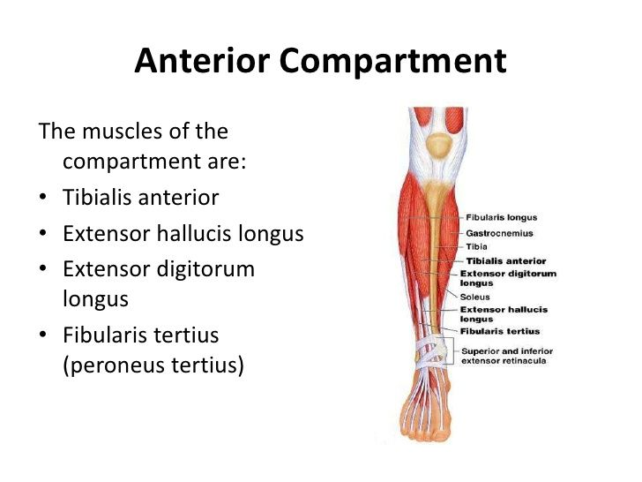
Arterial supply :
- Popliteal artery ends at the lower border of popliteus muscle by dividing into 2 branches 1) anterior tibial artery passes and supplies the anterior compartment and then it will continue in the dorsum of the foot at the level of ankle ,it becomes dorsalis pedis artery
# if a patient has a cast on thigh and leg > we know the effectiveness of the popliteal artery from dorsalis pedis, so this artery tells us that everything is ok and the cast does not compress the popliteal artery.
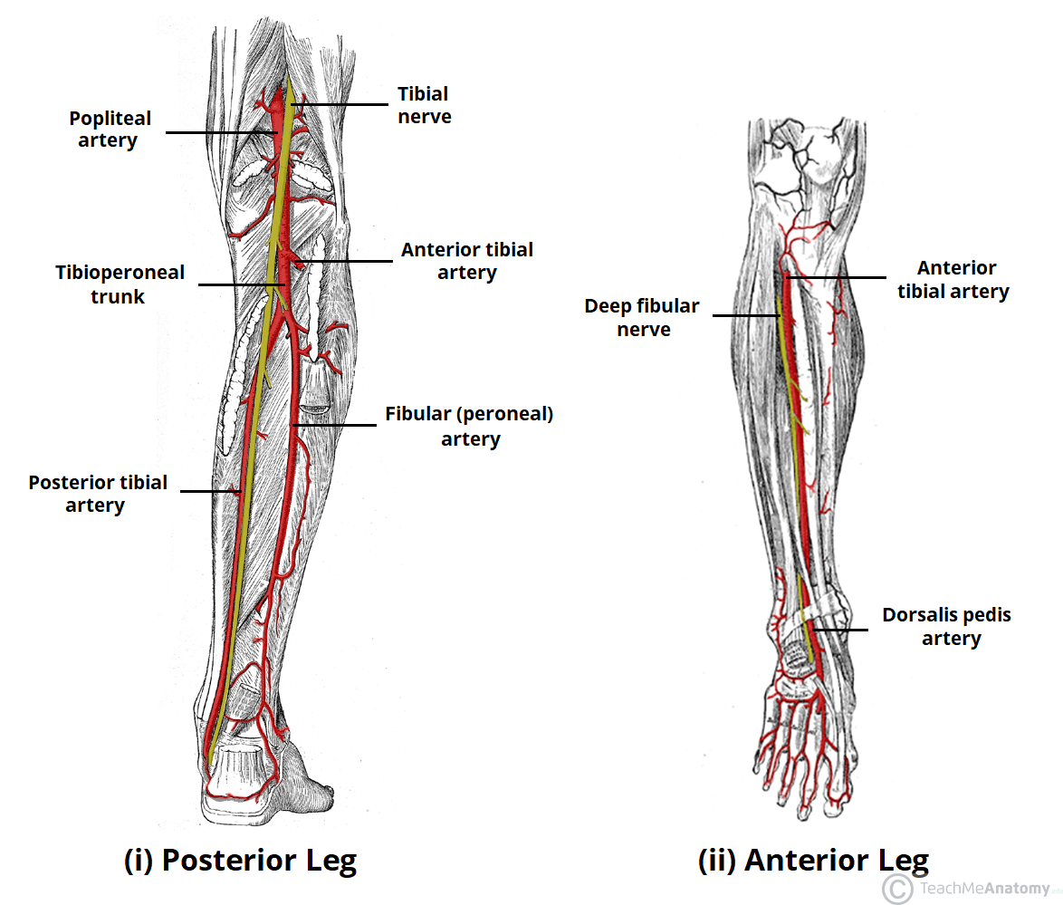
Lateral compartment of the leg :
- Peroneal or fibular compartment
- Consists of 2 muscles
- Fibularis (perneous) longus
- Fibularis (perneous) brevis
- Both originates from fibula.
- Both passes behind lateral malleolus.
- Both innervated by superficial fibular nerve.
- Both supplied by fibular artery which is branch from posterior tibial artery.
- Both passes below 2 fibular retinaculum (sup. and inf.).
- Both evert the foot (sole face outward).

** Insertion of muscles:
- Fibularis (perneous) brevis > inserted at the base of the fifth metatarsal bone it is important in elevating the lateral longitudinal arch.
- Fibularis (perneous) longus > inserted at the base of first metatarsal bone it is important in elevating the transverse arch.

- The muscle responsible for elevating medial longitudinal arch is tibialis anterior, so if tibialis anterior paralyzed > the foot becomes flat foot.

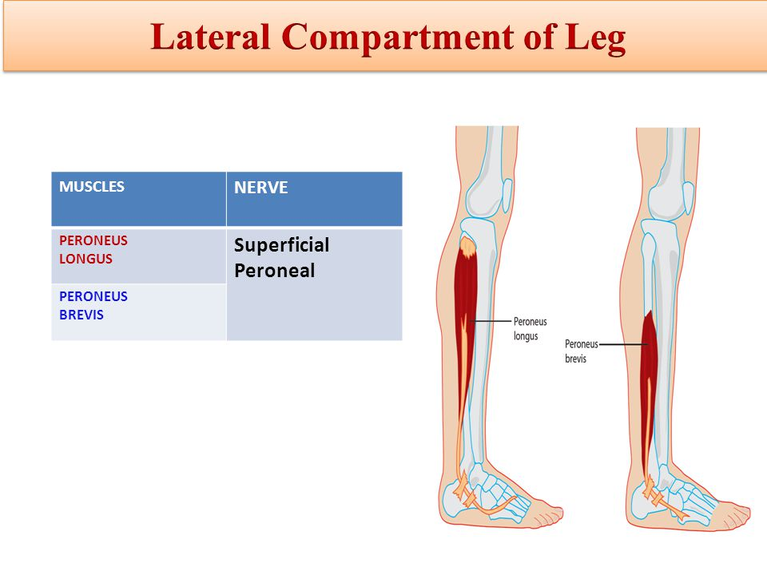

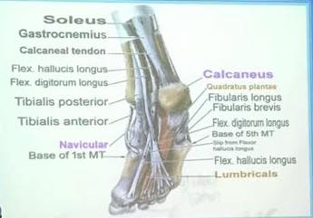

** The doctor did not explain the posterior compartment of the leg and the remaining parts

The End

