Lecture three
Pseudomonaciss, Moraxella, and B. anthracis

Dr. Hala Al Daghistani

Pseudomonades group
- gram-negative, motile, aerobic rods, some of which produce water-soluble pigments.
- The pseudomonads occur widely in soil, water, plants, and animals.
- P. aeruginosa is frequently present in small numbers in the normal intestinal flora and on the skin of humans and is the major pathogen of the group.

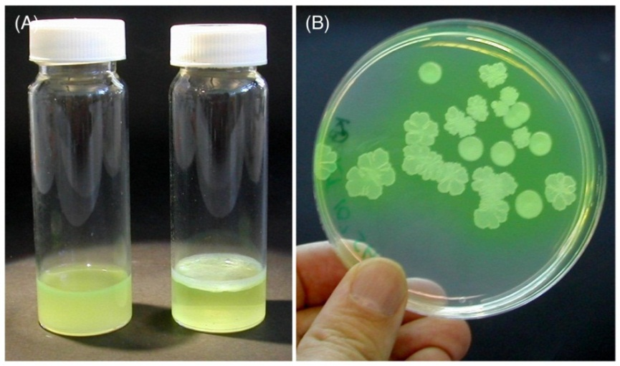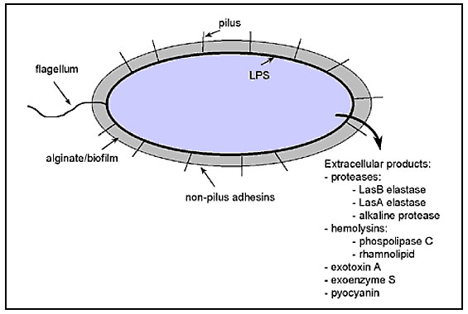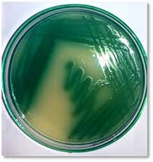

Pseudomonas aeruginosa
Morphology and Identification
- - P. aeruginosa is motile, gram negative, obligate aerobe that grows readily on many types of culture media, sometimes producing a sweet or grape-like odor, grows well at 37–42°C, oxidase positive.
. Some strains hemolysed blood, .
- forms smooth round colonies with a fluorescent greenish (pyoverdin).
- oft en produces the non-fluorescent bluish pigment (pyocyanin)
- some strains produce the dark red pigment (pyorubin)
- or the black pigment (pyomelanin)

Cultures from patients with cystic fibrosis (CF) often yield P. aeruginosa organisms that form mucoid colonies as a result of overproduction of alginate, an exopolysaccharide. This appears to provide the matrix for the organisms to live in a biofilm.

Antigenic Structure and virulence factors
- Pili (fimbriae) ,promote attachment to host epithelial cells.
- The exopolysaccharide is responsible for the mucoid colony. This layer is created by secretion of alginate. All P. aeruginosa produce moderate amounts of alginate, but those with mutations overproduce the polymer. These mutants appear as big mucoid colonies in cultures from the respiratory tract of patients with cystic fibrosis.
- The LPS, multiple immunotypes, is responsible for many of the endotoxic properties of the organism.
- Extracellular enzymes, including elastases, proteases, and two hemolysins (a heat-labile and a heat-stable).
- Many strains of P. aeruginosa produce Exotoxin A, which causes tissue necrosis. The toxin blocks protein synthesis. Exotoxin A enters cells via receptor-mediated endocytosis. It catalyzes the inactivation of EF-2 by ADP-ribosylation, leading to shutdown of protein synthesis and cell death.
- Most strains of P. aeruginosa produce hemolysin, lecithinase, collagenase, elastase. The elastase acts on a variety of substrates, including elastin, human IgA and IgG, complement components, and some collagens.

P. aeruginosa and Cystic Fibrosis (CF)
CF is a hereditary disorder affecting the lungs and other organs. It causes the production of abnormally thick mucus, leading to the blockage of the bronchi and often resulting in respiratory infection.

- P. aeruginosa is the most persistent of the infectious agents that complicate the course of CF.
- Once the bronchi are colonized, the organisms remain, forming a biofilm containing microcolonies of bacteria, which together are called a glycocalyx.
- The selective advantages of this biofilm include adhesion; inaccessibility of the immune system (complement, antibody, phagocytes); and interference with the action of antimicrobial agents.

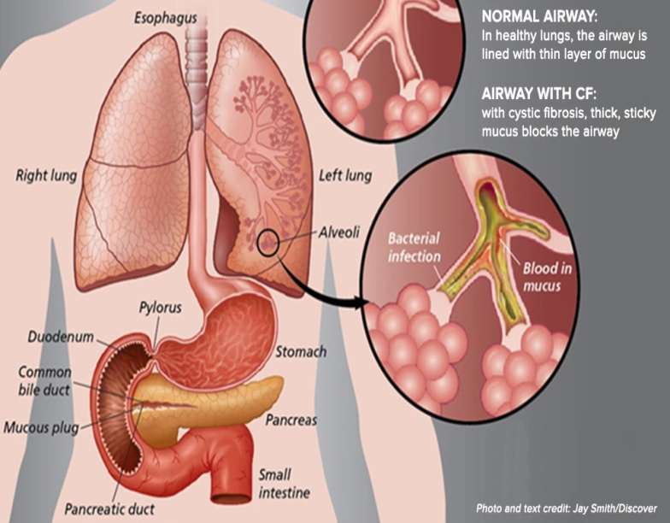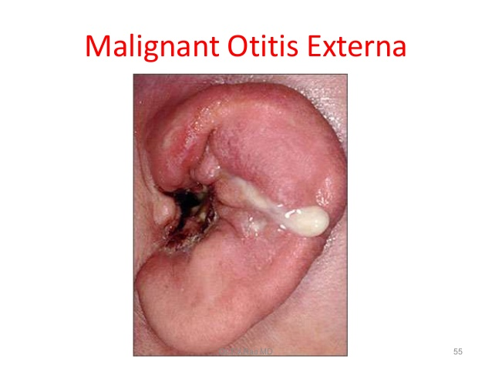

- P. aeruginosa pneumonia is a rapid, destructive, associated with alveolar necrosis, vascular invasion, and bacteremia.
- P. aeruginosa is also a common cause of otitis externa, including “swimmer’s ear” and a rare but life-threatening “malignant” otitis externa (skull base osteomylitis) seen in patients with diabetes (Malignant otitis externa is an aggressive infection rather than a malignancy, spreading to involve periostium and bone of the skull base).

Diagnostic Laboratory Tests
Specimens
Specimens from pus, blood, sputum are cultivated on blood agar and the differential media

Epidemiology and Control
P. aeruginosa is primarily a nosocomial pathogen, and the methods for control of infection are similar to those for other nosocomial pathogens.

MORAXELLA

Moraxella catarrhalis
- Another genus of coccobacillary, Gram-negative that are usually paired end to end. Some species require enriched media, such as blood or chocolate agar.

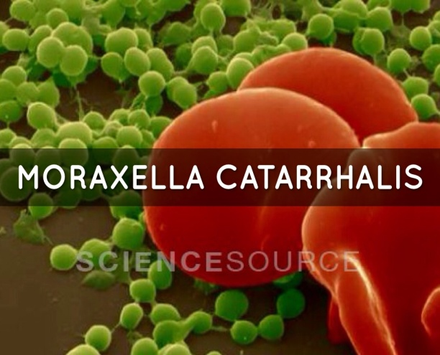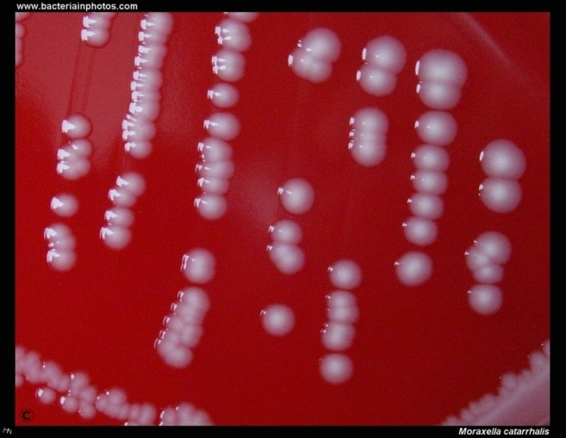

- Commonly colonizes the URT, particularly in children. For much of the last century, the bacterium was regarded as a commensal.
- M. catarrhalis is an important and common human respiratory tract pathogen, in particular as a cause of acute otitis media in children and of exacerbations of chronic obstructive pulmonary disease (COPD) in adults متفاقمة داء الانسداد الرئوي المزمن

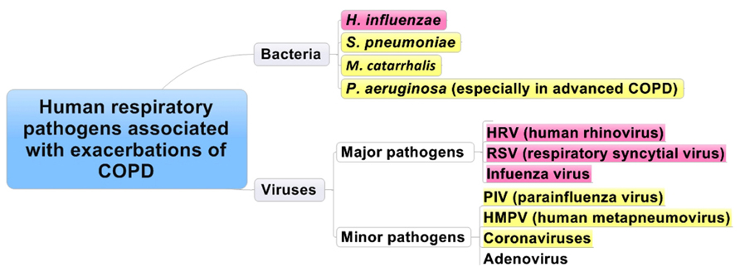

Most infants have upper respiratory tract colonization (NF) at some time in the first several years of life.

Because the pathogenesis of bacterial otitis media involves the migration of bacteria from the nasopharynx to the middle ear, patterns of nasopharyngeal colonization directly affect the distribution of pathogens that cause otitis media.
- Tympanocentesis ( is the drainage of fluid from the middle ear usually caused by otitis media, by using a small-gauge needle to puncture the tympanic membrane) is required to make an etiological diagnosis of otitis media, but this procedure is not performed routinely. Therefore, treatment of otitis media is generally empirical.

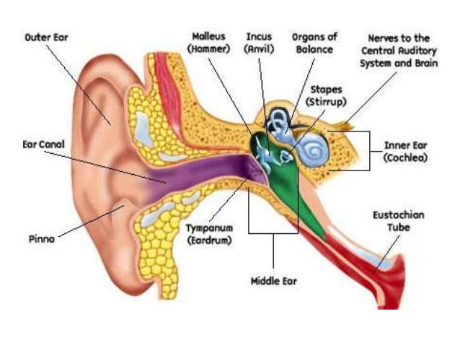

- Acute otitis media due to M. catarrhalis and H.influenzae are clinically milder than that caused by S. pneumonia, with less fever and a lower possibility of observing a red bulging tympanic membrane

- The cardinal symptoms of COPD exacerbations are increased sputum production, sputum purulence, and dyspnea, compared with baseline symptoms. Other features may include fever and fatigue.

- There is much variability in the combination of symptoms that occurs with each exacerbation.

Diagnosis: A Gram-stained smear of sputum or middle ear discharge reveals neutrophils and abundant gram-negative diplococci, including intracellular bacteria

Bacillus anthracis

- Anthrax is one of the most potential biological weapons in the world.
- Gram-positive, endospore-forming, rod-shaped bacterium. It lives in soils worldwide at mesophilic temperatures, facultative anaerobe.
- Anthrax is primarily a disease of herbivores—goats, sheep, cattle, horses, and so on; other animals ( rats) are relatively resistant to the infection.
- Humans become infected incidentally by contact with infected animals or their products.
- In humans, the infection is usually acquired by
- cutaneous root
- rarely gastrointestinal root
- inhalation of spores into the lung (inhalation anthrax).
- spores germinate in the tissue at the site of entry, and growth of the vegetative organisms results in the formation of edema and congestion.

B. anthracis isolates that do not produce a capsule are not virulent and do not induce anthrax in test animals.

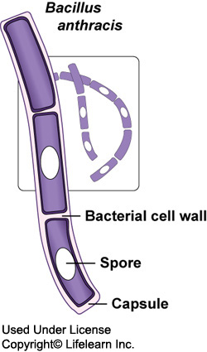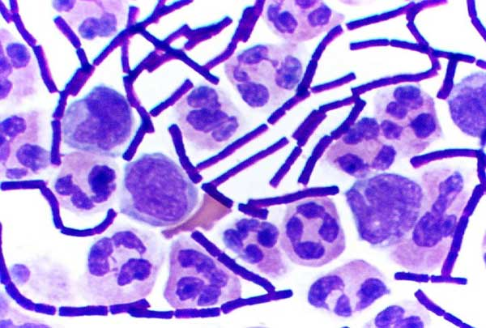

- The poly-d-glutamic acid capsule is antiphagocytic.
- Anthrax toxins are made up of three proteins
- protective antigen (PA)
- edema factor (EF)
- lethal factor (LF).
- PA binds to specific cell receptors, and it forms a channel that mediates entry of EF and LF into the cell.
- EF is an adenylate cyclase ( edema toxin).
- LF plus PA form lethal toxin, which is a major virulence factor and cause of death in infected animals and humans.

- inhalation anthrax (woolsorters’ disease), the spores from the dust of wool, hair, or hides are inhaled; phagocytosed in the lungs; and transported to lymph node where germination occurs. Infection usually develops from 1 to 7 days after exposure.
- This is followed by toxin production and the development of hemorrhagic mediastinitis and sepsis, which are rapidly fatal.

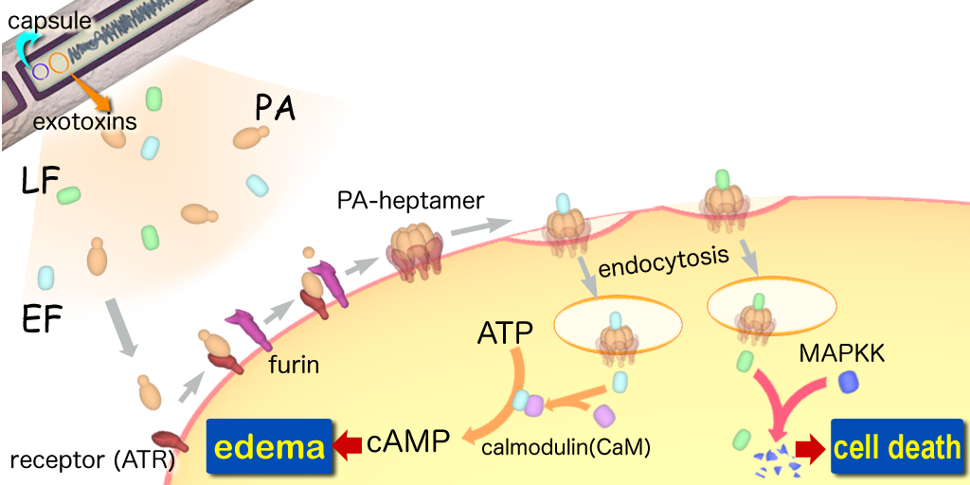

Clinical Findings
- Lymphangitis and lymphadenopathy and systemic signs and symptoms of fever, malaise, and headache may occur.
- The early clinical manifestations are associated with marked hemorrhagic necrosis and edema of the mediastinum.

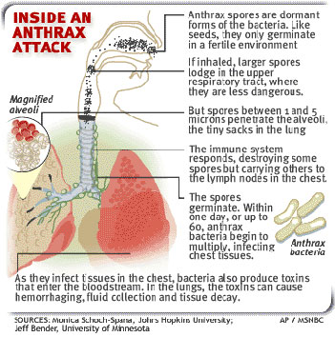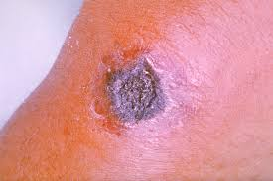

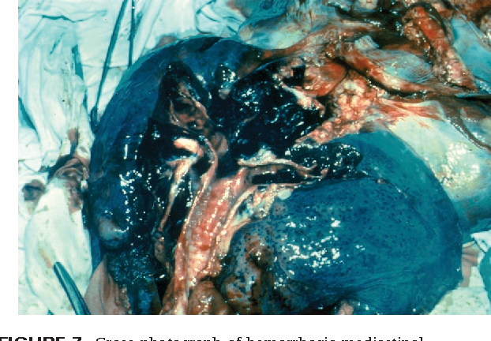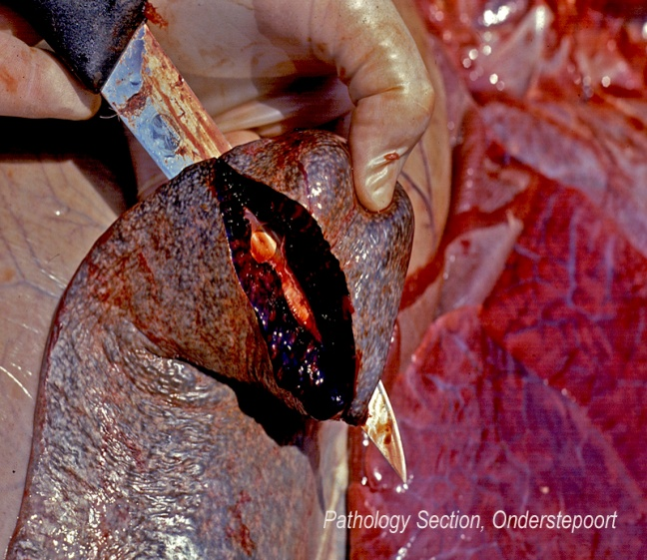

Diagnostic Laboratory Tests
- Fluid or pus, blood, pleural fluid, and CSF in inhalational anthrax associated with sepsis
- Comma-shaped outgrowths (Medusa head, “curled hair”) may project from the colony.

Gram stain shows large gram-positive rods, nonmotile

Epidemiology, Prevention, and Control
Soil is contaminated with anthrax spores from the carcasses of dead animals. This disease can be classified as a zoonosis, causing infected animals to transmit the disease to humans. Contact with infected animals or with their hair is the source of infection in humans.
Inhalation anthrax does not cause a true pneumonia. However, the spores get picked in the lungs up by the macrophages. The antibiotics are effective in killing the bacteria, but they do not destroy the deadly toxins that have already been released by the anthrax bacteria.

