Lecture three
Influenza virus

Dr. Hala Al Daghistani

- Respiratory disease accounts for an estimated 75 to 80% of all acute morbidity in the US population. Most of these illnesses (approximately 80%) are viral.
- The viruses that are major causes of acute respiratory disease (ARD) include
- Influenza viruses
- Parainfluenza viruses
- Rhinoviruses
- Adenoviruses
- Respiratory syncytial virus (RSV)
- Respiratory coronaviruses

- Transmission is direct, by infective droplet nuclei, or indirect, by hand transfer of contaminated secretions to nasal or conjunctival epithelium.
- All of these agents are associated with an increased risk of bacterial superinfection of the damaged tissue of the respiratory tract.

INFLUENZA VIRUSES
- Influenza viruses are enveloped, pleomorphic, ssRNA virus.
- They are classified into three major serotypes, A, B, and C, based on different ribonucleoprotein antigens.
- Type A is the most important one. Naturally infect a wide variety of species, including mammals and birds; and have a great tendency to undergo significant antigenic changes

- TypeB viruses are more antigenically stable; are only known to naturally infect humans.

- Type C viruses appear to be relatively minor causes of disease, affecting humans and pigs.

Influenza A
- A unique aspect of influenza A viruses is their ability to develop awide variety of subtypes through the processes of mutation and genetic Reassortment
- (is the mixing of the genetic material of species into new combinations in different individuals). If a single host ( human, chicken, or other animal) is infected by two different strains of the influenza virus, then it is possible that new assembled viral particles will be created from segments whose origin is mixed.
- Hemagglutinin (HA) and neuraminidase (NA) are the two large glycoproteins on the outside of the viral particles.
- HA mediates binding of the virus to target cells and entry of the viral genome into the target cell
- NA is involved in the release of progeny virus from infected cells
- The 15 subtypes of hemagglutinin and 9 neuraminidase subtypes known to exist among influenza A viruses that circulate in birds and mammals represent a reservoir of viral genes that can undergo reassortment, or “mixing” with human virus strains.
- Three hemagglutinins (H1, H2, and H3) and two neuraminidases (N1 and N2) appear to be of greatest importance in human infections.
- These subtypes are present according to the H and N antigens on their surface (e.g, H1N1 (Swine Flu in 2009), H3N2 (Hong Kong Flu in 1968), H5N1, most severe one, ( bird flu )

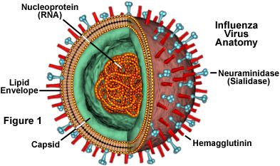

- Influenza virus types A and B typically cause more severe symptoms than influenza virus type C.
- The typical illness is characterized by an abrupt onset (over several hours) of
- Fever
- diffuse muscle aches
- chills.
- This is followed by respiratory signs, such as rhinitis, cough, and respiratory distress.

- The acute phase usually lasts 3 to 5 days, but a complete return to normal activities may take 2 to 6 weeks. Serious complications, especially pneumonia, are common.
- Some unusual acute manifestations of influenza include central nervous system (CNS) dysfunction, myositis, and myocarditis.

- In infants and children, a serious complication known as Reye’s syndrome may develop 2 to 12 days after onset of the infection. It is characterized by severe fatty infiltration of the liver and cerebral edema. This syndrome is associated not only with influenza viruses but with a wide variety of systemic viral illnesses. The risk is enhanced by exposure to some drugs such as aspirin.

- The most common and important complication of influenza virus infection is bacterial superinfection. The bacteria most commonly involved include Streptococcus pneumoniae, Haemophilus influenzae, and Staphylococcus aureus.

PATHOGENESIS
- Influenza viruses have affinity for the respiratory tract. Viremia is rarely detected.
- They multiply in ciliated respiratory epithelial cells, leading to functional and structural ciliary abnormalities. This is accompanied by desquamation of both ciliated and mucus-producing epithelial cells. Thus, there is an interference with the mechanical clearance mechanism of the respiratory tract.

- Other host cell functions are also severely impaired, particularly during the acute phase of infection, including impaired chemotactic, phagocytes, and intracellular killing functions of PMN and perhaps of alveolar macrophage activity. This damage renders the host highly susceptible to invasive bacterial superinfection.

- Recovery from infection begins with interferon production, which limits further virus replication, and with rapid generation of natural killer cells.
- Anti-hemagglutinin antibody is considered the most protective; it has the ability to neutralize virus on re-exposure.
- Antibody to neuraminidase antigen is not as protective as anti-hemagglutinin antibody but plays a role in limiting virus spread within the host.

DIAGNOSIS
- Influenza viruses can be readily isolated from respiratory tract specimens, such as nasopharyngeal and throat swabs.
- Grow in kidney cell cultures, and detected by hemadsorption or hemagglutination.

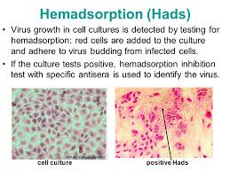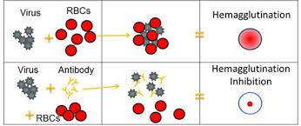
- Rapid diagnosis by direct immunofluorescence or immune-enzymatic detection of viral antigen in epithelial cells or secretions from the respiratory tract.
- A fourfold or greater increase in antibody titers in acute phase is considered significant.

Influenza virus vaccine is used to prevent infection. It is redeveloped each year to contain specific strains of inactivated (killed) flu virus that are recommended by public health officials for that year.

Respiratory syncytial virus (RSV)

- Respiratory syncytial virus (RSV) is an RNA virus, a paramyxovirus which causes disease of the respiratory tract.
- Almost all children are infected by age 4 years.
- Its name is derived from its ability to produce cell fusion in tissue culture (syncytium formation). Unlike influenza or parainfluenza viruses, it possesses no hemagglutinin or neuraminidase. The genome encoded 10 proteins.
- Protein G mediate the attachment
- Protein F is for syncytium formation

- At least two antigenic subgroups (A and B) of RSV are known to exist. This dimorphismis due primarily to differences in the G glycoprotein. Epidemiologic studies have suggested that group A infections tend to be more severe.

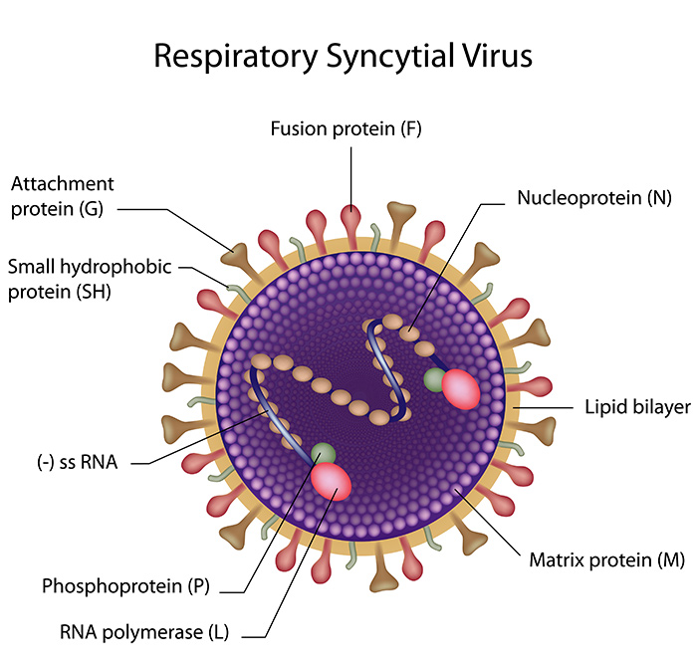

- RSV is the single most important etiologic agent in respiratory diseases of infancy, and it is the major cause of bronchitis, bronchiolitis and pneumonia among infants under 1 year of age.
- These include necrosis of epithelial cells; interstitial mononuclear cell inflammatory infiltrates, and plugging of smaller airways with material containing mucus, necrotic cells, and fibrin
- Multinucleated syncytial cells with intracytoplasmic inclusions (Viral inclusion bodies are unique structures generated by viral proteins together with some cellular proteins for efficient viral replication) are occasionally seen in the affected tracheobronchial epithelium.

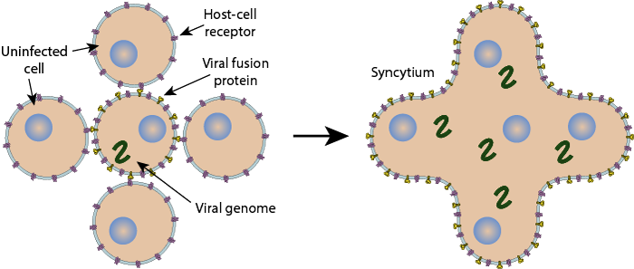

Respiratory syncytial virus diseases
- RSV primarily infects the bronchi, bronchioles, and alveoli of the lung.
- The acute phase of cough, wheezing and respiratory distress lasts 1 to 3 weeks.
- RSV is spread to the URT by contact with infective secretions.
- Infection appears to be confined primarily to the respiratory epithelium, with progressive involvement of the middle and lower airways. Viremia occurs rarely.
- The direct effect of virus on respiratory tract epithelial cells is similar to that described for influenza viruses
- Cytotoxic T cells appear to play an important role in early control of the acute infection (like influenzae virus).
- The apparent enhanced severity of disease, particularly in very young infants, may have an immunologic basis. Factors that have been proposed to play a role include

- qualitative or quantitative deficiency in humoral or secretory antibody responses to critical virus-specified proteins
- formation of antigen–antibody complexes within the respiratory tract resulting in complement activation
- Excessive damage from inflammatory cytokines.

DIAGNOSIS
- Rapid diagnosis of RSV infection can be made on nasal washing or swabs by immunofluorescence or immunoenzyme for detection of viral antigen.
- The virus can also be isolated from the respiratory tract by inoculation of specimens into cell cultures.
- Detection of multinucleated giant cells (synsitium)

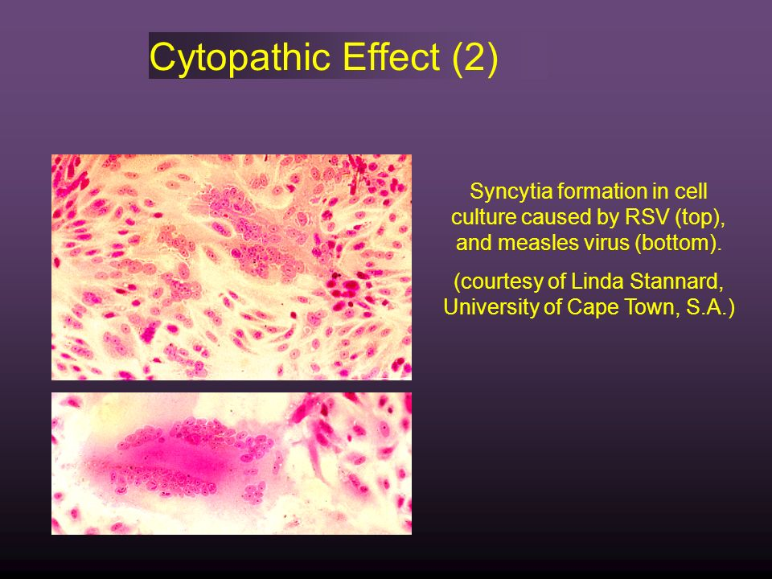

PREVENTION
No vaccine is currently available. Attenuated live virus vaccines and immunoglobulin containing high antibody titers to RSV are under active investigation

