Biochem sheet 22-11
Written by tasneem al abadi Edited by أصيل
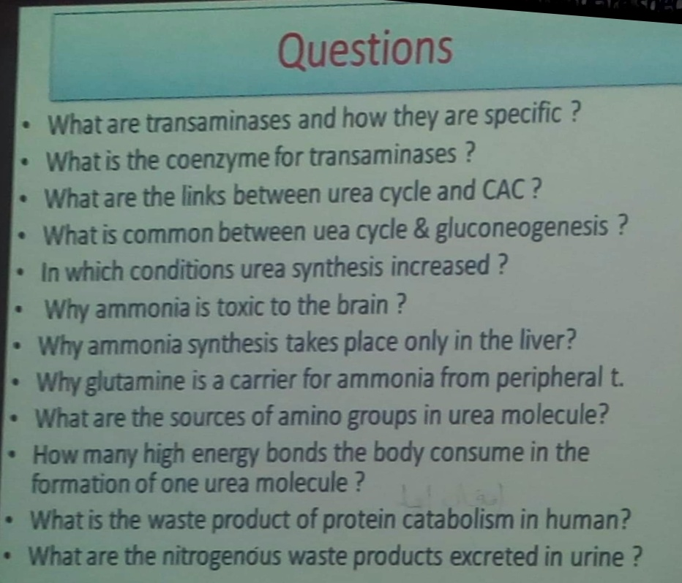
Transaminase :enzyme catalase the reaction between an amino acid and alpha keto acid to synthesis nonessential amino acid
*The body can synthesize nonessential amino acids.
-The mechanism to produce nonessential amino acid is transamination
*Oxidative deamination
*Oxidative decarboxylation ( an example of that is the production of histamine from histidine)

Glutamate+ alpha keto acid
Alpha kg +alpha amino acid (reversible reaction )

There are two enzyme :
الانزيم بتسمى حسب المتفاعلات او حسب النواتج*

1)ALT (according to the product =SGPT)
2) AST(according to the product =SGOT)

Both of them are found in liver and heart
But ALT is more specific in the liver and AST is more specific in heart) used in cardiac markers :AST, Mb ,LDH,IMA,CK-Mb,troponin )
MB : the first marker after the damage to cardiac muscles & it leaks to blood.
Other enzymes also leak out to the blood such as CPK ,CPKMB and homocysteine.
*ارتفاع الهوموسيستين يدل على انك معرض لتصاب
Myocardial infarction
*Homocystiene is a predictable marker for myocardial infarction.
*LDH isoenzyme in heart :LDH1 composed of H4.
* AST and ALT normal limits may record up to 40 international units per liter. Moreover, in myocardial infarction and liver cirrhosis they increase thousands of times.
Enzymes cause a problem if they increase 5 or 10 times the upper limit of normal.
*LDH increases as a result of exercising or any physical activity.
coenzyme in transaminases :
pyridoxal phosphate
vitamin B6 phosphate
urea cycle : consumption 4 ATP
net body use 1 for urea formation
arginase enzyme found only in liver , because of that urea synthesis occurs in liver.

urea nitrogen sources :
(Carbamoyl phosphate واحد من اول تفاعل(
والتاني من ال aspartate
Starvation(different from fasting )and severe exercise cause increase urea formation
Protein intake, starvation and severe muscular exercise increase urea up to 10-20 times.
*proteins are not excreted in urine.
*nitrogenous products that are excreted in urine are uric acid and urea.
Proteins differ from lipids and carbohydrates that they don’t have storage forms.

the coenzyme N-acetyl glutamate which activate carbamoyl phosphate come from the proteins so it increase protein intake , increase urea formation.

*Waste product( end product of protein degradation in human )is urea

why glutamine is a carrier for ammonia from peripheral tissue?
because it neutral (nontoxic ) so it can pass all barriers while ammonia is toxic (to the brain)
Ammonia reacts with alpha ketoglutarate which leads to a decrease in alpha ketoglutarate thus resulting in a malfunction in the citric acid cycle.

- Hepatic coma origin in liver because of the increase in ammonia concentration
*ammonia has no normal range in individuals, each patient has its own limit.
If ammonia concentration doesn’t fall down with time(every 6 hours) then the patient is not responding to the drug given and will remain in coma.

Albinisim : deficiency of tyrosinase
*phenylketonuria is a genetic disease that results from a deficiency in phenlyalanine hydroxylase.
In the case of phenylketonuria, phenylalanine accumulates and it’s converted into phenyl lactate, acetate and pyruvate which are excreted in urine.
*Alkaptonuria is characterized by brown/dark/black urine due to the auto oxidation of homogenetisic acid.
*maple syrup urine disease is characterized by orange urine and is a result of branched-chain alpha keto acid dehydrogenase complex or (BCKDC)*deficiency.

*WIKIPEDIA.

