Note : anything inside the boxes is slides information
Physiology lecture 3 :RENAL TUBULAR REABSORPTION AND SECRETION
Urine formation:
- Tubular reabsorption is selective and quantitatively large :
- Filtration rate of y = GFR x [plasma]y

- As the glomerular filtrate enters the renal tubules, it flows sequentially through the successive parts of the tubule—the proximal tubule, the loop of Henle, the distal tubule, the collecting tubule, and, finally, the collecting duct—before it is excreted as urine.
- Along this course, some substances are selectively reabsorbed from the tubules back into the blood, whereas others are secreted from the blood into the tubular lumen.
- Eventually, the urine that is formed and all the substances in the urine represent the sum of three basic renal processes—glomerular filtration, tubular reabsorption, and tubular secretion:
- Urinary excretion = Glomerular filtration – Tubular reabsorption + Tubular secretion
- For many substances, tubular reabsorption plays a much more important role than secretion in determining the final urinary excretion rate.
- However, tubular secretion accounts for significant amounts of potassium ions, hydrogen ions, and a few other substances that appear in the urine.
- ……………………………………………………………………………………………………………………………………
Tubular Reabsorption Is Quantitatively Large and Highly Selective
- Table 27-1 shows the renal handling of several substances that are all freely filtered in the kidneys and reabsorbed at variable rates.
- The rate at which each of these substances is filtered is calculated as
- Filtration = Glomerular filtration rate × Plasma concentration
- This calculation assumes that the substance is freely filtered and not bound to plasma proteins.
- For example, if plasma glucose concentration is 1 g/L, the amount of glucose filtered each day is about 180 L/day × 1 g/L, or 180 g/day.
- Because virtually none of the filtered glucose is normally excreted, the rate of glucose reabsorption is also 180 g/day.
- From Table 27-1, two things are immediately apparent.
- First, the processes of glomerular filtration and tubular reabsorption are quantitatively large relative to urinary excretion for many substances.
- This means that a small change in glomerular filtration or tubular reabsorption can potentially cause a relatively large change in urinary excretion.
- For example, a 10 percent decrease in tubular reabsorption, from 178.5 to 160.7 L/day, would increase urine volume from 1.5 to 19.3 L/day (almost a 13-fold increase) if the glomerular filtration rate (GFR) remained constant.
- In reality, however, changes in tubular reabsorption and glomerular filtration are closely coordinated so that large fluctuations in urinary excretion are avoided.
- Second, unlike glomerular filtration, which is relatively nonselective (essentially all solutes in the plasma are filtered except the plasma proteins or substances bound to them), tubular reabsorption is highly selective.
- Some substances, such as glucose and amino acids, are almost completely reabsorbed from the tubules, so the urinary excretion rate is essentially zero.
- Many of the ions in the plasma, such as sodium, chloride, and bicarbonate, are also highly reabsorbed, but their rates of reabsorption and urinary excretion are variable, depending on the needs of the body.
- Waste products, such as urea and creatinine, conversely, are poorly reabsorbed from the tubules and excreted in relatively large amounts.
- Therefore, by controlling the rate at which they reabsorb different substances, the kidneys regulate the excretion of solutes independently of one another, a capability that is essential for precise control of the body fluid composition.
- 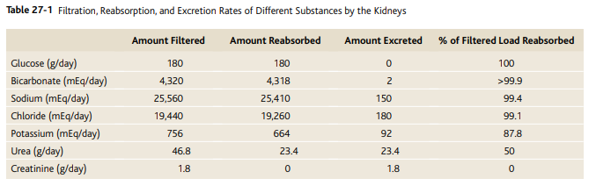

A: Reabsorption

- A: Reabsorption :
- Across tubular epithalial membrane into renal interstitial fluid . Then
- Through peritubular capillary back to the circulation :
- 1: Could be transcellular route OR paracellular route ( water and solutes, Na by both route) to the interstitial fluid then to circulation
- 2: Only by ultrafiltration (bulk flow) to the blood
- through peritubular capillaries

Tubular Reabsorption Includes Passive and Active Mechanisms
- For a substance to be reabsorbed, it must first be transported :
- (1) across the tubular epithelial membranes into the renal interstitial fluid and then
- (2) through the peritubular capillary membrane back into the blood
- Thus, reabsorption of water and solutes includes a series of transport steps.
- Reabsorption across the tubular epithelium into the interstitial fluid includes active or passive transport.
- For instance, water and solutes can be transported through the cell membranes themselves (transcellular route) or through the spaces between the cell junctions (paracellular route).
- Then, after absorption across the tubular epithelial cells into the interstitial fluid, water and solutes are transported through the peritubular capillary walls into the blood by ultrafiltration (bulk flow) that is mediated by hydrostatic and colloid osmotic forces.
- The peritubular capillaries behave like the venous ends of most other capillaries because there is a net reabsorptive force that moves the fluid and solutes from the interstitium into the blood.
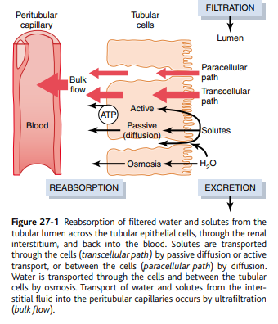
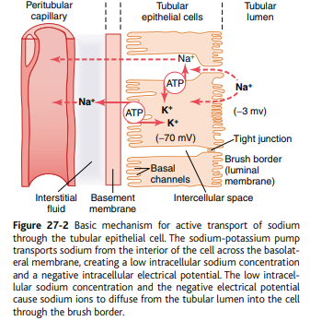
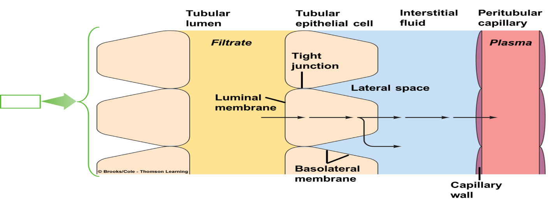
TYPES OF ABSORPTION:
1-ACITVE ABSORPTION
A-Primary active :Na-K ATPase,
H- ATPase, H-K ATPase and Ca
ATPase(against electrochemical gradient)
B-Secondary active reabsorption :Two
or more substances ,Na-Glucose , a.a.
co- transporter ( By SGLT2 90% in early proximal
tubule & by SGLT 1 10% in late part of proximal tubules), Cl

Active Transport
- Active transport can move a solute against an electrochemical gradient and requires energy derived from metabolism.
- Transport that is coupled directly to an energy source, such as the hydrolysis of adenosine triphosphate (ATP), is termed primary active transport.
- A good example of this is the sodium-potassium ATPase pump that functions throughout most parts of the renal tubule.
- Transport that is coupled indirectly to an energy source, such as that due to an ion gradient, is referred to as secondary active transport.
- Reabsorption of glucose by the renal tubule is an example of secondary active transport.
- Although solutes can be reabsorbed by active and/ or passive mechanisms by the tubule, water is always reabsorbed by a passive (nonactive) physical mechanism called osmosis, which means water diffusion from a region of low solute concentration (high water concentration) to one of high solute concentration (low water concentration).
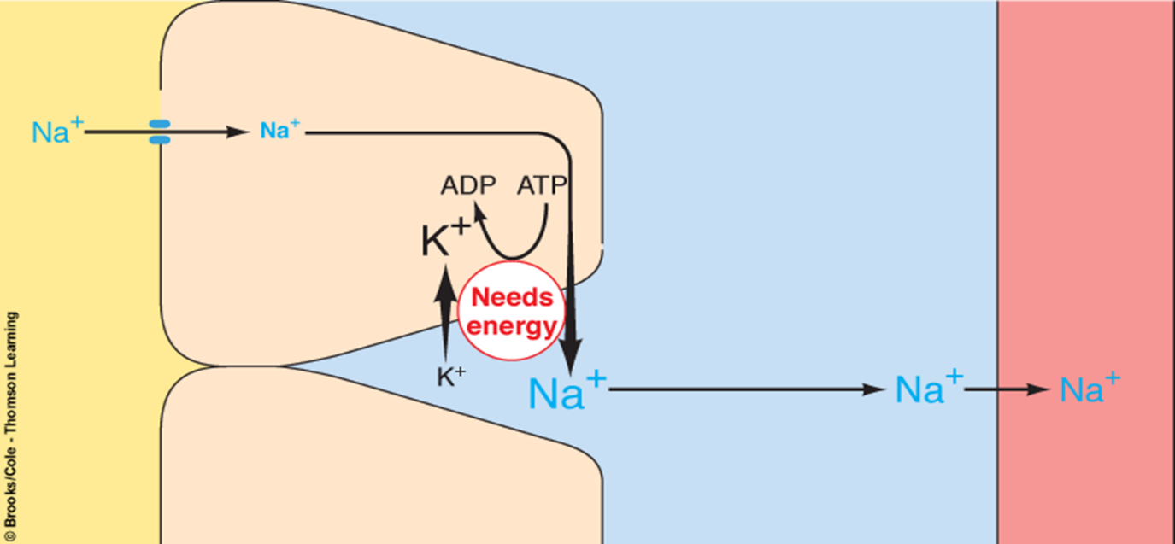
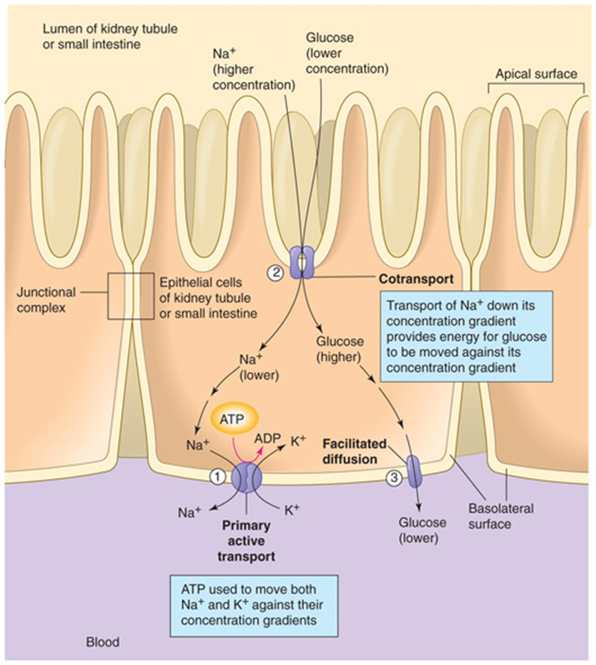
………………………………………………………………………………………………………………………………………………………………
Solutes Can Be Transported Through Epithelial Cells or Between Cells.
- Renal tubular cells, like other epithelial cells, are held together by tight junctions.
- Lateral intercellular spaces lie behind the tight junctions and separate the epithelial cells of the tubule.
- Solutes can be reabsorbed or secreted across the cells through the transcellular pathway or between the cells by moving across the tight junctions and intercellular spaces by way of the paracellular pathway.
- Sodium is a substance that moves through both routes, although most of the sodium is transported through the transcellular pathway.
- In some nephron segments, especially the proximal tubule, water is also reabsorbed across the paracellular pathway, and substances dissolved in the water, especially potassium, magnesium, and chloride ions, are carried with the reabsorbed fluid between the cells.
- ……………………………………………………………………………………………………………………………………
The primary active transport in the kidneys
The primary active transport in the kidneys are
1-Na-K ATPase
2- H ATPase
3- H-K ATPase
4-calcium ATPase

Primary Active Transport Through the Tubular Membrane Is Linked to Hydrolysis of ATP.
- The special importance of primary active transport is that it can move solutes against an electrochemical gradient.
- The energy for this active transport comes from the hydrolysis of ATP by way of membrane-bound ATPase; the ATPase is also a component of the carrier mechanism that binds and moves solutes across the cell membranes.
- The primary active transporters in the kidneys that are known include sodium-potassium ATPase, hydrogen ATPase, hydrogenpotassium ATPase, and calcium ATPase.
- A good example of a primary active transport system is the reabsorption of sodium ions across the proximal tubular membrane, as shown in Figure 27-2.
- On the basolateral sides of the tubular epithelial cell, the cell membrane has an extensive sodium-potassium ATPase system that hydrolyzes ATP and uses the released energy to transport sodium ions out of the cell into the interstitium.
- At the same time, potassium is transported from the interstitium to the inside of the cell.
- The operation of this ion pump maintains low intracellular sodium and high intracellular potassium concentrations and creates a net negative charge of about −70 millivolts within the cell.
- This active pumping of sodium out of the cell across the basolateral membrane of the cell favors passive diffusion of sodium across the luminal membrane of the cell, from the tubular lumen into the cell, for two reasons:
- (1) There is a concentration gradient favoring sodium diffusion into the cell because intracellular sodium concentration is low (12 mEq/L) and tubular fluid sodium concentration is high (140 mEq/L) and
- (2) the negative, −70-millivolt, intracellular potential attracts the positive sodium ions from the tubular lumen into the cell. Active reabsorption of sodium by sodium-potassium ATPase occurs in most parts of the tubule.
- In certain parts of the nephron, there are also additional provisions for moving large amounts of sodium into the cell.
- In the proximal tubule, there is an extensive brush border on the luminal side of the membrane (the side that faces the tubular lumen) that multiplies the surface area about 20-fold.
- There are also carrier proteins that bind sodium ions on the luminal surface of the membrane and release them inside the cell, providing facilitated diffusion of sodium through the membrane into the cell.
- These sodium carrier proteins are also important for secondary active transport of other substances, such as glucose and amino acids.
- Thus, the net reabsorption of sodium ions from the tubular lumen back into the blood involves at least three steps:
- 1. Sodium diffuses across the luminal membrane (also called the apical membrane) into the cell down an electrochemical gradient established by the sodium potassium ATPase pump on the basolateral side of the membrane.
- 2. Sodium is transported across the basolateral membrane against an electrochemical gradient by the sodium-potassium ATPase pump.
- 3. Sodium, water, and other substances are reabsorbed from the interstitial fluid into the peritubular capillaries by ultrafiltration, a passive process driven by the hydrostatic and colloid osmotic pressure gradients.
- ……………………………………………………………………………………………………………………………………..

Secondary Active Reabsorption Through the Tubular Membrane.
- In secondary active transport, two or more substances interact with a specific membrane protein (a carrier molecule) and are transported together across the membrane.
- As one of the substances (for instance, sodium) diffuses down its electrochemical gradient, the energy released is used to drive another substance (for instance, glucose) against its electrochemical gradient.
- Thus, secondary active transport does not require energy directly from ATP or from other highenergy phosphate sources.
- Rather, the direct source of the energy is that liberated by the simultaneous facilitated diffusion of another transported substance down its own electrochemical gradient.
- Figure 27-3 shows secondary active transport of glucose and amino acids in the proximal tubule.
- In both instances, specific carrier proteins in the brush border combine with a sodium ion and an amino acid or a glucose molecule at the same time.
- These transport mechanisms are so efficient that they remove virtually all the glucose and amino acids from the tubular lumen.
- After entry into the cell, glucose and amino acids exit across the basolateral membranes by diffusion, driven by the high glucose and amino acid concentrations in the cell facilitated by specific transport proteins.
- Sodium glucose co-transporters (SGLT2 and SGLT1) are located on the brush border of proximal tubular cells and carry glucose into the cell cytoplasm against a concentration gradient, as described previously.
- Approximately 90 percent of the filtered glucose is reabsorbed by SGLT2 in the early part of the proximal tubule (S1 segment) and the residual 10 percent is transported by SGLT1 in the latter segments of the proximal tubule.
- On the basolateral side of the membrane, glucose diffuses out of the cell into the interstitial spaces with the help of glucose transporters -GLUT2, in the S1 segment and GLUT1 in the latter part (S3 segment) of the proximal tubule.
- Although transport of glucose against a chemical gradient does not directly use ATP, the reabsorption of glucose depends on energy expended by the primary active sodiumpotassium ATPase pump in the basolateral membrane.
- Because of the activity of this pump, an electrochemical gradient for facilitated diffusion of sodium across the luminal membrane is maintained, and it is this downhill diffusion of sodium to the interior of the cell that provides the energy for the simultaneous uphill transport of glucose across the luminal membrane.
- Thus, this reabsorption of glucose is referred to as “secondary active transport” because glucose itself is reabsorbed uphill against a chemical gradient, but it is “secondary” to primary active transport of sodium.
- Another important point is that a substance is said to undergo “active” transport when at least one of the steps in the reabsorption involves primary or secondary active transport, even though other steps in the reabsorption process may be passive.
- For glucose reabsorption, secondary active transport occurs at the luminal membrane, but passive facilitated diffusion occurs at the basolateral membrane, and passive uptake by bulk flow occurs at the peritubular capillaries.
TYPES OF ABSORPTION CONT
C-Secondary active secretion:
Na-H counter-transporter ( As Na inter the cells H ions forced outward in opposite direction into tubular lumen.
D-Pintocytosis :
In proximal tubule active transport of protein by endocytosis . Protein attached to luminal membrane then invaginates to inside the cell. Then the protein digested into amino acid the absorbed to interstitial fluid. It is active because it needs energy

Secondary Active Secretion into the Tubules.
- Some substances are secreted into the tubules by secondary active transport.
- This often involves counter-transport of the substance with sodium ions.
- In counter-transport, the energy liberated from the downhill movement of one of the substances (e.g., sodium ions) enables uphill movement of a second substance in the opposite direction.
- One example of counter-transport, shown in Figure 27-3, is the active secretion of hydrogen ions coupled to sodium reabsorption in the luminal membrane of the proximal tubule.
- In this case, sodium entry into the cell is coupled with hydrogen extrusion from the cell by sodiumhydrogen counter-transport.
- This transport is mediated by a specific protein (sodium-hydrogen exchanger) in the brush border of the luminal membrane.
- As sodium is carried to the interior of the cell, hydrogen ions are forced outward in the opposite direction into the tubular lumen.
Pinocytosis—An Active Transport Mechanism for Reabsorption of Proteins.
- Some parts of the tubule, especially the proximal tubule, reabsorb large molecules such as proteins by pinocytosis.
- In this process the protein attaches to the brush border of the luminal membrane, and this portion of the membrane then invaginates to the interior of the cell until it is completely pinched off and a vesicle is formed containing the protein.
- Once inside the cell, the protein is digested into its constituent amino acids, which are reabsorbed through the basolateral membrane into the interstitial fluid.
- Because pinocytosis requires energy, it is considered a form of active transport.
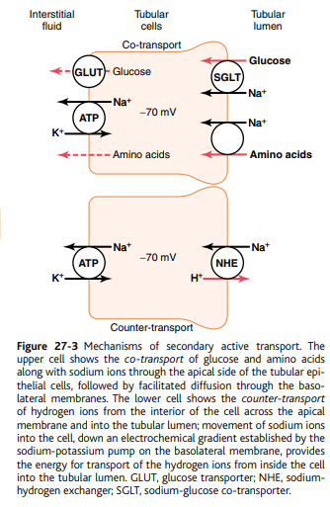
…………………………………………………………………………………………………..
Transport maximum for substances that actively reabsorbed
- Filtered load exceeds carrier capacity. Limit to the rate at which the solute can be transported.
- Tm Glucose = 375 mg/min
- Filtered load = 125 mg/min (GFR x [gl.]pl.
- Threshold Gl. = 200mg/dl =250 mg/min
(tubular Load)

Transport Maximum for Substances That Are Actively Reabsorbed.
- For most substances that are actively reabsorbed or secreted, there is a limit to the rate at which the solute can be transported, often referred to as the transport maximum.
- This limit is due to saturation of the specific transport systems involved when the amount of solute delivered to the tubule (referred to as tubular load) exceeds the capacity of the carrier proteins and specific enzymes involved in the transport process.
- The glucose transport system in the proximal tubule is a good example.
- Normally, measurable glucose does not appear in the urine because essentially all the filtered glucose is reabsorbed in the proximal tubule.
- However, when the filtered load exceeds the capability of the tubules to reabsorb glucose, urinary excretion of glucose does occur.
- In the adult human, the transport maximum for glucose averages about 375 mg/min, whereas the filtered load of glucose is only about 125 mg/min
- (GFR × plasma glucose = 125 ml/min × 1 mg/ml).
- With large increases in GFR and/or plasma glucose concentration that increase the filtered load of glucose above 375 mg/min, the excess glucose filtered is not reabsorbed and passes into the urine.
- Figure 27-4 shows the relation between plasma concentration of glucose, filtered load of glucose, tubular transport maximum for glucose, and rate of glucose loss in the urine.
- Note that when the plasma glucose concentration is 100 mg/100 ml and the filtered load is at its normal level, 125 mg/min, there is no loss of glucose in the urine.
- However, when the plasma concentration of glucose rises above about 200 mg/100 ml, increasing the filtered load to about 250 mg/min, a small amount of glucose begins to appear in the urine.
- This point is termed the threshold for glucose.
- Note that this appearance of glucose in the urine (at the threshold) occurs before the transport maximum is reached.
- One reason for the difference between threshold and transport maximum is that not all nephrons have the same transport maximum for glucose, and some of the nephrons therefore begin to excrete glucose before others have reached their transport maximum.
- The overall transport maximum for the kidneys, which is normally about 375 mg/min, is reached when all nephrons have reached their maximal capacity to reabsorb glucose.
- The plasma glucose of a healthy person almost never becomes high enough to cause glucose excretion in the urine, even after eating a meal.
- However, in uncontrolled diabetes mellitus, plasma glucose may rise to high levels, causing the filtered load of glucose to exceed the transport maximum and resulting in urinary glucose excretion.
- Some of the important transport maximums for substances actively reabsorbed by the tubules are as follows:
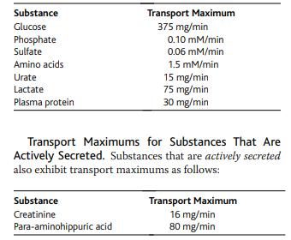

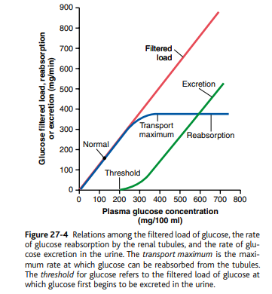
Not all the substances have transport maximum.
Transport of these substances depend on gradient, permeability and gradient time transport i.e ( time that substance in the fluid remains contact with luminal membrane of the tubule).

- Substances That Are Actively Transported but Do Not Exhibit a Transport Maximum.
- The reason that actively transported solutes often exhibit a transport maximum is that the transport carrier system becomes saturated as the tubular load increases.
- Some substances that are passively reabsorbed do not demonstrate a transport maximum because their rate of transport is determined by other factors, such as
- (1) the electrochemical gradient for diffusion of the substance across the membrane,
- (2) the permeability of the membrane for the substance, and
- (3) the time that the fluid containing the substance remains within the tubule.
- Transport of this type is referred to as gradient-time transport because the rate of transport depends on the electrochemical gradient and the time that the substance is in the tubule, which in turn depends on the tubular flow rate.
- Some actively transported substances also have characteristics of gradient-time transport.
SODIUM Na
1- Active transport in the proximal tubule.
2-Obeys gradient time.
3- Co-transporter and counter-transporter.
4- No maximum transporter in the proximal tub
5- Has maximum transporter in the distal part
and this can increase by aldosterone

- An example is sodium reabsorption in the proximal tubule.
- The main reason that sodium transport in the proximal tubule does not exhibit a transport maximum is that other factors limit the reabsorption rate besides the maximum rate of active transport.
- For example, in the proximal tubules, the maximum transport capacity of the basolateral sodium-potassium ATPase pump is usually far greater than the actual rate of net sodium reabsorption.
- One of the reasons for this is that a significant amount of sodium transported out of the cell leaks back into the tubular lumen through the epithelial tight junctions.
- The rate at which this backleak occurs depends on several factors, including
- (1) the permeability of the tight junctions and
- (2) the interstitial physical forces, which determine the rate of bulk flow reabsorption from the interstitial fluid into the peritubular capillaries.
- Therefore, sodium transport in the proximal tubules obeys mainly gradient-time transport principles rather than tubular maximum transport characteristics.
- This means that the greater the concentration of sodium in the proximal tubules, the greater its reabsorption rate.
- Also, the slower the flow rate of tubular fluid, the greater the percentage of sodium that can be reabsorbed from the proximal tubules.
- In the more distal parts of the nephron, the epithelial cells have much tighter junctions and transport much smaller amounts of sodium.
- In these segments, sodium reabsorption exhibits a transport maximum similar to that for other actively transported substances.
- Furthermore, this transport maximum can be increased by certain hormones, such as aldosterone.

Passive Water Reabsorption by Osmosis Is Coupled Mainly to Sodium Reabsorption
2.PASSIVE REABSORPTION:
A. Osmosis of water is coupled mainly to Na reabsorption
In proximal tubule osmotic flow of water through tight junction with high permeability to water but significant permeability to Na, Cl, K, Ca and Mg.
As water moves by osmosis through tight junction it can carry with it some sloutes.

Solute transport create concentration
difference that cause osmosis of water in the same direction of solute transport, large part through tight junctions
- Solvent drag some solute w/water
- ADH ^ permeability in distal, and coll.Tubule
- Ascending and first part of distal impermeable for water

- When solutes are transported out of the tubule by either primary or secondary active transport, their concentrations tend to decrease inside the tubule while increasing in the renal interstitium.
- This creates a concentration difference that causes osmosis of water in the same direction that the solutes are transported, from the tubular lumen to the renal interstitium.
- Some parts of the renal tubule, especially the proximal tubule, are highly permeable to water, and water reabsorption occurs so rapidly that there is only a small concentration gradient for solutes across the tubular membrane.
- A large part of the osmotic flow of water in the proximal tubules occurs through the so-called tight junctions between the epithelial cells, as well as through the cells themselves.
- The reason for this is that the junctions between the cells are not as tight as their name would imply and permit significant diffusion of water and small ions.
- This is especially true in the proximal tubules, which have a high permeability for water and a smaller but significant permeability to most ions, such as sodium, chloride, potassium, calcium, and magnesium.
- As water moves across the tight junctions by osmosis, it can also carry with it some of the solutes, a process referred to as solvent drag.
- And because the reabsorption of water, organic solutes, and ions is coupled to sodium reabsorption, changes in sodium reabsorption significantly influence the reabsorption of water and many other solutes.
- In the more distal parts of the nephron, beginning in the loop of Henle and extending through the collecting tubule, the tight junctions become far less permeable to water and solutes and the epithelial cells also have a greatly decreased membrane surface area.
- Therefore, water cannot move easily across the tight junctions of the tubular membrane by osmosis.
- However, antidiuretic hormone (ADH) greatly increases the water permeability in the distal and collecting tubules.
- Thus, water movement across the tubular epithelium can occur only if the membrane is permeable to water, no matter how large the osmotic gradient.
- In the proximal tubule, the water permeability is always high and water is reabsorbed as rapidly as the solutes.
- In the ascending loop of Henle, water permeability is always low, so almost no water is reabsorbed despite a large osmotic gradient.
- Water permeability in the last parts of the tubules—the distal tubules, collecting tubules, and collecting ducts— can be high or low, depending on the presence or absence of ADH.
…………………………………………………………………………………..
Reabsorption of Chloride, Urea, and Other Solutes by Passive Diffusion
Reabsorption of Cl, Urea and other solute by passive diffusion.
Mainly Cl (by paracellular pathway) and to lesser extent urea( Medullary collecting duct) reabsorbed by creating concentration gradient generated by active Na reabsorption.

D. Chloride
- Na+ inside cells attracts (-) charge of chloride
- Also Cl- passively after water influx [Cl-] out
- Also secondary active transport Na+ - Cl-
E. Urea : - passively 1/2 of the filtered is absorbed

- When sodium is reabsorbed through the tubular epithelial cell, negative ions such as chloride are transported along with sodium because of electrical potentials.
- That is, transport of positively charged sodium ions out of the lumen leaves the inside of the lumen negatively charged, compared with the interstitial fluid.
- This causes chloride ions to diffuse passively through the paracellular pathway.
- Additional reabsorption of chloride ions occurs because of a chloride concentration gradient that develops when water is reabsorbed from the tubule by osmosis, thereby concentrating the chloride ions in the tubular lumen (Figure 27-5).
- Thus, the active reabsorption of sodium is closely coupled to the passive reabsorption of chloride by way of an electrical potential and a chloride concentration gradient.
- Chloride ions can also be reabsorbed by secondary active transport.
- The most important of the secondary active transport processes for chloride reabsorption involves co-transport of chloride with sodium across the luminal membrane.
- Urea is also passively reabsorbed from the tubule, but to a much lesser extent than chloride ions.
- As water is reabsorbed from the tubules (by osmosis coupled to sodium reabsorption), urea concentration in the tubular lumen increases (see Figure 27-5).
- This creates a concentration gradient favoring the reabsorption of urea.
- However, urea does not permeate the tubule as readily as water.
- In some parts of the nephron, especially the inner medullary collecting duct, passive urea reabsorption is facilitated by specific urea transporters.
- Yet, only about one half of the urea that is filtered by the glomerular capillaries is reabsorbed from the tubules.
- The remainder of the urea passes into the urine, allowing the kidneys to excrete large amounts of this waste product of metabolism.
- In mammals, greater than 90 percent of waste nitrogen, mainly generated in the liver as a product of protein metabolism, is normally excreted by the kidneys as urea.
- Another waste product of metabolism, creatinine, is an even larger molecule than urea and is essentially impermeant to the tubular membrane.
- Therefore, almost none of the creatinine that is filtered is reabsorbed, so that virtually all the creatinine filtered by the glomerulus is excreted in the urine.

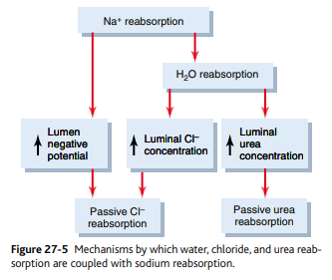

Reabsorption and Secretion Along Different Parts of the Nephron
1. Proximal tubule 65% :
65% of filtered load of H2O and Na+ and slightly lower of filtrated Cl- reabsorbed (Active and passive).
The proximal tubule epithelial cells have
A. Large number of Mitochondria and extensive brush border
B. Extensive labyrinth of intercellular and basal channels.
All these provide extensive membrane surface area for rapid transport of Na & other

Proximal tubule cont.
1. Large fraction of Na with co…transport of amino acid (AA) and glucose(GL)
2. Additional Na transported from lumen into cells by counter transport mechanism that reabsorbed Na and secrete H.
3. In the 1st half of proximal tubule Na is reabsorbed by co…transport with AA , GL and other solute.
In the 2nd half little AA &GL remain to absorbe but large CL absorbed.

Proximal Tubular Reabsorption
- Normally, about 65 percent of the filtered load of sodium and water and a slightly lower percentage of filtered chloride are reabsorbed by the proximal tubule before the filtrate reaches the loops of Henle.
- These percentages can be increased or decreased in different physiologic conditions.
- Proximal Tubules Have a High Capacity for Active and Passive Reabsorption.
- The high capacity of the proximal tubule for reabsorption results from its special cellular characteristics, as shown in Figure 27-6.
- The proximal tubule epithelial cells are highly metabolic and have large numbers of mitochondria to support powerful active transport processes.
- In addition, the proximal tubular cells have an extensive brush border on the luminal (apical) side of the membrane, as well as an extensive labyrinth of intercellular and basal channels, all of which together provide an extensive membrane surface area on the luminal and basolateral sides of the epithelium for rapid transport of sodium ions and other substances.
- The extensive membrane surface of the epithelial brush border is also loaded with protein carrier molecules that transport a large fraction of the sodium ions across the luminal membrane linked by way of the co-transport mechanism with multiple organic nutrients such as amino acids and glucose.
- Additional sodium is transported from the tubular lumen into the cell by counter-transport mechanisms that reabsorb sodium while secreting other substances into the tubular lumen, especially hydrogen ions.
- the secretion of hydrogen ions into the tubular lumen is an important step in the removal of bicarbonate ions from the tubule (by combining H+ with the HCO3 − to form H2 CO3 , which then dissociates into H2 O and CO2 ).
- Although the sodium-potassium ATPase pump provides the major force for reabsorption of sodium, chloride, and water throughout the proximal tubule, there are some differences in the mechanisms by which sodium and chloride are transported through the luminal side of the early and late portions of the proximal tubular membrane.
- In the first half of the proximal tubule, sodium is reabsorbed by co-transport along with glucose, amino acids, and other solutes.
- But in the second half of the proximal tubule, little glucose and amino acids remain to be reabsorbed.
- Instead, sodium is now reabsorbed mainly with chloride ions.
- The second half of the proximal tubule has a relatively high concentration of chloride (around 140 mEq/L) compared with the early proximal tubule (about 105 mEq/L) because when sodium is reabsorbed, it preferentially carries with it glucose, bicarbonate, and organic ions in the early proximal tubule, leaving behind a solution that has a higher concentration of chloride.
- In the second half of the proximal tubule, the higher chloride concentration favors the diffusion of this ion from the tubule lumen through the intercellular junctions into the renal interstitial fluid.
- Smaller amounts of chloride may also be reabsorbed through specific chloride channels in the proximal tubular cell membrane.
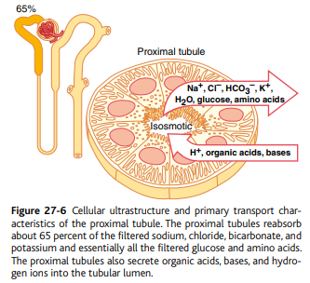
………………………………………………………………………………………………………………………………………………… Concentrations of Solutes Along the Proximal Tubule.
- Figure 27-7 summarizes the changes in concentrations of various solutes along the proximal tubule.
- Although the amount of sodium in the tubular fluid decreases markedly along the proximal tubule, the concentration of sodium (and the total osmolarity) remains relatively constant because water permeability of the proximal tubules is so great that water reabsorption keeps pace with sodium reabsorption.
- Certain organic solutes, such as glucose, amino acids, and bicarbonate, are much more avidly reabsorbed than water, so their concentrations decrease markedly along the length of the proximal tubule.
- Other organic solutes that are less permeant and not actively reabsorbed, such as creatinine, increase their concentration along the proximal tubule.
- The total solute concentration, as reflected by osmolarity, remains essentially the same all along the proximal tubule because of the extremely high permeability of this part of the nephron to water.
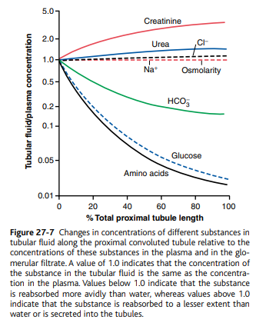
Secretion of Organic Acids and Bases by the Proximal Tubule.
Secretion: organic acids and bases (bile salts, oxalate, urate, catecholamines) .
These are products of metabolism
Secretion: Harmfull drugs(salicylates, penicillin) and PAH

- The proximal tubule is also an important site for secretion of organic acids and bases such as bile salts, oxalate, urate, and catecholamines.
- Many of these substances are the end products of metabolism and must be rapidly removed from the body.
- The secretion of these substances into the proximal tubule plus filtration into the proximal tubule by the glomerular capillaries and the almost total lack of reabsorption by the tubules, all combined, contribute to rapid excretion in the urine.
- In addition to the waste products of metabolism, the kidneys secrete many potentially harmful drugs or toxins directly through the tubular cells into the tubules and rapidly clear these substances from the blood.
- In the case of certain drugs, such as penicillin and salicylates, the rapid clearance by the kidneys creates a problem in maintaining a therapeutically effective drug concentration.
- Another compound that is rapidly secreted by the proximal tubule is para-aminohippuric acid (PAH).
- PAH is secreted so rapidly that the average person can clear about 90 percent of the PAH from the plasma flowing through the kidneys and excrete it in the urine.
- For this reason, the rate of PAH clearance can be used to estimate the renal plasma flow.
………………………………………………………………………………………………………………………………………………
Solute and Water Transport in the Loop of Henle
- U Shape
- Descending limb Thin :Minimal level of metabolism. Highly permeable to H2O & moderate permeable to solutes including urea and Na. 20 percent of filtered water absorbed here.
- Ascending Limb Thin and segments : Impermeable to water. Thick has high level of metabolism and it is the site of action of loop diuretic

2.LOOP OF HENLE 20% of filtered water
a. Descending part of thin segment : High permeable to H2O moderate to salts and urea.
b. Thick segment : 25% filtered loads of NaCl reabsorbed and K+ ,Ca++ , HCO3- , Mg++
(1 Na+ - 2 Cl- - 1K+(co-transporter)), Na -H counter transport, Impermeable to H2O

- The loop of Henle consists of three functionally distinct segments:
- the thin descending segment, the thin ascending segment, and the thick ascending segment.
- The thin descending and thin ascending segments, as their names imply, have thin epithelial membranes with no brush borders, few mitochondria, and minimal levels of metabolic activity (Figure 27-8).
- The descending part of the thin segment is highly permeable to water and moderately permeable to most solutes, including urea and sodium.
- The function of this nephron segment is mainly to allow simple diffusion of substances through its walls.
- About 20 percent of the filtered water is reabsorbed in the loop of Henle, and almost
all of this occurs in the thin descending limb.
- The ascending limb, including both the thin and the thick portions, is virtually impermeable to water, a characteristic that is important for concentrating the urine.
- The thick segment of the loop of Henle, which begins about halfway up the ascending limb, has thick epithelial cells that have high metabolic activity and are capable of active reabsorption of sodium, chloride, and potassium (see Figure 27-8).
- About 25 percent of the filtered loads of sodium, chloride, and potassium are reabsorbed in the loop of Henle, mostly in the thick ascending limb.
- Considerable amounts of other ions, such as calcium, bicarbonate, and magnesium, are also reabsorbed in the thick ascending loop of Henle.
- The thin segment of the ascending limb has a much lower reabsorptive capacity than the thick segment, and the thin descending limb does not reabsorb significant amounts of any of these solutes.
- An important component of solute reabsorption in the thick ascending limb is the sodium-potassium ATPase pump in the epithelial cell basolateral membranes.
- As in the proximal tubule, the reabsorption of other solutes in the thick segment of the ascending loop of Henle is closely linked to the reabsorptive capability of the sodium-potassium ATPase pump, which maintains a low intracellular sodium concentration.
- The low intracellular sodium concentration in turn provides a favorable gradient for movement of sodium from the tubular fluid into the cell.
- In the thick ascending loop, movement of sodium across the luminal membrane is mediated primarily by a 1-sodium, 2-chloride, 1-potassium co-transporter (Figure 27-9).
- This co-transport protein carrier in the luminal membrane uses the potential energy released by downhill diffusion of sodium into the cell to drive the reabsorption of potassium into the cell against a concentration gradient.
- The thick ascending limb of the loop of Henle is the site of action of the powerful “loop” diuretics furosemide, ethacrynic acid, and bumetanide, all of which inhibit the action of the sodium, 2-chloride, potassium co-transporter.
- The thick ascending limb also has a sodium-hydrogen counter-transport mechanism in its luminal cell membrane that mediates sodium reabsorption and hydrogen secretion in this segment (see Figure 27-9).
- There is also significant paracellular reabsorption of cations, such as Mg++, Ca++, Na+, and K+, in the thick ascending limb owing to the slight positive charge of the tubular lumen relative to the interstitial fluid.
- Although the 1-sodium, 2-chloride, 1-potassium co-transporter moves equal amounts of cations and anions into the cell, there is a slight backleak of potassium ions into the lumen, creating a positive charge of about +8 millivolts in the tubular lumen.
- This positive charge forces cations such as Mg++ and Ca++ to diffuse from the tubular lumen through the paracellular space and into the interstitial fluid.
- The thick segment of the ascending loop of Henle is virtually impermeable to water.
- Therefore, most of the water delivered to this segment remains in the tubule despite reabsorption of large amounts of solute.
- The tubular fluid in the ascending limb becomes very dilute as it flows toward the distal tubule, a feature that is important in allowing the kidneys to dilute or concentrate the urine under different conditions.
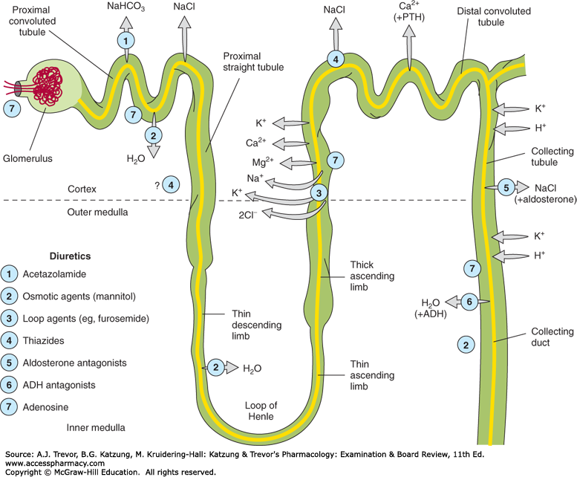
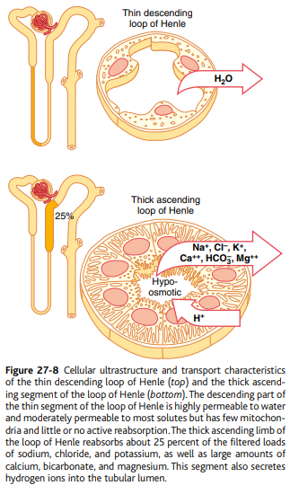
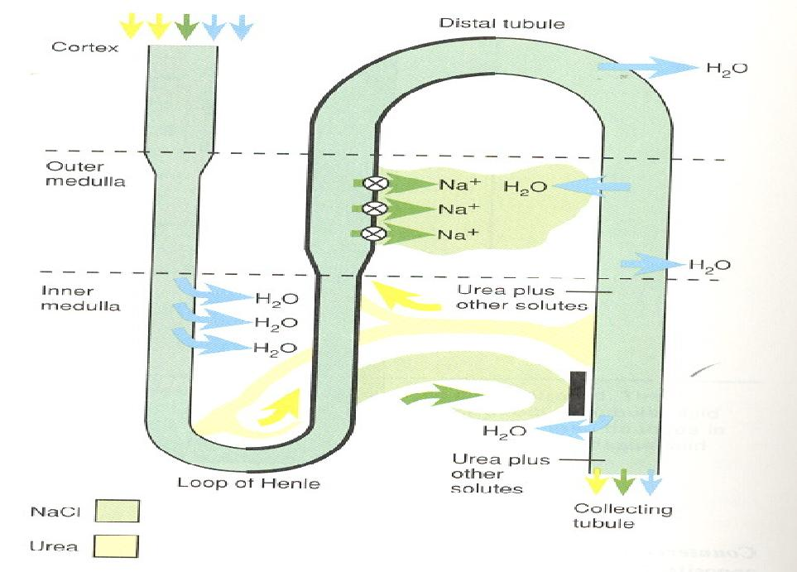

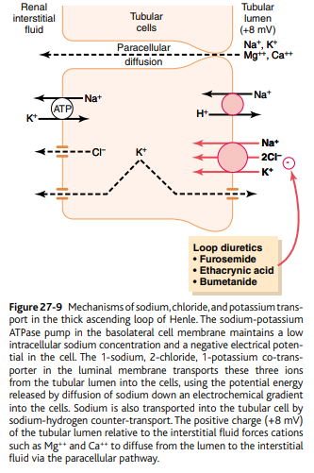

…………………………………………………………………………………………………………………………………………………………..
Distal Tubule
a. Next part(diluting segment) as thick ascending. 5% of filtered load of Nacl absorbed in early distal tubule
b. Late distal &cortical collecting tubule(have similar function) . They are compose of :
A-principle cells: Reab Na and water, and secrete K
( site of action of K sparing diuretics site)
B-Type A Intercalated cells reabsorb,Hco3, H secretion.
Type B Intercalated cells reabsorb, H, secretion Hco3

( Both Intercalated cells can also reabsorb or secrete K)
(Both Intercalated cells play a major role in acid base regulation)
C- Late distal & cortical tubule also are:
-Impermeable to urea
-Na+ reabsorb. by aldosterone and secrete K
- A&B intercalated cells involve in regulation of acid base of body fluid
-H2O permeability controlled by ADH

- The thick segment of the ascending limb of the loop of Henle empties into the distal tubule.
- The first portion of the distal tubule forms the macula densa, a group of closely packed epithelial cells that is part of the juxtaglomerular complex and provides feedback control of GFR and blood flow in this same nephron.
- The next part of the distal tubule is highly convoluted and has many of the same reabsorptive characteristics of the thick segment of the ascending limb of the loop of Henle.
- That is, it avidly reabsorbs most of the ions, including sodium, potassium, and chloride, but is virtually impermeable to water and urea.
- For this reason, it is referred to as the diluting segment because it also dilutes the tubular fluid.
- Approximately 5 percent of the filtered load of sodium chloride is reabsorbed in the early distal tubule.
- The sodium-chloride co-transporter moves sodium chloride from the tubular lumen into the cell, and the sodium-potassium ATPase pump transports sodium out of the cell across the basolateral membrane (Figure 27-10).
- Chloride diffuses out of the cell into the renal interstitial fluid through chloride channels in the basolateral membrane.
- The thiazide diuretics, which are widely used to treat disorders such as hypertension and heart failure, inhibit the sodium-chloride co-transporter.
- Late Distal Tubule and Cortical Collecting Tubule The second half of the distal tubule and the subsequent cortical collecting tubule have similar functional characteristics.
- Anatomically, they are composed of two distinct cell types, the principal cells and intercalated cells (Figure 27-11).
- The principal cells reabsorb sodium and water from the lumen and secrete potassium ions into the lumen.
- The intercalated cells reabsorb potassium ions and secrete hydrogen ions into the tubular lumen.
- Principal Cells Reabsorb Sodium and Secrete Potassium.
- Sodium reabsorption and potassium secretion by the principal cells depend on the activity of a sodium-potassium ATPase pump in each cell’s basolateral membrane (Figure 27-12).
- This pump maintains a low sodium concentration inside the cell and, therefore, favors sodium diffusion into the cell through special channels.
- The secretion of potassium by these cells from the blood into the tubular lumen involves two steps:
- (1) Potassium enters the cell because of the sodium-potassium ATPase pump, which maintains a high intracellular potassium concentration, and then
- (2) once in the cell, potassium diffuses down its concentration gradient across the luminal membrane into the tubular fluid.
- The principal cells are the primary sites of action of the potassium-sparing diuretics, including spironolactone, eplerenone, amiloride, and triamterene.
- Spironolactone and eplerenone are mineralocorticoid receptor antagonists that compete with aldosterone for receptor sites in the principal cells and therefore inhibit the stimulatory effects of aldosterone on sodium reabsorption and potassium secretion.
- Amiloride and triamterene are sodium channel blockers that directly inhibit the entry of sodium into the sodium channels of the luminal membranes and therefore reduce the amount of sodium that can be transported across the basolateral membranes by the sodium-potassium ATPase pump.
- This, in turn, decreases transport of potassium into the cells and ultimately reduces potassium secretion into the tubular fluid.
- For this reason the sodium channel blockers, as well as the aldosterone antagonists, decrease urinary excretion of potassium and act as potassium-sparing diuretics.
- Intercalated Cells Secrete Hydrogen and Reabsorb Bicarbonate and Potassium Ions.
- Hydrogen ion secretion by the intercalated cells is mediated by a hydrogenATPase transporter.
- Hydrogen is generated in this cell by the action of carbonic anhydrase on water and carbon dioxide to form carbonic acid, which then dissociates into hydrogen ions and bicarbonate ions.
- The hydrogen ions are then secreted into the tubular lumen, and for each hydrogen ion secreted, a bicarbonate ion becomes available for reabsorption across the basolateral membrane.
- The intercalated cells can also reabsorb potassium ions.
- The functional characteristics of the late distal tubule and cortical collecting tubule can be summarized as follows:
- 1. The tubular membranes of both segments are almost completely impermeable to urea, similar to the diluting segment of the early distal tubule; thus, almost all the urea that enters these segments passes on through and into the collecting duct to be excreted in the urine, although some reabsorption of urea occurs in the medullary collecting ducts.
- 2. Both the late distal tubule and the cortical collecting tubule segments reabsorb sodium ions, and the rate of reabsorption is controlled by hormones, especially aldosterone.
- At the same time, these segments secrete potassium ions from the peritubular capillary blood into the tubular lumen, a process that is also controlled by aldosterone and by other factors such as the concentration of potassium ions in the body fluids.
- 3. The intercalated cells of these nephron segments avidly secrete hydrogen ions by an active hydrogen-ATPase mechanism.
- This process is different from the secondary active secretion of hydrogen ions by the proximal tubule because it is capable of secreting hydrogen ions against a large concentration gradient, as much as 1000 to 1.
- This is in contrast to the relatively small gradient (4- to 10-fold) for hydrogen ions that can be achieved by secondary active secretion in the proximal tubule. Thus, the intercalated cells play a key role in acid-base regulation of the body fluids.
- 4. The permeability of the late distal tubule and cortical collecting duct to water is controlled by the concentration of ADH, which is also called vasopressin.
- With high levels of ADH, these tubular segments are permeable to water, but in the absence of ADH, they are virtually impermeable to water.
- This special characteristic provides an important mechanism for controlling the degree of dilution or concentration of the urine.
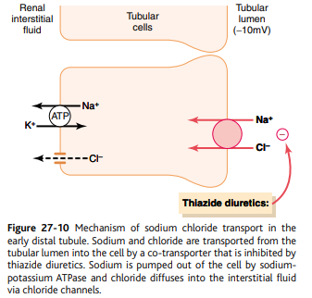

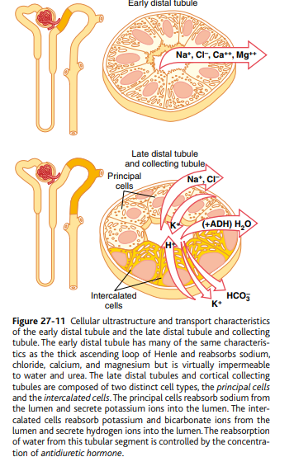
………………………………………………………………………………………………………………………………………..
Medullary Collecting Duct
Reabsorb about 10% of filtered water and Na
Final site for processing the urine
- Sodium reabsorption
- H2O ADH
- Permeable to urea (Can reabsorb urea) to increase osmolarity to form concentrate urine
- H+ secretion

- Although the medullary collecting ducts reabsorb less than 10 percent of the filtered water and sodium, they are the final site for processing the urine and, therefore, play an extremely important role in determining the final urine output of water and solutes.
- The epithelial cells of the collecting ducts are nearly cuboidal in shape with smooth surfaces and relatively few mitochondria (Figure 27-13).
- Special characteristics of this tubular segment are as follows:
- 1. The permeability of the medullary collecting duct to water is controlled by the level of ADH.
- With high levels of ADH, water is avidly reabsorbed into the medullary interstitium, thereby reducing the urine volume and concentrating most of the solutes in the urine.
- 2. Unlike the cortical collecting tubule, the medullary collecting duct is permeable to urea and there are special urea transporters that facilitate urea diffusion across the luminal and basolateral membranes.
- Therefore, some of the tubular urea is reabsorbed into the medullary interstitium, helping to raise the osmolality in this region of the kidneys and contributing to the kidneys’ overall ability to form concentrated urine.
- The medullary collecting duct is capable of secreting hydrogen ions against a large concentration gradient, as also occurs in the cortical collecting tubule.
- Thus, the medullary collecting duct also plays a key role in regulating acid-base balance.
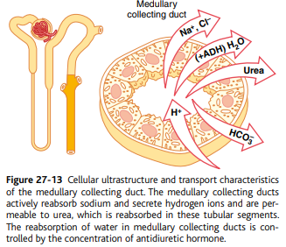
Summary of Concentrations of Different Solutes in the Different Tubular Segments
- Whether a solute will become concentrated in the tubular fluid is determined by the relative degree of reabsorption of that solute versus the reabsorption of water.
- If a greater percentage of water is reabsorbed, the substance becomes more concentrated.
- If a greater percentage of the solute is reabsorbed, the substance becomes more diluted.
- Figure 27-14 shows the degree of concentration of several substances in the different tubular segments.
- All the values in this figure represent the tubular fluid concentration divided by the plasma concentration of a substance.
- If plasma concentration of the substance is assumed to be constant, any change in the ratio of tubular fluid/plasma concentration rate reflects changes in tubular fluid concentration.
- As the filtrate moves along the tubular system, the concentration rises to progressively greater than 1.0 if more water is reabsorbed than solute, or if there has been a net secretion of the solute into the tubular fluid.
- If the concentration ratio becomes progressively less than 1.0, this means that relatively more solute has been reabsorbed than water.
- The substances represented at the top of Figure 27-14, such as creatinine, become highly concentrated in the urine.
- In general, these substances are not needed by the body, and the kidneys have become adapted to reabsorb them only slightly or not at all, or even to secrete them into the tubules, thereby excreting especially great quantities into the urine.
- Conversely, the substances represented toward the bottom of the figure, such as glucose and amino acids, are all strongly reabsorbed; these are all substances that the body needs to conserve, and almost none of them are lost in the urine.
- Tubular Fluid/Plasma Inulin Concentration Ratio Can Be Used to Measure Water Reabsorption by the Renal Tubules.
- Inulin, a polysaccharide used to measure GFR, is not reabsorbed or secreted by the renal tubules.
- Changes in inulin concentration at different points along the renal tubule, therefore, reflect changes in the amount of water present in the tubular fluid.
- For example, the tubular fluid/plasma concentration ratio for inulin rises to about 3.0 at the end of the proximal tubules, indicating that inulin concentration in the tubular fluid is three times greater than in the plasma and in the glomerular filtrate.
- Because inulin is not secreted or reabsorbed from the tubules, a tubular fluid/plasma concentration ratio of 3.0 means that only one third of the water that was filtered remains in the renal tubule and that two thirds of the filtered water has been reabsorbed as the fluid passes through the proximal tubule.
- At the end of the collecting ducts, the tubular fluid/plasma inulin concentration ratio rises to about 125 (see Figure 27-14), indicating that only 1/125 of the filtered water remains in the tubule and that more than 99% has been reabsorbed.
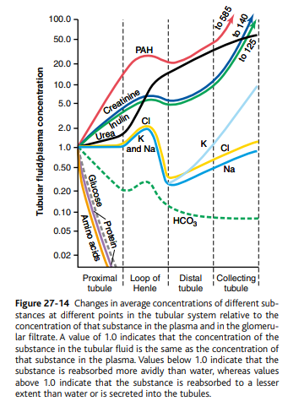

Questions

- The renal transport maximum ™ for a substance is :

A: the maximum rate at which it can be reabsorbed or secreted by the tubules.
- Transepetheilial transport of a substance include all of the following processes EXCEPT :

A: transport of a substance through para cellular way.

- sodium is transported up its electrochemical gradient in the:

A: basolateral membrane of the proximal tubule.

- Inulin is used has the same rate of GFR beacuse?

A: it is filtered only .

- ADH is stimulated and it is found to be of 5 folds increase, the infiltrate has the lowest
osmolarity in:

A: first part of the distal tubule.

- The primary function of the descending loop of Henle in the kidney is?

a. Reabsorption of sodium ions
b. Reabsoption of water by osmosis
c. Secretion of hydrogen ions
d. Secretion of potassium ions

- ADH has which of the following effects on the distal convoluted tubule?
a. Decrease water re-absorption
b. Increase water re-absorption
c. Decrease the concentration of urine
d. Increase the urine volume

- People with diabetes mellitus have glycosuria because:
a. The plasma glucose concentration is greater than the renal plasma threshold
b. The plasma glucose concentration is below 180 mg/100 ml
c. They have less number (Na/Glucose co-transport) protein carrier
d. The reabsorption of glucose in proximal tubule is deficits

- The percentage of filtered sodium that is subsequently reabsorbed back into the plasma in the renal tubules is 99.5%. The majority of this sodium reabsorption takes place in the:
a. descending loop of henli
b. ascending loop of henli
c. distal tubule
d. collecting duct
e. Proximal tubule.
- Which of the following is wrong regarding glucose reabsorption?

A:90% SGLT-1

- What's wrong regarding glucose reabsorbtion?

a.secondary active transport on luminal side
b. passive facilitated diffusion on basolateral membrane 13
c. bulk flow from interstitium
d.ultrafiltration from interstitium
e. majority of glucose is reabsorbed via SGLT1

- Which of the following is actively secreted in the kidney tubules?

A: H+ and potassium

- Which of the followings is NOT permeable to water even in the presence of ADH ?

- Ascending loop of Henle

- The filtrated renal fluid has relatively the same concentration of……………….in the early and late parts of the proximal tubules
- Na

- Healthy student, was deprived of water for two days, ADH plasma concentration was 5 times greater than normal. Which part of tubule would have the lowest tubular fluid osmolarity? –

early distal tubule

- Which of the followings reabsorbed by secondary active process and passive facilitated diffusion ?
- Glucose

