Al Balqa App[lied University
College of Medicine

Lecture 9
Entamoeba histolytica

Dr. Hala Al Daghistani

- Entamoeba histolytica cysts are present only in the lumen of the colon
- The cyst may contain a glycogen vacuole and chromatoid bodies with characteristic rounded ends.
- Nuclear division occurs within the cyst, resulting in a quadrinucleated cyst, and the chromatoid bodies and glycogen vacuoles disappear.
- Diagnosis in most cases rests on the characteristics of the cyst, as trophozoites usually appear only in diarrheic feces in active cases and survive for only a few hours.
- The ameboid trophozoite is the only form present in tissues. The cytoplasm has two zones, a hyaline outer margin and a granular inner region that may contain red blood cells but ordinarily contains no bacteria.
- The nuclear membrane surrounded a small central body ( karyosome).

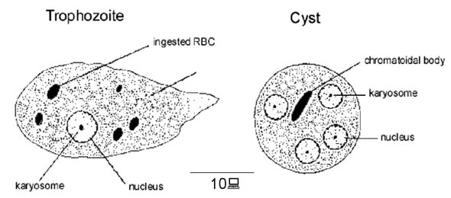

Pathology and Pathogenesis of
Invasive Amebiasis
- It is estimated that approximately 50 million cases of invasive disease occur each year.
- Disease results when the trophozoites of E. histolytica invade the intestinal epithelium and form discrete ulcers with a pinhead-sized center and raised edges, from which mucus, necrotic cells, and amebae pass.
- The trophozoites multiply and accumulate above the muscularis mucosae.
- Rapid lateral spread of the multiplying amebae follows, producing the characteristic “flask-shaped” ulcer of primary amebiasis: a small point of entry, leading via a narrow neck through the mucosa into an expanded necrotic area in the submucosa.

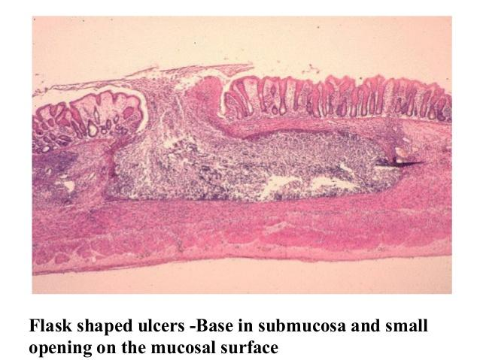

- Subsequent spread may occur, undermining large areas of the mucosal surface.
- Trophozoites may penetrate the muscle layers and occasionally the serosa, leading to perforation into the peritoneal cavity.
- Subsequent enlargement of the necrotic area produces gross changes in the ulcer, which may develop shaggy over hanging edges, secondary bacterial invasion, and accumulation of neutrophilic leukocytes.
- Secondary intestinal lesions may develop as extensions from the primary lesion (usually in the cecum, appendix, or nearby portion of the ascending colon).
- The sigmoid colon and rectum are favored sites for later lesions.
- An amebic inflammatory or granulomatous tumor-like mass (ameboma) may form on the intestinal wall, sometimes growing sufficiently large to block the lumen.

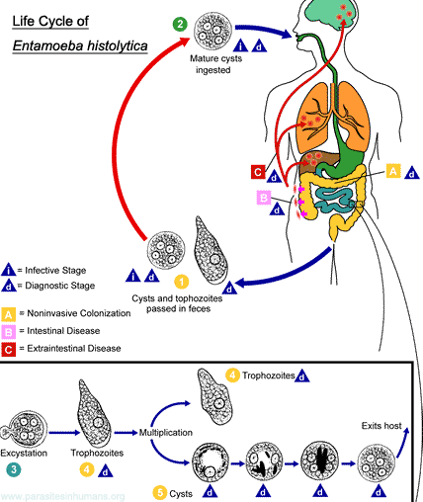

Factors that determine invasion of amebae include the following:
- the number of amebae ingested
- the pathogenic capacity of the parasite strain
- host factors such as gut motility, immune competence, and the presence of suitable enteric bacteria that enhance amebic growth.

Correct and prompt identification of the Entamoeba species remains a critical problem.
- Trophozoites, especially with red blood cells in the cytoplasm, found in liquid or semiformed stools are pathognomonic.
- Symptoms vary greatly depending on the site and intensity of lesions.
- Extreme abdominal tenderness
- Fulminating Dysentery
- Dehydration
- Incapacitation occur in serious disease.

- In less acute disease, onset of symptoms is usually gradual and often includes episodes of diarrhea, abdominal cramps, nausea and vomiting, and an urgent desire to defecate.
- More frequently, there will be weeks of cramps and general discomfort, loss of appetite, and weight loss, with general malaise.
- Symptoms may develop within 4 days of exposure, may occur up to a year later, or may never occur.
- Extraintestinal infection is metastatic and rarely occurs. By far the most common form is amebic hepatitis or liver abscess (4% or more of clinical infections).
- A true amebic abscess is progressive, nonsuppurative (unless secondarily infected), and destructive. The contents are necrotic and bacteriologically sterile, active amebae being confined to the walls.
- A characteristic “anchovy paste” is produced in the abscess and seen on surgical drainage.

- Rarely, amebic abscesses occur elsewhere (eg, lung, brain, spleen, or draining through the body wall). Any organ or tissue in contact with active trophozoites may become a site of invasion and abscess.

OTHER INTESTINAL AMEBAE
- Invasive or pathogenic E. histolytica is now considered a species distinct from the more common nonpathogenic commensal species
- Entamoeba dispar and the related E moshkovskii are differentiated by isoenzyme and genetic analyses.
- Entamoeba histolytica must be distinguished not only from all E. dispar and E moshkovskii but also from four other ameba-like organisms:
(1) Entamoeba coli, which is very common
(2) Dientamoeba fragilis (a flagellate), the only intestinal parasite other than E. histolytica that has been suspected of causing diarrhea and dyspepsia but is not invasive
(3) Iodamoeba bütschlii
(4) Endolimax nana.

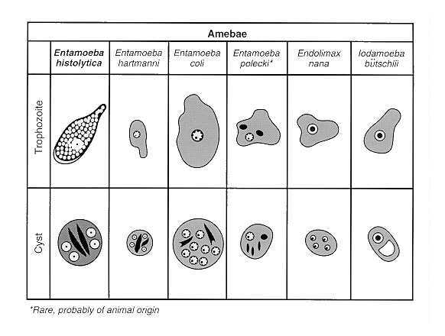

Diagnosis
- Enzyme immunoassay (EIA) kits are available commercially for serodiagnosis of amebiasis when stools are often negative.
- EIA tests to detect amebic antigen in the stool are also sensitive and specific for E histolytica and can distinguish between pathogenic and nonpathogenic infections.

Epidemiology
- Entamoeba histolytica occurs worldwide, mostly in developing countries where sanitation and hygiene are poor.
- Infections are transmitted via the fecal–oral route; cysts are usually ingested through contaminated water, vegetables, and food; flies have also been linked to transmission in areas of fecal pollution.
- Most infections are asymptomatic, with the asymptomatic cyst passes being a source of contamination for outbreaks where sewage leaks into the water supply or breakdown of sanitation occurs (as in mental, geriatric, or children’s institutions or prisons).

