CNS Embryology sheet #1

Anatomy lec11 (18th of Feb, 2020)

Written by: Hadeel Tawalbeh

Edited by: Roa’a Saed Thaher

“Writers” quick revision (skip it if you’re not interested):

Human developmental timeline:

9 months (280 days)

3rd trimester

2nd trimester

1st trimester

Fetal period

Embryonic period

Human development by weeks:

1. Week 1: Fertilization and blastocyst formation.

A fluid develops inside it

Fertilization Fertilization

cleavage

blastocyst Fertilization

Morula

Implantation starts

syncyriotrophoblast

cytotrophoblast

Embryoblast

(becomes the embryo)

Trophoblast

(becomes the placenta)

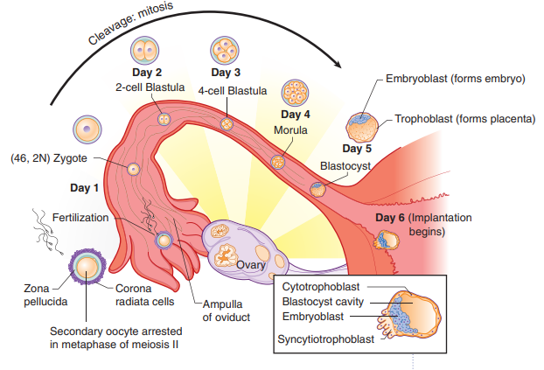

1. 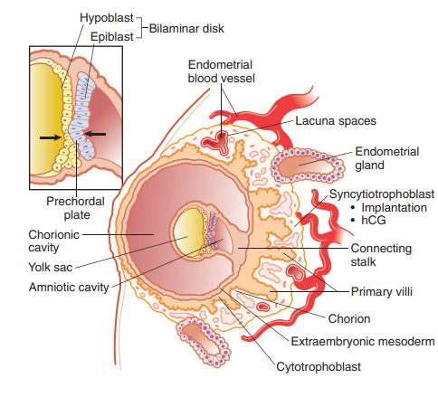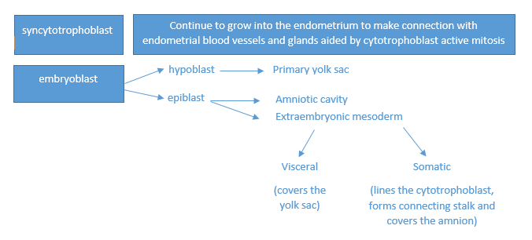Week 2: Implantation + bilaminar disk formation:

The fusion of the hypoblast and the epiblast

(the future mouth)

1. Week 3: Trilaminar disk (gastrulation).

mesoderm

Primitive streak

(in the epiblast)

p

endoderm

Ectoderm

On!

neuroectoderm

Neural

crest

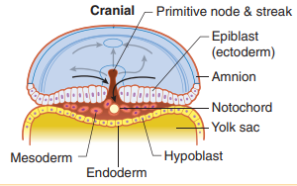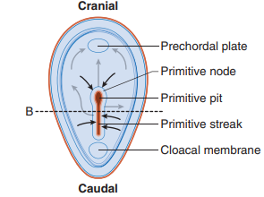

Sources: step1-Kaplan anatomy/ professor abd al-ameer slides/ hadeel’s own notes.

**Now, let’s start our lecture for today**

**Development of the CNS**

Clinical notes:

*neural plate forms the whole nervous system, an injury to it will result in injury in the nervous system for sure

*Neural tube injury effects only the CNS not the PNS

Neural plate

Neural tube

forms the PNS and the ANS

the ventricles and spinal canal

Neural canal

Neural crest

forms the CNS

Okay, let’s see how this happens:

After the formation of the trilaminar disk and the notochord (the ectoderm activated by notochord), the **Neurulation** step starts:

1. The ectoderm is a one layer of the ectodermal cells; the notochord excites the cells of the ectoderm to proliferate (still one layer of cells).

1. this one layer of proliferative cells is bigger than the disk itself resulting in folding of the disk above the notochord.
2. forming the neural plate > the neural plate edges come closer and closer to one another, forming a groove In between called the neural groove, those folds will eventually fuse together forming neural tube (will become neural canal later)
3. Neural tube forms and separate from the above ectoderm (the primordium of epidermis) in the third week
4. During the neural tube formation cells on the crest of the neural folds (neural crest) migrate laterally
5. Neural crest cells form the ganglia in the PNS and other tissue

-CNS developed from neural tube.

-Neural canal : the origin of spaces or champers of CNS (spinal canal & ventricles ).

**Contribution of the Neural Crest:**

The origin of the all structures of PNS from neural crest

ونضيف لها اي شي الأصل تبعه من الجهاز العصبي مثل :

Medulla of suprarenal gland (origin is postganglionic sympathetic neurons ) , melanocytes ,meninges (as a C.T)& all the mentioned structures below.

* Sensory neurons of the spinal nerves, cranial nerves (V, VII, IX, and X)
* Autonomic ganglia
* Sheathing cells of the peripheral nervous system
* Pigment cells of the dermis (Melanocytes)
* Muscles, connective tissues, and bones of pharyngeal arch origin. That why it’s believed to be special m. and has special fibers.
* Suprarenal medulla (treated as a postganglionic sympathetic neuron, its origin is from nerves actually) that receives pre-ganglionic neurons
* Meninges (coverings) of the brain and spinal cord (extra: pia matter and the arachnoid matter)

Sometimes there’re some cells in the adults that is not a part of the nervous system, but still originated from the neural crest as they have undifferentiated mother cells that can form different types of cells and so. (Don’t bother yourself with slide 7 table)

**By the end of the 4th week:**

1. Rostral neuropore closed and forebrain develop (25 day)
2. Caudal neuropore closed and caudal eminence develop (27 day)

#the nervous system is one of the earliest systems to develop followed by the cardiovascular.

#in this stage it appears to be the one of the largest structures in the developing embryo.

**Development of the Spinal Cord &** **Histogenesis of the Neural Tube**

Neural tube caudal to the 4th somites forms SC #recall, somites develops from the paraxial mesoderm > they made elevations externally and gradually increases in number

* Cells starts to proliferate, forming multiple layers and differentiate into different cell layers:

1. The mantle layer has most of cells/neurons > gray matter

# The mantel layer cells will start differentiation in both sides (rt and lt) them it’ll fold to eventually take the adult shape separating the sensory fibers from the motor fibers. It has two types of cells

The spinal cord and the brain develop at the same time with almost the same mechanism

1. Neuroblasts
   1. Motor neurons (somatic & Autonomic)
   2. Interneurons
2. Gliablasts (invade both mantle and marginal layers)
   1. Astrocytes

Microglia originates from bone marrow.

* 1. Oligodendrocytes > Produce myelin sheath

1. Marginal> white matter

# The marginal layer will start getting outside driven by the sensory nerves fibers development, nerves axons and the tracts until it surrounds the mantel layer.

1. The ependymal cells layer is one cell thick

# some cells will migrate to mantle layer called blast cells, the Remaining cells will make ependymal cells.

#The cell bodies of the motor neurons originate from the central nervous system whereas those of the sensory originate from the neural crest in the PNS

#All the interneurons and the dendrites are inside (not really understand what the doctor means) ….and the glioblasts makes glial cells.

#Someone asked if all the motor neurons located in the CNS and if there’re some exceptions: the doctor said: the postganglionic neurons (their origin is from the neural tube); their myelin sheathes from the neural crest.

**Regions of the Spinal Cord**

* Ependyma
* Marginal layer
* Roof and floor plates # Roof and floor plates: they’ll form the post. sulcus and ant. Fissure due to the otherward growth of the alar plates that narrows the space in between
* Sulcus limitans
* Mantle layer

Dorsal horn

* + Alar plates
    - dorsal gray columns
    - sensory input
    - Internuncials, Commissures, Tract fibers
* Thickening forms dorsal septum

ventral horn + lateral horn

* Basal plates – ventral gray columns
  + - Somatic & visceral motor neurons
* Thickening forms ventral median fissure

**Neural Tube Defects-Spina bifida:**

results from failure of the neural tube to close in the vertebral column. It has many types:

1. Spina bifida occulta
   * Defect in vertebral arch

– L5‐S1

* + No clinical symptoms

1. Spina bifida cystica
   * With meningocele
     + 1/1000
     + Sac contains meninges & CSF
   * With meningomyelocele
     + 2‐4/1000
     + Sac contains spinal cord and/or nerve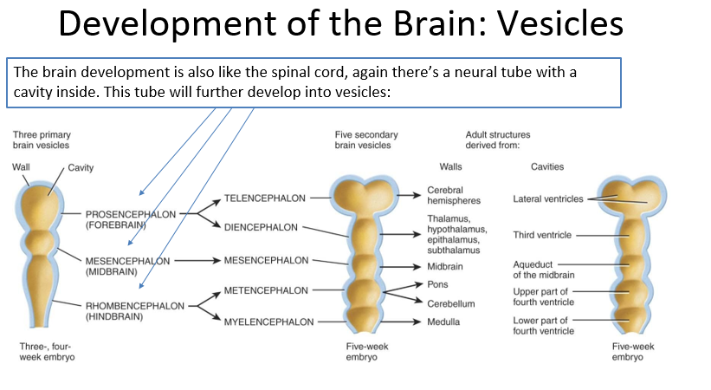s & Neurological deficits

Someone asked if the corpus callosum develops from the telencephalon, the doctor answered yes…he also said the basal nuclei develops there as well( all things other than diencephalon ).

-Prosencephalon 🡪 The most rostral.

-The doctor mentioned all this picture.

**Brain Flexures (folding in the brain sue to rapid growth)**

* Happens due to the rapid growth of the brain
  + Midbrain flexure

CERVICAL FLEXURE:

- The most caudal one

-ventrally oriented

* + - Ventrally
  + Cervical flexure
    - Between hindbrain & SC
    - Ventrally
  + Pontine flexure
    - Between metencephalon & myelencephalon
    - Dorsally (backward flexion)

Cervical 🡪 Pontine 🡪 Midbrain

Those flexures make the brain looks like S shape

**Myelencephalon**

# It’s a continuation to the spinal cord that has a central canal surrounded by aneural tube. the neural plates cells will proliferate and then differentiate making the alar and the basal plates those plates will extends in both the brain and the spinal cord. **We can divide it into:**

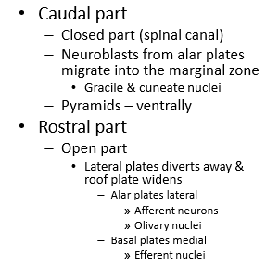

**Notes:**

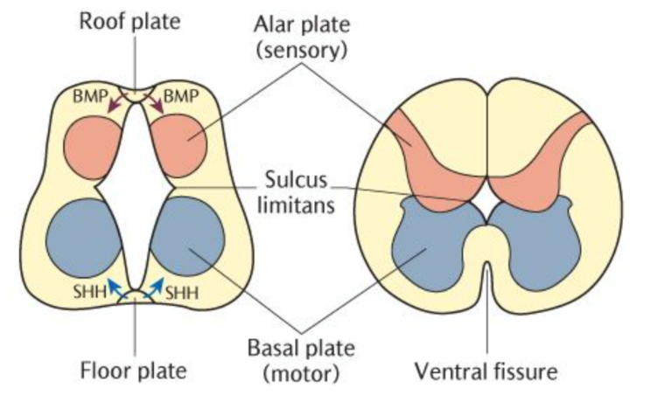# Along with The median sulcus (++ventrolateral and posterolateral sulci), there’s an embryological sulcus located lateral to the median sulcus. It develops between the alar and the basal plates or between the motor nuclei and the basal nuclei. this sulcus is called The sulcus limitans.

# The gracile & cuneate nuclei are the second order neurons of the gracile & cuneate fascicle presents dorsally in the closed part of the medulla oblongata or diencephalon in this case. Anteriorly the pyramids will be formed .

Extra:

* 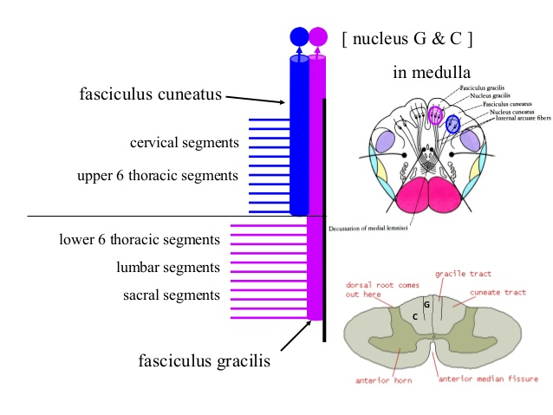The **gracile** fasciculus carries sensory information from the lower half of the body entering the spinal cord at the lumbar level.
* The **cuneate** fasciculus carries sensory information from the upper half of the body (upper limbs, trunk, and neck) entering the spinal cord at the cervical level

# Regard the dorsal part of the medulla oblongata, the lateral migration of the alar cells describes sth we’ve discussed in the previous lecture.

# What is the most lateral structures of the rhomboid fossa? (the doctor asked then)? The vestibular area with the vestibular nuclei

# Alar folds’ migration is also responsible for olive nuclei formation (those nuclei located mostly ventral and lateral compared to the pyramids).

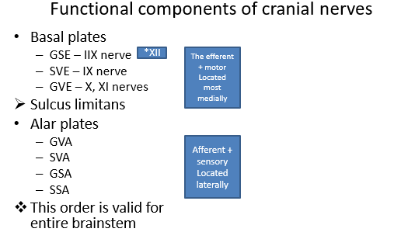

#Compared to the spinal cord which is simpler divided into ant. motor horn and post. sensory horn.

#In the brainstem, the fibers are further differentiated into different types.

This pattern is implied in pons and the midbrain

#The basal nuclei form the efferent fibers, e.g.: basal trigone and hypoglossal trigone. It’ll differentiate into:

1. GSE> from the midline towards the lateral side.

e.g: most of the hypoglossal n. > innervates tongue skeletal m.

1. GVE> dorsal vagal nucleus (just lateral to the hypoglossal n.)
2. SVE > IX & X (together they form the ambiguous nucleus) it’s located almost at the same level to others, but more posteriorly. It might also lock lateral to others with time.

#The sulcus limitans is still be seen the rhomboid fossa.

# Regarding the alar plate: we have

* 1. GVA & SVA: together they make the nucleus solitaires (located just lateral to motor nuclei)
  2. GSA: a group of nuclei (the largest) that are all related the trigeminal n. “the sensory nuclei of the trigeminal n.” here in the medulla oblongata we have the one ascends superiorly from the spinal cord, called spinal sensory nucleolus of the trigeminal n.

وهي مرادفة ل substantia glentinosa in the spinal cord

* 1. SSA: the vestibulocochlear nuclei (6-8 nuclei or so) in the vestibular area (located in the most lateral part of the rhomboid fossa as we previously mentioned)

#The GSE> most medially located whereas the SSA > most laterally located

#One’s can conclude: there’re different relations between the different nuclei in the medulla 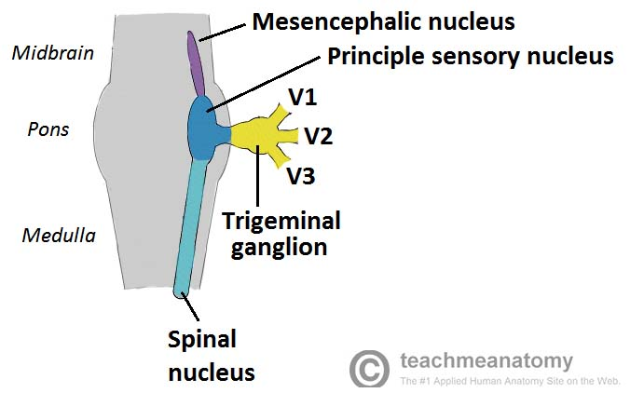oblongata due to the embryological origin.

**Metencephalon**

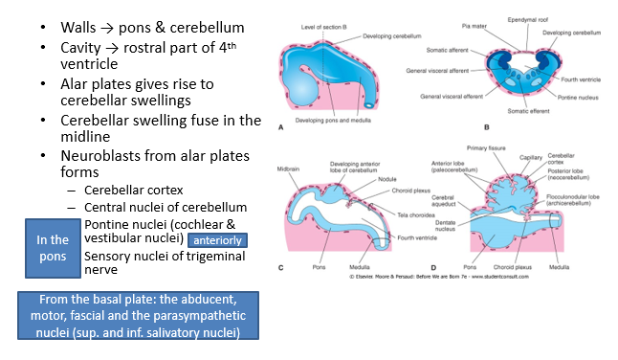#The Metencephalon forms both: the pons (ant.) & cerebellum (post.). The cerebellum is connected to the pons through the cerebellum peduncles that forms the lateral walls of the 4th ventricle.

#The pons development is very similar to the opened part of the medulla oblongata, but with different nuclei.

#The cerebellum will form from the edges of the opened part in which there’re will be proliferation and differentiation of the cells on both sides that eventually will come closer to each other forming the cerebellar hemisphere. the nuclei of the cerebellum are found in both sides as well.

#Then the neuroblasts will differentiate and the migrates toward the periphery forming the cerebellar gray matter/cerebellar cortex (like the gray matter of the cerebrum)> their fibers tend to go to the cerebrum mostly. It’s a part from the motor system. Don’t forget

#The cerebellar nuclei are all originated from the alar plate when it migrates towards the center of the cerebellar white matter

**Notes:**

# Like the medulla oblongata, there are some nuclei: abducent (GSE), facial and trigeminal (as a motor nuclei) along with some parasympathetic nuclei (sup. salivatory nucleus ) all originate from basal plate .

# Abducent n. located most medially in the pons (the ventricles tends to have almost the same organization. In this example the abducent n. is very similar to the location of the hypoglossal n.)

#The vestibular nuclei are spreaded between the pons and the medulla oblongata occupying the lateral most position of the rhomboid fossa.

The End ☺