CVS Physiology Sheet
(Blood Pressure 2-10-2019)
By Saeed Karajah
Corrections : http://bit.ly/2MZDlSv
Pressure in physics is a force present in our bodies mainly to keep the blood flowing because without blood flow we can’t exist
Types of Blood Pressure
1- Systolic BP
*Is the pressure generated by the LV and is present in the LV, aorta and large arteries (during the systolic period)
*During the systole the aortic valve is open so the LV, Aorta and large arteries act as a single chamber. That’s why when we measure the systemic pressure we do so in the brachial artery (although we are not directly measuring it in the LV or Aorta but because the brachial artery is at their same level the pressure value measured is representative of the pressure value in them, with a small negligible difference of about 1 or 2 mmHG).
Ex: when the blood pressure is 120mmhg in the upper arm it will be 121-122 in the LV.
*This difference of about 1-2 mmHg is large enough to create a gradient for blood flow but small enough that we can use it to predict systemic pressure.

2- Diastolic BP
*the pressure that’s present in the aorta and the large arteries during the diastolic period, at this particular moment there is no pressure in the LV and RV because the ventricles are resting = relaxed, (there could be 1-2 mmgh of pressure due to the remaining blood in the ventricles but it’s also negligible
3- Pulse pressure
*the difference between the systolic and diastolic pressures, normally it’s between 30-50 mmhg , it’s significantly increased in exercise & in valvular disease (like aortic incompetence)
4- Mean arterial BP
*It’s the average pressure present in the cardiovascular system during the cardiac cycle
Ex: if the BP is 120/80, the average of these numbers (80 + 81 + 82 +……+ 120) is the mean arterial BP
*it’s not the summation of 120+80 divided by 2 because the diastolic period is longer than the systolic period so mean arterial pressure is closer to the diastolic value
*the correct way to calculate it is (Mean arterial BP = diastolic pressure + 1/3 pulse pressure) so in this case it’s about 93 give or take

5- Circulatory filling pressure
*it’s the pressure present in the cardiovascular system if the blood flow stops (no heart beat), so it’s basically the weight of the blood in the vessels
*it’s very important for the regulation of venous return which is in turn very important for the regulation of the cardiac output
6- Central venous pressure
*it’s the pressure present in the right atrium because it’s the center of the venous blood (the blood coming from the superior and inferior vena cava ends up in the LA), so that is why we call it central venous pressure.
*normally after the atrium contracts the pressure will be zero, because all the blood flows into the ventricles but in practice it could be 1,2,3,4,5 mmhg and can be increased in exercise (physiologically).
Note: physiologically means in normal conditions without any pathology involved
*however in pathologic conditions like heart failure (we will talk more about this in the coming lectures), the atrium is unable to fully pump the blood into the right ventricle so its pressure will increase, so in patients with heart failure we use a catheter to measure the pressure in the right atrium because it is a clinical indication of the progression of the disease, but in this particular case we use a water based manometer rather than a mercury based one because the change in pressure will be very small and it is better visualized in a water manometer because the change in the water column will be more significant (remember that 1mmhg in the mercury manometer = 13.6 mmh2o in the water manometer)
*in old people an increased RA pressure value indicates hear failure or a heart problem most of the time.
7- Reference point for BP
*the reference point for blood pressure is the right atrium at the level of the tricuspid (see the diagram below)
*at this point any change in the body’s position won’t affect the pressure value
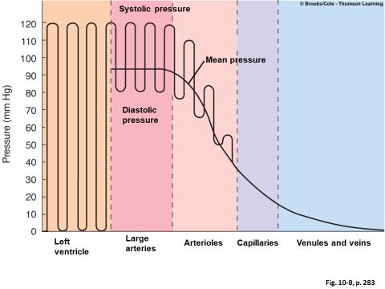
*The previous picture demonstrates the fluctuations in pressure in the different parts of the CVS
*Notice the mean pressure line
Hydrostatic pressure
*we measure the blood pressure in the upper arm because it’s at the level of the heart thus gravity won’t affect the pressure reading in the brachial artery
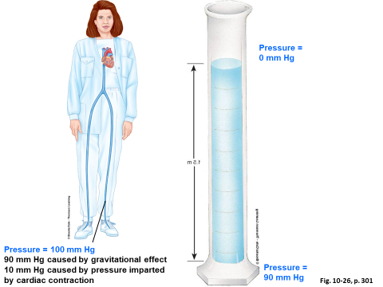
*if we look at this picture the surface of the tube has a pressure of 0 (in reality it’s equal to pressure of the atmosphere but we neglect it), if we go down it increases, if we go up it decreases
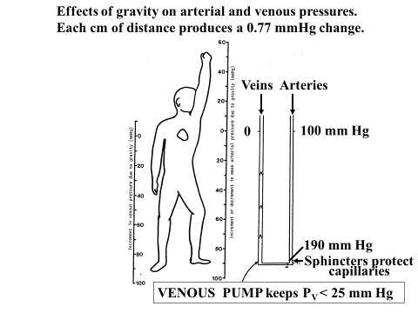
*Look at this picture, the arterial pressure is 100mmhg at the level of the heart because that is where the pressure is generated (in the LV), anything above is less than 100, anything below is more than 100 (this is for arterial pressure)
*if you measure the pressure in the arm of a patient who is sitting while his arm is raised, the reading will be less than if it was down (because if you raise your arm the brachial artery will now be higher than the level of the heart so according to what we have learned it should be less than the systemic pressure (which is equal to100mmg in the picture))
*For the venous BP, it’s 0 at the level of the heart (because it is 0 in the RA), anything above is less anything below is more

*The blood pressure in the sagittal sinus (in the skull) while we are standing is negative but when we are in a supine position now the effect of gravity is equal so it’s pressure won’t be negative and it’ll be more than that in the RA so the blood can flow from the skull to the RA
*This is the effect of gravity (hydrostatic pressure), for this reason with any change in position the reading will change in veins and arteries
CLINICAL METHOD FOR MEASURING BP
A.SYSTOLIC BP
B.DIASTOLIC BP
C.MEAN ARTERIAL BP
We have two methods of measuring blood pressure
1- PALPATION METHOD
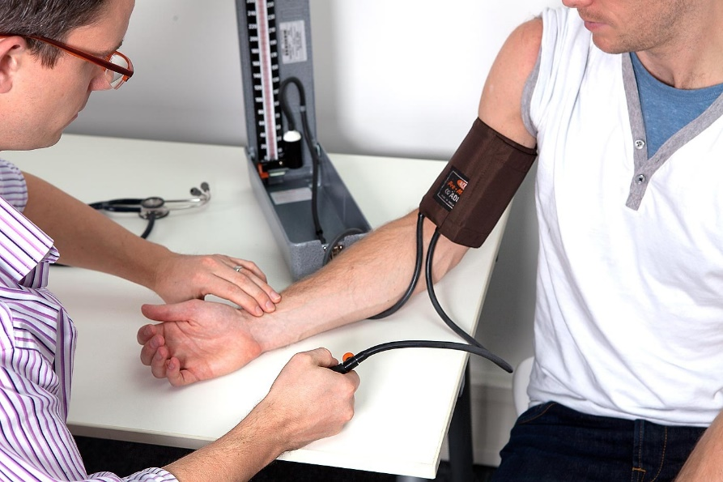
*In this method we basically position the cuff at the upper arm and we use our fingers to feel the pulse in the radial artery the cuff so we don’t use a stethoscope, this method only gives us the systolic pressure
*we inflate the bag which will apply pressure on the brachial artery, as you increase the pressure in the cuff the blood flow in the radial artery will decrease until it stops, at this point the pressure in the cuff is more than the systemic pressure, all you have to do now is to slowly decrease the pressure in the cuff while observing the pressure reading and feeling for a pulse, when you do feel the pulse again the reading will be the systolic pressure
*ex: let’s suppose that the systemic pressure is 120, if the pressure in the cuff is 119 or below the flow will continue and you can feel the pulse, if the pressure is 120 or more the flow will stop and you won’t feel the pulse.
2- AUSCULTATORY METHOD (KORTKOFF SOUNDS)
*this method is similar in principle to the previous one but what makes it different is that we use a stethoscope so we hear the pulse rather than feel it and with this method we can measure both the systolic and diastolic pressures (and from these you can calculate the pulse pressure and the mean arterial pressure)
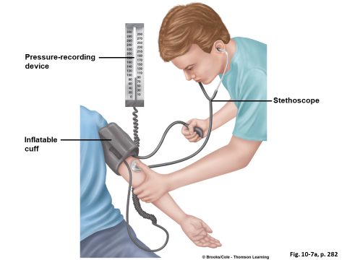
*first we put the cuff on the upper arm and raise the pressure above the systolic pressure to cut off the blood flow in the brachial artery, next we put the stethoscope on the brachial artery just below the cuff, not on the radial artery nor directly under the cuff because if we do so the cuff will apply pressure on the stethoscope and we won’t be able to hear the pulse clearly, now if you should hear no sound in the stethoscope, so next you decrease the pressure gradually, once the pressure in the cuff is less than that in the artery the blood will start to flow, but because the lumen of artery is not completely open the flow is turbulent and we will hear a sound with each beat of the heart, so the reading at this point (when we hear the sound of the first beat) is the systolic pressure, now we keep decreasing the pressure, the sound will now increase because we are opening the artery more and more and the accumulated blood will try to rush through it (the flow is still turbulent), but as we keep decreasing the pressure, the sound will gradually decrease until it fades completely, this means that the flow is now laminar and not turbulent, so at this point (right when the sound is gone) we have our diastolic pressure reading.
*Turbulent flow -> sound | Laminar flow -> no sound
To summarize
Step 1: when the pressure in the cuff is more than in the artery = no sound
Step 2: the first sound appears, this is the systolic pressure
Step 3: the sound will increase
Step 4: the sound will decrease
Step 5: the sound will disappear, this is the diastolic pressure

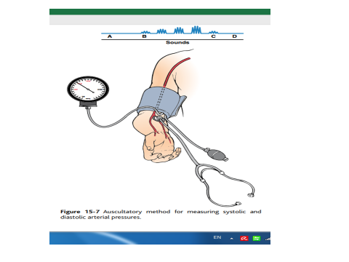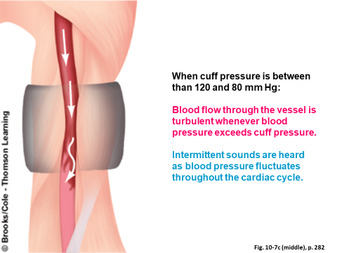
*The sounds we hear are called KORTKOFF SOUNDS because he is the scientist that described this method of measuring blood pressure
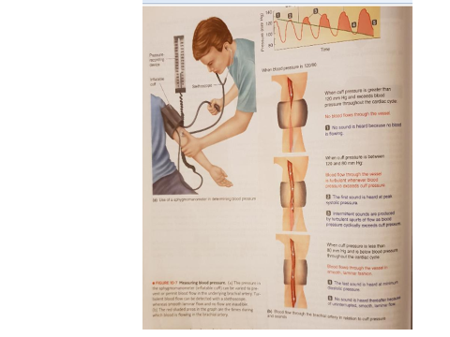
Students asked the professor: why do we consider the pressure at the point at which there is no sound (laminar flow) to be equal to the diastolic pressure
The professor’s answer was not complete (min 37:48)

HEART SOUNDS
1- LUB
*The first heart sound is caused by the closure of the AV valves (mitral and tricuspid)
2- DUP
*The second heart sound is caused by the closure of the semilunar valves
3- ?
*When you hear the heart sounds, which one is louder? the DUP, why ?
Because the intensity of the heart sounds are different
- The intensity of the first sound is 20+
- The intensity of the second sound is 30-40
Why ?
If you remember the anatomy of the valves, the AV valves are relatively wide and the pressure gradient between their 2 surfaces is “minimum“
While the semilunar valves have a narrower surface area in comparison to the AV valves and the pressure gradient is more
Ex from the doctor for simplification purposes: when it’s a windy day outside and you open the window a little bit, you will hear a whistle sound, but when you open the window completely there will be no sound or it will be a lot less noticeable
*the 3rd heart sound (the one with question mark), is mainly present in young adults, it is caused by the rapid filling of the ventricles because the blood will hit the septum and the papillary muscles and this causes a vibration which can cause the 3rd sound. But in old people the 3rd heart sound could be an indication of heart failure
CARDIAC MURMUR
*Sometimes there will be irregularities in the heart valves (aortic incompetence, mitral stenosis…etc) , so when there is stenosis or incompetence the flow will be turbulent and cause an abnormal sounds, these sounds are called cardiac murmurs
1- Systolic murmur
*during systole the aortic valve is open and the mitral is closed, imagine there is “aortic stenosis” (the valve is not opened properly), the flow will be turbulent and this will cause a sound called systolic murmur
*now imagine if the mitral valve is incompetent (which means that it doesn’t close completely), there will be regurgitation which will also cause systolic murmur
2- Diastolic murmur
*during the diastole the mitral valve should be open, now if there is mitral stenosis, the flow from the LA to the LV will be turbulent during diastole which will cause a diastolic murmur
To summarize Systolic murmur will occur with
- Aortic stenosis
- Mitral incompetence
And during systole
Diastolic murmur will occur with
- Aortic incompetence
- Mitral stenosis
And during diastole
The same could be applied to the valves of the right ventricle
*sometimes the same valve becomes calcified so it doesn’t close (incompetence) nor open (stenosis) properly causing systolic and diastolic murmurs
3- Continuous murmur
*during fetal life there is a connection between the left pulmonary artery and the arch of the aorta (the ductus arteriosus) after delivery this will close within one day
*sometimes it does not close,
During fetal life the lung does not work so the blood from the RA goes through the pulmonary artery to the aorta, after delivery the opposite will happen, the lungs are now open and the pressure in the pulmonary artery is less so the blood will flow from the aorta to the pulmonary artery. If the duct is not closed it will remain open (we call this a patent ductus arteriosus), because the flow is in this narrow duct it will be turbulent cause a sound present during both the systole and the diastole

If you find any mistake please contact me directly or at this email 2023od@gmail.com
Any mistakes will be listed and corrected here
http://bit.ly/2MZDlSv

