Lecture 8
Mycobacteria
Dr. Hala Al dAghistani

- The mycobacteria are rod-shaped, aerobic bacteria
- Although they do not stain readily, after being stained, they resistdecolorization by acid and are therefore called “acid-fast” bacilli”
- Mycobacterium tuberculosis causes tuberculosis
- Mycobacterium avium-intracellulareand other nontuberculous mycobacteria (NTM) frequently infect patients with AIDS

Mycobacterium tuberculosis
Morphology & Identification
- Tubercle bacilli are thin straight rods (in tissue). On artificial media, coccoid and filamentous forms.
- Acid-fastness depends on the integrity of the waxy envelope. The Ziehl-Neelsen technique of staining is employed
- (Löwenstein-Jensen media) contain defined salts, glycerol, and complex organic substancesia.
Growth Characteristics
- Mycobacteria are obligate aerobes, growth rate is much slower than that of most bacteria (GT is 18 h)
- Mycobacteria tend to be more resistant to chemical agents than other bacteria because of the hydrophobic nature of the cell surface and their clumped growth.
- Resistant to drying and survive for long periods in dried sputum.
- M tuberculosis and Mycobacterium bovis (zoonotic tuberculosis), are equally pathogenic for humans. The route of infection (respiratory versus intestinal) determines the pattern of lesions.
Constituents of Tubercle Bacilli (the cell wall)
- Mycobacteria are rich in lipids. These include mycolic acids, waxes, and phosphatides. The lipids are largely bound to proteins and polysaccharides.
- PG complexed with mycolic acids can cause granuloma formation
- Phospholipids induce caseous necrosis.
- Virulent strains of tubercle bacilli form microscopic cord"Serpentine cords" in which acid-fast bacilli are arranged in parallel chains.
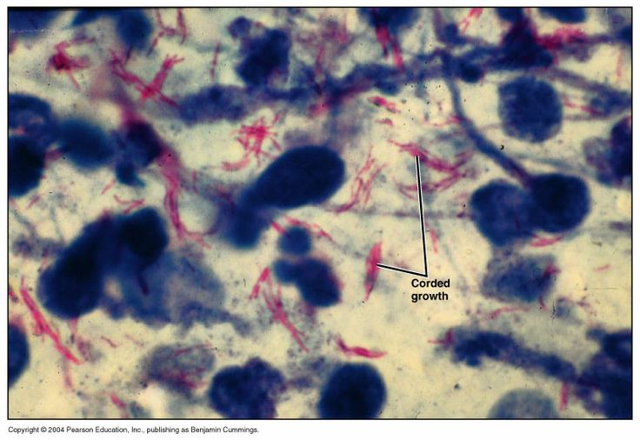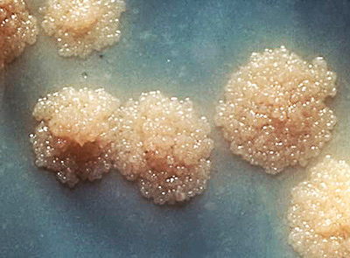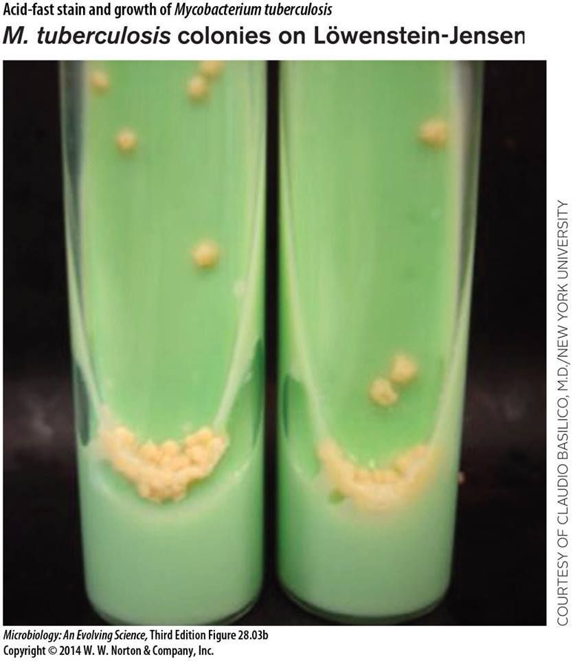
Pathogenesis
- Mycobacteria are emitted in droplets when infected persons cough, sneeze, or speak. The droplets evaporate, leaving organisms to be deposited in the alveoli.
- Inside the alveoli, the host's immune system responds by release of cytokines and lymphokines that stimulate monocytes and macrophages.
- Mycobacteria begin to multiply within macrophages. After 1–2 months of exposure, pathogenic lesions associated with infection, appear in the lung. Two Principal Lesions formed:
- Exudative type—This consists of an acute inflammatory reaction, with edema fluid, PMNs, and, later, monocytes around the tubercle bacilli (in lung).
- It may lead to massive necrosis of tissue; or it may develop into the second (productive) type of lesion. During the exudative phase, the tuberculin test becomes positive.
- Productive type—When fully developed, this lesion, a Chronic granuloma, consists of three zones: (1) a central area of large, multinucleated giant cells that formed by the fusion of epithelioid cells (macrophages) containing tubercle bacilli; (2) a mid zone of pale epithelioid cells, often arranged radially; and (3) a peripheral zone of fibroblasts, lymphocytes, and monocytes.
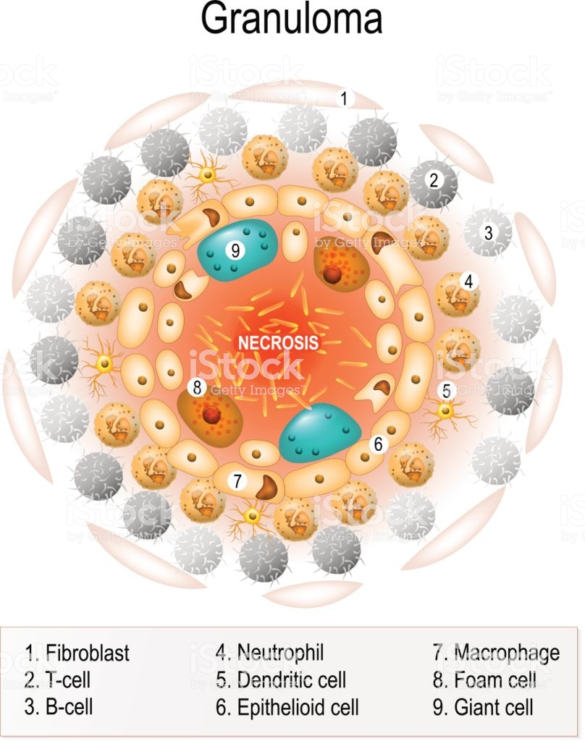
Later, peripheral fibrous tissue develops, and the central area undergoes caseation necrosis. Such a lesion is called a tubercle. A caseous tubercle may break into a bronchus, empty its contents there, and form a cavity. If a caseating lesion discharges its contents into a bronchus, they are aspirated and distributed to other parts of the lungs or are swallowed and passed into the stomach and intestines.``
Spread of Organisms in the Host
- In the first infection, tubercle bacilli always spread from the initial site via the lymphatics to the regional lymph nodes.
- The bacilli may spread farther and reach the bloodstream, which in turn distributes bacilli to all organs (Miliarydistribution).
Primary Infection & Reactivation of Tuberculosis
When a host has first contact with tubercle bacilli, the following are observed:
(1) An acute exudative lesion develops and rapidly spreads to the lymphatics and regional lymph nodes.
(2)The lymph node undergoes massive caseation, which usually calcifies (Ghon lesion) and represents events of primary pulmonary .
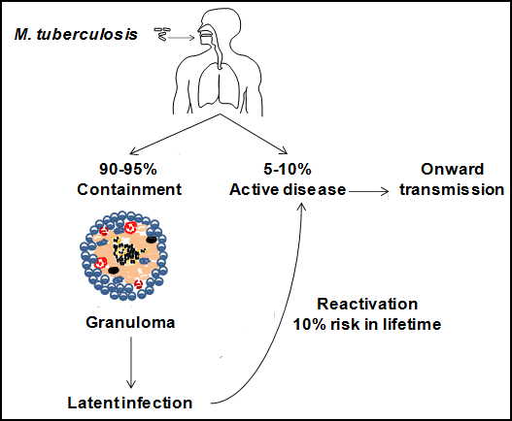
Reactivation type is usually caused by tubercle bacilli that have survived in the primary lesion. it is characterized by chronic tissue lesions, the formation of tubercles, caseation, and fibrosis. Regional lymph nodes are only slightly involved. The reactivation type almost always begins at the apex of the lung, where the oxygen tension (PO₂) is highest.
There are three types of TB
- Active TB Disease, an illness in which the TB bacteria are rapidly multiplying and invading different organs of the body.
- Miliary TB, is a rare form of active disease that occurs when TB bacteria find their way into the bloodstream.
- Latent TB Infection.
Clinical Findings
- Fatigue, weakness, weight loss, fever, and night sweats may be signs of tuberculous disease. Pulmonary involvement giving rise to chronic cough and spitting of blood usually is associated with far-advanced lesions.
- Meningitis or urinary tract involvement can occur in the absence of other signs of tuberculosis.
- Bloodstream dissemination leads to miliary tuberculosis with lesions in many organs and a high mortality rate.
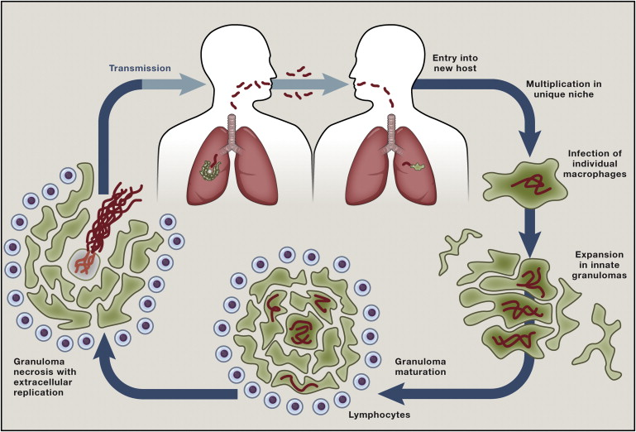
Tuberculin skin Test (Mantoux)
A purified protein derivative (PPD) is obtained by chemical fractionation of old tuberculin. In an individual who has not had contact with mycobacteria, there is no reaction to PPD.

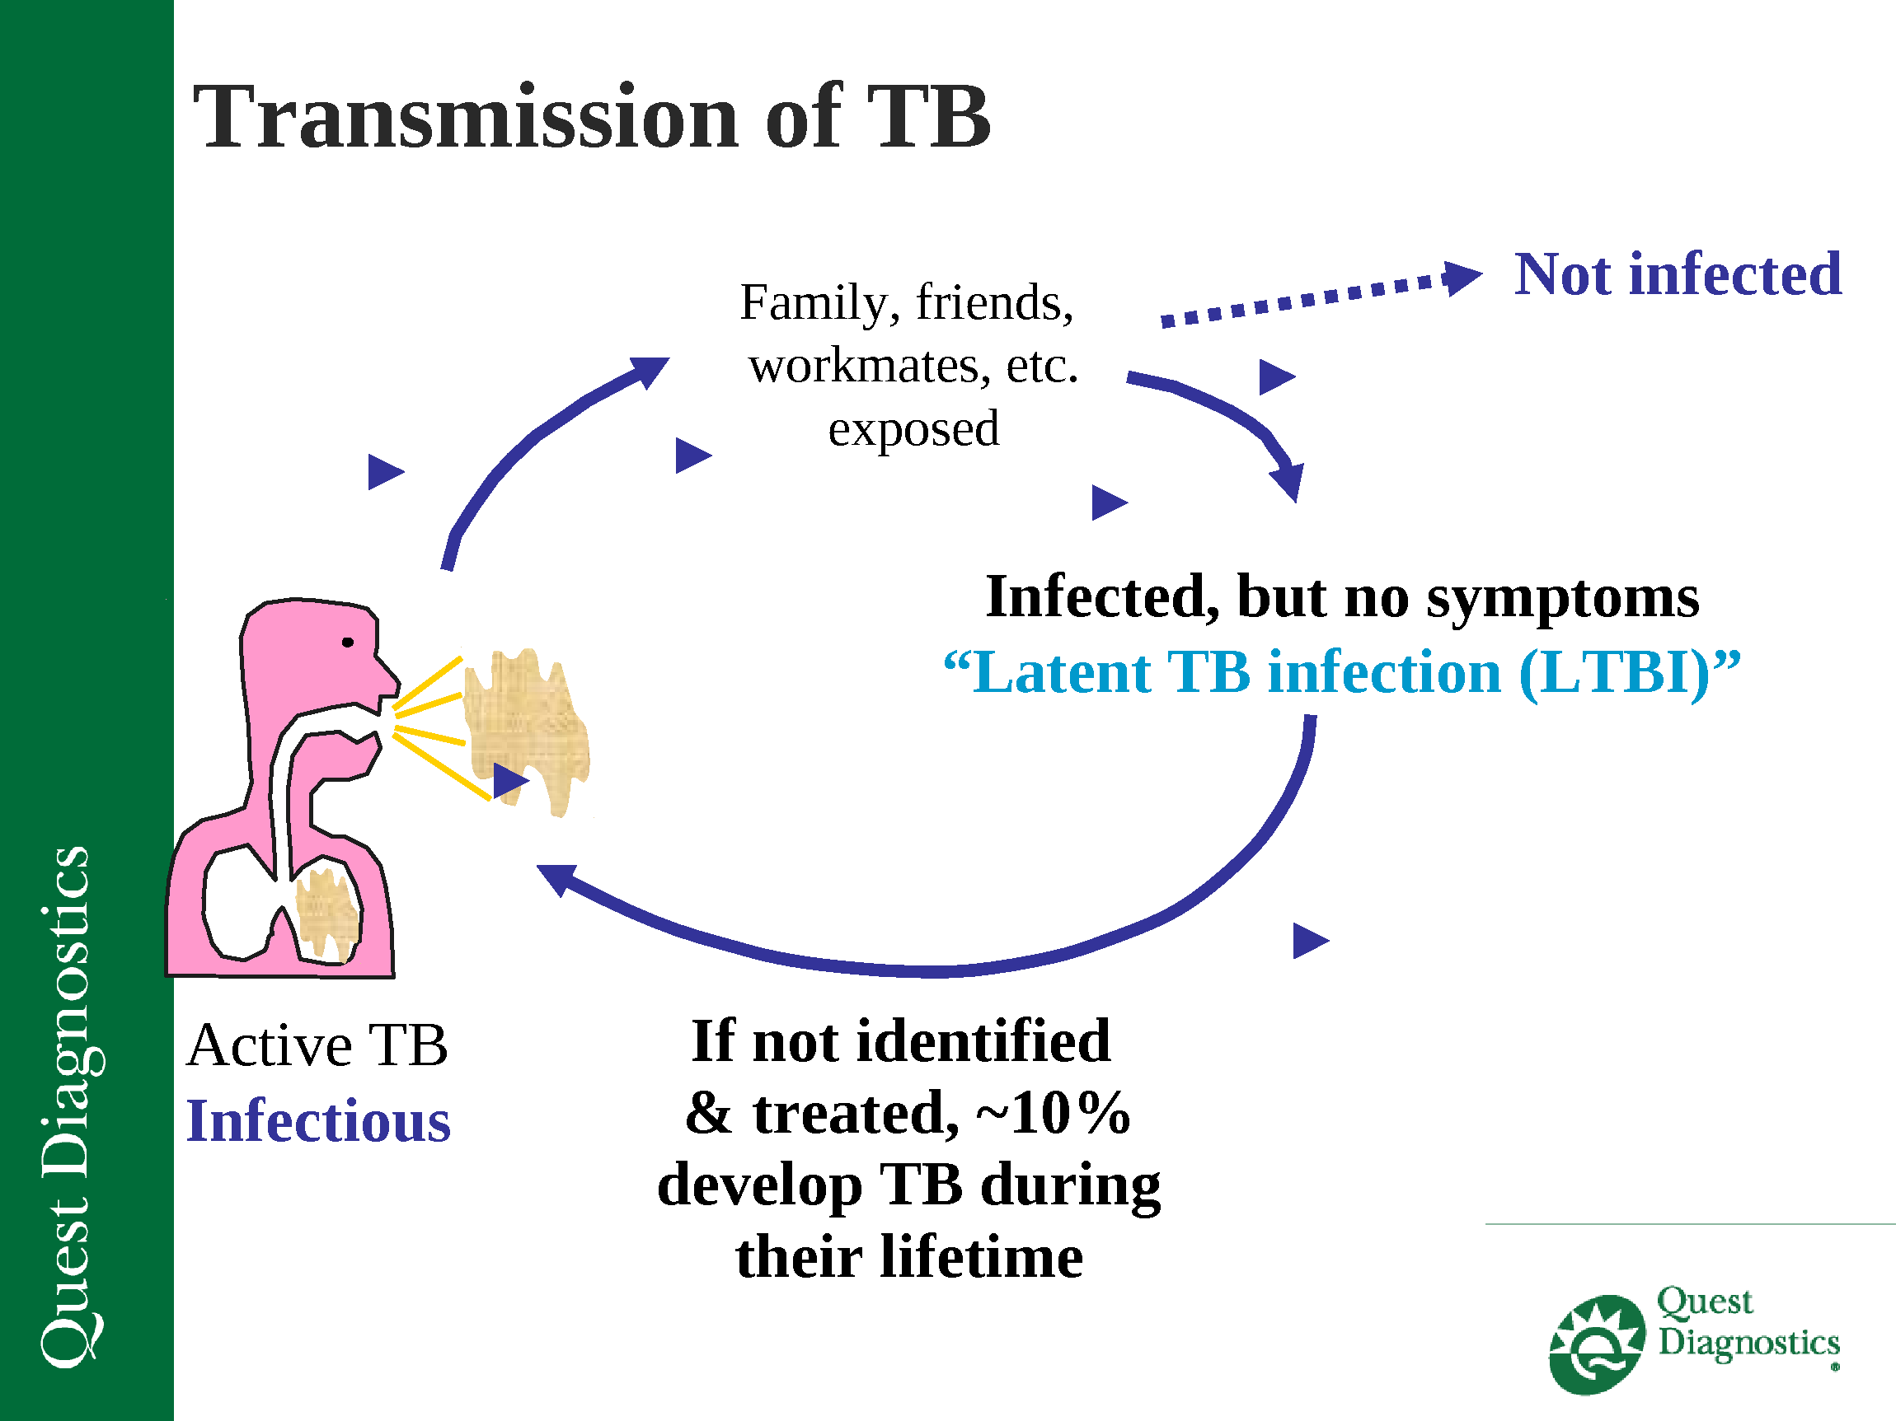
- An individual who has had a primary infection with tubercle bacilli develops edema, erythema in 24–48 hours, and, with very intense reactions, even central necrosis.
- The skin test should be read in 48 or 72 hours.
- After BCG vaccination, people convert to a positive test
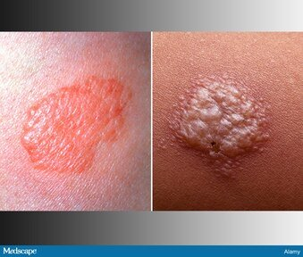
Interpretation of Tuberculin Test
- A positive tuberculin test indicates that an individual has been infected (active or latent).
- Tuberculin-positive persons are at risk of developing disease from reactivation of the primary infection, whereas tuberculin-negative persons who have never been infected are not subject to that risk, though they may become infected from an external source.
Epidemiology
- The most frequent source of infection is the human who excretes large numbers of tubercle bacilli from RT. The development of clinical disease after infection may have a genetic component. It may influenced by
- age (high risk in infancy and in the elderly)
- undernutrition
- immunologic status
- coexisting diseases (silicosis, diabetes), and other host resistance factors.
Endogenous reactivation tuberculosis occurs most commonly among persons with AIDS, immunosuppression, and elderly malnourished, or alcoholic destitute men.
Prevention & Control
Immunization: Various living avirulent tubercle bacilli, particularly BCG (bacillus Calmette-Guérin, an attenuated bovine organism), have been used to induce a certain amount of resistance in those heavily exposed to infection.

Other Mycobacteria
"A typical" mycobacteria were initially grouped according to speed of growth at various temperatures and production of pigments. Most of them occur in the environment, are not readily transmitted from person to person, and are opportunistic pathogens.

Mycobacterium avium Complex(MAC)
- The Mycobacterium avium complex is often called the MAC or MAI (M aviumintracellulare) complex.
- These organisms grow optimally at 41°C and produce non-pigmented colonies.
- They are ubiquitous in the environment and have been cultured from water, soil, food, and animals, including birds.
- MAC organisms infrequently cause disease in immunocompetent humans.
- Environmental exposure can led to MAC colonization occur either by respiratory or gastrointestinal tract.
- Persistent bacteremia and extensive infiltration of tissues resulting in organ dysfunction.
- In the lung, nodules, diffuse infiltrates, cavities, and endobronchial lesions are common. Other manifestations include pericarditis, soft tissue abscesses, skin lesions, lymph node involvement, bone infection, and central nervous system lesions.
- The patients often present with nonspecific symptoms of fever, night sweats, abdominal pain, diarrhea, and weight loss.

