Bone structure:
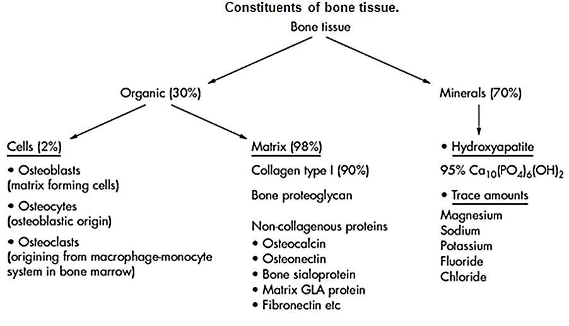
I. Minerals (70%):
Hydroxypatite (95%)
Hydroxypatite is a crystalline salts though may be present in amorphous forms
Hydroxypatite deposited in the organic matrix of bone and teeth
Hydroxypatite are composed principally of calcium and phosphate {Ca₁₀ (PO4)₆(OH) ₂}
Hydroxypatite crystals are platelets or rods, about 8 to 15A thick, 20 to 40A wide and 200 to 400A long.
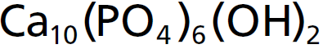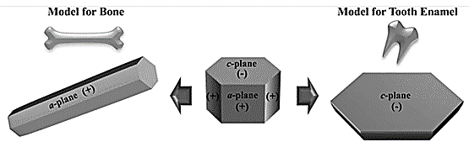
Hydroxypatite relative ratio of calcium to phosphorus can vary markedly under different nutritional conditions, with the calcium to phosphorus ratio on a weight basis varying between 1.3 and 2.0.
Magnesium, sodium, potassium, and carbonate ions are also present among the bone salts, although x-ray diffraction studies fail to show definite crystals formed by them.
Therefore, they are believed to be conjugated to the hydroxyapatite crystals rather than organized into distinct crystals of their own. This ability of many types of ions to conjugate to bone crystals extends to many ions normally foreign to bone, such as strontium, uranium, plutonium, the other transuranic elements, lead, gold, and other heavy metals. Deposition of radioactive substances in the bone can cause prolonged irradiation of the bone tissues, and if a sufficient amount is deposited, an osteogenic sarcoma (bone cancer) may eventually develop.
II. Organic (30%)
i. Matrix of Bone (98%).
The extracellular matrix functions in holding all the cells of a tissue in their place.
The extracellular matrix consists of two major substances: ground substances (Proteoglycans are a type of ground substances) and fibrous proteins (collagen are a type of fibrous proteins)
1) Collage type I (90%)
Type I collagen, is the major structural protein in bone, tendons and skin.
Type I collagen, which weight for weight is as strong as steel
Type I collagen, is made up of a triple helix of three polypeptides bound tightly together.
Type I collagen fibers extend primarily along the lines of tensional force and give bone its powerful tensile strength.
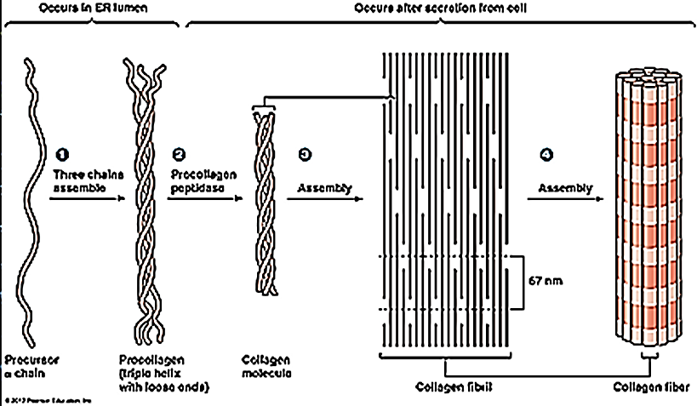
The collagen fibers of bone, like those of tendons, have great tensile strength, whereas the calcium salts have great compressional strength. These combined properties plus the degree of bondage between the collagen fibers and the crystals provide a bony structure that has both extreme tensile strength and compressional strength.
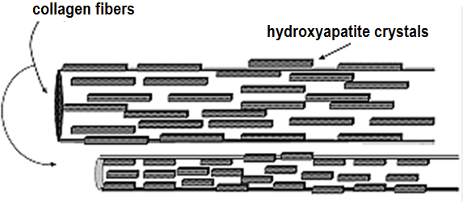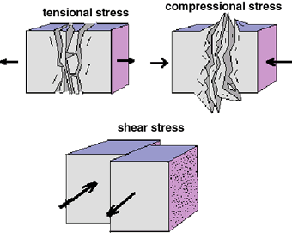
2) Non-Collagenous Proteins
I. Phosphoproteins include
A. bone sialoprotein and proteoglycans
Proteoglycans consist of glycosaminoglycan (GAG) and hyaluronic acid
Glycosaminoglycan consist of chondroitin sulfate and core protein.
Glycosaminoglycan make about 95% of the weight of proteoglycans
Functions of glycosaminoglycan
a. They have the special ability to bind large amounts of water, there by producing the gel-like matrix that forms the basis of the body’s ground substance. The bone matrix has a lower proteoglycan content than those in the cartilage. This is the reason bones take up less quantity of water and are, thus, more brittle.
b. Since glycosaminoglycan are negatively charged in the bone glycosaminoglycan attract and tightly bind cation like calcium (glycosaminoglycan bind tightly to hydroxyapatite which would protect hydroxyapatite molecules from the destructive effects of temperature and chemical agents after death) and sodium and potassium.
c. Proteoglycans inhibit calcification by masking the collagen fibrils or occupying critical spaces within the fibril and thereby diminishing diffusion, chemical interaction and sequestration of calcium ions or calcium phosphate complexes.
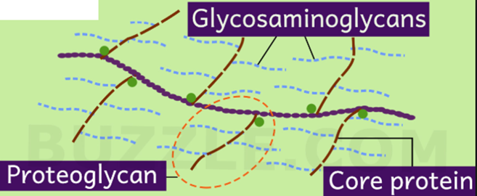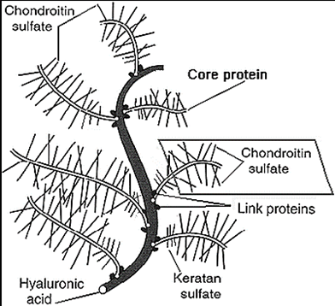
Some types of Proteoglycans
Decorin and biglycan
Lumican
Keratocan
Other proteoglycans like epiphycan, asporin, and fibromodulin
B. Osteocalcin also known as bone δ-carboxyglutamic acid-containing protein (BGLAP)
Osteocalcin is the most abundant non-collagenous protein in bone comprising about 20% of the non-collagen matrix proteins and produced by osteoblasts.
Osteocalcin contains three γ-carboxylglutamic acid (Gla) residues that bind calcium, and it is vitamin K-dependent.
Osteocalcin functions:
Osteocalcin has been postulated that rather than facilitating calcification it could retard it
Osteocalcin is a chemoattractant for osteoclasts.
Osteocalcin like alkaline phosphatase is used
i. clinically as a marker of osteoblast activity
ii. serum osteocalcin as a bone turnover marker.
C. Matrix Gla Protein (MGP)
Matrix Gla Protein is a possible regulator of extracellular matrix calcification
Matrix Gla Protein, like osteocalcin, is a member of the vitamin K-dependant γ-carboxylglutamic acid (Gla) proteins
D. Alkaline phosphatase is an ecto-enzyme produced by osteoblasts and linked by Robison
E. Lipid and proteolipids
II. Cell Attachment Proteins
In addition to the above matrix proteins are a number of different cell attachment proteins that have the common RGD amino acid sequence (arginin-glycin-aspartic acid), which is responsible for mediating attachment of these proteins to integrins (integral membrane proteins) on the cell surface. These cell attachment proteins include fibronectin, osteopontin, osteonectin, Fibronectin, thrombospondin and several other bone sialoproteins including one called bone sialoprotein and a second called BAG (bone acidic glycoprotein).
III. Regulatory Growth Factors in Bone
A. Transforming growth factor β (TGFβ) including transforming growth factor βI (TGFβI), and TGFβII
B. Fibroblast growth factors (FGFs)
C. Bone morphogenetic proteins (BMPs) or osteogenic proteins
D. Insulin-like growth factors (IGFs), IGF-I and IGF-II, are proteins with high sequence similarity to insulin.
Insulin-like growth factors are present in the circulation and synthesized by many tissues, including bone, where they act similarly as local regulators of cell metabolism.
In bone IGF-I is more potent than IGF-II
Insulin-like growth factors functions
a. Insulin-like growth factors associated with bone growth
b. Insulin-like growth factor-I stimulates
i. mitogenesis
ii. collagen synthesis
iii. infusion causes a generalized anabolic effect and an increase in bone remodelling
E. Platelet-derived growth factor (PDGF)
F. Colony stimulating factor (CSF) also called monocyte-macrophage colony stimulating factor (M-CSF)
G. Lymphotoxin and tumor necrosis factor (TNF)
H. Prostaglandins
ii. Cellular component
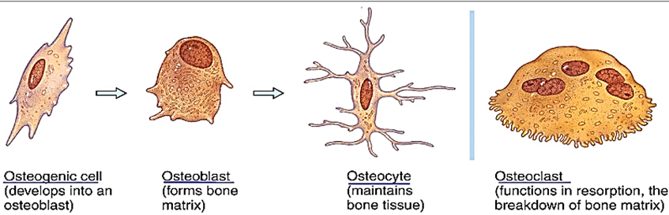
A. Osteoblasts: The cells responsible for bone formation
Osteoblasts are modified fibroblasts.
Osteoblasts early development from the mesenchyme is the same as that of fibroblasts, with extensive growth factor regulation. Later, ossification specific transcription factors, such as Cbfa1/Runx2, contribute to their differentiation.
Normal osteoblasts are able to lay down type 1 collagen and form new bone.
B. osteoclasts: the cells responsible for bone resorption
Mechanism of Bone Calcification:
First step: osteoid formation
Osteoid is the unmineralized, organic portion of the bone matrix that forms prior to the maturation of bone tissue.
Osteoid makes up about fifty percent of bone volume and forty percent of bone weight.
Osteoblasts begin the process of forming bone tissue by secreting the osteoid as several specific proteins. When the osteoid becomes mineralized, it and the adjacent bone cells have developed into new bone tissue.
As the osteoid is formed, some of the osteoblasts become entrapped in the osteoid and become quiescent خامل. At this stage they are called osteocytes.
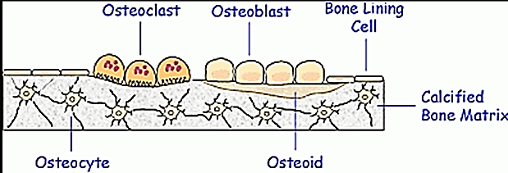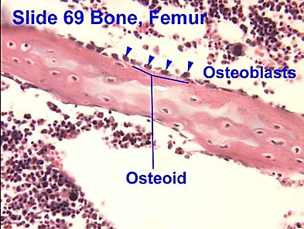
Osteoid is composed of
A. collagen molecules (called collagen monomers)
B. ground substance: The ground substance is mostly made up of chondroitin and osteocalcin.
Second step: mineral precipitation (mineralization) and bone hardening
The hardness and rigidity of bone is due to the presence of mineral salt in the osteoid matrix, which is a crystalline complex of calcium and phosphate (hydroxyapatite). Calcified bone contains about 25% organic matrix (2-5% of which are cells), 5% water and 70% inorganic mineral (hydroxyapatite).
1. Nucleation theory (seeding mechanism) of mineralization:
Within a few days after the osteoid is formed, calcium salts begin to precipitate on the surfaces of the collagen fibers. The precipitates first appear at intervals along each collagen fiber, forming minute nidi (single: nidus; a nest or cluster; the point of origin or focus) that rapidly multiply and grow over a period of days and weeks into the finished product, hydroxyapatite crystals.
The initial calcium salts to be deposited are not hydroxyapatite crystals but amorphous compounds (noncrystalline), a mixture of salts such as CaHPO₄ × 2H₂O, Ca₃ (PO₄)₂ × 3H₂O, and others. Then, by a process of substitution and addition of atoms, or reabsorption and re-precipitation, these salts are converted into the hydroxyapatite crystals over a period of weeks or months. A few percent may remain permanently in the amorphous غير متبلورform, which is important because these amorphous salts can be absorbed rapidly when there is a need for extra calcium in the extracellular fluid.
2. Matrix vesicle theory of mineralization (most acceptable theory of mineralization)
Mineralization takes place in two distinct processes.
Hypertrophic chondrocytes, osteoblasts, and odontoblasts bud matrix vesicles when mineralization begins. Matrix vesicles are membrane-invested vesicles of 50–200 nm in diameter
The first step of the mineralization process occurs within the matrix vesicles, in which hydroxyapatite
(Ca₁₀ (PO₄)₆(OH)₂) crystals are formed.
a. Phosphate (Pi) is derived from
1. Membrane phospholipids, which are hydrolyzed by phospholipase C (PLC) to produce phosphocholine (PCho) and phosphoethanolamine (PEA). These phosphor-compounds are hydrolyzed by PHOSPO1: phosphoethanolamine/phosphocholine phosphatase, a cytosolic phosphatase that is abundant in the matrix vesicles, to yield inorganic phosphate (Pi).
2. Another source of Pi in the matrix vesicles is Pi that is transported through the Na/Pi cotransporter Pit1 that is also abundant on the matrix vesicle membrane.
b. Calcium is incorporated into the matrix vesicles through annexin Ca²⁺ channels
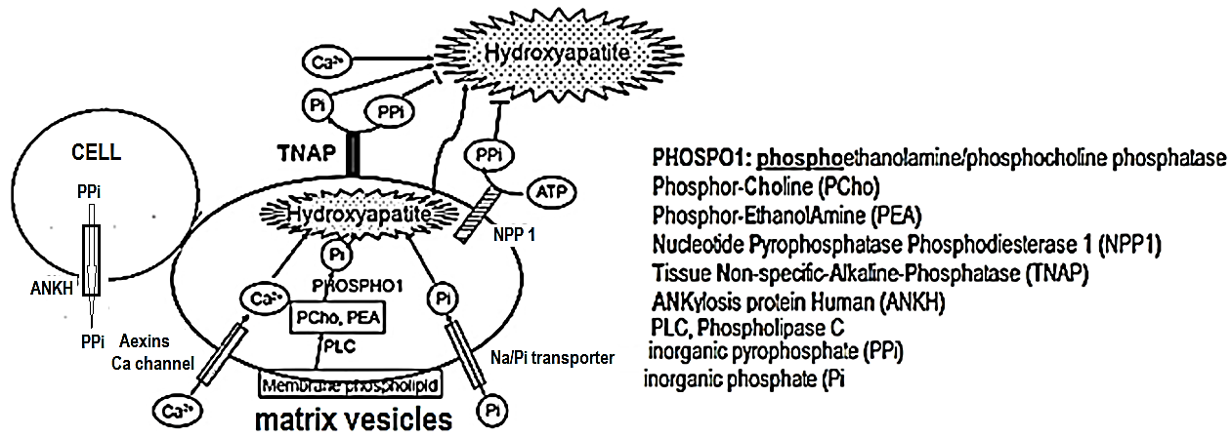
Developing hydroxyapatite crystals then penetrate the matrix vesicle membrane, are elongated in the extracellular space, and eventually deposit in the spaces between collagen fibrils to complete extracellular matrix mineralization.
The concentration ratio of inorganic phosphate (Pi) to inorganic pyrophosphate (PPi) in the extracellular matrix is crucial in the second step of mineralization because PPi is an inhibitor of hydroxyapatite formation.
Two mechanisms are used for inorganic pyrophosphate (PPi) formation (decrease hydroxyapatite crystals).
1. Inorganic pyrophosphate (PPi) is formed in the extracellular matrix from ATP by the matrix vesicle membrane enzyme nucleotide pyrophosphatase phosphodiesterase 1 (NPP1)
2. Inorganic pyrophosphate (PPi) is also provided through the PPi transporter ankylosis protein human (ANKH) from the cytoplasm, in which inorganic pyrophosphate (PPi) is routinely formed by cellular metabolism.
ankylosis protein human (ANKH) is distributed on the plasma membrane of hypertrophic chondrocytes and osteoblasts.
Tissue non-specific-alkalin-ephosphatase (TNAP) on the membrane of the matrix vesicles hydrolyzes inorganic pyrophosphate (PPi) and yields inorganic phosphate (Pi), thereby reducing the levels of the PPi and promoting hydroxyapatite formation (increase hydroxyapatite crystals)
زيادة inorganic pyrophosphate (PPi) ) يعني نقصان ال(hydroxyapatite crystals )
زيادةinorganic phosphate (Pi) ) يعني زيادة ال (hydroxyapatite crystals )
This balance between the activities of TNAP, NPP1, and ANKH is crucial for the second step of mineralization.
Deficiencies of Nucleotide Pyrophosphatase Phosphodiesterase 1 (NPP1) or ANKylosis protein Human (ANKH) cause decreased extracellular Inorganic pyrophosphate (PPi) and excessive calcification of bone, such as bone spurs, or even calcification of other tissues such as tendons and ligaments of the spine, which occurs in people with a form of arthritis called ankylosing spondylitis.
3. Robinson’s alkaline phosphatase theory of mineralization (least acceptable theory):
Alkaline phosphatase present in organic matrix hydrolyzes organic pyrophosphate present in plasma to organic phosphate with help of calcium to calcified the bone if it is present in excess amount
Precipitation of calcium in Non-osseous tissues under abnormal conditions.
Hydroxyapatite crystals fail to precipitate in normal tissues except in bone despite the state of super-saturation of the ions, because inhibitors are present in almost all tissues of the body, as well as in plasma, to prevent such precipitation; such inhibitor are pyrophosphate, Matrix Gla protein (MGP), Osteopontin (OPN) and Fetain
For instance,
They precipitate in arterial walls in arteriosclerosis and cause the arteries to become bonelike tubes.
Calcium salts frequently deposit in degenerating tissues (as old fibrous TB) or in old blood clots.
Bone remodeling
Deposition of Bone by the Osteoblasts.
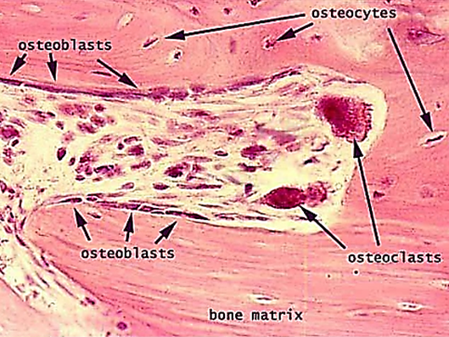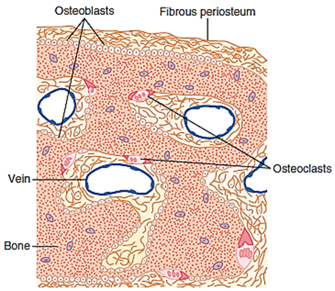
Bone is continually being deposited by osteoblasts, and it is continually being resorbed where osteoclasts are active. This mechanism is always is in balance (called bone remodelling). Any disturbance of this mechanism ill causes a disease. For example increase osteocyte activity (bone resorption) will causes osteoporosis or increase activity of osteocyte followed by increased activity of osteoblast with abnormal bone causes Paget's disease
Osteoblasts are found on the outer surfaces of the bones and in the bone cavities. A small amount of osteoblastic activity occurs continually in all living bones (on about 4 percent of all surfaces at any given time in an constantly).
Resorption of Bone—Function of the Osteoclasts.
Bone is also being continually resorbed in the presence of osteoclasts, which are large, phagocytic, multinucleated cells (containing as many as 50 nuclei, abundant mitochondria and a large number of vacuoles and lysosomes) that are derivatives of monocytes or monocyte-like cells formed in the bone marrow. The osteoclasts are normally active on less than 1 percent of the bone surfaces of an adult.
Osteoblast secret three materials
receptor activator for nuclear factor κ-B ligand (RANKL)
macrophage colony-stimulating factor (M-CSF)
osteo-protegerin (OPG), sometimes called osteo-clasto-genesis inhibitory factor
How osteoclast stimulated
Vitamin D3, Parathyroid hormone, Prostaglandin E2 and Interleukin-11 will stimulate osteoblastic cell then Osteoblasts express two cytokines essential for osteoclast differentiation:
a. RANKL (Receptor Activator of Nuclear factor-Kappa B Ligand)
b. M-CSF (Monocyte- colony stimulating Factor)
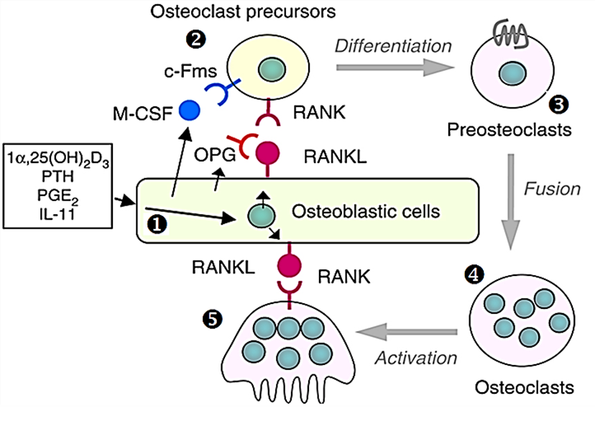
Osteoclast precursor will bind to receptor activator where
a. nuclear factor κ-B ligand (RANKL) bind to receptor activator for nuclear factor κ-B (RANK)
b. macrophage colony-stimulating factor (M-CSF) bind to macrophage colony-stimulating factor (M-CSF) receptor which is c-Fms
The above activation will differentiate Osteoclast precursors into pre-osteoclasts
Many pre-osteoclast meet together forming one large multinucleated mature osteoclast
Osteoblastic cell will be activated when RANK of Osteoclast cell will join (RANKL receptor) of osteoblastic cell. The mature osteoclasts then develop a ruffled border and release enzymes and acids that promote bone resorption
How osteoclast inhibited
Many factors as 17-β oestradiol, Interlukin-4, Tumor growth factor-β, calcitonin all will stimulate osteoblastic cell to produce Osteoprotegerin (OPG), also known as osteoclastogenesis inhibitory factor (OCIF). OPG binding to RANKL on osteoblastic cell, blocks the RANKL-RANK interaction between osteoblast cells and osteoclast precursors. This has the effect of inhibiting the differentiation of the osteoclast precursor into a mature osteoclast.
The therapeutic importance of the OPG-RANKL pathway is currently being exploited. Novel drugs that mimic the action of OPG by blocking the interaction of RANKL with its receptor appear to be useful for treating bone loss in postmenopausal women (osteoporosis) and in some patients with bone cancer.
Bone deposition and resorption are normally in equilibrium.
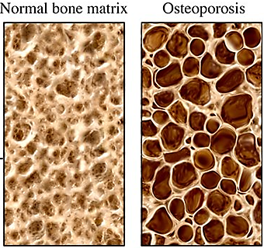
Mechanism of osteoclast mediated bone resorption
Histologically, bone absorption occurs immediately adjacent to the osteoclasts.
Osteoclasts erode and absorb previously formed bone. Osteoclasts become attached to bone via integrins in a membrane extension called the sealing zone. This creates an isolated area between the bone and a portion of the osteoclast. The mechanism of this resorption is believed to be the following:
The villi secrete two types of substances:
(1) Proteolytic enzymes, released from the lysosomes of the osteoclasts
a. Cathepsin K is the major protease involved in the degradation of type I collagen and other non-collagenous proteins
b. Matrix metallo-proteinases (MMPs)
(2) Resorption pit at ruffled border (villus-like projections toward the bone)
Several acids, including citric acid and lactic acid, (they acidify the area to approximately pH 4.0) released from the mitochondria and secretory vesicles. The enzymes digest or dissolve the organic matrix of the bone, and the acids cause dissolution of the bone salts.
The osteoclastic cells also imbibe تمتصminute particles of bone matrix and crystals by phagocytosis, eventually also dissolute these particles and releasing the products into the blood.
Except in growing bones, the rates of bone deposition and resorption are normally equal, so the total mass of bone remains constant.
Osteoclasts usually exist in small but concentrated masses, and once a mass of osteoclasts begins to develop, it usually eats away at the bone for about 3 weeks, creating a tunnel that ranges in diameter from 0.2 to 1 millimeter and is several millimeters long. At the end of this time, the osteoclasts disappear and the tunnel is invaded by osteoblasts instead; then new bone begins to develop. Bone deposition continues for several months, with the new bone being laid down in successive layers of concentric circles (lamellae) on the inner surfaces of the cavity until the tunnel is filled. Deposition of new bone ceases when the bone begins to encroach on the blood vessels supplying the area. The canal through which these vessels run, called the haversian canal, is all that remains of the original cavity. Each new area of bone deposited in this way is called an osteon. Throughout life, bone is being constantly resorbed and new bone is being formed. The calcium in bone turns over at a rate of 100% per year in infants and 18% per year in adults.

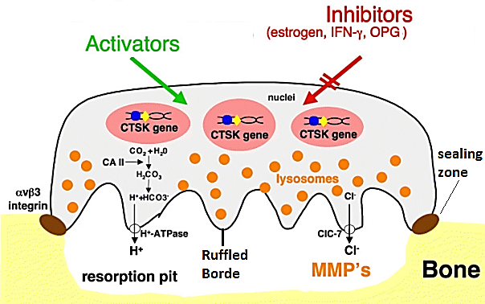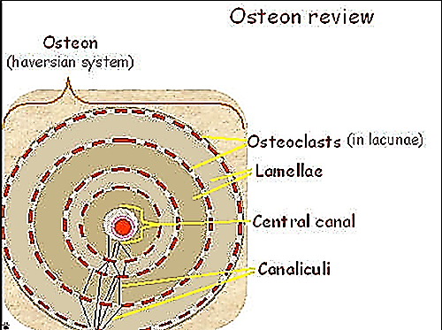
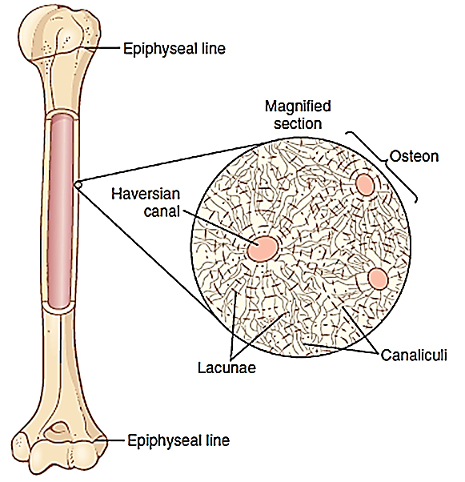
Value of Continual Bone Remodeling.
The continual deposition and resorption of bone have several physiologically important functions.
First, bone ordinarily adjusts its strength in proportion to the degree of bone stress. Consequently, bones thicken when subjected to heavy loads.
Second, even the shape of the bone can be rearranged for proper support of mechanical forces by deposition and resorption of bone in accordance with stress patterns.
Third, because old bone becomes relatively brittle هشand weak, new organic matrix is needed as the old organic matrix degenerates. In this manner, the normal toughness of bone is maintained.
Indeed, the bones of children, in whom the rates of deposition and absorption are rapid, show little brittleness in comparison with the bones of the elderly, in whom the rates of deposition and resorption are slow.
Control of the rate of boned تحديد شكل العظمposition by bone “Stress.”
Bone stress determines osteoblastic deposition and calcification of bone
Bone is deposited in proportion to the compressional load that the bone must carry. For instance, the bones of athletes become considerably heavier than those of non-athletes.
Also, if a person has one leg in a cast but continues to walk on the opposite leg, the bone of the leg in the cast becomes thin and as much as 30 percent remains thick and normally calcified. Therefore, continual physical stress stimulates osteoblastic deposition and calcification of bone.
Bone stress determines the shape of bones under certain circumstances.
For instance, if a long bone of the leg breaks in its center and then heals at an angle, the compression stress on the inside of the angle causes increased deposition of bone. Increased resorption occurs on the outer side of the angle where the bone is not compressed. After many years of increased deposition on the inner side of the angulated bone and resorption on the outer side, the bone can become almost straight, especially in children because of the rapid remodeling of bone at younger ages.
