Al Balqa Applied University
College of Sciences
Dr. Hala Al Daghistani
Viral infection
Herpes virus
The name come from: Herpes- “creeping” or snake-like eruption; Simplex- uncomplicated compared to other blistering eruptions as generally confined to and recurrent in one area of body.
- HHV-1 Herpes simplex virus-1, Oral (fever blisters), ocular lesions, encephalitis

- HHV-2 Herpes simplex virus-2, Genital, anal lesions, Severe neonatal infections, meningitis

- HHV-3 Varicella–zoster virus, Chickenpox (primary infection), Shingles (reactivation)

- HHV-4 Epstein–Barr virus, Infectious mononucleosis, (Primary infection), Tumors, including B, T-cell tumors

- HHV-5 Cytomegalovirus, Mononucleosis, gastroenteritis, retinitis, pneumonia

- HHV-6 Human herpesvirus-6, Roseola in infants (primary infection), Infections in allograft recipients(pneumonia, marrow failure)

- HHV-7 Human herpesvirus-7, Some cases of Roseola (sixth disease, roseola infantum).

- HHV-8 Kaposi’s sarcoma–associated herpesvirus,(KSHV), Some B-cell lymphoma

Two distinct epidemiologic and antigenic types of HSV exist (HSV-1 and HSV-2). Their nucleic acids demonstrate approximately 50% base sequence homology,

HSV-1 and HSV-2 share antigens in almost all their surface glycoproteins and other structural polypeptides, but differences in Glycoprotein B (gB), ( HSV-1 has gB1 and HSV-2 has gB2).

Numerous strains of both HSV-1 andHSV-2 exist.

Herpes Simplex Diseases
- HSV is one of the best known of all viruses, associated with recurrent ulcers in areas of the skin and mucous membranes.
- Herpes simplex virus persists in a latent form and reactivates to cause certain diseases.

EPIDEMIOLOGY
- Direct contact with infected secretions is the principal mode of spread.
- Detection of HSV-2 antibody before puberty is unusual. The virus is associated with sexual activity, and direct sexual transmission is the major mode of spread.
- Asymptomatic shedding accounts for transmission from a partner who has no active genital lesions

PATHOGENESIS: Acute Infections
Pathologic changes during acute infections consist of development of :
- Multinucleated giant cells (is a mass formed by the union of several distinct cells (usually histiocytes), often forming a granuloma.
- Degeneration of epithelial cells
- Focal necrosis
- Eosinophilic intranuclear inclusion bodies
- An inflammatory response characterized by an initial PMN infiltrate and a subsequent mononuclearcell infiltrate.
The virus can spread intraneuronally or through supporting cellular networks of an axon or nerve, resulting in latent infection of sensory and autonomic nerve ganglia.

Latent Infection
- In humans, latent infection by HSV-1 has been demonstrated in trigeminal, superior cervical, and vagal nerve ganglia, and occasionally in the S2–S3 dorsal sensory nerve root ganglia. Latent HSV-2 infection has been demonstrated in the sacral (S2–S3) region.
- Latent infection of nervous tissue by HSV does not result in the death of the cell; however, the exact mechanism of viral genome interaction with the cellis incompletely understood.
- Reactivation of virus from latently infected ganglionic cells with subsequent release of infectious virions appears to account for most recurrences of both genital and orolabial infections.
- Factors that are known to initiate reactivation of herpes simplex include;
- Exposure to ultraviolet light
- Fever
- Trauma (eg, oral intubation).

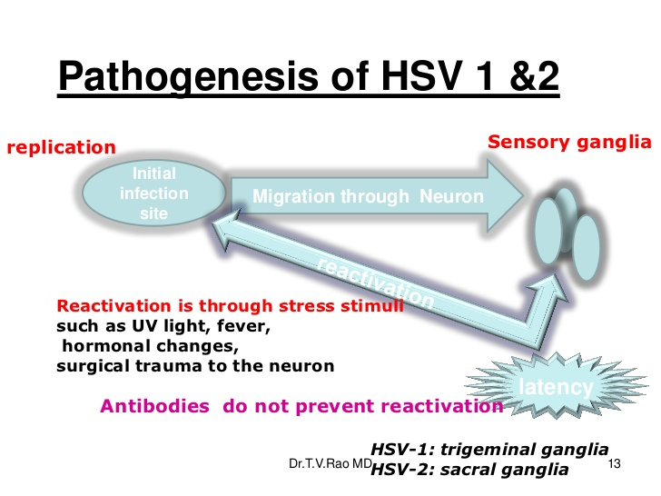

Immunity
- Many episodes of HSV infection are either asymptomatic or mildly symptomatic.
- Initial symptomatic clinical episodes of the disease are more severe than recurrent episodes, probably because of the presence of anti-HSV antibodies and immune lymphocytes in persons with recurrent infections.
- Prior infection with HSV-1 may protect against or shorten the duration of symptoms and lesions from subsequent infection with HSV-2 due to some degree of cross protection.
- Both cellular and humoral immune responses are important in immunity to HSV.
- By the second week after infection, cytotoxic T lymphocytes can be detected that are able to destroy HSV-infected cells prior to completion of the replication cycle.

Manifestations of Herpes Simplex Type 1
- Infection with HSV-1 is usually “above the waist.”
- It consists of grouped or single vesicular lesions that become pustular and combined to form single or multiple ulcers.
- On dry surfaces, these ulcers scrab before healing
- Infections generally involve the skin, mouth, conjunctiva, and nervous system.
Clinical presentation: Patient will have vesicles at inoculation site, with regional lymphadenopathy. +/- malaise, fever, fatigue, myalgias, headache

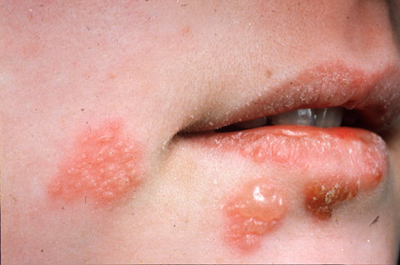

- Primary infection with HSV-1 is often asymptomatic. When symptomatic, typically in children, it appears most frequently as gingivostomatitis, with fever and ulcerative lesions involving the buccal mucosa, tongue, gums, and pharynx.The lesions are quite painful, and the acute illness usually lasts 5 to 12 days.

- After this initial infection, HSV may become latent within sensory nerve root ganglia of the trigeminal nerve. Lesions usually repeated on a specific area of the lip;these lesions are referred to as mucocutaneous and are commonly called “cold sores” or “fever blisters.” Because reactivation is usually from a single latent source, these lesions are typically unilateral.

Herpes simplex virus sometimes infects the finger or nail area. This infection, termed herpetic whitlow, usually results from the inoculation of infected secretions through a small cut in the skin. Painful vesicular lesions of the finger develop and postulate.

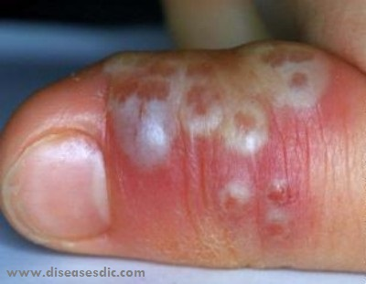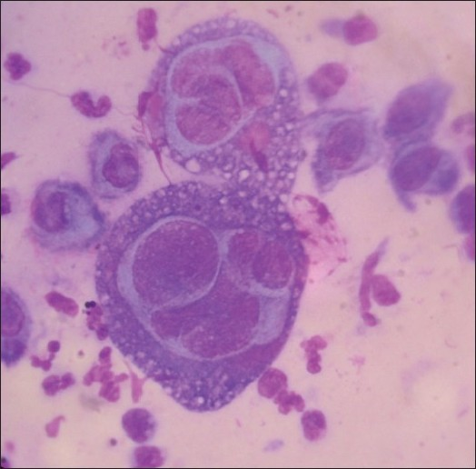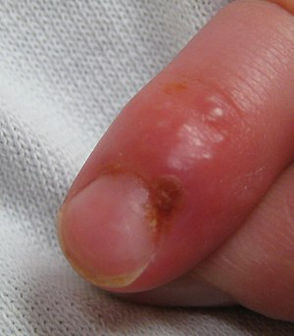

Diagnosis:
- Viral Culture for HSV1/HSV2
- A direct smear prepared from the lesion and stained by either the Giemsa or Papanicolaou method may show multinucleated giant cells typical of herpes (Tzanck test)
- Dermatopathology
- Isolates of HSV-1 and HSV-2 can be differentiated by staining virus-infected cells with type-specific monoclonal antibodies to the two types.
- Serology EIA (takes 2 to 6 weeks to seroconvert HSV antibodies after primary infection)
- Antigen detection/PCR: gold-standard diagnostic test.

Herpes Simplex Type 2
- Genital herpes is an important STD.
- For the relatively few individuals who develop clinically evident primary genital HSV disease, the mean incubation period from sexual contact to onset of lesions is 5 days.
- Lesions begin as small erythematous papules that soon form vesicles and then pustules .
- Within 3 to 5 days, the vesiculopustular lesions break to form painful merged ulcers that subsequently dry; some form crusts and heal without scarring.
- Bilateral enlarged tender inguinal lymph nodes are usually present.
- At least 80% of patients with primary genital HSV-2 infection develop recurrent episodes of genital herpes within 12 months.

Neonatal Herpes
Neonatal herpes usually results from transmission of virus during delivery through infected genital secretions from the mother. Babies are most at risk for neonatal herpes if the mother contracts genital herpes late in pregnancy. This is because a newly infected mother does not have antibodies against the virus, so there is no natural protection for the baby during birth. In addition, a new herpes infection is frequently active, so there is an increased possibility the virus will be present in the birth canal during delivery.
Some infants show disseminated vesicular lesions with a widespread internal organ involvement and necrosis of the liver and adrenal glands, and others have involvement of the CNS with seizures.

VARICELLA–ZOSTER VIRUS
- Varicella–zoster virus (VZV) has the same general structure as herpes simplex but contains its own envelope glycoproteins and other structures.

Varicella –Zoster Diseases
VZV causes two diseases
- Chickenpox (varicella)
- Shingles (zoster).
- The former usually occurs in children, the latter in the elderly.
- The virus remains latent in neural ganglia but activates later.
- The major mode of transmission is respiratory, although direct contact with vesicular or pustular lesions may result in transmission.

PATHOGENESIS
- Respiratory spread leads to infection of the contact patient’s followed by replication in regional lymph nodes and PRIMARY VIREMIA.
- The latter results in infection of the RES and a subsequent SECONDARY VIREMIA associated with T lymphocytes. Following secondary viremia, there is infection of the skin and finally a host immune response.
- Latency of VZV occurs in sensory ganglia many years after varicella infection. Herpes zoster (shingles) occurs when latent varicella zoster virus reactivates and multiplies within a sensory ganglion and then travels back down the sensory nerve to the skin.

IMMUNITY
- Both humoral immunity and cell-mediated immunity are important factors in determining the frequency of reinfection and reactivation of varicella–zoster.
- Circulating antibody prevents reinfection, and cell-mediated immunity appears to control reactivation.
- In patients with depressed cell-mediated immune responses, especially those with bone marrow transplants, Hodgkin’s disease, AIDS, and lymphoproliferative disorders, reactivation can occur, and VZV infections are more frequent and more severe.

MANIFESTATIONS
- VZV produces a primary infection in normal children characterized by a generalized vesicular rash termed Chickenpox or varicella.
- Chickenpox lesions generally appear on the back of the head and ears, then spread to the face, neck, trunk, and proximal extremities.
- Involvement of mucous membranes is common, and fever may occur early in the course of disease.
- Lesions appear in different stages of evolution; this characteristic is one of the major features used to differentiate varicella from smallpox, in which lesions are concentrated on the extremities and all had a similar appearance.
- Varicella lesions are itchy, and the number of lesions may vary from10 to several hundred.
- The complications of VZV infection are varied and depend on age and host immune factors. Postherpetic neuralgia is a common complication of herpes zoster in elderly adults. It is characterized by persistence of pain in the dermatome.

DIAGNOSIS
- Varicella or herpes zoster lesions can be diagnosed clinically
- Scrapings of lesions may reveal multinucleated giant cells
- For rapid viral diagnosis, is to demonstrate varicella–zoster antigen in cells from lesions by immunofluorescent antibody staining.
- VZV can be isolated from vesicular fluid or cells inoculated onto human fibroblasts; and cytopathic effects are detected
- PCR of CSF may be useful in the diagnosis of VZV encephalitis

Measles (Rubeola)
- Common name for measles include rubeola, 5-day measles, and hard measles.
- The measles virus is classified in the paramyxovirus family. It containsd RNA, which encodes at least six virion structural proteins. The receptor for measles virus is CD46, a regulator of complement activation. Only a single serotype restricted to human infection is recognized.
- infections often produce severe illness in children, associated with high fever, widespread rash, and transient immunosuppression. This condition remains a major cause of mortality among children in developing countries.
- Different immune abnormalities have been associated with measles, including, impaired lymphocyte and antigen-presenting cell functions, down-regulation of pro-inflammatory interleukin 12 production, and altered interferon signalling pathways. Several viral proteins have been suggested to hinder immune functions: hemagglutinin, fusion protein, nucleoprotein and others.

EPIDEMIOLOGY
- The highest attack rates have been in children.
- However, in developing countries an estimated 1 million children still die from this disease each year.
- Epidemics tend to occur during the winter and spring. The period of communicability is estimated to be 3 to 5 days before appearance of the rash to 4 days afterward.

PATHOGENESIS
- After implantation in the upper respiratory tract, viral replication proceeds in the respiratory mucosal epithelium.
- Replication is followed by viremic and lymphatic dissemination throughout the host to distant sites, including lymphoid tissues, bone marrow, abdominal viscera, and skin.
- During the viremic phase, measles virus infects T and B lymphocytes, monocytes, and PMN.
- One to three days after onset, pinpoint gray–white spots surrounded by erythema (grains-of-salt appearance) appear on mucous membranes. This sign, called Koplik’s spots, is usually most noticeable over the buccal mucosa opposite the molar teeth and persists for 1 to 2 days. Within a day of the appearance of Koplik’s spots, the typical measles rash begins, first on the head, then on the trunk and extremities.
- The skin lesions show vasculitis characterized by vascular dilation, edema, and perivascular mononuclear cell infiltrates.
- The lymphoid tissues show hyperplastic changes, and large multinucleated reticuloendothelial giantcells are often observed.
- The incubation period ranges from 7 to 18 days.

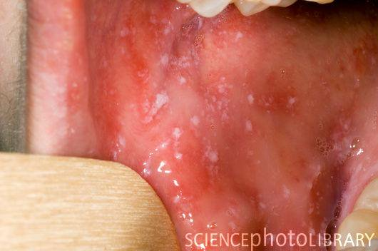

- The rash is maculopapular and semiconfluent; it persists for3 to 5 days before shrinkage.
- Fever and severe systemic symptoms gradually diminish as the rash progresses to the extremities.
Complications
- Bacterial superinfection, the most common complication. Such infections include acute otitis media, mastoiditis, sinusitis, pneumonia, and sepsis.
- Clinical signs of encephalitis develop in 1 of 500 to 1000 cases. The mortality in measles encephalitis is approximately 15%
- Thrombocytopenic purpura and bleeding occur in acute phase
DIAGNOSIS
- Clinical findings, but laboratory confirmation is necessary.
- Virus isolation from the oropharynx or urine is usually most productive in the first 5 days of illness.
- Tissue cultures, producing multinucleated giant cells similar to those observed in infected host tissues.
- Measles antigen may be identified in urinary sediment or pharyngeal cells by DII .
- Serologic diagnosis may involve complement fixation, hemagglutination inhibition, EIA, or indirect fluorescent antibody methods.

German meseals (Rubella)
- Rubella is commonly known as German measles or 3-day measles. The incubation period for acquired infection is 14 to 21 days (average, 16 days). Illness is generally very mild, consisting primarily of low-grade fever, upper respiratory symptoms, and lymphadenopathy. Patients with primary acquired infections are contagious from 7 days before to 7 days after the onset of rash
- A macular rash appeared and lasts 1 to 3 days. This rash, which is often quite faint, is usually most prominent over the head, neck, and trunk.
- Petechial lesions may also be seen over the soft palate (the soft tissue constituting the back of the roof of the mouth) during the acute phase.
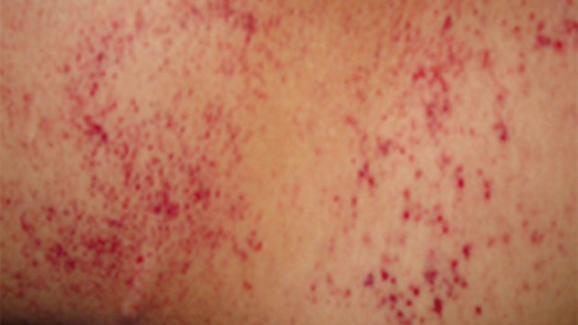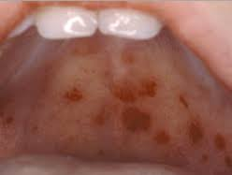

- The most common complication is arthralgia or arthritis, which may affect the joints of the fingers, wrists, elbows, knees, and ankles. Other, rare complications include thrombocytopenic purpura and encephalitis.
- The major significance of rubella is the risk of fetal damage in pregnant women, particularly when they contract primary infection during the first trimester. The risk of fetal malformation and chronic fetal infection is high
- Congenital infection occurs as a result of maternal viremia that leads to placental infection and then transplacental spread to the fetus. After birth, affected infants continue to excrete the virus in the throat, urine, and intestinal tract
PATHOGENESIS
- In acquired infection, the virus enters the host through the URT, replicates, and then spreads by the bloodstream to distant sites, including lymphoid tissues, skin, and organs.
- Cellular immune responses and circulating virus–antibody immune complexes are thought to play a role in mediating the inflammatory responses to infection, such as arthritis.

DIAGNOSIS
- Because of the rather nonspecific nature of the illness, a diagnosis of rubella cannot be made on clinical grounds alone.
- The virus may be isolated from respiratory secretions in the acute phase (and from urine, tissues, and feces in infected infants) by inoculationin to a variety of cell cultures, or detected by PCR.
- Serologic diagnosis is most commonly used in acquired infections. Hemagglutination inhibition, IIF, EIA, and other tests are available.

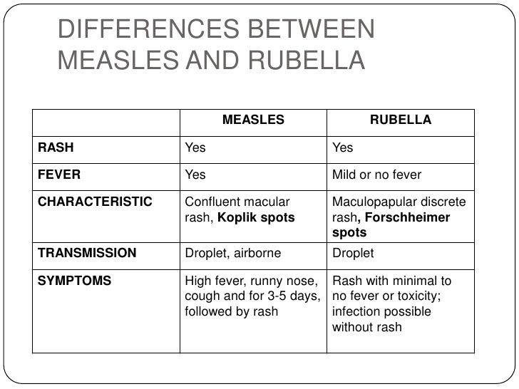

Forschheimer spot: red spots (petechiae) on the soft palate

