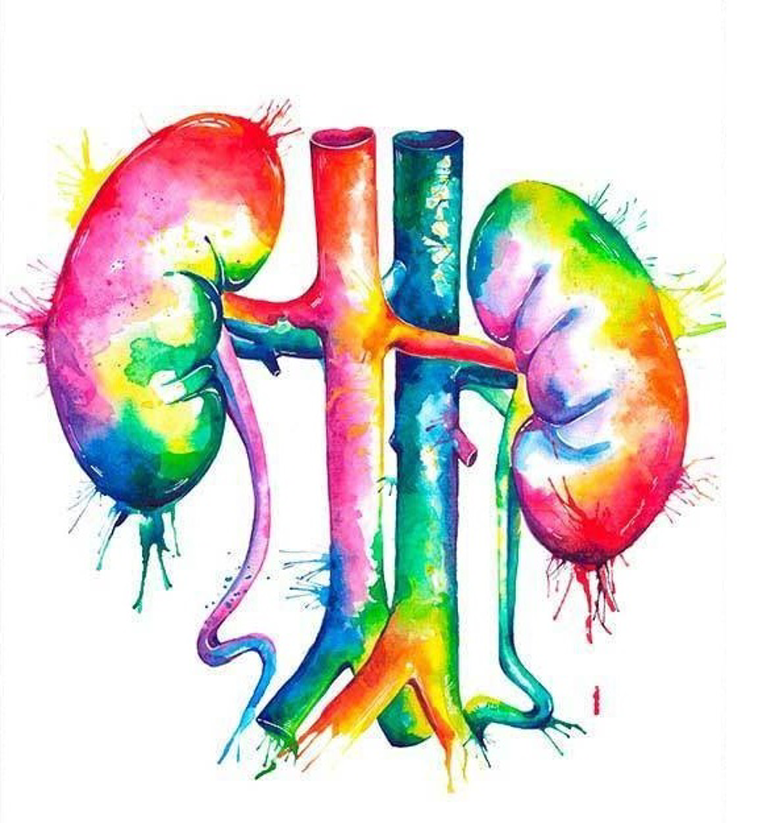• System: GUS
• Subject: physiology ( reabsorption & secretion )
• Sheet # 3
• Lecture Date: 14-4-2020
• Writer:Nour Adel Shahin
• Editor: Nawal Nsour
Sheet Corrections: http://bit.ly/gusphysio

plz read carefully and study the figures and be attention fot the title for each one in this lecture .

✅ **the nephrons are the functional unit in our kidneys , which are consist of :
Glomerulus (bowman’s capsule), Proximal tubule , loop of henle , distal tubule, collecting ducts , medullary collecting duct < pelvis < ureter < bladder
✅** the 4 major process which are done by nephrons :
1-filtration 2-reabsorption(our topic today)3-secretion 4- excretion (which will finally make the urine ).
✅** We previously talked about renal handling of several substances that are all freely filtered in the kidneys and reabsorbed at variable rates.
- Remember: The tubular reabsorption is selective and quantitatively large
The rate at which each of these substances is filtered is calculated as
Filtration of Y= Glomerular filtration rate × Plasma concentration of Y
▪️**keep in mind :
GFR = 125 ml/min = 180 L/day , more than 99% of that filtered fluid will be reabsorbed again through kidney tubes.
TUBULAR REABSORPTION >>>
▪️Tubular reabsorption is quantitatively large and highly selective .
What prof said about the next table :
*glucose ( freely filtered , complete reapsorbe 100 % ) >> no glucose in urine in healthy person >> amount of filtration = amount of reabsorbed = 180 g/day .
*creatinine (freely filtered , complete excreted ) >> reabsorption = 0% , amount of filtration = amount of excreted = 1.8 g/day .
*Bicarbonate , sodium and chloride >> more than 99% of them are reabsorbed , but for potassium it’s a little bit less (88%)
* Urea >> reabsorbed:excreted = 50%:50%

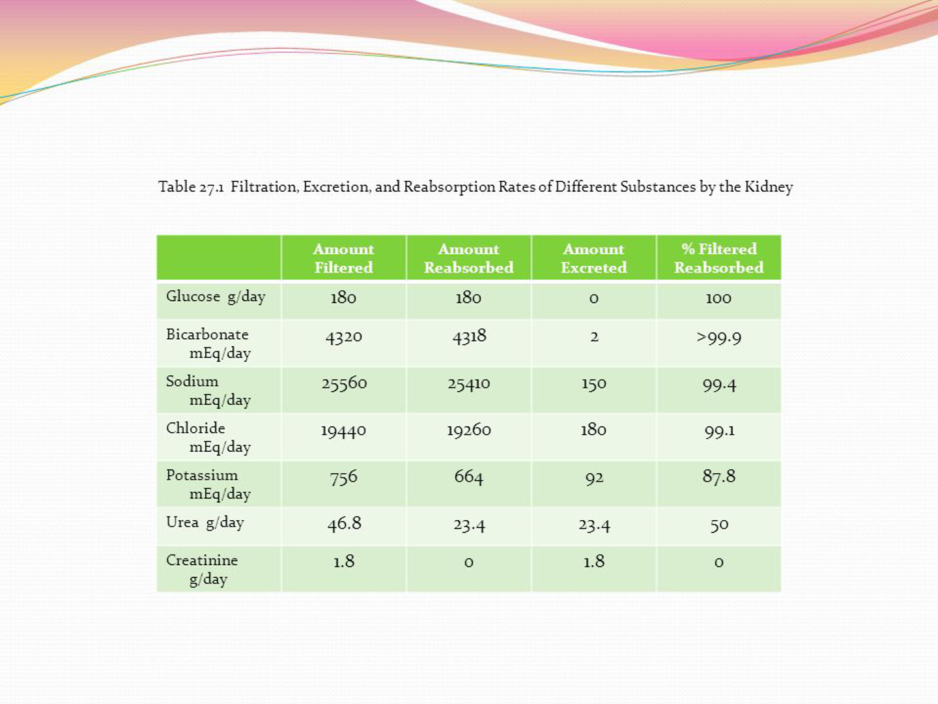

How the reabsorption done ?
The path for the solutes :
From the tubular lumen will pass through tubular epithelial membrane > interstitial space > then to peritubular capillaries and back to the circulation
( not passing directly to BLD )
In order to pass the epithelial cells to reach the interstitium space, the have 2 routes : ( next pic will help u )
1-transcellular route : through the membrane of cells .
2- paracellular route : through the tight junction intercellular spaces .
Substance that takes both routes : solutes , water and Na .

Then , transportation into the capillary wall into BLD by ultrafiltration (bulk flow ) (extra note : this flow is mediated by hydrostatic pressure and colloid osmotic forces bcz the behave as venous ends so there will be net reabsorptive forces . Source : guyton textbook ).

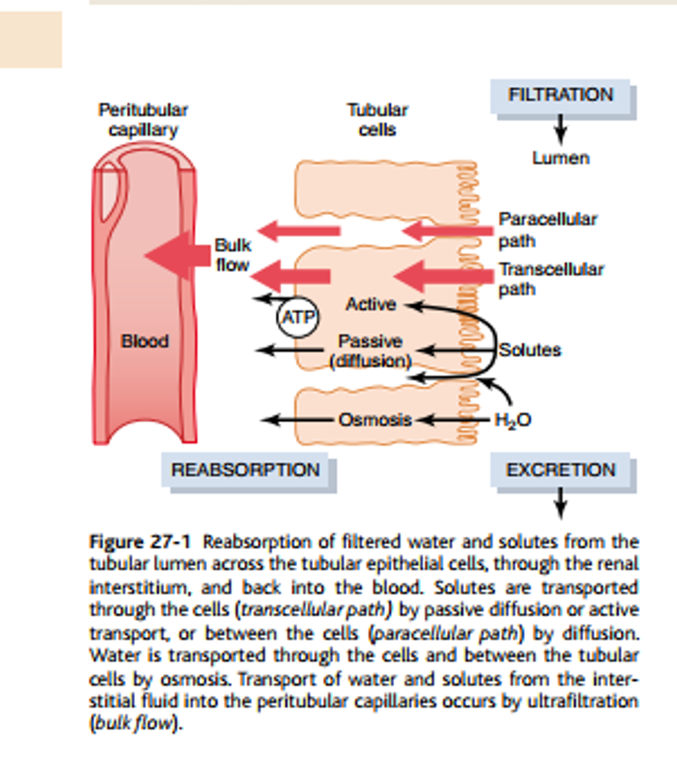

Types of Absorption :
1- active absorption 2- passive absorption .
🔸 active transport :
Active >> that needs energy bcz it transports against the electrical gradient (from low to high).
Examples :
A: primary active transport (major one ) :
That use energy source from hydrolysis of ATP >>
-H-ATPase -H-K ATPase - Ca ATPase – Na-K ATPase
B: secondary active transport :
2 or more substances interact with the carrier and are transported together in the same direction .
-Na-glucose -A.A co-transport .
Source of energy here :
One substance will diffuse down its electrochemical gradient , the energy released is used to drive another substance against its electrochemical gradient . ( Na will diffuse >>> release energy >>>> glucose use it to pass ) .
Prof ex : imagine that u are driving a car and someone is sitting near u , u are the Na that use energy by driving the that some one is the glucose that will be relaxed and just transport.
** sodium glucose co-transporter (SGLT2 >>>> 90% of filtered glucose is reabsorbed by it which is located in early proximal tubule , SGLT1 >>> 10% will reapsobred the residual amount which is located in late in part of proximal tubule . )

C:secondary active secretion :
Counter transporter mechanism : one of the solute get inside the cell and the other one is forced to get out (opposite direction ) into tubular lumen .
-Na-H counter transporter >>>> Na gets into tubular epithelial cells and H ions are forced outward to lumen .
D:pinocytosis :
This occurs in the proximal tubule , which is an active transport (need energy ) of protein by endocytosis . protein attached to luminal membrane then invaginates to inside the cell , then protein will be digested into AA that will be reabsorbed into interstitial space (( we know that protein does not filtrate but this mechanism will occur for protein if they escape in little amount )) .
Please read everything in the picture carefully
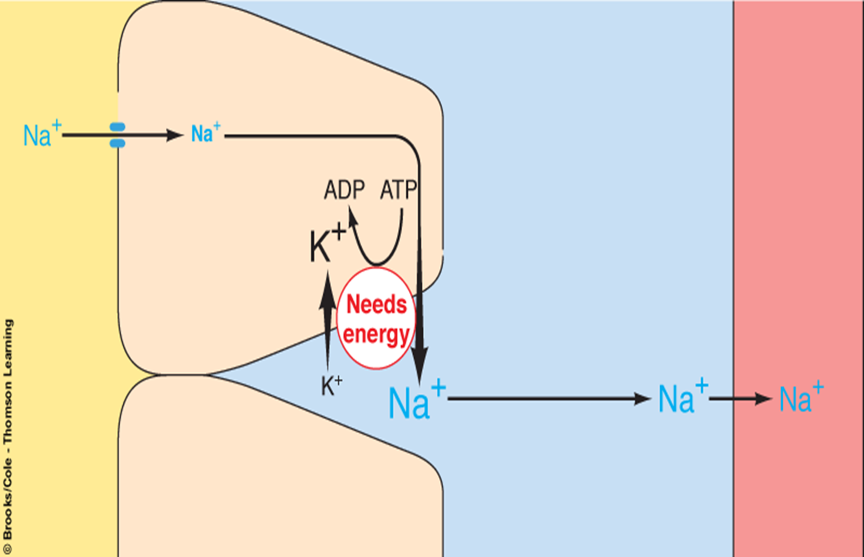
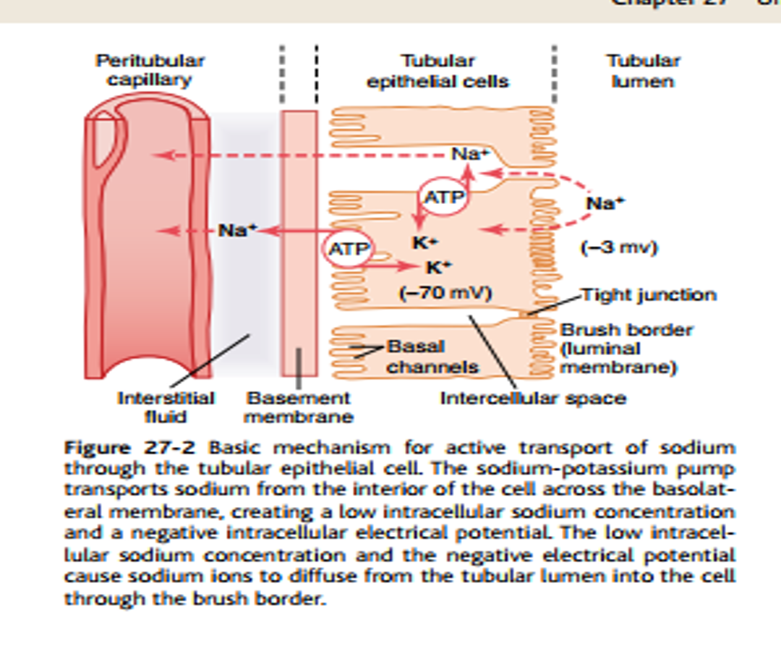
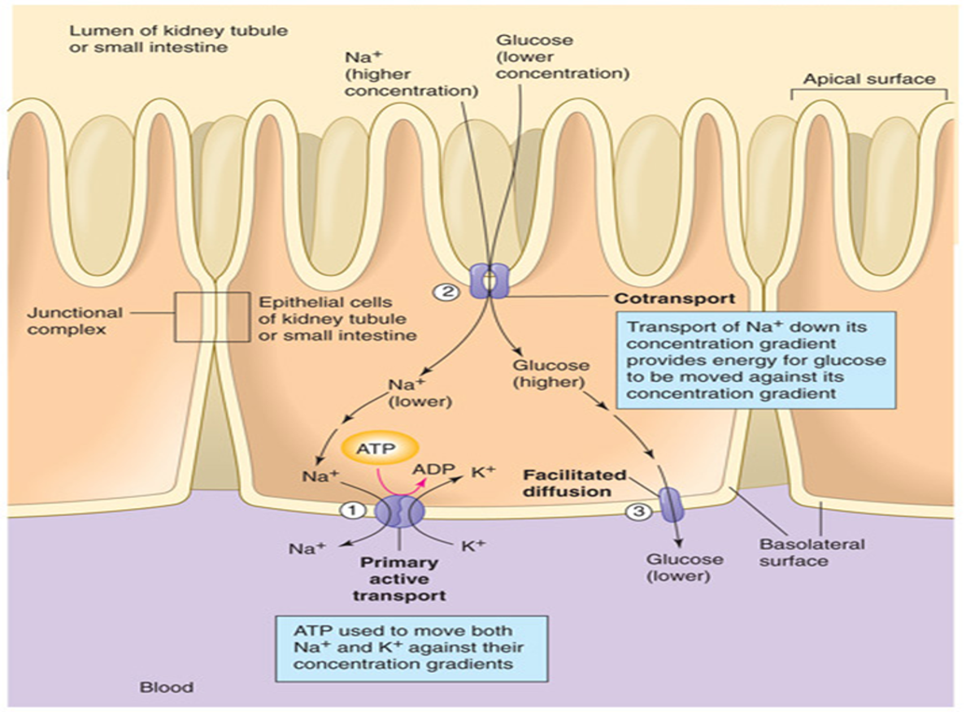
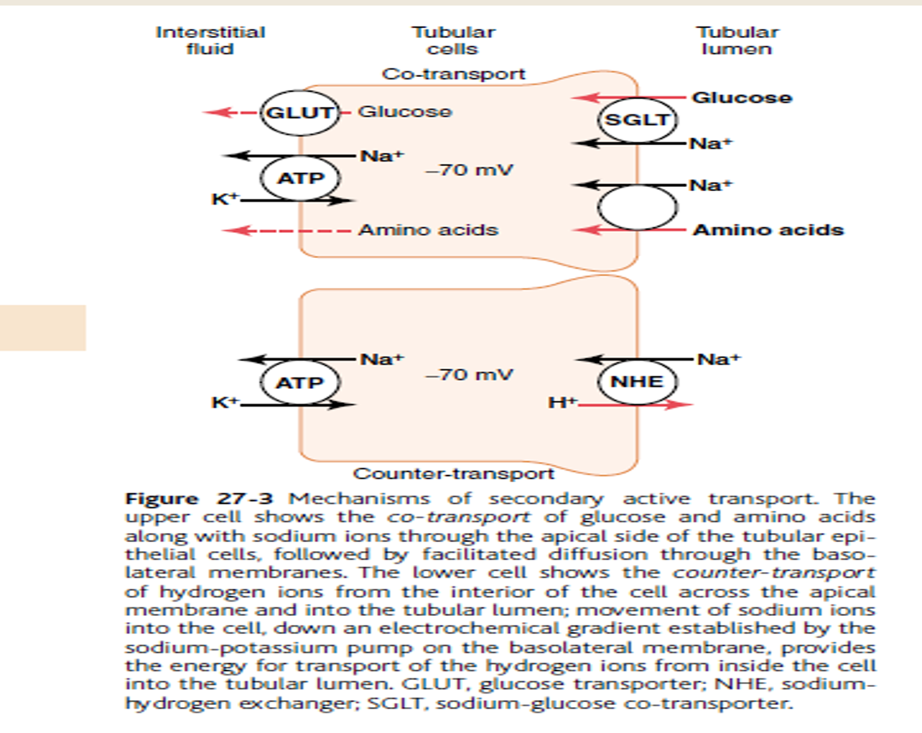

Transporter maximum
This simply means that our nephrons have limitations in transport substances .
So ( for most substances _not all of them _ that are actively reabsorbed or secreted , there is a limit to the rate at which the solute can be transported and back into BLD ) this will happen if the filtration load exceeds carrier capacity .
Ex for better understanding :
Glu normally does not appear in urine , it completely reabsorbed **keep in mind that (this for glucose ) :
Filtered load = GFR * plasma conc. = 125mL/ min .
Tm = 375 mg/min .
So the amount of glucose that gets into the tubule does not exceed the TM , so all of it will be transported and there will be zero in urine (healthy person ) .
In the case of DM , glucose plasma conc will be higher and more amounts will be filtered and that exceed the Tm lead to glycosuria .
Glucose threshold : (extra note : when glu level exceeds the 160-180 mg/dl , the proximal tubule becomes overwhelmed and begins and excrete the glu in urine ) when the glucose conc is higher than 200mg/100ml , filtered load will reach 250mg/min , glucose begin to appear in urine , see the next figure .
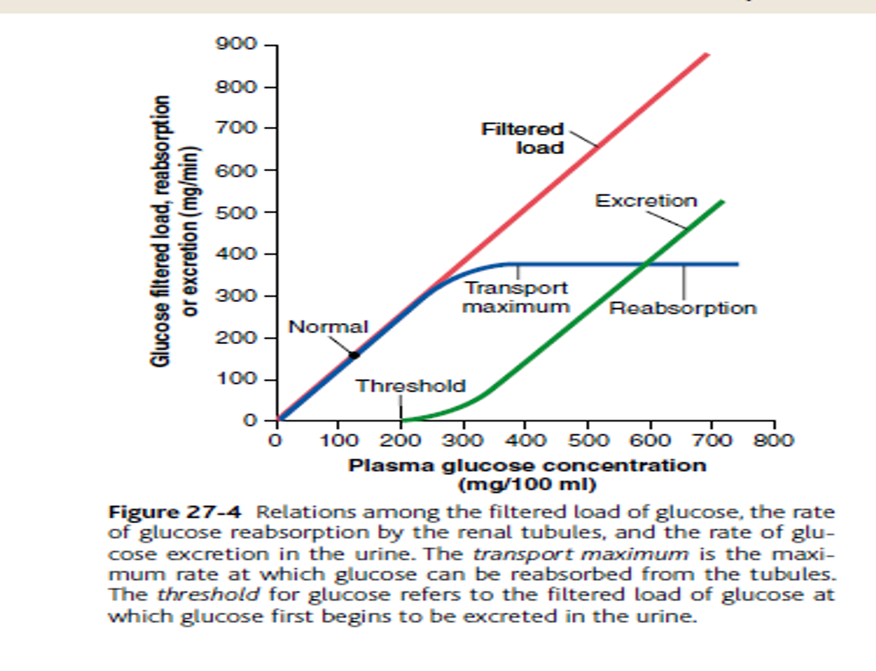
In this figure : when the filtered inc will inc the excretion

But why do we have a difference between Tm and threshold ??
Bcz not all the nephrons work at the same time and not all of them have the same Tm for glucose , so may some nephron start to excrete the glucose while other does not reach their Tm yet .

Tm for some substance :
Creatinine = 16mg/min
PAH = 80 mg/min
AA = 105 mg/min
Plasma protein = 30 mg / min
Urate = 15 mg / min
Note that the sodium in proximal tubule does not have Tm instead it has gradient – time transport ( the greater the conc of Na filtered , the more reabsorbed )

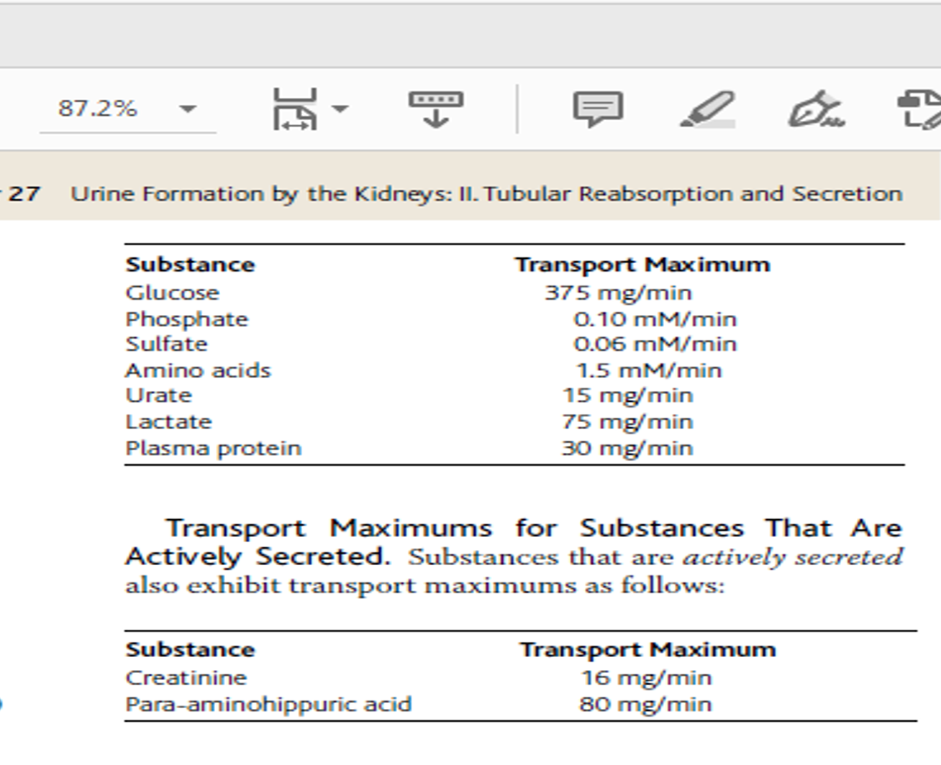
Not all the substances have the same Tm . transport of these depend on :
- Gradient between the tubule and capillary (more gradient more reabsorption )
- Permeability of the membrane
- Gradient time transport ( time that substance in fluid remains in contact with the luminal membrane of the tubule ) , when the flow is at low velocity that means more time for reabsorption .

Lets summaries what we have learnt about Na :
- It is transported by primary active transport mainly in the proximal tubule
-co-transported with glucose , AA .
-counter-transporter with H ions .
- obeys gradient time .
- no Tm in proximal tubules , but has Tm in distal tubules and this can increase by aldosterone .
passive transport
simply no need for energy .
A: osmosis of water is coupled mainly to Na reabsorption :
In proximal tubule osmotic flow of H2O through tight junction , high permeability to H2O and less permeability (but still significant for Na CL, K , Ca and Mg ) , so water moves by osmosis and carry with it some solutes this mechanism called solvent drag.
Keep in mind that in the ascending part in the loop of henle to collect ducts , the permeability of H2O will decrease and other solutes so that antidiuretic ADH will increase the permeability ( discussed later ) .

B:diffusion :
Mainly for CL ( by paracellular path ) and less extent urea
(Medullary collecting duct )( do not forget that is 50% reabsorbed ) reabsorbed by creating conc gradient generated by active Na reabsorption. Mainly through paracellular

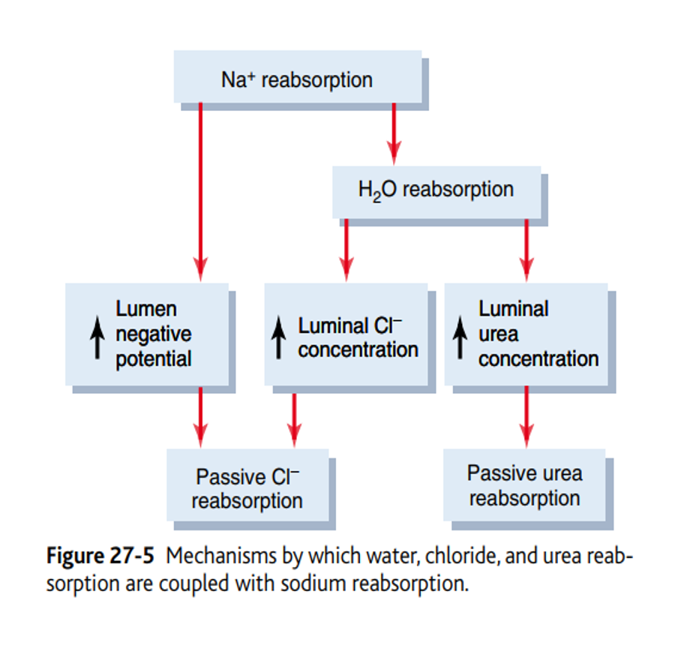
(that is transported of positively charged Na ions out of the lumen ( active transport of Na ) leaves the lumen with negative charged compared to interstitial space . this make the cl pass by electrical gradient . also , osmosis of H2O developed cl concentration gradient which will contribute in transport CL passively .

REABSORPTION AND SECRETION IN DIFFERENT PARTS OF THE NEPHRON

Secretion : get into the kidneys tubules not by glomerular filtration (out of bld and into the urine )
proximal tubule :
65% of filtered load of H2O and Na+ and slightly lower of filtrated Cl- reabsorbed (active and passive ) .
The proximal tubule epithelial cell extensive membrane surface area for rapid transport of these substance :
- large num of mitochondria and extensive brush border
- extensive labyrinth of intercellular and basal channels .
In proximal tubules reapsorption :
- cotransport Na ( large fraction ) with AA , glu .
- counter-transporter Na and H ions .
- in the first half of the tubule (large cotransport of Na with AA and Glu and little for Cl absorption ) BUT in the second half ( little for AA and Glu absorption and large absorption for CL- ) .
In proximal tubules secretion :
- organic acids and bases ( bile salt , oxalate , urate , catecholamines ) , these are products of metabolism .
- harmful drugs ( salicylates and penicillin ) and PAH (aminohippuric acid ) .

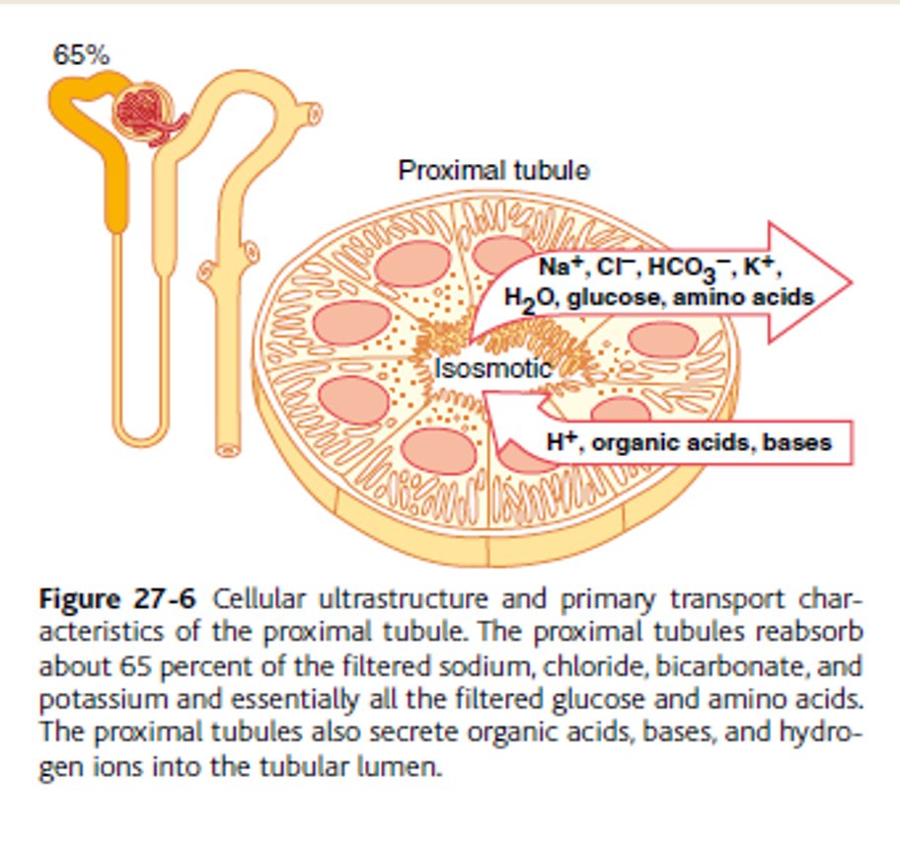
This for the next figure :
AA and glu HCO3- significantly dec during time .
Creatinine inc bcz of secretion , urea inc also but in less than creatinine
CL- little dec
Na+ reabsorption is always increase , but concentration of Na and osmolarity stay constant bcz of H2O permeability
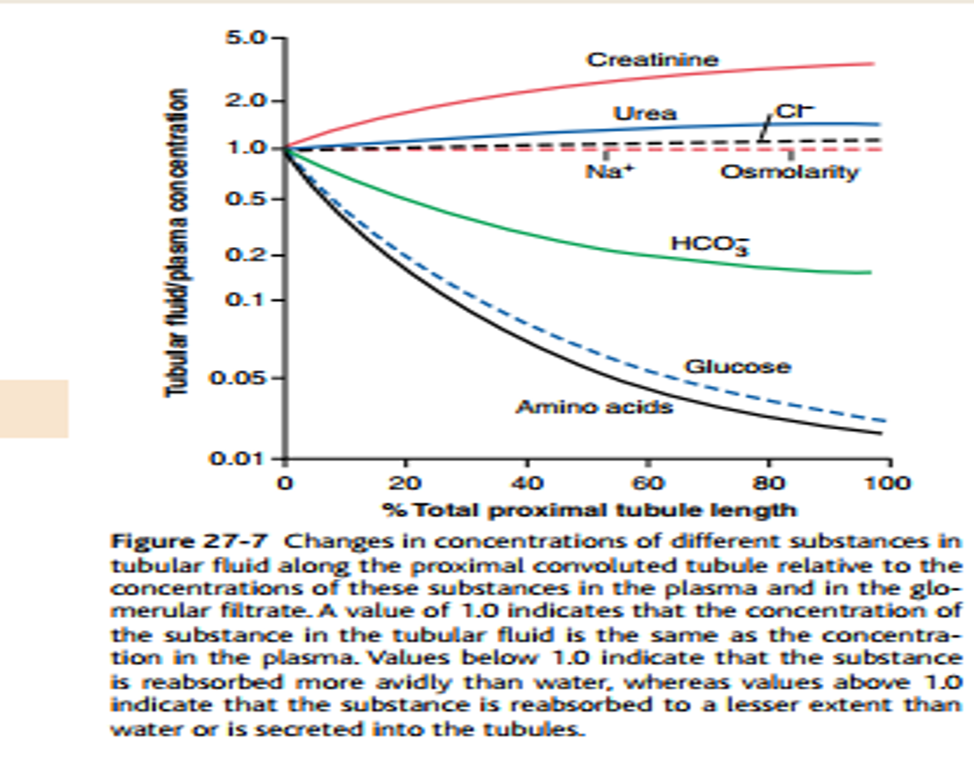

loop of henle (more details about this in next lectures )
>> U shape
anatomically , it has 2 part :
Descending thin limb :
-minimal level of metabolism –highly premeable to H2O (20% of filterated H2O reabsorbed here )– moderate permeable to solute ( Na , salt and urea ) .
Ascending limb :
Thin segment > impermeable to H2O
Thick segment > -high level of metabolism –the site of action of loop diuretic –reabsorption >> Hco-3, Ca+2, Mg+2 , (K+ , Na+ , CL-2 (co-transporter))>> so it will make this the hypoosmotic part in kidney –reabsorbs 25% of filtered load NaCl - permeable to water .
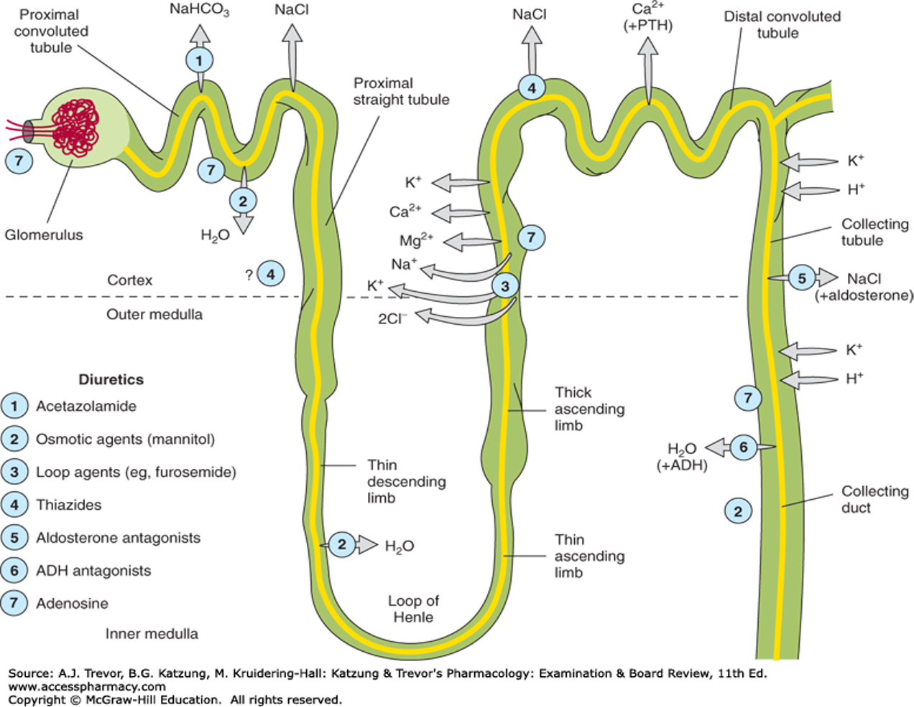
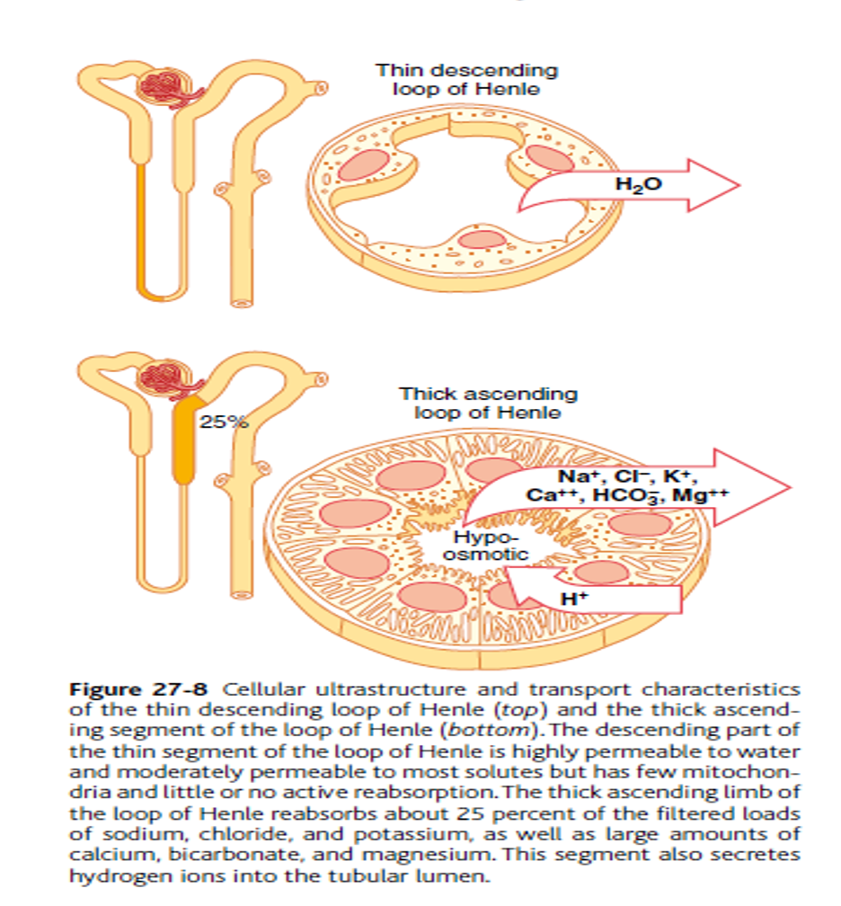
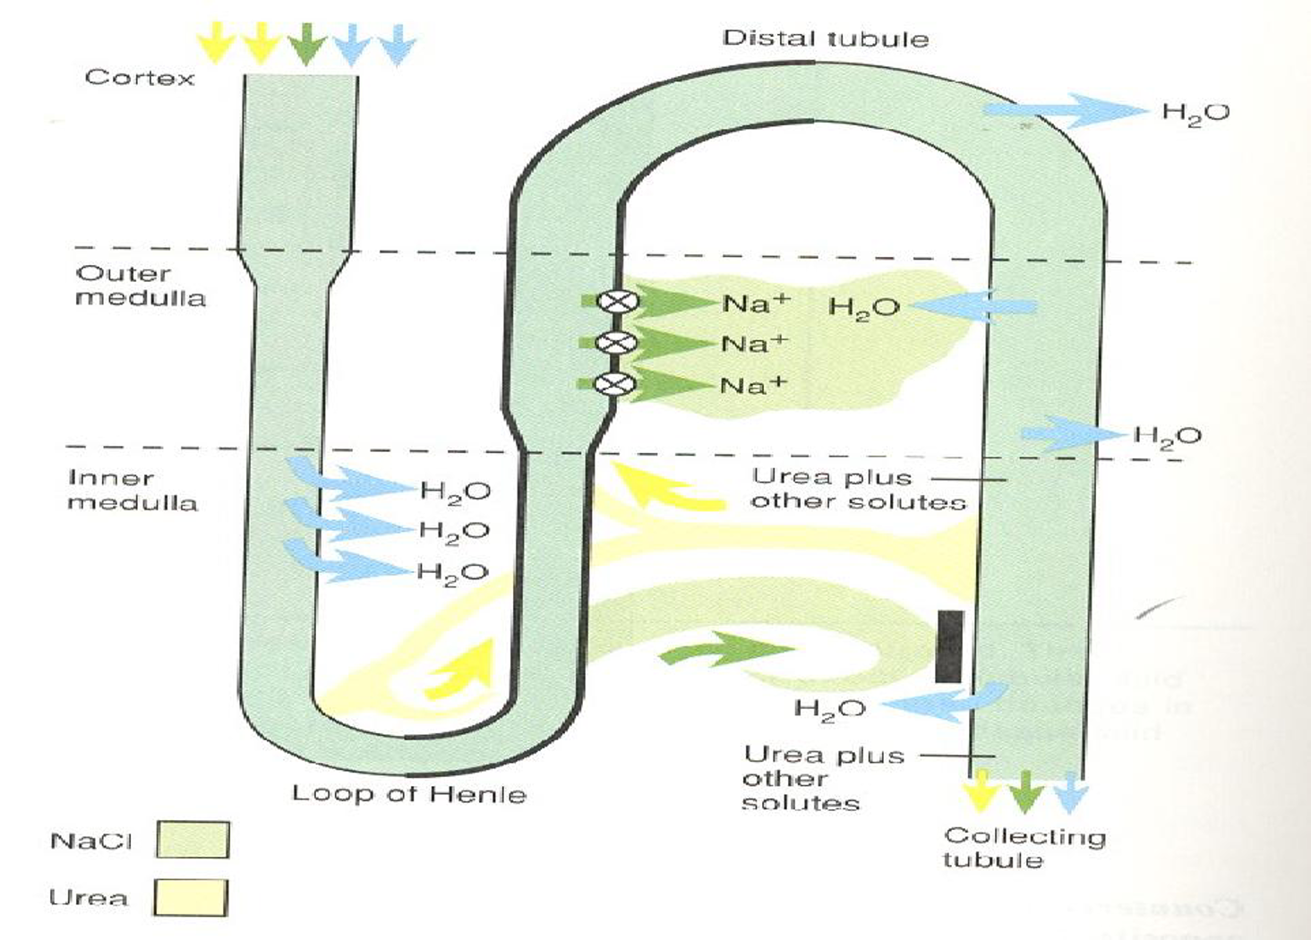

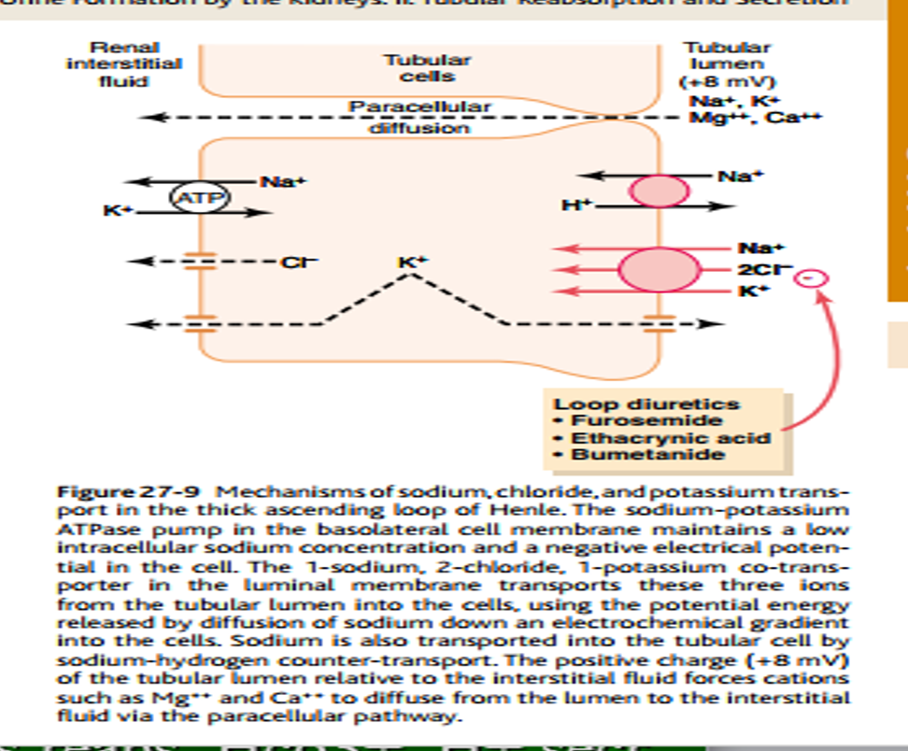

Distal tubule
First portion is macula densa >> they are sensitive to concentration of sodium chloride passing the tubule
It has 2 part :
Early part >> diluting segment , as thick ascending seg , absorbed 5% of filtered load of NaCl .
Late part along with cortical collecting tubule (both have similar fxn ) ,
-impermeable to urea –Na reabsorb by aldosterone
they are composed of :
- principal cells :
-reabsorb Na and water
-secrete K ( site of action of K sparing diuretics site > we will take it in pharmacology and prof did not talk about it .
2- intercalated cells :
-type A >> reabsorb HCO3- , secrete H+ .
-type B >> reabsorb H+ , secrete HCO3- . ( opposite in fxn )).
*** they play a major role in acid – base regulation .
*** both secrete and reabsorb K+ .
*** H2O permeability controlled here by ADH .
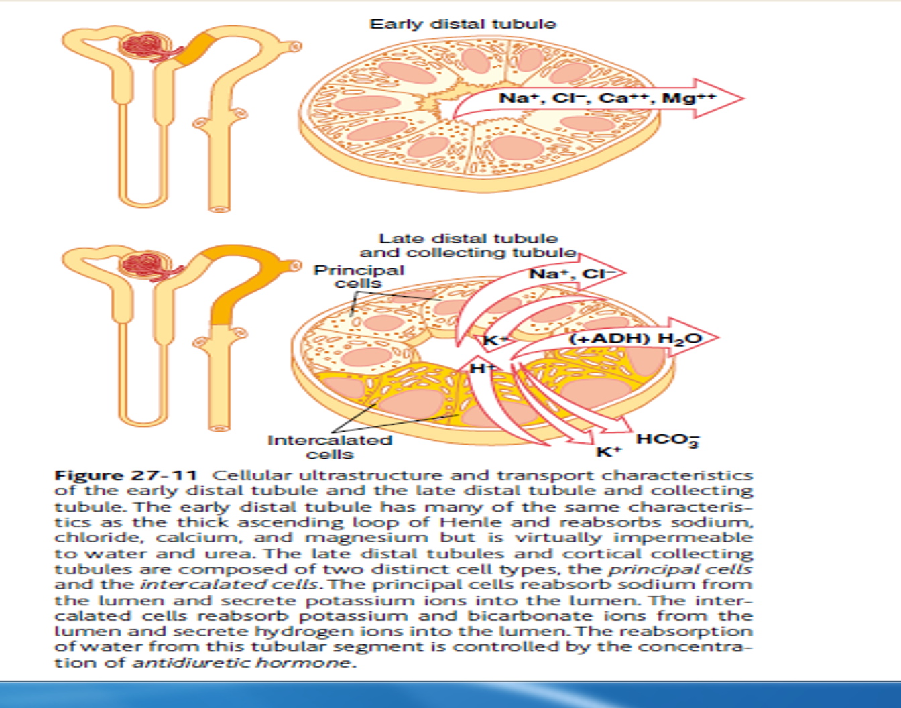

this for the next figure :
in distal and cortical , these drugs are working here ( take them in pharma.
Note collecting duct has 2 parts : medullary and cortical and both imp in diluting and concentrated the urine .
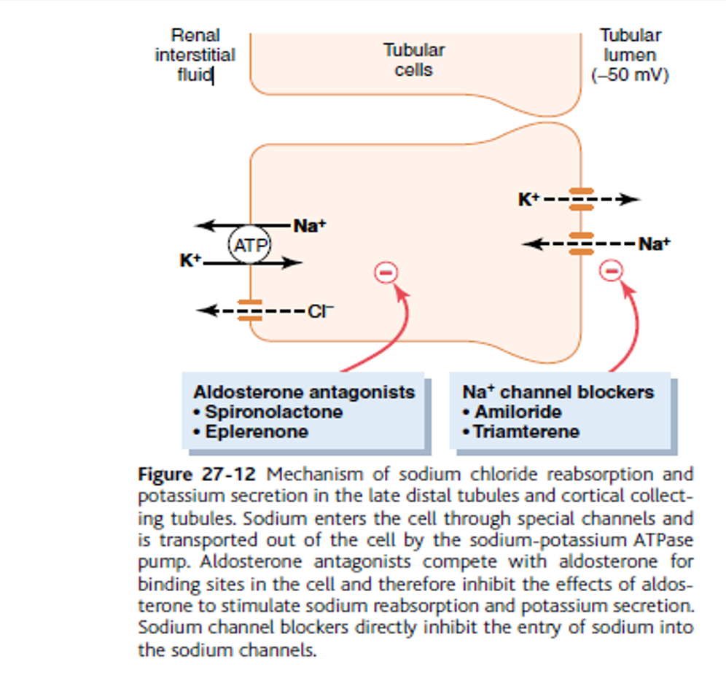

Medullary collecting duct
Final site for processing the urine
- Absorbe about 20% of filtered water( under control of ADH ) and Na
- Permeable for urea > can reabsorb urea to inc osmolarity to form urine
- H+ secretion
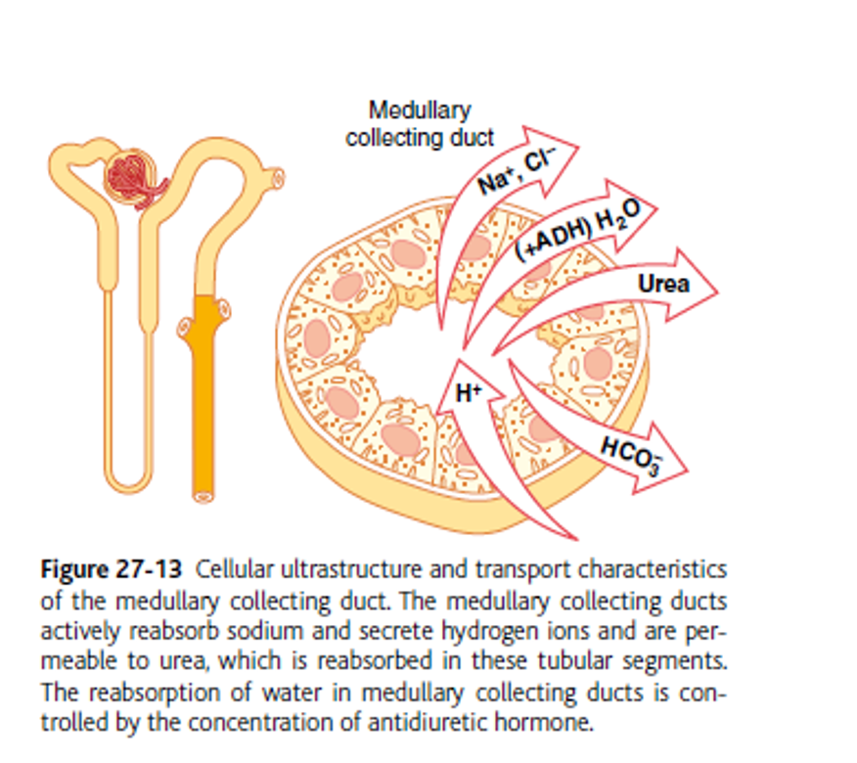

Summary :
-each live represents concentration of solute in different part in tubules .
-glu , protein , aa all of them reabsorb in proximal tubule
- PAH , creatinine , inuline , urea >> are products of metabolism so the concn will inc along tubules to get rid of our body .
- CL , K and Na it will inc in loop of henle then will dec then inc but the increment will be less than PAH , creatinine , inuline , urea.
-HCO3- it dec also .

