Al Balqa Applied University
College of Sciences
Dr. Hala Al Daghistani
Aerobic infections

Major Causes of Skin and Wound Infections
Impetigo Group A streptococci, Staphylococcus aureus
Folliculitis Pseudomonas aeruginosa, Candida albicans, Staphylococcus aureus
Acne Propionibacterium acne
Furuncle Staphylococcus aureus
Cellulitis Group A streptococci, Staphylococcus aureus, Haemophilus influenza
Intertrigo Inflammation caused by the rubbing of one area of skin on another. Staphylococcus aureus, Candida albicans, Enterobacteriaceae
Chronic ulcers Treponema pallidum, Sporothrix, Herpesvirus, Haemophilus ducreyi , Corynebacterium, Bacillus anthracis, Nocardia, Mycobacterium

Wounds
Trauma Clostridium, Enterobacteriaceae, Pseudomonas aeruginosa,
- Surgical (clean) Staphylococcus aureus, Enterobacteriaceae, Group A streptococci
- Surgical (dirty) Staphylococcus aureus, Enterobacteriaceae, Anaerobes
Burns Pseudomonas aeruginosa C. albicans S. aureus, Enterobacteriaceae
Animal bites Pasteurella multocida
Folliculitis التهاب الجريبات
Folliculitis is the name given to a group of skin conditions in which there are inflamed hair follicles. The result is a tender red spot, often with a surface pustule. It can affect any where there are hairs, including chest, back, arms and legs
- is a minor infection of the hair follicles and is usually caused by S. aureus.
- often associated with areas of friction and of sweat gland activity and is thus seen most frequently on the neck, face, and axillae.
- Blockage of ducts with thick sebum, predisposes to the condition.
- Folliculitis can also be caused by Pseudomonas aeruginosa, and this form of the disease has become more common in recent years, with the popularity of hot tubs and pool baths. Unless these facilities are thoroughly cleansed and adequately chlorinated, they can grow large numbers of pseudomonads at their normal operating temperatures, causing extensive folliculitis on areas of the body that have been immersed.
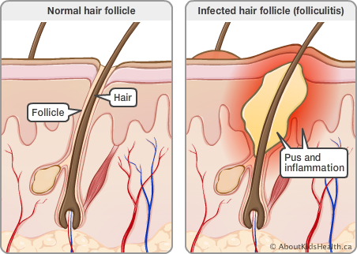
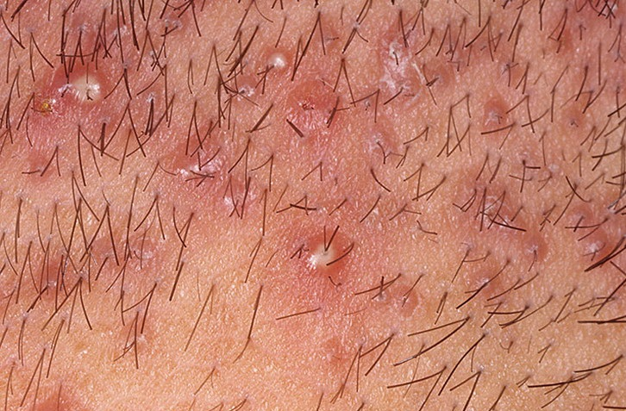
- Occasionally, folliculitis may be caused by infection with Candida albicans. Such cases are particularly common in immunocompromised hosts.

Acne vulgaris حب الشباب
Acne and its variants are also types of folliculitis.
- Involves inflammation of hair follicles and associated sebaceous glands.
- Four key elements of pathogenesis:
- follicular epidermal hyperproliferation
- excess sebum production
- Inflammation
- the presence and activity of Propionibacterium acnes.
- The comedo of acne results from multiplication of Propionibacterium acnes, the predominant anaerobe of the normal skin, behind and within inspissated sebum.
- Organic acids produced by the organism are believed to stimulate an inflammatory response and thus contribute to the disease process.
- However, the primary cause of the disease is hormonal influences on sebum secretion that occur at puberty, and the disease usually resolves in early adult life.
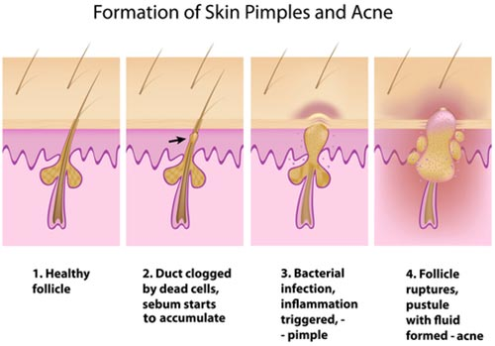
The key difference between acne and folliculitis is the location: folliculitis can be anywhere there is a hair follicle, whereas, acne is only located on your face, chest, or back.
Furuncle الدمل
- A furuncle (boil), is a deep folliculitis, infection of the hair follicle. It is most commonly caused by infection by the bacterium Staphylococcus aureus.
- A Carbuncle is an interconnected boils arising in a cluster of hair follicles
- Spread of infection to the dermis and subcutaneous tissues can result in a more extensive multiloculated abscess, the carbuncle.
- Chronic furunculosis may require attempts to eliminate nasal carriage of S. aureus, which is sometimes the source of the infection.
Infection of Keratinized Layers
- The only organisms that can use the keratin on cells, hairs, and nails are the Dermatophyte fungi.
- The dermatophytes are particularly well adapted to these sites, cannot grow at 37°C, and fail to invade deeper layers. The clinical manifestations of these infections result from the inflammatory and delayed hypersensitivity responses of the host, and the desquamation
Impetigo Pyoderma الحصف المقيح للجلد
Pyoderma: means any skin disease that is pyogenic (has pus). These include superficial bacterial infections such as impetigo, folliculitis, furuncle, tropical ulcer..etc.
- Impetigo is a common and highly contagious skin infection that mainly affects infants and children. Usually appears as red sores on the face, especially around the nose and mouth, and on hands and feet.
- The disease is caused primarily by group A Streptococci.
- The initial lesion is often a small vesicle that develops at the site of invasion and ruptures with superficial spread characterized by skin erosion and a serous exudate, which dries to produce a honeycolored crust.
- The exudate and crust contain numerous infecting Streptococci.
- S. aureus may occasionally produce pustular impetigo or contaminate the lesions caused by streptococci. Epidemic impetigo is most common in childhood and under conditions of heat, humidity, poor hygiene, and overcrowding. The infection may be spread by fomites such as clothing and towels.
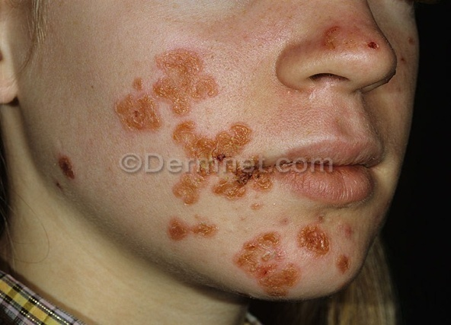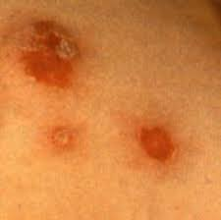
Bullous Impetigo الحصف الفقاعي
Bullous impetigo is a bacterial skin infection caused by Staphylococcus aureus that results in the formation of large blisters called bullae, usually in areas with skin folds includin the axilla, groin, between the fingers or toes, beneath the breast, and between the buttocks.
- is a distinct disease caused by strains of S. aureus that produce exfoliation. It is most common in small children, but may occur at any age.
- The infection is characterized by large serum-filled bullae (blisters) within the skin layers at the site of infection.
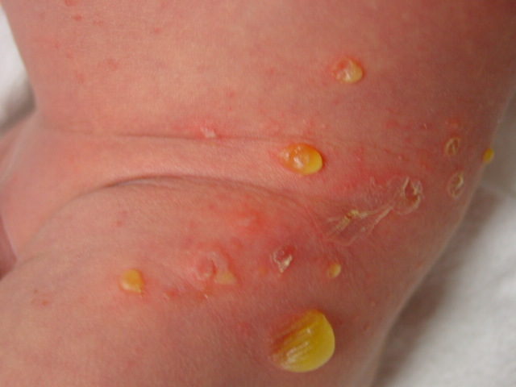

Erysipelas الحمرة
Erysipelas is a bacterial infection in the upper layer of the skin. It is an infection of the upper dermis that extends into the superficial cutaneous lymphatics.
- Is usually caused by beta-hemolytic group A Streptococcus on scratches or otherwise infected areas.
- It is similar to another skin disorder known as cellulitis, but erysipelas is more superficial than cellulitis, and is typically more raised and demarcated.
- Erysipelas may rapidly spread to the deeper layers of the dermis and progress to septicemia or local necrosis of skin.
- It is associated with edema of the skin; marked erythema; pain; and systemic manifestations of infection, including fever and lymphadenopathy.
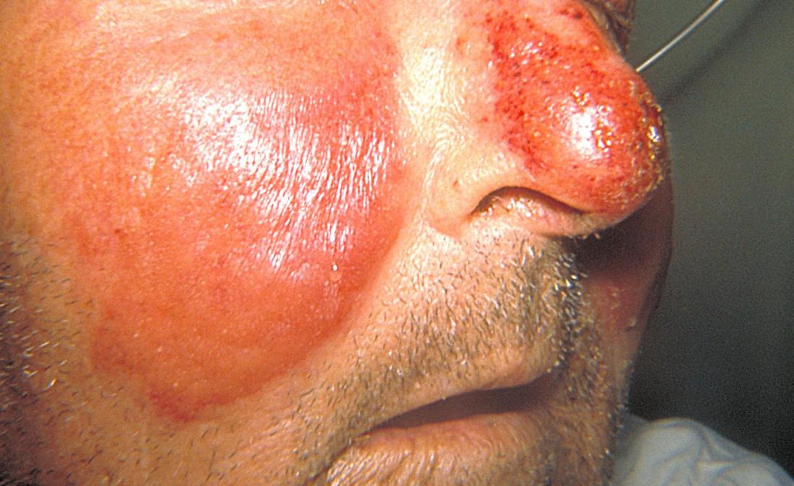
Cellulitis التهاب النسيج الخلوي
Cellulitis: inflammation of subcutaneous connective tissue
- it is not a skin infection as such, but it can develop by extension from skin or wound infections.
- It can be caused by many pathogenic bacteria, but S. aureus and group A streptococci are most common. Haemophilus influenzae type b is a cause in infants and children. Enteric Gram-negative rods, clostridia, and other anaerobes may also cause cellulitis as a complication of wound infections, particularly in immunocompromised hosts and individuals with uncontrolled diabetes.
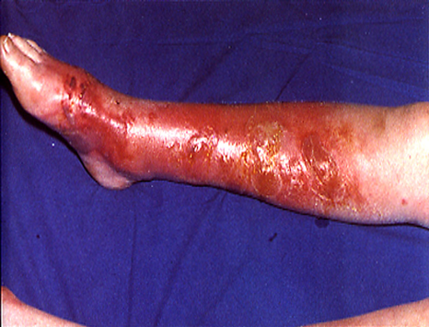

Skin Ulcers and Granulomatous Lesions القرح والافات الحبيبية
- Many acute and subacute skin infections are characterized by ulceration or a granulomatous response.
- Some are sexually transmitted and, others derive from systemic infection and are not direct infections of skin.
- Herpes simplex virus can invade through the skin to produce a local vesicular lesion followed by ulceration.
- Skin diphtheria, is remains common in some tropical areas. The organism gains access through a wound or insect bite and causes chronic erosion and ulceration of the skin, sometimes with evidence of the systemic effects of diphtheria toxin.
- Mycobacterium marinum produces a self-limiting granuloma, usually of the forearms and knees. The organism usually enters through superficial abrasions from rocks or swimming pool walls.

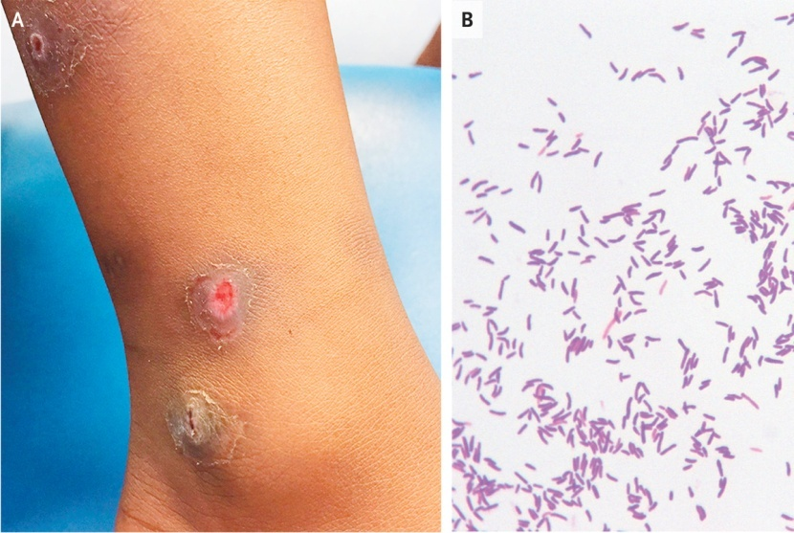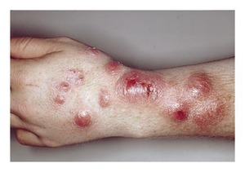
- Infections with M. ulcerans are more serious and produce progressive ulceration.
- Several rare forms of necrotic spreading skin ulceration tend to develop in immunosuppressed hosts, in diabetics, and as complications of abdominal surgery.

WOUND INFECTIONS
Wounds subject to infection can be surgical, traumatic, or physiologic. The latter include the endometrial surface, after separation of the placenta, and the umbilical stump in the neonate.
- Traumatic wounds comprise such diverse damage as deep cuts, compound fractures, frost bite necrosis, and thermal burns.
Sources of infection include
- the patient’s own normal flora
- material from infected individuals or carriers that may reach the wound on fomites, hands, or through the air
- pathogens from the environment that can contaminate the wound through soil, clothing, and other foreign material.
Examples of such infections include contamination of a penetrating stab wound to the abdomen by colonic flora, contamination of a clean surgical wound in the operating room with S. aureus spread from the flora of a perineal carrier, and introduction of spores of Clostridium tetani into the tissues on a splinter.
Classification of Wounds
Surgical and traumatic wounds are classified according to the extent of potential contamination and thus, the risk of infection.
- Clean wounds are surgical wounds made under aseptic conditions that do not traverse infected tissues or extend into sites with a normal flora. Infection rates in clean surgical wounds should be less than 1%
- Contaminated wounds include fresh surgical and traumatic wounds with a major risk of contamination, such as incisions entering infected tissues.

Factors Contributing to Wound Infection
- The contaminating dose of microorganisms , their virulence can be critical
- The physical and physiologic condition of the wound also influences the probability of infection (areas of necrosis, hematomas, excessive edema, poor blood supply, all compromise normal defense mechanisms.
- The general health, nutritional status, and ability of patients to mount an inflammatory response are also major determinants of whether a wound infection develops.
- Infection rates are higher in the elderly, the obese, individuals with uncontrolled diabetes, and those on immunosuppressive or corticosteroid therapy.
- Nutritional deficiencies enhance the risk of infection
Etiologic agents of wound infections
- S. aureus remains the single most common cause of infection of clean surgical wounds; however, the number of infections caused by opportunistic Gram-negative organisms is increasing.
- Severe invasive group A streptococcal infections with the toxic shock-like syndrome often begin with a simple skin or wound infection.
- Anaerobic Gram-negative wound infections have been reported increasingly in the last two decades or so as a result of the higher incidence of such infections in immunocompromised patients and better laboratory recognition.
- Most infecting organisms derive from normal floral sites and the majority are Bacteroides, often in combination with anaerobic Gram-positive cocci and facultative aerobic bacteria.
- However, P. aeruginosa causes particularly serious infections in burns, with loss of skin grafts and a high risk of septicemia and death. If the fluid electrolyte and nutritional deficiencies of a burned patient can be controlled, the greatest hazard to life is infection.

