Blood–brain barrier
There are three types of Blood Brain Barrier (BBB) all collectively known as Blood Brain Barrier:
(a) The blood–brain barrier is a barrier between the lumen of cerebral blood vessels and brain parenchyma.
i. The capillaries in the brain substance
resemble non-fenestrated capillaries in muscle
there are tight junctions between the endothelial cells that limit the passage of substances through the junctions; forming the physical barrier of the inter-endothelial cleft
there are relatively few vesicles in the endothelial cytoplasm
presumably little vesicular transport.
ii. Outside the endothelial cell is a basement membrane which also surrounds the pericytes.
iii. Around all these structures are the astrocytic end-feet processes from nearby astrocytes. These end-feet are closely applied to the basal lamina of the capillaries, but they do not cover the entire capillary wall, and gaps of about 20 nm occur between end-feet.
All these structures together are often referred to as the neurovascular unit.
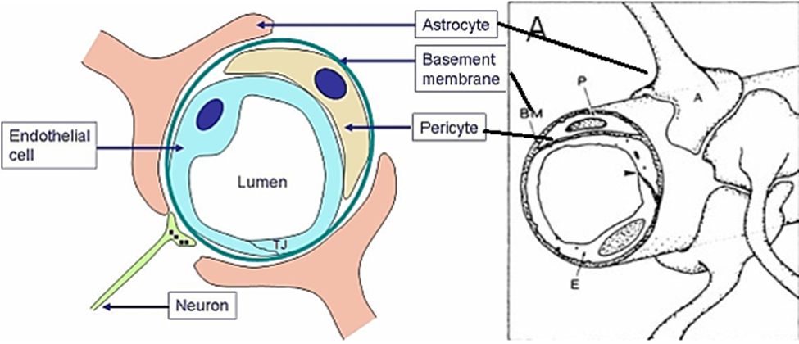
(b) The blood–CSF barrier, a barrier between choroid plexus blood vessels and the CSF.
i. The choroid plexus is continuous with the ependymal cell layer that lines the ventricles, but unlike the ependyma, the epithelial layer has tight junction between the cells on the side facing the ventricle (apical surface).
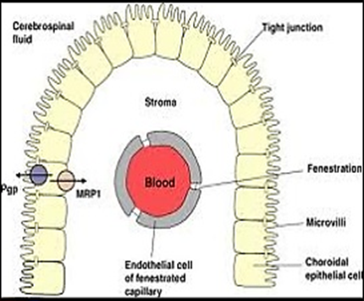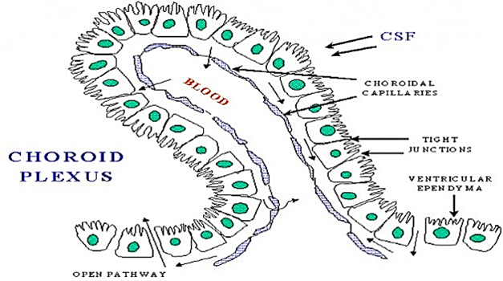
ii. There are gaps between the endothelial cells of the capillary wall, blood vessels are fenestrated and form a nonrestrictive barrier
(c) The meningeal barrier is the least studied and structurally most complex of all the brain barriers.
The areas outside the blood–brain barrier; in or near the brain stem and all have fenestrated capillaries are referred to collectively as the circumventricular organs (around the ventricle), can be classified as:
A. The sensory organs
They have the ability to sense plasma molecules and then pass that information into other regions of the brain. Through this, they provide direct information to the autonomic nervous system from the systemic circulation Area postrema ► Subfornical organ (SFO) Vascular organ of the lamina terminalis
B. The secretory organs
These organs are responsible for secreting hormones and glycoproteins into the peripheral vascular system using feedback from both the brain environment and external stimuli. Subcommissural organ.Posterior pituitary. Median eminence. Pineal gland.
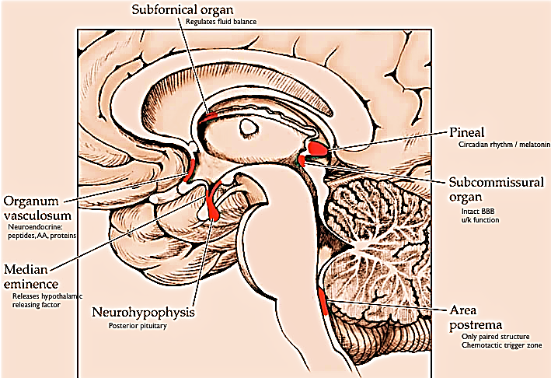
Functions of the blood-brain barrier
1. Blood-brain barrier maintains a constant environment for neurons in the CNS
2. Blood-brain barrier protects the brain from endogenous or exogenous toxins.
3. Blood-brain barrier prevents the escape of neurotransmitters from their functional sites in the CNS into the general circulation.
Drugs penetrate the blood-brain barrier to varying degrees. For example, non-ionized (lipid-soluble) drugs cross more readily than ionized (water-soluble) drugs.
Inflammation, irradiation, and tumors may destroy the blood-brain barrier and permit entry into the brain of substances that are usually excluded (e.g., antibiotics, radiolabeled markers).
Blood–brain barrier is immature at birth
Water, CO2, and O2 penetrate the Blood–brain barrier with ease, as do the lipid-soluble free forms of steroid hormones, whereas their protein-bound forms and, in general, all proteins and polypeptides do not
Regulation cerebral blood flow:
Cerebral blood flow is highly related to the tissue metabolism.
A. Several metabolic factors are believed to contribute to cerebral blood flow regulation:
(1) Carbon dioxide concentration and hydrogen ion concentration,
Carbon dioxide is the most important cerebral vasodilator, but it does not work directly but through increase hydrogen ions this is why acidic substances as lactic acid, pyruvic acid also induce dilation.
Small changes in arterial CO₂ are particularly potent to change cerebral blood flow (1 mmHg variation in arterial CO₂ changes cerebral blood flow by 3%–4%)
(2) Oxygen concentration,
The rate of oxygen utilization by the brain tissue 3.5 (±0.2) milliliters of oxygen per 100 grams of brain tissue per minute.
Cerebral tissue partial pressure of oxygen (PO2) normal value is 35 to 40 mm Hg
The oxygen deficiency (below 30mm Hg) almost immediately causes vasodilation
Fall in cerebral Po2 below 20 mmHg can lead to a coma
(3) Substances released from astrocytes
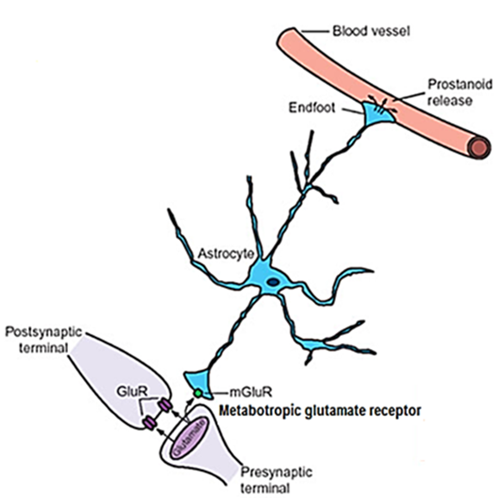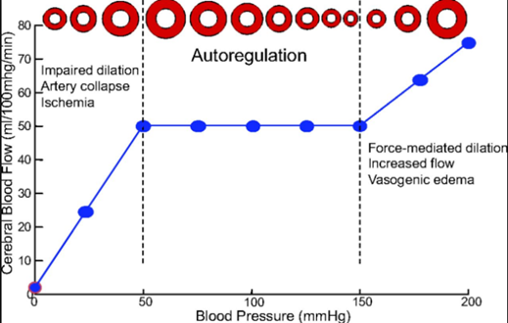
Gray matter astrocytes (protoplasmic astrocytes) extend fine processes that cover most synapses.
Neurotransmitters released from active neurons also join the Metabotropic glutamate receptor at astrocytes

Increase Calcium inside astrocytes

Release vasodilator mediators are still unclear (nitric oxide, metabolites of arachidonic acid, potassium ions, and adenosine) from astrocyte end-feet onto blood vessels
B. Mean Arterial blood pressure
Cerebral blood flow is “autoregulated” extremely well between arterial pressure limits of 60 and 140 mm Hg. During normal daily activities, arterial pressure can fluctuate widely, rising to high levels during states of excitement or strenuous activity and falling to low levels during sleep.
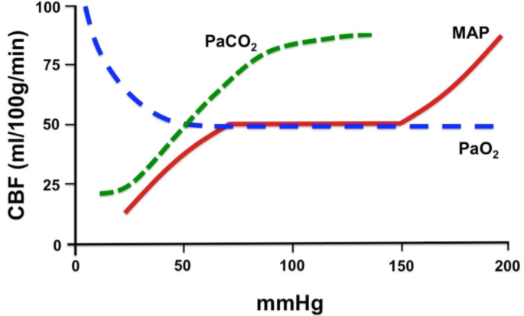
C. Intracranial pressure
Intracranial pressure (ICP) is the pressure inside the skull and thus in the brain tissue and CSF.
Intracranial pressure (ICP) is the pressure applied on the brain by blood or mass or CSF
Intracranial pressure normally at supine position less than 15 mmHg
The cranial cavity normally contains a brain weighing approximately 1400 g, 75 mL of blood, and 75 mL of spinal fluid. Because brain tissue and spinal fluid are essentially incompressible, the volume of blood, spinal fluid, and brain in the cranium at any time must be relatively constant (Monro–Kellie doctrine).
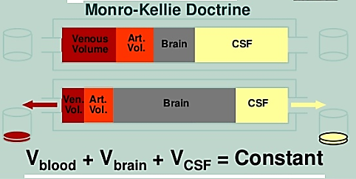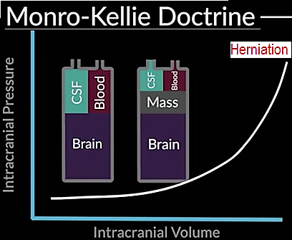
Intracranial pressure will increase by: mass (tumor), Brain swelling (edema, bleeding), increase venous pressure (venous thrombosis), Obstruction CSF flow increased CSF production
Intracranial pressure will causes: collapses veins, decrease effective cerebral perfusion pressure, reduce cerebral blood flow
D. Mean venous pressure at brain
Mean arterial pressure push cerebral blood in
Mean venous pressure push cerebral blood out
Cerebral perfusion pressure = Mean arterial pressure – Mean venous pressure (or intracranial pressure)
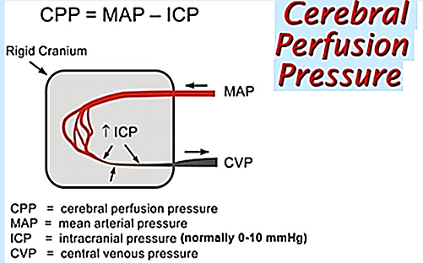
The rise in venous pressure decreases cerebral blood flow
The cerebral vessels are compressed whenever the intracranial pressure rises.
Three systems of nerves innervate the cerebral blood vessels.
A. Postganglionic sympathetic neurons have their cell bodies in the superior cervical ganglia, and their endings contain norepinephrine, neuropeptide Y
Sympathetic stimulation vasoconstrictor effect will be countered by “auto-regulation”
B. Cholinergic neurons that probably originate in the spheno-palatine ganglia also innervate the cerebral vessels, and the postganglionic cholinergic neurons on the blood vessels contain acetylcholine.
C. Sensory nerves are found on more distal arteries. They have their cell bodies in the trigeminal ganglia and contain substance P, neurokinin A, and calcitonin gene-related peptide (CGRP).
Touching or pulling on the cerebral vessels causes pain.
Cerebral microcirculation:
Cerebral blood supply increase with area having high metabolic rate (gray higher than white matter); blood flow in each individual segment of the brain changes as much as 100 to 150 percent within seconds in response to changes in local neuronal activity.
Cerebral blood vessels less leaky than other part of the body
Because no true lymphatic are present in brain tissue, excess protein in the brain tissue leaves the tissue flowing with fluid through the perivascular spaces into the subarachnoid spaces.
Brain Metabolism:
Under resting but awake conditions, the metabolism of the brain accounts for about 15 percent of the total metabolism in the body.
The major need for metabolism in the neurons (70%) is for Na-K ATPase
Under normal conditions, almost all the energy used by the brain cells is supplied by glucose derived from the blood but does not dependent on insulin
Brain cells lack of significant anaerobic metabolism, so it cannot stand long time in lack of oxygen or glucose for more than 2 minutes and this due to high metabolic rate
Function of cerebro-spinal fluid (CSF):
A major function of the cerebrospinal fluid is to cushion the brain within its solid vault
The brain weighs about 1400 g in air, but in its “water bath “of CSF it has a net weight of only 50 g.
Removal of CSF during lumbar puncture can cause a severe headache after the fluid is removed, because the brain hangs on the vessels and nerve roots, and traction on them stimulates pain fibers.
Composition of CSF comparing to plasma
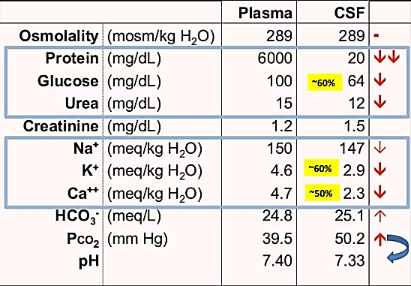
CSF fills the ventricles and subarachnoid space.
In humans, the volume of CSF is about 150 mL and the rate of CSF production is about 550 mL/d. Thus the CSF turns over about 3.7 times a day.
It has been estimated that 50–70% of the CSF is formed in the choroid plexuses and the remainder is formed around blood vessels and along ventricular walls.
Lumbar CSF pressure is normally 70 to 180 mm H2O. Up to pressures well above this range, the rate of CSF formation is independent of intra-ventricular pressure. However, absorption is proportional to the pressure.
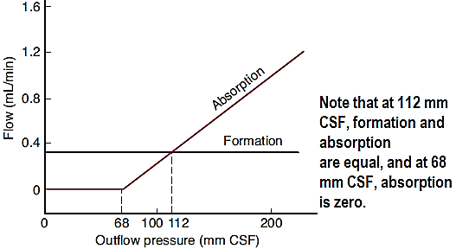
At a pressure of 112 mm H2O, which is the average normal CSF pressure, filtration and absorption are equal.
Below a pressure of approximately 68 mm H2O, absorption stops. Large amounts of fluid accumulate when the capacity for CSF reabsorption is decreased (external hydrocephalus, communicating hydrocephalus).
Fluid also accumulates proximal to the block and distends the ventricles when the foramens of Luschka and Magendie are blocked or there is obstruction within the ventricular system (internal hydrocephalus, non-communicating hydrocephalus).
