Male reproductive functions can be divided into three major subdivisions: (1) spermatogenesis, which means the formation of sperm; (2) performance of the male sexual act; and (3) regulation of male reproductive func­ tions by the various hormones. Associated with these reproductive functions are the effects of the male sex hormones on the accessory sexual organs, cellular metab­ olism, growth, and other functions of the body.
U N I T X I V
division and continually proliferate and differentiate through definite stages of development to form sperm, as shown in Figure 81-2B.

STEPS OF SPERMATOGENESIS
Spermatogenesis occurs in the seminiferous tubules during active sexual life as the result of stimulation by anterior pituitary gonadotropic hormones. Spermato­ genesis begins at an average age of 13 years and continues throughout most of the remainder of life but decreases markedly in old age.

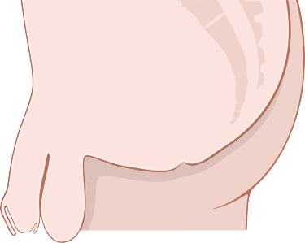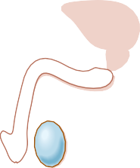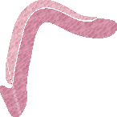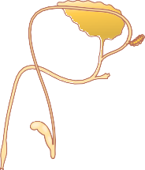Urinary bladder
Physiological Anatomy of the Male Sexual Organs
Figure 81-1A shows the various portions of the male reproductive system, and Figure 81-1B gives a more detailed structure of the testis and epididymis. The testis is composed of up to 900 coiled seminiferous tubules, each averaging more than one­half meter long, in which the sperm are formed. The sperm then empty into the epididy- mis, which is another coiled tube about 6 meters long. The epididymis leads into the vas deferens, which enlarges into the ampulla of the vas deferens immediately before the vas enters the body of the prostate gland.
Two seminal vesicles, one located on each side of the prostate, empty into the prostatic end of the ampulla, and the contents from both the ampulla and the seminal vesi­ cles pass into an ejaculatory duct leading through the body of the prostate gland and then emptying into the internal urethra. Prostatic ducts also empty from the prostate gland into the ejaculatory duct and from there into the prostatic urethra.
Finally, the urethra is the last connecting link from the testis to the exterior. The urethra is supplied with mucus derived from a large number of minute urethral glands located along its entire extent and even more so from bilat­ eral bulbourethral glands (Cowper glands) located near the origin of the urethra.

Prostate
gland

Urethra
Erectile tissue

Prepuce
Glans
A penis

Testis Scrotum

Head of epididymis

Epididymis

Ampulla
Seminal vesicle
Ejaculatory duct
Bulbourethral gland
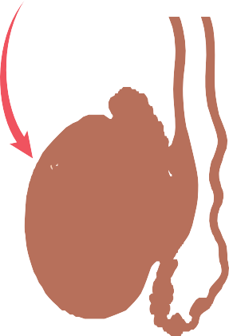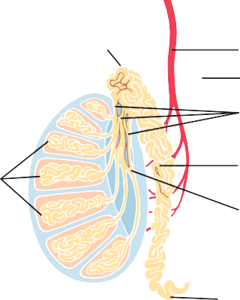Vas deferens

Testicular artery Vas deferens
Efferent ductules

Seminiferous
tubules

SPERMATOGENESIS
During formation of the embryo, the primordial germ B

Body of epididymis
Rete testis

Tail of epididymis

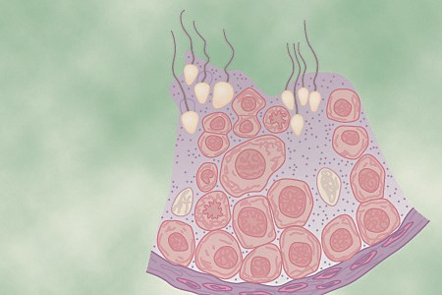cells migrate into the testes and become immature germ cells called spermatogonia, which lie in two or three layers of the inner surfaces of the seminiferous tubules (a cross section of a tubule is shown in Figure 81-2A). At puberty the spermatogonia begin to undergo mitotic
Reproductive and Hormonal Functions
of the Male (and Function of the Pineal Gland)
C H A P T E R 8 1
Figure 81-1. A, The male reproduction system. B, The internal struc- ture of the testis and the relation of the testis to the epididymis. (A, Modified from Bloom V, Fawcett DW: Textbook of Histology, 10th ed. Philadelphia: WB Saunders, 1975. B, Modified from Guyton AC: Anatomy and Physiology. Philadelphia: Saunders College Publishing, 1985.)

Primordial germ cell

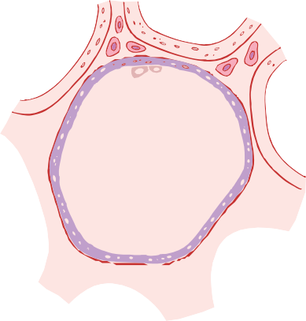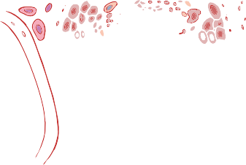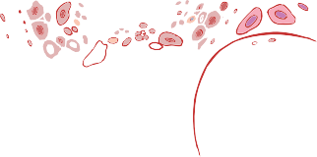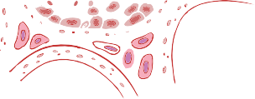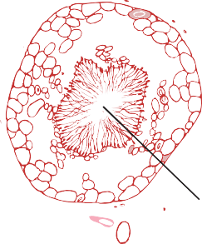1
Leyd (Inte
Seminiferous tubules
Birth
2-14
ears
Enters testis
Puberty
Spermatogonia proliferate by mitotic cell division inside testis
ays
Primary spermatocyte
ays
Meiotic division I

Secondary spermatocytes
ays
Meiotic division II
Spermatids
ays
Differentiation
y
Spermatogonia
ig cells rstitial cells)

A

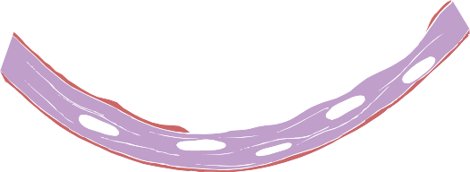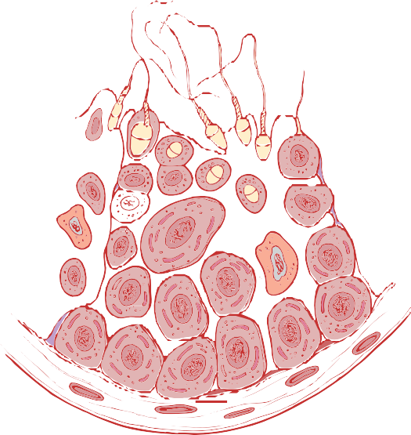Spermatids

Spermatozoa

25 d

Secondary spermatocyte

Primary
spermatocyte 9 d Sertoli cell

19 d

Spermatogonium
B

Figure 81-2. A, Cross section of a seminiferous tubule. B, Stages in the development of sperm from spermatogonia.

In the first stage of spermatogenesis, the spermatogo­ nia migrate among Sertoli cells toward the central lumen of the seminiferous tubule. The Sertoli cells are large, with overflowing cytoplasmic envelopes that surround the developing spermatogonia all the way to the central lumen of the tubule.
Meiosis. Spermatogonia that cross the barrier into the Sertoli cell layer become progressively modified and enlarged to form large primary spermatocytes (Figure 81-3). Each of these primary spermatocytes, in turn, undergoes meiotic division to form two secondary sper- matocytes. After another few days, these secondary sper­ matocytes also divide to form spermatids that are eventually modified to become spermatozoa (sperm).
During the change from the spermatocyte stage to the spermatid stage, the 46 chromosomes (23 pairs of chro­ mosomes) of the spermatocyte are divided, and thus 23 chromosomes go to one spermatid and the other 23 go to the second spermatid. The chromosomal genes are also divided so that only one half of the genetic characteristics of the eventual fetus are provided by the father, with the

21 d
Mature sperm

Figure 81-3. Cell divisions during spermatogenesis. During embry- onic development, the primordial germ cells migrate to the testis, where they become spermatogonia. At puberty (usually 12 to 14 years after birth), the spermatogonia proliferate rapidly by mitosis. Some begin meiosis to become primary spermatocytes and continue through meiotic division I to become secondary spermatocytes. After completion of meiotic division II, the secondary spermatocytes produce spermatids, which differentiate to form spermatozoa.

other half being derived from the oocyte provided by the mother.
The entire period of spermatogenesis, from spermato­ gonia to spermatozoa, takes about 74 days.
Sex Chromosomes. In each spermatogonium, one of the 23 pairs of chromosomes carries the genetic informa­ tion that determines the sex of each eventual offspring. This pair is composed of one X chromosome, which is

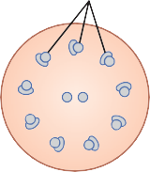Acrosome
Surface membrane Vacuole
Head Anterior head cap
axoneme in the proximal portion of the tail (called the
body of the tail).
Back­and­forth movement of the tail (flagellar move­ ment) provides motility for the sperm. This movement
U N I T X I V

Tail (flagellum)
Posterior head cap Neck
Body

Mitochondria Microtubules
results from a rhythmical longitudinal sliding motion between the anterior and posterior tubules that make up the axoneme. The energy for this process is supplied in the form of adenosine triphosphate, which is synthesized by the mitochondria in the body of the tail.
Normal sperm move in a fluid medium at a velocity of 1 to 4 mm/min, which allows them to move through the female genital tract in quest of the ovum.

Hormonal Factors That Stimulate Spermatogenesis
The role of hormones in reproduction is discussed later in detail; for now, note that several hormones play essen­ tial roles in spermatogenesis. Some of these roles are as follows:
- Testosterone, secreted by the Leydig cells located in the interstitium of the testis (see Figure 81-2), is essential for growth and division of the testicular germinal cells, which is the first stage in forming

Figure 81-4. Structure of the human spermatozoon.

Chapter 81 Reproductive and Hormonal Functions of the Male (and Function of the Pineal Gland)

called the female chromosome, and one Y chromosome, the male chromosome. During meiotic division, the male Y chromosome goes to one spermatid that then becomes a male sperm, and the female X chromosome goes to another spermatid that becomes a female sperm. The sex of the eventual offspring is determined by which of these two types of sperm fertilizes the ovum. This process is discussed further in Chapter 83.
Formation of Sperm. When the spermatids are first formed, they still have the usual characteristics of epithe­ lioid cells, but soon they begin to differentiate and elon­ gate into spermatozoa. As shown in Figure 81-4, each spermatozoon is composed of a head and a tail. The head comprises the condensed nucleus of the cell, with only a thin cytoplasmic and cell membrane layer around its surface. On the outside of the anterior two thirds of the head is a thick cap called the acrosome that is formed mainly from the Golgi apparatus. The acrosome contains several enzymes similar to those found in lysosomes of the typical cell, including hyaluronidase (which can digest proteoglycan filaments of tissues) and powerful proteo- lytic enzymes (which can digest proteins). These enzymes play important roles in allowing the sperm to enter the ovum and fertilize it.
The tail of the sperm, called the flagellum, has three major components: (1) a central skeleton constructed of
11 microtubules, collectively called the axoneme (the structure of the axoneme is similar to that of cilia found on the surfaces of other types of cells described in Chapter 2); (2) a thin cell membrane covering the axoneme; and (3) a collection of mitochondria surrounding the
sperm.
- Luteinizing hormone, secreted by the anterior pitu­ itary gland, stimulates the Leydig cells to secrete testosterone.
- Follicle-stimulating hormone, also secreted by the anterior pituitary gland, stimulates the Sertoli cells; without this stimulation, the conversion of the sper­ matids to sperm (the process of spermiogenesis) will not occur.
- Estrogens, formed from testosterone by the Sertoli cells when they are stimulated by follicle­ stimulating hormone, are probably also essential for spermiogenesis.
- Growth hormone (as well as most of the other body hormones) is necessary for controlling background metabolic functions of the testes. Growth hormone specifically promotes early division of the sper­ matogonia themselves; in its absence, as in pituitary dwarfs, spermatogenesis is severely deficient or absent, thus causing infertility.

Maturation of Sperm in the Epididymis
After formation in the seminiferous tubules, the sperm require several days to pass through the 6­meter­long tubule of the epididymis. Sperm removed from the semi­ niferous tubules and from the early portions of the epi­ didymis are nonmotile and cannot fertilize an ovum. However, after the sperm have been in the epididymis for 18 to 24 hours, they develop the capability of motility, even though several inhibitory proteins in the epididymal fluid still prevent final motility until after ejaculation.
Storage of Sperm in the Testes. The two testes of the human adult form up to 120 million sperm each day. Most

of these sperm are stored in the epididymis, although a small quantity is stored in the vas deferens. They can remain stored, while maintaining their fertility, for at least a month. During this time, they are kept in a deeply sup­ pressed, inactive state by multiple inhibitory substances in the secretions of the ducts. Conversely, with a high level of sexual activity and ejaculations, they may be stored no longer than a few days.
After ejaculation, the sperm become motile and capable of fertilizing the ovum, a process called matura- tion. The Sertoli cells and the epithelium of the epididymis secrete a special nutrient fluid that is ejaculated along with the sperm. This fluid contains hormones (including both testosterone and estrogens), enzymes, and special nutrients that are essential for sperm maturation.
Physiology of the Mature Sperm. The normal motile, fertile sperm are capable of flagellated movement through the fluid medium at velocities of 1 to 4 mm/min. The activity of sperm is greatly enhanced in a neutral and slightly alkaline medium, as exists in the ejaculated semen, but it is greatly depressed in a mildly acidic medium. A strong acidic medium can cause the rapid death of sperm. The activity of sperm increases markedly with increas­ ing temperature, but so does the rate of metabolism, causing the life of the sperm to be considerably shortened. Although sperm can live for many weeks in the sup­ pressed state in the genital ducts of the testes, the life expectancy of ejaculated sperm in the female genital tract
is only 1 to 2 days.

FUNCTION OF THE SEMINAL VESICLES
Each seminal vesicle is a tortuous, loculated tube lined with a secretory epithelium that secretes a mucoid mate­ rial containing an abundance of fructose, citric acid, and other nutrient substances, as well as large quantities of prostaglandins and fibrinogen. During the process of emission and ejaculation, each seminal vesicle empties its contents into the ejaculatory duct shortly after the vas deferens empties the sperm. This action adds greatly to the bulk of the ejaculated semen, and the fructose and other substances in the seminal fluid are of considerable nutrient value for the ejaculated sperm until one of the sperm fertilizes the ovum.
Prostaglandins are believed to aid fertilization in two ways: (1) by reacting with the female cervical mucus to make it more receptive to sperm movement and (2) by possibly causing backward, reverse peristaltic contrac­ tions in the uterus and fallopian tubes to move the ejacu­ lated sperm toward the ovaries (a few sperm reach the upper ends of the fallopian tubes within 5 minutes).

FUNCTION OF THE PROSTATE GLAND
The prostate gland secretes a thin, milky fluid that contains calcium, citrate ion, phosphate ion, a clotting
enzyme, and a profibrinolysin. During emission, the capsule of the prostate gland contracts simultaneously with the contractions of the vas deferens so that the thin, milky fluid of the prostate gland adds further to the bulk of the semen. A slightly alkaline characteristic of the pros­ tatic fluid may be quite important for successful fertiliza­ tion of the ovum because the fluid of the vas deferens is relatively acidic owing to the presence of citric acid and metabolic end products of the sperm and, consequently, helps inhibit sperm fertility. Also, the vaginal secretions of the female are acidic (with a pH of 3.5 to 4.0). Sperm do not become optimally motile until the pH of the sur­ rounding fluids rises to about 6.0 to 6.5. Consequently, it is probable that the slightly alkaline prostatic fluid helps neutralize the acidity of the other seminal fluids during ejaculation and thus enhances the motility and fertility of the sperm.

SEMEN
Semen, which is ejaculated during the male sexual act, is composed of the fluid and sperm from the vas deferens (about 10 percent of the total), fluid from the seminal vesicles (almost 60 percent), fluid from the prostate gland (about 30 percent), and small amounts from the mucous glands, especially the bulbourethral glands. Thus, the bulk of the semen is seminal vesicle fluid, which is the last to be ejaculated and serves to wash the sperm through the ejaculatory duct and urethra.
The average pH of the combined semen is about 7.5, with the alkaline prostatic fluid having more than neutral­ ized the mild acidity of the other portions of the semen. The prostatic fluid gives the semen a milky appearance, and fluid from the seminal vesicles and mucous glands gives the semen a mucoid consistency. Also, a clotting enzyme from the prostatic fluid causes the fibrinogen of the seminal vesicle fluid to form a weak fibrin coagulum that holds the semen in the deeper regions of the vagina where the uterine cervix lies. The coagulum then dis­ solves during the next 15 to 30 minutes because of lysis by fibrinolysin formed from the prostatic profibrinolysin. In the early minutes after ejaculation, the sperm remain relatively immobile, possibly because of the viscosity of the coagulum. As the coagulum dissolves, the sperm simultaneously become highly motile.
Although sperm can live for many weeks in the male genital ducts, once they are ejaculated in the semen, their maximal life span is only 24 to 48 hours at body temperature. At lowered temperatures, however, semen
can be stored for several weeks, and when frozen at temperatures below −100°C, sperm have been preserved for years.

“Capacitation” of Spermatozoa Is Required for Fertilization of the Ovum
Although spermatozoa are said to be “mature” when they leave the epididymis, their activity is held in check by

multiple inhibitory factors secreted by the genital duct epithelia. Therefore, when they are first expelled in the semen, they are unable to fertilize the ovum. However, on coming in contact with the fluids of the female genital tract, multiple changes occur that activate the sperm for the final processes of fertilization. These collective changes are called capacitation of the spermatozoa, which nor­ mally requires from 1 to 10 hours. The following changes are believed to occur:

Chapter 81 Reproductive and Hormonal Functions of the Male (and Function of the Pineal Gland)
  - The uterine and fallopian tube fluids wash away the various inhibitory factors that suppress sperm activity in the male genital ducts.
  - While the spermatozoa remain in the fluid of the male genital ducts, they are continually exposed to many floating vesicles from the seminiferous tubules containing large amounts of cholesterol. This cho­ lesterol is continually added to the cellular mem­ brane covering the sperm acrosome, toughening this membrane and preventing release of its enzymes. After ejaculation, the sperm deposited in the vagina swim away from the cholesterol vesicles upward into the uterine cavity, and they gradually lose much of their other excess cholesterol during the next few hours. In so doing, the membrane at the head of the sperm (the acrosome) becomes much weaker.
  - The membrane of the sperm also becomes much more permeable to calcium ions, so calcium now enters the sperm in abundance and changes the activity of the flagellum, giving it a powerful whip­ lash motion in contrast to its previously weak undu­ lating motion. In addition, the calcium ions cause changes in the cellular membrane that cover the leading edge of the acrosome, making it possible for the acrosome to release its enzymes rapidly and easily as the sperm penetrates the granulosa cell mass surrounding the ovum, and even more so as it attempts to penetrate the zona pellucida of the ovum.
Thus, multiple changes occur during the process of capacitation. Without these changes, the sperm cannot make its way to the interior of the ovum to cause fertilization.

Acrosome Enzymes, the “Acrosome Reaction,” and Penetration of the Ovum
Stored in the acrosome of the sperm are large quantities of hyaluronidase and proteolytic enzymes. Hyaluronidase depolymerizes the hyaluronic acid polymers in the inter­ cellular cement that holds the ovarian granulosa cells together. The proteolytic enzymes digest proteins in the structural elements of tissue cells that still adhere to the ovum.
When the ovum is expelled from the ovarian follicle into the fallopian tube, it still carries with it multiple layers of granulosa cells. Before a sperm can fertilize the ovum, it must dissolute these granulosa cell layers, and
then it must penetrate through the thick covering of the ovum itself, the zona pellucida. To achieve this penetra­ tion, the stored enzymes in the acrosome begin to be released. It is believed that the hyaluronidase among these enzymes is especially important in opening pathways between the granulosa cells so that the sperm can reach the ovum.
When the sperm reaches the zona pellucida of the ovum, the anterior membrane of the sperm binds specifically with receptor proteins in the zona pellucida. Next, the entire acrosome rapidly dissolves and all the acrosomal enzymes are released. Within minutes, these enzymes open a penetrating pathway for passage of the sperm head through the zona pellucida to the inside of the ovum. Within another 30 minutes, the cell membranes of the sperm head and of the oocyte fuse with each other to form a single cell. At the same time, the genetic material of the sperm and the oocyte combine to form a completely new cell genome, contain­ ing equal numbers of chromosomes and genes from mother and father. This is the process of fertilization; the embryo then begins to develop, as discussed in Chapter 83.
U N I T X I V

Why Does Only One Sperm Enter the Oocyte? With as many sperm as there are, why does only one enter the oocyte? The reason is not entirely known, but within a few minutes after the first sperm penetrates the zona pel­ lucida of the ovum, calcium ions diffuse inward through the oocyte membrane and cause multiple cortical gran­ ules to be released by exocytosis from the oocyte into the perivitelline space. These granules contain substances that permeate all portions of the zona pellucida and prevent binding of additional sperm, and they even cause any sperm that have already begun to bind to fall off. Thus, almost never does more than one sperm enter the oocyte during fertilization.

Abnormal Spermatogenesis and Male Fertility
The seminiferous tubular epithelium can be destroyed by several diseases. For instance, bilateral orchitis (inflamma­ tion) of the testes resulting from mumps causes sterility in some affected males. Also, some male infants are born with degenerate tubular epithelia as a result of strictures in the genital ducts or other abnormalities. Finally, another cause of sterility, usually temporary, is excessive temperature of the testes.
Effect of Temperature on Spermatogenesis. Increas­ ing the temperature of the testes can prevent sper­ matogenesis by causing degeneration of most cells of the seminiferous tubules besides the spermatogonia. It has often been stated that the reason the testes are located in the dangling scrotum is to maintain the temperature of these glands below the internal temperature of the
body, although usually only about 2°C below the internal temperature. On cold days, scrotal reflexes cause the

musculature of the scrotum to contract, pulling the testes close to the body to maintain this 2­degree differential. Thus, the scrotum acts as a cooling mechanism for the testes (but a controlled cooling), without which spermato­ genesis might be deficient during hot weather.
Cryptorchidism. Cryptorchidism means failure of a testis to descend from the abdomen into the scrotum at or near the time of birth of a fetus. During development of the male fetus, the testes are derived from the genital ridges in the abdomen. However, at about 3 weeks to
1 month before birth of the baby, the testes normally descend through the inguinal canals into the scrotum. Occasionally this descent does not occur or occurs incom­ pletely, and as a result one or both testes remain in the abdomen, in the inguinal canal, or elsewhere along the route of descent.
A testis that remains in the abdominal cavity through­ out life is incapable of forming sperm. The tubular epithe­ lium becomes degenerate, leaving only the interstitial structures of the testis. It has been claimed that even the few degrees’ higher temperature in the abdomen than in the scrotum is sufficient to cause this degeneration of the tubular epithelium and, consequently, to cause sterility, although this effect is not certain. Nevertheless, for this reason, operations to relocate the cryptorchid testes from the abdominal cavity into the scrotum before the beginning of adult sexual life can be performed on boys who have undescended testes.
Testosterone secretion by the fetal testes is the normal stimulus that causes the testes to descend into the scrotum from the abdomen. Therefore, many, if not most, instances of cryptorchidism are caused by abnormally formed testes that are unable to secrete enough testosterone. The surgical operation for cryptorchidism in these patients is unlikely to be successful.
Effect of Sperm Count on Fertility. The usual quantity of semen ejaculated during each coitus averages about
3.5 milliliters, and each milliliter of semen contains an average of about 120 million sperm, although even in “normal” males this quantity can vary from 35 million to

Figure 81-5. Abnormal infertile sperm, compared with a normal sperm on the right.

MALE SEXUAL ACT

NEURONAL STIMULUS FOR PERFORMANCE OF THE MALE SEXUAL ACT
The most important source of sensory nerve signals for initiating the male sexual act is the glans penis. The glans contains an especially sensitive sensory end­organ system that transmits into the central nervous system that special modality of sensation called sexual sensation. The slippery massaging action of intercourse on the glans stimulates the sensory end organs, and the sexual signals in turn pass through the pudendal nerve, then through the sacral plexus into the sacral portion of the spinal cord, and finally up the cord to undefined areas of the brain.
Impulses may also enter the spinal cord from areas adjacent to the penis to aid in stimulating the sexual act. For instance, stimulation of the anal epithelium, the

200 million. This means an average total of 400 million sperm are usually present in the several milliliters of each ejaculate. When the number of sperm in each milliliter falls below about 20 million, the person is likely to be infertile. Thus, even though only a single sperm is necessary to fertilize the ovum, for reasons that are not understood, the ejaculate usually must contain a tremen­ dous number of sperm for only one sperm to fertilize the ovum.
Effect of Sperm Morphology and Motility on Fertility. Occasionally a man has a normal number of sperm but is still infertile. When this situation occurs, sometimes as many as one half of the sperm are found to be abnormal physically, having two heads, abnormally shaped heads, or abnormal tails, as shown in Figure 81-5. At other times, the sperm appear to be structurally normal, but for reasons not understood, they are either entirely nonmotile or rela­ tively nonmotile. Whenever most of the sperm are mor­ phologically abnormal or are nonmotile, the person is likely to be infertile, even though the remainder of the sperm appear to be normal.
scrotum, and perineal structures in general can send
signals into the cord that add to the sexual sensation. Sexual sensations can even originate in internal struc­ tures, such as in areas of the urethra, bladder, prostate, seminal vesicles, testes, and vas deferens. Indeed, one of the causes of “sexual drive” is filling of the sexual organs with secretions. Mild infection and inflammation of these sexual organs may sometimes stimulate sexual desire, and some “aphrodisiac” drugs, such as cantharidin, irritate the bladder and urethral mucosa, inducing inflammation and vascular congestion.
Psychic Element of Male Sexual Stimulation. Appro­ priate psychic stimuli can greatly enhance the ability of a person to perform the sexual act. Simply thinking sexual thoughts or even dreaming that the act of intercourse is being performed can initiate the male act, culminating in ejaculation. Indeed, nocturnal emissions during dreams, often called “wet dreams,” occur in many males during some stages of sexual life, especially during the teens.

Integration of the Male Sexual Act in the Spinal Cord. Although psychic factors usually play an important part in the male sexual act and can initiate or inhibit it, brain function is probably not necessary for its perfor­ mance because appropriate genital stimulation can cause ejaculation in some animals and occasionally in humans after their spinal cords have been cut above the lumbar region. The male sexual act results from inherent reflex mechanisms integrated in the sacral and lumbar spinal cord, and these mechanisms can be initiated by either psychic stimulation from the brain or actual sexual stimu­ lation from the sex organs, but usually it is a combination of both.

STAGES OF THE MALE SEXUAL ACT
Penile Erection—Role of the Parasympathetic Nerves. Penile erection is the first effect of male sexual stimu­ lation, and the degree of erection is proportional to the degree of stimulation, whether psychic or physical. Erection is caused by parasympathetic impulses that pass from the sacral portion of the spinal cord through the pelvic nerves to the penis. These parasympathetic nerve fibers, in contrast to most other parasympathetic fibers, are believed to release nitric oxide and/or vasoactive intes- tinal peptide in addition to acetylcholine. Nitric oxide activates the enzyme guanylyl cyclase, causing increased formation of cyclic guanosine monophosphate (GMP). The cyclic GMP especially relaxes the arteries of the penis and the trabecular meshwork of smooth muscle fibers in the erectile tissue of the corpora cavernosa and corpus spongiosum in the shaft of the penis, shown in Figure 81-6. As the vascular smooth muscles relax, blood flow into the penis increases, causing release of nitric oxide from the vascular endothelial cells and further vasodilation.
The erectile tissue of the penis consists of large cavern­ ous sinusoids that are normally relatively empty of blood but become dilated tremendously when arterial blood flows rapidly into them under pressure while the venous outflow is partially occluded. Also, the erectile bodies, especially the two corpora cavernosa, are surrounded by strong fibrous coats; therefore, high pressure within the sinusoids causes ballooning of the erectile tissue to such

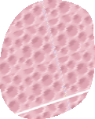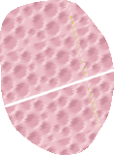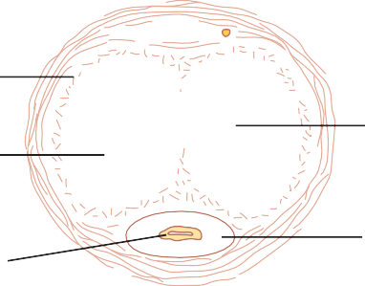Deep penile
fascia
an extent that the penis becomes hard and elongated, which is the phenomenon of erection.
Lubrication Is a Parasympathetic Function. During sexual stimulation, the parasympathetic impulses, in addition to promoting erection, cause the urethral glands and the bulbourethral glands to secrete mucus. This mucus flows through the urethra during intercourse to aid in the lubrication during coitus. However, most of the lubrication of coitus is provided by the female sexual organs rather than by the male organs. Without satis­ factory lubrication, the male sexual act is seldom success­ ful because unlubricated intercourse causes grating, painful sensations that inhibit rather than excite sexual sensations.
U N I T X I V

Emission and Ejaculation Are Functions of the Sympathetic Nerves. Emission and ejaculation are the culmination of the male sexual act. When the sexual stimulus becomes extremely intense, the reflex centers of the spinal cord begin to emit sympathetic impulses that leave the cord at T12 to L2 and pass to the genital organs through the hypogastric and pelvic sympathetic nerve plexuses to initiate emission, the forerunner of ejaculation.
Emission begins with contraction of the vas deferens and the ampulla to cause expulsion of sperm into the internal urethra. Then, contractions of the muscular coat of the prostate gland followed by contraction of the seminal vesicles expel prostatic and seminal fluid also into the urethra, forcing the sperm forward. All these fluids mix in the internal urethra with mucus already secreted by the bulbourethral glands to form the semen. The process to this point is emission.
The filling of the internal urethra with semen elicits sensory signals that are transmitted through the pudendal nerves to the sacral regions of the cord, giving the feeling of sudden fullness in the internal genital organs. Also, these sensory signals further excite rhythmical contrac­ tion of the internal genital organs and cause contraction of the ischiocavernosus and bulbocavernosus muscles that compress the bases of the penile erectile tissue. These effects together cause rhythmical, wavelike increases in pressure in both the erectile tissue of the penis and the genital ducts and urethra, which “ejaculate” the semen from the urethra to the exterior. This final process is called ejaculation. At the same time, rhythmical contractions of the pelvic muscles and even of some of the muscles of the body trunk cause thrusting movements of the pelvis and

Chapter 81 Reproductive and Hormonal Functions of the Male (and Function of the Pineal Gland)
Corpus cavernosum

Urethra

Figure 81-6. Erectile tissue of the penis.

Central artery

Corpus spongiosum
penis, which also help propel the semen into the deepest recesses of the vagina and perhaps even slightly into the cervix of the uterus.
This entire period of emission and ejaculation is called the male orgasm. At its termination, the male sexual excitement disappears almost entirely within 1 to 2 minutes and erection ceases, a process called resolution.

TESTOSTERONE AND OTHER MALE SEX HORMONES

SECRETION, METABOLISM, AND CHEMISTRY OF THE MALE
all these androgens is normally so slight (<5 percent of the total in the adult male) that even in women they do not
cause significant masculine characteristics, except for causing growth of pubic and axillary hair. However, when a tumor of the adrenal androgen­producing cells occurs, the quantity of androgenic hormones may then become great enough to cause all the usual male secondary sexual characteristics to occur, even in the female. These effects are described in connection with the adrenogenital syn­ drome in Chapter 78.
Rarely, embryonic crest cells in the ovary can develop into a tumor that produces excessive quantities of andro­ gens in women; one such tumor is the arrhenoblastoma. The normal ovary also produces minute quantities of androgens, but they are not significant.
Chemistry of the Androgens. All androgens are steroid compounds, as shown by the formulas in Figure 81-8 for testosterone and dihydrotestosterone. Both in the testes and in the adrenals, the androgens can be synthesized either from cholesterol or directly from acetyl coenzyme A.
Metabolism of Testosterone. After secretion by the testes, about 97 percent of the testosterone becomes either loosely bound with plasma albumin or more tightly bound with a beta globulin called sex hormone–binding globulin and circulates in the blood in these states for 30 minutes to several hours. By that time, the testosterone is either transferred to the tissues or degraded into inactive prod­ ucts that are subsequently excreted.
Much of the testosterone that becomes fixed to the tissues is converted within the tissue cells to dihydrotestos- terone, especially in certain target organs such as the pros­ tate gland in the adult and the external genitalia of the male fetus. Some but not all actions of testosterone depend on this conversion. The intracellular functions are discussed later in this chapter.
Degradation and Excretion of Testosterone. The tes­ tosterone that does not become fixed to the tissues is rapidly converted, mainly by the liver, into androsterone and dehydroepiandrosterone and simultaneously conju­ gated as either glucuronides or sulfates (glucuronides, par­ ticularly). These substances are excreted either into the gut by way of the liver bile or into the urine through the kidneys. Production of Estrogen in the Male. In addition to testosterone, small amounts of estrogens are formed in the male (about one fifth the amount in the nonpregnant female), and a reasonable quantity of estrogens can be
SEX HORMONE
Secretion of Testosterone by the Interstitial Cells of Leydig in the Testes. The testes secrete several male sex hormones, which are collectively called androgens, includ­ ing testosterone, dihydrotestosterone, and androstenedi- one. Testosterone is so much more abundant than the others that one can consider it to be the primary testicular hormone, although much of the testosterone is eventually converted into the more active hormone dihydrotestos­ terone in the target tissues.
Testosterone is formed by the interstitial cells of Leydig, which lie in the interstices between the seminiferous tubules and constitute about 20 percent of the mass of the adult testes, as shown in Figure 81-7. Leydig cells are almost nonexistent in the testes during childhood when the testes secrete almost no testosterone, but they are numerous in the newborn male infant for the first few months of life and in the adult male after puberty; at both these times the testes secrete large quantities of testoster­ one. Furthermore, when tumors develop from the inter­ stitial cells of Leydig, great quantities of testosterone are secreted. Finally, when the germinal epithelium of the testes is destroyed by x­ray treatment or excessive heat, the Leydig cells, which are less easily destroyed, often continue to produce testosterone.
Secretion of Androgens Elsewhere in the Body. The term “androgen” means any steroid hormone that has mas­ culinizing effects, including testosterone; it also includes male sex hormones produced elsewhere in the body besides the testes. For instance, the adrenal glands secrete at least five androgens, although the total masculinizing activity of

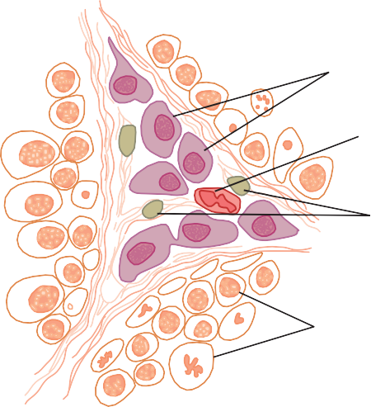
Interstitial cells of Leydig

Blood vessel

Fibroblasts

OH CH3
OH
CH3 CH3
CH3

Germinal epithelium

Figure 81-7. Interstitial cells of Leydig, the cells that secrete testos- terone, located in the interstices between the seminiferous tubules.
O
Testosterone
O
H
H
Dihydrotestosterone
Figure 81-8. Testosterone and dihydrotestosterone.

FUNCTIONS OF TESTOSTERONE
In general, testosterone is responsible for the distinguish­ ing characteristics of the masculine body. Even during fetal life, the testes are stimulated by chorionic gonado­ tropin from the placenta to produce moderate quantities of testosterone throughout the entire period of fetal development and for 10 or more weeks after birth; there­ after, essentially no testosterone is produced during child­ hood until about the ages of 10 to 13 years. Testosterone production then increases rapidly under the stimulus of anterior pituitary gonadotropic hormones at the onset of puberty and lasts throughout most of the remainder of life, as shown in Figure 81-9, dwindling rapidly beyond age 50 years to become 20 to 50 percent of the peak value by age 80 years.

Functions of Testosterone During Fetal Development
Testosterone begins to be elaborated by the male fetal testes at about the seventh week of embryonic life. Indeed,
one of the major functional differences between the female and the male sex chromosome is that the male chromosome has the sex-determining region Y (SRY) gene that encodes a protein called the testis determining factor (also called the SRY protein). The SRY protein initiates a cascade of gene activations that cause the genital ridge cells to differentiate into cells that secrete testosterone and eventually become the testes, whereas the female chromosome causes this ridge to differentiate into cells that secrete estrogens.
Injection of large quantities of male sex hormone into pregnant animals causes development of male sexual organs, even though the fetus is female. Also, early removal of the testes in the male fetus causes develop­ ment of female sexual organs.
U N I T X I V
Thus, testosterone secreted first by the genital ridges and later by the fetal testes is responsible for the develop­ ment of the male body characteristics, including the for­ mation of a penis and a scrotum rather than formation of a clitoris and a vagina. It also causes formation of the prostate gland, seminal vesicles, and male genital ducts, while at the same time suppressing the formation of female genital organs.

Effect of Testosterone to Cause Descent of the Testes. The testes usually descend into the scrotum during the last 2 to 3 months of gestation when the testes begin secreting reasonable quantities of testosterone. If a male child is born with undescended but otherwise normal testes, administration of testosterone usually causes the testes to descend in the usual manner if the inguinal canals are large enough to allow the testes to pass.
Administration of gonadotropic hormones, which stimulate the Leydig cells of the newborn child’s testes
Sperm production (% of maximal)

5.0
1st 2nd 3rd
Trimester gestation Birth
1 10
17 40 60 80
Year
Old age
Adult
Pubertal
Neonatal
Fetal
Plasma testosterone (ng/ml)

100

Chapter 81 Reproductive and Hormonal Functions of the Male (and Function of the Pineal Gland)
recovered from a man’s urine. The exact source of estrogens in the male is unclear, but the following information is known:
- The concentration of estrogens in the fluid of the seminiferous tubules is quite high and probably plays an important role in spermiogenesis. This estrogen is believed to be formed by the Sertoli cells by con­ verting testosterone to estradiol.
- Much larger amounts of estrogens are formed from testosterone and androstanediol in other tissues of the body, especially the liver, probably accounting for as much as 80 percent of the total male estrogen production.

2.5 50

Figure 81-9. The different stages of male sexual function as reflected by average plasma testoster- one concentrations (red line) and sperm production (blue line) at different ages. (Modified from Griffin JF, Wilson JD: The testis. In: Bondy PK, Rosenberg LE [eds]: Metabolic Control and Disease, 8th ed. Philadelphia: WB Saunders, 1980.)
Plasma testosterone (ng/ml)
Sperm production (% of maximal)

to produce testosterone, can also cause the testes to descend. Thus, the stimulus for descent of the testes is testosterone, indicating again that testosterone is an important hormone for male sexual development during fetal life.

Effect of Testosterone on Development of Adult Primary and Secondary Sexual Characteristics
After puberty, increasing amounts of testosterone secre­ tion cause the penis, scrotum, and testes to enlarge about eightfold before the age of 20 years. In addition, testoster­ one causes the secondary sexual characteristics of the male to develop, beginning at puberty and ending at maturity. These secondary sexual characteristics, in addi­ tion to the sexual organs themselves, distinguish the male from the female as follows.
Effect on the Distribution of Body Hair. Testosterone causes growth of hair (1) over the pubis, (2) upward along the linea alba of the abdomen sometimes to the umbilicus and above, (3) on the face, (4) usually on the chest, and
(5) less often on other regions of the body, such as the back. It also causes the hair on most other portions of the body to become more prolific.
Male Pattern Baldness. Testosterone decreases the growth of hair on the top of the head; a man who does not have functional testes does not become bald. However, many virile men never become bald because baldness is a result of two factors: first, a genetic background for the development of baldness and, second, superimposed on this genetic background, large quantities of androgenic hormones. When a long­sustained androgenic tumor develops in a woman who has the appropriate genetic background, she becomes bald in the same manner as does a man.
Effect on the Voice. Testosterone secreted by the testes or injected into the body causes hypertrophy of the laryn­ geal mucosa and enlargement of the larynx. The effects at first cause a relatively discordant, “cracking” voice that gradually changes into the typical adult masculine voice.

Testosterone Increases Thickness of the Skin and Can Contribute to the Development of Acne. Testosterone increases the thickness of the skin over the entire body and the ruggedness of the subcutaneous tissues. Testosterone also increases the rate of secretion by some or perhaps all of the body’s sebaceous glands. Especially important is excessive secretion by the sebaceous glands of the face, which can result in acne. Therefore, acne is one of the most common features of male adolescence when the body is first becoming introduced to increased testosterone. After several years of testosterone secretion, the skin normally adapts to the testosterone in a way that allows it to overcome the acne.
Testosterone Increases Protein Formation and Muscle Development. One of the most important male charac­ teristics is development of increasing musculature after puberty, averaging about a 50 percent increase in muscle mass over that in the female. This increase in muscle mass is associated with increased protein in the nonmuscle parts of the body as well. Many of the changes in the skin are due to deposition of proteins in the skin, and the changes in the voice also result partly from this protein anabolic function of testosterone.
Because of the great effect that testosterone and other androgens have on the body musculature, synthetic androgens are widely used by athletes to improve their muscular performance. This practice is to be severely deprecated because of prolonged harmful effects of excess androgens, as discussed in Chapter 85 in relation to sports physiology. Testosterone or synthetic androgens are also occasionally used in old age as a “youth hormone” to improve muscle strength and vigor, but with questionable results.

Testosterone Increases Bone Matrix and Causes Calcium Retention. After the great increase in circulat­ ing testosterone that occurs at puberty (or after prolonged injection of testosterone), the bones grow considerably thicker and deposit considerable additional calcium salts. Thus, testosterone increases the total quantity of bone matrix and causes calcium retention. The increase in bone matrix is believed to result from the general protein anabolic function of testosterone plus deposition of calcium salts in response to the increased protein.
Testosterone has a specific effect on the pelvis to
(1) narrow the pelvic outlet, (2) lengthen it, (3) cause a funnel­like shape instead of the broad ovoid shape of the female pelvis, and (4) greatly increase the strength of the entire pelvis for load bearing. In the absence of testoster­ one, the male pelvis develops into a pelvis that is similar to that of the female.
Because of the ability of testosterone to increase the size and strength of bones, it is sometimes used in older men to treat osteoporosis.
When great quantities of testosterone (or any other androgen) are secreted abnormally in the still­growing child, the rate of bone growth increases markedly, causing a spurt in total body height. However, the testosterone also causes the epiphyses of the long bones to unite with the shafts of the bones at an early age. Therefore, despite the rapidity of growth, this early uniting of the epiphyses prevents the person from growing as tall as he would have grown had testosterone not been secreted at all. Even in normal men, the final adult height is slightly less than that which occurs in males castrated before puberty.

Testosterone Increases the Basal Metabolic Rate. Injection of large quantities of testosterone can increase the basal metabolic rate by as much as 15 percent. Also, even the usual quantity of testosterone secreted by the

testes during adolescence and early adult life increases the rate of metabolism some 5 to 10 percent above the value that it would be were the testes not active. This increased rate of metabolism is possibly an indirect result of the effect of testosterone on protein anabolism, with the increased quantity of proteins—the enzymes especially— increasing the activities of all cells.

Chapter 81 Reproductive and Hormonal Functions of the Male (and Function of the Pineal Gland)
Testosterone Increases Red Blood Cells. When normal quantities of testosterone are injected into a cas­ trated adult, the number of red blood cells per cubic millimeter of blood increases 15 to 20 percent. Also, the average man has about 700,000 more red blood cells per cubic millimeter than the average woman. Despite the strong association of testosterone and increased hemato­ crit, testosterone does not appear to directly increase erythropoietin levels or have a direct effect on red blood cell production. The effect of testosterone to increase red blood cell production may be at least partly indirect because of the increased metabolic rate that occurs after testosterone administration.
Effect on Electrolyte and Water Balance. As pointed out in Chapter 78, many steroid hormones can increase the reabsorption of sodium in the distal tubules of the kidneys. Testosterone also has such an effect, but only to a minor degree in comparison with the adrenal mineralo­ corticoids. Nevertheless, after puberty, the blood and extracellular fluid volumes of the male in relation to body weight increase as much as 5 to 10 percent.

BASIC INTRACELLULAR MECHANISM OF ACTION OF TESTOSTERONE
Most of the effects of testosterone result basically from increased rate of protein formation in the target cells. This phenomenon has been studied extensively in the prostate gland, which is one of the organs that is most affected by testosterone. In this gland, testosterone enters the pros­ tatic cells within a few minutes after secretion. Then it is most often converted, under the influence of the intracel­
lular enzyme 5α­reductase, to dihydrotestosterone, which in turn binds with a cytoplasmic “receptor protein.” This
combination migrates to the cell nucleus, where it binds with a nuclear protein and induces DNA­RNA transcrip­ tion. Within 30 minutes, RNA polymerase has become activated and the concentration of RNA begins to increase in the prostatic cells, which is followed by a progressive increase in cellular protein. After several days, the quan­ tity of DNA in the prostate gland has also increased, and a simultaneous increase in the number of prostatic cells has occurred.
Testosterone stimulates production of proteins virtu­ ally everywhere in the body, although more specifically affecting the proteins in “target” organs or tissues respon­ sible for the development of both primary and secondary male sexual characteristics.
Recent studies suggest that testosterone, like other ste­ roidal hormones, may also exert some rapid, nongenomic effects that do not require synthesis of new proteins. The physiological role of these nongenomic actions of testos­ terone, however, has yet to be determined.

CONTROL OF MALE SEXUAL FUNCTIONS BY HORMONES FROM THE HYPOTHALAMUS AND ANTERIOR PITUITARY GLAND
U N I T X I V
A major share of the control of sexual functions in both the male and the female begins with secretion of gonadotropin-releasing hormone (GnRH) by the hypo­ thalamus (Figure 81-10). This hormone in turn stimu­ lates the anterior pituitary gland to secrete two other hormones called gonadotropic hormones: (1) luteinizing hormone (LH) and (2) follicle-stimulating hormone (FSH). In turn, LH is the primary stimulus for the secretion of testosterone by the testes, and FSH mainly stimulates spermatogenesis.

GnRH and Its Effect in Increasing the Secretion of Luteinizing Hormone and Follicle-Stimulating Hormone
GnRH is a 10–amino acid peptide secreted by neurons whose cell bodies are located in the arcuate nuclei of the hypothalamus. The endings of these neurons terminate mainly in the median eminence of the hypothalamus, where they release GnRH into the hypothalamic­ hypophysial portal vascular system. The GnRH is then transported to the anterior pituitary gland in the hypoph­ ysial portal blood and stimulates the release of the two gonadotropins, LH and FSH.
GnRH is secreted intermittently a few minutes at a time once every 1 to 3 hours. The intensity of this hor­ mone’s stimulus is determined in two ways: (1) by the frequency of these cycles of secretion and (2) by the quan­ tity of GnRH released with each cycle.
The secretion of LH by the anterior pituitary gland is also cyclical, with LH following fairly faithfully the pulsa­ tile release of GnRH. Conversely, FSH secretion increases and decreases only slightly with each fluctuation of GnRH secretion; instead, it changes more slowly over a period of many hours in response to longer­term changes in GnRH. Because of the much closer relation between GnRH secretion and LH secretion, GnRH is also widely known as LH-releasing hormone.

Gonadotropic Hormones: Luteinizing Hormone and Follicle-Stimulating Hormone
Both of the gonadotropic hormones, LH and FSH, are secreted by the same cells, called gonadotropes, in the anterior pituitary gland. In the absence of GnRH secre­ tion from the hypothalamus, the gonadotropes in the pituitary gland secrete almost no LH or FSH.

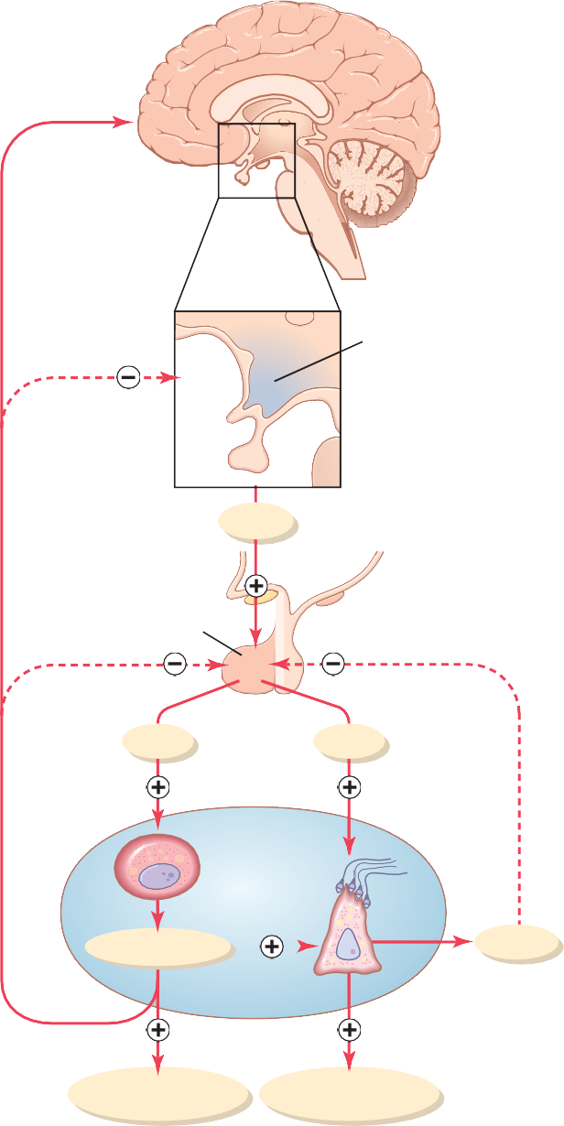CNS
Behavorial effects

Hypothalamus
GnRH
Anterior pituitary
LH
FSH
Testis

Leydig cell
Sertoli cell
Testosterone Inhibin
Androgenic effects Spermatogenesis
Figure 81-10. Feedback regulation of the hypothalamic-pituitary- testicular axis in males. Stimulatory effects are shown by plus signs, and negative feedback inhibitory effects are shown by minus signs. CNS, central nervous system; FSH, follicle-stimulating hormone; GnRH, gonadotropin-releasing hormone; LH, luteinizing hormone.

LH and FSH are glycoproteins. They exert their effects on their target tissues in the testes mainly by activating the cyclic adenosine monophosphate second messenger system, which in turn activates specific enzyme systems in the respective target cells.

Regulation of Testosterone Production by Luteinizing Hormone. Testosterone is secreted by the interstitial cells of Leydig in the testes, but only when they are stimulated by LH from the anterior pituitary gland. Furthermore, the quantity of testosterone that is secreted increases
approximately in direct proportion to the amount of LH that is available.
Mature Leydig cells are normally found in a child’s testes for a few weeks after birth but then disappear until after the age of about 10 years. However, injection of puri­ fied LH into a child at any age or secretion of LH at puberty causes testicular interstitial cells that look like fibroblasts to evolve into functioning Leydig cells.

Inhibition of Anterior Pituitary Secretion of LH and FSH by Testosterone-Negative Feedback Control of Testosterone Secretion. The testosterone secreted by the testes in response to LH has the reciprocal effect of inhibiting anterior pituitary secretion of LH (see Figure 81-10). Most of this inhibition probably results from a direct effect of testosterone on the hypothalamus to decrease the secretion of GnRH. This effect in turn causes a corresponding decrease in secretion of both LH and FSH by the anterior pituitary, and the decrease in LH reduces the secretion of testosterone by the testes. Thus, whenever secretion of testosterone becomes too great, this automatic negative feedback effect, operating through the hypothalamus and anterior pituitary gland, reduces the testosterone secretion back toward the desired oper­ ating level. Conversely, too little testosterone allows the hypothalamus to secrete large amounts of GnRH, with a corresponding increase in anterior pituitary LH and FSH secretion and consequent increase in testicular testoster­ one secretion.

Regulation of Spermatogenesis by Follicle-Stimulating Hormone and Testosterone
FSH binds with specific FSH receptors attached to the Sertoli cells in the seminiferous tubules, which causes the Sertoli cells to grow and secrete various spermatogenic substances. Simultaneously, testosterone (and dihydrotes­ tosterone) diffusing into the seminiferous tubules from the Leydig cells in the interstitial spaces also has a strong tropic effect on spermatogenesis. Thus, both FSH and testosterone are necessary to initiate spermatogenesis.

Role of Inhibin in Negative Feedback Control of Seminiferous Tubule Activity. When the seminiferous tubules fail to produce sperm, secretion of FSH by the anterior pituitary gland increases markedly. Conversely, when spermatogenesis proceeds too rapidly, pituitary secretion of FSH diminishes. The cause of this negative feedback effect on the anterior pituitary is believed to be secretion by the Sertoli cells of still another hormone called inhibin (see Figure 81-10). This hormone has a strong direct effect on the anterior pituitary gland to inhibit the secretion of FSH.
Inhibin is a glycoprotein, like both LH and FSH, with a molecular weight between 10,000 and 30,000. It has been isolated from cultured Sertoli cells. Its potent inhibi­ tory feedback effect on the anterior pituitary gland

provides an important negative feedback mechanism for control of spermatogenesis, operating simultaneously with and in parallel to the negative feedback mechanism for control of testosterone secretion.

Chapter 81 Reproductive and Hormonal Functions of the Male (and Function of the Pineal Gland)

Human Chorionic Gonadotropin Secreted by the Placenta During Pregnancy Stimulates Testosterone Secretion
by the Fetal Testes
During pregnancy the hormone human chorionic gonad- otropin (hCG) is secreted by the placenta and circulates both in the mother and in the fetus. This hormone has almost the same effects on the sexual organs as LH.
During pregnancy, if the fetus is a male, hCG from the placenta causes the testes of the fetus to secrete testoster­ one. This testosterone is critical for promoting formation of the male sexual organs, as pointed out earlier. We discuss hCG and its functions during pregnancy in greater detail in Chapter 83.

Puberty and Regulation of Its Onset
Initiation of the onset of puberty has long been a mystery, but it has now been determined that during childhood the hypothalamus does not secrete significant amounts of GnRH. One of the reasons for this is that, during child­ hood, the slightest secretion of any sex steroid hormones exerts a strong inhibitory effect on hypothalamic secre­ tion of GnRH. Yet, for reasons still not understood, at the time of puberty, the secretion of hypothalamic GnRH breaks through the childhood inhibition and adult sexual life begins.
Male Adult Sexual Life and Male Climacteric. After puberty, gonadotropic hormones are produced by the male pituitary gland for the remainder of life, and at least some spermatogenesis usually continues until death. Most men, however, begin to exhibit slowly decreasing sexual func­ tions in their late 50s or 60s. There is considerable variation in this decline, with some men continuing to be virile until their 80s and 90s.
The gradual decline in sexual function is related, in part, to a decrease in testosterone secretion, as shown in Figure 81-9. The decrease in male sexual function is called the male climacteric. Occasionally the male climacteric is associated with symptoms of hot flashes, suffocation, and psychic disorders similar to the menopausal symptoms of the female. These symptoms can be abrogated by admin­ istration of testosterone, synthetic androgens, or even estrogens that are used for treatment of menopausal symp­ toms in the female.
Abnormalities of Male Sexual Function
The Prostate Gland and Its Abnormalities
The prostate gland remains relatively small throughout childhood and begins to grow at puberty under the stimu­ lus of testosterone. This gland reaches an almost stationary size by the age of 20 years and remains at this size up to
the age of about 50 years. At that time, in some men it begins to involute, along with decreased production of tes­ tosterone by the testes.
A benign prostatic fibroadenoma frequently develops in the prostate in many older men and can cause urinary obstruction. This hypertrophy is caused not by testosterone but instead by abnormal overgrowth of prostate tissue.
U N I T X I V
Cancer of the prostate gland is a different problem that accounts for about 2 to 3 percent of all male deaths. Once cancer of the prostate gland occurs, the cancerous cells are usually stimulated to more rapid growth by testosterone and are inhibited by removal of both testes so that testos­ terone cannot be formed. Prostatic cancer usually can be inhibited by administration of estrogens. Even some patients who have prostatic cancer that has already metas­ tasized to almost all the bones of the body can be success­ fully treated for a few months to years by removal of the testes, estrogen therapy, or both; after initiation of this therapy, the metastases usually diminish in size and the bones partially heal. This treatment does not stop the cancer but slows it and sometimes greatly diminishes the severe bone pain.
Hypogonadism in the Male
When the testes of a male fetus are nonfunctional during fetal life, none of the male sexual characteristics develop in the fetus. Instead, female organs are formed. The reason for this is that the basic genetic characteristic of the fetus, whether male or female, is to form female sexual organs if there are no sex hormones. However, in the presence of testosterone, formation of female sexual organs is sup­ pressed and male organs are induced instead.
When a boy loses his testes before puberty, a state of eunuchism ensues in which he continues to have infantile sex organs and other infantile sexual characteristics throughout life. The height of an adult eunuch is slightly greater than that of a normal man because the bone epiph­ yses are slow to unite, although the bones are quite thin and the muscles are considerably weaker than those of a normal man. The voice is childlike, there is no loss of hair on the head, and the normal adult masculine hair distribu­ tion on the face and elsewhere does not occur.
When a man is castrated after puberty, some of his male secondary sexual characteristics revert to those of a child and others remain of adult masculine character. The sexual organs regress slightly in size but not to a childlike state, and the voice regresses from the bass quality only slightly. However, there is loss of masculine hair production, loss of the thick masculine bones, and loss of the musculature of the virile male.
Also in a castrated adult male, sexual desires are decreased but not lost, provided sexual activities have been practiced previously. Erection can still occur as before, although with less ease, but it is rare that ejaculation can take place, primarily because the semen­forming organs degenerate and there has been a loss of the testosterone­ driven psychic desire.
Some instances of hypogonadism are caused by a genetic inability of the hypothalamus to secrete normal amounts of GnRH. This condition is often associated with a simultaneous abnormality of the feeding center of the

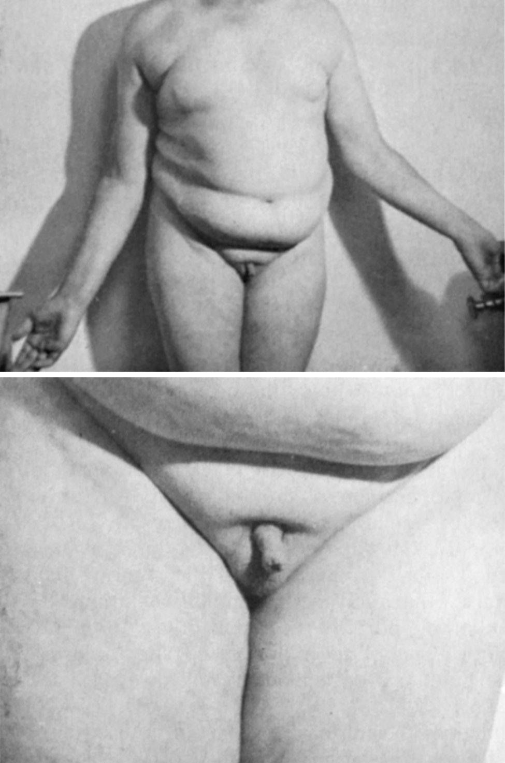
Figure 81-11. Adiposogenital syndrome in an adolescent male. Note the obesity and childlike sexual organs. (Courtesy Dr. Leonard Posey.)
hypothalamus, causing the person to greatly overeat. Consequently, obesity occurs along with eunuchism. A patient with this condition is shown in Figure 81-11; the condition is called adiposogenital syndrome, Fröhlich’s syn- drome, or hypothalamic eunuchism.
Testicular Tumors and Hypergonadism in the Male
Interstitial Leydig cell tumors develop in rare instances in the testes. These tumors sometimes produce as much as 100 times the normal quantities of testosterone. When such tumors develop in young children, they cause rapid growth of the musculature and bones but also early uniting of the epiphyses, so that the eventual adult height is actually considerably less than that which would have been achieved otherwise. Such interstitial cell tumors also cause excessive development of the male sexual organs, all skeletal muscles, and other male sexual characteristics. In the adult male, small interstitial cell tumors are difficult to diagnose because masculine features are already present.
Much more common than interstitial Leydig cell tumors are tumors of the germinal epithelium. Because germinal cells are capable of differentiating into almost any type of cell, many of these tumors contain multiple tissues, such as placental tissue, hair, teeth, bone, skin, and so forth, all found together in the same tumorous mass called a
teratoma. These tumors often secrete few hormones, but if a significant quantity of placental tissue develops in the tumor, it may secrete large quantities of hCG with func­ tions similar to those of LH. Also, estrogenic hormones are sometimes secreted by these tumors and cause the condi­ tion called gynecomastia (overgrowth of the breasts).

Erectile Dysfunction in the Male
Erectile dysfunction, also called “impotence,” is character­ ized by an inability of the man to develop or maintain an erection of sufficient rigidity for satisfactory sexual inter­ course. Neurological problems, such as trauma to the para­ sympathetic nerves from prostate surgery, deficient levels of testosterone, and some drugs (e.g., nicotine, alcohol, and antidepressants) can also contribute to erectile dysfunction.
In men older than 40 years, erectile dysfunction is most often caused by underlying vascular disease. As discussed previously, adequate blood flow and nitric oxide formation are essential for penile erection. Vascular disease, which can occur as a result of uncontrolled hypertension, diabetes, and atherosclerosis, reduces the ability of the body’s blood vessels, including those in the penis, to dilate. Part of this impaired vasodilation is due to decreased release of nitric oxide.
Erectile dysfunction caused by vascular disease can often be successfully treated with phosphodiesterase-5 (PDE-5) inhibitors such as sildenafil (Viagra), vardenafil (Levitra), or tadalafil (Cialis). These drugs increase cyclic GMP levels in the erectile tissue by inhibiting the enzyme phosphodiesterase-5, which rapidly degrades cyclic GMP. Thus, by inhibiting the degradation of cyclic GMP, the PDE­5 inhibitors enhance and prolong the effect of cyclic GMP to cause erection.

The Function of the Pineal Gland in Controlling Seasonal Fertility in Some Animals
For as long as the pineal gland has been known to exist, myriad functions have been ascribed to it, including
- enhancing sex, (2) staving off infection, (3) promoting sleep, (4) enhancing mood, and (5) increasing longevity (as much as 10 to 25 percent). It is known from comparative anatomy that the pineal gland is a vestigial remnant of what was a third eye located high in the back of the head in some lower animals. Many physiologists have been content with the idea that this gland is a nonfunctional remnant, but others have claimed for many years that it plays important roles in the control of sexual activities and reproduction.
Now, after years of research, it appears that the pineal gland does indeed play a regulatory role in sexual and reproductive function. In animals that bear their young at certain seasons of the year and in which the pineal gland has been removed or the nervous circuits to the pineal gland have been sectioned, the normal periods of seasonal fertility are lost. To these animals, such seasonal fertility is important because it allows birth of the offspring at the time of year, usually springtime or early summer, when survival is most likely. The mechanism of this effect is not entirely clear, but it seems to be the following.

Chapter 81 Reproductive and Hormonal Functions of the Male (and Function of the Pineal Gland)
First, the pineal gland is controlled by the amount of light or “time pattern” of light seen by the eyes each day. For instance, in the hamster, more than 13 hours of dark- ness each day activates the pineal gland, whereas less than that amount of darkness fails to activate it, with a critical balance between activation and nonactivation. The nervous pathway involves the passage of light signals from the eyes to the suprachiasmal nucleus of the hypothalamus and then to the pineal gland, activating pineal secretion.
Second, the pineal gland secretes melatonin and several other similar substances. Either melatonin or one of the other substances is believed to pass either by way of the blood or through the fluid of the third ventricle to the anterior pituitary gland to decrease gonadotropic hormone secretion.
Thus, in the presence of pineal gland secretion, gonado­ tropic hormone secretion is suppressed in some species of animals, and the gonads become inhibited and even partly involuted, which is what presumably occurs during the early winter months when there is increasing darkness. However, after about 4 months of dysfunction, gonado­ tropic hormone secretion breaks through the inhibitory effect of the pineal gland and the gonads become functional once more, ready for a full springtime of activity.
Does the pineal gland have a similar function for control of reproduction in humans? The answer to this question is unknown. However, tumors sometimes occur in the region of the pineal gland. Some of these tumors secrete excessive quantities of pineal hormones, whereas others are tumors of surrounding tissue and press on the pineal gland to destroy it. Both types of tumors are often associated with hypogonadal or hypergonadal function, so perhaps the pineal gland does play at least some role in controlling sexual drive and reproduction in humans.

Bibliography
Barakat B, Itman C, Mendis SH, Loveland KL: Activins and inhibins in mammalian testis development: new models, new insights. Mol Cell Endocrinol 359:66, 2012.
U N I T X I V
Basaria S: Reproductive aging in men. Endocrinol Metab Clin North Am 42:255, 2013.
Basaria S: Male hypogonadism. Lancet 383:1250, 2014.
Darszon A, Nishigaki T, Beltran C, Treviño CL: Calcium channels in the development, maturation, and function of spermatozoa.
Physiol Rev 91:1305, 2011.
Feng CW, Bowles J, Koopman P: Control of mammalian germ cell entry into meiosis. Mol Cell Endocrinol 382:488, 2014.
Groth KA, Skakkebæk A, Høst C, et al: Clinical review: Klinefelter syndrome—a clinical update. J Clin Endocrinol Metab 98:20, 2013.
Guerrero-Bosagna C, Skinner MK: Environmentally induced epigen- etic transgenerational inheritance of male infertility. Curr Opin Genet Dev 26C:79, 2014.
Kovac JR, Pan MM, Lipshultz LI, Lamb DJ: Current state of practice regarding testosterone supplementation therapy in men with pros-
tate cancer. Steroids 89C:27, 2014.
Lasker GF, Pankey EA, Kadowitz PJ: Modulation of soluble guanylate cyclase for the treatment of erectile dysfunction. Physiology (Bethesda) 28:262, 2013.
Matzuk M, Lamb D: The biology of infertility: research advances and clinical challenges. Nature Medicine 14:1197, 2008.
Oatley JM, Brinster RL: The germline stem cell niche unit in mam- malian testes. Physiol Rev 92:577, 2012.
Plant TM, Marshall GR: The functional significance of FSH in sper- matogenesis and the control of its secretion in male primates. Endocr Rev 22:764, 2001.
Shamloul R, Ghanem H: Erectile dysfunction. Lancet 381:153,
2013.
Svingen T, Koopman P: Building the mammalian testis: origins, dif- ferentiation, and assembly of the component cell populations. Genes Dev 27:2409, 2013.
Wilhelm D, Palmer S, Koopman P: Sex determination and gonadal development in mammals. Physiol Rev 87:1, 2007.

Female reproductive functions can be divided into two major phases: (1) preparation of the female body for con- ception and pregnancy and (2) the period of pregnancy itself. This chapter is concerned with preparation of the female body for pregnancy, and Chapter 83 presents the physiology of pregnancy and childbirth.
U N I T X I V
PHYSIOLOGICAL ANATOMY OF THE FEMALE SEXUAL ORGANS

Figures 82-1 and 82-2 show the principal organs of the human female reproductive tract, including the ovaries, fallopian tubes (also called uterine tubes), uterus, and vagina. Reproduction begins with the development of ova in the ovaries. In the middle of each monthly sexual cycle, a single ovum is expelled from an ovarian follicle into the abdominal cavity near the open fimbriated ends of the two fallopian tubes. This ovum then passes through one of the fallopian tubes into the uterus; if it has been fertil- ized by a sperm, it implants in the uterus, where it devel- ops into a fetus, a placenta, and fetal membranes—and eventually into a baby.
OOGENESIS AND FOLLICULAR DEVELOPMENT IN THE OVARIES

A developing egg (oocyte) differentiates into a mature egg (ovum) through a series of steps called oogenesis (Figure 82-3). During early embryonic development, pri- mordial germ cells from the dorsal endoderm of the yolk sac migrate along the mesentery of the hindgut to the outer surface of the ovary, which is covered by a germinal epithelium, derived embryologically from the epithelium of the germinal ridges. During this migration, the germ cells divide repeatedly. Once these primordial germ cells reach the germinal epithelium, they migrate into the sub- stance of the ovarian cortex and become oogonia or pri- mordial ova.
Each primordial ovum then collects around it a layer of spindle cells from the ovarian stroma (the supporting tissue of the ovary) and causes them to take on epithelioid characteristics; these epithelioid-like cells are then called granulosa cells. The ovum surrounded by a single layer of
the ovum is still immature and is called a primary oocyte, requiring two more cell divisions before it can be fertil- ized by a sperm.
The oogonia in the embryonic ovary complete mitotic replication and the first stage of meiosis by the fifth month of fetal development. The germ cell mitosis then ceases and no additional oocytes are formed. At birth the ovary contains about 1 to 2 million primary oocytes.
The first meiotic division of the oocyte occurs after puberty. Each oocyte divides into two cells, a large ovum (secondary oocyte) and a small first polar body. Each of these cells contains 23 duplicated chromosomes. The first polar body may or may not undergo a second meiotic division and then disintegrates. The ovum undergoes a second meiotic division, and after the sister chromatids separate, there is a pause in meiosis. If the ovum is fertil- ized, the final step in meiosis occurs and the sister chro- matids in the ovum go to separate cells.
When the ovary releases the ovum (ovulation) and if the ovum is fertilized, the final meiosis occurs. Half of the sister chromatids remain in the fertilized ovum and the other half are released in a second polar body, which then disintegrates.
At puberty, only about 300,000 oocytes remain in the ovaries, and only a small percentage of these oocytes become mature. The many thousands of oocytes that do

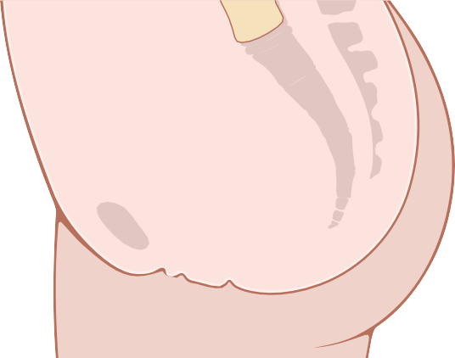Uterine tube
Rectum

Ovary Uterus Cervix
Urinary
bladder Vagina Urethra
Clitoris

Labium majus Labium minus Anus

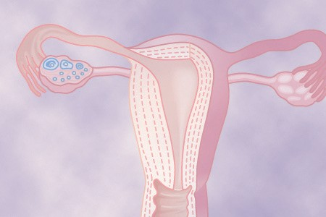granulosa cells is called a primordial follicle. At this stage
Female Physiology Before Pregnancy and Female Hormones
C H A P T E R 8 2
Figure 82-1. The female reproductive organs.

Perimetrium
Isthmus of uterine tube
Ovarian ligament
Ovarian stroma

Ampullae of fallopian tube
Mucosal folds of uterine tube

Uterine cavity Endometrium
Myometrium
Uterosacral ligament
Cervical canal
Vagina

Vaginal rugae

Isthmus of uterus Cervix

Ovarian follicles Corpus luteum
Broad ligament of uterus
Fimbriae

Ovarian vessels

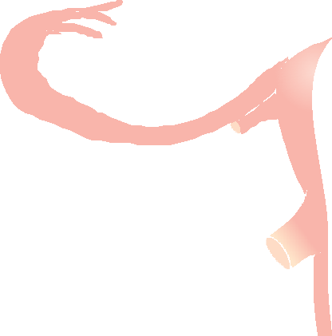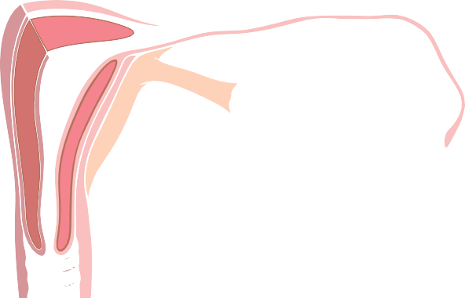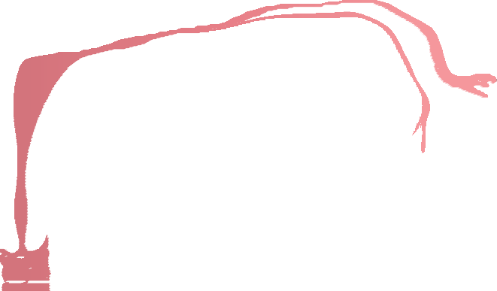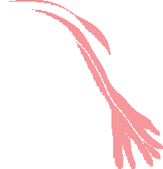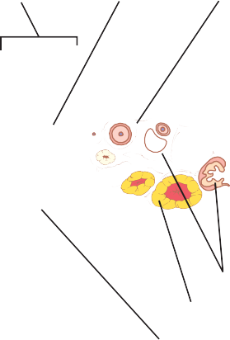Figure 82-2. Internal structures of the uterus, ovary, and a uterine tube.

Before birth

Repeated cell divisions
Oogenesis

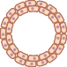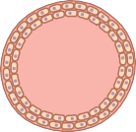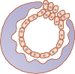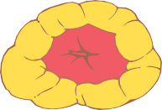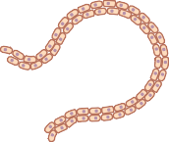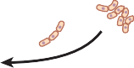Primordial germ cell
Follicle Development in Ovary

At birth
(1 to 2 million oocytes)

Each month from puberty to menopause

Ovulation

Fertilization
Migrates to ovarian cortex

Meiosis I

First polar body (degenerates)

Oogonium (primordial ovum)

Primary oocyte (arrested in prophase I)

Secondary oocyte (arrested in metaphase II)

Ovulated secondary oocyte

Sperm

Granulosa cells

Primordial follicle

Primary follicle

Preovulatory (mature) follicle

Meiosis II completed only if fertilized

Second polar body (degenerates)

Ovum (zygote)
Corpus luteum

Figure 82-3. Oogenesis and follicle development.

not mature degenerate. During all the reproductive years of adult life, between about 13 and 46 years of age, only 400 to 500 of the primordial follicles develop enough to expel their ova—one each month; the remainder degener- ate (i.e., become atretic). At the end of reproductive capa- bility (at menopause), only a few primordial follicles remain in the ovaries, and even these follicles degenerate soon thereafter.

The female hormonal system, like that of the male hor- monal system, consists of three hierarchies of hormones, as follows:
  - A hypothalamic releasing hormone, called
gonadotropin-releasing hormone (GnRH)
  - The anterior pituitary sex hormones, follicle- stimulating hormone (FSH) and luteinizing hormone (LH), both of which are secreted in response to the release of GnRH from the hypothalamus
  - The ovarian hormones, estrogen and progesterone, which are secreted by the ovaries in response to the two female sex hormones from the anterior pitu- itary gland
These various hormones are secreted at drastically dif- fering rates during different parts of the female monthly sexual cycle. Figure 82-4 shows the approximate chang- ing concentrations of the anterior pituitary gonadotropic hormones FSH and LH (bottom two curves) and of the ovarian hormones estradiol (estrogen) and progesterone (top two curves).
The amount of GnRH released from the hypothal- amus increases and decreases much less drastically during the monthly sexual cycle. It is secreted in short pulses averaging once every 90 minutes, as occurs in the male.

The normal reproductive years of the female are charac- terized by monthly rhythmical changes in the rates of secretion of the female hormones and corresponding physical changes in the ovaries and other sexual organs. This rhythmical pattern is called the female monthly sexual cycle (or, less accurately, the menstrual cycle). The duration of the cycle averages 28 days. It may be as short as 20 days or as long as 45 days in some women, although abnormal cycle length is frequently associated with decreased fertility.
The female sexual cycle has two significant results. First, only a single ovum is normally released from the ovaries each month, so normally only a single fetus will begin to grow at a time. Second, the uterine endometrium is prepared in advance for implantation of the fertilized ovum at the required time of the month.
U N I T
X I V

GONADOTROPIC HORMONES AND THEIR EFFECTS ON
THE OVARIES
The ovarian changes that occur during the sexual cycle depend completely on the gonadotropic hormones FSH and LH, which are secreted by the anterior pituitary gland. Both FSH and LH are small glycoproteins that have molecular weights of about 30,000. In the absence of these hormones, the ovaries remain inactive, which is the case throughout childhood, when almost no pituitary gonado- tropic hormones are secreted. At age 9 to 12 years, the pituitary begins to secrete progressively more FSH and LH, which leads to the onset of normal monthly sexual cycles beginning between the ages of 11 and 15 years. This period of change is called puberty, and the time of the first

800
Progesterone
Estradiol
LH
FSH
600
Estradiol (pg/mL)
400
200
0
Menstruation
800
FSH and LH (ng/mL)
600
400
200
0
0 4

8 12
8

4

0
Ovulation

16 20 24 28
menstrual cycle is called menarche. During each month of the female sexual cycle, there is a cyclical increase and decrease of FSH and LH, as shown in the bottom of Figure 82-4. These cyclical variations cause cyclical ovarian changes, which are explained in the following sections.
Both FSH and LH stimulate their ovarian target cells by combining with highly specific FSH and LH receptors in the ovarian target cell membranes. In turn, the activated receptors increase the cells’ rates of secretion and usually the growth and proliferation of the cells as well. Almost all these stimulatory effects result from activation of the cyclic adenosine mono- phosphate second messenger system in the cell cyto-
Progesterone (ng/mL)

Days of female sexual cycle

Chapter 82 Female Physiology Before Pregnancy and Female Hormones
FEMALE HORMONAL SYSTEM
MONTHLY OVARIAN CYCLE; FUNCTION OF THE GONADOTROPIC HORMONES
Figure 82-4. Approximate plasma concentrations of the gonadotro- pins and ovarian hormones during the normal female sexual cycle. FSH, follicle-stimulating hormone; LH, luteinizing hormone.
plasm, which causes the formation of protein kinase and multiple phosphorylations of key enzymes that stimulate sex hormone synthesis, as explained in Chapter 75.

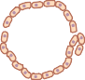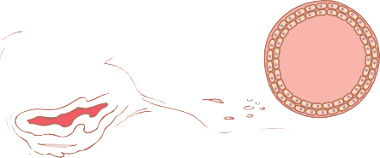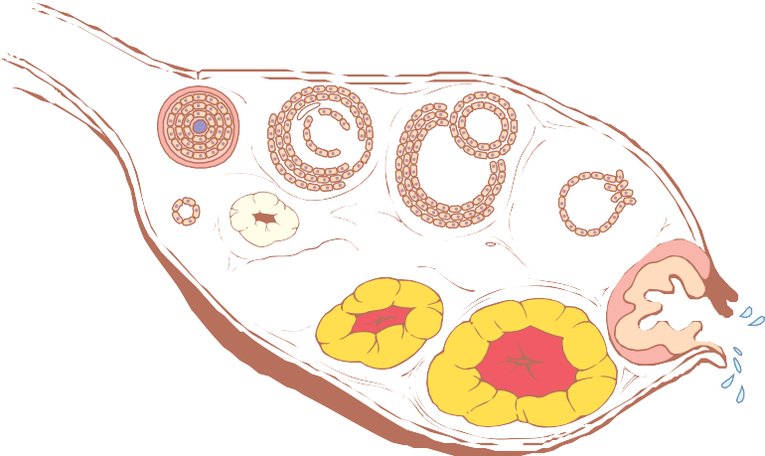
Preantral follicle
Zona pellucida
Theca
Antrum
Antral follicle
Ovum
Granulosa cells
Primary follicle
Preovulatory (mature) follicle
Primordial
follicle

Corpus albicans
Ovulation
Degenerating corpus luteum

Corpus luteum
Ovum
Corona radiata
Figure 82-5. Stages of follicular growth in the ovary, also showing formation of the corpus luteum.

OVARIAN FOLLICLE GROWTH—THE FOLLICULAR PHASE OF
THE OVARIAN CYCLE
Figure 82-5 shows the progressive stages of follicular growth in the ovaries. When a female child is born, each ovum is surrounded by a single layer of granulosa cells; the ovum, with this granulosa cell sheath, is called a primordial follicle, as shown in the figure. Throughout childhood, the granulosa cells are believed to provide nourishment for the ovum and to secrete an oocyte maturation inhibiting factor that keeps the ovum sus- pended in its primordial state in the prophase stage of meiotic division. Then, after puberty, when FSH and LH from the anterior pituitary gland begin to be secreted in significant quantities, the ovaries (together with some of the follicles within them) begin to grow.
The first stage of follicular growth is moderate enlarge- ment of the ovum, which increases in diameter twofold to threefold. That stage is followed by growth of addi- tional layers of granulosa cells in some of the follicles. These follicles are known as primary follicles.
Development of Antral and Vesicular Follicles. During the first few days of each monthly female sexual cycle, the concentrations of both FSH and LH secreted by the ante- rior pituitary gland increase slightly to moderately, with the increase in FSH slightly greater than that of LH and preceding it by a few days. These hormones, especially FSH, cause accelerated growth of 6 to 12 primary follicles each month. The initial effect is rapid proliferation of the granulosa cells, giving rise to many more layers of these
cells. In addition, spindle cells derived from the ovary interstitium collect in several layers outside the granulosa cells, giving rise to a second mass of cells called the theca. The theca is divided into two layers. In the theca interna, the cells take on epithelioid characteristics similar to those of the granulosa cells and develop the ability to secrete additional steroid sex hormones (estrogen and progesterone). The outer layer, the theca externa, devel- ops into a highly vascular connective tissue capsule that becomes the capsule of the developing follicle.
After the early proliferative phase of growth, which lasts for a few days, the mass of granulosa cells secretes a follicular fluid that contains a high concentration of estro- gen, one of the important female sex hormones (discussed later). Accumulation of this fluid causes an antrum to appear within the mass of granulosa cells, as shown in Figure 82-5.
The early growth of the primary follicle up to the antral stage is stimulated mainly by FSH alone. Greatly acceler- ated growth then occurs, leading to still larger follicles called vesicular follicles. This accelerated growth is caused by the following mechanisms:
- Estrogen is secreted into the follicle and causes the granulosa cells to form increasing numbers of FSH receptors, which causes a positive feedback effect because it makes the granulosa cells even more sen- sitive to FSH.
- The pituitary FSH and the estrogens combine to promote LH receptors on the original granulosa cells, thus allowing LH stimulation to occur in addi- tion to FSH stimulation and creating an even more rapid increase in follicular secretion.

- The increasing estrogens from the follicle plus the increasing LH from the anterior pituitary gland act together to cause proliferation of the follicular thecal cells and increase their secretion as well.
Once the antral follicles begin to grow, their growth occurs almost explosively. The ovum also enlarges in
Luteinizing hormone

Follicular steroid hormones (progesterone)
U N I T X I V

diameter another threefold to fourfold, giving a total ovum diameter increase up to 10-fold, or a mass increase of 1000-fold. As the follicle enlarges, the ovum remains embedded in a mass of granulosa cells located at one pole of the follicle.

Only One Follicle Fully Matures Each Month, and the Remainder Undergo Atresia. After a week or more of growth—but before ovulation occurs—one of the follicles begins to outgrow all the others, and the remaining 5 to 11 developing follicles involute (a process called atresia);
Proteolytic enzymes (collagenase)
Weakened follicle wall

Degeneration of stigma
Follicular hyperemia and
prostaglandin secretion

Plasma transudation into follicle

Follicle swelling

these follicles are said to become atretic.

Chapter 82 Female Physiology Before Pregnancy and Female Hormones
The cause of the atresia is unclear, but it has been postulated to be the following: The large amounts of estrogen from the most rapidly growing follicle act on the hypothalamus to depress further enhancement of FSH secretion by the anterior pituitary gland, in this way blocking further growth of the less well-developed follicles. Therefore, the largest follicle continues to grow because of its intrinsic positive feedback effects, while all the other follicles stop growing and actually involute.
This process of atresia is important because it normally allows only one of the follicles to grow large enough each month to ovulate, which usually prevents more than one child from developing with each pregnancy. The single follicle reaches a diameter of 1 to 1.5 centimeters at the time of ovulation and is called the mature follicle.

Ovulation
Ovulation in a woman who has a normal 28-day female sexual cycle occurs 14 days after the onset of menstrua- tion. Shortly before ovulation the protruding outer wall of the follicle swells rapidly, and a small area in the center of the follicular capsule, called the stigma, protrudes like a nipple. In another 30 minutes or so, fluid begins to ooze from the follicle through the stigma, and about 2 minutes later, the stigma ruptures widely, allowing a more viscous fluid, which has occupied the central portion of the fol- licle, to evaginate outward. This viscous fluid carries with it the ovum surrounded by a mass of several thousand small granulosa cells, called the corona radiata.

A Surge of Luteinizing Hormone Is Necessary for Ovulation. LH is necessary for final follicular growth and ovulation. Without this hormone, even when large quantities of FSH are available, the follicle will not pro- gress to the stage of ovulation.
About 2 days before ovulation (for reasons that are not completely understood but are discussed later in this chapter), the rate of secretion of LH by the anterior pitu- itary gland increases markedly, rising 6- to 10-fold and
Follicle rupture

Evagination of ovum
Figure 82-6. The postulated mechanism of ovulation.

peaking about 16 hours before ovulation. FSH also increases about twofold to threefold at the same time, and the FSH and LH act synergistically to cause rapid swelling of the follicle during the last few days before ovulation. The LH also has a specific effect on the granulosa and theca cells, converting them mainly to progesterone- secreting cells. Therefore, the rate of secretion of estrogen begins to fall about 1 day before ovulation, while increas- ing amounts of progesterone begin to be secreted.
It is in this environment of (1) rapid growth of the fol- licle, (2) diminishing estrogen secretion after a prolonged phase of excessive estrogen secretion, and (3) initiation of secretion of progesterone that ovulation occurs. Without the initial preovulatory surge of LH, ovulation will not take place.
Initiation of Ovulation. Figure 82-6 provides a schema for the initiation of ovulation, showing the role of the large quantity of LH secreted by the anterior pituitary gland. This LH causes rapid secretion of follicular ste- roid hormones that contain progesterone. Within a few hours, two events occur, both of which are necessary for ovulation:
- The theca externa (i.e., the capsule of the follicle) begins to release proteolytic enzymes from lyso- somes, and these enzymes cause dissolution of the follicular capsular wall and consequent weakening of the wall, resulting in further swelling of the entire follicle and degeneration of the stigma.
- Simultaneously there is rapid growth of new blood vessels into the follicle wall, and at the same time, prostaglandins (local hormones that cause vasodila- tion) are secreted into the follicular tissues.
These two effects cause plasma transudation into the follicle, which contributes to follicle swelling. Finally, the

combination of follicle swelling and simultaneous degen- eration of the stigma causes follicle rupture, with dis- charge of the ovum.

CORPUS LUTEUM—THE LUTEAL PHASE OF THE OVARIAN CYCLE
During the first few hours after expulsion of the ovum from the follicle, the remaining granulosa and theca interna cells change rapidly into lutein cells. They enlarge in diameter two or more times and become filled with lipid inclusions that give them a yellowish appearance. This process is called luteinization, and the total mass of cells together is called the corpus luteum, which is shown in Figure 82-5. A well-developed vascular supply also grows into the corpus luteum.
The granulosa cells in the corpus luteum develop extensive intracellular smooth endoplasmic reticula that form large amounts of the female sex hormones proges- terone and estrogen (with more progesterone than estro- gen during the luteal phase). The theca cells form mainly the androgens androstenedione and testosterone rather than female sex hormones. However, most of these hor- mones are also converted by the enzyme aromatase in the granulosa cells into estrogens, the female hormones.
The corpus luteum normally grows to about 1.5 centi- meters in diameter, reaching this stage of development 7 to 8 days after ovulation. Then the corpus luteum begins to involute and eventually loses its secretory function and its yellowish, lipid characteristic about 12 days after ovu- lation, becoming the corpus albicans; during the ensuing few weeks, the corpus albicans is replaced by connective tissue and over months is absorbed.
Luteinizing Function of Luteinizing Hormone. The change of granulosa and theca interna cells into lutein cells is dependent mainly on LH secreted by the anterior pituitary gland. In fact, this function gives LH its name— “luteinizing,” for “yellowing.” Luteinization also depends on extrusion of the ovum from the follicle. A yet unchar- acterized local hormone in the follicular fluid, called luteinization-inhibiting factor, seems to hold the lutein- ization process in check until after ovulation.

Secretion by the Corpus Luteum: An Additional Function of Luteinizing Hormone. The corpus luteum is a highly secretory organ, secreting large amounts of both progesterone and estrogen. Once LH (mainly that secreted during the ovulatory surge) has acted on the granulosa and theca cells to cause luteinization, the newly formed lutein cells seem to be programmed to go through a preordained sequence of (1) proliferation, (2) enlarge- ment, and (3) secretion, followed by (4) degeneration. All this occurs in about 12 days. We shall see in the discussion of pregnancy in Chapter 83 that another hormone with almost exactly the same properties as LH, chorionic gonadotropin, which is secreted by the placenta, can
act on the corpus luteum to prolong its life—usually maintaining it for at least the first 2 to 4 months of pregnancy.
Involution of the Corpus Luteum and Onset of the Next Ovarian Cycle. Estrogen in particular and proges- terone to a lesser extent, secreted by the corpus luteum during the luteal phase of the ovarian cycle, have strong feedback effects on the anterior pituitary gland to main- tain low secretory rates of both FSH and LH.
In addition, the lutein cells secrete small amounts of the hormone inhibin, the same as the inhibin secreted by the Sertoli cells of the male testes. This hormone inhibits FSH secretion by the anterior pituitary gland. Low blood concentrations of both FSH and LH result, and loss of these hormones finally causes the corpus luteum to degenerate completely, a process called involution of the corpus luteum.
Final involution normally occurs at the end of almost exactly 12 days of corpus luteum life, which is around the 26th day of the normal female sexual cycle, 2 days before menstruation begins. At this time, the sudden cessation of secretion of estrogen, progesterone, and inhibin by the corpus luteum removes the feedback inhibition of the anterior pituitary gland, allowing it to begin secreting increasing amounts of FSH and LH again. FSH and LH initiate the growth of new follicles, beginning a new ovarian cycle. The paucity of secretion of progesterone and estrogen at this time also leads to menstruation by the uterus, which will be explained later.

SUMMARY
About every 28 days, gonadotropic hormones from the anterior pituitary gland cause 8 to 12 new follicles to begin to grow in the ovaries. One of these follicles finally becomes “mature” and ovulates on the 14th day of the cycle. During growth of the follicles, estrogen is mainly secreted.
After ovulation, the secretory cells of the ovulating follicle develop into a corpus luteum that secretes large quantities of the major female hormones, progesterone and estrogen. After another 2 weeks, the corpus luteum degenerates, whereupon the ovarian hormones estrogen and progesterone decrease greatly and menstruation begins. A new ovarian cycle then follows.
FUNCTIONS OF THE OVARIAN HORMONES—ESTRADIOL AND PROGESTERONE

The two types of ovarian sex hormones are the estrogens and the progestins. By far the most important of the estro- gens is the hormone estradiol, and by far the most impor- tant progestin is progesterone. The estrogens mainly promote proliferation and growth of specific cells in the body that are responsible for the development of most

secondary sexual characteristics of the female. The pro- gestins function mainly to prepare the uterus for preg- nancy and the breasts for lactation.

CHEMISTRY OF THE SEX HORMONES
Estrogens. In the normal nonpregnant female, estrogens are secreted in significant quantities only by the ovaries, although minute amounts are also secreted by the adre- nal cortices. During pregnancy, large quantities of estro- gens are also secreted by the placenta, as discussed in Chapter 83.
Only three estrogens are present in significant quanti- ties in the plasma of the human female: β-estradiol, estrone, and estriol, the formulas for which are shown
in Figure 82-7. The principal estrogen secreted by the ovaries is β-estradiol. Small amounts of estrone are also secreted, but most of this is formed in the peripheral
tissues from androgens secreted by the adrenal cortices and by ovarian thecal cells. Estriol is a weak estrogen; it is an oxidative product derived from both estradiol and estrone, with the conversion occurring mainly in the liver.
The estrogenic potency of β-estradiol is 12 times that of estrone and 80 times that of estriol. Considering these
relative potencies, one can see that the total estrogenic effect of β-estradiol is usually many times that of the other two together. For this reason, β-estradiol is considered the
major estrogen, although the estrogenic effects of estrone
U N I T X I V
are not negligible.

Progestins. By far the most important of the progestins is progesterone. However, small amounts of another progestin, 17-α-hydroxyprogesterone, are secreted along
with progesterone and have essentially the same effects.
Yet, for practical purposes, it is usually reasonable to consider progesterone to be the only important progestin.
In the nonpregnant female, progesterone is usually secreted in significant amounts only during the latter half of each ovarian cycle, when it is secreted by the corpus luteum.
As we shall see in Chapter 83, large amounts of pro- gesterone are also secreted by the placenta during preg- nancy, especially after the fourth month of gestation.
Synthesis of the Estrogens and Progestins. Note from the chemical formulas of the estrogens and proges- terone in Figure 82-7 that they are all steroids. They are

Cholesterol

Pregnenolone Progesterone

17a-Hydroxypregnenolone

Dehydroepiandrosterone (DHEA)

Chapter 82 Female Physiology Before Pregnancy and Female Hormones

OH
17a-Hydroxyprogesterone
Androstenedione
Testosterone
CH3
O
CH3
H
Estrone (E1)
1-Estradiol (E2)
HO
Aromatase

HO

HO
Liver
Liver
CH H
3 OH
Estriol (E3)
H
OH
Figure 82-7. Synthesis of the principal female hormones. The chemical structures of the precursor hormones, including progesterone, are shown in Figure 78-2.

Figure 82-8. Interaction of follicular theca and granulosa cells for production of estrogens. The theca cells, under the control of luteinizing hormone (LH), produce androgens that diffuse into the granulosa cells. In mature follicles, follicle-stimulating hormone (FSH) acts on granulosa cells to stimulate aromatase activity, which converts the androgens to estrogens. AC, adenylate cyclase; ATP, adenosine triphosphate; cAMP, cyclic adenosine monophosphate; LDL, low-density lipoproteins.
Theca cell
Granulosa cell
ATP
AC Cholesterol cAMP
Pregnenolone
Cholesterol

Pregnenolone
Progesterone
Progesterone
Androgens
Androgens ATP
AC
+
Capillaries/ Extracellular fluid
Aromatase
cAMP
Estrogens
FSH

synthesized in the ovaries mainly from cholesterol derived from the blood but also to a slight extent from acetyl coenzyme A, multiple molecules of which can combine to form the appropriate steroid nucleus.
During synthesis, mainly progesterone and androgens (testosterone and androstenedione) are synthesized first; then, during the follicular phase of the ovarian cycle, before these two initial hormones can leave the ovaries, almost all the androgens and much of the progesterone are converted into estrogens by the enzyme aromatase in the granulosa cells. Because the theca cells lack aro- matase, they cannot convert androgens to estrogens. However, androgens diffuse out of the theca cells into the adjacent granulosa cells, where they are converted to estrogens by aromatase, the activity of which is stimulated by FSH (Figure 82-8).
During the luteal phase of the cycle, far too much progesterone is formed for all of it to be converted, which accounts for the large secretion of progesterone into the circulating blood at this time. Also, about one fifteenth as much testosterone is secreted into the plasma of the female by the ovaries as is secreted into the plasma of the male by the testes.

Estrogens and Progesterone Are Transported in the Blood Bound to Plasma Proteins. Both estrogens and progesterone are transported in the blood bound mainly with plasma albumin and with specific estrogen- and progesterone-binding globulins. The binding between these hormones and the plasma proteins is loose enough that they are rapidly released to the tissues over a period of 30 minutes or so.
Functions of the Liver in Estrogen Degradation. The liver conjugates the estrogens to form glucuronides and sulfates, and about one fifth of these conjugated products is excreted in the bile; most of the remainder is excreted in the urine. Also, the liver converts the potent estrogens estradiol and estrone into the almost totally impotent estrogen estriol. Therefore, diminished liver function actually increases the activity of estrogens in the body, sometimes causing hyperestrinism.
Fate of Progesterone. Within a few minutes after secre- tion, almost all the progesterone is degraded to other steroids that have no progestational effect. As with the estrogens, the liver is especially important for this meta- bolic degradation.
The major end product of progesterone degradation is pregnanediol. About 10 percent of the original progester- one is excreted in the urine in this form. Therefore, one can estimate the rate of progesterone formation in the body from the rate of this excretion.

FUNCTIONS OF THE ESTROGENS— THEIR EFFECTS ON THE PRIMARY AND SECONDARY FEMALE
SEX CHARACTERISTICS
A primary function of the estrogens is to cause cellular proliferation and growth of the tissues of the sex organs and other tissues related to reproduction.
Effect of Estrogens on the Uterus and External Female Sex Organs. During childhood, estrogens are

secreted only in minute quantities, but at puberty, the quantity secreted in the female under the influence of the pituitary gonadotropic hormones increases 20-fold or more. At this time, the female sex organs change from those of a child to those of an adult. The ovaries, fallopian tubes, uterus, and vagina all increase several times in size. Also, the external genitalia enlarge, with deposition of fat in the mons pubis and labia majora and enlargement of the labia minora.

Chapter 82 Female Physiology Before Pregnancy and Female Hormones
In addition, estrogens change the vaginal epithelium from a cuboidal into a stratified type, which is consider- ably more resistant to trauma and infection than is the prepubertal cuboidal cell epithelium. Vaginal infections in children can often be cured by the administration of estrogens simply because of the resulting increased resis- tance of the vaginal epithelium.
During the first few years after puberty, the size of the uterus increases twofold to threefold, but more important than the increase in uterus size are the changes that take place in the uterine endometrium under the influence of estrogens. Estrogens cause marked proliferation of the endometrial stroma and greatly increased development of the endometrial glands, which will later aid in providing nutrition to the implanted ovum. These effects are dis- cussed later in the chapter in connection with the endo- metrial cycle.
Effect of Estrogens on the Fallopian Tubes. The estrogens’ effects on the mucosal lining of the fallopian tubes are similar to their effects on the uterine endome- trium. They cause the glandular tissues of this lining to proliferate, and especially important, they cause the number of ciliated epithelial cells that line the fallo- pian tubes to increase. Also, activity of the cilia is con- siderably enhanced. These cilia always beat toward the uterus, which helps propel the fertilized ovum in that direction.
Effect of Estrogens on the Breasts. The primordial breasts of females and males are exactly alike. In fact, under the influence of appropriate hormones, the mascu- line breast during the first 2 decades of life can develop sufficiently to produce milk in the same manner as the female breast.
Estrogens cause (1) development of the stromal tissues of the breasts, (2) growth of an extensive ductile system, and (3) deposition of fat in the breasts. The lobules and alveoli of the breast develop to a slight extent under the influence of estrogens alone, but it is progesterone and prolactin that cause the ultimate determinative growth and function of these structures.
In summary, the estrogens initiate growth of the breasts and of the milk-producing apparatus. They are also responsible for the characteristic growth and external appearance of the mature female breast. However, they do not complete the job of converting the breasts into milk-producing organs.
Effect of Estrogens on the Skeleton. Estrogens inhibit osteoclastic activity in the bones and therefore stimulate bone growth. As discussed in Chapter 80, at least part of this effect is due to stimulation of osteoprotegerin, which is also called osteoclastogenesis inhibitory factor, a cyto- kine that inhibits bone resorption.
At puberty, when the female enters her reproductive years, her growth in height becomes rapid for several years. However, estrogens have another potent effect on skeletal growth: They cause uniting of the epiphyses with the shafts of the long bones. This effect of estrogen in the female is much stronger than the similar effect of testos- terone in the male. As a result, growth of the female usually ceases several years earlier than growth of the male. A female eunuch who is devoid of estrogen produc- tion usually grows several inches taller than a normal mature female because her epiphyses do not unite at the normal time.
U N I T X I V

Osteoporosis of the Bones Caused by Estrogen Deficiency in Old Age. After menopause, almost no estrogens are secreted by the ovaries. This estrogen defi- ciency leads to (1) increased osteoclastic activity in the bones, (2) decreased bone matrix, and (3) decreased deposition of bone calcium and phosphate. In some women this effect is extremely severe, and the resulting condition is osteoporosis, described in Chapter 80. Because osteoporosis can greatly weaken the bones and lead to bone fracture, especially fracture of the vertebrae, many postmenopausal women are treated prophylactically with estrogen replacement to prevent the osteoporotic effects.
Estrogens Slightly Increase Protein Deposition. Estro- gens cause a slight increase in total body protein, which is evidenced by a slight positive nitrogen balance when estrogens are administered. This effect mainly results from the growth-promoting effect of estrogen on the sexual organs, the bones, and a few other tissues of the body. The enhanced protein deposition caused by testos- terone is much more general and much more powerful than that caused by estrogens.

Estrogens Increase Body Metabolism and Fat Depo- sition. Estrogens increase the whole-body metabolic rate slightly, but only about one third as much as the increase caused by the male sex hormone testosterone. Estrogens also cause deposition of increased quantities of fat in the subcutaneous tissues. As a result, the percentage of body fat in the female body is considerably greater than that in the male body, which contains more protein. In addition to deposition of fat in the breasts and subcutaneous tissues, estrogens cause the deposition of fat in the but- tocks and thighs, which is characteristic of the feminine figure.

Estrogens Have Little Effect on Hair Distribution.
Estrogens do not greatly affect hair distribution. However,

hair does develop in the pubic region and in the axillae after puberty. Androgens formed in increased quantities by the female adrenal glands after puberty are mainly responsible for this development of hair.
Effect of Estrogens on the Skin. Estrogens cause the skin to develop a texture that is soft and usually smooth, but even so, the skin of a woman is thicker than that of a child or a castrated female. Estrogens also

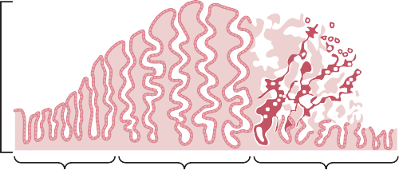
Proliferative phase
Endometrial thickness
(11 days)

Secretory phase
(12 days)

Menstrual phase
(5 days)

cause the skin to become more vascular, which is often associated with increased warmth of the skin and also promotes greater bleeding of cut surfaces than is observed in men.
Effect of Estrogens on Electrolyte Balance. The chemical similarity of estrogenic hormones to adrenocor- tical hormones has been pointed out. Estrogens, like aldo- sterone and some other adrenocortical hormones, cause sodium and water retention by the kidney tubules. This effect of estrogens is normally slight and rarely of signifi- cance, but during pregnancy the tremendous formation of estrogens by the placenta may contribute to body fluid retention, as discussed in Chapter 83.

FUNCTIONS OF PROGESTERONE
Progesterone Promotes Secretory Changes in the Uterus. A major function of progesterone is to promote secretory changes in the uterine endometrium during the latter half of the monthly female sexual cycle, thus prepar- ing the uterus for implantation of the fertilized ovum. This function is discussed later in connection with the endometrial cycle of the uterus.
In addition to this effect on the endometrium, proges- terone decreases the frequency and intensity of uterine contractions, thereby helping to prevent expulsion of the implanted ovum.
Effect of Progesterone on the Fallopian Tubes. Progesterone also promotes increased secretion by the mucosal lining of the fallopian tubes. These secre- tions are necessary for nutrition of the fertilized, divid- ing ovum as it traverses the fallopian tube before implantation.

Progesterone Promotes Development of the Breasts. Progesterone promotes development of the lobules and alveoli of the breasts, causing the alveolar cells to prolifer- ate, enlarge, and become secretory. However, progester- one does not cause the alveoli to secrete milk; as discussed in Chapter 83, milk is secreted only after the prepared breast is further stimulated by prolactin from the anterior pituitary gland.
Progesterone also causes the breasts to swell. Part of this swelling is due to the secretory development in the lobules and alveoli, but part also results from increased fluid in the tissue.
Figure 82-9. Phases of endometrial growth and menstruation during each monthly female sexual cycle.

MONTHLY ENDOMETRIAL CYCLE AND MENSTRUATION
Associated with the monthly cyclical production of estro- gens and progesterone by the ovaries is an endometrial cycle in the lining of the uterus that operates through the following stages: (1) proliferation of the uterine endome- trium; (2) development of secretory changes in the endo- metrium; and (3) desquamation of the endometrium, which is known as menstruation. The various phases of this endometrial cycle are shown in Figure 82-9.
Proliferative Phase (Estrogen Phase) of the Endo- metrial Cycle, Occurring Before Ovulation. At the beginning of each monthly cycle, most of the endome- trium has been desquamated by menstruation. After menstruation, only a thin layer of endometrial stroma remains and the only epithelial cells that are left are those located in the remaining deeper portions of the glands and crypts of the endometrium. Under the influence of estrogens, secreted in increasing quantities by the ovary during the first part of the monthly ovarian cycle, the stromal cells and the epithelial cells proliferate rapidly. The endometrial surface is re-epithelialized within 4 to 7 days after the beginning of menstruation.
Then, during the next week and a half, before ovulation occurs, the endometrium increases greatly in thickness, owing to increasing numbers of stromal cells and to pro- gressive growth of the endometrial glands and new blood vessels into the endometrium. At the time of ovulation, the endometrium is 3 to 5 millimeters thick.
The endometrial glands, especially those of the cervical region, secrete thin, stringy mucus. The mucus strings actually align themselves along the length of the cervical canal, forming channels that help guide sperm in the proper direction from the vagina into the uterus.

Secretory Phase (Progestational Phase) of the Endometrial Cycle, Occurring After Ovulation. During most of the latter half of the monthly cycle, after ovulation has occurred, progesterone and estrogen together are secreted in large quantities by the corpus luteum. The estrogens cause slight additional cellular proliferation in the endometrium during this phase of the cycle, whereas

progesterone causes marked swelling and secretory devel- opment of the endometrium. The glands increase in tor- tuosity, and an excess of secretory substances accumulates in the glandular epithelial cells. In addition, the cytoplasm of the stromal cells increases, lipid and glycogen deposits increase greatly in the stromal cells, and the blood supply to the endometrium further increases in proportion to the developing secretory activity, with the blood vessels becoming highly tortuous. At the peak of the secretory phase, about 1 week after ovulation, the endometrium has a thickness of 5 to 6 millimeters.

Chapter 82 Female Physiology Before Pregnancy and Female Hormones
The whole purpose of all these endometrial changes is to produce a highly secretory endometrium that contains large amounts of stored nutrients to provide appropriate conditions for implantation of a fertilized ovum during the latter half of the monthly cycle. From the time a fertil- ized ovum enters the uterine cavity from the fallopian tube (which occurs 3 to 4 days after ovulation) until the time the ovum implants (7 to 9 days after ovulation), the uterine secretions, called “uterine milk,” provide nutrition for the early dividing ovum. Then, once the ovum implants in the endometrium, the trophoblastic cells on the surface of the implanting ovum (in the blastocyst stage) begin to digest the endometrium and absorb the endometrial stored substances, thus making great quantities of nutri- ents available to the early implanting embryo.

Menstruation. If the ovum is not fertilized, about 2 days before the end of the monthly cycle, the corpus luteum in the ovary involutes and the ovarian hormones (estrogens and progesterone) decrease to low levels of secretion, as shown in Figure 82-4. Menstruation follows.
Menstruation is caused by the reduction of estrogens and progesterone, especially progesterone, at the end of the monthly ovarian cycle. The first effect is decreased stimulation of the endometrial cells by these two hor- mones, followed rapidly by involution of the endome- trium to about 65 percent of its previous thickness. Then, during the 24 hours preceding the onset of menstruation, the tortuous blood vessels leading to the mucosal layers of the endometrium become vasospastic, presumably because of some effect of involution, such as release of a vasoconstrictor material—possibly one of the vasocon- strictor types of prostaglandins that are present in abun- dance at this time.
The vasospasm, the decrease in nutrients to the endo- metrium, and the loss of hormonal stimulation initiate necrosis in the endometrium, especially of the blood vessels. As a result, blood at first seeps into the vascular layer of the endometrium and the hemorrhagic areas grow rapidly over a period of 24 to 36 hours. Gradually, the necrotic outer layers of the endometrium separate from the uterus at the sites of the hemorrhages until, about 48 hours after the onset of menstruation, all the superficial layers of the endometrium have desquamated. The mass of desquamated tissue and blood in the uterine cavity, plus contractile effects of prostaglandins or
other substances in the decaying desquamate, all acting together, initiate uterine contractions that expel the uterine contents.
During normal menstruation, approximately 40 milli- liters of blood and an additional 35 milliliters of serous fluid are lost. The menstrual fluid is normally nonclotting because a fibrinolysin is released along with the necrotic endometrial material. If excessive bleeding occurs from the uterine surface, the quantity of fibrinolysin may not be sufficient to prevent clotting. The presence of clots during menstruation is often clinical evidence of uterine disease.
U N I T X I V
Within 4 to 7 days after menstruation starts, the loss of blood ceases because, by this time, the endometrium has become re-epithelialized.
Leukorrhea During Menstruation. During menstrua- tion, large numbers of leukocytes are released along with the necrotic material and blood. A substance liberated by the endometrial necrosis likely causes this outflow of leu- kocytes. As a result of these leukocytes and possibly other factors, the uterus is highly resistant to infection during menstruation, even though the endometrial surfaces are denuded. This resistance to infection is of extreme protec- tive value.
REGULATION OF THE FEMALE MONTHLY RHYTHM—INTERPLAY BETWEEN THE OVARIAN AND HYPOTHALAMIC-PITUITARY HORMONES

Now that we have presented the major cyclical changes that occur during the monthly female sexual cycle, we can attempt to explain the basic rhythmical mechanism that causes the cyclical variations.

THE HYPOTHALAMUS SECRETES GnRH, WHICH CAUSES THE ANTERIOR PITUITARY GLAND TO SECRETE
LH AND FSH
As pointed out in Chapter 75, secretion of most of the anterior pituitary hormones is controlled by “releasing hormones” formed in the hypothalamus and then trans- ported to the anterior pituitary gland by way of the hypothalamic-hypophysial portal system. In the case of the gonadotropins, one releasing hormone, GnRH, is important. This hormone has been purified and has been found to be a decapeptide with the following formula:
Glu-His-Trp-Ser-Tyr-Gly-Leu-Arg-Pro-Gly-NH2

Intermittent, Pulsatile Secretion of GnRH by the Hypothalamus Stimulates Pulsatile Release of LH from the Anterior Pituitary Gland. The hypothalamus does not secrete GnRH continuously but instead secretes

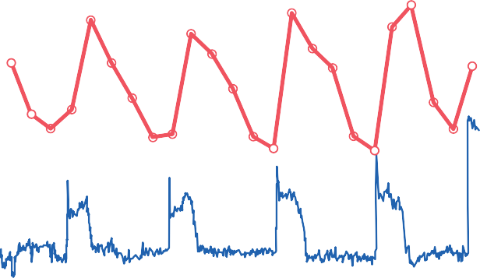100
LH
MUA

80
Luteinizing hormone (LH) (ng/mL)
Multi-unit electrical activity (MUA) (spikes/min)

2000 60

40
0
1000

0 120 240 360 480
Minutes
Figure 82-10. Red line: Pulsatile change in luteinizing hormone (LH) in the peripheral circulation of a pentobarbital-anesthetized ovariectomized rhesus monkey. Blue line: Minute-by-minute recording of multi-unit electrical activity (MUA) in the mediobasal hypothalamus. (Data from Wilson RC, Kesner JS, Kaufman JM, et al: Central electrophysiologic correlates of pulsatile luteinizing hormone secretion. Neuroendocrinology 39:256, 1984.)

it in pulses lasting 5 to 25 minutes that occur every 1 to 2 hours. The lower curve in Figure 82-10 shows the electrical pulsatile signals in the hypothalamus that cause the hypothalamic pulsatile output of GnRH.
It is intriguing that when GnRH is infused continu- ously so that it is available all the time rather than in pulses, its ability to cause the release of LH and FSH by the anterior pituitary gland is lost. Therefore, for reasons that are unknown, the pulsatile nature of GnRH release is essential to its function.
The pulsatile release of GnRH also causes intermittent output of LH secretion about every 90 minutes, which is shown by the upper curve in Figure 82-10.
Hypothalamic Centers for Release of Gonadotropin- Releasing Hormone. The neuronal activity that causes pulsatile release of GnRH occurs primarily in the medio- basal hypothalamus, especially in the arcuate nuclei of this area. Therefore, it is believed that these arcuate nuclei control most female sexual activity, although neurons located in the preoptic area of the anterior hypothalamus also secrete GnRH in moderate amounts. Multiple neu- ronal centers in the higher brain’s “limbic” system (the system for psychic control) transmit signals into the arcuate nuclei to modify both the intensity of GnRH release and the frequency of the pulses, thus providing a partial explanation of why psychic factors often modify female sexual function.

NEGATIVE FEEDBACK EFFECTS OF ESTROGEN AND PROGESTERONE TO DECREASE LH AND FSH SECRETION
Estrogen in small amounts has a strong inhibitory effect on the production of both LH and FSH. Also, when pro- gesterone is available, the inhibitory effect of estrogen is
multiplied, even though progesterone by itself has little effect (Figure 82-11).
These feedback effects seem to operate mainly on the anterior pituitary gland directly, but they also operate to a lesser extent on the hypothalamus to decrease secretion of GnRH, especially by altering the frequency of the GnRH pulses.

Inhibin from the Corpus Luteum Inhibits FSH and LH Secretion. In addition to the feedback effects of estrogen and progesterone, other hormones seem to be involved, especially inhibin, which is secreted along with the steroid sex hormones by the granulosa cells of the ovarian corpus luteum in the same way that Sertoli cells secrete inhibin in the male testes (see Figure 82-11). This hormone has the same effect in the female as in the male—that is, inhibiting the secretion of FSH and, to a lesser extent, LH by the anterior pituitary gland. Therefore, it is believed that inhibin might be especially important in causing the decrease in secretion of FSH and LH at the end of the monthly female sexual cycle.

POSITIVE FEEDBACK EFFECT OF ESTROGEN BEFORE OVULATION—THE PREOVULATORY LUTEINIZING HORMONE SURGE
For reasons that are not completely understood, the ante- rior pituitary gland secretes greatly increased amounts of LH for 1 to 2 days beginning 24 to 48 hours before ovula- tion. This effect is demonstrated in Figure 82-4. The figure shows a much smaller preovulatory surge of FSH as well.
Experiments have shown that infusion of estrogen into a female above a critical rate for 2 to 3 days during the latter part of the first half of the ovarian cycle will cause rapidly accelerating growth of the ovarian follicles, as well

CNS

Chapter 82 Female Physiology Before Pregnancy and Female Hormones
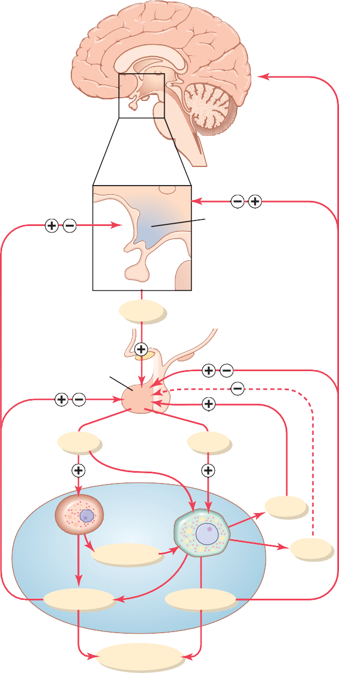
Behavioral effects
Hypothalamus
GnRH
Anterior pituitary
LH
FSH
Ovary
Activin
Theca cell
Androgens
Inhibin
Granulosa cell
Progestins Estrogens
Target tissues
Figure 82-11. Feedback regulation of the hypothalamic-pituitary- ovarian axis in females. Stimulatory effects are shown by plus signs; negative feedback inhibitory effects are shown by minus signs. Estrogens and progestins exert both negative and positive feedback effects on the anterior pituitary and hypothalamus depending on the stage of the ovarian cycle. Inhibin has a negative feedback effect on the anterior pituitary, whereas activin has the opposite effect, stimu- lating FSH secretion by the anterior pituitary. CNS, central nervous system; FSH, follicle-stimulating hormone; GnRH, gonadotropin- releasing hormone; LH, luteinizing hormone.

as rapidly accelerating secretion of ovarian estrogens. During this period, secretions of both FSH and LH by the anterior pituitary gland are at first slightly suppressed. Secretion of LH then increases abruptly sixfold to eight- fold, and secretion of FSH increases about twofold. The greatly increased secretion of LH causes ovulation to occur.
The cause of this abrupt surge in LH secretion is not known. However, the following explanations are possible:
- It has been suggested that at this point in the cycle estrogen has a peculiar positive feedback effect of stimulating pituitary secretion of LH and, to a lesser extent, FSH (see Figure 82-11), which is in sharp contrast to the normal negative feedback effect of estrogen that occurs during the remainder of the female monthly cycle.
U N I T X I V
- The granulosa cells of the follicles begin to secrete small but increasing quantities of progesterone a day or so before the preovulatory LH surge, and it has been suggested that this secretion might be the factor that stimulates the excess LH secretion.
Without this normal preovulatory surge of LH, ovula- tion will not occur.

FEEDBACK OSCILLATION OF THE HYPOTHALAMIC-PITUITARY- OVARIAN SYSTEM
Now that we have discussed much of the known informa- tion about the interrelations of the different components of the female hormonal system, we can explain the feed- back oscillation that controls the rhythm of the female sexual cycle. It seems to operate in approximately the fol- lowing sequence of three events.
- Postovulatory secretion of the ovarian hormones and depression of the pituitary gonadotropins. Between ovulation and the beginning of menstrua- tion, the corpus luteum secretes large quantities of progesterone and estrogen, as well as the hormone inhibin. All these hormones together have a com- bined negative feedback effect on the anterior pituitary gland and hypothalamus, causing the sup- pression of both FSH and LH secretion and decreas- ing them to their lowest levels about 3 to 4 days before the onset of menstruation. These effects are shown in Figure 82-4.
- Follicular growth phase. Two to 3 days before men- struation, the corpus luteum has regressed to almost total involution and the secretion of estrogen, pro- gesterone, and inhibin from the corpus luteum decreases to a low ebb, which releases the hypo- thalamus and anterior pituitary from the negative feedback effect of these hormones. Therefore, a day or so later, at about the time that menstruation begins, pituitary secretion of FSH begins to increase again, as much as twofold; then, several days after menstruation begins, LH secretion increases slightly as well. These hormones initiate new ovarian follicle growth and a progressive increase in the secretion of estrogen, reaching a peak estrogen secretion at about 12.5 to 13 days after the onset of the new female monthly sexual cycle. During the first 11 to 12 days of this follicle growth, the rates of pituitary

secretion of the gonadotropins FSH and LH decrease slightly because of the negative feedback effect, mainly of estrogen, on the anterior pituitary gland. Then there is a sudden, marked increase in the secretion of LH and, to a lesser extent, FSH. This increased secretion is the preovulatory surge of LH and FSH, which is followed by ovulation.
- The preovulatory surge of LH and FSH causes ovula- tion. About 111 2 to 12 days after the onset of the monthly cycle, the decline in secretion of FSH and LH comes to an abrupt halt. The high level of estro- gens at this time (or the beginning of progesterone secretion by the follicles) is believed to cause a posi-
60

50
Female
Menopause
Puberty
Male
Total urinary gonadotropins (units/24 hr)

40

30

20

10

0
0 10

20 30

40 50 60

70 80

tive feedback stimulatory effect on the anterior pituitary, as explained earlier, which leads to a large surge in the secretion of LH and, to a lesser extent, FSH. Whatever the cause of this preovulatory LH and FSH surge, the great excess of LH leads to both ovulation and subsequent development of and secretion by the corpus luteum. Thus, the hormonal system begins its new round of secretions until the
Age (yr)
Figure 82-12. Total rates of secretion of gonadotropic hormones throughout the sexual lives of female and male human beings, showing an especially abrupt increase in gonadotropic hormones at menopause in the female.

400
Estrogens excreted in urine (µg/24 hr)

next instance of ovulation.

Anovulatory Cycles—Sexual Cycles at Puberty
If the preovulatory surge of LH is not of sufficient mag- nitude, ovulation will not occur and the cycle is said to be “anovulatory.” The phases of the sexual cycle continue, but they are altered in the following ways: First, lack of ovula-

300

200

100

0

Puberty

Menopause

tion causes failure of development of the corpus luteum, so there is almost no secretion of progesterone during the latter portion of the cycle. Second, the cycle is shortened by several days, but the rhythm continues. Therefore, it is likely that progesterone is not required for maintenance of the cycle itself, although it can alter the cycle’s rhythm. The first few cycles after the onset of puberty are usually anovulatory, as are the cycles occurring several months to years before menopause, presumably because the LH surge is not potent enough at these times to cause
ovulation.

PUBERTY AND MENARCHE
Puberty means the onset of adult sexual life, and men- arche means the beginning of the cycle of menstruation. The period of puberty is caused by a gradual increase in gonadotropic hormone secretion by the pituitary, begin- ning in about the eighth year of life, as shown in Figure 82-12, and usually culminating in the onset of puberty and menstruation between ages 11 and 16 years in girls (average, 13 years).
In the female, as in the male, the infantile pituitary gland and ovaries are capable of full function if they are appropriately stimulated. However, as is also true in the male, and for reasons that are not understood, the hypo- thalamus does not secrete significant quantities of GnRH during childhood. Experiments have shown that the
0 12 13 40 50 60
Age (yr)
Figure 82-13. Estrogen secretion throughout the sexual life of the female human being.

hypothalamus is capable of secreting this hormone, but the appropriate signal from some other area of the brain to cause the secretion is lacking. Therefore, it is now believed that the onset of puberty is initiated by some maturation process that occurs elsewhere in the brain, perhaps somewhere in the limbic system.
Figure 82-13 shows (1) the increasing levels of estrogen secretion at puberty, (2) the cyclical variation during the monthly sexual cycle, (3) the further increase in estrogen secretion during the first few years of repro- ductive life, (4) the progressive decrease in estrogen secretion toward the end of reproductive life, and, finally,
(5) almost no estrogen or progesterone secretion beyond menopause.

MENOPAUSE
At age 40 to 50 years, the sexual cycle usually becomes irregular and ovulation often fails to occur. After a few months to a few years, the cycle ceases altogether, as shown in Figure 82-13. The period during which the cycle ceases and the female sex hormones diminish to almost none is called menopause.

The cause of menopause is “burning out” of the ovaries. Throughout a woman’s reproductive life, about 400 of the primordial follicles grow into mature follicles and ovulate, and hundreds of thousands of ova degenerate. At about age 45 years, only a few primordial follicles remain to be stimulated by FSH and LH, and, as shown in Figure 82-13, the production of estrogens by the ovaries decreases as the number of primordial follicles approaches zero. When estrogen production falls below a critical value, the estrogens can no longer inhibit the production of the gonadotropins FSH and LH. Instead, as shown in Figure 82-12, the gonadotropins FSH and LH (mainly FSH) are produced after menopause in large and continu- ous quantities, but as the remaining primordial follicles become atretic, the production of estrogens by the ovaries falls virtually to zero.

Chapter 82 Female Physiology Before Pregnancy and Female Hormones
as early as they do in a normal woman. Consequently, the female eunuch is essentially as tall as or perhaps even slightly taller than her male counterpart of similar genetic background.
When the ovaries of a fully developed woman are removed, the sexual organs regress to some extent so that the uterus becomes almost infantile in size, the vagina becomes smaller, and the vaginal epithelium becomes thin and easily damaged. The breasts atrophy and become pen- dulous, and the pubic hair becomes thinner. The same changes occur in women after menopause.
Irregularity of Menses, and Amenorrhea Caused by Hypogonadism. As pointed out in the preceding discus- sion of menopause, the quantity of estrogens produced by the ovaries must rise above a critical value to cause rhyth- mical sexual cycles. Consequently, in hypogonadism or when the gonads are secreting small quantities of estrogens as a result of other factors, such as hypothyroidism, the ovarian cycle often does not occur normally. Instead, several months may elapse between menstrual periods or menstruation may cease altogether (amenorrhea). Pro- longed ovarian cycles are frequently associated with failure of ovulation, presumably because of insufficient secretion of LH at the time of the preovulatory surge of LH, which is necessary for ovulation.
Hypersecretion by the Ovaries. Extreme hypersecre- tion of ovarian hormones by the ovaries is a rare clinical entity because excessive secretion of estrogens automati- cally decreases the production of gonadotropins by the pituitary, which limits the production of ovarian hormones. Consequently, hypersecretion of feminizing hormones is usually recognized clinically only when a feminizing tumor develops.
A rare granulosa cell tumor can develop in an ovary; development of this tumor occurs more often after meno- pause than before menopause. These tumors secrete large quantities of estrogens, which exert the usual estrogenic effects, including hypertrophy of the uterine endometrium and irregular bleeding from this endometrium. In fact, bleeding is often the first and only indication that such a tumor exists.
U N I T X I V
At the time of menopause, a woman must readjust her life from one that has been physiologically stimulated by estrogen and progesterone production to one devoid of these hormones. The loss of estrogens often causes marked physiological changes in the function of the body, including (1) “hot flushes” characterized by extreme flushing of the skin, (2) psychic sensations of dyspnea,
(3) irritability, (4) fatigue, (5) anxiety, and (6) decreased strength and calcification of bones throughout the body. These symptoms are of sufficient magnitude in about 15 percent of women to warrant treatment. Daily adminis- tration of estrogen in small quantities usually reverses the symptoms, and by gradually decreasing the dose, post- menopausal women can likely avoid severe symptoms.
Large clinical trials have provided evidence that admin- istration of estrogen after menopause, although amelio- rating many of the symptoms of menopause, may increase the risk for cardiovascular disease. As a result, hormone replacement therapy with estrogen is no longer routinely prescribed for postmenopausal women. Some studies, however, suggest that estrogen therapy may actually reduce the risk for cardiovascular disease if it is begun early in the postmenopausal years. Therefore, it is cur- rently recommended that postmenopausal women who are considering hormone replacement therapy should discuss with their physicians whether the benefits out- weigh the risks.

Abnormalities of Secretion by the Ovaries
Hypogonadism-Reduced Secretion by the Ovaries. Less than normal secretion by the ovaries can result from poorly formed ovaries, lack of ovaries, or genetically abnormal ovaries that secrete the wrong hormones because of missing enzymes in the secretory cells. When ovaries are absent from birth or when they become nonfunctional before puberty, female eunuchism occurs. In this condition the usual secondary sexual characteristics do not appear, and the sexual organs remain infantile. Especially charac- teristic of this condition is prolonged growth of the long bones because the epiphyses do not unite with the shafts

FEMALE SEXUAL ACT

Stimulation of the Female Sexual Act. As is true in the male sexual act, successful performance of the female sexual act depends on both psychic stimulation and local sexual stimulation.
Thinking sexual thoughts can lead to female sexual desire, and this aids greatly in the performance of the female sexual act. Such desire is based on psychological and physiological drive, although sexual desire does increase in proportion to the level of sex hormones secreted. Desire also changes during the monthly sexual cycle, reaching a peak near the time of ovulation, probably because of the high levels of estrogen secretion during the preovulatory period.
Local sexual stimulation in women occurs in more or less the same manner as in men because massage and

other types of stimulation of the vulva, vagina, and other perineal regions can create sexual sensations. The glans of the clitoris is especially sensitive for initiating sexual sensations.
As in the male, the sexual sensory signals are transmit- ted to the sacral segments of the spinal cord through the pudendal nerve and sacral plexus. Once these signals have entered the spinal cord, they are transmitted to the cere- brum. Also, local reflexes integrated in the sacral and lumbar spinal cord are at least partly responsible for some of the reactions in the female sexual organs.
Female Erection and Lubrication. Located around the introitus and extending into the clitoris is erectile tissue almost identical to the erectile tissue of the penis. This erectile tissue, like that of the penis, is controlled by the parasympathetic nerves that pass through the nervi eri- gentes from the sacral plexus to the external genitalia. In the early phases of sexual stimulation, parasympathetic signals dilate the arteries of the erectile tissue, probably resulting from release of acetylcholine, nitric oxide, and vasoactive intestinal polypeptide at the nerve endings. This allows rapid accumulation of blood in the erectile tissue so that the introitus tightens around the penis, which aids the male in his attainment of sufficient sexual stimulation for ejaculation to occur.
Parasympathetic signals also pass to the bilateral Bartholin glands located beneath the labia minora and cause them to secrete mucus immediately inside the introitus. This mucus is responsible for much of the lubri- cation during sexual intercourse, although much lubrica- tion is also provided by mucus secreted by the vaginal epithelium, and a small amount is provided from the male urethral glands. This lubrication is necessary during inter- course to establish a satisfactory massaging sensation rather than an irritative sensation, which may be pro- voked by a dry vagina. A massaging sensation constitutes the optimal stimulus for evoking the appropriate reflexes that culminate in both the male and female climaxes.
Female Orgasm. When local sexual stimulation reaches maximum intensity, and especially when the local sensa- tions are supported by appropriate psychic conditioning signals from the cerebrum, reflexes are initiated that cause the female orgasm, also called the female climax. The female orgasm is analogous to emission and ejaculation in the male, and it may help promote fertilization of the ovum. Indeed, the human female is known to be some- what more fertile when inseminated by normal sexual intercourse rather than by artificial methods, thus indi- cating an important function of the female orgasm. Possible reasons for this phenomenon are as follows.
First, during the orgasm, the perineal muscles of the female contract rhythmically, which results from spinal cord reflexes similar to those that cause ejaculation in the male. It is possible that these reflexes increase uterine and fallopian tube motility during the orgasm, thus helping to
transport the sperm upward through the uterus toward the ovum; information on this subject is scanty, however. Also, the orgasm seems to cause dilation of the cervical canal for up to 30 minutes, thus allowing easy transport of the sperm.
Second, in many animals, copulation causes the pos- terior pituitary gland to secrete oxytocin; this effect is probably mediated through the brain amygdaloid nuclei and then through the hypothalamus to the pituitary. The oxytocin causes increased rhythmical contractions of the uterus, which have been postulated to cause increased transport of the sperm. A few sperm have been shown to traverse the entire length of the fallopian tube in the cow in about 5 minutes, a rate at least 10 times as fast as that which the swimming motions of the sperm could possibly achieve. Whether this effect occurs in the human female is unknown.
In addition to the possible effects of the orgasm on fertilization, the intense sexual sensations that develop during the orgasm also pass to the cerebrum and cause intense muscle tension throughout the body. After culmination of the sexual act, this tension gives way during the succeeding minutes to a sense of satisfaction characterized by relaxed peacefulness, an effect called resolution.

Female Fertility
Fertile Period of Each Sexual Cycle. The ovum remains viable and capable of being fertilized probably no longer than 24 hours after it is expelled from the ovary. Therefore, sperm must be available soon after ovulation if fertilization is to take place. A few sperm can remain fertile in the female reproductive tract for up to 5 days. Therefore, for fertilization to take place, intercourse must occur some- time between 4 and 5 days before ovulation up to a few hours after ovulation. Thus, the period of female fertility during each month is short—about 4 to 5 days.
Rhythm Method of Contraception. One commonly practiced method of contraception is to avoid intercourse near the time of ovulation. The difficulty with this method of contraception is predicting the exact time of ovulation. Yet, the interval from ovulation until the next succeeding onset of menstruation is almost always between 13 and 15 days. Therefore, if the menstrual cycle is regular, with an exact periodicity of 28 days, ovulation usually occurs within 1 day of the 14th day of the cycle. If, in contrast, the peri- odicity of the cycle is 40 days, ovulation usually occurs within 1 day of the 26th day of the cycle. Finally, if the periodicity of the cycle is 21 days, ovulation usually occurs within 1 day of the seventh day of the cycle. Therefore, it is usually stated that avoidance of intercourse for 4 days before the calculated day of ovulation and 3 days afterward prevents conception. However, such a method of contra- ception can be used only when the periodicity of the men- strual cycle is regular. The failure rate of this method of contraception, resulting in an unintentional pregnancy, may be as high as 20 to 25 percent per year.

Hormonal Suppression of Fertility—“The Pill”
It has long been known that administration of either estro- gen or progesterone, if given in appropriate quantities during the first half of the monthly cycle, can inhibit ovula- tion. The reason for this is that appropriate administration of either of these hormones can prevent the preovulatory surge of LH secretion by the pituitary gland, which is essen- tial in causing ovulation.
It is not fully understood why administration of estrogen or progesterone prevents the preovulatory surge of LH secretion. However, experimental work has suggested that immediately before the surge occurs, a sudden depression of estrogen secretion by the ovarian follicles probably occurs, which might be the necessary signal that causes the subsequent feedback effect on the anterior pituitary that leads to the LH surge. The administration of sex hormones (estrogens or progesterone) could prevent the initial ovarian hormonal depression that might be the initiating signal for ovulation.
The challenge in devising methods for the hormonal suppression of ovulation has been in developing appropri- ate combinations of estrogens and progestins that suppress ovulation but do not cause other, unwanted effects. For instance, too much of either hormone can cause abnormal menstrual bleeding patterns. However, use of certain syn- thetic progestins in place of progesterone, especially the 19-norsteroids, along with small amounts of estrogens, usually prevents ovulation yet allows an almost normal pattern of menstruation. Therefore, almost all “pills” used for the control of fertility consist of some combination of synthetic estrogens and synthetic progestins. The main reason for using synthetic estrogens and progestins is that the natural hormones are almost entirely destroyed by the liver within a short time after they are absorbed from the gastrointestinal tract into the portal circulation. However, many of the synthetic hormones can resist this destructive propensity of the liver, thus allowing oral administration.
Two of the most commonly used synthetic estrogens are ethinyl estradiol and mestranol. Among the most com- monly used progestins are norethindrone, norethynodrel, ethynodiol, and norgestrel. The drug is usually begun in the early stages of the monthly cycle and continued beyond the time that ovulation would normally occur. Then the drug is stopped, allowing menstruation to occur and a new cycle to begin.
The failure rate, resulting in an unintentional pregnancy, for hormonal suppression of fertility using various forms of the “pill” is about 8 to 9 percent per year.

Abnormal Conditions That Cause Female Sterility
About 5 to 10 percent of women are infertile. Occasionally, no abnormality can be discovered in the female genital organs, in which case it must be assumed that the infertility is due to either abnormal physiological function of the genital system or abnormal genetic development of the ova themselves.
The most common cause of female sterility is failure

99°

98°
Body temperature (°F)

97°

0

Ovulation
0 2 4 6 8 10 12 14 16 18 20 22 24 26 28
Day of cycle

to ovulate. This failure can result from hyposecretion of

Chapter 82 Female Physiology Before Pregnancy and Female Hormones
gonadotropic hormones, in which case the intensity of the hormonal stimuli is simply insufficient to cause ovulation, or it can result from abnormal ovaries that do not allow ovulation. For instance, thick ovarian capsules occasionally exist on the outsides of the ovaries, making ovulation difficult.
Because of the high incidence of anovulation in sterile women, special methods are often used to determine whether ovulation occurs. These methods are based mainly on the effects of progesterone on the body because the normal increase in progesterone secretion usually does not occur during the latter half of anovulatory cycles. In the absence of progestational effects, the cycle can be assumed to be anovulatory.
One of these tests is simply to analyze the urine for a surge in pregnanediol, the end product of progesterone metabolism, during the latter half of the sexual cycle; the lack of this substance indicates failure of ovulation. Another common test is for the woman to chart her body tempera- ture throughout the cycle. Secretion of progesterone during the latter half of the cycle raises the body temperature
about 0.5°F, with the temperature rise coming abruptly at the time of ovulation. Such a temperature chart, showing
the point of ovulation, is illustrated in Figure 82-14. Lack of ovulation caused by hyposecretion of the pitu-
itary gonadotropic hormones can sometimes be treated by appropriately timed administration of human chorionic gonadotropin, a hormone (discussed in Chapter 83) that is extracted from the human placenta. This hormone, although secreted by the placenta, has almost the same effects as LH and is therefore a powerful stimulator of ovulation. However, excess use of this hormone can cause ovulation from many follicles simultaneously, which results in multiple births, an effect that has caused as many as eight babies (stillborn in many cases) to be born to mothers treated for infertility with this hormone.
One of the most common causes of female sterility is endometriosis, a common condition in which endometrial tissue almost identical to that of the normal uterine endometrium grows and even menstruates in the pelvic cavity surrounding the uterus, fallopian tubes, and ovaries. Endometriosis causes fibrosis throughout the pelvis, and this fibrosis sometimes so enshrouds the ovaries that an
U N I T X I V
Figure 82-14. Elevation in body temperature shortly after ovulation.

ovum cannot be released into the abdominal cavity. Often, endometriosis occludes the fallopian tubes, either at the fimbriated ends or elsewhere along their extent.
Another common cause of female infertility is salpingi- tis, that is, inflammation of the fallopian tubes; this inflam- mation causes fibrosis in the tubes, thereby occluding them. In the past, such inflammation occurred mainly as a result of gonococcal infection. However, with modern therapy, salpingitis is becoming a less prevalent cause of female infertility.
Still another cause of infertility is secretion of abnormal mucus by the uterine cervix. Ordinarily, at the time of ovulation, the hormonal environment of estrogen causes the secretion of mucus with special characteristics that allow rapid mobility of sperm into the uterus and actually guide the sperm up along mucous “threads.” Abnormali- ties of the cervix, such as low-grade infection or inflam- mation, or abnormal hormonal stimulation of the cervix, can lead to a viscous mucous plug that prevents fertilization.

Bibliography
Barros RP, Gustafsson JÅ: Estrogen receptors and the metabolic network. Cell Metab 14:289, 2011.
Beltramo M, Dardente H, Cayla X, Caraty A: Cellular mechanisms and integrative timing of neuroendocrine control of GnRH secre- tion by kisspeptin. Mol Cell Endocrinol 382:387, 2014.
Blaustein JD: Progesterone and progestin receptors in the brain: the neglected ones. Endocrinology 149:2737, 2008.
Bulun SE: Uterine fibroids. N Engl J Med 369:1344, 2013.
Campbell RE, Herbison AE: Gonadal steroid neuromodulation of developing and mature hypothalamic neuronal networks. Curr Opin Neurobiol 29C:96, 2014.
Crandall CJ, Barrett-Connor E: Endogenous sex steroid levels and cardiovascular disease in relation to the menopause: a systematic review. Endocrinol Metab Clin North Am 42:227, 2013.
de la Iglesia HO, Schwartz WJ: Minireview: timely ovulation: circadian regulation of the female hypothalamo-pituitary-gonadal axis. Endocrinology 147:1148, 2006.
Dey P, Barros RP, Warner M, et al: Insight into the mechanisms of action of estrogen receptor β in the breast, prostate, colon, and CNS. J Mol Endocrinol 51:T61, 2013.
Federman DD: The biology of human sex differences. N Engl J Med 354:1507, 2006.
Gordon CM: Clinical practice. Functional hypothalamic amenorrhea. N Engl J Med 363:365, 2010.
Heldring N, Pike A, Andersson S, et al: Estrogen receptors: how do they signal and what are their targets. Physiol Rev 87:905, 2007. Hodis HN, Mack WJ: Hormone replacement therapy and the associa- tion with coronary heart disease and overall mortality: clinical application of the timing hypothesis. J Steroid Biochem Mol Biol
142:68, 2014.
Kelly MJ, Zhang C, Qiu J, Rønnekleiv OK: Pacemaking kisspeptin neurons. Exp Physiol 98:1535, 2013.
Maranon R, Reckelhoff JF: Sex and gender differences in control of blood pressure. Clin Sci (Lond) 125:311, 2013.
Nilsson S, Makela S, Treuter E, et al: Mechanisms of estrogen action. Physiol Rev 81:1535, 2001.
Niswender GD, Juengel JL, Silva PJ, et al: Mechanisms controlling the function and life span of the corpus luteum. Physiol Rev 80:1, 2000. Palmert MR, Dunkel L: Clinical practice. Delayed puberty. N Engl J
Med 366:443, 2012.
Pavone ME, Bulun SE: Clinical review: the use of aromatase inhibitors for ovulation induction and superovulation. J Clin Endocrinol Metab 98:1838, 2013.
Pfaff D, Waters E, Khan Q, et al: Minireview: estrogen receptor- initiated mechanisms causal to mammalian reproductive behaviors. Endocrinology 152:1209, 2011.
Pinilla L, Aguilar E, Dieguez C, et al: Kisspeptins and reproduction: physiological roles and regulatory mechanisms. Physiol Rev 92: 1235, 2012.
Santen RJ, Kagan R, Altomare CJ, et al: Current and evolving approaches to individualizing estrogen receptor-based therapy for menopausal women. J Clin Endocrinol Metab 99:733, 2014.
Vasudevan N, Ogawa S, Pfaff D: Estrogen and thyroid hormone receptor interactions: physiological flexibility by molecular specific- ity. Physiol Rev 82:923, 2002.

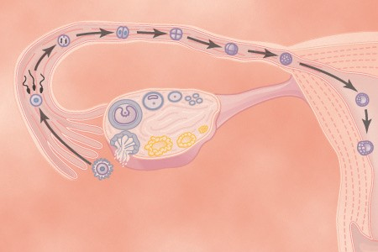In Chapters 81 and 82, the sexual functions of the male and female are described to the point of fertilization of the ovum. If the ovum becomes fertilized, a new sequence of events called gestation or pregnancy takes place, and the fertilized ovum eventually develops into a full-term fetus. The purpose of this chapter is to discuss the early stages of ovum development after fertilization and then to discuss the physiology of pregnancy. In Chapter 84, some special aspects of fetal and early childhood physiol- ogy are discussed.
Pregnancy and Lactation
C H A P T E R 8 3
U N I T X I V
MATURATION AND FERTILIZATION OF THE OVUM

While still in the ovary, the ovum is in the primary oocyte stage. Shortly before it is released from the ovarian folli- cle, its nucleus divides by meiosis and a first polar body is expelled from the nucleus of the oocyte. The primary oocyte then becomes the secondary oocyte. In this process, each of the 23 pairs of chromosomes loses one of its partners, which becomes incorporated in a polar body that is expelled. This leaves 23 unpaired chromosomes in the secondary oocyte. It is at this time that the ovum, which is still in the secondary oocyte stage, is ovulated into the abdominal cavity. Then, almost immediately, it enters the fimbriated end of one of the fallopian tubes.

Entry of the Ovum Into the Fallopian Tube (Uterine Tube). When ovulation occurs, the ovum, along with a hundred or more attached granulosa cells that constitute the corona radiata, is expelled directly into the peritoneal cavity and must then enter one of the fallopian tubes (also called uterine tubes) to reach the cavity of the uterus. The fimbriated ends of each fallopian tube fall naturally around the ovaries. The inner surfaces of the fimbriated tentacles are lined with ciliated epithelium, and the cilia are acti- vated by estrogen from the ovaries, which causes the cilia to beat toward the opening, or ostium, of the involved fallopian tube. One can actually see a slow fluid current flowing toward the ostium. By this means, the ovum enters one of the fallopian tubes.
Although one might suspect that many ova fail to enter the fallopian tubes, conception studies suggest that up to 98 percent of ova succeed in this task. Indeed, in some recorded cases, women with one ovary removed and the
opposite fallopian tube removed have had several chil- dren with relative ease of conception, thus demonstrating that ova can even enter the opposite fallopian tube.
Fertilization of the Ovum. After the male ejaculates semen into the vagina during intercourse, a few sperm are transported within 5 to 10 minutes upward from the vagina and through the uterus and fallopian tubes to the ampullae of the fallopian tubes near the ovarian ends of the tubes. This transport of the sperm is aided by contrac- tions of the uterus and fallopian tubes stimulated by pros- taglandins in the male seminal fluid and also by oxytocin released from the posterior pituitary gland of the female during her orgasm. Of the almost half a billion sperm deposited in the vagina, a few thousand succeed in reach- ing each ampulla.
Fertilization of the ovum normally takes place in the ampulla of one of the fallopian tubes soon after both the sperm and the ovum enter the ampulla. Before a sperm can enter the ovum, however, it must first penetrate the multiple layers of granulosa cells attached to the outside of the ovum (the corona radiata) and then bind to and penetrate the zona pellucida surrounding the ovum. The mechanisms used by the sperm for these purposes are presented in Chapter 81.
Once a sperm has entered the ovum (which is still in the secondary oocyte stage of development), the oocyte divides again to form the mature ovum plus a second polar body that is expelled. The mature ovum still carries in its nucleus (now called the female pronucleus) 23 chro- mosomes. One of these chromosomes is the female chro- mosome, known as the X chromosome.
In the meantime, the fertilizing sperm has also changed. On entering the ovum, its head swells to form a male pronucleus, shown in Figure 83-1D. Later, the 23 unpaired chromosomes of the male pronucleus and the 23 unpaired chromosomes of the female pronucleus align themselves to re-form a complete complement of 46 chromosomes (23 pairs) in the fertilized ovum or zygote (Figure 83-1E).

WHAT DETERMINES THE SEX
OF THE FETUS THAT IS CREATED?
After formation of the mature sperm, half of these carry in their genome an X chromosome (the female

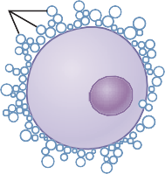
Corona radiata

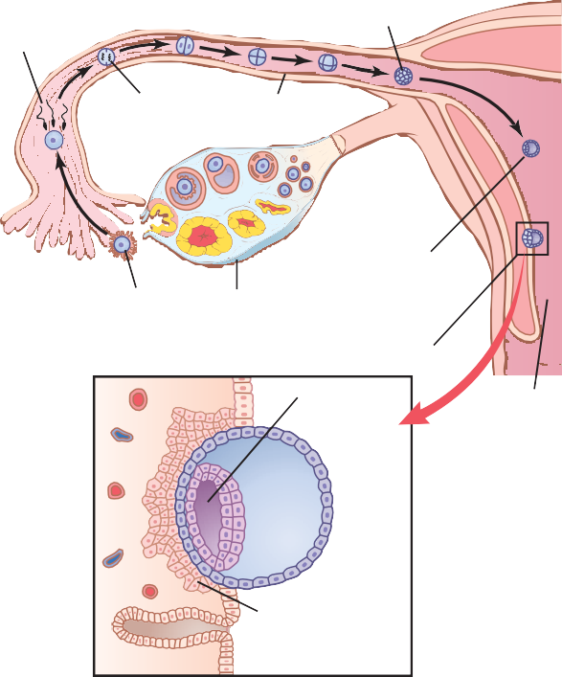Dispersed corona radiata
Fertilization (day 1)
Cell division
Blastocyst
Zygote
Fallopian tube

Blastocyst reaches uterus (days 4-5)
Ovulation
Ovum Ovary
A
Blastocyst implants (days 5-7)

Amniotic cavity
Uterus

B
Trophoblastic cells invading endometrium

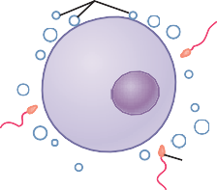A B
Sperm
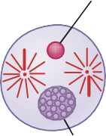
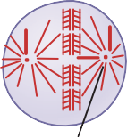
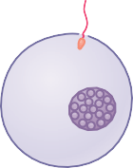Male pronucleus
Sperm

Female
C D pronucleus
E Centrosome

Figure 83-1. Fertilization of the ovum. A, The mature ovum sur- rounded by the corona radiata. B, Dispersal of the corona radiata. C, Entry of the sperm. D, Formation of the male and female pronu- clei. E, Reorganization of a full complement of chromosomes and beginning division of the ovum. (Modified from Arey LB: Developmental Anatomy: A Textbook and Laboratory Manual of Embryology, 7th ed. Philadelphia: WB Saunders, 1974.)

chromosome) and half carry a Y chromosome (the male chromosome). Therefore, if an X chromosome from a sperm combines with an X chromosome from an ovum, giving an XX combination, a female child will be born, as explained in Chapter 81. If a Y chromosome from a sperm is paired with an X chromosome from an ovum, giving an XY combination, a male child will be born.

TRANSPORT OF THE FERTILIZED OVUM IN THE FALLOPIAN TUBE
After fertilization has occurred, an additional 3 to 5 days is normally required for transport of the fertilized ovum through the remainder of the fallopian tube into the cavity of the uterus (Figure 83-2). This transport is effected mainly by a feeble fluid current in the tube resulting from epithelial secretion plus action of the ciliated epithelium that lines the tube; the cilia always beat toward the uterus. Weak contractions of the fallopian tube may also aid passage of the ovum.
The fallopian tubes are lined with a rugged cryptoid surface that impedes passage of the ovum despite the fluid current. Also, the isthmus of the fallopian tube (the last 2 centimeters before the tube enters the uterus) remains spastically contracted for about the first 3 days after ovu- lation. After this time, the rapidly increasing progesterone secreted by the ovarian corpus luteum first promotes increasing progesterone receptors on the fallopian tube smooth muscle cells; then the progesterone activates the receptors, exerting a tubular relaxing effect that allows entry of the ovum into the uterus.
This delayed transport of the fertilized ovum through the fallopian tube allows several stages of cell division to
Figure 83-2. A, Ovulation, fertilization of the ovum in the fallopian tube, and implantation of the blastocyst in the uterus. B, The action of trophoblast cells in implantation of the blastocyst in the uterine endometrium.

occur before the dividing ovum—now called a blastocyst, with about 100 cells—enters the uterus. During this time, the fallopian tube secretory cells produce large quantities of secretions used for the nutrition of the developing blastocyst.

IMPLANTATION OF THE BLASTOCYST IN THE UTERUS
After reaching the uterus, the developing blastocyst usually remains in the uterine cavity an additional 1 to 3 days before it implants in the endometrium; thus, implan- tation ordinarily occurs on about the fifth to seventh day after ovulation. Before implantation, the blastocyst obtains its nutrition from the uterine endometrial secre- tions, called “uterine milk.”
Implantation results from the action of trophoblast cells that develop over the surface of the blastocyst. These cells secrete proteolytic enzymes that digest and liquefy the adjacent cells of the uterine endometrium. Some of the fluid and nutrients released are actively transported by the same trophoblast cells into the blasto- cyst, adding more sustenance for growth. Figure 83-3 shows an early implanted human blastocyst with a small embryo. Once implantation has taken place, the trophoblast cells and other adjacent cells (from the blas- tocyst and the uterine endometrium) proliferate rapidly, forming the placenta and the various membranes of pregnancy.

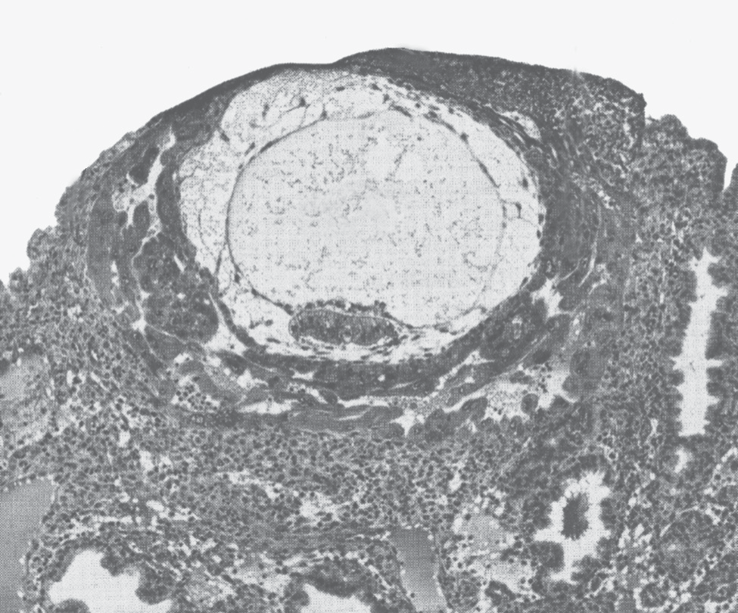100
Endometrium
Trophoblasts
Ovum
Placental diffusion
Trophoblastic nutrition
Placental membrane conductivity (% of maximum)

75
U N I T X I V

50
Ovulation
Parturition

25

0
0 4 8 12 16 20 24 28 32 36 40
Duration of pregnancy (weeks after last menstruation)

Chapter 83 Pregnancy and Lactation

Figure 83-3. Implantation of the early human embryo, showing trophoblastic digestion and invasion of the endometrium. (Courtesy Dr. Arthur Hertig.)
EARLY NUTRITION OF THE EMBRYO

In Chapter 82, we pointed out that the progesterone secreted by the ovarian corpus luteum during the latter half of each monthly sexual cycle has an effect on the uterine endometrium, converting the endometrial stromal cells into large swollen cells containing extra quantities of glycogen, proteins, lipids, and even some minerals neces- sary for development of the conceptus (the embryo and its adjacent parts or associated membranes). Then, when the conceptus implants in the endometrium, the contin- ued secretion of progesterone causes the endometrial cells to swell further and to store even more nutrients. These cells are now called decidual cells, and the total mass of cells is called the decidua.
As the trophoblast cells invade the decidua, digesting and imbibing it, the stored nutrients in the decidua are used by the embryo for growth and development. During the first week after implantation, this is the only means by which the embryo can obtain nutrients; the embryo continues to obtain at least some of its nutrition in this way for up to 8 weeks, although the placenta also begins to provide nutrition after about the 16th day beyond fertilization (a little more than 1 week after implantation). Figure 83-4 shows this trophoblastic period of nutrition, which gradually gives way to placental nutrition.
ANATOMY AND FUNCTION OF THE PLACENTA

While the trophoblastic cords from the blastocyst are attaching to the uterus, blood capillaries grow into the cords from the vascular system of the newly forming embryo. About 21 days after fertilization, blood also begins to be pumped by the heart of the human embryo. Simultaneously, blood sinuses supplied with blood from
Figure 83-4. Nutrition of the fetus. Most of the early nutrition is due to trophoblastic digestion and absorption of nutrients from the endo- metrial decidua, and essentially all the later nutrition results from diffusion through the placental membrane.

the mother develop around the outsides of the tropho- blastic cords. The trophoblast cells send out more and more projections, which become placental villi into which fetal capillaries grow. Thus, the villi, carrying fetal blood, are surrounded by sinuses that contain maternal blood.
The final structure of the placenta is shown in Figure 83-5. Note that the fetus’s blood flows through two umbilical arteries, then into the capillaries of the villi, and finally back through a single umbilical vein into the fetus. At the same time, the mother’s blood flows from her uterine arteries into large maternal sinuses that surround the villi and then back into the uterine veins of the mother. The lower part of Figure 83-5 shows the relationship between the fetal blood of each fetal placental villus and the blood of the mother surrounding the outsides of the villus in the fully developed placenta.
The total surface area of all the villi of the mature placenta is only a few square meters—many times less than the area of the pulmonary membrane in the lungs. Nevertheless, nutrients and other substances pass through this placental membrane mainly by diffusion in much the same manner that diffusion occurs through the alveolar membranes of the lungs and the capillary mem- branes elsewhere in the body.

PLACENTAL PERMEABILITY AND MEMBRANE DIFFUSION CONDUCTANCE
The major function of the placenta is to provide for dif- fusion of foodstuffs and oxygen from the mother’s blood into the fetus’s blood and diffusion of excretory products from the fetus back into the mother.
In the early months of pregnancy, the placental mem- brane is still thick because it is not fully developed. Therefore, its permeability is low. Further, the surface area is small because the placenta has not grown significantly. Therefore, the total diffusion conductance is minuscule at

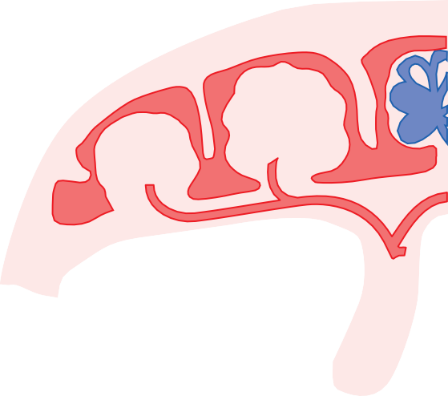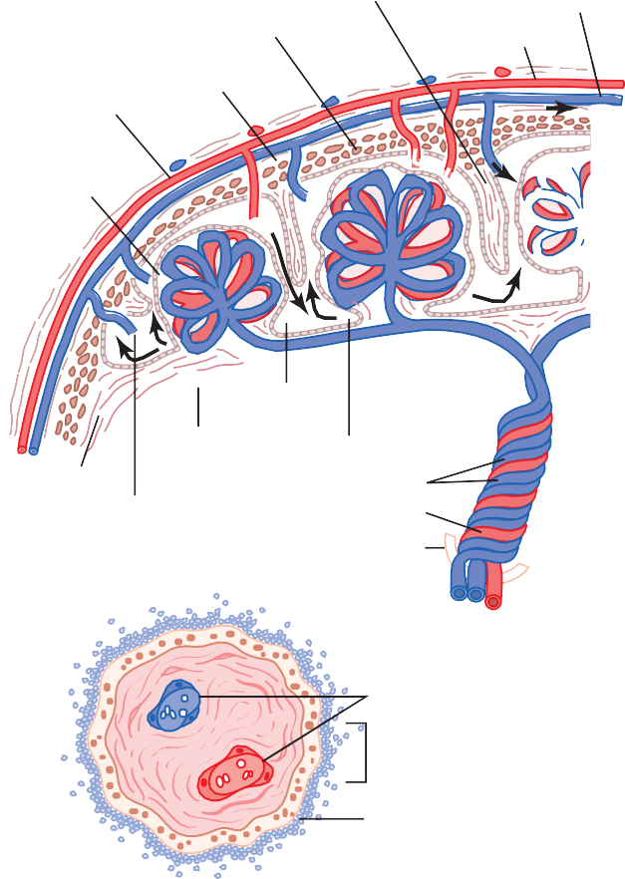100
Placenta
Placental septum
Stratum spongiosum
To the mother
From the mother
Maternal vessels
Limiting layer
Villus
Amnion
Chorion
Marginal sinus
Intravillus space
Trophoblast Umbilical arteries
Umbilical vein
Umbilical cord
Villus
Fetal capillaries Intervillous space
Chorionic epithelium
Fetal
Maternal
Human

80
Oxyhemoglobin (%)

60

40

20

0
0 20 40

60 80 100

Figure 83-5. Top, Organization of the mature placenta. Bottom, Relation of the fetal blood in the villus capillaries to the mother’s blood in the intervillous spaces.

first. Conversely, in later pregnancy, the permeability increases because of thinning of the membrane diffusion layers and because the surface area expands many times over, thus giving the tremendous increase in placental diffusion shown in Figure 83-4.
Rarely, “breaks” occur in the placental membrane, which allows fetal blood cells to pass into the mother or, even less commonly, the mother’s cells to pass into the fetus. Fortunately, it is rare for the fetus to bleed severely into the mother’s circulation because of a ruptured pla- cental membrane.

Diffusion of Oxygen Through the Placental Mem- brane. Almost the same principles for diffusion of oxygen through the pulmonary membrane (discussed in detail in Chapter 40) are applicable for diffusion of oxygen through the placental membrane. The dissolved oxygen in the blood of the large maternal sinuses passes into the fetal blood by simple diffusion, driven by an oxygen pres- sure gradient from the mother’s blood to the fetus’s blood. Near the end of pregnancy, the mean partial pressure of oxygen (PO₂) of the mother’s blood in the placental sinuses is about 50 mm Hg, and the mean PO₂ in the fetal blood after it becomes oxygenated in the placenta is about
PO2 (mm Hg)
Figure 83-6. Oxygen-hemoglobin dissociation curves for maternal and fetal blood, showing that fetal blood can carry a greater quantity of oxygen than can maternal blood for a given blood PO₂. (Data from Metcalfe J, Moll W, Bartels H: Gas exchange across the placenta. Fed Proc 23:775, 1964.)

30 mm Hg. Therefore, the mean pressure gradient for dif- fusion of oxygen through the placental membrane is about 20 mm Hg.
One might wonder how it is possible for a fetus to obtain sufficient oxygen when the fetal blood leaving the placenta has a PO₂ of only 30 mm Hg. There are three reasons why even this low PO₂ is capable of allowing the fetal blood to transport almost as much oxygen to the fetal tissues as is transported by the mother’s blood to her tissues.
First, the hemoglobin of the fetus is mainly fetal hemo­ globin, which is a type of hemoglobin synthesized in the fetus before birth. Figure 83-6 shows the comparative oxygen dissociation curves for maternal hemoglobin and fetal hemoglobin, demonstrating that the curve for fetal hemoglobin is shifted to the left of that for maternal hemoglobin. This means that at the low PO₂ levels in fetal blood, the fetal hemoglobin can carry 20 to 50 percent more oxygen than can maternal hemoglobin.
Second, the hemoglobin concentration of fetal blood is about 50 percent greater than that of the mother, which is an even more important factor in enhancing the amount of oxygen transported to the fetal tissues.
Third, the Bohr effect, which is explained in relation to the exchange of carbon dioxide and oxygen in the lung in Chapter 41, provides another mechanism to enhance the transport of oxygen by fetal blood. That is, hemoglobin can carry more oxygen at a low PCO₂ than it can at a high PCO₂. The fetal blood entering the placenta carries large amounts of carbon dioxide, but much of this carbon dioxide diffuses from the fetal blood into the maternal blood. Loss of the carbon dioxide makes the fetal blood more alkaline, whereas the increased carbon dioxide in the maternal blood makes it more acidic.
These changes cause the capacity of fetal blood to combine with oxygen to increase and that of maternal blood to decrease, which forces still more oxygen from

the maternal blood while enhancing oxygen uptake by the fetal blood. Thus, the Bohr shift operates in one direction in the maternal blood and in the other direction in the fetal blood. These two effects make the Bohr shift twice as important here as it is for oxygen exchange in the lungs; therefore, it is called the double Bohr effect.

Chapter 83 Pregnancy and Lactation
By these three means, the fetus is capable of receiving more than adequate oxygen through the placental mem- brane, despite the fact that the fetal blood leaving the placenta has a PO₂ of only 30 mm Hg.
The total diffusing capacity of the entire placenta for oxygen at term is about 1.2 milliliters of oxygen per minute per millimeter of mercury oxygen pressure differ- ence across the membrane, which compares favorably with that of the lungs of the newborn baby.

Diffusion of Carbon Dioxide Through the Placental Membrane. Carbon dioxide is continually formed in the tissues of the fetus in the same way that it is formed in maternal tissues, and the only means for excreting the carbon dioxide from the fetus is through the placenta into the mother’s blood. The partial pressure of carbon dioxide (PCO₂) of the fetal blood is 2 to 3 mm Hg higher than that of the maternal blood. This small pressure gradi- ent for carbon dioxide across the membrane is more than sufficient to allow adequate diffusion of carbon dioxide because the extreme solubility of carbon dioxide in the placental membrane allows carbon dioxide to diffuse about 20 times as rapidly as oxygen.

Diffusion of Foodstuffs Through the Placental Membrane. Other metabolic substrates needed by the fetus diffuse into the fetal blood in the same manner as oxygen does. For instance, in the late stages of pregnancy, the fetus often uses as much glucose as is used by the entire body of the mother. To provide this much glucose, the trophoblast cells lining the placental villi provide for facilitated diffusion of glucose through the placental membrane—that is, the glucose is transported by carrier molecules in the trophoblast cells of the membrane. Even so, the glucose level in fetal blood is 20 to 30 percent lower than that in maternal blood.
Because of the high solubility of fatty acids in cell membranes, these fatty acids also diffuse from the mater- nal blood into the fetal blood, but more slowly than glucose, so glucose is used more easily by the fetus for nutrition. Also, such substances as ketone bodies and potassium, sodium, and chloride ions diffuse with relative ease from the maternal blood into the fetal blood.

Excretion of Waste Products Through the Placental Membrane. In the same manner that carbon dioxide diffuses from the fetal blood into the maternal blood, other excretory products formed in the fetus also diffuse through the placental membrane into the maternal blood and are then excreted along with the excretory products of the mother. These products include especially the
nonprotein nitrogens such as urea, uric acid, and creati­ nine. The level of urea in fetal blood is only slightly greater than that in maternal blood because urea diffuses through the placental membrane with great ease. However, creati- nine, which does not diffuse as easily, has a fetal blood concentration considerably higher than that in the moth- er’s blood. Therefore, excretion from the fetus depends mainly, if not entirely, on the diffusion gradients across the placental membrane and its permeability. Because there are higher concentrations of the excretory products in the fetal blood than in the maternal blood, there is continual diffusion of these substances from the fetal blood to the maternal blood.

HORMONAL FACTORS IN PREGNANCY
U N I T X I V

In pregnancy, the placenta forms especially large quanti- ties of human chorionic gonadotropin, estrogens, proges­ terone, and human chorionic somatomammotropin, the first three of which, and probably the fourth as well, are all essential to a normal pregnancy.

HUMAN CHORIONIC GONADOTROPIN CAUSES PERSISTENCE OF
THE CORPUS LUTEUM AND PREVENTS MENSTRUATION
Menstruation normally occurs in a nonpregnant woman about 14 days after ovulation, at which time most of the endometrium of the uterus sloughs away from the uterine wall and is expelled to the exterior. If this should happen after an ovum has implanted, the pregnancy would ter- minate. However, this sloughing is prevented by the secretion of human chorionic gonadotropin by the newly developing embryonic tissues.
Coincidental with the development of the trophoblast cells from the early fertilized ovum, the hormone human chorionic gonadotropin is secreted by the syncytial tro- phoblast cells into the fluids of the mother, as shown in Figure 83-7. The secretion of this hormone can first be measured in the blood 8 to 9 days after ovulation, shortly after the blastocyst implants in the endometrium. Then the rate of secretion rises rapidly to reach a maximum at about 10 to 12 weeks of pregnancy and decreases back to a lower value by 16 to 20 weeks. It continues at this level for the remainder of the pregnancy.
Function of Human Chorionic Gonadotropin. Human chorionic gonadotropin is a glycoprotein having a molec- ular weight of about 39,000 and much the same molecular structure and function as luteinizing hormone secreted by the pituitary gland. By far, the most important function of human chorionic gonadotropin is to prevent involution of the corpus luteum at the end of the monthly female sexual cycle. Instead, it causes the corpus luteum to secrete even larger quantities of its sex hormones— progesterone and estrogens—for the next few months.

120
Human chorionic gonadotropin (IU/mL)

100

80

60
Ovulation

40

20

0

0 4 8 12 16 20
24
22
Human chorionic gonadotropin
Estrogens
Progesterone
20
18
16
14
Parturition
12
10
8
6
4
2
0
24 28 32 36 40

300

200
Progesterone (mg/24 hr)
Estrogens (mg/24 hr estradiol equivalent)

100

0

Duration of pregnancy (weeks after last menstruation)
Figure 83-7. Rates of secretion of estrogens and progesterone and concentration of human chorionic gonadotropin at different stages of pregnancy.

These sex hormones prevent menstruation and cause the endometrium to continue to grow and store large amounts of nutrients rather than being shed in the menstruum. As a result, the decidua­like cells that develop in the endo- metrium during the normal female sexual cycle become actual decidual cells—greatly swollen and nutritious—at about the time that the blastocyst implants.
Under the influence of human chorionic gonadotro- pin, the corpus luteum in the mother’s ovary grows to about twice its initial size by a month or so after preg- nancy begins. Its continued secretion of estrogens and progesterone maintains the decidual nature of the uterine endometrium, which is necessary for the early develop- ment of the fetus.
If the corpus luteum is removed before approximately the seventh week of pregnancy, spontaneous abortion almost always occurs, sometimes even up to the 12th week. After that time, the placenta secretes sufficient quantities of progesterone and estrogens to maintain pregnancy for the remainder of the gestation period. The corpus luteum involutes slowly after the 13th to 17th week of gestation.

Human Chorionic Gonadotropin Stimulates the Male Fetal Testes to Produce Testosterone. Human chorionic gonadotropin also exerts an interstitial cell– stimulating effect on the testes of the male fetus, resulting in the production of testosterone in male fetuses until the time of birth. This small secretion of testosterone during gestation is what causes the fetus to grow male sex organs instead of female organs. Near the end of pregnancy, the testosterone secreted by the fetal testes also causes the testes to descend into the scrotum.

SECRETION OF ESTROGENS BY THE PLACENTA
The placenta, like the corpus luteum, secretes both estro- gens and progesterone. Histochemical and physiological
studies show that these two hormones, like most other placental hormones, are secreted by the syncytial tropho­ blast cells of the placenta.
Figure 83-7 shows that toward the end of preg- nancy, the daily production of placental estrogens increases to about 30 times the mother’s normal level of production. However, the secretion of estrogens by the placenta is quite different from secretion by the ovaries. Most important, the estrogens secreted by the placenta are not synthesized de novo from basic sub- strates in the placenta. Instead, they are formed almost entirely from androgenic steroid compounds, dehydro­ epiandrosterone and 16­hydroxydehydroepiandrosterone, which are formed both in the mother’s adrenal glands and in the adrenal glands of the fetus. These weak andro- gens are transported by the blood to the placenta and converted by the trophoblast cells into estradiol, estrone, and estriol. (The cortices of the fetal adrenal glands are extremely large, and about 80 percent consists of a so-called fetal zone, the primary function of which seems to be to secrete dehydroepiandrosterone during pregnancy.)

Function of Estrogen in Pregnancy. In Chapter 82, we pointed out that estrogens exert mainly a proliferative function on most reproductive and associated organs of the mother. During pregnancy, the extreme quantities of estrogens cause (1) enlargement of the mother’s uterus,
- enlargement of the mother’s breasts and growth of the breast ductal structure, and (3) enlargement of the moth- er’s female external genitalia.
The estrogens also relax the pelvic ligaments of the mother, so the sacroiliac joints become relatively limber and the symphysis pubis becomes elastic. These changes allow easier passage of the fetus through the birth canal. There is much reason to believe that estrogens also affect many general aspects of fetal development during preg- nancy, for example, by affecting the rate of cell reproduc- tion in the early embryo.

SECRETION OF PROGESTERONE BY THE PLACENTA

Chapter 83 Pregnancy and Lactation
Progesterone is also essential for a successful pregnancy; in fact, it is just as important as estrogen. In addition to being secreted in moderate quantities by the corpus luteum at the beginning of pregnancy, progesterone is secreted later in tremendous quantities by the placenta, as shown in Figure 83-7.
The following special effects of progesterone are essen- tial for the normal progression of pregnancy:
  - Progesterone causes decidual cells to develop in the uterine endometrium. These cells play an important role in the nutrition of the early embryo.
  - Progesterone decreases the contractility of the pregnant uterus, thus preventing uterine contrac- tions from causing spontaneous abortion.
  - Progesterone contributes to the development of the conceptus even before implantation because it spe- cifically increases the secretions of the mother’s fallopian tubes and uterus to provide appropriate nutritive matter for the developing morula (the spherical mass of 16 to 32 blastomeres formed before the blastula) and blastocyst. There is also reason to believe that progesterone affects cell cleavage in the early developing embryo.
  - The progesterone secreted during pregnancy helps estrogen prepare the mother’s breasts for lactation, which is discussed later in this chapter.

HUMAN CHORIONIC SOMATOMAMMOTROPIN
Human chorionic somatomammotropin, a protein hor- mone with a molecular weight of about 22,000, begins to be secreted by the placenta at about the fifth week of pregnancy. Secretion of this hormone increases progres- sively throughout the remainder of pregnancy in direct proportion to the weight of the placenta. Although the functions of chorionic somatomammotropin are uncer- tain, it is secreted in quantities several times greater than that of all the other pregnancy hormones combined. It has several possible important effects.
First, when administered to several types of animals, human chorionic somatomammotropin causes at least partial development of the animal’s breasts and in some instances causes lactation. Because this was the first func- tion of the hormone that was discovered, it was first named human placental lactogen and was believed to have functions similar to those of prolactin. However, attempts to use it to promote lactation in humans have not been successful.
Second, this hormone has weak actions similar to those of growth hormone, causing the formation of protein tissues in the same way that growth hormone does. It also has a chemical structure similar to that of growth hormone, but 100 times as much human
chorionic somatomammotropin as growth hormone is required to promote growth.
Third, human chorionic somatomammotropin causes decreased insulin sensitivity and decreased utilization of glucose in the mother, thereby making larger quantities of glucose available to the fetus. Because glucose is the major substrate used by the fetus to energize its growth, the possible importance of such a hormonal effect is obvious. Further, the hormone promotes the release of free fatty acids from the fat stores of the mother, thus providing this alternative source of energy for the mother’s metabolism during pregnancy. Therefore, it appears that human chorionic somatomammotropin is a general metabolic hormone that has specific nutritional implications for both the mother and the fetus.
U N I T X I V
Other Hormonal Factors in Pregnancy
Almost all the nonsexual endocrine glands of the mother also react markedly to pregnancy. This reaction results mainly from the increased metabolic load on the mother but also, to some extent, from the effects of placental hor- mones on the pituitary and other glands. The following effects are some of the most notable.
Pituitary Secretion. The anterior pituitary gland of the mother enlarges at least 50 percent during pregnancy and increases its production of corticotropin, thyrotropin, and prolactin. Conversely, pituitary secretion of follicle- stimulating hormone and luteinizing hormone is almost totally suppressed as a result of the inhibitory effects of estrogens and progesterone from the placenta.
Increased Corticosteroid Secretion. The rate of adre- nocortical secretion of the glucocorticoids is moderately increased throughout pregnancy. It is possible that these glucocorticoids help mobilize amino acids from the moth- er’s tissues so these amino acids can be used for the syn- thesis of tissues in the fetus.
Pregnant women usually have about a twofold increase in aldosterone secretion, reaching a peak at the end of gestation. This increase, along with the actions of estro- gens, causes a tendency for even a normal pregnant woman to reabsorb excess sodium from her renal tubules and, therefore, to retain fluid, which occasionally leads to pregnancy­induced hypertension.
Increased Thyroid Gland Secretion. The mother’s thyroid gland ordinarily enlarges up to 50 percent during pregnancy and increases its production of thyroxine a cor- responding amount. The increased thyroxine production is caused at least partly by a thyrotropic effect of human chorionic gonadotropin secreted by the placenta and by small quantities of a specific thyroid-stimulating hormone, human chorionic thyrotropin, also secreted by the placenta.
Increased Parathyroid Gland Secretion. The mother’s parathyroid glands usually enlarge during pregnancy; this enlargement especially occurs if the mother’s diet is defi- cient in calcium. Enlargement of these glands causes calcium absorption from the mother’s bones, thereby maintaining normal calcium ion concentration in the mother’s extracellular fluid even while the fetus removes

calcium to ossify its own bones. This secretion of parathy- roid hormone is even more intensified during lactation after the baby’s birth because the growing baby requires many times more calcium than does the fetus.
Secretion of “Relaxin” by the Ovaries and Placenta. Another substance besides the estrogens and progesterone, a hormone called relaxin, is secreted by the corpus luteum of the ovary and by placental tissues. Its secretion is increased by a stimulating effect of human chorionic gonadotropin at the same time that the corpus luteum and the placenta secrete large quantities of estrogens and progesterone.
Relaxin is a 48–amino acid polypeptide with a molecu- lar weight of about 9000. This hormone, when injected, causes relaxation of the ligaments of the symphysis pubis in the estrous rat and guinea pig. This effect is weak or possibly even absent in pregnant women. Instead, this role is probably played mainly by the estrogens, which also cause relaxation of the pelvic ligaments. It has also been claimed that relaxin softens the cervix of the pregnant woman at the time of delivery. Relaxin is also thought to serve as a vasodilator, contributing to increased blood flow in various tissues, including the kidneys, and increasing venous return and cardiac output in pregnancy.

Response of the Mother’s Body to Pregnancy
Most apparent among the many reactions of the mother to the fetus and to the higher levels of hormones of pregnancy is the increased size of the various sexual organs. For instance, the uterus increases from about 50 grams to 1100 grams, and the breasts approximately double in size. At the same time, the vagina enlarges and the introitus opens more widely. Also, the various hormones can cause marked changes in a pregnant woman’s appearance, sometimes resulting in the development of edema, acne, and mascu- line or acromegalic features.
Weight Gain in the Pregnant Woman
The average weight gain during pregnancy is about 25 to 35 pounds, with most of this gain occurring during the last two trimesters. Of this added weight, about 8 pounds is fetus and 4 pounds is amniotic fluid, placenta, and fetal membranes. The uterus increases about 3 pounds and the breasts another 2 pounds, still leaving an average weight increase of 8 to 18 pounds. About 5 pounds of this added weight is extra fluid in the blood and extracellular fluid, and the remaining 3 to 13 pounds is generally fat accumulation. The extra fluid is excreted in the urine during the first few days after birth—that is, after loss of the fluid-retaining hormones from the placenta.
During pregnancy, a woman often has a greatly increased desire for food, partly as a result of removal of food substrates from the mother’s blood by the fetus and partly because of hormonal factors. Without appropriate prenatal control of diet, the mother’s weight gain can be as great as 75 pounds instead of the usual 25 to 35 pounds.
Metabolism During Pregnancy
As a consequence of the increased secretion of many hormones during pregnancy, including thyroxine, adreno- cortical hormones, and the sex hormones, the basal
metabolic rate of the pregnant woman increases about 15 percent during the latter half of pregnancy. As a result, she frequently has sensations of becoming overheated. Also, owing to the extra load she is carrying, greater amounts of energy than normal must be expended for muscle activity.
Nutrition During Pregnancy
By far the greatest growth of the fetus occurs during the last trimester of pregnancy; its weight almost doubles during the last 2 months of pregnancy. Ordinarily, the mother does not absorb sufficient protein, calcium, phos- phates, and iron from her diet during the last months of pregnancy to supply these extra needs of the fetus. However, in anticipation of these extra needs, the mother’s body has already been storing these substances—some in the pla- centa, but most in the normal storage depots of the mother. If appropriate nutritional elements are not present in a pregnant woman’s diet, several maternal deficiencies can occur, especially in calcium, phosphates, iron, and the vita- mins. For example, the fetus needs about 375 milligrams of iron to form its blood, and the mother needs an additional 600 milligrams to form her own extra blood. The normal store of nonhemoglobin iron in the mother at the outset of pregnancy is often only 100 milligrams and almost never more than 700 milligrams. Therefore, without sufficient iron in her food, a pregnant woman usually develops hypo­ chromic anemia. Also, it is especially important that she receive vitamin D, because although the total quantity of calcium used by the fetus is small, calcium is normally poorly absorbed by the mother’s gastrointestinal tract without vitamin D. Finally, shortly before birth of the baby, vitamin K is often added to the mother’s diet so the baby will have sufficient prothrombin to prevent hemorrhage, particularly brain hemorrhage, caused by the birth process.
Changes in the Maternal Circulatory System During Pregnancy
Blood Flow Through the Placenta and Maternal Cardiac Output Increase During Pregnancy. About 625 milliliters of blood flows through the maternal circulation of the pla- centa each minute during the last month of pregnancy. This flow, plus the general increase in the mother’s metabolism, increases the mother’s cardiac output to 30 to 40 percent above normal by the 27th week of pregnancy; then, for unexplained reasons, the cardiac output falls to only a little above normal during the last 8 weeks of pregnancy, despite the high uterine blood flow, indicating that blood flow in some other tissue(s) may be reduced.
Maternal Blood Volume Increases During Pregnancy. The maternal blood volume shortly before term is about 30 percent above normal. This increase occurs mainly during the latter half of pregnancy, as shown by the curve of Figure 83-8. The cause of the increased volume is likely due, at least in part, to aldosterone and estrogens, which are greatly increased in pregnancy, and to increased fluid retention by the kidneys. In addition, the bone marrow becomes increasingly active and produces extra red blood cells to go with the excess fluid volume. Therefore, at the time of the birth of the baby, the mother has about 1 to 2 liters of extra blood in her circulatory system. Only about

6
Blood volume (liters)

5
Parturition

4
0
0 4 8 12 16 20 24 28 32 36 40 44
Duration of pregnancy (weeks)
and 1 liter, but it can be only a few milliliters or as much as several liters. Isotope studies of the rate of formation of amniotic fluid show that, on average, the water in amniotic fluid is replaced once every 3 hours and the electrolytes sodium and potassium are replaced an average of once every 15 hours. A large portion of the fluid is derived from renal excretion by the fetus. Likewise, a certain amount of absorption occurs by way of the gastrointestinal tract and lungs of the fetus. However, even after in utero death of a

Figure 83-8. The effect of pregnancy in increasing the mother’s blood volume.

Chapter 83 Pregnancy and Lactation
one fourth of this amount is normally lost through bleeding during delivery of the baby, thereby allowing a considerable safety factor for the mother.
Maternal Respiration Increases During Pregnancy. Because of the increased basal metabolic rate of a pregnant woman and because of her greater size, the total amount of oxygen used by the mother shortly before the birth of the baby is about 20 percent above normal, and a com- mensurate amount of carbon dioxide is formed. These effects cause the mother’s minute ventilation to increase. It is also believed that the high levels of progesterone during pregnancy increase the minute ventilation even more, because progesterone increases the sensitivity of the respi- ratory center to carbon dioxide. The net result is an increase in minute ventilation of about 50 percent and a decrease in arterial PCO2 to several millimeters of mercury below that in a nonpregnant woman. Simultaneously, the growing uterus presses upward against the abdominal contents, which press upward against the diaphragm, so the total excursion of the diaphragm is decreased. Consequently, the respiratory rate is increased to maintain the extra ventilation.
Maternal Kidney Function During Pregnancy
The rate of urine formation by a pregnant woman is usually slightly increased because of increased fluid intake and increased load of excretory products. In addition, several special alterations of kidney function occur.
First, the renal tubules’ reabsorptive capacity for sodium, chloride, and water is increased as much as 50 percent as a consequence of increased production of salt and water- retaining hormones, especially steroid hormones by the placenta and adrenal cortex.
Second, the renal blood flow and glomerular filtration rate increase up to 50 percent during normal pregnancy as a result of renal vasodilation. Although the mechanisms that cause renal vasodilation in pregnancy are still unclear, some studies suggest that increased levels of nitric oxide or the ovarian hormone relaxin may contribute to these changes. The increased glomerular filtration rate likely occurs, at least in part, as a compensation for increased tubular reabsorption of salt and water. Thus, the normal pregnant woman ordinarily accumulates only about 5 pounds of extra water and salt.
Amniotic Fluid and Its Formation
Normally, the volume of amniotic fluid (the fluid inside the uterus in which the fetus floats) is between 500 milliliters
U N I T X I V
fetus, some turnover of the amniotic fluid still occurs, which indicates that some of the fluid is formed and absorbed directly through the amniotic membranes.
Preeclampsia and Eclampsia
About 5 percent of all pregnant women experience pregnancy­induced hypertension, that is, a rapid rise in arterial blood pressure to hypertensive levels during the last few months of pregnancy that is also associated with leakage of large amounts of protein into the urine. This condition is called preeclampsia or toxemia of pregnancy. It is often characterized by excess salt and water retention by the mother’s kidneys and by weight gain and the devel- opment of edema and hypertension in the mother. In addi- tion, function of the vascular endothelium is impaired and arterial spasm occurs in many parts of the mother’s body, most significantly in the kidneys, brain, and liver. Both the renal blood flow and the glomerular filtration rate are decreased, which is exactly opposite to the changes that occur in the normal pregnant woman. The renal effects also include thickened glomerular tufts that contain a protein deposit in the basement membranes.
Various attempts have been made to prove that pre- eclampsia is caused by excessive secretion of placental or adrenal hormones, but proof of a hormonal basis is still lacking. Another theory is that preeclampsia results from some type of autoimmunity or allergy in the mother caused by the presence of the fetus. In support of this theory, the acute symptoms usually disappear within a few days after birth of the baby.
Evidence also indicates that preeclampsia is initiated by insufficient blood supply to the placenta, resulting in the placenta’s release of substances that cause widespread dys- function of the maternal vascular endothelium. During normal placental development, the trophoblasts invade the arterioles of the uterine endometrium and completely remodel the maternal arterioles into large blood vessels with low resistance to blood flow. In women with pre- eclampsia, the maternal arterioles fail to undergo these adaptive changes, for reasons that are still unclear, and blood supply to the placenta is insufficient. This insufficient blood supply, in turn, causes the placenta to release various substances that enter the mother’s circulation and cause impaired vascular endothelial function, decreased blood flow to the kidneys, excess salt and water retention, and increased blood pressure.
Although the factors that link reduced placental blood supply with maternal endothelial dysfunction are still uncertain, some experimental studies suggest a role for increased levels of inflammatory cytokines such as tumor necrosis factor­α and interleukin­6. Placental factors that impede angiogenesis (blood vessel growth) have also been

shown to contribute to increased inflammatory cytokines and preeclampsia. For example, the antiangiogenic proteins soluble fms­related tyrosine kinase 1 (s-Flt1) and soluble endoglin are increased in the blood of women with pre- eclampsia. These substances are released by the placenta into the maternal circulation in response to ischemia and hypoxia of the placenta. Soluble endoglin and s-Flt1 have multiple effects that may impair function of the maternal vascular endothelium and result in hypertension, protein- uria, and the other systemic manifestations of preeclamp- sia. However, the precise role of the various factors released from the ischemic placenta in causing the multiple cardio- vascular and renal abnormalities in women with pre- eclampsia is still uncertain.
Eclampsia is an extreme degree of preeclampsia char- acterized by vascular spasm throughout the body; clonic seizures in the mother, sometimes followed by coma; greatly decreased kidney output; malfunction of the liver; often extreme hypertension; and a generalized toxic condi- tion of the body. It usually occurs shortly before the birth of the baby. Without treatment, a high percentage of mothers with eclampsia die. However, with optimal and immediate use of rapidly acting vasodilating drugs to reduce the arterial pressure to normal, followed by imme- diate termination of pregnancy—by cesarean section if necessary—the mortality even in mothers with eclampsia has been reduced to 1 percent or less.

PARTURITION

INCREASED UTERINE EXCITABILITY NEAR TERM
Parturition means birth of the baby. Toward the end of pregnancy, the uterus becomes progressively more excit- able, until finally it develops such strong rhythmical con- tractions that the baby is expelled. The exact cause of the increased activity of the uterus is not known, but at least two major categories of effects lead up to the intense contractions responsible for parturition: (1) progressive hormonal changes that cause increased excitability of the uterine musculature and (2) progressive mechanical changes.

Hormonal Factors That Increase Uterine Contractility
Increased Ratio of Estrogens to Progesterone. Progesterone inhibits uterine contractility during preg- nancy, thereby helping to prevent expulsion of the fetus. Conversely, estrogens have a definite tendency to increase the degree of uterine contractility, partly because estro- gens increase the number of gap junctions between the adjacent uterine smooth muscle cells, but also because of other poorly understood effects. Both progesterone and estrogen are secreted in progressively greater quantities throughout most of pregnancy, but from the seventh month onward, estrogen secretion continues to increase while progesterone secretion remains constant or perhaps
even decreases slightly. Therefore, it has been postulated that the estrogen­to­progesterone ratio increases suffi- ciently toward the end of pregnancy to be at least partly responsible for the increased contractility of the uterus.
Oxytocin Causes Contraction of the Uterus. Oxytocin, a hormone secreted by the neurohypophysis, specifically causes uterine contraction (see Chapter 76). There are four reasons to believe that oxytocin might be important in increasing the contractility of the uterus near term:
- The uterine muscle increases its oxytocin receptors and therefore increases its responsiveness to a given dose of oxytocin during the latter few months of pregnancy.
- The rate of oxytocin secretion by the neurohypoph- ysis is considerably increased at the time of labor.
- Although hypophysectomized animals can still deliver their young at term, labor is prolonged.
- Experiments in animals indicate that irritation or stretching of the uterine cervix, as occurs during labor, can cause a neurogenic reflex through the paraventricular and supraoptic nuclei of the hypo- thalamus that causes the posterior pituitary gland (the neurohypophysis) to increase its secretion of oxytocin.
Effect of Fetal Hormones on the Uterus. The fetus’s pituitary gland secretes increasing quantities of oxytocin, which might play a role in exciting the uterus. Also, the fetus’s adrenal glands secrete large quantities of cortisol, another possible uterine stimulant. In addition, the fetal membranes release prostaglandins in high concentration at the time of labor. These prostaglandins, too, can increase the intensity of uterine contractions.

Mechanical Factors That Increase Uterine Contractility
Stretch of the Uterine Musculature. Simply stretching smooth muscle organs usually increases their contractil- ity. Further, intermittent stretch, which occurs repeatedly in the uterus because of fetal movements, can also elicit smooth muscle contraction. Note especially that twins are born, on average, 19 days earlier than a single child, which emphasizes the importance of mechanical stretch in elic- iting uterine contractions.
Stretch or Irritation of the Cervix. There is reason to believe that stretching or irritating the uterine cervix is particularly important in eliciting uterine contractions. For instance, obstetricians frequently induce labor by rupturing the membranes so the head of the baby stretches the cervix more forcefully than usual or irritates it in other ways.
The mechanism by which cervical irritation excites the body of the uterus is not known. It has been suggested that stretching or irritation of nerves in the cervix initi- ates reflexes to the body of the uterus, but the effect could

also result simply from myogenic transmission of signals from the cervix to the body of the uterus.

ONSET OF LABOR—A POSITIVE FEEDBACK MECHANISM FOR ITS INITIATION
During most of the months of pregnancy, the uterus undergoes periodic episodes of weak and slow rhythmical contractions called Braxton Hicks contractions. These contractions become progressively stronger toward the end of pregnancy; then they change suddenly, within hours, to become exceptionally strong contractions that start stretching the cervix and later force the baby through the birth canal, thereby causing parturition. This process is called labor, and the strong contractions that result in final parturition are called labor contractions.
We do not know what suddenly changes the slow, weak rhythmicity of the uterus into strong labor contractions. However, on the basis of experience with other types of physiological control systems, a theory has been pro- posed to explain the onset of labor. The positive feedback theory suggests that stretching of the cervix by the fetus’s head finally becomes great enough to elicit a strong reflex increase in contractility of the uterine body. This pushes the baby forward, which stretches the cervix more and initiates more positive feedback to the uterine body. Thus, the process repeats until the baby is expelled. This theory is shown in Figure 83-9, and the following observations support this theory.
First, labor contractions obey all the principles of positive feedback. That is, once the strength of uterine
contraction becomes greater than a critical value, each contraction leads to subsequent contractions that become stronger and stronger until maximum effect is achieved. By referring to the discussion in Chapter 1 of positive feedback in control systems, one can see that this is the precise nature of all positive feedback mecha- nisms when the feedback gain becomes greater than a critical value.
Second, two known types of positive feedback increase uterine contractions during labor: (1) Stretching of the cervix causes the entire body of the uterus to contract, and this contraction stretches the cervix even more because of the downward thrust of the baby’s head, and
U N I T X I V
- cervical stretching also causes the pituitary gland to secrete oxytocin, which is another means for increasing uterine contractility.
To summarize, we can assume that multiple factors increase the contractility of the uterus toward the end of pregnancy. Eventually a uterine contraction becomes strong enough to irritate the uterus, especially at the cervix, and this irritation increases uterine contractility still more because of positive feedback, resulting in a second uterine contraction stronger than the first, a third stronger than the second, and so forth. Once these contractions become strong enough to cause this type of feedback, with each succeeding contraction greater than the preceding one, the process proceeds to comple- tion. One might ask about the many instances of false labor, in which the contractions become stronger and stronger and then fade away. Remember that for a positive feedback to continue, each new cycle of the positive feed- back must be stronger than the previous one. If at any time after labor starts some contractions fail to re-excite the uterus sufficiently, the positive feedback could go into a retrograde decline and the labor contractions would fade away.

ABDOMINAL MUSCLE CONTRACTIONS DURING LABOR
Once uterine contractions become strong during labor, pain signals originate both from the uterus and from the birth canal. These signals, in addition to causing suffering, elicit neurogenic reflexes in the spinal cord to the abdomi- nal muscles, causing intense contractions of these muscles. The abdominal contractions add greatly to the force that causes expulsion of the baby.

Chapter 83 Pregnancy and Lactation

  - 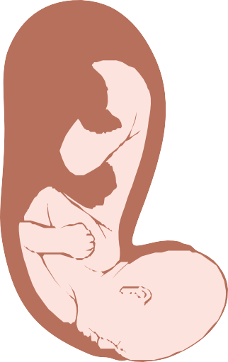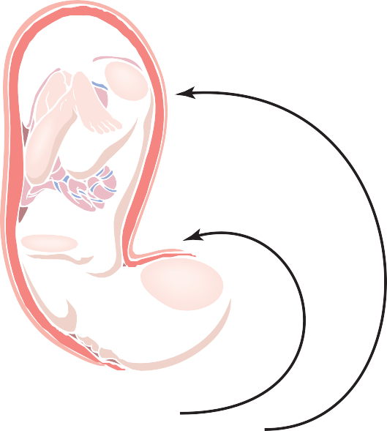Baby's head stretches cervix
Mechanics of Parturition
The uterine contractions during labor begin mainly at the top of the uterine fundus and spread downward over the body of the uterus. Also, the intensity of contraction is great in the top and body of the uterus but weak in the lower segment of the uterus adjacent to the cervix. Therefore, each uterine contraction tends to force the baby downward toward the cervix.
  - Cervical stretch excites fundic contraction
  - Fundic contraction pushes baby down and stretches cervix some more
  - Cycle repeats over and over again
Figure 83-9. Theory for the onset of intensely strong contractions during labor.

In the early part of labor, the contractions might occur only once every 30 minutes. As labor progresses, the con- tractions finally appear as often as once every 1 to 3 minutes and the intensity of contraction increases greatly, with only a short period of relaxation between contractions. The combined contractions of the uterine and abdominal mus- culature during delivery of the baby cause a downward force on the fetus of about 25 pounds during each strong contraction.
It is fortunate that the contractions of labor occur inter- mittently, because strong contractions impede or some- times even stop blood flow through the placenta and would cause death of the fetus if the contractions were continu- ous. Indeed, overuse of various uterine stimulants, such as oxytocin, can cause uterine spasm rather than rhythmical contractions and can lead to death of the fetus.
In more than 95 percent of births, the head is the first part of the baby to be expelled, and in most of the remain- ing instances, the buttocks are presented first. Entering the birth canal with the buttocks or feet first is called a breech presentation.
The head acts as a wedge to open the structures of the birth canal as the fetus is forced downward. The first major obstruction to expulsion of the fetus is the uterine cervix. Toward the end of pregnancy, the cervix becomes soft, which allows it to stretch when labor contractions begin in the uterus. The so-called first stage of labor is a period of progressive cervical dilation, lasting until the cervical opening is as large as the head of the fetus. This stage usually lasts for 8 to 24 hours in the first pregnancy but often only a few minutes after many pregnancies.
Once the cervix has dilated fully, the fetal membranes usually rupture and the amniotic fluid is lost suddenly through the vagina. Then the head of the fetus moves rapidly into the birth canal, and with additional force from above, it continues to wedge its way through the canal until delivery occurs. This is called the second stage of labor, and it may last from as little as 1 minute after many pregnancies to 30 minutes or more in the first pregnancy.
Separation and Delivery of the Placenta
For 10 to 45 minutes after birth of the baby, the uterus continues to contract to a smaller and smaller size, which causes a shearing effect between the walls of the uterus and the placenta, thus separating the placenta from its implan- tation site. Separation of the placenta opens the placental sinuses and causes bleeding. The amount of bleeding is limited to an average of 350 milliliters by the following mechanism: The smooth muscle fibers of the uterine mus- culature are arranged in figures of eight around the blood vessels as the vessels pass through the uterine wall. Therefore, contraction of the uterus after delivery of the baby constricts the vessels that had previously supplied blood to the placenta. In addition, it is believed that vaso- constrictor prostaglandins formed at the placental separa- tion site cause additional blood vessel spasm.
Labor Pains
With each uterine contraction, the mother experiences considerable pain. The cramping pain in early labor is

probably caused mainly by hypoxia of the uterine muscle resulting from compression of the blood vessels in the uterus. This pain is not felt when the visceral sensory hypo­ gastric nerves, which carry the visceral sensory fibers leading from the uterus, have been sectioned.
During the second stage of labor, when the fetus is being expelled through the birth canal, much more severe pain is caused by cervical stretching, perineal stretching, and stretching or tearing of structures in the vaginal canal itself. This pain is conducted to the mother’s spinal cord and brain by somatic nerves instead of by the visceral sensory nerves.
Involution of the Uterus After Parturition
During the first 4 to 5 weeks after parturition, the uterus involutes. Its weight becomes less than half its immediate postpartum weight within 1 week, and in 4 weeks, if the mother lactates, the uterus may become as small as it was before pregnancy. This effect of lactation results from the suppression of pituitary gonadotropin and ovarian hormone secretion during the first few months of lactation, as discussed later. During early involution of the uterus, the placental site on the endometrial surface autolyzes, causing a vaginal discharge known as lochia, which is first bloody and then serous in nature and continues for a total of about 10 days. After this time, the endometrial surface becomes re-epithelialized and ready for normal, nongravid sex life again.

LACTATION

DEVELOPMENT OF THE BREASTS
The breasts, shown in Figure 83-10, begin to develop at puberty. This development is stimulated by the estrogens of the monthly female sexual cycle; estrogens stimulate growth of the breasts’ mammary glands plus the deposi- tion of fat to give the breasts mass. In addition, far greater growth occurs during the high-estrogen state of preg- nancy, and only then does the glandular tissue become completely developed for the production of milk.

Estrogens Stimulate Growth of the Ductal System of the Breasts. All through pregnancy, the large quantities of estrogens secreted by the placenta cause the ductal system of the breasts to grow and branch. Simultaneously, the stroma of the breasts increases in quantity, and large quantities of fat are laid down in the stroma.
Also important for growth of the ductal system are at least four other hormones: growth hormone, prolactin, the adrenal glucocorticoids, and insulin. Each of these hormones is known to play at least some role in protein metabolism, which presumably explains their function in the development of the breasts.

Progesterone Is Required for Full Development of the Lobule-Alveolar System. Final development of the breasts into milk-secreting organs also requires

A

Lobule Alveoli
B

Pectoralis major
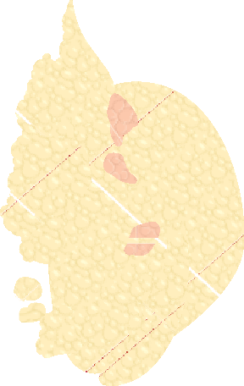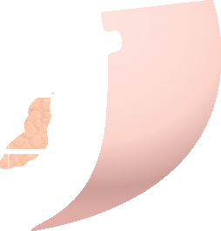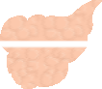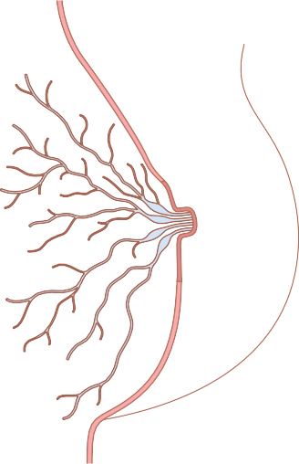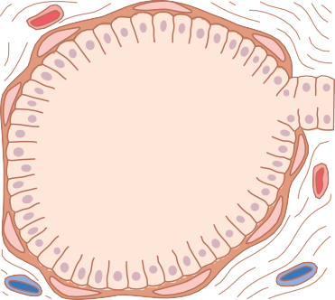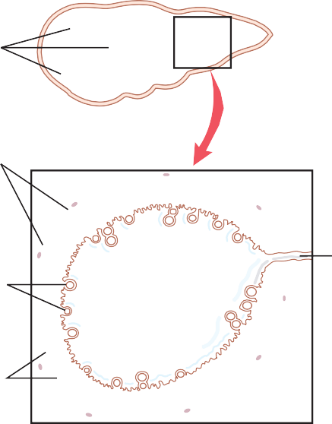Adipose tissue
Lobules and alveoli
Lactiferous sinus (ampulla)
Lactiferous duct Nipple
Areola
progesterone. Once the ductal system has developed, progesterone—acting synergistically with estrogen, as well as with the other hormones just mentioned—causes additional growth of the breast lobules, with budding of alveoli and development of secretory characteristics in the cells of the alveoli. These changes are analogous to the secretory effects of progesterone on the endome- trium of the uterus during the latter half of the female menstrual cycle.

PROLACTIN PROMOTES LACTATION
U N I T X I V
Although estrogen and progesterone are essential for the physical development of the breasts during pregnancy, a specific effect of both these hormones is to inhibit the actual secretion of milk. Conversely, the hormone prolac­ tin has exactly the opposite effect and promotes milk secretion. Prolactin is secreted by the mother’s anterior pituitary gland, and its concentration in her blood rises steadily from the fifth week of pregnancy until birth of the baby, at which time it has risen to 10 to 20 times the normal nonpregnant level. This high level of prolactin at the end of pregnancy is shown in Figure 83-11.
In addition, the placenta secretes large quantities of

Myoepithelial cells

Milk

Milk secreting epithelial
cells

C

Ductule
human chorionic somatomammotropin, which probably has lactogenic properties, thus supporting the prolactin from the mother’s pituitary during pregnancy. Even so, because of the suppressive effects of estrogen and proges- terone, no more than a few milliliters of fluid are secreted each day until after the baby is born. The fluid secreted during the last few days before and the first few days after parturition is called colostrum; it contains essentially the same concentrations of proteins and lactose as milk, but it has almost no fat and its maximum rate of pro- duction is about 1/100 the subsequent rate of milk production.

Figure 83-10. The breast and its secretory lobules, alveoli, and lactiferous ducts (milk ducts) that constitute its mammary gland (A). The enlargements show a lobule (B) and milk-secreting cells of an alveolus (C).
Immediately after the baby is born, the sudden loss of both estrogen and progesterone secretion from the pla- centa allows the lactogenic effect of prolactin from the

Chapter 83 Pregnancy and Lactation

Figure 83-11. Changes in rates of secretion of estrogens, progesterone, and prolactin for 8 weeks before parturition and 36 weeks thereaf- ter. Note especially the decrease of prolactin secretion back to basal levels within a few weeks after parturition, but also the intermittent periods of marked prolactin secretion (for about 1 hour at a time) during and after periods of nursing.

300

200
Progesterone (mg/24 hr)

100

0
2.0

1.5
Estrogens (mg/24 hr estradiol equivalent)

1.0

0.5

0

–8 –4 0 4 8 12 16 20 24 28 32 36
Parturition
Weeks after parturition
200

100
Estrogens Progesterone Prolactin
Intermittent secretion of prolactin during nursing
Prolactin (ng/mL)

0

mother’s pituitary gland to assume its natural milk- promoting role, and during the next 1 to 7 days, the breasts begin to secrete copious quantities of milk instead of colos- trum. This secretion of milk requires an adequate back- ground secretion of most of the mother’s other hormones as well, but most important are growth hormone, cortisol, parathyroid hormone, and insulin. These hormones are necessary to provide the amino acids, fatty acids, glucose, and calcium required for the formation of milk.
After the birth of the baby, the basal level of prolactin secretion returns to the nonpregnant level during the next few weeks, as shown in Figure 83-11. However, each time the mother nurses her baby, nervous signals from the nipples to the hypothalamus cause a 10- to 20-fold surge in prolactin secretion that lasts for about 1 hour, which is also shown in Figure 83-11. This prolactin acts on the mother’s breasts to keep the mammary glands secreting milk into the alveoli for the subsequent nursing periods. If this prolactin surge is absent or blocked as a result of hypothalamic or pituitary damage or if nursing does not continue, the breasts lose their ability to produce milk within 1 week or so. However, milk production can continue for several years if the child continues to suckle, although the rate of milk formation normally decreases considerably after 7 to 9 months.

The Hypothalamus Secretes Prolactin Inhibitory Hormone. The hypothalamus plays an essential role in controlling prolactin secretion, as it does for almost all the other anterior pituitary hormones. However, this control is different in one aspect: The hypothalamus mainly stimulates production of all the other hormones, but it mainly inhibits prolactin production. Conse- quently, damage to the hypothalamus or blockage of the hypothalamic-hypophysial portal system often increases prolactin secretion while it depresses secretion of the other anterior pituitary hormones.
Therefore, it is believed that anterior pituitary secre- tion of prolactin is controlled either entirely or almost entirely by an inhibitory factor formed in the hypo- thalamus and transported through the hypothalamic- hypophysial portal system to the anterior pituitary gland. This factor is sometimes called prolactin inhibitory hormone, but it is almost certainly the same as the cate- cholamine dopamine, which is known to be secreted by the arcuate nuclei of the hypothalamus and can decrease prolactin secretion as much as 10-fold.

Suppression of the Female Ovarian Cycles in Nursing Mothers for Many Months After Delivery. In most nursing mothers, the ovarian cycle (and ovulation) does not resume until a few weeks after cessation of nursing. The reason seems to be that the same nervous signals from the breasts to the hypothalamus that cause prolactin secretion during suckling—either because of the nervous signals or because of a subsequent effect of increased prolactin—inhibit secretion of gonadotropin-releasing
hormone by the hypothalamus. This inhibition, in turn, suppresses formation of the pituitary gonadotropic hormones—luteinizing hormone and follicle-stimulating hormone. However, after several months of lactation, in some mothers (especially those who nurse their babies only some of the time), the pituitary begins to secrete sufficient gonadotropic hormones to reinstate the monthly sexual cycle, even though nursing continues.

EJECTION (OR “LET-DOWN”) PROCESS IN MILK SECRETION—FUNCTION
OF OXYTOCIN
Milk is secreted continuously into the alveoli of the breasts, but it does not flow easily from the alveoli into the ductal system and, therefore, does not continually leak from the nipples. Instead, the milk must be ejected from the alveoli into the ducts before the baby can obtain it. This ejection is caused by a combined neurogenic and hormonal reflex that involves the posterior pituitary hormone oxytocin.
When the baby suckles, it receives virtually no milk for the first half minute or so. Sensory impulses must first be transmitted through somatic nerves from the nipples to the mother’s spinal cord and then to her hypothalamus, where they cause nerve signals that promote oxytocin secretion at the same time that they cause prolactin secre- tion. The oxytocin is carried in the blood to the breasts, where it causes myoepithelial cells (which surround the outer walls of the alveoli) to contract, thereby expressing the milk from the alveoli into the ducts at a pressure of
+10 to 20 mm Hg. Then the baby’s suckling becomes effective in removing the milk. Thus, within 30 seconds to 1 minute after a baby begins to suckle, milk begins to flow. This process is called milk ejection or milk let­down.
Suckling on one breast causes milk flow not only in that breast but also in the opposite breast. It is especially interesting that fondling of the baby by the mother or hearing the baby crying often gives enough of an emo- tional signal to the hypothalamus to cause milk ejection.
Inhibition of Milk Ejection. A particular problem in nursing a baby comes from the fact that many psycho- genic factors or even generalized sympathetic nervous system stimulation throughout the mother’s body can inhibit oxytocin secretion and consequently depress milk ejection. For this reason, many mothers must have an undisturbed period of adjustment after childbirth if they are to be successful in nursing their babies.

MILK COMPOSITION AND THE METABOLIC DRAIN ON
THE MOTHER CAUSED BY LACTATION
Table 83-1 lists the contents of human milk and cow’s milk. The concentration of lactose in human milk is about

Table 83-1 Composition of Milk

Chapter 83 Pregnancy and Lactation

Constituent | Human Milk (%) | Cow’s Milk (%)
Water | 88.5 | 87.0
Fat | 3.3 | 3.5
Lactose | 6.8 | 4.8
Casein | 0.9 | 2.7
Lactalbumin and other proteins | 0.4 | 0.7
Ash | 0.2 | 0.7

50 percent greater than in cow’s milk, but the concentra- tion of protein in cow’s milk is ordinarily two or more times greater than in human milk. Finally, only one third as much ash, which contains calcium and other minerals, is found in human milk compared with cow’s milk.
At the height of lactation in the human mother, 1.5 liters of milk may be formed each day (and even more if the mother has twins). With this degree of lactation, great quantities of energy are drained from the mother; approx- imately 650 to 750 kilocalories per liter (or 19 to 22 kilo- calories per ounce) are contained in breast milk, although the composition and caloric content of the milk depends on the mother’s diet and other factors such as the fullness of the breasts.
Large amounts of metabolic substrates are also lost from the mother. For instance, about 50 grams of fat enter the milk each day, as well as about 100 grams of lactose, which must be derived by conversion from the mother’s glucose. Also, 2 to 3 grams of calcium phosphate may be lost each day; unless the mother is drinking large quanti- ties of milk and has an adequate intake of vitamin D, the output of calcium and phosphate by the lactating mammae will often be much greater than the intake of these sub- stances. To supply the needed calcium and phosphate, the parathyroid glands enlarge greatly and the bones become progressively decalcified. The mother’s bone decalcifica- tion is usually not a big problem during pregnancy, but it can become more important during lactation.

Antibodies and Other Anti-infectious Agents in Milk. Not only does milk provide the newborn baby with needed nutrients, but it also provides important pro- tection against infection. For instance, multiple types of antibodies and other anti-infectious agents are secreted in milk along with the nutrients. Also, several different types of white blood cells are secreted, including both neutrophils and macrophages, some of which are espe- cially lethal to bacteria that could cause deadly infections
in newborn babies. Particularly important are antibodies and macrophages that destroy Escherichia coli bacteria, which often cause lethal diarrhea in newborns.
When cow’s milk is used to supply nutrition for the baby in place of mother’s milk, the protective agents in it are usually of little value because they are normally destroyed within minutes in the internal environment of the human being.
U N I T X I V

Bibliography
Anand-Ivell R, Ivell R: Regulation of the reproductive cycle and early pregnancy by relaxin family peptides. Mol Cell Endocrinol 382:472, 2014.
Arck PC, Hecher K: Fetomaternal immune cross-talk and its conse- quences for maternal and offspring’s health. Nat Med 19:548, 2013.
August P: Preeclampsia: a “nephrocentric” view. Adv Chronic Kidney Dis 20:280, 2013.
Augustine RA, Ladyman SR, Grattan DR: From feeding one to feeding many: hormone-induced changes in bodyweight homeostasis during pregnancy. J Physiol 586:387, 2008.
Bertram R, Helena CV, Gonzalez-Iglesias AE, et al:. A tale of two rhythms: the emerging roles of oxytocin in rhythmic prolactin release. J Neuroendocrinol 22:778, 2010.
Carter AM: Evolution of placental function in mammals: the molecu- lar basis of gas and nutrient transfer, hormone secretion, and immune responses. Physiol Rev 92:1543, 2010.
Conrad KP, Davison JM: The renal circulation in normal pregnancy and preeclampsia: is there a place for relaxin? Am J Physiol Renal Physiol 306:F1121, 2014.
Freeman ME, Kanyicska B, Lerant A, Nagy G: Prolactin: structure, function, and regulation of secretion. Physiol Rev 80:1523, 2000.
Gimpl G, Fahrenholz F: The oxytocin receptor system: structure, func- tion, and regulation. Physiol Rev 81:629, 2001.
Iams JD: Clinical practice. Prevention of preterm parturition. N Engl J Med 370:254, 2014.
LaMarca B, Cornelius D, Wallace K: Elucidating immune mechanisms causing hypertension during pregnancy. Physiology (Bethesda) 28:225, 2013.
Maltepe E, Bakardjiev AI, Fisher SJ: The placenta: transcriptional, epigenetic, and physiological integration during development. J Clin Invest 120:1016, 2010.
Osol G, Mandala M: Maternal uterine vascular remodeling during pregnancy. Physiology (Bethesda) 24:58, 2009.
Palei AC, Spradley FT, Warrington JP, et al: Pathophysiology of hyper- tension in pre-eclampsia: a lesson in integrative physiology. Acta Physiol (Oxf) 208:224, 2013.
Rana S, Karumanchi SA, Lindheimer MD: Angiogenic factors in diag- nosis, management, and research in preeclampsia. Hypertension 63:198, 2014.
Shennan DB, Peaker M: Transport of milk constituents by the mammary gland. Physiol Rev 80:925, 2000.
Smith R: Parturition. N Engl J Med 356:271, 2007.
Wang A, Rana S, Karumanchi SA: Preeclampsia: the role of angio- genic factors in its pathogenesis. Physiology (Bethesda) 24:147, 2009.

A complete discussion of fetal development, physiology of the child immediately after birth, and growth and development through the early years of life lies within the province of formal courses in obstetrics and pediatrics. However, many physiological principles are peculiar to the infant, and this chapter discusses the more important of these principles.
the average is 7 pounds, with the final birth weight varying from as low as 4.5 pounds to as high as 11 pounds in normal infants with normal gestational periods.
Development of the Organ Systems
Within 1 month after fertilization of the ovum, the gross characteristics of all the different organs of the fetus have already begun to develop, and during the next 2 to 3 months, most of the details of the different organs are established. Beyond month 4, the organs of the fetus are grossly the same as those of the neonate. However, cellular development in each organ is usually far from complete and requires the full remaining 5 months of pregnancy for complete development. Even at birth, certain structures, particularly in the nervous system, the kidneys, and the liver, lack full development, as discussed later in this chapter.
Circulatory System. The human heart begins beating during the fourth week after fertilization, contracting at a rate of about 65 beats/min. This rate increases steadily to about 140 beats/min immediately before birth.
Formation of Blood Cells. Nucleated red blood cells begin to be formed in the yolk sac and mesothelial layers of the placenta at about the third week of fetal develop- ment. This is followed 1 week later (at 4 to 5 weeks) by the formation of non-nucleated red blood cells by the fetal mesenchyme and also by the endothelium of the fetal blood vessels. At 6 weeks, the liver begins to form blood cells, and in the third month, the spleen and other lymphoid tissues of the body begin forming blood cells. Finally, from the third month on, the bone marrow gradually becomes the principal source of the red blood cells, as well as most of the white blood cells, except for continued lymphocyte and plasma cell production in lymphoid tissue.
Respiratory System. Respiration cannot occur during fetal life because there is no air to breathe in the amniotic cavity. However, attempted respiratory movements do take place beginning at the end of the first trimester of preg- nancy. Tactile stimuli and fetal asphyxia especially cause these attempted respiratory movements.
During the last 3 to 4 months of pregnancy, the respira- tory movements of the fetus are mainly inhibited, for reasons unknown, and the lungs remain almost completely deflated. The inhibition of respiration during the later months of fetal life prevents filling of the lungs with fluid and debris from the meconium excreted by the fetus’s
U N I T
X I V
Growth and Functional Development of the Fetus
Initial development of the placenta and fetal membranes occurs far more rapidly than does development of the fetus. In fact, during the first 2 to 3 weeks after implantation of the blastocyst, the fetus remains almost microscopic, but thereafter, as shown in Figure 84-1, the length of the fetus increases almost in proportion to age. At 12 weeks, the length is about 10 centimeters; at 20 weeks, 25 centimeters; and at term (40 weeks), 53 centimeters (about 21 inches). Because the weight of the fetus is approximately propor- tional to the cube of length, the weight increases almost in proportion to the cube of the age of the fetus.
Note in Figure 84-1 that the weight remains minuscule during the first 12 weeks and reaches 1 pound only at 23 weeks (51 2 months) of gestation. Then, during the last tri- mester of pregnancy, the fetus gains weight rapidly, so that 2 months before birth, the weight averages 3 pounds; 1 month before birth, the average is 4.5 pounds; and at birth,

50
Length
Weight
Length (centimeters)

40

30

20
Ovulation

10

0
0 4 8

12 16 20 24

3

2
Weight (kilograms)
Parturition

1

0
28 32 36 40

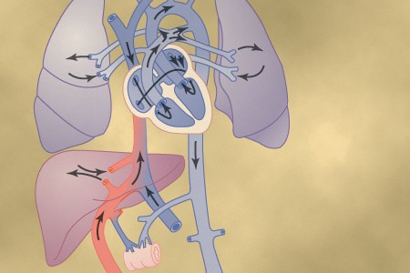Age of fetus (weeks after last menstruation)
Fetal and Neonatal Physiology
C H A P T E R 8 4
Figure 84-1. Growth of the fetus.

gastrointestinal tract into the amniotic fluid. Also, small amounts of fluid are secreted into the lungs by the alveolar epithelium up until the moment of birth, thus keeping only clean fluid in the lungs.
Nervous System. Most of the reflexes of the fetus that involve the spinal cord and even the brain stem are present by the third to fourth months of pregnancy. However, the nervous system functions that involve the cerebral cortex are still only in the early stages of development even at birth. Indeed, myelinization of some major tracts of the brain becomes complete only after about 1 year of postna- tal life.
Gastrointestinal Tract. By midpregnancy the fetus begins to ingest and absorb large quantities of amniotic

25

20
Iron
Calcium

Phosphorus
Grams of calcium or phosphorus stored

15

10
Ovulation
Parturition

5

0
0 4 8 12 16 20 24 28 32 36 40

250

200
Milligrams of iron stored

150

100

50

0

fluid, and during the last 2 to 3 months, gastrointestinal function approaches that of the normal neonate. By that time, small quantities of meconium are continually formed in the gastrointestinal tract and excreted from the anus into the amniotic fluid. Meconium is composed partly of residue from swallowed amniotic fluid and partly of mucus, epithelial cells, and other residues of excretory products from the gastrointestinal mucosa and glands.
in the mother’s bones, and thus the drain of these sub- stances from the mother is minimal. A much greater drain occurs after birth during lactation.
Accumulation of Iron
Figure 84-2 also shows that iron accumulates in the fetus even more rapidly than does calcium and phosphate. Most of the iron is in the form of hemoglobin, which begins to be formed as early as the third week after fertilization of the ovum.
Small amounts of iron are concentrated in the mother’s uterine progestational endometrium even before implanta- tion of the ovum; this iron is ingested into the embryo by the trophoblastic cells and is used to form the very early red blood cells. About one third of the iron in a fully devel- oped fetus is normally stored in the liver. This iron can then be used for several months after birth by the neonate for the formation of additional hemoglobin.
Utilization and Storage of Vitamins
The fetus needs vitamins equally as much as the adult and in some instances to a far greater extent. In general, the vitamins function the same in the fetus as in the adult, as discussed in Chapter 72. Special functions of several vita- mins should be mentioned, however.
The B vitamins, especially vitamin B₁₂ and folic acid, are necessary for the formation of red blood cells and nervous tissue, as well as for overall growth of the fetus.
Vitamin C is necessary for appropriate formation of intercellular substances, especially the bone matrix and fibers of connective tissue.
Vitamin D is necessary for normal bone growth in the fetus, but even more important, the mother needs it for adequate absorption of calcium from her gastrointestinal tract. If the mother has plenty of vitamin D in her body fluids, large quantities of the vitamin will be stored by the fetal liver to be used by the neonate for several months after birth.
The mechanisms of the functions of vitamin E are not entirely clear, but it is necessary for normal development of the early embryo. In its absence in laboratory animals,
Kidneys. The fetal kidneys begin to excrete urine during the second trimester, and fetal urine accounts for about 70 to 80 percent of the amniotic fluid. Abnormal kidney devel- opment or severe impairment of kidney function in the fetus greatly reduces the formation of amniotic fluid (oligo- hydramnios) and can lead to fetal death.
Although the fetal kidneys form urine, the renal control systems for regulating fetal extracellular fluid volume and electrolyte balances, and especially acid-base balance, are almost nonexistent until late fetal life and do not reach full development until a few months after birth.

Fetal Metabolism
The fetus mainly uses glucose for energy. The fetus has a high capability of storing fat and protein, with much if not most of the fat being synthesized from glucose rather than being absorbed directly from the mother’s blood. In addi- tion to these generalities, there are special problems of fetal metabolism in relation to calcium, phosphate, iron, and some vitamins.
Metabolism of Calcium and Phosphate
Figure 84-2 shows the rates of calcium and phosphate accumulation in the fetus, demonstrating that about 22.5 grams of calcium and 13.5 grams of phosphorus are accu- mulated in the average fetus during gestation. About one half of these accumulate during the last 4 weeks of gesta- tion, which is coincident with the period of rapid ossifica- tion of the fetal bones and with the period of rapid weight gain of the fetus.
During the earlier part of fetal life, the bones are rela- tively unossified and have mainly a cartilaginous matrix. Indeed, x-ray films ordinarily do not show any ossification until after the fourth month of pregnancy.
Note especially that the total amounts of calcium and phosphate needed by the fetus during gestation represent only about 2 percent of the quantities of these substances
Age of fetus (weeks after last menstruation)
Figure 84-2. Iron, calcium, and phosphorus storage in the fetus at different stages of gestation.

spontaneous abortion usually occurs at an early stage of pregnancy.

Chapter 84 Fetal and Neonatal Physiology
Vitamin K is used by the fetal liver for formation of Factor VII, prothrombin, and several other blood coag- ulation factors. When vitamin K is insufficient in the mother, Factor VII and prothrombin become deficient in the fetus and the mother. Because most vitamin K is formed by bacterial action in the mother’s colon, the neonate has no adequate source of vitamin K for the first week or so of life after birth until normal colonic bacterial flora become established in the newborn infant. Therefore, prenatal storage in the fetal liver of at least small amounts of vitamin K derived from the mother is helpful in prevent- ing fetal hemorrhage, particularly hemorrhage in the brain when the head is traumatized by squeezing through the birth canal.

Adjustments of the Infant to Extrauterine Life
Onset of Breathing
The most obvious effect of birth on the baby is loss of the placental connection with the mother and, therefore, loss of this means of metabolic support. One of the most important immediate adjustments required of the infant is to begin breathing.
Cause of Breathing at Birth. After normal delivery from a mother whose system has not been depressed by anesthetics, the child ordinarily begins to breathe within seconds and has a normal respiratory rhythm within less than 1 minute after birth. The promptness with which the fetus begins to breathe indicates that breathing is initiated by sudden exposure to the exterior world, probably result- ing from a slightly asphyxiated state that is incident to the birth process and from sensory impulses that originate in the suddenly cooled skin. In an infant who does not breathe immediately, the body becomes progressively more hypoxic and hypercapnic, which provides additional stimulus to the respiratory center and usually causes breathing within an additional minute after birth.
Delayed or Abnormal Breathing at Birth—Danger of Hypoxia. If the mother’s system has been depressed by a general anesthetic during delivery, which at least partially anesthetizes the fetus as well, the onset of respiration is likely to be delayed for several minutes, thus demonstrating the importance of using as little anesthesia as feasible. Also, many infants who have had head trauma during delivery or who undergo prolonged delivery are slow to breathe or sometimes do not breathe at all. This can result from two possible effects: First, in a few infants, intracranial hemor- rhage or brain contusion causes a concussion syndrome with a greatly depressed respiratory center. Second, and probably much more important, prolonged fetal hypoxia during delivery can cause serious depression of the respira- tory center.
Hypoxia frequently occurs during delivery because of
- compression of the umbilical cord; (2) premature sepa- ration of the placenta; (3) excessive contraction of the uterus, which can cut off the mother’s blood flow to the placenta; or (4) excessive anesthesia of the mother, which depresses oxygenation even of her blood.
Degree of Hypoxia That an Infant Can Tolerate. In adults, failure to breathe for only 4 minutes often causes death, but neonates often survive as long as 10 minutes without breathing after birth. Permanent and serious brain impairment often ensues if breathing is delayed more than 8 to 10 minutes. Indeed, actual lesions develop mainly in the thalamus, in the inferior colliculi, and in other brain stem areas, thus permanently affecting many of the motor functions of the body.
Expansion of the Lungs at Birth. At birth, the walls of the alveoli are at first collapsed because of the surface tension of the viscid fluid that fills them. More than 25 mm Hg of negative inspiratory pressure in the lungs is usually required to oppose the effects of this surface tension and to open the alveoli for the first time. Once the alveoli open, however, further respiration can be effected with relatively weak respiratory movements. Fortunately, the first inspirations of the normal neonate are extremely powerful; they are usually capable of creat- ing as much as 60 mm Hg negative pressure in the intra- pleural space.
U N I T X I V
Figure 84-3 shows the tremendous negative intrapleu- ral pressures required to open the lungs at the onset of breathing. At the top of the figure, the pressure-volume curve (“compliance” curve) for the first breath after birth is shown. Observe, first, that the lower part of the curve begins at the zero pressure point and moves to the right. The curve shows that the volume of air in the lungs remains almost exactly zero until the negative pressure has reached
−40 centimeters of water (−30 mm Hg). Then, as the nega- tive pressure increases to −60 centimeters of water, about 40 milliliters of air enters the lungs. To deflate the lungs, considerable positive pressure, about +40 centimeters of water, is required because of viscous resistance offered by the fluid in the bronchioles.
Note that the second breath is much easier, requiring far less negative and positive pressures. Breathing does not become completely normal until about 40 minutes after birth, as shown by the third compliance curve, the shape of which compares favorably with that for the normal adult, as shown in Chapter 39.
Respiratory Distress Syndrome Is Caused When Surfactant Secretion Is Deficient. In a small number of infants, especially premature infants and infants born of mothers with diabetes mellitus, severe respiratory distress develops in the early hours to the first several days after birth, and some infants die within the next day or so. The alveoli of these infants at death contain large quantities of proteinaceous fluid, almost as if pure plasma had leaked out of the capillaries into the alveoli. The fluid also contains desquamated alveolar epithelial cells. This condition is called hyaline membrane disease because microscopic slides of the lung show that the material filling the alveoli looks like a hyaline membrane.
A characteristic finding in respiratory distress syn- drome is failure of the respiratory epithelium to secrete adequate quantities of surfactant, a substance normally secreted into the alveoli that decreases the surface tension of the alveolar fluid, therefore allowing the alveoli to open easily during inspiration. The surfactant-secreting cells (type II alveolar epithelial cells) do not begin to secrete

First Breath
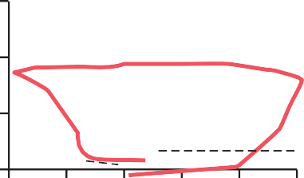
60

40
Volume (ml)

20
Superior vena cava

Aorta Ductus arteriosus

0
+40 +20 0

–20 –40

–60

Pressure

Second Breath
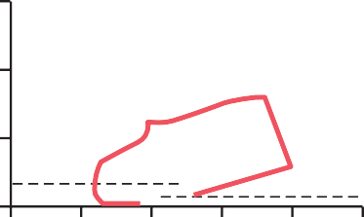
60

40
Volume (ml)

20

0
+40 +20 0

–20 –40

–60

Pressure

40 Minutes
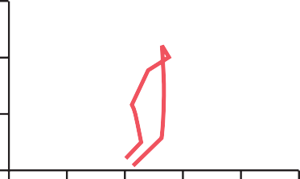
60

40
Volume (ml)

20

0
+40 +20 0

–20 –40

–60

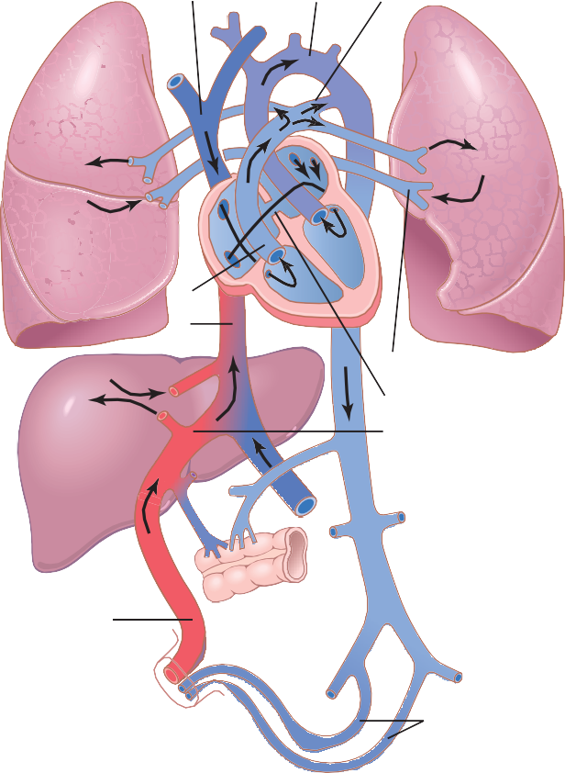Figure 84-4. Organization of the fetal circulation.
Lung
Lung
Pulmonary artery
Inferior vena cava
Liver
Pulmonary vein Foramen ovale
Ductus venosus
Gut
Umbilical
vein
Umbilical arteries

Pressure
Specific Anatomical Structure of the Fetal Circulation
Because the lungs are mainly nonfunctional during fetal life and because the liver is only partially functional, it is not necessary for the fetal heart to pump much blood through either the lungs or the liver. However, the fetal heart must pump large quantities of blood through the placenta. Therefore, special anatomical arrangements cause the fetal circulatory system to operate much differently from that of the newborn baby.
First, as shown in Figure 84-4, blood returning from the placenta through the umbilical vein passes through the ductus venosus, mainly bypassing the liver. Then most of the blood entering the right atrium from the inferior vena cava is directed in a straight pathway across the posterior aspect of the right atrium and through the foramen ovale directly into the left atrium. Thus, the well-oxygenated blood from the placenta enters mainly the left side of the heart, rather than the right side, and is pumped by the left ventricle mainly into the arteries of the head and forelimbs.
The blood entering the right atrium from the superior vena cava is directed downward through the tricuspid valve into the right ventricle. This blood is mainly deoxygenated blood from the head region of the fetus. It is pumped by the right ventricle into the pulmonary artery and then
Figure 84-3. Pressure-volume curves of the lungs (“compliance” curves) of a neonate immediately after birth, showing the extreme forces required for breathing during the first two breaths of life and development of a nearly normal compliance curve within 40 minutes after birth. (Modified from Smith CA: The first breath. Sci Am 209:32, 1963. Copyright 1963 by Scientific American, Inc.)

surfactant until the last 1 to 3 months of gestation. Therefore, many premature babies and a few full-term babies are born without the capability to secrete sufficient surfactant, which causes both a collapse tendency of the alveoli and development of pulmonary edema. The role of surfactant in preventing these effects is discussed in Chapter 38.
Circulatory Readjustments at Birth
Equally as essential as the onset of breathing at birth are immediate circulatory adjustments that allow adequate blood flow through the lungs. In addition, circulatory adjustments during the first few hours of life cause more and more blood flow through the baby’s liver, which up to this point has had little blood flow. To describe these read- justments, we first consider the anatomical structure of the fetal circulation.

resistance to blood flow decreases severalfold. Also, in fetal life, the hypoxia of the lungs causes considerable tonic vasoconstriction of the lung blood vessels, but vasodilation
Forequarters
15
43
Ductus arteriosus
42
30
58
Lungs
46
Foramen ovale
18
12
Hindquarters
55
Placenta
Left
ventricle
Left
atrium
15 takes place when aeration of the lungs eliminates the
U N I T X I V
hypoxia. All these changes together reduce the resistance
to blood flow through the lungs as much as fivefold, which reduces the pulmonary arterial pressure, right ventricular pressure, and right atrial pressure.
Closure of the Foramen Ovale. The low right atrial
27 pressure and the high left atrial pressure that occur second-
arily to the changes in pulmonary and systemic resistances
73 at birth cause blood to now attempt to flow backward through the foramen ovale, that is, from the left atrium into
the right atrium, rather than in the other direction, as occurred during fetal life. Consequently, the small valve that lies over the foramen ovale on the left side of the atrial
73 septum closes over this opening, thereby preventing further
flow through the foramen ovale.
In two thirds of all people, the valve becomes adherent over the foramen ovale within a few months to a few years and forms a permanent closure. However, even if perma- nent closure does not occur—a condition called patent foramen ovale—throughout life the left atrial pressure nor-

Figure 84-5. Diagram of the fetal circulatory system, showing rela- tive distribution of blood flow to the different vascular areas. The numerals represent the percentage of the total output from both sides of the heart flowing through each particular area.

Chapter 84 Fetal and Neonatal Physiology
Right ventricle
Right atrium
mainly through the ductus arteriosus into the descending aorta, then through the two umbilical arteries into the placenta, where the deoxygenated blood becomes oxygenated.
Figure 84-5 shows the relative percentages of the total blood pumped by the heart that pass through the different vascular circuits of the fetus. Approximately 55 percent of all the blood goes through the placenta, leaving only 45 percent to pass through all the tissues of the fetus. Furthermore, during fetal life, only 12 percent of the blood flows through the lungs, whereas immediately after birth, virtually all the blood flows through the lungs.
Changes in Fetal Circulation at Birth
The basic changes in fetal circulation at birth are discussed in Chapter 23 in relation to congenital anomalies of the ductus arteriosus and foramen ovale that persist through- out life in a few persons. These changes are briefly described in the following sections.
Decreased Pulmonary and Increased Systemic Vascular Resistances at Birth. The primary changes in the circula- tion at birth are, first, loss of the tremendous blood flow through the placenta, which approximately doubles the systemic vascular resistance at birth. This doubling of the systemic vascular resistance increases the aortic pressure, as well as the pressures in the left ventricle and left atrium. Second, the pulmonary vascular resistance greatly decreases as a result of expansion of the lungs. In the unex- panded fetal lungs, the blood vessels are compressed because of the small volume of the lungs. Immediately on expansion, these vessels are no longer compressed and the
mally remains 2 to 4 mm Hg greater than the right atrial pressure, and the backpressure keeps the valve closed.
Closure of the Ductus Arteriosus. The ductus arterio- sus also closes, but for different reasons. First, the increased systemic resistance elevates the aortic pressure while the decreased pulmonary resistance reduces the pulmonary arterial pressure. As a consequence, after birth, blood begins to flow backward from the aorta into the pulmonary artery through the ductus arteriosus, rather than in the other direction, as in fetal life. However, after only a few hours, the muscle wall of the ductus arteriosus constricts markedly and within 1 to 8 days, the constriction is usually sufficient to stop all blood flow. This is called functional closure of the ductus arteriosus. Then, during the next 1 to 4 months, the ductus arteriosus ordinarily becomes ana- tomically occluded by growth of fibrous tissue into its lumen.
The cause of ductus arteriosus closure relates to the increased oxygenation of the blood flowing through the ductus, as well as loss of the vascular relaxing effects of prostaglandin E₂ (PGE₂). In fetal life the partial pressure of oxygen (PO2) of the ductus blood is only 15 to 20 mm Hg, but it increases to about 100 mm Hg within a few hours after birth. Furthermore, many experiments have shown that the degree of contraction of the smooth muscle in the ductus wall is highly related to this availability of oxygen.
In one of several thousand infants, the ductus fails to close, resulting in a patent ductus arteriosus, the conse- quences of which are discussed in Chapter 23. The failure of closure has been postulated to result from excessive ductus dilation caused by vasodilating prostaglandins, especially PGE₂, in the ductus wall. In fact, administration of the drug indomethacin, which blocks synthesis of pros- taglandins, often leads to closure.
Closure of the Ductus Venosus. In fetal life the portal blood from the fetus’s abdomen joins the blood from the umbilical vein, and these together pass by way of the ductus

venosus directly into the vena cava immediately below the heart but above the liver, thus bypassing the liver.
Immediately after birth, blood flow through the umbili- cal vein ceases, but most of the portal blood still flows through the ductus venosus, with only a small amount passing through the channels of the liver. However, within 1 to 3 hours the muscle wall of the ductus venosus con- tracts strongly and closes this avenue of flow. As a conse- quence, the portal venous pressure rises from near 0 to 6 to 10 mm Hg, which is enough to force portal venous blood flow through the liver sinuses. Although the ductus venosus rarely fails to close, we know little about what causes the closure.
Nutrition of the Neonate
Before birth, the fetus derives almost all its energy from glucose obtained from the mother’s blood. After birth, the amount of glucose stored in the infant’s body in the form of liver and muscle glycogen is sufficient to supply the infant’s needs for only a few hours. The liver of the neonate is still far from functionally adequate at birth, which pre- vents significant gluconeogenesis. Therefore, the infant’s blood glucose concentration frequently falls the first day to as low as 30 to 40 mg/dl of plasma, which is less than half the normal value. Fortunately, appropriate mechanisms are available that allow the infant to use its stored fats and proteins for metabolism until mother’s milk can be pro- vided 2 to 3 days later.
Special problems are also frequently associated with getting an adequate fluid supply to the neonate because the infant’s rate of body fluid turnover averages seven times that of an adult, and the mother’s milk supply requires several days to develop. Ordinarily, the infant’s weight decreases 5 to 10 percent and sometimes as much as 20 percent within the first 2 to 3 days of life. Most of this weight loss is loss of fluid rather than of body solids.

Special Functional Problems in the Neonate
An important characteristic of the neonate is instability of the various hormonal and neurogenic control systems. This instability results partly from immature development of the different organs of the body and partly from the fact that the control systems simply have not become adjusted to the new way of life.
Respiratory System
The normal rate of respiration in a neonate is about 40 breaths per minute, and tidal air with each breath averages 16 milliliters, which results in a total minute respiratory volume of 640 ml/min—about twice as great in relation to the body weight as that of an adult. The functional residual capacity of the infant’s lungs is only one-half that of an adult in relation to body weight. This difference causes excessive cyclical increases and decreases in the newborn baby’s blood gas concentrations if the respiratory rate becomes slowed, because it is the residual air in the lungs that smoothes out the blood gas variations.
Circulation
Blood Volume. The blood volume of a neonate immedi- ately after birth averages about 300 milliliters, but if the

infant is left attached to the placenta for a few minutes after birth or if the umbilical cord is stripped to force blood out of its vessels into the baby, an additional 75 milliliters of blood enters the infant, to make a total of 375 milliliters. Then, during the ensuing few hours, fluid is lost into the neonate’s tissue spaces from this blood, which increases the hematocrit but returns the blood volume once again to the normal value of about 300 milliliters. Some pediatri- cians believe that this extra blood volume that results from stripping the umbilical cord can lead to mild pulmonary edema with some degree of respiratory distress, but the extra red blood cells are often valuable to the infant.
Cardiac Output. The cardiac output of the neonate averages 500 ml/min, which, like respiration and body metabolism, is about twice as much in relation to body weight as in the adult. Occasionally a child is born with an especially low cardiac output caused by hemorrhage of much of its blood volume from the placenta at birth.
Arterial Pressure. The arterial pressure during the first day after birth averages about 70 mm Hg systolic and 50 mm Hg diastolic and increases slowly during the next several months to about 90/60. A much slower rise then occurs during the subsequent years until the adult pressure of 115/70 is attained at adolescence.
Blood Characteristics. The red blood cell count in the neonate averages about 4 million per cubic millimeter. If blood is stripped from the cord into the infant, the red blood cell count rises an additional 0.5 to 0.75 million during the first few hours of life, giving a red blood cell count of about 4.75 million per cubic millimeter, as shown in Figure 84-6. Subsequently, however, few new red blood cells are formed in the infant during the first few weeks of life, presumably because the hypoxic stimulus of fetal life is no longer present to stimulate red blood cell production. Thus, as shown in Figure 84-6, the average red blood cell count falls to less than 4 million per cubic millimeter by about 6 to 8 weeks of age. From that time on, increasing activity by the baby provides the appropriate stimulus for the red blood cell count to return to normal within another 2 to 3 months. Immediately after birth, the white blood cell count of the neonate is approximately 45,000 per cubic

5 5
Red blood cell count
Bilirubin
Red blood cell count (millions/mm3)

4 4
Serum bilirubin (mg/dl)

3 3

2 2

1 1

0 0
0 2 4 6 8 10 12 14 16
Age (weeks)
Figure 84-6. Changes in the red blood cell count and in serum bili- rubin concentration during the first 16 weeks of life, showing physi- ological anemia at 6 to 12 weeks of life and physiological hyperbilirubinemia during the first 2 weeks of life.

millimeter, which is about five times as great as that of the normal adult.

Chapter 84 Fetal and Neonatal Physiology
Neonatal Jaundice and Erythroblastosis Fetalis. Biliru- bin formed in the fetus can cross the placenta into the mother and be excreted through the liver of the mother, but immediately after birth, the only means for ridding the neonate of bilirubin is through the neonate’s own liver, which for the first week or so of life functions poorly and is incapable of conjugating significant quantities of bili- rubin with glucuronic acid for excretion into the bile. Consequently, the plasma bilirubin concentration rises from a normal value of less than 1 mg/dl to an average of 5 mg/dl during the first 3 days of life and then gradually falls back to normal as the liver becomes functional. This effect, called physiological hyperbilirubinemia, is shown in Figure 84-6, and it is associated with mild jaundice (yel- lowness) of the infant’s skin and especially of the sclerae of its eyes for a week or two.
However, by far the most important abnormal cause of serious neonatal jaundice is erythroblastosis fetalis, which is discussed in detail in Chapter 33 in relation to Rh factor incompatibility between the fetus and mother. Briefly, the erythroblastotic baby inherits Rh-positive red blood cells from the father, while the mother is Rh negative. The mother then becomes immunized against the Rh-positive factor (a protein) in the fetus’s blood cells, and her antibod- ies destroy fetal red blood cells, releasing extreme quanti- ties of bilirubin into the fetus’s plasma and often causing fetal death because of a lack of adequate red blood cells. Before the advent of modern obstetrical therapeutics, mild or serious cases of this condition occurred in 1 of every 50 to 100 neonates.
Fluid Balance, Acid-Base Balance, and Renal Function
The rate of fluid intake and fluid excretion in the newborn infant is seven times as great in relation to weight as in the adult, which means that alteration of even a slight percent- age in fluid intake or fluid output can cause rapidly devel- oping abnormalities.
The rate of metabolism in the infant is also twice as great in relation to body mass as in the adult, which means that twice as much acid is normally formed, creating a tendency toward acidosis in the infant. Functional develop- ment of the kidneys is not complete until the end of about the first month of life. For instance, the kidneys of the neonate can concentrate urine to only 1.5 times the osmo- lality of the plasma, whereas the adult can concentrate the urine to three to four times the plasma osmolarity. Therefore, considering the immaturity of the kidneys, together with the marked fluid turnover in the infant and the rapid formation of acid, one can readily understand that among the most important problems of infancy are acido- sis, dehydration, and, more rarely, overhydration.
Liver Function
During the first few days of life, liver function in the neonate may be quite deficient, as evidenced by the following effects:
- The liver of the neonate conjugates bilirubin with glucuronic acid poorly and therefore excretes only a
slight amount of bilirubin during the first few days of life.
- Because the liver of the neonate is deficient in forming plasma proteins, the plasma protein concen- tration falls during the first weeks of life to 15 to 20 percent less than that for older children. Occasionally the protein concentration falls so low that hypopro- teinemic edema develops.
U N I T X I V
- The gluconeogenesis function of the neonate’s liver is particularly deficient. As a result, the blood glucose level of the unfed neonate falls to about 30 to 40 mg/dl (about 40 percent of normal), and the infant must depend mainly on its stored fats for energy until sufficient feeding can occur.
- The liver of the neonate usually also forms too little of the blood factors needed for normal blood coagulation.

Digestion, Absorption, and Metabolism of Energy Foods and Nutrition
In general, the ability of the neonate to digest, absorb, and metabolize foods is no different from that of the older child, with the following three exceptions:
- Secretion of pancreatic amylase in the neonate is defi- cient, so the neonate uses starches less adequately than do older children.
- Absorption of fats from the gastrointestinal tract is somewhat less than that in the older child. Conse- quently, milk with a high fat content, such as cow’s milk, is often inadequately absorbed.
- Because the liver functions imperfectly during at least the first week of life, the glucose concentration in the blood is unstable and low.
The neonate is especially capable of synthesizing and storing proteins. Indeed, with an adequate diet, up to 90 percent of the ingested amino acids is used for formation of body proteins, which is a much higher percentage than in adults.
Increased Metabolic Rate and Poor Body Temperature Regulation. The normal metabolic rate of the neonate in relation to body weight is about twice that of the adult, which also accounts for the fact that cardiac output and minute respiratory volume are twice as great in relation to body weight in the infant.
Because the body surface area is large in relation to body mass, heat is readily lost from the body. As a result, the body temperature of the neonate, particularly of premature infants, falls easily. Figure 84-7 shows that the body tem- perature of even a normal infant often falls several degrees during the first few hours after birth but returns to normal in 7 to 10 hours. Still, the body temperature regulatory mechanisms remain poor during the early days of life, allowing marked deviations in temperature, which are also shown in Figure 84-7.
Nutritional Needs During the Early Weeks of Life. At birth, a neonate is usually in complete nutritional balance, provided the mother has had an adequate diet. Furthermore, the function of the gastrointestinal system is usually more than adequate to digest and assimilate all the nutritional needs of the infant if appropriate nutrients are provided in

99
Birth

98
Body temperature (°F)

97

96

95

94

93
0 2 4 6 8 10 12 2
Hours after birth

4 6 8 10 12 14 16 18 20

Days after birth
own immune system begins to form antibodies and the gamma globulin concentration returns essentially to normal by the age of 12 to 20 months.
Despite the decrease in gamma globulins soon after birth, the antibodies inherited from the mother protect the infant for about 6 months against most major child- hood infectious diseases, including diphtheria, measles, and polio. Therefore, immunization against these diseases before 6 months is usually not necessary. However, the inherited antibodies against whooping cough are normally insufficient to protect the neonate; therefore, for full safety, the infant requires immunization against this disease within the first month or so of life.

Figure 84-7. Fall in body temperature of the neonate immediately after birth, and instability of body temperature during the first few days of life.
the diet. However, three specific problems occur in the early nutrition of the infant.
Need for Calcium and Vitamin D. Because the neonate is in a stage of rapid ossification of its bones at birth, a ready supply of calcium throughout infancy is necessary. This is ordinarily supplied adequately by the usual diet of milk. Yet, absorption of calcium by the gastrointestinal tract is poor in the absence of vitamin D. Therefore, within only a few weeks, severe rickets can develop in infants who have vitamin D deficiency. This is particularly true in premature babies because their gastrointestinal tracts absorb calcium even less effectively than do those of normal infants.
Necessity for Iron in the Diet. If the mother has had adequate amounts of iron in her diet, the infant’s liver usually has stored enough iron to keep forming blood cells for 4 to 6 months after birth. However, if the mother has had insufficient iron in her diet, severe anemia is likely to occur in the infant after about 3 months of life. To prevent this possibility, early feeding of the infant with egg yolk, which contains reasonably large quantities of iron, or the administration of iron in some other form is desirable by the second or third month of life.
Vitamin C Deficiency in Infants. Ascorbic acid (vitamin
C) is not stored in significant quantities in the fetal tissues, yet it is required for proper formation of cartilage, bone, and other intercellular structures of the infant. However, adequate amounts of vitamin C are normally provided in the mother’s breast milk unless the mother has severe vitamin C deficiency. Cow’s milk has only one fourth as much vitamin C as human milk. In some cases orange juice or other sources of ascorbic acid are prescribed for infants with vitamin C deficiency.
Immunity
The neonate inherits a great degree of immunity from the mother because many protein antibodies diffuse from the mother’s blood through the placenta into the fetus. However, the neonate does not form antibodies of its own to a significant extent. By the end of the first month, the baby’s gamma globulins, which contain the antibodies, have decreased to less than half the original level, with a corresponding decrease in immunity. Thereafter, the baby’s
Allergy. Newborn infants are seldom subject to aller- gies. Several months later, however, when the infant’s own antibodies first begin to form, extreme allergic states can develop, often resulting in serious eczema, gastrointestinal abnormalities, and even anaphylaxis. As the child grows older and still higher degrees of immunity develop, these allergic manifestations usually disappear. This relation of immunity to allergy is discussed in Chapter 35.
Endocrine Problems
Ordinarily, the endocrine system of the infant is highly developed at birth, and infants seldom exhibit any imme- diate endocrine abnormalities. However, the endocri- nology of infancy is important in the following special circumstances:
- If a pregnant mother bearing a female child is treated with an androgenic hormone or if an androgenic tumor develops during pregnancy, the child will be born with a high degree of masculinization of her sexual organs, thus resulting in a type of hermaphroditism.
- The sex hormones secreted by the placenta and by the mother’s glands during pregnancy occasionally cause the neonate’s breasts to form milk during the first days of life. Sometimes the breasts then become inflamed, or infectious mastitis develops.
- An infant born of an untreated diabetic mother will have considerable hypertrophy and hyperfunction of the islets of Langerhans in the pancreas. As a conse- quence, the infant’s blood glucose concentration may fall to lower than 20 mg/dl shortly after birth. Fortunately, however, in the neonate—unlike in the adult—insulin shock or coma from this low level of blood glucose concentration only rarely develops. Maternal type 2 diabetes is the most common cause of large babies. Type 2 diabetes in the mother is associated with resistance to the metabolic effects of insulin and compensatory increases in plasma insulin concentration. The high levels of insulin are believed to stimulate fetal growth and contribute to increased birth weight. An increased supply of glucose and other nutrients to the fetus may also contribute to increased fetal growth. However, most of the increased fetal weight is due to increased body fat; there is usually little increase in body length, although the size of some organs may be increased (organo- megaly). When a mother has uncontrolled type 1 diabetes (caused by lack of insulin secretion), fetal

growth may be stunted because of metabolic deficits in the mother, and growth and tissue maturation of the neonate are often impaired. Also, there is a high rate of intrauterine mortality. Among the fetuses that do come to term, there is still a high mortality rate. Two thirds of the infants who die succumb to respi- ratory distress syndrome, which is described earlier in this chapter.

Chapter 84 Fetal and Neonatal Physiology
- Occasionally a child is born with hypofunctional adrenal cortices, often resulting from agenesis of the adrenal glands or exhaustion atrophy, which can occur when the adrenal glands have been vastly overstimulated.
- If a pregnant woman has hyperthyroidism or is treated with excess thyroid hormone, the infant is likely to be born with a temporarily hyposecreting thyroid gland. Conversely, if before pregnancy a woman had had her thyroid gland removed, her pitu- itary gland may secrete great quantities of thyrotro- pin during gestation and the child might be born with temporary hyperthyroidism.
- In a fetus lacking thyroid hormone secretion, the bones grow poorly and there is mental retardation, resulting in the condition called cretin dwarfism, which is discussed in Chapter 77.

Special Problems of Prematurity
All the problems in neonatal life just noted are severely exacerbated in prematurity. They can be categorized under the following two headings: (1) immaturity of certain organ systems and (2) instability of the different homeo- static control systems. Because of these effects, a premature baby seldom lives if it is born more than 3 months before term.
Immature Development of the Premature Infant
Almost all the organ systems of the body are immature in the premature infant and require particular attention if the life of the premature baby is to be saved.
Respiration. The respiratory system is especially likely to be underdeveloped in the premature infant. The vital capacity and the functional residual capacity of the lungs are especially small in relation to the size of the infant. In addition, surfactant secretion is depressed or absent. As a consequence, respiratory distress syndrome is a common cause of death. Also, the low functional residual capacity in the premature infant is often associated with periodic breathing of the Cheyne-Stokes type.
Gastrointestinal Function. Another major problem of the premature infant is ingesting and absorbing adequate food. In infants who are more than 2 months premature, the digestive and absorptive systems are almost always inadequate. The absorption of fat is so poor that the pre- mature infant must have a low-fat diet. Furthermore, because the absorption of calcium is unusually difficult in premature infants, severe rickets can develop before the difficulty is recognized. For this reason, special attention to adequate calcium and vitamin D intake is necessary.
Function of Other Organs. Immaturity of other organ systems that frequently causes serious difficulties in the
premature infant includes (1) immaturity of the liver, which results in poor intermediary metabolism and often a bleed- ing tendency as a result of poor formation of coagulation factors; (2) immaturity of the kidneys, which are particu- larly deficient in their ability to rid the body of acids, thereby predisposing the infant to acidosis and to serious fluid balance abnormalities; (3) immaturity of the blood- forming mechanism of the bone marrow, which allows rapid development of anemia; and (4) depressed formation of gamma globulin by the lymphoid system, which often leads to serious infection.
Instability of the Homeostatic Control Systems in Premature Infants
U N I T X I V
Immaturity of the different organ systems in the premature infant creates a high degree of instability in the homeo- static mechanisms of the body. For instance, the acid-base balance can vary tremendously, particularly when the rate of food intake varies from time to time. Likewise, the blood protein concentration is usually low because of immature liver development, often leading to hypoprotein- emic edema. Inability of the infant to regulate its calcium ion concentration may bring on hypocalcemic tetany. Also, the blood glucose concentration can vary between the extremely wide limits of 20 to more than 100 mg/dl, depending principally on the regularity of feeding. Given these extreme variations in the internal environment of the premature infant, it is no wonder that mortality is high if a baby is born 3 or more months prematurely.
Instability of Body Temperature. One of the particular problems of the premature infant is the inability to main- tain a normal body temperature. The premature infant’s temperature tends to approach that of its surroundings. At normal room temperature, the infant’s temperature (in degrees Fahrenheit) may stabilize in the low 90s or even in the 80s. Studies show that a body temperature maintained below 96°F (35.5°C) is associated with a particularly high incidence of death, which explains the almost mandatory use of the incubator when treating prematurity.
Danger of Blindness Caused by Excess Oxygen Therapy in the Premature Infant
Because premature infants frequently experience respira- tory distress, oxygen therapy has often been used to treat these infants. However, excess use of oxygen in treating premature infants, especially in early prematurity, can lead to blindness because too much oxygen stops the growth of new blood vessels in the retina. Then, when oxygen therapy is stopped, the blood vessels try to make up for lost time and burst forth with a great mass of vessels that grow all through the vitreous humor, blocking light from the pupil to the retina. Later, the vessels are replaced with a mass of fibrous tissue where the eye’s clear vitreous humor should be.
This condition, known as retrolental fibroplasias, causes permanent blindness. For this reason, it is particu- larly important to avoid treatment of premature infants with high concentrations of respiratory oxygen. Physio- logical studies indicate that premature infants are usually safe with up to 40 percent oxygen in the air breathed, but some child physiologists believe that complete safety can

70
Boys
Girls

60

50
Height (inches)

40

30

20
0 4 8 12 16 20 24 4

8 12 16 20
12
Walks alone
11 Stands alone
10 Walks with support
9 Pulls up
8 Grasps
Age (months)
7 Crawls
6 Sits briefly
5 Rolls over
4
Hand control
3 Head control
2 Vocalizes

Age (months) Age (years)
Figure 84-8. Average height of boys and girls from infancy to 20 years of age.
1

0
Birth
Smiles Suckles

Figure 84-9. Behavioral development of the infant during the first year of life.
be achieved only at normal oxygen concentration in the air breathed.

Growth and Development of the Child
The major physiological problems of the child beyond the neonatal period are related to special metabolic needs for growth, which have been fully covered in the sections of this book on metabolism and endocrinology.
Figure 84-8 shows the changes in heights of boys and girls from the time of birth until the age of 20 years. Note especially that these heights parallel each other almost exactly until the end of the first decade of life. Between the ages of 11 and 13 years, the female estrogens begin to be formed and cause rapid growth in height but early uniting of the epiphyses of the long bones at about the 14th to 16th year of life, so growth in height then ceases. In contrast, the effect of testosterone in the male causes extra growth at a slightly later age—mainly between ages 13 and 17 years. The male, however, undergoes more prolonged growth because of delayed uniting of the epiphyses, so his final height is considerably greater than that of the female.
Behavioral Growth
Behavioral growth is principally related to maturity of the nervous system. It is difficult to dissociate maturity of the anatomical structures of the nervous system from maturity caused by training. Anatomical studies show that certain major tracts in the central nervous system are not com- pletely myelinated until the end of the first year of life. For this reason, it is frequently stated that the nervous system is not fully functional at birth. The brain cortex and its associated functions, such as vision, seem to require several months after birth for final functional development to occur.
At birth, the infant brain mass is only 26 percent of the adult brain mass and 55 percent at 1 year, but it reaches almost adult proportions by the end of the second year.
This process is also associated with closure of the fontanels and sutures of the skull, which allows only 20 percent addi- tional growth of the brain beyond the first 2 years of life. Figure 84-9 shows a normal progress chart for the infant during the first year of life. Comparison of this chart with the baby’s actual development is used for clinical assess- ment of mental and behavioral growth.

Bibliography
Brew N, Walker D, Wong FY: Cerebral vascular regulation and brain injury in preterm infants. Am J Physiol Regul Integr Comp Physiol 306:R773, 2014.
Coceani F, Baragatti B: Mechanisms for ductus arteriosus closure. Semin Perinatol 36:92, 2012.
Forhead AJ, Fowden AL: Thyroid hormones in fetal growth and pre- partum maturation. J Endocrinol 221:R87, 2014.
Fowden AL, Giussani DA, Forhead AJ: Intrauterine programming of physiological systems: causes and consequences. Physiology
(Bethesda) 21:29, 2006.
Gao Y, Raj JU: Regulation of the pulmonary circulation in the fetus and newborn. Physiol Rev 90:1291, 2010.
Gluckman PD, Hanson MA, Cooper C, Thornburg KL: Effect of in utero and early-life conditions on adult health and disease. N Engl J Med 359:61, 2008.
Grijalva J, Vakili K: Neonatal liver physiology. Semin Pediatr Surg 22:185, 2013.
Hilaire G, Duron B: Maturation of the mammalian respiratory system. Physiol Rev 79:325, 1999.
Hines MH: Neonatal cardiovascular physiology. Semin Pediatr Surg
22:174, 2013.
Johnson MH: Functional brain development in humans. Nat Rev Neurosci 2:475, 2001.
Kugelman A, Colin AA: Late preterm infants: near term but still in a critical developmental time period. Pediatrics 132:741, 2013.
Luyckx VA, Bertram JF, Brenner BM, et al: Effect of fetal and child health on kidney development and long-term risk of hypertension and kidney disease. Lancet 382:273, 2013.

Muglia LJ, Katz M: The enigma of spontaneous preterm birth. N Engl J Med 362:529, 2010.
Osol G, Mandala M: Maternal uterine vascular remodeling during pregnancy. Physiology (Bethesda) 24:58, 2009.
Palinski W: Effect of maternal cardiovascular conditions and risk factors on offspring cardiovascular disease. Circulation 129:2066, 2014.
Raju TN: Developmental physiology of late and moderate prematu- rity. Semin Fetal Neonatal Med 17:126, 2012.
Salmaso N, Jablonska B, Scafidi J, et al: Neurobiology of premature brain injury. Nat Neurosci 17:341, 2014.
Sferruzzi-Perri AN, Vaughan OR, Forhead AJ, Fowden AL: Hormonal and nutritional drivers of intrauterine growth. Curr Opin Clin Nutr Metab Care 16:298, 2013.
U N I T X I V
Sulemanji M, Vakili K: Neonatal renal physiology. Semin Pediatr Surg 22:195, 2013.

Chapter 84 Fetal and Neonatal Physiology

