Pain Sensation and Nociceptive:
Pain is protective function, warning signal, and vital sign
Nociception is the reception of noxiousمؤذي sensory information elicited استثارby tissue injury, which is transmitted to the CNS by nociceptors. مستقبلات ألألم
Pain is the perception ادراك ألألم of discomfort or an agonizingمؤلم sensation of variable magnitude, evoked أثارby the stimulation of sensory nerve endings
(Nociception ) تعني حدوث مسبب ألألم ونقله حتى يصل الدماغ اما (Pain) تعني ادراك ألألم من قبل الدماغ
Perception is a conscious process; sensation is not
According to International Association for the Study of Pain (IASP) as,
Pain definition “an unpleasant sensory and emotional experience associated with actual or potential tissue damage, or described in terms of such damage.” This is to be distinguished from the term
Nociception definition “unconscious activity induced by a harmful stimulus applied to sense receptors”
Pain receptors (nociceptors ) characteristics:
1. Pain receptors are free nerve ending
2. Pain receptors adapted very little.
3. Pain receptor adequate stimuli
4. Pain receptor is not as specific as that for others, because they can be stimulating by a variety of strong stimuli (as thermal, chemical, mechanical).
5. Pain receptor probably serve no other function than the detection of pain
Pain characteristics:
1. Pain is produced by over-stimulation of other receptor.
2. Pain is unique among the sensation in that it has a (built- in) unpleasant effect
3. Pain perception alone does not requires the cortex.
4. Painful stimuli generally initiate potent withdrawal and avoidance response (i.e. when painful stimuli applied to hand, you pull your hand away).
5. The cortical receiving area apparently concerned with discriminative, exact and meaningful interpretation of pains some of its emotional components
How can I describe my pain?
There are different categories used when describing or attempting to gather information about pain.
These include:
location: where the pain is felt
intensity: how severe the pain is
frequency: how often the pain occurs
quality: the type of pain
duration: how long the pain lasts when it occurs
pattern: what causes the pain and what improves it
Causes of pain
A. Tissue damage:
1. The intensity of pain is closely correlated with the rate at which damage to the tissues (by heat, bacterial infection, injures etc.) is occurring and not with the total damage that has already occurred.
2. The intensity of the pain felt correlates with the local increase in potassium ion concentration or the increase in proteolytic enzymes that directly attack the nerve endings and excite pain by making the nerve membranes more permeable to ions. The chemical substances are especially important in stimulating the slow, suffering type of pain that occurs after tissue injury.
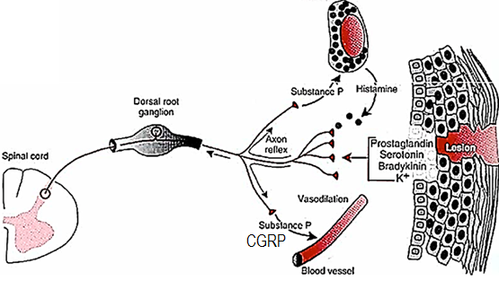
Bradykinin might be the agent most responsible for causing pain after tissue damage.
Tissue injury releases bradykinin and prostaglandins that sensitize or activate nociceptors, which in turn releases substance P and calcitonin gene-related peptide (CGRP).
a. Substance P (Lewis pain-producing factor or pain factor) acts on mast cells to cause degranulation and release histamine, which activates nociceptors.
b. Substance P causes plasma extravasation and CGRP dilates blood vessels; the resulting edema causes additional release of bradykinin. Serotonin (5-HT) is released from platelets and activates nociceptors.
B. Tissue ischemia:
Tissue ischemia pain is due to accumulation of large amounts of lactic acid in the tissues
Tissue ischemia pain is formed as a consequence of anaerobic metabolism
Tissue ischemia pain is more rapidly appears with greater rate of tissue metabolism
Clinically
Angina pectoris
Angina pectoris pain is sub-sternal pain that develops when the myocardium becomes ischemic during exertion.
Angina pectoris pain is a classic example of the accumulation of P factor in a muscle.
Angina pectoris pain relieved by rest because this decreases the myocardial O₂ requirement and permits the blood supply to remove the factor.
Intermittent claudication
Intermittent claudication pain produced in the leg muscles of persons with occlusive vascular disease,
Intermittent claudication comes on while the patient is walking and disappears on stopping.
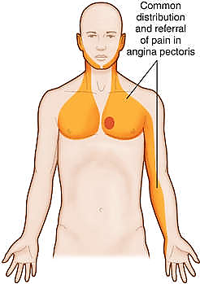
C. Muscle Spasm: This pain probably results partially from the direct effect of muscle spasm in stimulating mechano-sensitive pain receptors, but it might also result from the indirect effect of muscle spasm to compress the blood vessels and cause ischemia.
Pathophysiology Types of Pain
Several distinct types of pain have been described:
1. Nociceptive pain:
Nociceptive pain is an actually or potentially tissue damaging event
Nociceptive pain types are:
Somatic pain
a. Superficial somatic pain arises from nociceptive receptors in the skin and mucous membranes
b. Deep somatic pain
Deep somatic pain originates from structures such as joints, bones, tendons, and muscles.
Deep somatic pain may be dull and aching, which is similar to visceral pain.
Dull Like aching pain
a. at a low level over not sever not stop you from daily activity
b. a long period of time
c. may intensify when you put pressure on the affected body part.
Visceral pain
Types of Nociceptors
Nociceptors can be classified depending on stimuli excite pain receptors:
A. Mechano-sensitive nociceptors (of Aδ fibers)
Mechanical nociceptors a sensory receptor for painful stimuli respond to strong pressure (e.g. from a sharp object).
B. Temperature-sensitive (thermo-sensitive) nociceptors (of Aδ and C fibers)
Thermal nociceptors are activated by skin temperatures above 45 °C or by severe cold.
C. Chemically sensitive nociceptors
D. Polymodal nociceptors (of C fibers)
Polymodal nociceptors respond to combinations of these stimuli. Although most nociceptors are sensitive to one particular type of painful stimulus, some may respond to two or more types
The nociceptive system is a key physiologic function that prevents further tissue damage due to the body’s withdrawal reflex.
2. Inflammatory pain:
Inflammation (inflammatory mediators)is initiated upon tissue injury and sets off a cascade of biochemical reactions that primeالمسؤل الرئيسي the nervous system for pain sensing.
Long-term inflammation reinforces adaptive changes in the nervous system that can cause the sensation of pain to become exaggerated (hypersensitivity) or inappropriate
The inflammatory response contributes to pain hypersensitivity that serves to Prevent contact or
Movement of the injured part until healing is complete, thus reducing further damage.
Pain hypersensitivity
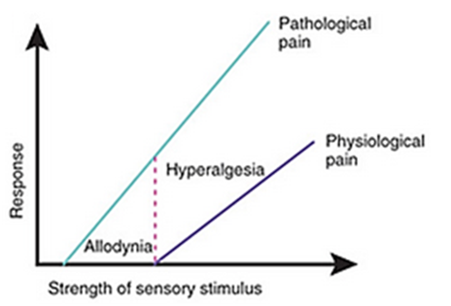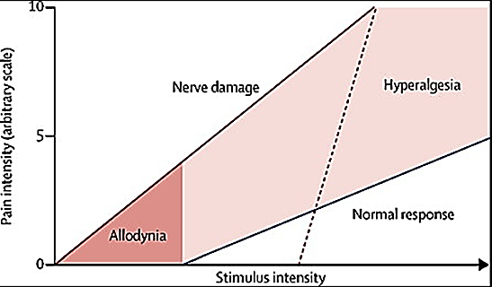
Pain systems need to be sensitive enough to detect potentially harmful stimuli. But often they become too sensitive, causing us pain that provides no benefit.
Pain hypersensitivity occur in slow-aching-nauseous pain, as the pain stimulus continues.
Pain hypersensitivity takes two forms:
A. allodynia: thresholds are lowered so that stimuli that would normally not produce pain now begin
B. hyperalgesia: responsiveness is increased, so that noxious stimuli produce an exaggerated and prolonged pain. Paresthesia is an abnormal sensation such as tingling, tickling, pricking, numbness or burning commonly referred to as 'pins and needles.'
Types of hyper-sensitization
i. Peripheral sensitization
Peripheral sensitization is a reduction in threshold and an increase in responsiveness of the peripheral ends of nociceptors,
Peripheral sensitization results from the increased excitability of peripheral nociceptive sensory fibers produced by the action of inflammatory mediators as platelet-activating factor (PAF). This excitatory effect, in turn, is a result of the altered activity of ion channels within affected sensory fibers.
An example is the painful sensation from a warm shower when the skin is damaged by sunburn
ii. Central sensitization
Central sensitization is an increase in the excitability of neurons within the central nervous system, so that normal inputs begin to produce abnormal responses due to alteration of the strength of synaptic connections between the nociceptor and the neurons of the spinal cord
3. Neuropathic pain
It is defined as chronic, spontaneous, hypersensitivity to pain; associated with damage, dysfunction, or injure in the peripheral nervous system as in
Painful diabetic peripheral neuropathy (DPN),
Acquired immunodeficiency syndrome (AIDS),
Poly-neuropathy,
Post-herpetic neuralgia (PHN); or
Pain originating in the central nervous system (CNS), that which occurs with
Spinal cord injury,
Multiple sclerosis (is an inflammatory disease in which the fatty myelin sheaths around the axons of the brain and spinal cord are damaged)
Stroke
Causalgia severe burning pain in a limb caused by injury to a peripheral nerve.
4. Functional pain (functional pain syndrome):
When a physiological or organic cause for the pain cannot be found, often after extensive testing and multiple referrals, functional pain syndrome is diagnosed.
A relatively newer concept is pain sensitivity due to an abnormal processing or function of the central nervous system in response to normal stimuli.
Several conditions considered to have this abnormal sensitivity or hyper-responsiveness include:
Fibromyalgia Irritable bowel syndrome
Referred Pain:
Irritation of a visceral organ frequently produces pain that is felt not at that site but in some somatic structure that may be a considerable distance away.
Such pain is said to be referred to the somatic structure. Obviously, knowledge of referred pain and the common sites of pain referral from each of the viscera are of great importance to the physician. Perhaps the best-known examples are
Referral of cardiac pain to the inner aspect of the left arm
Pain in the tip of the shoulder caused by irritation of the central portion of the diaphragm
Pain in the testicle due to distention of the ureter.
You should differentiate between referred pain and radiate pain
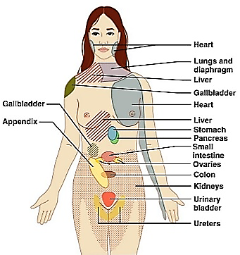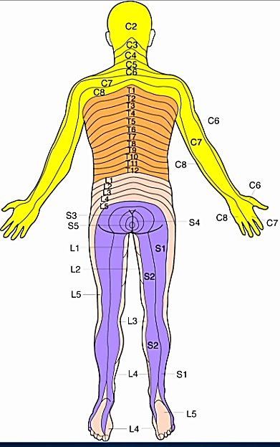
Explanation:
1. Dermatomal rule: When pain is referred, it is usually to a structure that developed from the same embryonic segment or dermatome as the structure in which the pain originates. For example, the heart and the arm have the same segmental origin, and the testicle has migrated with its nerve supply from the primitive urogenital ridge from which the kidney and ureter have developed.
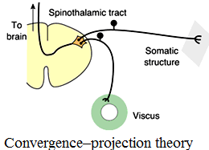
2. Convergence–projection theory: The basis for referred pain may be convergence of somatic and visceral pain fibers on the same second-order neurons in the dorsal horn that project to the thalamus and then to the somatosensory cortex.
3. Role of experience: patients may explain new tooth pain as maxillary sinus pain depending on old, long history of maxillary sinusitis.
Visceral Pain:
Visceral pain is used for diagnosing different visceral diseases (visceral inflammation and infectious)
Essentially all visceral pain that originates in the thoracic and abdominal cavities is transmitted through small type C pain fibers and, therefore, can transmit only the chronic-aching-suffering type of pain
Visceral pain can be caused by any stimulus that excites pain nerve endings in diffuse areas of the viscera.
Such stimuli include:
ischemia of visceral tissue (MI)
chemical damage to the surfaces of the viscera (PU)
spasm of the smooth muscle of a hollow viscus, (billary colic, ureter colic)
excess distention of a hollow viscus,(GIT distention)
stretching of the connective tissue surrounding or within the viscus.
Visceral pain characterizes as:
vague, poorly localized, and not well understood or clearly defined,
unpleasant,
associated with nausea and autonomic symptoms,
radiates or is referred to other areas.
Visceral pain seldom severe even in highly localized types of damage to the viscera
Visceral pain often feels like a deep squeeze, pressure, or aching.
Visceral pain, like somatic pain, initiates reflex contraction of nearby skeletal muscle. This reflex spasm is usually in the abdominal wall and makes abdominal wall rigid and it is called (guarding).
Visceral autonomic reflex:
Visceral reflex is unconscious, automatic, stereotype responses to stimuli
Visceral reflex is usually of two types:
a. short visceral reflex: where CNS is not involved such as reflex at the wall of GIT
b. long visceral reflex: where CNS is involved such as defecation and micturition
Long visceral reflex arc: Receptor, afferent neurons (to CNS), interneurons, efferent neurons (away from CNS), effectors
Visceral autonomic reflex:
Visceral reflex is unconscious, automatic, stereotype responses to stimuli
Visceral reflex is usually of two types:
a. short visceral reflex: where CNS is not involved such as reflex at the wall of GIT
b. long visceral reflex: where CNS is involved such as defecation and micturition
Long visceral reflex arc: Receptor, afferent neurons (to CNS), interneurons, efferent neurons (away from CNS), effectors
Visceral Receptors:
Nociceptors are present, although they are more sparsely قليلةdistributed than in somatic structures.
There are no proprioceptors in the viscera, few temperature and touch receptors and chemoreceptors (pH and osmolarity of food).
The receptors in the walls of the hollow viscera are especially sensitive to distention of these organs. Distention can produces pain that waxes and wanes (increase and decrease as in intestinal colic). When a visceral organ is inflamed or hyperemic, relatively minor stimuli cause severe pain. This is probably a form of hyperalgesia.
Afferent and Efferent fibers and CNS via sympathetic and parasympathetic nerves.
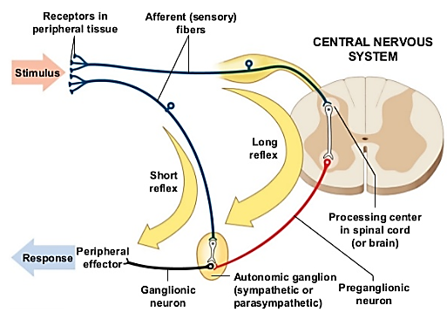
Pain Modulationتعديل
Modulation of pain (inhibition of nociceptive impulses) can occur by a number of processes.
First: Based on the gate control theory,
Pain modulation may occur at the level of the dorsal horn. Since the brain can process only a limited number of signals at one time, other sensory stimuli at nociceptors may alter pain perception. This theory supports the effectiveness of:
1. Counter-irritants: is a substance which creates inflammation in one location with the goal of lessening the inflammation in another location. Stimulation of the skin over an area of visceral inflammation produces some relief of the pain due to the visceral disease.
2. Trans-cutaneous electrical nerve stimulation (TENS): involves the transmission of electrical energy from an external stimulator to the peripheral nervous system via cutaneously placed conductive gel pads). It is a type of pain management.
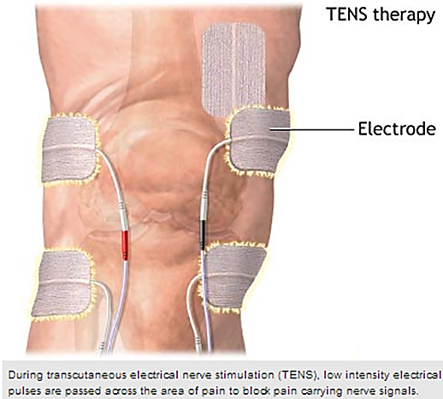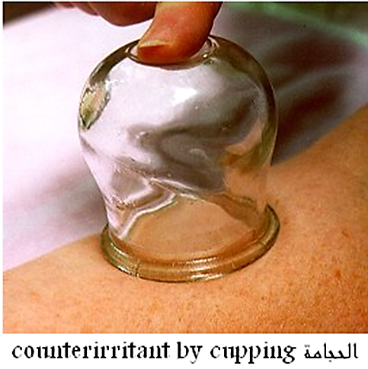
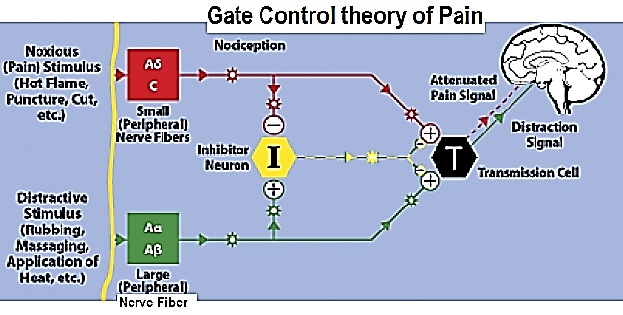
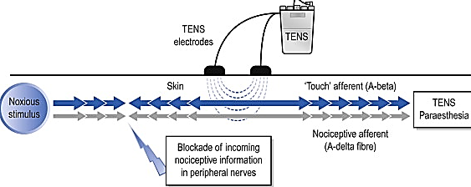
Second: The perception of pain involves not only nociceptive stimulation but physiologic and emotional input that contributes to the perception of pain. Consequently, cognitive behavioral treatments such as distraction, relaxation, and guided imagery, positive self-talk, thought stopping can reduce pain perception by altering pain processing in the cortex.
Third: Surgical procedures undertaken to relieve severe pain include cutting the nerve from the site of injury or ventrolateral cordotomy, in which the spinothalamic tracts are carefully cut.
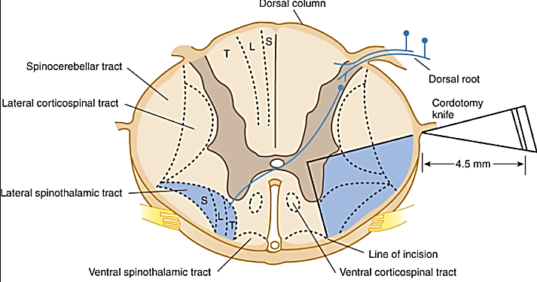
Fourth: The endogenous opiate system
It is well known that soldiers wounded in the heat of battle often feel no pain until the battle is over
(Stress-induced analgesia). A component of stress induced analgesia appears to be mediated by endogenous opioids system
The endogenous opioid system is innate pain-relieving systems.
The endogenous opioid system consists of widely scattered neurons that produce endogenous opioids: beta-endorphin, enkephalins (met-enkephalin and leu-enkephalin), and the dynorphins.
The endogenous opioid act as neurotransmitters and neuromodulators at three major classes of receptors, termed μ (Mu), δ (delta), and κ (Kappa) receptors throughout the CNS to inhibit pain impulses and alter perception and produce analgesia.
The CNS also includes inhibitory descending pathways from the brain that can attenuate pain transmission in the dorsal horn. Neurotransmitters involved in this descending system include endogenous opioids, serotonin, nor-epinephrine, γ-aminobutyric acid (GABA) and neurotensin.
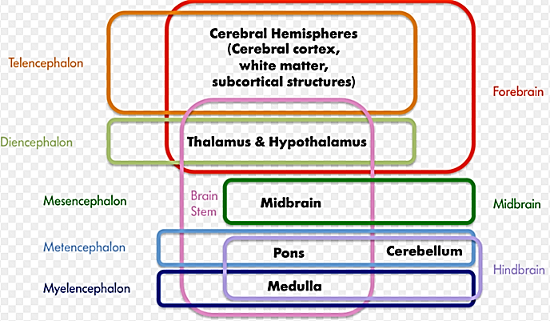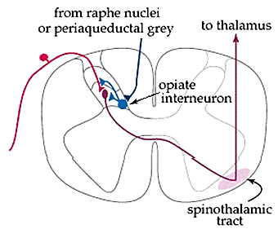
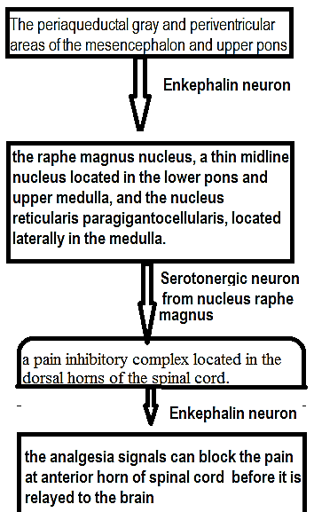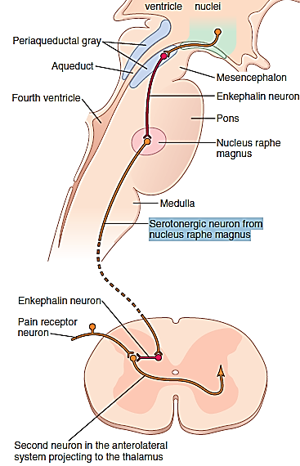
Acupuncture at a location distant from the site of a pain may act by releasing endorphins.
Acupuncture at the site of the pain appears to act primarily in the same way as touching or shaking (gate-control mechanism).
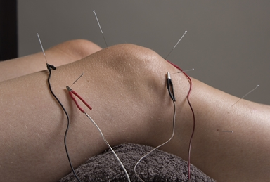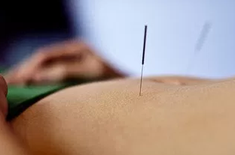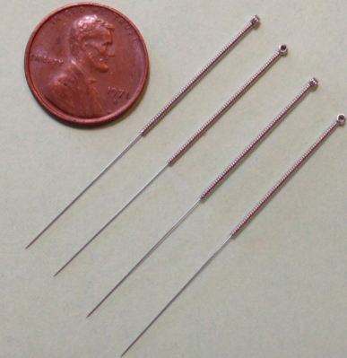
Sensory pathway for transmitting somatic signals into CNS:
(A) The dorsal column–medial lemniscal system
It has large, myelinated nerve fibers, velocities of 30 to 110 m/sec
It has a high degree of spatial orientation of the nerve fibers with respect to their origin,
It does not has the ability to transmit a broad spectrum of sensory modalities
It has the ability to transmit:
1. Touch sensations requiring a high degree of localization of the stimulus
2. Touch sensations requiring transmission of fine gradations of intensity
3. Phasic sensations, such as vibratory sensations
4. Sensations that signal movement against the skin
5. Position sensations from the joints
6. Pressure sensations related to fine degrees of judgment of pressure intensity
Pain pathways from the body
Pain classification depending on the type
Fast, acute, well-localized, short, sharp, electric, pricking (pinprick). | Slow, chronic, poorly localized, long  dull, burning, aching, throbbing, nauseous, and, , persistent, (stretching of a tendon)
- 1.felt after pain stimuli applied : 0.1 sec (Short Latency and short duration)  2. Good capability of nervous system to localize fast pain.  3. Caused by mechanical and chemical pain stimuli.  4. Less emotional  do not elicit an affective component associated with the experience  5. Not block by morphine  First order neurons  - Group III ( A δ fiber)  - myelinated  - 2-5 µm diameter  conduct rat 6 and 30 m/sec  Second order neurons  Carry by lateral or direct (neo-spino-thalamic) tract  Dorsal horn of the spinal cord at laminas I (lamina marginals).  Spinal cord neurotransmitter is glutamine  Higher center: Cerebral cortex | - 1.felt after pain stimuli applied : 1 sec  - (Slow Onset and long duration)  - 2. Poor capability of nervous system to localize precisely source of pain.  - 3. Caused by mechanical, thermal, and chemical pain stimuli.  4. Emotional and autonomic response  elicit an affective component associated with the experience  5. Block by morphine  First order neurons  Group IV (C fiber)  un-myelinated  0.4- 1.2 µm diameter  conduct rat 0.5-2 m/sec  Second order neurons  Carry by ventral, anterior, or indirect (paleo-spino-thalamic) tract  Dorsal horn of the spinal cord at laminas II and III (substantia gelatinosa).  Spinal cord neurotransmitter is substance P  Higher center: Thalamus
When only receptors are stimulated, without the simultaneous stimulation of tactile receptors, even fast pain may be poorly localized, often only within 10 centimeters or so of the stimulated area. Yet when tactile receptors that excite the dorsal column–medial lemniscal system are simultaneously stimulated, the localization can be nearly exact.
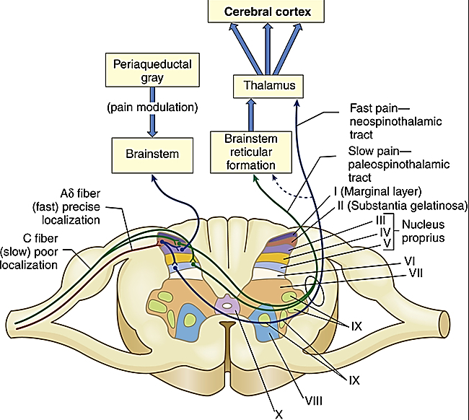
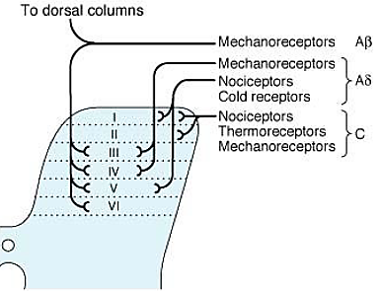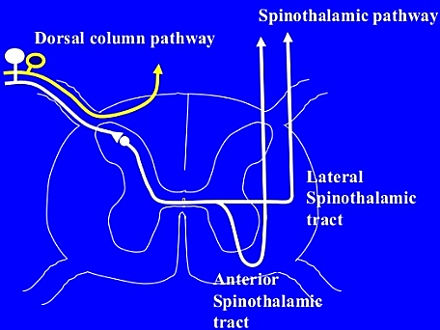
Structure of cerebral cortex:
The cerebral cortex contains six layers of neurons, beginning with layer I next to the brain surface and extending progressively deeper to layer VI
Afferent:
1. The incoming sensory signal excites neuronal layer IV first; the signal then spreads toward the surface of the cortex and also toward deeper layers.
2. Layers I and II receive diffuse, nonspecific input signals from lower brain centers that facilitate specific regions of the cortex. This input mainly controls the overall level of excitability of the respective regions stimulated.
Efferent
1. The neurons in layers V and VI send axons to the deeper parts of the nervous system.
a. Layer V are generally larger and project to more distant areas, such as to the basal ganglia, brain stem, and spinal cord, where they control signal transmission.
b. From layer VI, especially large numbers of axons extend to the thalamus, providing signals from the cerebral cortex that interact with and help to control the excitatory levels of incoming sensory signals entering the thalamus.
2. The neurons in layers II and III send axons to related portions of the cerebral cortex on the opposite side of the brain through the corpus callosum.
Functionally, the neurons of the somatosensory cortex are arranged in vertical columns
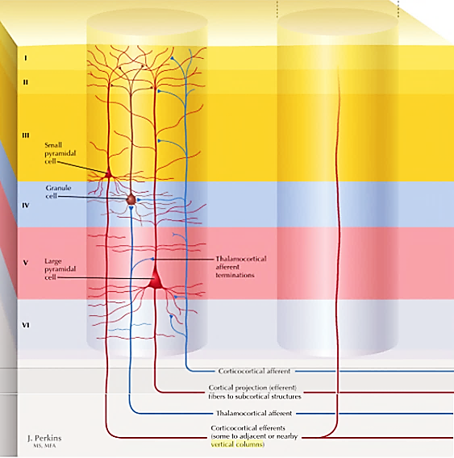
Functionally, the neurons of the somatosensory cortex are arranged in vertical columns
Vertical columns cylindrical vertical zone extending all the way through the six layers of the cortex
Vertical columns diameter expanse of a larger pyramidal cell in the unit; where it vary from (0.5 to1.0 mm) in diameter.
Vertical columns represent a basic functional unit for sensory processing
Vertical columns serves a single specific sensory modality; some columns respond to stretch receptors around joints, some to stimulation of tactile hairs, others to discrete localized pressure points on the skin, and so forth.
Vertical columns neurons function almost entirely separately from one another.
Vertical columns detect a different sensory spot on the body
At layer IV, the input sensory signals first enter the cortex, thalamus is the main source of input to cortex
Vertical columns main input is layer IV which receives thalamic input
Vertical columns can send information to near vertical columns via cortico-cortical efferent or can be send to distance structure
At other levels of the columns, interactions occur that initiate analysis of the meanings of the sensory signals.
In the most posterior portion of somatosensory area I, about 6 percent of the vertical columns respond only when a stimulus moves across the skin in a particular direction.
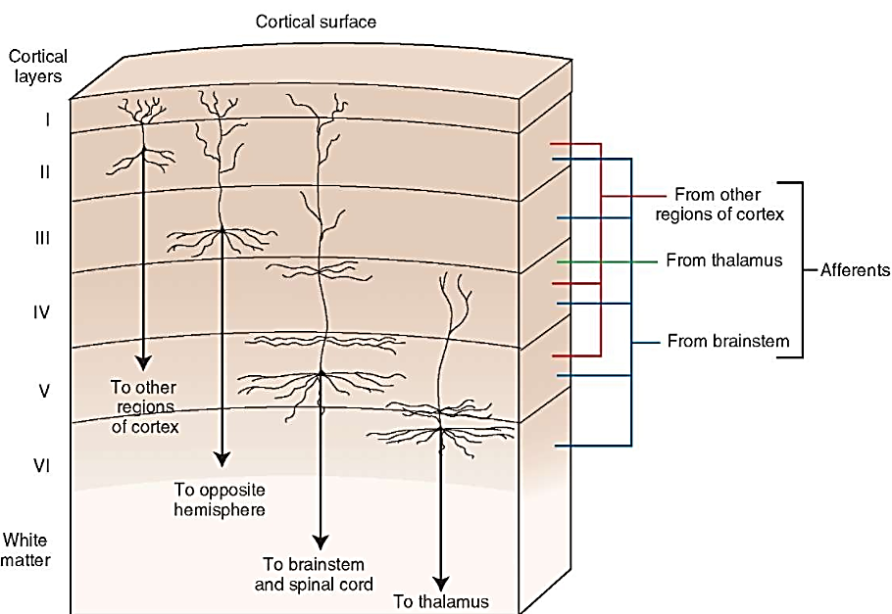
Somatosensory Areas I and II.
Somatosensory Areas I (or Primary Somatosensory Areas; Brodmann area 1, 2, and 3),
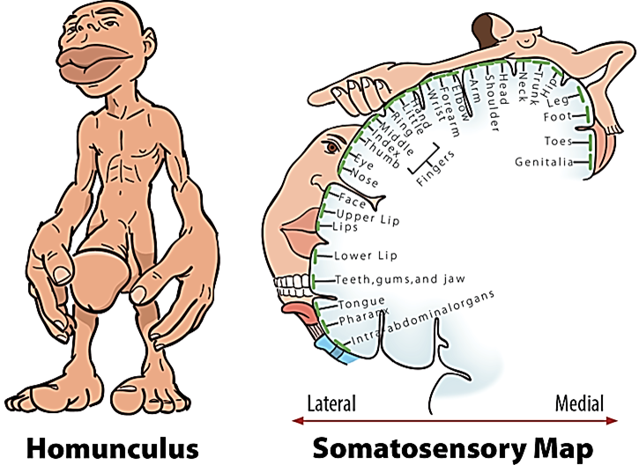
Somatosensory Areas II (or Secondary Somatosensory Areas; Brodmann area 40)
Sensory associated area (Brodmann area 5, and 7)
Somatosensory Areas I has sensory homunculus includes cortical representation of the body based on the degree of sensory innervations. Very sensitive areas such as the lips and the fingertips have a huge representation.
If a region is amputated (such as a finger) there is reorganization with neurons responding to stimulation of adjacent body parts. This can also happen as the result of increased use of a body part.
Functions of Somatosensory Area I
Widespread bilateral excision of somatosensory area I causes loss of the following types of sensory judgment:
1. The person is unable to localize discretely the different sensations in the different parts of the body.
2. The person is unable to judge critical degrees of pressure against the body.
3. The person is unable to judge the weights of objects.
4. The person is unable to judge shapes or forms of objects. This condition is called astereognosis.
5. The person is unable to judge texture of materials because this type of judgment depends on highly critical sensations caused by movement of the fingers over the surface to be judged.
For pain and temperature sense:
in the list nothing has been said about loss of pain and temperature sense. In the specific absence of only somatosensory area I, appreciation of these sensory modalities is still preserved both in quality and intensity. However, the sensations are poorly localized, indicating that pain and temperature localization depend greatly on the topographical map of the body in somatosensory area I to localize the source.
However, he or she can localize these sensations crudely, such as to a particular hand, to a major level of the body trunk, or to one of the legs. Thus, it is clear that the brain stem, thalamus, or parts of the cerebral cortex not normally considered to be concerned with somatic sensations can perform some degree of localization.
Somatosensory Areas II
Somatosensory Areas I is so much more extensive important degree of localization of the different parts of the body, comparing to Somatosensory Areas II
Much less is known about the function of somatosensory area II, signals enter this area from the brain stem, somatosensory area I, visual and auditory areas.
Projections from somatosensory area I are required for function of somatosensory area II. However, removal of parts of somatosensory area II has no apparent effect on the response of neurons in somatosensory area I
Somatosensory associated area:
Somatosensory associated area play important roles in deciphering فك رموزdeeper meanings of the sensory information in the somatosensory areas.
Electrical stimulation in a somatosensory association area can occasionally cause an awake person to experience a complex body sensation, sometimes even the “feeling” of an object such as a knife or a ball. Therefore, it seems clear that the somatosensory association area combines information arriving from multiple points in the primary somatosensory area to decipher its meaning. This occurrence also fits with the anatomical arrangement of the neuronal tracts that enter the somatosensory association area because it receives signals from (1) somatosensory area I, (2) the ventrobasal nuclei of the thalamus, (3) other areas of the thalamus, (4) the visual cortex, and (5) the auditory cortex.
Effect of removing the somatosensory association area (Amorphosynthesis).
When the somatosensory association area is removed on one side of the brain, the person loses:
the ability to recognize complex objects and complex forms felt on the opposite side of the body.
most of the sense of form of his or her own body or body parts on the opposite side.
a. the person is mainly oblivious غافلto the opposite side of the body (that is, forgets that it is there).
b. the person often forgets to use the other side for motor functions as well.
c. when feeling objects, the person tends to recognize only one side of the object and forgets that the other side even exists. This complex sensory deficit is called amorphosynthesis.
Segmental Fields of Sensation—Dermatomes
Each spinal nerve innervates a “segmental field” of the skin called a dermatome.
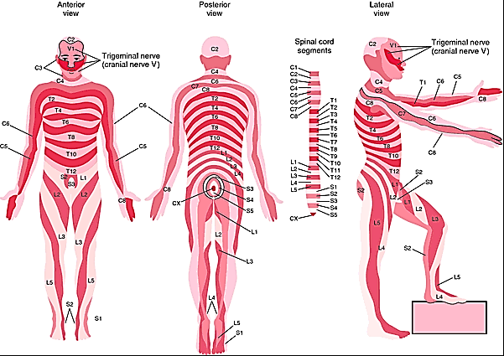
Function of the Thalamus in Somatic Sensation
When the somatosensory cortex of a human being is destroyed, that person loses most critical tactile sensibilities, but a slight degree of crude tactile sensibility does return. Therefore, it must be assumed that the thalamus (as well as other lower centers) has a slight ability to discriminate tactile sensation, even though the thalamus normally functions mainly to relay this type of information to the cortex. When the thalamus is damaged along with the cortex, the loss of cerebral function is far greater than when the cortex alone is damaged because thalamic excitation of the cortex is necessary for almost all cortical activity. Therefore, the cortex operates in close association with the thalamus and can almost be considered both anatomically and functionally a unit with the thalamus; for this reason, the thalamus and the cortex together are sometimes called the thalamo-cortical system. Almost all pathways from the sensory receptors and sensory organs to the cortex pass through the thalamus, with the principal exception of some sensory pathways of olfaction.

