Anatomy lecture
The skull
22-9-2019
ميرنا رمضان حجازين
روان عبد العزيز
Sheet correction link: bit.ly/mssanatomy

Note: check the lecture’s slides
##the skull consists of 22bones + 6 bones of the middle ear also known as ossicles ( malleus, incus, and stapes)

The skull consists of 2 parts:
- Superior fixed part (skull proper), we can call it cranium or neurocranium- contain the brain.
- Inferior mobile part (mandibular part).
1 & 2 => are articulated with each other by synovial joint called temporomandibular joint (TMJ)

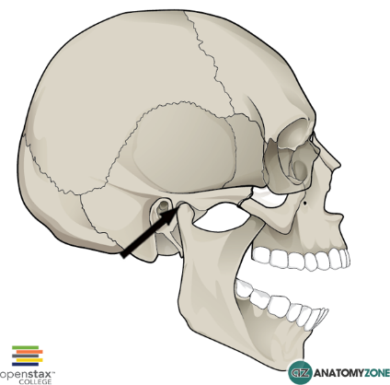
Cranium is divided into 2 parts:
- Neurocranium => (cover the brain and its nerve), bones of the brain.
- Viscerocranium => (cover face or viscera mouth, nose pharynx), bones of the face.

Development of bone …. There are 2 methods:
- Endocondral ossification: Mesenchymal cells form => cartilage => then transform for bone ( osteoblasts replace cartilage with bone ). It means ossification inside cartilage

- Intramembranous ossification: Mesenchymal cells directly transform into bone example the scapula which is flat bone and skull 2سوسو.

*** ALL bones of skull ossified by intramembranous EXCEPT occipital bone and base of skull *** so the skull developed by 2 methods

## fractures in flat bones of skull (which is developed by intramembranous ossification called depressed fracture ‘flexible like football’) it is simple
## fracture in occipital bone called crack fracture it is dangerous

## most of skull fracture is depressed fracture
## vision centre is located at base of skull

Question:
A patient come to you with ear or nose bleeding due to fracture in his skull, the site of fracture is:
Answer:
Base of skull (endochondral ossification)

Cavities:
Paranasal sinuses [air spaces cavity into the bone named according to these bones]:
- Ant. Two Maxillary 2- above them two Frontal 3- post. Two Ethmoidal 4- sphenoid.
Sinuses importance => lighten the skull & resonance of sound and increase surface area of respiratory mucous membrane ‘which is pseudostratified columnar.’
Paranasal sinuses are evasinations of mucous membrane of nasal cavity

- Cranial cavity which contain the brain.
- Orbital cavity.
- Nasal cavity.
- Middle ear cavity.
- Paranasal sinuses

Bones of the skull:
- Cranial => occipital, temporal, parietal, sphenoid, ethmoid, frontal.
- Facial =>
may be single : mandible & vomer “which is in the lower part of nasal septum”
Or paired: maxilla “bone of the upper jaw”, zygomatic” cheek bones”, nasal” we cut them in rhinoplasty”, palatine, lacrimal, inferior nasal concha” in lateral sides of nasal cavity”.
Superior view:
2 frontal bones*, 2 parietal bones, 2 occipital bones*.
*in embryo
Lateral view:
2 temporal bones.
****Cranial bones are connected to each other by joint called suture.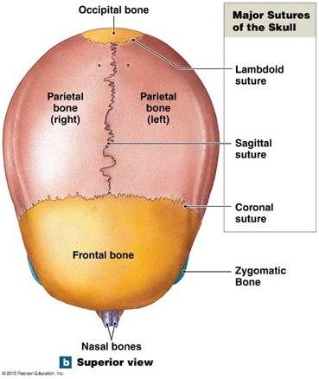
- Coronal suture => between frontal and parietal bone. { anterior}
- Sagittal suture => between 2 parietal bones.
- Lambdoid suture => between occipital and parietal bones. {posterior}
- Squamous suture => lateral view.
Question: How many suture we can see from superior view?
Answer: 3, coronal, sagittal and lambdoid

- New babies show spaces between sutures which called fontanels.
The anterior fontanel which is diamond in shape [between 2 frontal & 2 parietal] closes or ossify at the end of 2 year or BTW 18 and 24 months.
The posterior between parietal & occipital which is triangular in shape closes at the end of 2 month. مشان الطفل يقدر ينام ع راسه

** the importance of fontanel => minimise the circumference of the skull during birth to ease passage & expansion of brain (post-natal growth). **
اذا كان رأس الطفل للأسفل قبل الولادة we can feel these soft spots(fontanels)
CSF
-it is body fluid found in brain & spinal cord it is sent from its source to venous system
- its source: lateral ventricles in CNS
- lateral ventricles terminate into interventricular foramina, these foramina help CSF moving away from lateral ventricles
-in the case of meningitis bacteria & WBCs accumulate & close these foramina leading to accumulation of CSF near the fontanels (hydrocephalus)
-in newborn “bcz of fontanels” it is treated by shunting CSF to superior vena cava, but in elderly we can’t and the accumulated CSF will compress brain cells leading to alzhimer, barkinson etc…

Pterionصرصور اذنه
It is a site of confluence of sutures
This is a dangerous area where these for bones united:
Parietal bone, frontal, temporal, sphenoid.

Below the pterion [the anterior branch of middle meningeal artery] is located
##It comes from maxillary artery=> which come from external carotid artery.
## middle meningeal artery runs through foramen spinosum then gives Ant. And post. Middle meningeal arteries
## ant. Middle meningeal artery located between dura & bone so outside adural matter
A hit on this area that may cause injury – to the ant. Middle meningeal artery- will collect the blood there which press on the brain and cause extradural hematoma.
لما شخص ينظرب على هاي المنطقة ويجي على الطوارىء (رح يكون يشكي من دوخة ثم فقدان للوعي واذا لم تتم معالجتة يؤدي للوفاة ) لازم نخليه تحت المراقبة لمدة 24 ساعة لانه بأي لحظة ممكن يصير النزيف.
Drowsiness---unconsciousness—death
the blood almost always must be removed surgically to reduce the pressure on the brain

External carotid artery gives 8 branches, 5 below and 3 above the post. Digastric
*** Branches of external carotid artery (not same as the doctor’s mnemonics)

## Some Anatomists Like Freaking Out Poor Medical Students
- S: superior thyroid artery
- A: ascending pharyngeal artery
- L: lingual artery
- F: facial artery
- O: occipital artery
- P: posterior auricular artery
- M: maxillary artery
- S: superficial temporal artery

*** the top part of the skull called claveria it covers the cranial cavity. The cranial fossa divided into 3 parts, anterior, middle & posterior
Each part composed of different bones and has different foramina & structures passing through
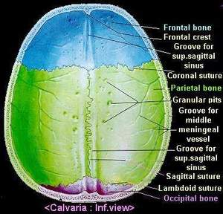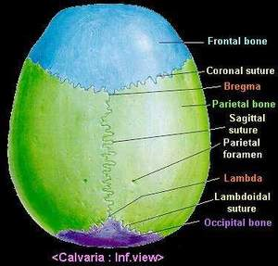
Vision area is located at base of skull
Hearing area at temporal reagon
Thinking or memory area at parital

