Sensory system:
Interrelations among the tactile sensations الاحساس اللمسيof Touch, Pressure, and Vibration.
Although touch, pressure, and vibration are frequently classified as separate sensations, they are all detected by the same types of receptors.
There are three principal differences among them:
(1) touch sensation generally results from stimulation of tactile receptors in the skin or in tissues immediately beneath the skin;
(2) pressure sensation generally results from deformation of deeper tissues; and
(3) vibration sensation results from rapidly repetitive sensory signals, but some of the same types of receptors as those for touch and pressure are used.
Distinctions between them are not well defined.
Fine touch and pressure receptors provide detailed information about a source of stimulation, including the exact location, shape, size, texture, and movement. These receptors are extremely sensitive and have relatively narrow receptive fields.
Crude touch (or non-discriminative touch) is a sensory modality that allows the subject to sense that something has touched them, without being able to localize where they were touched (contrasting "fine touch").and pressure receptors provide poor localization and information.
Tactile Receptors.
First, some free nerve endings,
Which are found everywhere in the skin and in many other tissues, can detect touch and pressure.
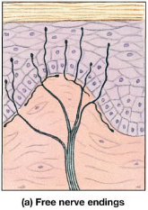
Second Meissner’s corpuscle
An elongated encapsulated nerve ending of a large (type Aβ) myelinated sensory nerve fiber.
Inside the capsulation are many branching terminal nerve filaments.
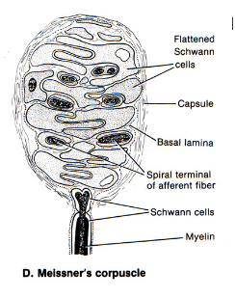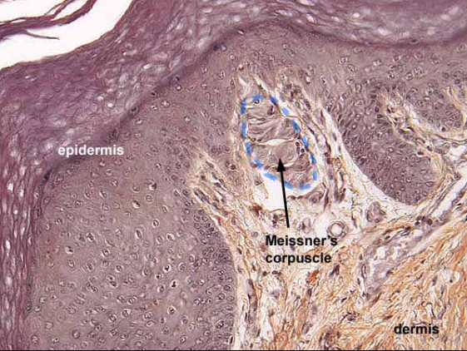
These corpuscles are present in the non-hairy parts of the skin and are particularly abundant in the fingertips, lips, and other areas of the skin where one’s ability to discern تعرف تبينspatial locations of touch sensations is highly developed.
Meissner corpuscles:
Adapt in a fraction of a second after they are stimulated, which means that they are particularly sensitive to movement of objects over the surface of the skin, to low-frequency vibrationa touch receptor with great sensitivity
Third Merkel discs
Merkel discs receptors differ from Meissner’s corpuscles in that they transmit an initially strong but partially adapting signal and then a continuing responsible for giving steady-state signals that allow one to determine continuous touch of objects against the skin.
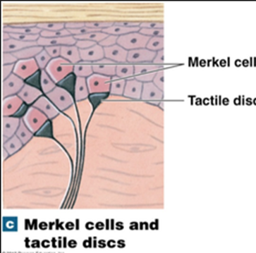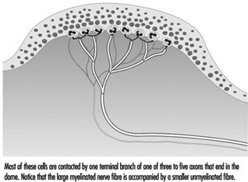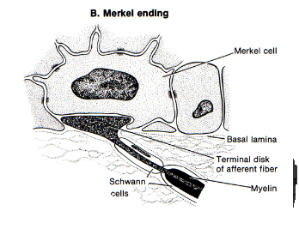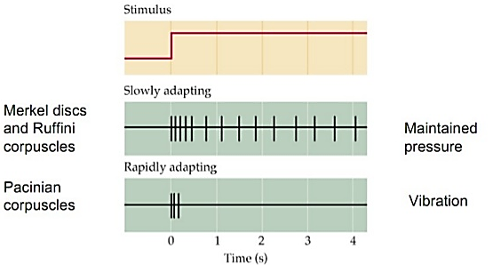
Merkel discs are often grouped together in a receptor organ called the Iggo dome receptor, which projects upward against the underside of the epithelium of the skin. This upward projection causes the epithelium at this point to protrude outward, thus creating a dome and constituting an extremely sensitive receptor.
Also note that the entire group of Merkel’s discs is innervated by a single large myelinated nerve fiber (type Aβ). These receptors, along with the Meissner’s corpuscles, play extremely important roles in localizing touch sensations to specific surface areas of the body and in determining the texture of what is felt.
Fourth, hair end-organ or free nerve ending of root hair plexus:
each hair and its basal nerve fiber, called the hair end-organ
are touch receptors
slight movement of any hair on the body stimulates a nerve fiber entwining تلتف حولits base
A receptor adapts readily and, like Meissner’s corpuscles, detects mainly
(a) movement of objects on the surface of the body or
(b) initial contact with the body.
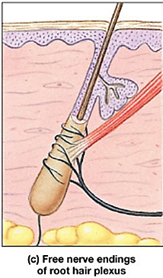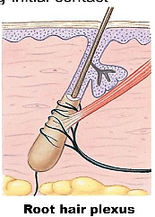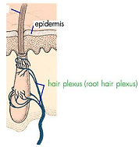
Fifth, Ruffini’s endings
located in
the deeper layers of the skin
in still deeper internal tissues
Ruffini’s endings is supplied by a single myelinated axon that branches repeatedly to form diffuse unmyelinated terminals among bundles of collagen fibers in the core of the capsule
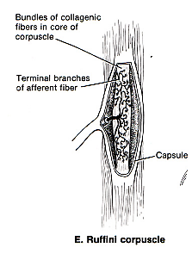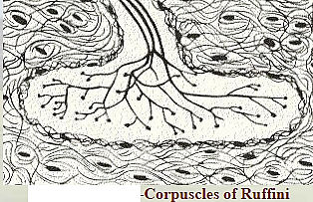
Ruffini’s endings adapt very slowly and, therefore, are important for signaling continuous states of deformation of the tissues, such as heavy prolonged touch and pressure signals.
Ruffini’s endings are also found in joint capsules and help to signal the degree of joint rotation.
Sixth, Pacinian corpuscles
Pacinian corpuscles lie both immediately beneath the skin and deep in the fascial tissues of the body.
Pacinian corpuscles are stimulated only by rapid local compression of the tissues because they adapt in a few hundredths of a second.
Pacinian corpuscles are particularly important for detecting tissue vibration or other rapid changes in the mechanical state of the tissues.
Pacinian corpuscles are found in the skin, fingers, breasts, and external genitalia, as well as in joint capsules, mesenteries, the pancreas, and walls of the urinary bladder
Sense organs and receptors:
Information about internal and external environment reaches the CNS via a variety of sensory receptors.
Receptor Classification:
I. Source of stimulation:
A. Extero-receptor: receive stimuli from outside (e.g. Eye, ear …etc).
B. Entro-receptor: receive stimuli from inside (e.g. chemoreceptor…. etc).
II. Types of stimuli energy:
A. Mechano-receptors: There are four types of mechanoreceptors:
(a) Cochlear hair cells are found in the ear.
(b) Golgi tendon organs and joint receptors are found in muscle and joints.
(c) Pacinian corpuscles and Meissner’s corpuscles are found in skin and viscera.
(d) Arterial baroreceptors are found in the cardiovascular system.
B. Thermo-receptor: detect environmental temperature. There are two types of thermo-receptors:
(a) Warm and cold receptors are found in the skin.
(b) Temperature-sensing hypothalamic neurons are found in the CNS.
C. Photoreceptors (or Electro-magnetic receptor) are the rods and cones of the retina. That detects light.
D. Chemoreceptor: detect substance produce chemical changes.
There are two types of chemo-receptors:
(a) Smell and taste receptors are found in the olfactory and gustatory systems.
(b) Carotid body O₂ receptors
(c) osmo-receptors
E. Nociceptors (Pain receptors):
Mechanoreceptors (Touch / pressure / position):
Mechanoreceptors are sensitive to stimuli that distort their cell membranes.
Mechanoreceptors contain mechanically regulated ion channels, which open and close in response to movement. There are three classes: tactile, baroreceptors, and proprioceptors.
I. Proprioceptors
Proprioceptors monitor
position of joints,
tension in tendons and ligaments, and the
state of muscular contraction.
Proprioceptors provide uninterrupted knowledge about the general position of our body in space prior to and during movement
Proprioceptors provides us with information regarding where body segments relative to each other are
Proprioceptors are the most structurally and functionally complex of all the sensory receptors.
Types:
muscle spindles
Golgi tendon organs
Joint kinestheticحركي receptor (sensory nerve ending within joint capsules, monitor stretch in synovial joints)
Types of Joint kinesthetic receptor
a. Pacinian corpuscles,
b. Ruffini’s endings, and
c. receptors similar to the Golgi tendon receptors found in muscle tendons.
The Pacinian corpuscles and muscle spindles are especially adapted for detecting rapid rates of change. It is likely that these are the receptors most responsible for detecting rate of movement.
Position senses:
The position senses are frequently also called proprioceptive senses.
Proprioceptive senses can be divided into two subtypes:
(1) Static position sense (joint position),
Static position sense means conscious perception of the orientation of the different parts of the body with respect to one another and what each part is doing.
(2) Dynamic position sense or rate of movement sense (joint movement), also called kinesthesia proprioception
Position Sensory Receptors.
Knowledge of position, both static and dynamic, depends on knowing the
Degrees of angulation of all joints in all planes and
Therefore, multiple different types of receptors help to determine joint angulation and are used together for position sense.
a. Both skin tactile receptors and are used.
In the case of the fingers, where skin receptors are in great abundance, as much as half of position recognition is believed to be detected through the skin receptors.
b. deep receptors near the joints
Conversely, for most of the larger joints of the body, deep receptors are more important.
Position Sensory Receptors.
Knowledge of position, both static and dynamic, depends on knowing the
Degrees of angulation of all joints in all planes and
Therefore, multiple different types of receptors help to determine joint angulation and are used together for position sense.
a. skin tactile receptors.
In the case of the fingers, where skin receptors are in great abundance, as much as half of position recognition is believed to be detected through the skin receptors.
b. deep receptors near the joints
Conversely, for most of the larger joints of the body, deep receptors are more important.
For determining joint angulation
1. In midranges of motion, the muscle spindles are among the most important receptors. When the angle of a joint is changing, some muscles are being stretched while others are loosened, and the net stretch information from the spindles is transmitted into the computational system of the spinal cord and higher regions of the dorsal column system for deciphering joint angulations.
2. At the extremes of joint angulation, stretch of the ligaments and deep tissues around the joints is an additional important factor in determining position
Their rates of change
. II. Baro-receptors (or baroceptors):
III. Tactile receptors
1. Touch Receptors: fine touch
Meissner’s corpuscle Merkel disks Root hair plexus
2. Touch Receptors: pressure sensitive
Ruffini’s endings Pacinian corpuscles Krause's end bulbs (found skin, mucosa of the oral cavity, conjunctiva, and other parts, consisting of a laminated capsule of connective tissue enclosing the terminal, branched, convoluted ending of an afferent nerve fiber; generally believed to be sensitive to touch and pressure)
3. Temperature
Free nerve endings, some responsive to heat and others responsive to cold
4. Pain
Transmission of Tactile Signals in Peripheral Nerve Fibers.
Almost all specialized sensory receptors, such as Meissner’s corpuscles, Iggo dome receptors (Merkel discs), hair receptors, Pacinian corpuscles, and Ruffini’s endings, transmit their signals in type Aβ nerve fibers that have transmission velocities ranging from 30 to 70 m/sec.
Free nerve ending tactile receptors:
transmit signals mainly by way of the small type Aδ myelinated fibers that conduct at velocities of only 5 to 30 m/sec.
Some tactile free nerve endings transmit by way of type C un-myelinated fibers at velocities from a fraction of a meter up to 2 m/sec; these nerve endings send signals into the spinal cord and lower brain stem, probably sub-serving mainly the sensation of tickle.
A. the more critical types of sensory signals; are all transmitted in more rapidly conducting types of sensory nerve fibers
determine precise localization on the skin,
minute gradations تدرجof intensity, or
rapid changes in sensory signal intensity
B. the cruder types of signals are
transmitted by way of much slower,
very small nerve fibers that require much less space in the nerve bundle than the fast fibers
such as
pressure,
poorly localized touch, and especially tickle
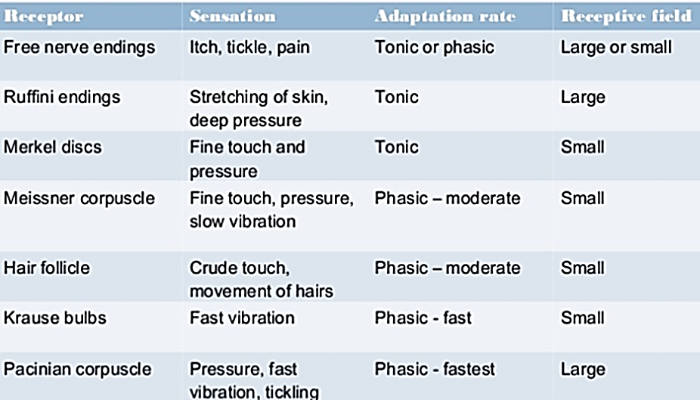

Nerve fiber types and functions:
Sensory neurons are classified depending on axon diameter or propagation velocity.
The information provided by the larger (and so more rapidly conducting fibers) is more precise than that provided by the smaller (and so more slowly conducting fibers).
ROMAN numbers are used to classified axon according to size,
LETTER is used to classified axon according to propagation velocity.
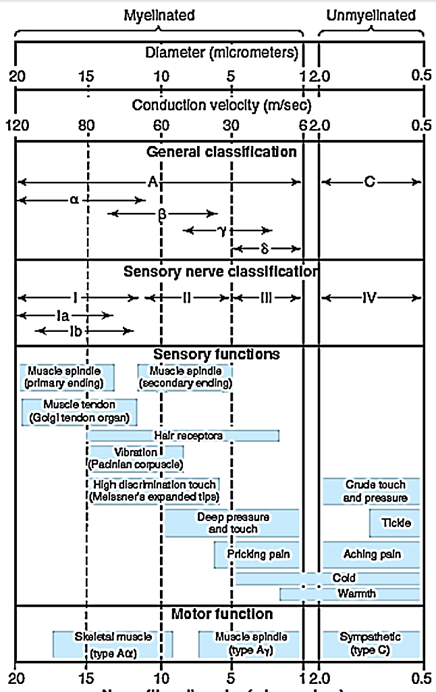
Fiber type | Fiber number | Fiber Function | Fiber Diameter(mm) | Conduction velocity(m/s)
A | Ia | Muscle spindle, annulo-spiral ending, | 12-20 | 70-120
A | Ib | Gologi tendon organ | 12-20 | 70-120
Aβ | II | Muscle spindle, flower-spray ending , touch, pressure | 5-12 | 30-70
Aγ |  | Motor to muscle spindles (intrafusal fibers) | 3-6 | 15-30
Aδ | III | Fast Pain, cold, touch, pressure | 2-5 | 12-30
B |  | Pre-ganglionic autonomic | <3 | 3-5
C(Dorsal root) | IV | Pain, temperature, some mechanoreceptor , reflex response | 0.4-1.2 | 0.5-2
C(sympathetic) | IV | Post-ganglionic sympathetic | 0.3-1.3 | 0.7-2.3
Note:
A fibers are myelinated while C fibers are un-myelinated.
Only 1/3 of all axons carrying sensory information are myelinated
In addition to variation in speed of conduction and fiber diameter, the various classes of fibers in peripheral nerve differ in their sensitivity to hypoxia and anesthetics. This fact has clinical as well as physiological significance.
Local anesthesia depress transmission in the group C fibers before they affect the touch fibers in the A group.
Conversely, pressure on the nerve can loss of conduction in larger diameter motor, touch, and pressure, fibers while pain sensation remains relatively intact. Patterns of this type are sometimes seen in individuals who sleep with their arms under their head for long period, causing compression of the nerve in the arm. Because of the association of deep sleep with alcoholic intoxication, the syndrome is commonest on weekends and has acquired the interesting name Saturday night or Sunday morning paralysis
Sensory Transduction:
Pacinian corpuscle:
Pacinian corpuscle considered perfect example of changes in receptor potential.
Pacinian corpuscle consists of straight, un-myelinated ending sensory nerve ending surrounded by concentric lamellas of connective tissue (corpuscle). The myelin sheath of the sensory nerve begins inside the corpuscle. The first node of Ranvier is also located inside, whereas the second is usually near the point at the nerve fiber leaves the corpuscle.

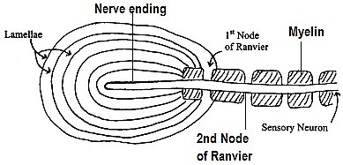
Stimulus Transduction by the Pacinian corpuscle
Transduction (Trans - across; duct - lead) is the conversion of one form of energy into another
Sensory transduction converts the energy of the stimulus into a receptor or generator potential
Sensory transduction is the process of transforming properties of the external and internal environments into nerve impulses
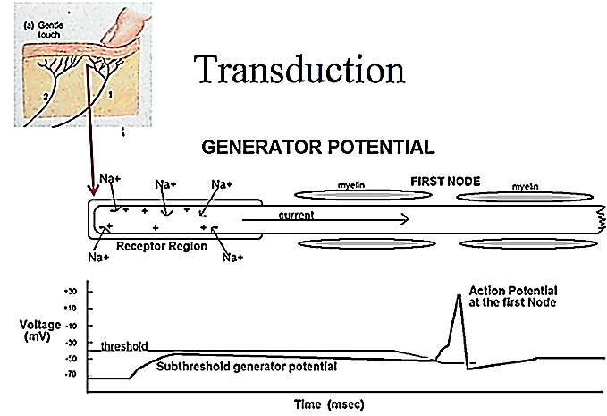
When you press on a Pacinian corpuscle, you deform the lamellae and cause them to press on the tip of the sensory neuron. That, in turn, physically deforms the neuron's plasma membrane and makes it 'leaky' to sodium ions (i.e., the deformation increases gNa+). This will tend to depolarize the membrane at the site of the deformation. The tip of the sensory neuron, however, is like the dendritic zone of a neuron in that it lacks voltage-gated Na+ channels and therefore cannot generate or propagate action potentials, so you can think of this depolarization as a large-amplitude EPSP (dmV = 5-10 mV, depending on how strong the pressure is)
When a small amount of pressure is applied, a non- propagated depolarization potential resembling an EPSP (excitatory postsynaptic potential) is recorded. This is called (generator potential or receptor potential). The generator or receptor potentials are local or non-propagated events as shown by the degradation of their amplitudes with increasing distance from the receptor.
The generator or receptor potentials are graded responses as opposed to the all-or-none character of the action potential. As the pressure is increased, the magnitude of the receptor potential increased. When the magnitude of the generator potential is about 10 mV, an action potential is generated in the sensory nerve. As the pressure is further increased, the generator potential become even larger and the nerve fire repetitively
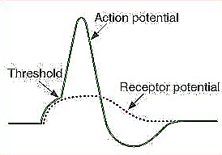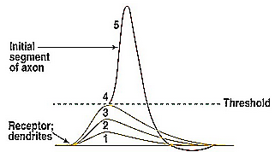
The first part on the sensory neuron that does have the voltage-gated Na+ channels required for action potential generation is the 1st Node of Ranvier.
The receptor potential in turn induces a local circuit of current flow, shown by the arrows, that spreads along the nerve fiber. At the first node of Ranvier, which itself lies inside the capsule of the pacinian corpuscle, the local current flow depolarizes the fiber membrane at this node, which then sets off typical action potentials that are transmitted along the nerve fiber toward the central nervous system.
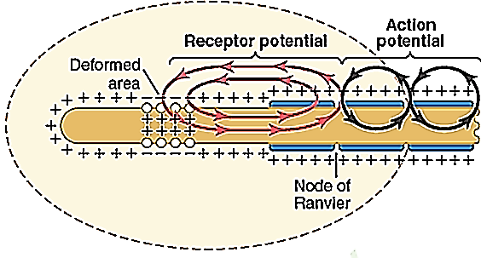
The generator potential in a Pacinian corpuscle originates in the unmyelinated nerve terminal. Loewenstein's experiments with the Pacinian corpuscle (1959)
(1) The electrical responses to a pressure of 1x, 2x, 3x (c) were recorded. The strongest stimulus produced an action potential in the sensory nerve (d).
(2) The layers of the corpuscle have been removed, leaving the nerve terminal intact. The response to application of mechanical force is unchanged from (1) except that the responses were more prolonged because of partial loss of adaptation.
(3) The generator potential persisted but the action potential was absent when the first node of Ranvier was blocked by pressure or with narcotics (arrow).
(4) All responses disappeared when the sensory nerve was cut (arrow) and prevents the creation of the generator voltage.
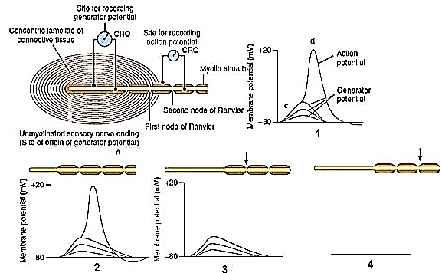
Maximum Receptor Potential amplitude.
There is an increase in amplitude of the receptor potential caused by progressively stronger mechanical compression (increasing “stimulus strength”) applied experimentally to the central core of a Pacinian corpuscle. Note that the amplitude increases rapidly at first but then progressively less rapidly at high stimulus strength.
The maximum amplitude of most sensory receptor potentials is about 100 millivolts, but this level occurs only at an extremely high intensity of sensory stimulus. This is about the same maximum voltage recorded in action potentials and is also the change in voltage when the membrane becomes maximally permeable to sodium ions.
Relation of the Receptor Potential to Action Potentials.
When the receptor potential rises above the threshold for eliciting action potentials in the nerve fiber attached to the receptor, then action potentials occur.
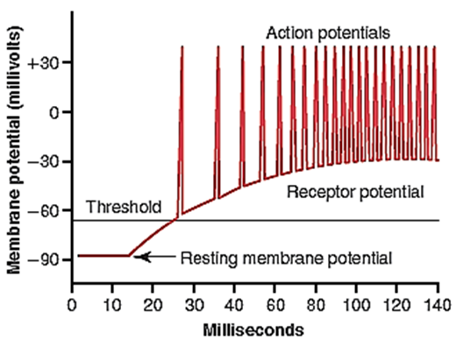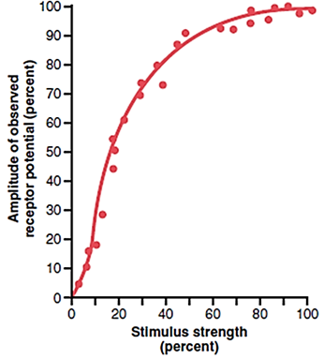
If the generator potential is great enough, the neuron fires again as soon as it repolarizes, and it continues to fire as long as the generator potential is large enough to bring the membrane potential of the node to the firing level.
The more the receptor potential rises above the threshold level, the greater becomes the action potential frequency
Sensory Coding
Sensory coding is a type of information processing (messages) from receptors to brain
1. Duration receptor exposure to stimuli & Adaptation of sensory receptors:
Duration refers to the time from start to end of a response in the receptor
Adaptation or desensitization: when sensory process (the frequency of the action potentials in its sensory nerve) become less sensitive to stimuli; even though the stimulus is of constant strength is applied to a receptor
Type of adaptation:
A. Tonic receptor (slow adapt receptor)
Example (muscle spindle; pressure; slow pain, cold, lung inflation, baro-receptor, and chemoreceptor):
Tonic receptor respond repetitively to a prolonged stimulus.
Tonic receptor detect a steady stimulus (Continuous Stimulus Strength)
Tonic receptor show little, slow and incomplete adaptation in response to a prolonged stimulus
Tonic receptor are better at coding the intensity of a stimulus for its entire duration; so continue to transmit impulse to brain as long as the stimuli is present
B. Phasic receptor (rapidly adapt receptor) or “Rate Receptors,” or “Movement Receptors,”
Examples: pacinian corpuscle; light touch:
Phasic receptor show a decline in action potential frequency with time in response to a constant stimulus.
Phasic receptor primarily detect onset and offset of a stimulus.
Phasic receptor rapidly adapting receptors code changes in stimulus intensity (strength) better but not the duration
Phasic receptor cannot be used to transmit continues signal, because these receptor are stimulated only when stimulus strength changes this is why these receptors are called rate receptors, movement receptors, or phasic receptors. Yet they react strongly while a change actually
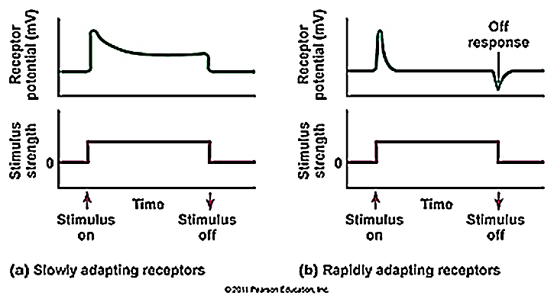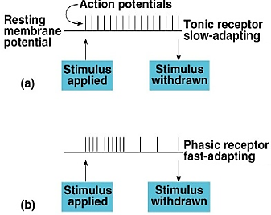
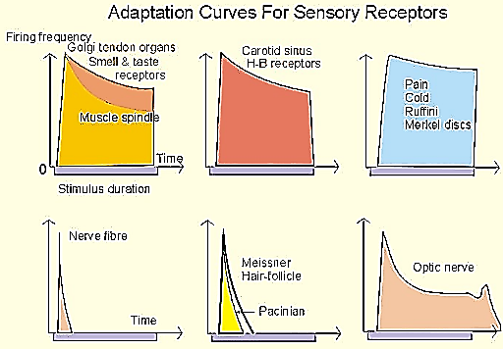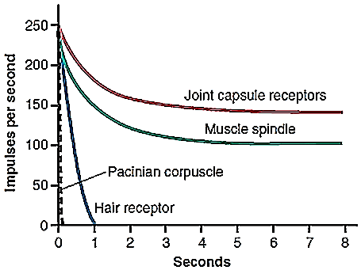
Mechanisms by which receptors adapt
The mechanism differ from receptor to receptor but for Pacinian corpuscles adapt may be due to
First redistribution of fluid at the visco-elastic capsule that the pressure on the capsule will not be transmitted to the nerve ending
Second (accommodation or slow adaptation) due to decrease in the number of opened Na channel
Adaptation time varies depending on the receptors some take short time like the Pacinian corpuscles adapt to “extinction” within a few hundredths of a second.
Others takes very long times so (sometimes they call them non-adapting receptors) like carotid and aortic baroreceptors
2. Specificity of response or Law of adequate stimulus:
The particular form of energy to which a receptor is most sensitive is called its adequate stimulus
The adequate stimulus for the rods and cones in the eye, for example, is light (an example of electromagnetic energy).
Receptors do respond to forms of energy other than their adequate stimuli, but the threshold for these nonspecific responses is much higher. Pressure on the eyeball will stimulate the rods and cones, for example, but the threshold of these receptors to pressure is much higher than the threshold of the pressure receptors in the skin.
Frequency coding (Temporal Summation)
Increasing the frequency of nerve impulses in each fiber, which is called temporal summation
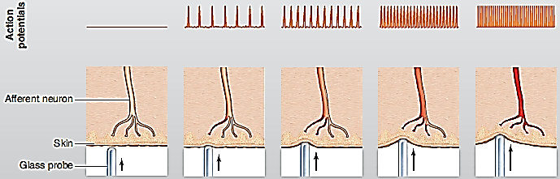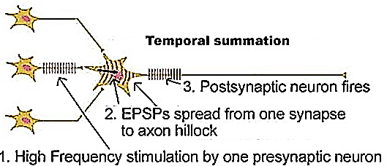
Weber-Fechner law:
The magnitude of sensation is proportional to the log of intensity of the stimulus
The relation is not liner but power relation where the stimuli frequency is very high at beginning then decrease. This allows the receptor to have an extreme range of response from very weak to very intense
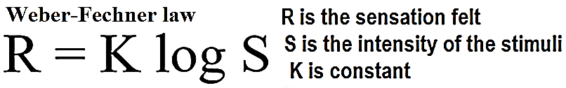
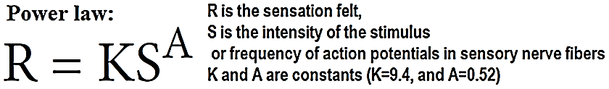
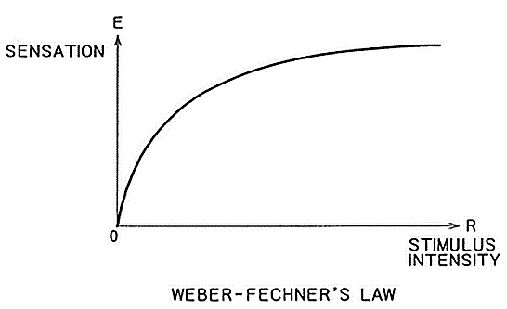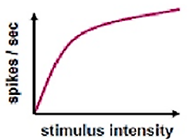
The relation between sensation and stimulus intensity is determined primarily by the properties of the peripheral receptors.
3. Receptor modalityانماط اشكال:
Humans have four basic classes of receptors based on their sensitivity
Different receptors can be excited in one of several ways to cause receptor potentials by:
(1) Mechanical: mechanical deformation of the receptor
(2) Chemical: application of a chemical to the membrane
(3) Thermal: change of the temperature of the membrane
(4) Electromagnetic: the effects of electromagnetic radiation
4. Location of sensory stimuli:
Location is the site on the body or space where the stimulus originated.
Sensory unit: is a single sensory axon and all its peripheral branches (these branches vary in number but may be numerous, especially in cutaneous sense); and all receptors associated with it.
Pathways for different modalities (sensation) terminate on different places of the cerebral cortex.
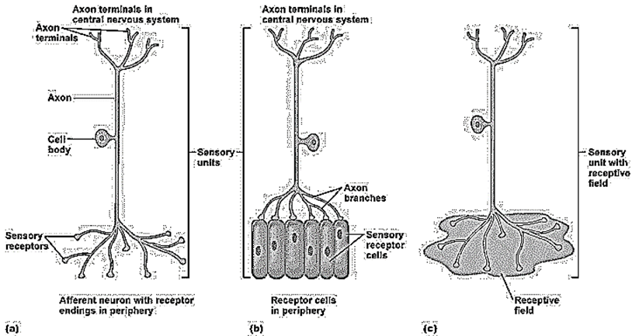
Receptive field of a sensory unit is the area from which a stimulus produce a response in that unit.
Receptive field is an area of the body that, when stimulated, changes the firing rate of a sensory neuron.
If the firing rate of the sensory neuron is increased, the receptive field is excitatory.
If the firing rate of the sensory neuron is decreased, the receptive field is inhibitory.
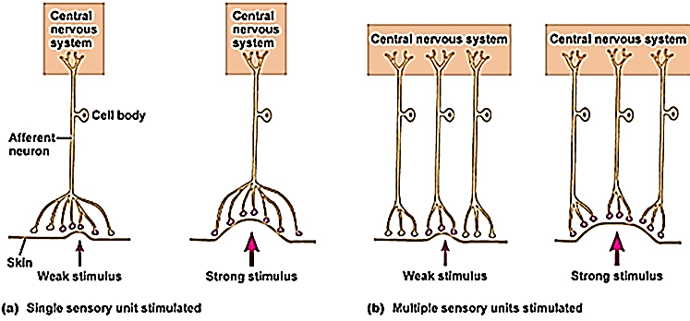
Sensory information
The speed of conduction and other characteristics of sensory nerve fibers vary, but action potentials are similar in all nerves.
This raises the question of
Why stimulation of a touch receptor causes a sensation of touch and not of warmth?
A. Law of specific nerve energies or Muller’s Doctrine (نظرية مولر (of specific energies:
No matter where along the nerve pathway one stimulates, the type of sensation will depend on which part of the brain is finally going to be stimulated
B. Law of projection:
No matter where a long particular sensory pathway is stimulated along its course to the cortex; the conscious sensation (the sensation will be felt) produced is referred to the to the location of the receptor
Example:
During neurosurgical procedures on conscious patients; when the cortical receiving area for impulses from the left hand is stimulated, the patient reports sensation in the left hand, not any other area.
Phantom limb
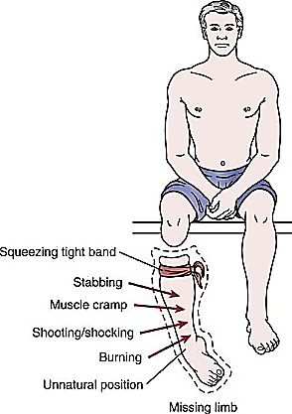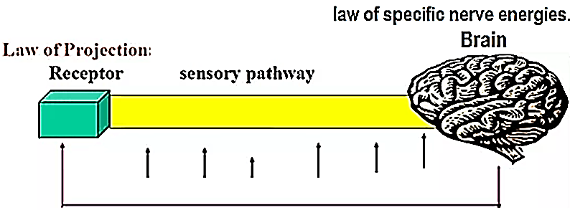
Recruitment تطويعof sensory unit or Population coding (Spatial Summation)
The precision دقه of stimulus location is acuity. Sensory Acuity depends on:
a. Receptive field size: the smaller the receptive field, the better the acuity
b. Receptive density: the more receptors per receptive field, the better the acuity generally, receptors are concentrated in the center of the receptive field
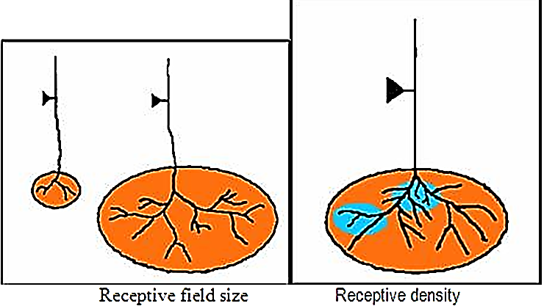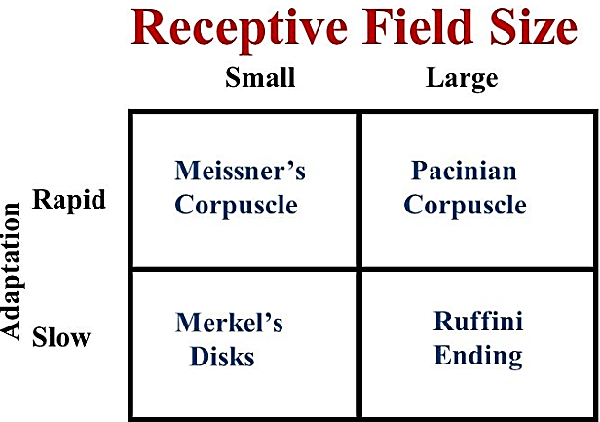
c. Lateral Inhibition (Also Called Surround Inhibition):
Lateral inhibition is one of the most important mechanisms that enable localization of a stimulus site
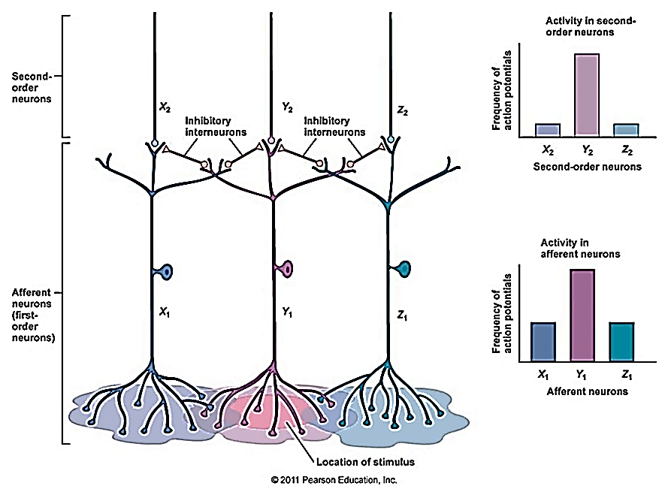
Lateral inhibition is because
a. information from sensory neurons whose receptors are at the peripheral edge of the stimulus is inhibited by neurons with neighboring receptive fields compared to information from the sensory neurons at the center of the stimulus.
b. short lateral pathways transmit inhibitory signals to the surrounding neurons— that is, these signals pass through additional interneurons that secrete an inhibitory transmitter.
Lateral inhibition increases acuity because lateral inhibition enhances the contrast between the center and periphery of a stimulated area and increases the ability of the brain to localize a sensory input.
How it is possible to tell whether the touch is light or heavy?
To answer the question
a. Number of receptors
Weak stimuli activate the receptors with the lowest thresholds
Strong stimuli activate the receptors with the highest thresholds
As we gradually increase the threshold of stimuli; the receptor response first is that with low threshold receptors; then with the increase intensity of stimuli high threshold receptors will be affected
b. Area of stimuli
As the strength of a stimulus is increased stimulus tends to spread over a large area and generally not only activates the sense organs immediately in contact with it but also “recruits” those in the surrounding area.
Because of overlap and inter-digitation تشابكof one unit with another, however, receptors of other units are also stimulated, and consequently more units fire. In this way, more afferent pathways are activated, which is interpreted in the brain as an increase in intensity of the sensation.
Spatial summation means increasing signal strength is transmitted by using progressively greater numbers of nerve fibers.
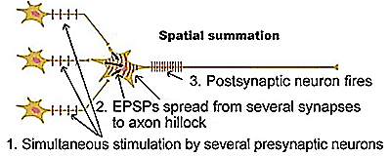
Classification of sensation:
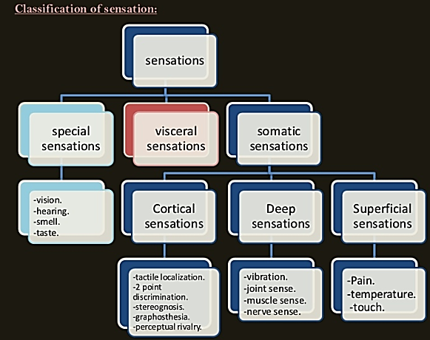
Thermal Sensation:
Thermal receptors and their excitation:
The human being can perceive different gradations of cold and heat:
From freezing cold cold cool indifferent to warm hot burning hot.
Thermal gradations are discriminated by at least three types of sensory receptors:
Cold receptors, & warmth receptors
- The cold and warmth receptors are located immediately under the skin at discrete separated spots. Because the sense organs are located sub-epithelially, it is the temperature of the subcutaneous tissues that determines the responses.
- Cool metal objects feel colder than wooden objects of the same temperature because the metal conducts heat away from the skin more rapidly, cooling the subcutaneous tissues to a greater degree.
- Most areas of the body have 3 to 10 times as many cold spots as warmth spots, and the number in different areas of the body varies from 15 to 25 cold spots per square centimeter in the lips to 3 to 5 cold spots per square centimeter in the finger to less than 1 cold spot per square centimeter in some broad surface areas of the trunk.
- The temperature sense organs are naked nerve endings.
Warmth receptors:
Although psychological tests show that the existence of distinctive warmth nerve endings is quite certain, they have not been identified histologically.
Warmth receptors are presumed to be free nerve endings
Warmth signals are transmitted mainly over free nerve endings of unmyelinated type C nerve fibers at transmission velocities of only 0.4 to 2 m/sec.
Cold receptors:
A definitive cold receptor has been identified.
Cold receptors is a free nerve endings, small type Aδ myelinated nerve ending that branches several times, the tips of which protrude into transmitted from these receptors via type Aδ nerve fibers at velocities of about 20 m/sec. Some cold sensations are believed to be transmitted in type C nerve fibers as well, which suggests that some free nerve endings also might function as warmth receptors.
Pain receptors (Temperature-sensitive nociceptors). The pain receptors are stimulated only by extreme degrees of heat or cold and, therefore, are responsible, along with the cold and warmth receptors, for “freezing cold” and “burning hot” sensations.
Stimulation of Thermal Receptors (Sensations of Cold, Cool, Indifferent, Warm, and Hot):
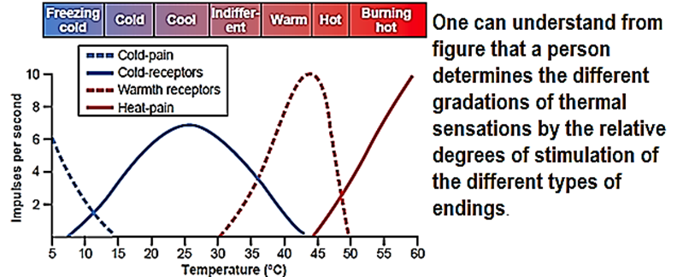
The effects of different temperatures on the responses of four types of nerve fibers
(1) a pain fiber stimulated by cold (5 to 15°C)
For instance, in the very cold region, only the cold-pain fibers are stimulated but if the skin becomes even colder so that it nearly freezes or actually does freeze (0 to 5 °C), these fibers cannot be stimulated).
(2) a cold fiber,
As the temperature rises to +10°C to 15°C, the cold-pain impulses cease, but the cold receptors begin to be stimulated, reaching peak stimulation at about 24°C and fading out slightly above 40°C.
(3) a warmth fiber, and
Above about 30°C, the warmth receptors begin to be stimulated, but these also fade out at about 49°C.
(4) a pain fiber stimulated by heat.
Finally, at around 45°C, the heat-pain fibers begin to be stimulated by heat and, paradoxicallyبشكل متناقض, some of the cold fibers begin to be stimulated again, possibly because of damage to the cold endings caused by the excessive heat.
why extreme degrees of both cold and heat can be painful
why extreme degrees of both cold and heat, may give almost the same quality of sensation—that is, freezing cold and burning hot sensations feel almost alike.
Adaptation of Thermal Receptors:
Thermal receptor “adapts” to a great extent, but never 100 per cent.
Thermal senses respond markedly to changes in temperature, in addition to being able to respond to steady states of temperature. This means that when the temperature of the skin is actively falling, a person feels much colder than when the temperature remains cold at the same level. The same thing for hot temperature.
هذا يفسر لماذا تشعر ان ماء المسبح بارد جدا(بسبب الفرق بين درجة حرارة الجسم و الماء) عندما تدخل الماء
ثم تتعود على البرود لان (بسبب اسقرار درجة الحرارة)
- The receptor name for moderate cold is the cold- and menthol-sensitive receptor 1 (CMR 1).
- Two types name of vanilloid receptors respond to noxious heat are (VR1 and VRL-1)
The VR1 (vanilloid receptors) respond not only to capsaicin but also to protons and to potentially harmful temperatures above 43 °C
VRL-1(Varmint Light), which responds to temperatures above 50 °C but not to capsaicin. Vanillins are a group of compounds, including capsaicin (the active component of chili peppers), that cause pain.
Mechanism of stimulation of thermal receptors:
It is believed that the cold and warmth receptors are stimulated by changes in their metabolic rates and that these changes result from the fact that temperature alters the rate of intracellular chemical reactions more than twofold for each 10°C change. In other words, thermal detection probably results not from direct physical effects of heat or cold on the nerve endings but from chemical stimulation of the endings as modified by temperature.
Spatial Summation of Thermal Sensations.
Because the number of cold or warm endings in any one surface area of the body is slight, it is difficult to judge gradations of temperature when small skin areas are stimulated. However, when a large skin area is stimulated all at once, the thermal signals from the entire area summate. For instance, rapid changes in temperature as little as 0.01°C can be detected if this change affects the entire surface of the body simultaneously. Conversely, temperature changes 100 times as great often will not be detected when the affected skin area is only 1 square centimeter in size.

