**Al Balqa Applied University**



**College of Medicine**

**Lecture 8**

**Hepatitis viruses**

**Dr. Hala Al Daghistani**

Hepatitis

* Inflammation of the liver
* May result from drug or chemical toxicity, EB virus, CMV, or the Hepatitis viruses
* Symptoms- abdominal pain or distention, fatigue, jaundice, loss of appetite, low-grade fever, nausea , vomiting, and weight loss

**Epidemiological and clinical features of hepatitis viruses**

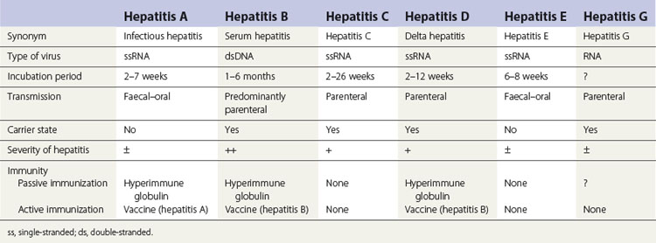

Hepatitis Virus

* Viral hepatitis is a systemic disease primarily involving the liver.
* Most cases of acute viral hepatitis in children and adults are caused by one of the following six agents:
* **Hepatitis A virus(HAV),** the etiologic agent of viral hepatitis type A (infectious hepatitis). HAV is a distinct member of the picornavirus,cubic, ssRNA. Only one serotype is known
* **Hepatitis B virus (HBV)**, which is associated with viral hepatitis B (serum hepatitis)
* **Hepatitis C virus (HCV)**, the agent of hepatitis C (posttransfusion hepatitis)
* **Hepatitis D (HDV),** a defective virus dependent on coinfection or preinfectionwith HBV.
* **Hepatitis E virus (HEV),** the agent of enterically transmitted hepatitis. HEV is transmitted enterically and occurs in epidemic form in developing countries, where water or food supplies are sometimes fecally contaminated. Pregnant women may have a high (20%) mortality rate if fulminant hepatitis develops.
* **HepatitisGvirus(HGV)**,a distant relative of HCV.Often patients with hepatitis G are infected at the same time by [hepatitis](http://medical-dictionary.thefreedictionary.com/hepatitis+B)B or C virus, or both.

**HBV HCV**

* **Virus Classification DNA RNA**
* **Family Hepadnavirus Flavivirus**
* **Clinical illness (jaundice) 30%–50% 20%**
* **Chronic infection 90% (infants) ~70%**

**5–10% (adults)**

* **Mortality from CLD, cirrhosis25% 1-5%**

**Hepatitis Type B**

**Structure and Composition of HBV**

The virus particle consists of an outer [lipid](https://en.wikipedia.org/wiki/Lipid) envelope and an [icosahedral](https://en.wikipedia.org/wiki/Icosahedron) [nucleocapsid](https://en.wikipedia.org/wiki/Nucleocapsid" \o "Nucleocapsid) core composed of [protein](https://en.wikipedia.org/wiki/Protein). Electron microscopy reveals **three morphologic forms.** The most numerous are spherical particles made up exclusively of **HBsAg** that are surrounds a inner nucleocapsid core (**HBcAg**)

* Infectious virion attaches to cells and becomes uncoated. In the nucleus, the viral genomeis converted to covalently closed circular dsDNA which serves as templatefor all viral transcripts.

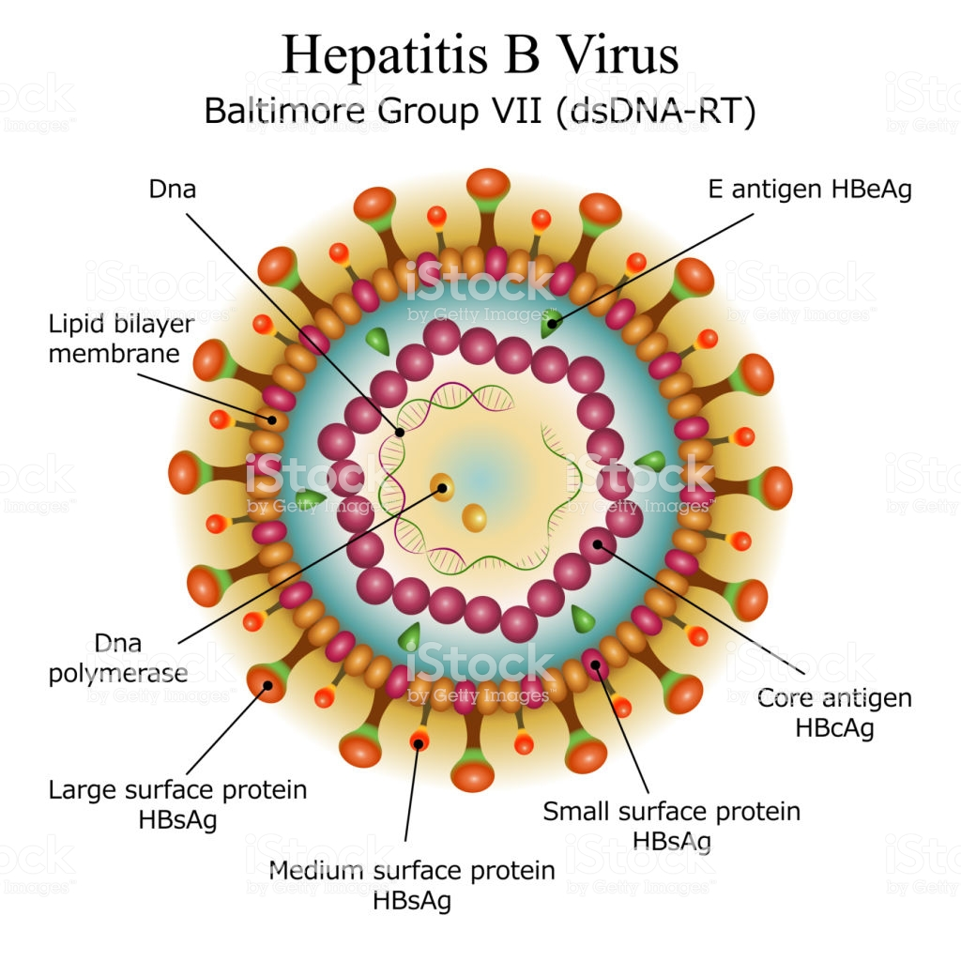

Histopathology of HBV infection

* Parenchymal cell degeneration, with necrosis of hepatocytes
* Adiffuse lobular inflammatory reaction and disruption of liver cell cords.
* These parenchymal changes are accompanied by reticuloendothelial (Kupffer) cell hyperplasia,periportal infiltration by mononuclear cells, and cell degeneration.
* Later in the course of the disease, there is an accumulation of macrophages near degenerating hepatocytes.
* The damaged hepatic tissue is usually restored in 8–12 weeks.
* Chronic carriers of HBsAg may or may not have demonstrable evidence of liver disease. Persistent (unresolved) viral hepatitis, a mild benign disease is characterized by sporadically abnormal aminotransferase values and hepatomegaly with slight to absent fibrosis.
* None of the hepatitis viruses are typically cytopathogenic, and it is believed that the cellular damage seen in hepatitis is immune-mediated.
* Both HBV and HCV have significant roles in the development of hepatocellular carcinoma that may appear many (15–60) years after establishment of chronic infection.

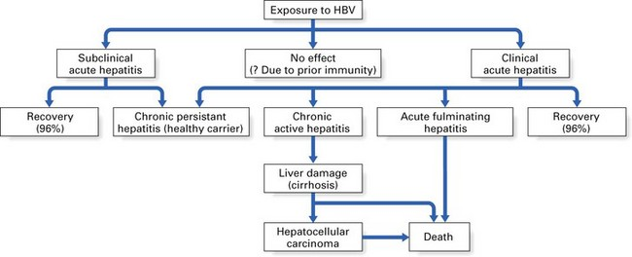

**Hepatitis Type C**

* Several non-A, non-B (NANB) hepatitis agents that, based on serologic tests, were not related to HAV orHBV. The major agent was identified as HCV.
* Most cases of post-transfusion NANB hepatitis were caused by HCV.Most new infections with HCV are subclinical.
* In some countries, as in Japan, HCV infection often leads to hepatocellular carcinoma.
* The virus undergoes sequence variation during chronic infections. This complex viral population in a host is referred to as “quasi-species.” This genetic diversity is not correlated with differences in clinical disease, although differences do exist in response to antiviral therapy according to viral genotype.
* **Chronic infection with the hepatitis C virus (HCV) is a major risk factor for the development of hepatocellular carcinoma (HCC) worldwide. The pathogenesis of HCC in HCV infection has extensively been analysed. Hepatitis C virus-induced chronic inflammation and the effects of cytokines in the development of fibrosis and liver cell proliferation are considered as one of the major pathogenic mechanisms.**

**Hepatitis viruses produce acute inflammation of the liver, resulting in a clinical illness characterized by :**Fever, Nausea, Vomiting, jaundice.

* In viral hepatitis, onset of jaundice is often preceded by gastrointestinal symptoms such as nausea, vomiting, anorexia, and mild fever.
* Jaundice may appear within a few days of the prodromal period, but anicteric hepatitis is more common (A mild form of hepatitis in which there is no jaundice).
* Extrahepatic manifestations of viral hepatitis (primarily type B) include a transient serum sickness-like prodrome consisting of fever, skin rash, and polyarthritis; necrotizing vasculitis (polyarteritisnodosa); and glomerulonephritis.
* 80–95% of infants and young children infected with HBV become chronic carriers, and their serum remains positive for HBsAg. Chronic carriers are at high risk of developing hepatocellular carcinoma. The vast majority of individuals with chronic HBV remain asymptomatic for many years; there may or may not be biochemical and histological evidence of liver disease.
* Hepatitis C is usually clinically mild, with only minimal to moderate elevation of liver enzymes. 70–90% of cases progress to chronic liver disease. Most patients are asymptomatic, but histologic evaluation often reveals evidence of chronic active hepatitis,especially in those whose disease is acquired after transfusion.

Cirrhosis is a disease in which liver cells become damaged and are replaced by scar tissue. People with cirrhosis have an increased risk of liver cancer. There are several possible causes of cirrhosis. Most cases occur in people who abuse alcohol or have chronic HBV or HCV infections.

**Serological diagnosis**

* **HBsAg is a general and first marker for infection.**
* **HBsAg persists for more than 6 months** (chronic infection)
* **HBsAg indicates that the person is a carrier and potentially infective**.
* HBeAg indicate active replication of the virus
* This state can persist for months until recovery, or for years in chronic carrier states.
* Antibody to hepatitis B surface antigen (anti-HBs) appears in serum during the recovery phase and is long-lived; its presence indicates recovery and immunity to further HBV infection; also seen in high titer after successful vaccination for HBV, as the active ingredient of the hepatis

